AUSTRALIAN HAEMOVIGILANCE DATA AT A GLANCE IN 2019-20
The National Blood Authority (NBA) has been collecting haemovigilance data from states and territories and publishing reports under the National Blood Agreement since 2008. The following data was derived from the 11th Australian Haemovigilance Report (2019-20). One hundred and thirty hospitals (106 public hospitals and 24 private hospitals) reported adverse events for 2019-20. All adverse events are reported events and it should be noted that there are some quality issues in relation to data completeness, standardisation and relevance. The use of different haemovigilance reporting processes across the jurisdictions, may lead to data inconsistencies. For further details, see page 4 of the annual report.
Fresh blood product and blood transfusion have become increasingly safe in Australia. From 2015-16 to 2019-20, states and territories reported 326 transfusion-related serious adverse events (SAE) to the national haemoviglance program. Key findings include:
- all states and territories have participated in the national haemovigilance reporting since 2015-16
- 52% of the reported transfusion-related SAEs are transfusion-associated circulatory overload (TACO) and anaphylactic reactions
- 55 out of 131 reported life-threatening cases are anaphylactic reactions.

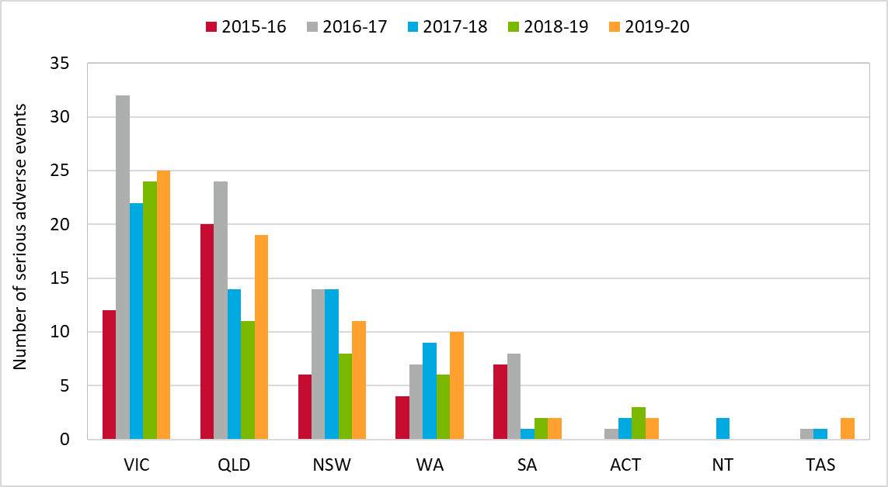
Figure 1: Tranfusion related serious adverse events by state, 2015-16 to 2019-20
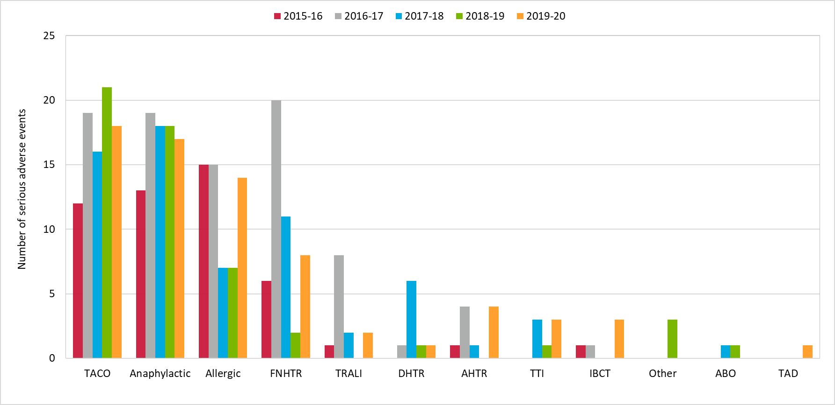
Figure 2: Tranfusion related adverse events in Australia, 2015-16 to 2019-20

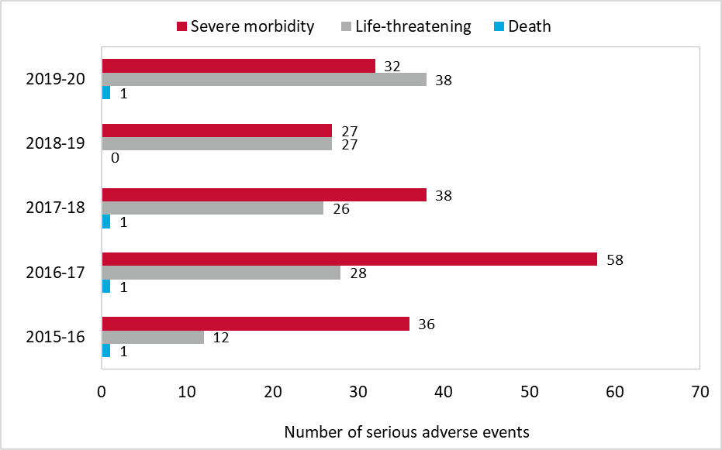
Figure 3: Death, life-threatening and severe morbidity, 2015-16 to 2019-20

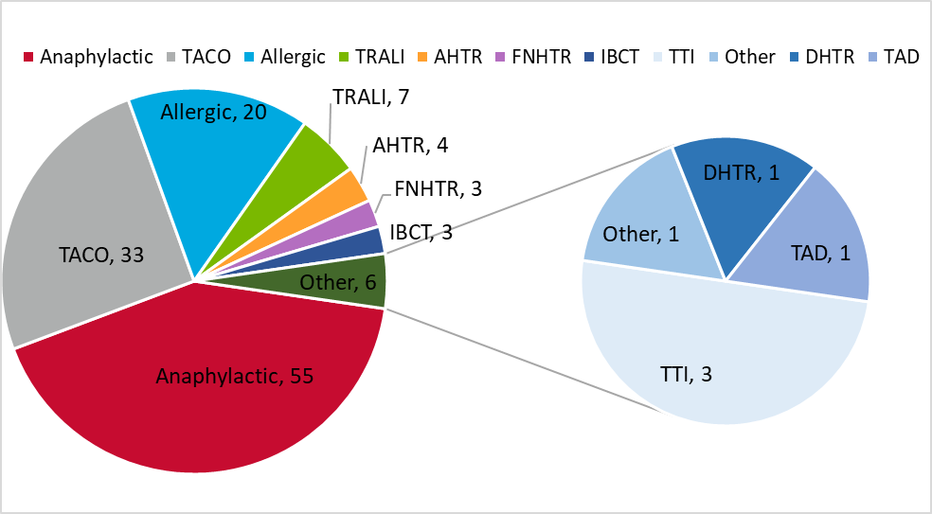
Figure 4: Life-threatening adverse events in Australia, 2015-16 to 2019-20

- A transfusion related serious adverse event is an event which is classified as ‘possible’ or ‘likely/probable’, or ‘confirmed/certain’ to be related to blood transfusion and results in ‘severe morbidity’ or ‘life-threatening’ outcome or death to a patient.
- ABO=ABO Incompatibility; AHTR=Acute Haemolytic Transfusion Reaction; Anaphylactic=Anaphylactic Reaction; Allergic=Allergic Reaction; FNHTR=Febrile Non-Haemolytic Transfusion Reaction; DHTR=Delayed Haemolytic Transfusion Reaction; IBCT=Incorrect Blood Component Transfused; Other=Other Reaction; TACO=Transfusion-Associated Circulatory Overload; TAD=Transfusion Associated Dyspnoea; TRALI=Transfusion-Related Acute Lung Injury; TTI= Transfusion Transmitted Infection

The haemovigilance data has been collected based on the Australian Haemovigilance Minimum Data Set (AHMDS 2015) and the National Haemovigilance Data Dictionary 2010. For more information, please visit the NBA website.
https://www.blood.gov.au/haemovigilance
https://www.blood.gov.au/haemovigilance-reporting

