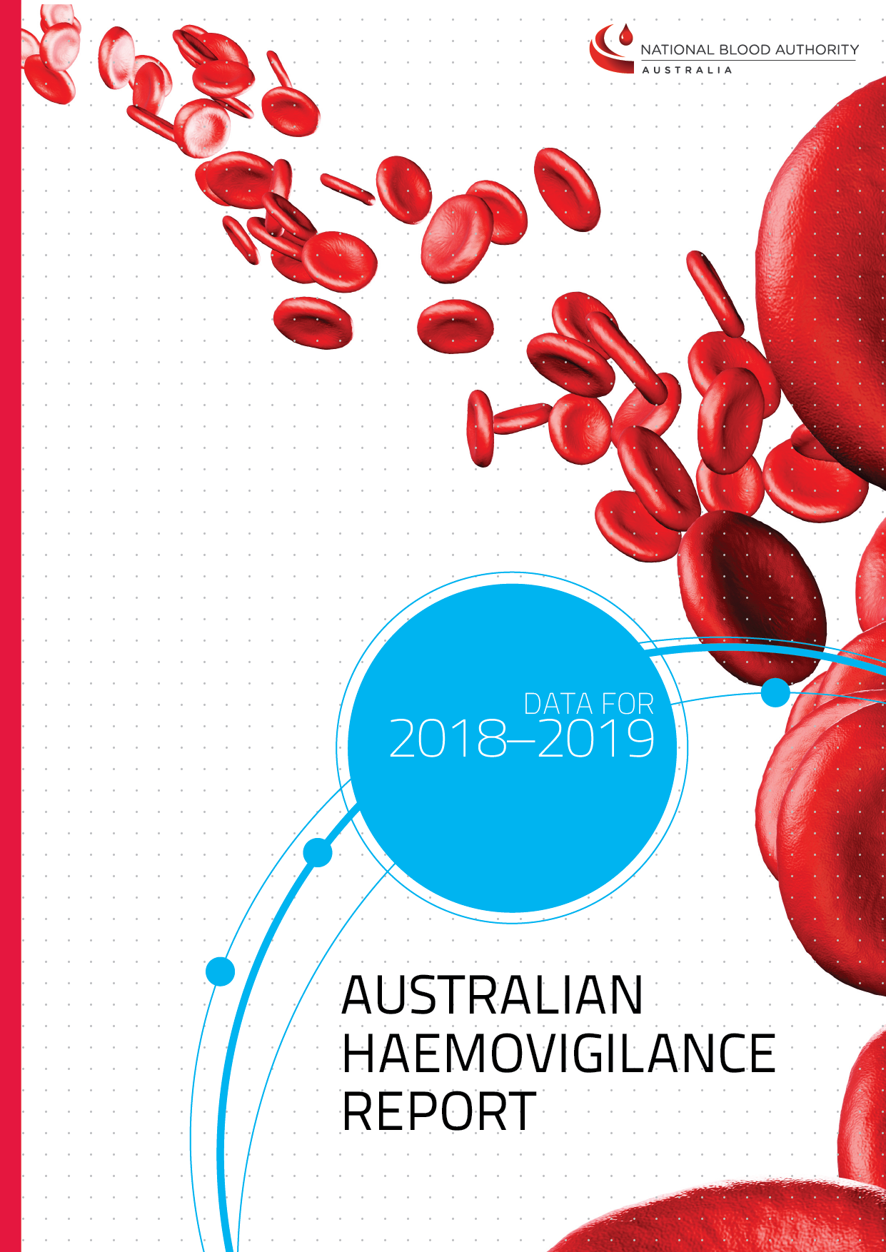



With the exception of any logos and registered trademarks, and where otherwise noted, all material presented in this document is provided under a Creative Commons Attribution 4.0 license (https://creativecommons.org/licenses/by/4.0/)

The details of the relevant license conditions are available on the Creative Commons website (accessible using the links provided) as is the full legal code for the CC BY 4.0 license (https://creativecommons.org/licenses/by/4.0/legalcode)

The content obtained from this document or derivative of this work must be attributed as:

Australian Haemovigilance Report, Data for 2018-19 published by the National Blood Authority.

ISSN 1838-1790

This report is available online at www.blood.gov.au/haemovigilance-reporting

Contact officer:

Communications Manager

Locked Bag 8430

Canberra ACT 2601

Phone: +61 2 6151 5000

Fax: +61 2 6151 5300

Email: haemovigilance@blood.gov.au

Website: www.blood.gov.au

TABLE OF CONTENTS

TABLES AND FIGURES 4

SECTION 1 6

Australian Haemovigilance Data 6

Acknowledgements 6

Caveats 6

Collection and reporting process 7

Summary of findings for 2018-19 8

Cumulative results for 2013-14 to 2018-19 13

Febrile non haemolytic transfusion reaction (FNHTR) 17

Allergic reaction 18

Transfusion-associated circulatory overload (TACO) 19

Incorrect blood component transfused (IBCT) 20

Anaphylactic or anaphylactoid reaction 22

Delayed haemolytic transfusion reaction (DHTR) 23

Acute haemolytic transfusion reaction (AHTR) 24

Transfusion-transmitted infection (TTI) 25

Transfusion related acute lung injury (TRALI) 26

Delayed serologic reaction (DSTR) 28

Hypotensive transfusion reaction (Hypotensive) 29

ABO incompatibility (ABO) 30

Transfusion associated dyspnoea (TAD) 31

Other adverse events 32

Contributory factors 33

SECTION 2 34

Donor vigilance data 34

Method for Reporting Donor Adverse Events 34

Reporting Period 34

Donor Adverse Event Categories 35

Denominator Cohort 35

Donor Adverse Events 37

Donor Adverse Events by Donation Category 37

Trends over the 2015-16 to 2018-19 period 39

Vasovagal events 41

Events requiring external referral 45

Conclusion 46

APPENDIXES 47

Appendix 1: Current policies and interventions to minimise the risk of donor adverse events 47

ABBREVIATIONS 48

ACKNOWLEDGEMENTS LIST 49

# TABLES AND FIGURES

Table 1: Adverse events by state, 2018–19 8

Table 2: Adverse events by imputability score, 2018–19 8

Table 3: Adverse events by blood product, 2018–19 9

Table 4: Adverse events by clinical outcome severity, 2018–19 10

Table 5: Reported adverse events by sex, 2018–19 11

Table 6: Adverse events by age and sex, 2018–19 11

Table 7: Serious adverse events by outcome severity and imputability score, 2018–19 12

Table 8: Adverse events by state, 2014–15 to 2018–19 13

Table 9: Adverse events by hospital type, 2014–15 to 2018–19 13

Table 10: Australian adverse event data, 2014–15 to 2018–19 14

Table 11: Serious Adverse events by state, 2014–15 to 2018–19 14

Table 12: Serious adverse events, 2014–15 to 2018–19 15

Table 13: Serious adverse events by product, 2014–15 to 2018–19 15

Table 14: Serious adverse events by transfusion time, 2014–15 to 2018–19 16

Table 15: Serious adverse events by week day/weekend, 2014–15 to 2018–19 16

Table 16: Serious adverse events by age group, 2014–15 to 2018–19 16

Table 17: FNHTR data summary, 2018–19 17

Table 18: FNHTR clinical outcome severity by imputability, 2018–19 17

Table 19: Allergic reaction data summary, 2018–19 18

Table 20: Allergic reaction clinical outcome severity by imputability, 2018–19 18

Table 21: TACO data summary, 2018–19 19

Table 22: TACO clinical outcome severity by imputability, 2018–19 19

Table 23: IBCT data summary, 2018–19 20

Table 24: IBCT clinical outcome severity by imputability, 2018–19 20

Table 25: Contributory factors cited in IBCT, 2014–15 to 2018–19 21

Table 26: Anaphylactic or anaphylactoid reaction data summary, 2018–19 22

Table 27: Anaphylactic or anaphylactoid reaction clinical outcome severity by imputability, 2018–19 22

Table 28: DHTR data summary, 2018–19 23

Table 29: DHTR clinical outcome severity by imputability, 2018–19 23

Table 30: AHTR data summary, 2018–19 24

Table 31: AHTR clinical outcome severity by imputability, 2018–19 24

Table 32: TTI data summary, 2018–19 25

Table 33: TTI clinical outcome severity by imputability, 2018–19 25

Table 34: TRALI data summary, 2018–19 26

Table 35: TRALI clinical outcome severity by imputability, 2018–19 26

Table 36: PTP data summary, 2018–19 27

Table 37: PTP clinical outcome severity by imputability, 2018–19 27

Table 38: DSTR data summary, 2018–19 28

Table 39: DSTR clinical outcome severity by imputability, 2018–19 28

Table 40: Hypotensive data summary, 2018–19 29

Table 41: Hypotensive clinical outcome severity by imputability, 2018–19 29

Table 42: ABO data summary, 2018–19 30

Table 43: ABO clinical outcome severity by imputability, 2018–19 30

Table 44: ABO data summary, 2018–19 31

Table 45: TAD clinical outcome severity by imputability, 2018–19 31

Table 46: Other data summary, 2018–19 32

Table 47: Other clinical outcome severity by imputability, 2018–19 32

Table 48: Contributory factors data summary, 2018–19 33

Table 49: Contributory factors cited by adverse event and by clinical outcome severity, 2018–19 33

Table 50: Number of donations in the denominator cohort for FY 2015-16 to 2018-19 36

Table 51: Donor demographics by donation category for FY 2018-19 36

Table 52: Donor adverse event rates per 10,000 donations by donation type for FY 2018-19 38

Table 53: Specific apheresis-related donor adverse event rates per 10,000 donations for FY 2018-19 38

Table 54: Total donor adverse event rates per 10,000 donations for FY 2015-16 to 2018-19 39

Table 55: Phlebotomy-related injury rate per 10,000 donations for FY 2015-16 to 2018-19 40

Table 56: Vasovagal events per 10,000 donations* by donation category for FY 2018-19 41

Table 57: Vasovagal events associated with loss of consciousness per 10,000 donations by donation category for FY 2015-16 to 2018-19 42

Table 58: Vasovagal rates in new and returned female and male whole blood donors for FY 2018-2019 43

Table 59: Vasovagal rates in new and returned female and male plasma donors for FY 2018-2019 43

Table 60: Rates and relative risk for vasovagal events in females for all donation categories by age for 2018-19 44

Table 61: Rates and relative risk for vasovagal events in males for all donation categories by age for 2018-19 44

Table 62: Donor adverse events requiring hospital attendance (per 10,000 donations), FY 2015-16 to 2018-19 45

Table 63: Donor adverse events requiring external care (rates per 10,000 donations) for FY 2018-19 45

# SECTION 1

# Australian Haemovigilance Data

**July 2018 – June 2019**

### Acknowledgements

This report is published on behalf of the states and territories who voluntarily provided data to the national system. The National Blood Authority (NBA) thanks them for their contributions and ongoing commitment to haemovigilance.

Appreciation is also extended to the members of the Haemovigilance Advisory Committee (HAC) for their advice on improvements in adverse event reporting and analysis of the data for this report.

### Caveats

Reporting of haemovigilance data to the national haemovigilance program is voluntary and data validation is not performed in all instances in Australia.

When using the data from this report it is important to note that it has quality issues in relation to data completeness, standardisation and relevance.

Notwithstanding these limitations, the NBA is publishing this data as an aid to relevant analysis and to maintain the time series of data published during the last ten years.

* Data in this report are in accordance with either the National Blood Authority National Haemovigilance Data Dictionary (NHDD) 2010 or the Australian Haemovigilance Minimum Data Set (AHMDS) 2015.
* Data contributions vary across years and between states/territories.
* Near misses and denominator data (number of transfusions) are not collected and reported at national level.
* All the adverse events in this report are reported cases rather than confirmed cases.
* The definitions for the adverse events in Appendix I of the 2010 NHDD and 2015 AHMDS align with those used by the International Haemovigilance Network (IHN) and International Society Blood Transfusion (ISBT) unless otherwise stated. However, it is not expected that they are applied rigorously.

The national data set accepts the categorisation assigned by the contributing jurisdiction and the reviewing clinicians, regardless of minor differences to definitions.

### Collection and reporting process

* Data is provided to the national haemovigilance program according to each jurisdiction’s review and reporting requirements.
* Data for bacterial contamination and TRALI is reconciled with data from Lifeblood.
* State and territory health departments aggregate and de-identify data and report to the NBA.

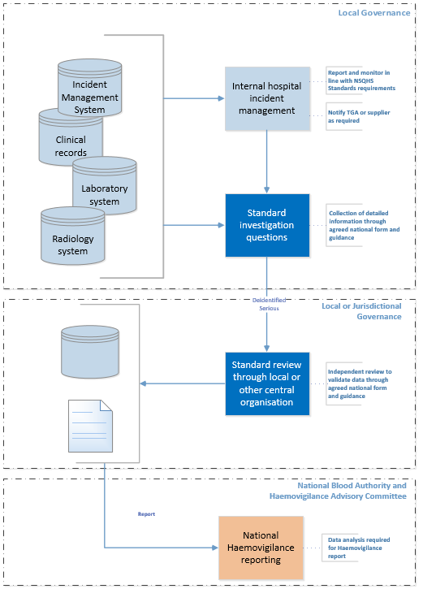

### Summary of findings for 2018-19

**Table 1: Adverse events by state, 2018–19**



Notes

1. All states/territories contributed the data
2. All TTIs were suspected but not confirmed bacterial infection
3. STIR uses a higher level temperature threshold for the reporting of FNHTR
4. QLD uses the 2010 AHMDS for all reporting
5. In 2018-19, some states reported new adverse events in accordance with the 2015 AHMDS. Refer to each adverse event reporting for details

**Table 2: Adverse events by imputability score, 2018–19**



Notes

1. All states/territories contributed the data
2. All TTIs were suspected but not confirmed bacterial infection
3. STIR uses a higher level temperature threshold for the reporting of FNHTR
4. QLD uses the 2010 AHMDS for all reporting
5. In 2018-19, some states reported new adverse events in accordance with the 2015 AHMDS. Refer to individual adverse event reporting further in Section 1

**Table 3: Adverse events by blood product, 2018–19**



Notes

1. All states/territories contributed the data
2. All TTIs were suspected but not confirmed bacterial infection
3. STIR uses a higher level temperature threshold for the reporting of FNHTR
4. QLD uses the 2010 AHMDS for all reporting
5. In 2018-19, some states reported new adverse events in accordance with the 2015 AHMDS. Refer to each adverse event reporting for details

**Table 4: Adverse events by clinical outcome severity, 2018–19**



Notes

1. All states/territories contributed the data
2. All TTIs were suspected but not confirmed bacterial infection
3. STIR uses a higher level temperature threshold for the reporting of FNHTR
4. QLD uses the 2010 AHMDS for all reporting
5. In 2018-19, some states reported new adverse events in accordance with the 2015 AHMDS. Refer to each adverse event reporting for details

**Table 5: Reported adverse events by sex, 2018–19**



Notes

1. Sex data incomplete for NSW
2. In 2018-19, some states reported new adverse events in accordance with the 2015 AHMDS. Refer to each adverse event reporting for details

**Table 6: Adverse events by age and sex, 2018–19**



Note: Sex data incomplete for NSW

**Table 7: Serious adverse events by outcome severity and imputability score, 2018–19**



Notes

1. Not assessable and excluded/unlikely imputability scores are not included in the analysis
2. Outcome severity with unknown outcomes, minor and no morbidities are not included in the analysis

#### Cumulative results for 2013-14 to 2018-19

**Table 8: Adverse events by state, 2014–15 to 2018–19**



Notes

1. ACT reported zero adverse events for 2014–15
2. TAS reported zero events for 2015–16 and 2018–19
3. WA did not contribute data for 2014–15
4. STIR uses a higher level temperature threshold for the reporting of FNHTR and cases are validated by an expert group prior to finalisation of the report
5. QLD uses the 2010 AHMDS for all reporting

**Table 9: Adverse events by hospital type, 2014–15 to 2018–19**



Notes

1. ACT reported zero adverse events for 2014–15
2. TAS reported zero events for 2015–16 and 2018–19
3. WA did not contribute data for 2014–15
4. Only VIC, QLD and WA contributed private hospital data
5. Private hospitals include private free-standing day hospital and other private hospitals

**Table 10: Australian adverse event data, 2014–15 to 2018–19**

*Australian Lifeblood (2020), Blood Component Information: An extension of blood component labels

Notes

1. ACT reported zero adverse events for 2014–15
2. TAS reported zero events for 2015–16 and 2018–19
3. WA did not contribute data for 2014–15
4. All TTIs were suspected but not confirmed bacterial infections
5. In 2018-19, some states reported new adverse events in accordance with the 2015 AHMDS. Refer to each adverse event reporting for details

**Table 11: Serious Adverse events by state, 2014–15 to 2018–19**



Notes

1. TAS reported zero events for 2015–16 and 2018–19
2. ACT reported zero adverse events for 2014–15
3. WA did not contribute data for 2014–15
4. All TTIs were suspected but not confirmed bacterial infections
5. In 2018-19, some states reported new adverse events in accordance with the 2015 AHMDS. Refer to each adverse event reporting for details

**Table 12: Serious adverse events, 2014–15 to 2018–19**



Notes

1. TAS reported zero events for 2015–16 and 2018–19
2. ACT reported zero adverse events for 2014–15
3. WA did not contribute data for 2014–15
4. All TTIs were suspected but not confirmed bacterial infections
5. In 2018-19, some states reported new adverse events in accordance with the 2015 AHMDS. Refer to each adverse event reporting for details

**Table 13: Serious adverse events by product, 2014–15 to 2018–19**



Notes

1. TAS reported zero events for 2015–16 and 2018–19
2. ACT reported zero adverse events for 2014–15
3. WA did not contribute data for 2014–15
4. All TTIs were suspected but not confirmed bacterial infections
5. In 2018-19, some states reported new adverse events in accordance with the 2015 AHMDS. Refer to each adverse event reporting for details

**Table 14: Serious adverse events by transfusion time, 2014–15 to 2018–19**



Notes

1. ACT reported zero adverse events for 2014–15
2. TAS reported zero events for 2015–16 and 2018–19
3. WA did not contribute data for 2014–15
4. SA did not report transfusion time data for 2014–15

**Table 15: Serious adverse events by week day/weekend, 2014–15 to 2018–19**



Notes

1. ACT reported zero adverse events for 2014–15
2. TAS reported zero events for 2015–16 and 2018–19
3. WA did not contribute data for 2014–15

**Table 16: Serious adverse events by age group, 2014–15 to 2018–19**



Notes

1. ACT reported zero adverse events for 2014–15
2. TAS reported zero events for 2015–16 and 2018–19
3. WA did not contribute data for 2014–15

#### Febrile non haemolytic transfusion reaction (FNHTR)

**Table 17: FNHTR data summary, 2018–19**



**Table 18: FNHTR clinical outcome severity by imputability, 2018–19**



#### Allergic reaction

**Table 19: Allergic reaction data summary, 2018–19**



**Table 20: Allergic reaction clinical outcome severity by imputability, 2018–19**



#### Transfusion-associated circulatory overload (TACO)

**Table 21: TACO data summary, 2018–19**



**Table 22: TACO clinical outcome severity by imputability, 2018–19**



#### Incorrect blood component transfused (IBCT)

**Table 23: IBCT data summary, 2018–19**



**Table 24: IBCT clinical outcome severity by imputability, 2018–19**



**Table 25: Contributory factors cited in IBCT, 2014–15 to 2018–19**



* refers to potentially avoidable human errors

#### Anaphylactic or anaphylactoid reaction

**Table 26: Anaphylactic or anaphylactoid reaction data summary, 2018–19**



**Table 27: Anaphylactic or anaphylactoid reaction clinical outcome severity by imputability, 2018–19**



#### Delayed haemolytic transfusion reaction (DHTR)

**Table 28: DHTR data summary, 2018–19**



**Table 29: DHTR clinical outcome severity by imputability, 2018–19**



#### Acute haemolytic transfusion reaction (AHTR)

**Table 30: AHTR data summary, 2018–19**



**Table 31: AHTR clinical outcome severity by imputability, 2018–19**



#### Transfusion-transmitted infection (TTI)

**Table 32: TTI data summary, 2018–19**



**Table 33: TTI clinical outcome severity by imputability, 2018–19**



#### Transfusion related acute lung injury (TRALI)

**Table 34: TRALI data summary, 2018–19**



**Table 35: TRALI clinical outcome severity by imputability, 2018–19**



Post-transfusion purpura (PTP)

**Table 36: PTP data summary, 2018–19**



**Table 37: PTP clinical outcome severity by imputability, 2018–19**



#### Delayed serologic reaction (DSTR)

**Table 38: DSTR data summary, 2018–19**



Note: WA and VIC reported DSTR in accordance with the 2015 AHMDS in 2018-19

**Table 39: DSTR clinical outcome severity by imputability, 2018–19**



#### Hypotensive transfusion reaction (Hypotensive)

**Table 40: Hypotensive data summary, 2018–19**



Note: WA, SA and NSW reported hypotensive reaction in accordance with the 2015 AHMDS in 2018-19

**Table 41: Hypotensive clinical outcome severity by imputability, 2018–19**



#### ABO incompatibility (ABO)

**Table 42: ABO data summary, 2018–19**



Note: SA reported ABO incompatibility in accordance with the 2015 AHMDS in 2018-19

**Table 43: ABO clinical outcome severity by imputability, 2018–19**



#### Transfusion associated dyspnoea (TAD)

**Table 44: ABO data summary, 2018–19**



Note: NSW, WA, and SA reported TAD in accordance with the 2015AHMDS in 2018-19

**Table 45: TAD clinical outcome severity by imputability, 2018–19**



#### Other adverse events

**Table 46: Other data summary, 2018–19**



Note: WA, SA and VIC reported "other" adverse events in accordance with the 2015 AHMDS in 2018-19

**Table 47: Other clinical outcome severity by imputability, 2018–19**



#### Contributory factors

**Table 48: Contributory factors data summary, 2018–19**



* refers to potentially avoidable human errors

**Table 49: Contributory factors cited by adverse event and by clinical outcome severity, 2018–19**



* refers to potentially avoidable human errors

Notes

1. In 2018-19, some states reported new adverse events in accordance with the 2015 AHMDS. Refer to each adverse event reporting for details

# SECTION 2

# Donor vigilance data

**July 2018 - June 2019**

Whilst blood donation is generally a safe process, there are recognised complications which can occur. Lifeblood’s donor vigilance system monitors adverse events in blood donors that have a temporal relationship to blood donation. The system underpins Lifeblood’s comprehensive and continuous improvement approach to the mitigation and management of donor adverse events to improve donor safety and experience and is integral to Lifeblood’s Clinical and Quality Governance Framework (See Appendix 1 - Current policies and interventions to minimise the risk of donor adverse events).

### Method for Reporting Donor Adverse Events

#### Reporting Period

This report provides donor adverse event rates for the 2018-19 financial year (FY) along with comparative data from the three previous years. The method of collecting donor adverse event data continues to evolve to improve reporting robustness and access to real-time data. As such, data presented in this report may not be consistent with data presented in previous reports. The data in this report is accurate as at 14 September 2019.

A whole blood donation involves the collection of approximately 500mL of blood which takes an average of 8-9 minutes[1] from when the needle is inserted. This donation process does not involve the return of any blood components back to the donor.

The donation of plasma and/or platelet components is by apheresis and involves the use of a cell-separating machine. The machine draws blood from the donor and mixes it with anticoagulant (citrate) solution to prevent clotting. It then separates out the plasma and/or platelets and returns the remainder of the blood (which includes the donor’s red cells), along with a small amount of anticoagulant solution, to the donor. This cycle is repeated until the target collection volume is reached. Plasmapheresis is associated with larger collection volumes than plateletpheresis and as an additional safety measure, plasmapheresis donors receive 500mL of saline solution through the donation needle at the middle and/or end of the donation. A plasmapheresis donation takes an average of approximately 41 minutes[2] and a plateletpheresis donation, 73 minutes[3]. Since 2015-16, plateletpheresis donations have been predominantly collected from male donors as a risk mitigation strategy for transfusion-related acute lung injury (TRALI).

#### Donor Adverse Event Categories

Donor adverse events are categorised into the following four categories:

**Vasovagal reactions**

Donors may feel faint and experience symptoms such as dizziness, light-headedness and nausea. In some cases the donor may faint (lose consciousness). These symptoms may be triggered by anxiety or pain and/or occur as a result of the reduction in blood volume. In many cases when donors feel faint or faint, there are multiple contributing factors.

**Phlebotomy related injury**

These refer to the complications that can arise from having a needle inserted. These include bleeding or bruising (haematoma) which may result from incorrect placement or dislodgment of the needle from the vein, piercing of an artery (arterial puncture), irritation or damage to a nerve (nerve injury), infection (cellulitis) or inflammation (phlebitis) which may be associated with clot formation (thrombophlebitis).

**Apheresis specific events**

These events relate to exposure to citrate, the return of red cells, the administration of saline solution and apheresis machine/process issues. Citrate binds calcium temporarily reducing calcium levels in the blood which can cause symptoms such as tingling around the mouth, a metallic taste in the mouth or altered sensation of hands and feet. Leakage of blood and/or saline solution into the tissues may occur during a return cycle (infiltration/extravasation) and lead to swelling and bruising in the arm and in very rare circumstances compartment syndrome.

Donation procedures and machine safety features minimise the risk of machine issues and operator error. Machine or process issues can result in damage to the donor’s red cells (haemolysis), air entering the line or insufficient administration of anticoagulant, which may lead to a donor adverse event. Should this occur, processes are in place to manage and refer donors accordingly and investigate the root cause.

**Other category**

This captures all other events that occur within 24 hours of the donation including allergic reactions, chest pain and major thrombotic events. In these cases, an assessment is made as to the imputability of the donation as the cause.

#### Denominator Cohort

The denominator cohort used to calculate donor adverse event rates are those attendances that progress to a donation attempt and have a needle inserted, regardless of whether the target collection volume was achieved. The number of donations that make up the denominator cohort for FY 2015-16 to 2018-19 are provided in Table 50. Of note, FY 2018-19 is the first year that plasmapheresis donations have exceeded whole blood. Table 51 provides an overview of the donor demographic for FY 2018-19.

**Table 50: Number of donations in the denominator cohort for FY 2015-16 to 2018-19**

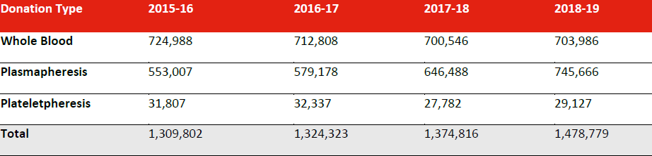

**Table 51: Donor demographics by donation category for FY 2018-19**

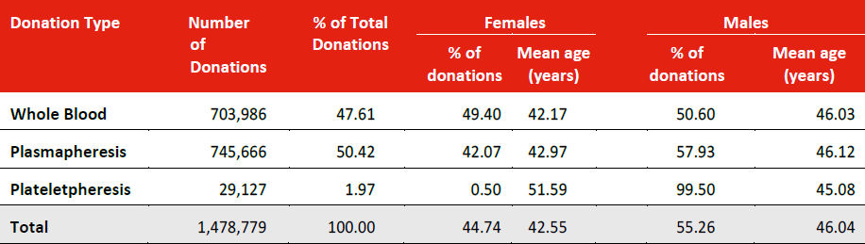

### Donor Adverse Events

#### Donor Adverse Events by Donation Category

An overview of the donor adverse event rates applicable across all donation categories are provided in Table 52. The rates for apheresis-specific donor adverse events are provided in Table 53.

**Whole blood**

Whole blood donations have lower rates of phlebotomy-related events but have a significantly higher rate of vasovagal reactions (210.59 per 10,000 donations) compared with plasma (123.42 per 10,000 donations; RR: 1.71, 95% CI 1.66-1.75; p<0.0001) and platelets (133.55 per 10,000 donations; RR: 1.58, 95% CI 1.43-1.74; p <0.0001). This is attributed to the higher proportion of first time (new) blood donors in this group. Approximately 20% and 14% of whole blood donations are made by new female and male donors respectively, compared with plasmapheresis where 12.1% and 6.9% of donations are made by female and male donors respectively who have not previously donated plasma, noting that one third of these were new donors and therefore had not made a prior whole blood donation.

**Apheresis**

The higher rate of phlebotomy-related events in apheresis donations compared with whole blood relates to the longer collection time, the use of citrate anticoagulant, the return of red cells and the delivery of saline solution. A higher rate of haematomas and painful arm are observed in plateletpheresis compared with plasmapheresis and is postulated to be the result of the longer collection time and a higher dose of citrate anti-coagulant. The higher rate of citrate reactions in plateletpheresis is related to the higher dose of citrate delivered during plateletpheresis compared with plasmapheresis. All plateletpheresis and plasmapheresis donors are offered calcium supplements prior to their donation with the aim of reducing the likelihood of a citrate reaction. Of note, approximately 94% of all citrate reactions are mild and most cases are managed using simple measures such as reducing return flow rates and calcium supplements.

**Table 52: Donor adverse event rates per 10,000 donations by donation type for FY 2018-19**

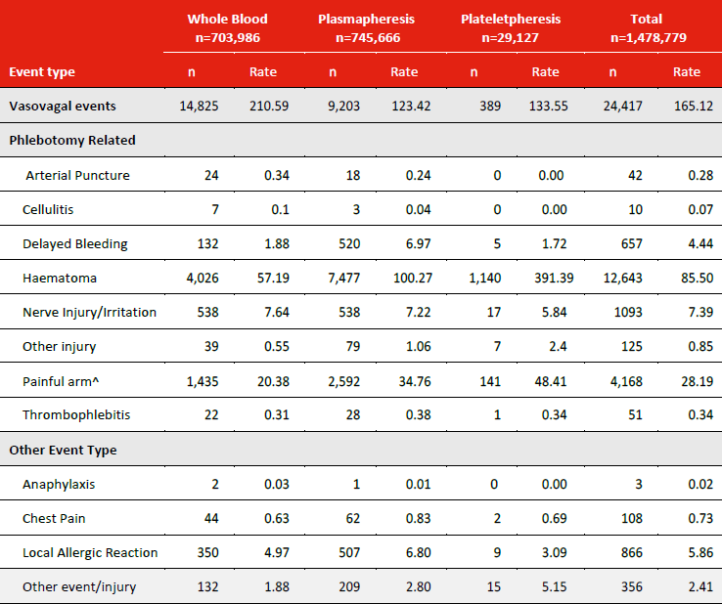

**Table 53: Specific apheresis-related donor adverse event rates per 10,000 donations for FY 2018-19**

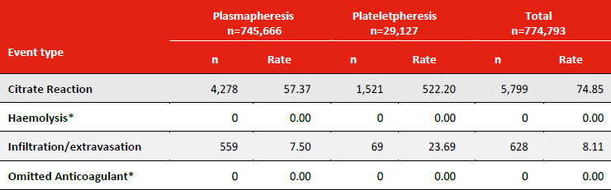*An event is not recorded if the issue is detected and the donation stopped before cells are returned to the donor.

#### Trends over the 2015-16 to 2018-19 period

Donor adverse event rates have been influenced by several factors over the last four years. These include the impact of new mitigation strategies, changing donor demographics including the extent of previous donation experience, expanding donor adverse event categories to include the reporting of additional minor events and an increasing internal focus on donor adverse event reporting. Table 54 provides total donor adverse event rates by donation type. A donation may be associated with more than one type of adverse event. The total rate for the year will only include a donation once even if more than one event was reported for that donation.

**Table 54: Total donor adverse event rates per 10,000 donations for FY 2015-16 to 2018-19**

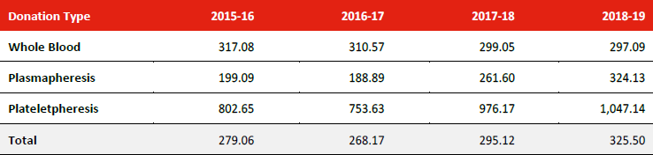

**Whole blood**

With respect to whole blood donations, total donor adverse event rates are significantly reduced in the 2018-19 FY compared with 2015-16 FY (297.09 vs 317.08 pre-10,000 donations; Relative Risk (RR): 0.94; 95% CI 0.92-0.95; p<0.0001). This is primarily a result of the decrease in vasovagal reactions (210.59 vs 292.45 per 10,000 donations: RR: 0.72; 95% CI:0.71-0.74; p<0.0001) which is the result of the introduction of in-centre pre-donation water loading (500mL) and use of applied muscle tension exercises during key points in the collection process.

**Apheresis**

There has been an increase in the overall reported rate of donor adverse events observed in both plasmapheresis and plateletpheresis collections over the four-year period. This is a result of the increase in vasovagal and phlebotomy injury rates. Vasovagal reactions have increased from 99.93 per 10,000 in 2016-17 FY to 123.42 per 10,000 in 2018-19 FY (RR: 1.24; 95% CI: 1.20-1.28; p<0.0001). This is suspected to be due to an increase in less experienced donors entering the plasma pool. Prior to December 2017, all donors were required to make a whole blood donation prior to a plasmapheresis donation. Whilst the proportion of donations made by first-time plasma donors has been similar over the last three FY periods (8.8, 8.9 and 9.1% for FY 2016-17 , 2017-18 and 2018-19 respectively), since December 2017 this first-time plasma cohort has constituted an increasing proportion of new donors who have not previously made a whole blood donation. In 2017-18, 19% of plasmapheresis donations made by first time plasma donors, were made by donors making their first donation compared with 33.8% in 2018-19 FY.

Rates of phlebotomy-related injuries have increased across all donation categories over the last two financial years (Table 55). One major contributing factor is the change to haematoma reporting introduced in 2017 that required all haematomas regardless of size to be reported, where previously only haematomas greater than 5cm were reported. As the change was implemented in September 2017, the full effect was not fully realised in the 2017-18 period, and accounts for some of the increase in the 2018-19 FY, which is the first full year of reporting. The limitations of the database do not permit a detailed analysis to determine if the increase is fully accounted for by haematomas less than 5cm.

The haematoma reporting change has coincided with significant increases in rates of painful arm (without haematoma or nerve injury) in all donation categories and in infiltration/extravasation and delayed bleeding in apheresis donations. This is considered to largely be due to improved reporting compliance as a result of heightened awareness by staff to report phlebotomy related trauma, associated with the reporting change to haematomas. It is relevant to note that there has been no change in the whole blood collection procedure, nor have there been change to the apheresis procedures in this period which would account for these increases. Of note, Lifeblood commenced the roll-out of a new plasmapheresis collection platform (Fresenius Aurora) on 20 May 2019. In the 2018-19 FY, 4,982 plasma donations were collected on the Aurora, accounting for approximately 0.7% of the total plasmapheresis collections for the year. Whilst the reported rates of some phlebotomy-related events have increased, the rate of sustaining one or more phlebotomy-related event (including a haematoma less than 5cm) in the 2018-19 FY is less than 1%, 2% and 5% for whole blood, plasmapheresis and plateletpheresis collections respectively.

**Table 55: Phlebotomy-related injury rate per 10,000 donations for FY 2015-16 to 2018-19**

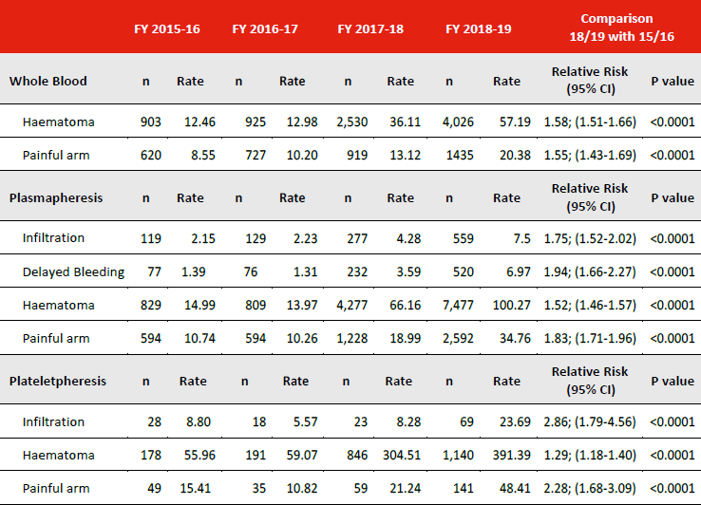

#### Vasovagal events

Vasovagal events are the most common donor adverse event if considered across all donation categories. The overall rate of vasovagal events across all donation categories for the FY 2018-19 was 165.12 per 10,000 donations (Table 52). Table 56 provides rates of vasovagal events by location and if associated with loss of consciousness and/or injury. Approximately 90% of vasovagal reactions occurred on-site. Events occurring on-site were less likely to be associated with loss of consciousness (6.9% vs 16.8%; RR: 0.41; 95% CI 0.37- 0.45; p<0.0001) and those sustaining loss of consciousness, had a lower rate of injury if the event occurred on-site (2.32% vs 11.26%; RR: 0.21; 95% CI 0.14-0.31; p<0.0001). In 2018-19 there were 79 reports (0.52 per 10,000 donations) of vasovagal reactions occurring whilst driving. Two motor vehicle accidents were reported in association with these events.

Whilst donors are encouraged to report adverse events that occur after leaving the donor centre, it is likely that minor off-site events are under-reported. Figures may therefore overstate both the proportion of events that occur on-site and the association between off-site events and loss of consciousness and/or injury

**Table 56: Vasovagal events per 10,000 donations* by donation category for FY 2018-19**

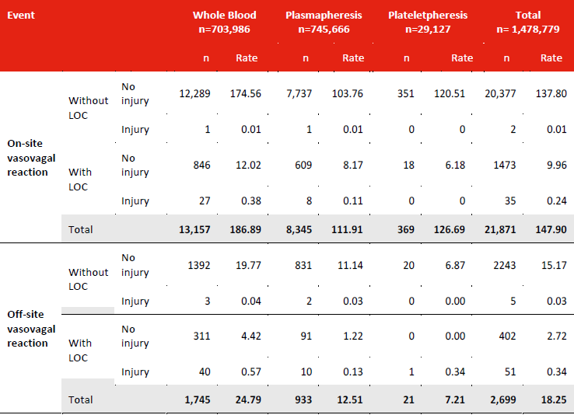

* A single donation can be associated with more than one vasovagal event. This table captures each vasovagal event separately. The total vasovagal events in this table therefore exceeds the total vasovagal events in Table 52, which in comparison reports the number of donations associated with at least one vasovagal event.

Table 57 demonstrates that in terms of severe vasovagal events, there has been a significant overall reduction over time in vasovagal events associated with loss of consciousness that is attributed to whole blood donors. Given that a vasovagal event associated with loss of consciousness is more likely to be associated with injury than a vasovagal without loss of consciousness, this is an important donor safety reduction to note over time.

**Table 57: Vasovagal events associated with loss of consciousness per 10,000 donations by donation category for FY 2015-16 to 2018-19**

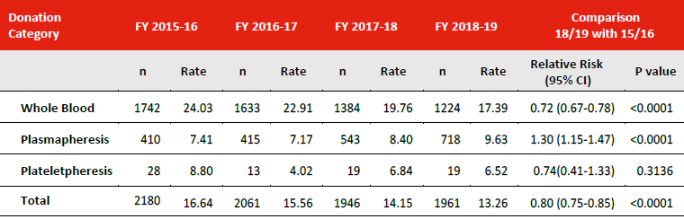

**Vasovagal rates and donor experience**

Significantly lower rates of vasovagal are observed in both male and female returning donors compared with new donors. The effect is observed in both whole blood and plasmapheresis and is greatest in males. The risk of a vasovagal event occurring in a returning donor is less because returning donors become increasingly familiar with the process and relevant mitigation strategies and new donors who experience a reaction on the first visit (and who are potentially more prone to future vasovagal events) are less likely to return, or if the reaction is severe, they are deferred from further donation.

The relative risk of a new whole blood donor having a vasovagal reaction compared with a returning whole blood donor is 3.61 and 6.98 for females and males respectively (Table 58).

The relative risk of a new plasma donor who has made a previous whole blood donation having a vasovagal reaction compared with a returning plasma donor is 6.37 for females and 12.96 for males (Table 59).

From December 2017, donors were no longer required to make a whole blood donor prior to donating plasma. In 2018-2019, the excess risk of a new donor who is donating plasma having a vasovagal reaction is 2.93% for females and 1.74% for males compared to first time whole blood donors. This is not unexpected given a first-time plasma donor who has previously donated whole blood has a higher rate of a vasovagal reaction than an experienced plasma donor.

**Table 58: Vasovagal rates in new and returned female and male whole blood donors for FY 2018-2019**

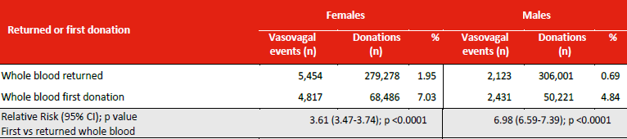

**Table 59: Vasovagal rates in new and returned female and male plasma donors for FY 2018-2019**

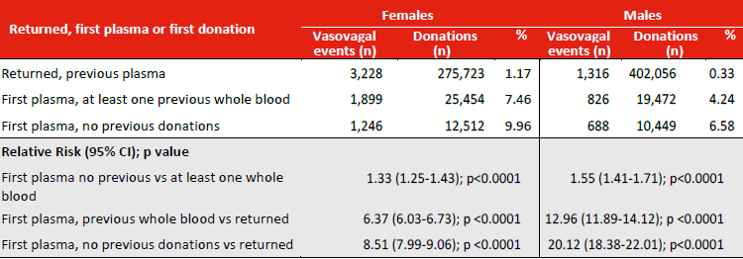

**Vasovagal rates, gender and age**

The relative risk of a vasovagal reduces with age in both males and females (Tables 60 and 61). Females and males aged 18-20 years have a relative risk of 3.36 and 4.61 respectively, compared with other donors in their gender cohort. A significant proportion of this increase is attributed to donor experience with younger donors being more likely to be first time or less experienced donors. The rates of vasovagal reactions are higher in females. Females aged 18-20 have a relative risk of 1.89 (95% CI 1.76-2.03) compared with males of the same age.

**Table 60: Rates and relative risk for vasovagal events in females for all donation categories by age for 2018-19**

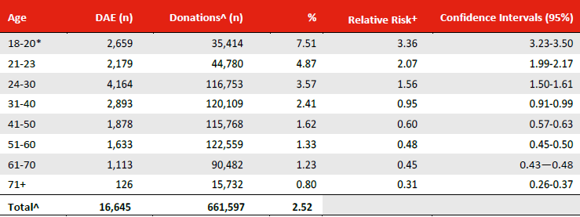

+ Risk compared to all other female donors

* The minimum age for blood donation is 18 years. Therapeutic donors are accepted from 16 years. In the 18-20 age group, eight donations were collected from donors aged 16-17.

^ One collection has been excluded as an age was not recorded.

**Table 61: Rates and relative risk for vasovagal events in males for all donation categories by age for 2018-19**

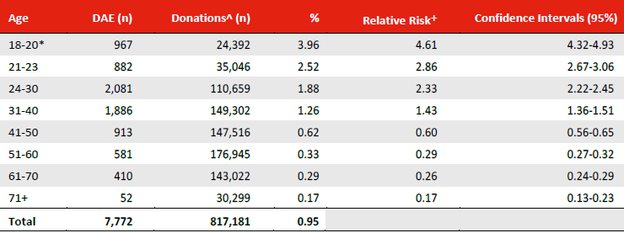

#### Events requiring external referral

Hospital attendance rates have remained relatively stable over the last two financial periods for all donation categories (Table 62). In 2018-19, there were 424 donor adverse events (2.87 per 10,000 donations) that were associated with a hospital attendance. Vasovagal reactions continue to remain the single most common event associated with a hospital attendance; approximately 91% and 75% of whole blood and plasmapheresis events respectively. In the 2018-19 FY, 100 events required an ambulance to attend the donor centre but did not require hospital transfer, and 679 events (4.59 per 10,000 donations) were associated with an attendance at the donor’s general practitioner (GP) (Table 63).

**Table 62: Donor adverse events requiring hospital attendance (per 10,000 donations), FY 2015-16 to 2018-19**

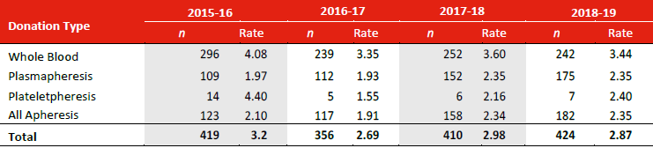

**Table 63: Donor adverse events requiring external care (rates per 10,000 donations) for FY 2018-19**

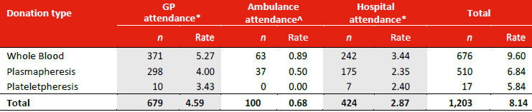

*Initiated by Lifeblood or donor.

^Attendance by ambulance not requiring transfer to hospital.

Conclusion  
Over the course of the last four financial periods, donor adverse event rates have been influenced by new mitigation strategies, reporting requirements, the changing profile of donors and the increasing proportion of plasma to whole blood donations.

Vasovagal rates are the most common adverse event. These events are more likely to occur in females, younger donors and donors who are new to whole blood or new to plasmapheresis. The reduced rate of vasovagal reactions seen in whole blood over the last few years is related to the introduction of water loading and applied muscle tension exercises. The increased vasovagal rate seen in plasmapheresis is likely to be related to the increasing proportion of collections from relatively inexperienced donors.

Reported rates of phlebotomy-related injury have increased significantly over the last two financial years and is primarily the result of the reporting change in September 2017 which required that all haematomas, regardless of size, were reported, together with staff hypervigilance which has resulted in the reporting of more minor events.

There has been no change in the whole blood collection or apheresis procedures in this period, nor have there been significant changes to the staffing model or other environmental factors which would account for these increases.

In addition hospital attendance rates have remained relatively stable over the last two financial periods for all donation categories and vasovagal events associated with loss of consciousness, where injury is more likely to occur, have significantly decreased over time.

The Lifeblood donor vigilance system continues to evolve to improve the robustness and translation of adverse event data and serves to underpin our continuous improvement approach to mitigate donor adverse events and ensure the blood donation process is as safe as possible. The data will continue to inform research, guide targeted interventions and support process evaluation.

# APPENDIXES

### Appendix 1: Current policies and interventions to minimise the risk of donor adverse events

|  |  |
| --- | --- |
| **Donor assessment** | The donor assessment process includes questionnaire, interview and physical checks to assess a donor’s eligibility for donation.  The process includes identifying previous donation-related events and medical history that may preclude donation and ensures that donors meet minimum criteria for age, weight and donation intervals:   * Minimum age for whole blood and apheresis is 18 years (2018) * Weight limit 50kg for all donation categories (2015) * Physical checks   + Blood Pressure (all donors on each attendance)   + Pulse (apheresis donors)   + Haemoglobin screening test (all donors on each attendance) |
| **Donor information and awareness** | Several platforms are used to deliver information regarding:   * Pre-donation strategies including pre-arrival hydration, in-centre water loading for whole blood donors and calcium supplementation for apheresis donors * Use of applied muscle tension exercises * Post-donation strategies including onsite recovery time, hydration and avoidance measures |
| **Donation selection and process** | All donors:   * Assessment of veins prior to phlebotomy attempt Plasmapheresis: * Incremental increase in collection volume based on donor height and weight to maximum of 16% total blood volume capped at 800mL. * Saline replacement of 500mL Plateletpheresis: * Minimum platelet count required to proceed with collection |
| **Management of donors with adverse events** | Procedures and training support teams to identify and manage donor adverse events.  Onsite care includes:   * Administration of oral calcium for citrate reactions * Provision of advice cards to donors to support after-care * Observation period for donors who sustain vasovagal reactions. Those with prolonged recovery times are referred to hospital for ongoing care and evaluation.   After-donation care includes:   * 24-hour access to Lifeblood Medical Officer * Contacting donors who sustain a significant event to assess clinical outcome, contributory factors and suitability for future donations and if eligible, providing advice to minimise risk of future events. * Reducing collection volume for apheresis donors who are suitable to continue donating * Where the event is severe or recurrent, the donor is permanently deferred. |
| **Clinical Governance** | Lifeblood has a Clinical and Quality Governance Framework that supports the provision of a safe, high quality service that works to monitor, mitigate and manage donor adverse events, including:   * Data monitoring and reporting to executive committees * Clinical audits * Continuous improvement and corrective action processes * International benchmarking |

# ABBREVIATIONS

AABB American Association of Blood Banks

ABO The human red cell ABO blood group system

ACT Australian Capital Territory

AHTR Acute haemolytic transfusion reaction (other than ABO incompatibility)

ATR Acute transfusion reactions

DAE Donor adverse event

DHTR Delayed haemolytic transfusion reaction

DVT Deep vein thrombosis

FNHTR Febrile non haemolytic transfusion reaction

GP General Practitioner

HAC Haemovigilance Advisory Committee

HBsAg Hepatitis B surface antigen

HBV Hepatitis B virus

HCV Hepatitis C virus

HIV Human Immunodeficiency virus

HTC Haemophilia Treatment Centre

HTLV Human T-cell lymphoma virus

IBCT Incorrect blood component transfused

IHN International Haemovigilance Network

ISBT International Society for Blood Transfusion

LOC Loss of consciousness

NAT Nucleic acid testing

NBA National Blood Authority

NBMS National Blood Management System

NDDP New donors direct to plasma

NHDD National Haemovigilance Data Dictionary

NSW New South Wales

NT Northern Territory

PTP Post transfusion purpura

QLD Queensland

SA South Australia

STIR Serious Transfusion Incident Reporting

TACO Transfusion-associated circulatory overload

TAS Tasmania

TIA Transient ischaemic attack

TRALI Transfusion-related acute lung injury

TTI Transfusion-transmitted infection

vCJD Variant Creutzfeldt-Jakob disease

VIC Victoria

VVR Vasovagal reaction

WA Western Australia

WB Whole blood

# ACKNOWLEDGEMENTS LIST

**National Blood Authority Haemovigilance Advisory Committee (HAC)**

**Members**

Associate Professor Alison Street NBA Board member and NBA appointed HAC Chair

Mr Brett Aitken Australian Private Hospitals Association

Associate Professor Lilon Bandler NBA Patient Blood Management Advisory Committee Chair

Mr Geoffrey Bartle Consumer Representative

Ms Linley Bielby VIC Health

Ms Maria Burgess ACT Health

Dr James Daly Australian Red Cross Lifeblood

Dr Chris Hogan Non-affiliated Haematologist

Ms Penny O’Beid NSW Health

Dr Sharon Nowrojee WA Health

Associate Professor David Roxby Australian and New Zealand Society of Blood Transfusion

Dr Neil Everest Commonwealth Department of Health

Professor Erica Wood Non-affiliated Haematologist

**Expert Advisors**

Dr Heather Buchan Australian Commission on Safety and Quality in Health Care

Dr Angela Gowland Therapeutic Goods Administration

Dr Adrian Webster Australian Institute of Health and Welfare

**National Blood Authority**

Mr John Cahill Chief Executive

Ms Sandra Cochrane Senior Advisor, Blood and Data Services

Ms Suzie Cong Senior Data Analyst, Blood and Data Services

Ms Leia Earnshaw Assistant Director, Haemovigilance, Blood and Data Services

Ms Allison Peters Senior Data Analyst, Blood and Data Services

**Australian Government and State and Territory contributors**

NSW Health Clinical Excellence Commission Blood Watch Program

VIC Department of Health and Human Services Blood Matters Program

QLD Health

SA Health BloodSafe Program

WA Department of Health

TAS Department of Health and Human Services

ACT Health

NT Department of Health

SECTION 2 – DONOR VIGILANCE was contributed by the Australian Red Cross Lifeblood.

1. Based on minimum collection of 450mL for males and females
2. Based on minimum collection volume of 422mL for females and 488mL for males excluding anticoagulant
3. Based on collection of double-dose platelet

   1,2,3 Collection times are based on data from FY 2015/16 to 2018/19