STRATEGIC FRAMEWORK FOR THE nATIONAL HAEMOVIGILANCE PROGRAM

September 2014

# Why conduct Haemovigilance?

The World Health Organisation suggests that *"Haemovigilance is required to identify and prevent occurrence or recurrence of transfusion related unwanted events, to increase the safety, efficacy and efficiency of blood transfusion, covering all activities of the transfusion chain from donor to recipient.  
The system should include monitoring, identification, reporting, investigation and analysis of adverse events near-misses and reactions related to transfusion and manufacturing."*

Haemovigilance is defined by the International Haemovigilance Network as *‘a set of surveillance procedures covering the whole transfusion chain (from the collection of blood and its components to the follow up of recipients), intended to collect and assess information on unexpected or undesirable effects resulting from the therapeutic use of labile blood products, and to prevent their occurrence or recurrence’.*

It is widely acknowledged that haemovigilance is an important tool to improve the effective and appropriate management of blood and blood products, and to ensure the safety of people receiving and donating blood.

The *National Blood Authority Act 2003* states that the National Blood Authority (NBA) is “*to carry out national blood arrangements relating to safety measures, quality measures, contingency measures and risk mitigation measures for the supply of blood products and services”*, and to provide information, advice and assistance to various stakeholders under the national blood arrangements.

The National Blood Agreement requires the NBA to perform the following activities:

* promote optimal safety and quality in the supply, management and use of products, including through uniform national standards
* make best use of available resources, and to give financial and performance accountability for the use of resources by all entities involved in the Australian blood sector
* undertake national information gathering, monitoring of new developments, reporting and research in relation to the Australian blood sector
* undertake or facilitate national information management, benchmarking and cost and performance evaluation for the national blood supply
* facilitate the development of national information systems for safety and quality issues in relation to the Australian blood sector.

# Haemovigilance in Australia

The transfusion of blood and blood products is a core part of healthcare service delivery to patients. While the use of blood and blood products can be lifesaving, there are also risks associated with the transfusion. Incidents can occur and some of these can have serious consequences to patients if not well managed.

In Australia the rationale for setting up a national haemovigilance program is to:

* enable transfusion practice improvements
* enable product improvements
* identify contributory and comparator factors
* place Australian transfusion risks into an international perspective

This was done to promote safety and quality improvements through:

* education
* supply chain efficiencies
* research and development
* guidelines

The National Safety Quality Heath Service (NSQHS) Standard 7 – Blood and Blood products requires under 7.3 that health organisations ensure blood and blood product adverse events are included in the incidents management and investigation system:

7.3.1 Reporting on blood and blood product incidents is included in regular incident reports

7.3.2 Adverse blood and blood product incidents are reported to and reviewed by the highest level of governance in the health service organisation

7.3.3 Health service organisations participate in relevant haemovigilance activities conducted by the organisation or at state or national level

The [Stewardship Statement](http://www.blood.gov.au/sites/default/files/documents/nba-stewardship-stewardship-statement.pdf) outlines measures that Health Ministers expect all health providers to adopt within their organisation. As illustrated below, this includes the requirement to manage blood and blood products in ways that ensure transfusion related adverse event information is collected and managed according to jurisdictional requirements.

The roles and responsibilities within Australia are depicted below, together with the data collection and reporting obligations at each level.

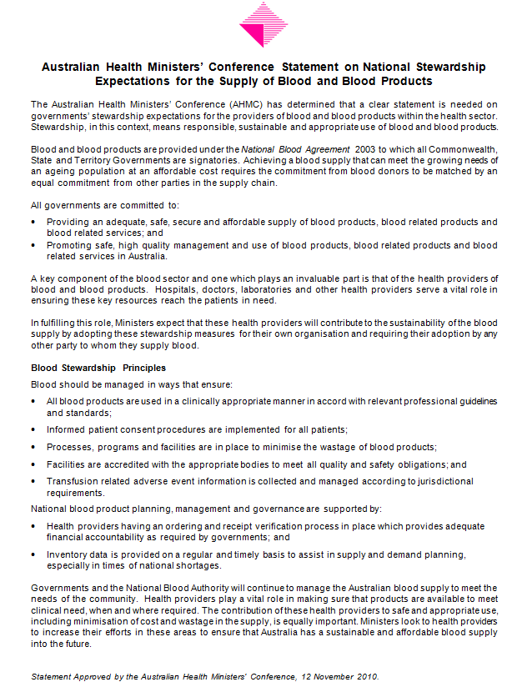

# Haemovigilance in Australia – Roles and Responsibilities



|  |  |  |  |
| --- | --- | --- | --- |
|  | **Local Organisation (Private and Public Hospital, LHN)** | **State or Territory** | **National** |
| **Incident Management** | * Incident management system * Manage incident and identify causation * Monitor and review and quality improvement process * Incident management reporting and local governance   + Escalate/notify depending on severity (eg supplier/TGA (eg product issue) * Review by clinical group, Governance Committee/Quality Improvement Committee | * Incident management reporting and governance depending on severity level   + Escalated from local organisation to state/territory   + If issue identified at state/territory level, deal with at state/territory level   + Compare with supplier/TGA reporting if required | * Incident management reporting depending on severity level as a notifiable event through supplier contracts   + Escalated from local organisation to TGA/Supplier (eg product issue)   + Compare with supplier/TGA reporting if required |
| **Haemovigilance** | * Haemovigilance reporting and local governance   + Responsible for independent review   + Establish validity classification and imputability assessment – either conducting or arranging through Hospital/LHN/STIR or other central organisation or committee   + Only serious adverse events reported (to be defined in ANHDD) to state and territory * Review by clinical group, Governance Committee/Quality Improvement Committee | * Haemovigilance reporting   + Collate de-identified data from local organisations at agreed timing   + Provide collated data to national level based on ANHDD   + May choose to provide comparator and cumulative reporting at cross-organisational level     - Choose level of incident/trend analysis, feedback and recommendations undertaken     - Only serious adverse events reported (to be defined in ANHDD) * May choose to co-ordinate independent review or find a mechanism of action with the state or territory to deliver this service when necessary, but otherwise review sits at local organisation level * May choose to Identify opportunities for improvement or seek indication of resolution * Enter into MOUs or data sharing agreements with private hospitals to enable reporting * National report review and analysed at jurisdictional level – trends acted on if required * Comparison with supplier/TGA reporting if required | * Annual National Haemovigilance reporting and analysis   + collate and collect data from states and territories   + Only serious adverse events   + De-identified patient and health provider data reported   + Comparative and cumulative data   + Publish national report * Identify possible items for active surveillance such as clinical audits * Contribution to international reporting if required * Identify opportunities for improvement * Comparison with supplier/TGA reporting if required   + Monitor and identify causation |

# The National Haemovigilance Program

## THE PROCESS

In Australia, haemovigilance is undertaken at local or state/territory, supported by a national data collection and reporting process. Data is collected at the local or state/territory level and the local area is responsible for the review of reported incidents to assess the validity and imputability of the incident with respect to whether it was reported correctly, the seriousness of the incident, and assessment of the cause of the incident being related to the transfusion. Some states and territories/local organisations provide their data to STIR to conduct this review, while others manage this process themselves, or do not do a review outside of the local level. Following review, the data is aggregated and provided to the NBA for national analysis and reporting.



Since 2008, the NBA has collected haemovigilance data from states and territories to publish a national haemovigilance report.

De-identified data is collated, aggregated and reported. Privacy principles are upheld, and data cannot be manipulated to identify patient, clinician or facility.

## Collection and submission of haemovigilance data

The NBA requests data from State and Territory Departments of Health through the JBC member or proxy. Data can be submitted through the NBA data portal on [www.govdex.gov.au](http://www.govdex.gov.au) or through other agreed means. To support a national approach to haemovigilance, states and territories have agreed to progressively align their reporting systems with the agreed dataset requirements to contribute to a comprehensive national dataset. It is recognised that this will require all users of labile blood products to:

* Participate in the provision and analysis of data
* Investigate and report adverse events in accordance with the national dataset

To ensure the quality, comparability and imputability of data, all information provided by states and territories for national reporting has been fully validated and de-identified by the jurisdiction before submission to the NBA.

## National haemovigilance reports

Aggregated haemovigilance data, supplied through State and Territory Departments of Health, will be analysed for national trends and other indicators. Reports will also refer to the national data in the context of previous national haemovigilance data. The function of national haemovigilance reports will be to identify the incidence and causes of voluntarily reported adverse transfusion events and make recommendations for national quality and safety investments that can lead to genuine improvements in patient safety outcomes in Australia. National haemovigilance reports are issued by the NBA after advice from the Haemovigilance Advisory Committee (HAC). It is desirable to publish national reports annually. Following publication of a national report, the NBA will table HAC recommendations present in the report for noting to JBC and the development of action items as part of the HAC annual work program.

## National haemovigilance reporting process

All national haemovigilance data is held and managed by the NBA in a secure manner to prevent disaggregation and identification of patients, clinicians or facilities, and to meet relevant privacy requirements. Haemovigilance data analysis by the NBA will be presented for discussion at the HAC. It is the role of the HAC to advise on further data analysis and revision and to develop conclusions and national recommendations based on the resulting evidence. The HAC may also advise on stakeholder and sector consultation and dissemination of the conclusions and recommendations.  It is the role of the NBA to draft, finalise and publish periodic national haemovigilance reports for public dissemination. Depending on the reporting intervals from states and territories, an annual reporting period for national haemovigilance may represent the optimum interval to work towards. The NBA may require the approval of the appropriate JBC representative for publication of any and all jurisdiction-specific data, conclusions or recommendations.

## Publication processes

The NBA is responsible for publishing national haemovigilance reports and other reports, presentations, case studies, commentaries or research articles in relevant academic or professional body forums. Publication and dissemination will be managed in accordance with NBA policies and management instructions, which guide the construction of internal and external publications. These policies ensure that all publications are of a similar high standard and follow a consistent format, and outline the procedures for developing, drafting, approving, printing and releasing NBA publications. Other reports, presentations, case studies, commentaries or research articles in relevant academic or professional body forums will be published in line with that publisher’s specifications. It is anticipated that the published reports will be made available to all identified primary stakeholders, who will be encouraged to comment on the scope of the report and its recommendations. The NBA will actively engage with the health, education and quality and safety sectors to disseminate national recommendations widely, effectively and efficiently and will seek written feedback from primary stakeholders on published national haemovigilance reports.

# Action Plan

The Action Plan for the NBA and HAC over the next three years includes the development of tools such as forms to support data collection at the local and state/territory level and improvements to the current national haemovigilance reporting with regard to the data included as well as timeliness of the reports.

A number of activities will be undertaken to improve the consistency of data provided for national reporting, as outlined below:

#### Review the national data dictionary

The ANHDD will be reviewed and redefined for consistency against international definitions. Important haemovigilance concepts, such as incident, adverse event, adverse reaction and near miss, would be defined and added to the dictionary. Definitions for incident types such as WBIT (wrong blood in tube) will be added to the dictionary as well. Some definitions (such as FNHTR) will be reviewed/revised to improve alignment with international standards. The NBA will also consider developing a data dictionary to define the input data elements (such as symptoms/signs) which are used to generate the output data elements required by the ANHDD.

#### Develop tools

In conjunction with Queensland Health the NBA has developed a Data Collection Tool to be used by hospitals for haemovigilance reporting. This Data Collection Tool is now being reviewed by the the NBA for wider distribution. The tool has been tested and will be published on the NBA website in 2014. The NBA is also considering using a software tool for visual analytics as a dissemination/publishing tool for the NBA data including haemovigilance data.

In addition to this, the NBA could develop other tools such as data validation and review tools to support haemovigilance data reporting.

#### Standardise forms

National incident reporting and investigation forms could be developed in hard copy and/or eForms. Computer technologies such as smart phone apps and smart web-based forms could be utilised to improve accessibility and improve ease of data entry. These forms could work with current local or state/territory systems to reduce duplication of effort. National standard forms are important for haemovigilance reporting at national and local level and the forms can be used as educational tools to improve the transfusion practice in Australia

#### Guidelines and case studies

The NBA is working with stakeholders to develop *Guidance on Recognition and Management of Acute Transfusion-Related Adverse Events*. This may improve consistency of clinical assessment of transfusion incidents and provide greater consistency in reporting. The NBA could also develop guidelines on the management of transfusion incidents such as the guidelines for incident reporting, investigation, validation and review to support activities under the NSQHS Standards, as well as to support national haemovigilance activities.

In addition case studies could be developed to support health service organisations identify what is best practice with regard to responding to an incident from the perspective of reporting and quality improvement.

#### Education and Training

Best practice management, with regard to the use of blood and blood products, is critical to optimise patient outcomes, minimise adverse events and ensure judicious use of costly blood and blood products.

The National Blood Sector Education and Training Strategy 2013‑2016 outlines a plan to work with current education and training providers to address the growing demand for high quality, well-tailored education, training and health promotion materials to support the implementation of evidence-based practice and attainment of health service accreditation under the new National Safety and Quality Health Service Standards (NSQHS).

The NBA could engage with key stakeholders in the sector and enter into collaborations, joint arrangements and outsourcing to develop education and training tools or programs that support health service organisations identify what is best practice with regard to responding to an incident from the perspective of reporting and quality improvement.

#### Audits

Audits could include several other quality improvement strategies such as record reviews, peer review, standard reviews (to see if standards are being met, guidelines followed and or evidence based practice used) and patient surveys.

The NBA could develop audit tools for use by organisations to conduct clinical audits to improve the quality of incident and haemovigilance reporting by systematically reviewing the care provided against set criteria. The gap between the criteria and the assessed performance could also provide guidance for priority improvement strategies and further education and training.