Blood Fridges Module
The BloodNet Blood Fridges Module
- Provides a secure area for facilities to share their on-site and off-site blood fridge oversight, management and AS3864.2-2012 compliance information with other laboratories and fridge users.
- Allows facilities who are not currently using BloodNet (such as affiliated hospitals) to share their blood fridge records via BloodPortal.
- Assists in minimising blood wastage by improving blood cold chain security, governance and facilitating stock rotation and transfers. All users of the fridge can confidently dispatch, rotate and transfer blood between health providers, with or without on-site laboratories, with a subsequent reduction in wastage.

OVERVIEW
Users can:
- set their fridge access permissions
- create incident notifications and their management
- share their blood fridge maintenance records and AS3864.2-2012 compliance
- confidently accept returns and transfers knowing the blood fridges they access are AS3864.2-2012 compliant.

ROLES
There are 2 roles in the BloodNet Fridges Module that fridge users can utilise:
- Fridge Users – These users can add or update maintenance or incident records.
- Fridge Administrators – In addition to the user functions, administrators can add or edit fridges, acknowledge incident notifications, share fridges with other facilities and request access to fridges belonging to other facilities.

BLOOD FRIDGE MAINTENANCE
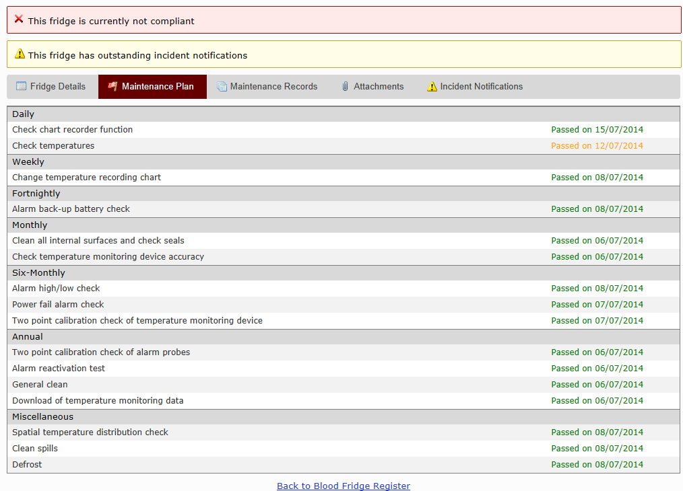
BloodNet Blood Fridge Maintenance allows users to:
- Record their AS3864.2-2012 maintenance activities as a simple Pass or Fail for each of their fridges. The maintenance periods can be set by the fridge administrator.
- View the compliance status of each of the fridges including when a particular maintenance task was last performed and what the outcome was.
- Review any attachments related to the maintenance record and whether there are any related incident notifications.
INCIDENT NOTIFICATIONS
An incident notification is created when a fridge experiences an event, for example an alarm condition, or where a maintenance record has one or more checks that have a status of ‘Fail’. Fridge users can view these incident notifications and be assured that a fridge will not show as compliant until the fridge administrator verifies that appropriate action has been taken.
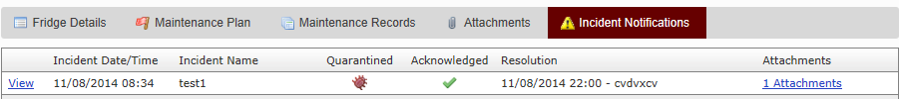
FOR MORE INFORMATION
To learn more about the BloodNet Blood Fridge module telephone 13000 BLOOD (13000 25663) or email support@blood.gov.au

