BloodSTAR - ‘Do Not Prescribe’ function
Medical Officers, Nurses and Midwives can add a ‘Do Not Prescribe’ alert to a BloodSTAR patient record for patients who have had a known adverse reaction to an immunoglobulin product. If a BloodSTAR user tries to allocate a product listed under the patient’s do not prescribe list, it will alert them to choose an alternative immunoglobulin product.
Please Note: Adding a Do Not Prescribe alert in BloodSTAR does not report an adverse event. Information about reporting adverse events can be found here: https://www.blood.gov.au/reporting-adverse-events

Steps to add a Do Not Prescribe alert to a BloodSTAR patient record:
Step | Action
 | Navigate to www.blood.gov.au/bloodportal and log in. Select the BloodSTAR tile.
Find patient under the Home page or Patients > Authorised Patients at this facility.
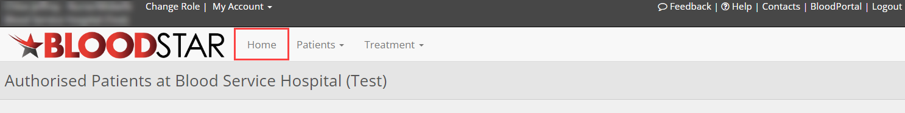

Alternatively, patients can be found through a patient search.
Select the Patients tile on the BloodSTAR home page, select the Search option.

Search for the patient either by Authorisation Number or at least two search terms (given name and family name together are deemed one search term). Select the view hyperlink to open patient record.
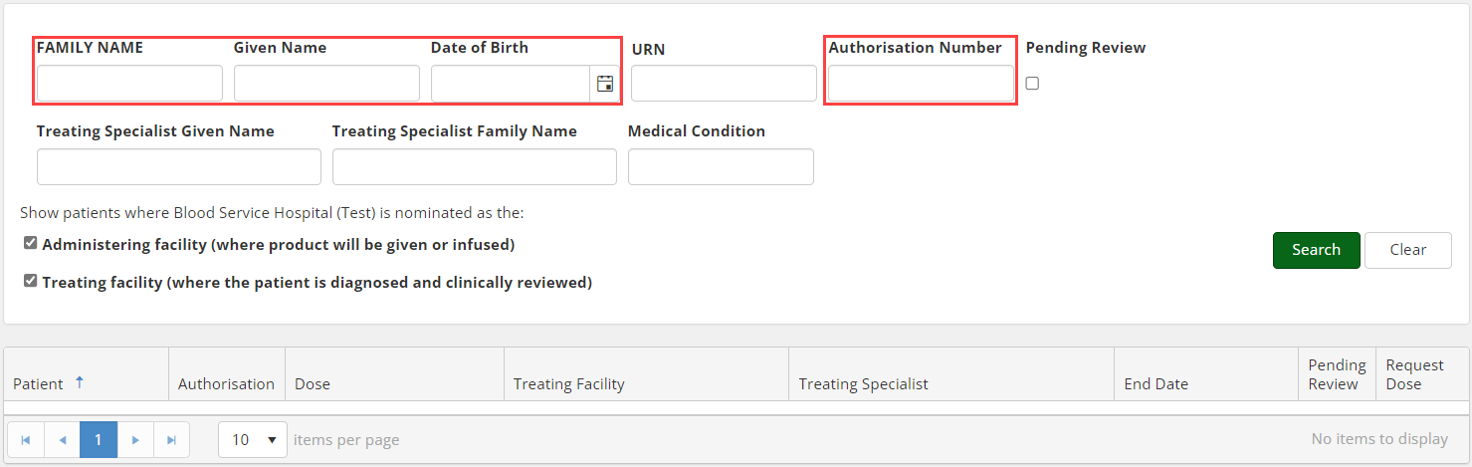
The patients record will open.
Scroll down to the Do Not Prescribe section on the patient record and select the + Add Do Not Prescribe option.
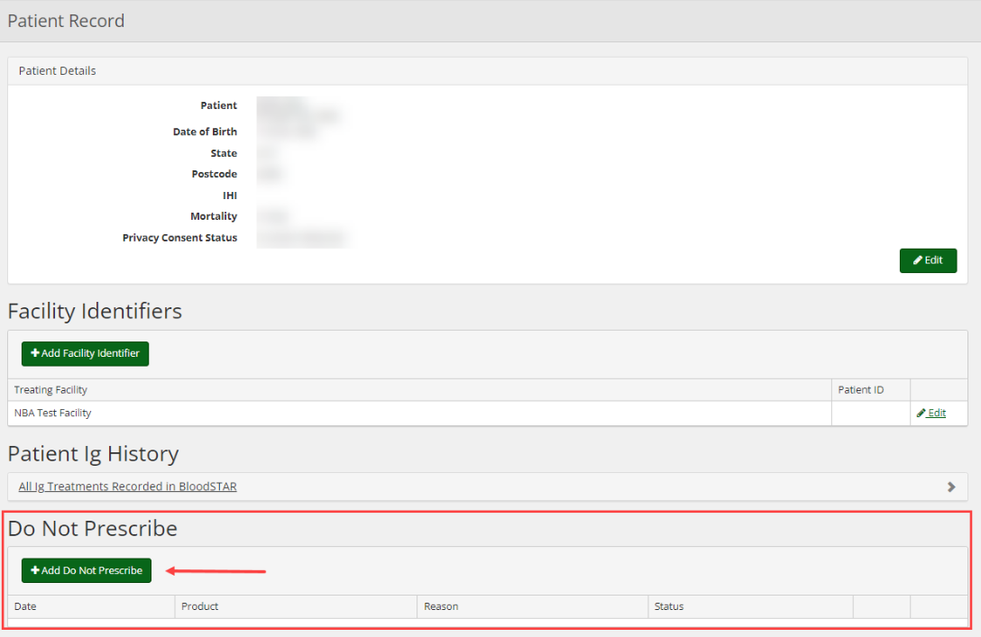

The Do Not Prescribe options will open.

Fill in the details of the Do Not Prescribe including the Product, Date, Reason and any Details/Notes, then press Save. 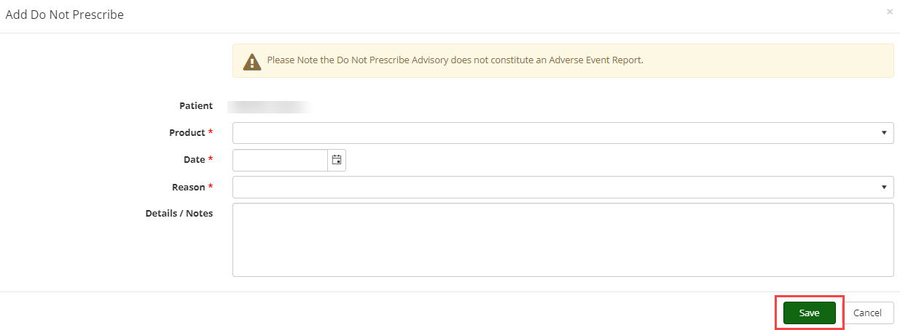
The alert will then be added to the Patient Record.

