Creating a Dispense from an Authorisation Record
This tip sheet outlines how to dispense a dose of immunoglobulin (Ig) in BloodNet from a patient’s BloodSTAR authorisation record. All Ig dispenses must be recorded on BloodNet.
- From the home page of BloodNet, click the ‘Authorisation’ tile.
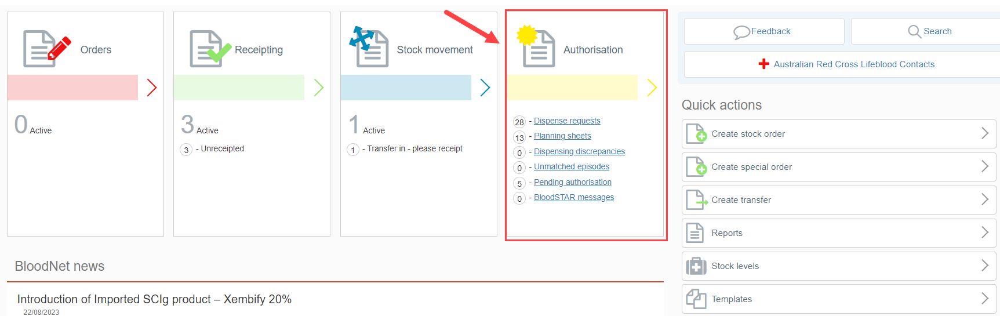
- A list of ‘Authorised patients’ assigned to the dispensing facility will appear.
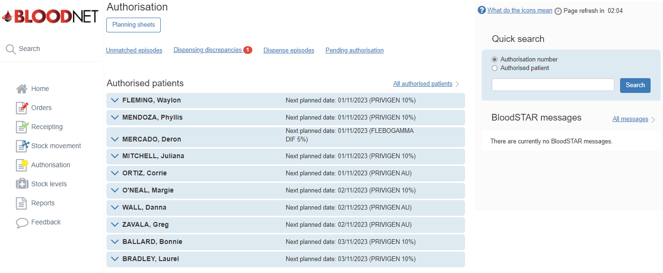
Please note: The layout of the ‘Authorisation’ page will look different based on the preferences set by the facility. This can be changed by a Facility Administrator via ‘Facility Management’.

- If the patient is visible, click the blue drop down arrow and open the authorisation by clicking the ‘View’ button or the ‘Authorisation’ link.
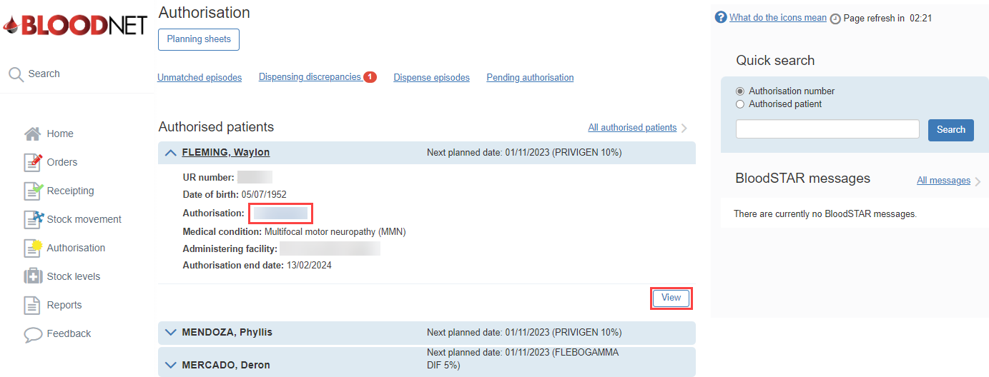
- If the patient is not visible, click ‘All authorised patients’ to search authorised patients at the facility.
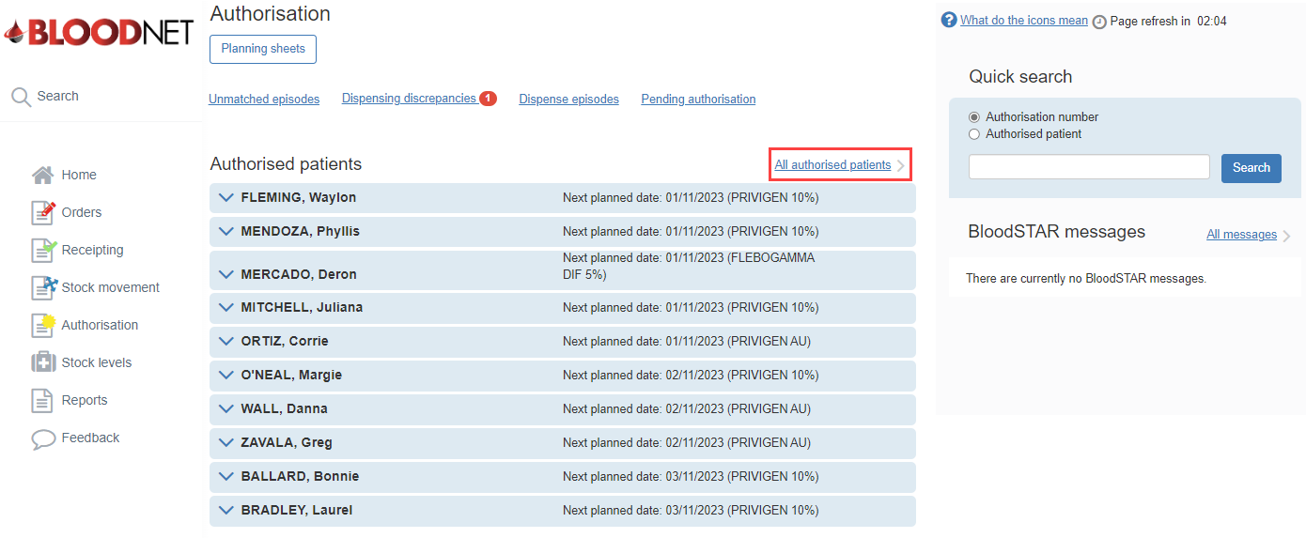

- Search for the patient by entering the patient details into the search fields and clicking the ‘Search’ button.
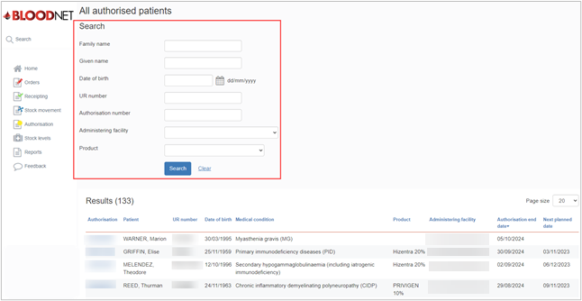
Please note: The patients can be filtered by the Administering facility and Product.
- The ‘View authorisation’ page will open. This page displays the patient’s ‘Authorisation details’ and their ‘Treatment plan’. Scroll down the page to the ‘Current regimen', locate the appropriate planned treatment and click the ‘Dispense’ link on the right of the page.
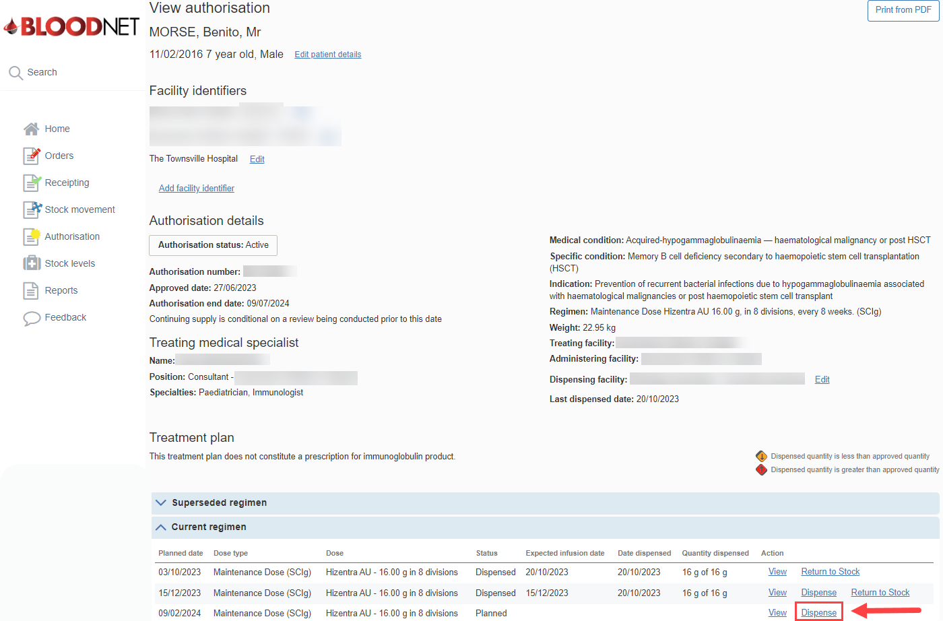
- The ‘View authorisation’ page will open. This page displays the patient’s ‘Authorisation details’ and their ‘Treatment plan’. Scroll down the page to the ‘Current regimen', locate the appropriate planned treatment and click the ‘Dispense’ link on the right of the page.
- On the ‘New dispense episode’ page, enter the ‘Dispense Date’ and ‘Dispense time’.
- Scan or enter the lot number/s and Quantity of product being dispensed in the blue box on the right side of the page and click the ‘Add Item’ button.
- Enter the ‘Expected infusion date’. This is the date the patient is expected to receive the infusion.
Please note: It is important the ‘Expected infusion date’ is as accurate as possible as the patient’s next Planned Date will be calculated from this date.
- Click the ‘Save Dispense episode’ button at the bottom right of the page to record the dispense.
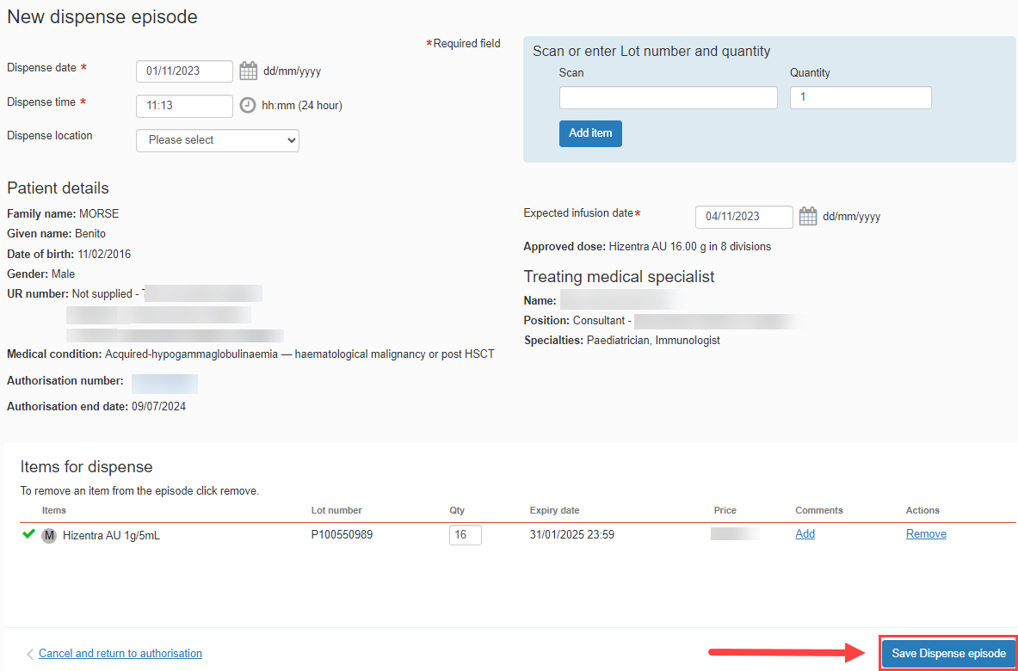

Please note: A warning message will appear if the ‘Dispensed product does not match authorised product.’ If the incorrect product is dispensed, this will cause a Dispense Discrepancy.
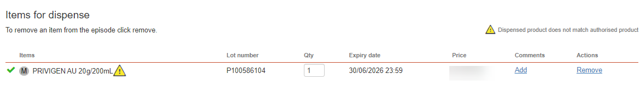
- The dispense episode has now been saved.
Please note: A receipt of the dispense episode can be printed by clicking the ‘Print from PDF’ button on the right side of the page.
