Creating a Stock Order Template
This tip sheet outlines how to create a stock order template. Stock order templates provide a set list of fresh blood components and manufactured products that can be ordered by a facility. A facility may have up to 10 templates.
Please note: Only BloodNet Facility Administrators can create a stock order Template.
- From the BloodNet home page, select ‘Templates’ located in the ‘Quick actions’ bar on the right side of the page.
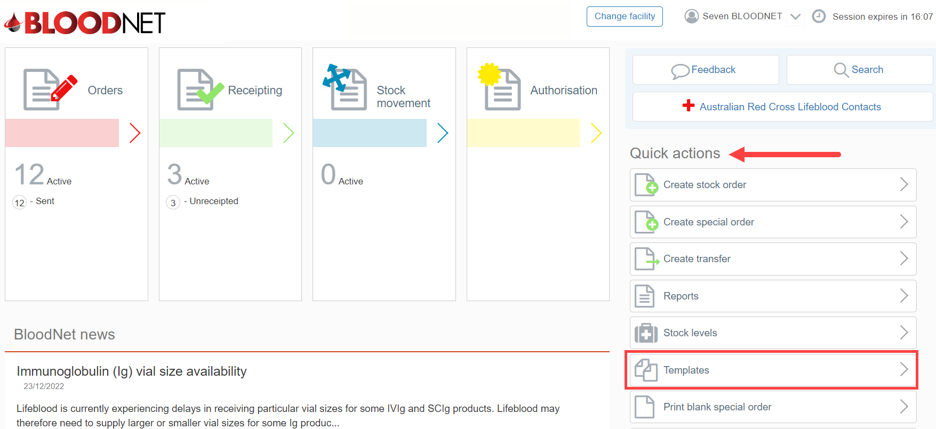
- A list of current template/s will appear with options to ‘Edit’, ‘Print’ or ‘Delete’ by clicking on the links in the ‘Actions’ column.
Please note: The ‘Default’ template cannot be deleted.
- Click the ‘Create template’ button to create a new template.
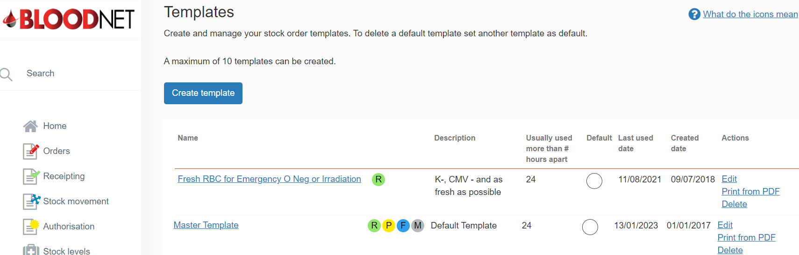

- Enter the ‘Name’ and ‘Description’ of the template in the ‘Template details’ section, select the preferred ‘Distribution site’ and set the time period to ‘Warn if the template was used in an active order’.
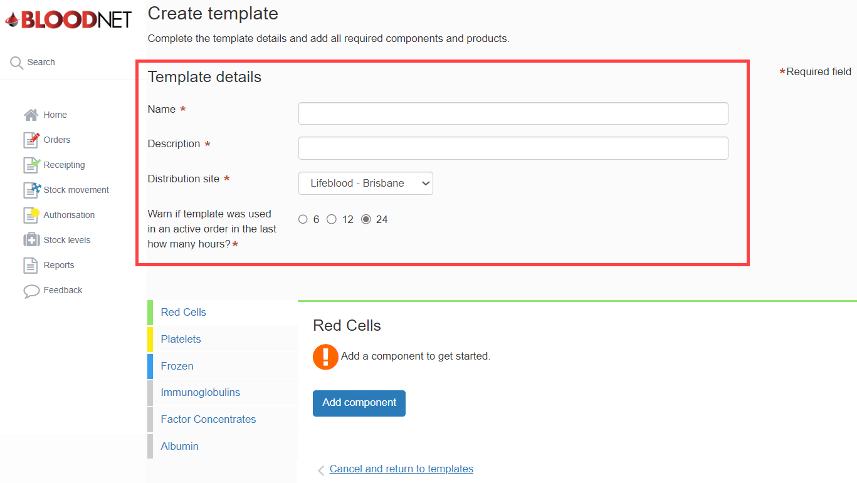
- Click on a component or product group from the menu on the left side of the page to add it to the template. Once selected, click the ‘Add component’ or ‘Add product’ button.
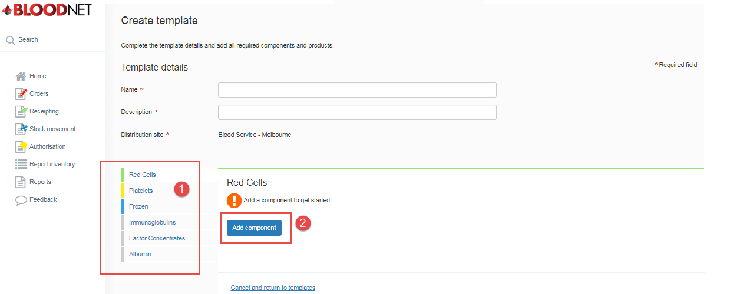

- Select the specific component or product required from the options available in the drop down menu.
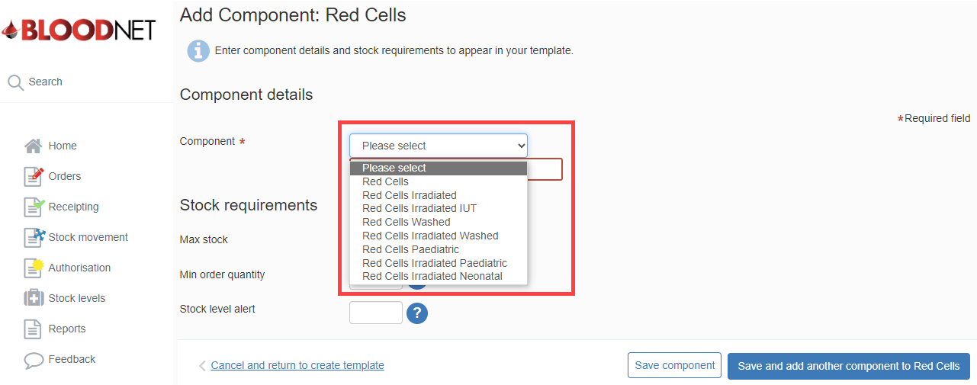
- Complete all mandatory and Stock requirement fields and click the ‘Save and add another component’ button to add more components to the template. For manufactured products, click the ‘Save product’ button to continue.
Please note: Comments can be added to components only by selecting ‘Add comment’.
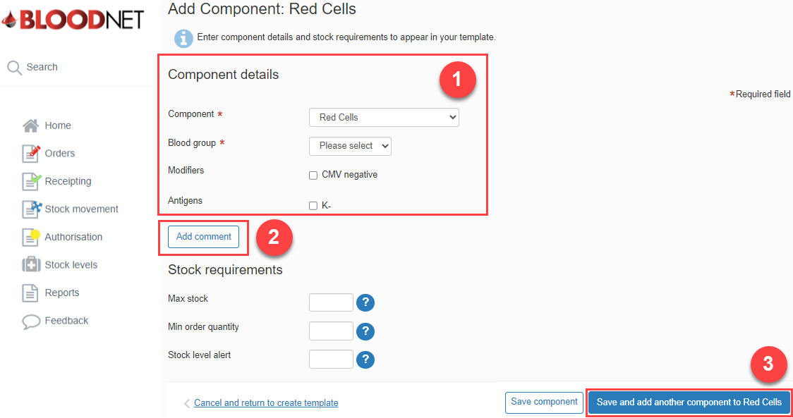

- Once all desired components and products have been added, click ‘Save Component’ or 'Save Product’ button to return to the ‘Create Template’ page to finalise the template.
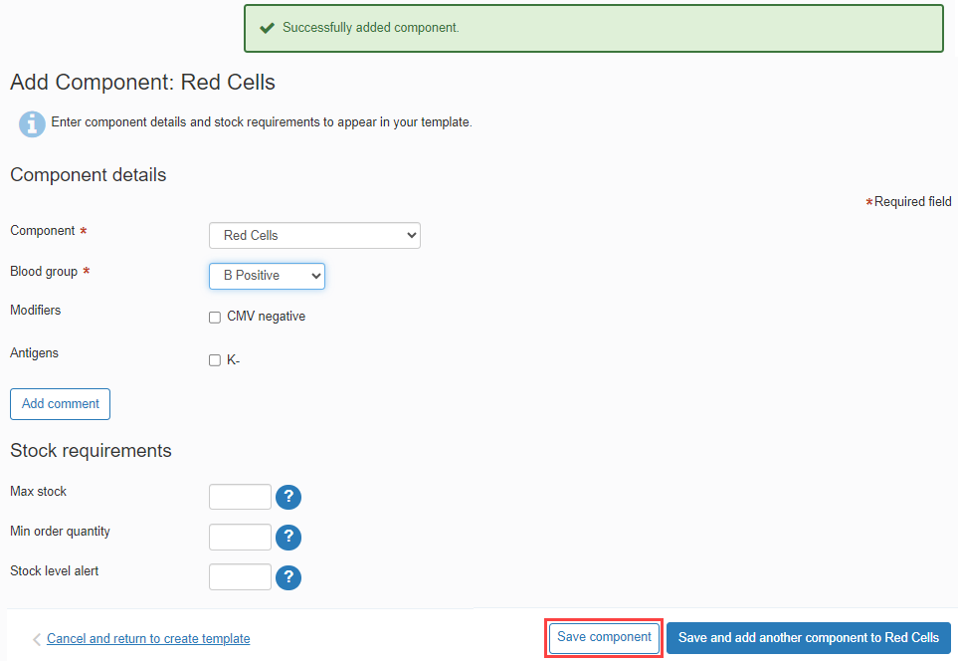
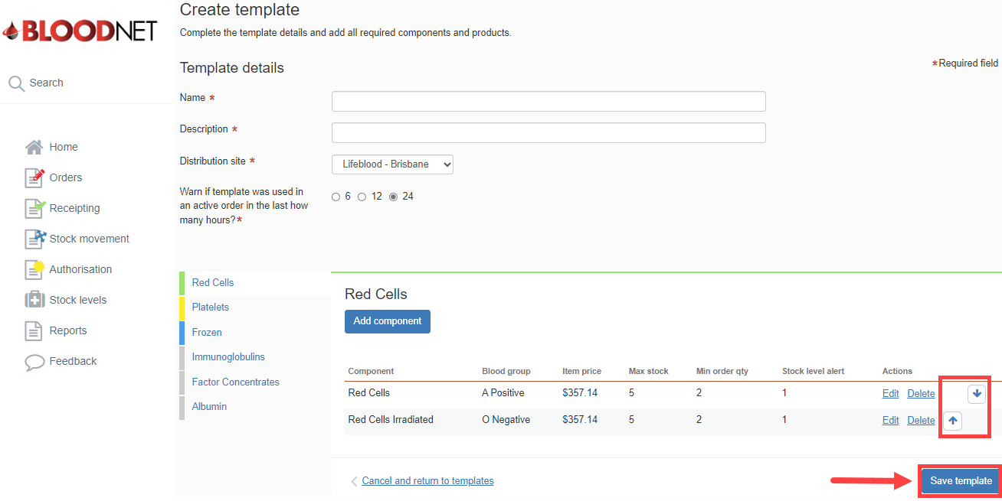
- The order of components or products in the template can be adjusted by clicking the up or down arrows.

- Click the ‘Save template’ button to finalise the template.
