Managing Draft Orders – Tip sheet
The Draft orders screen displays orders that have been partially completed and saved, but not yet sent to Australian Red Cross Lifeblood. Draft orders can be deleted if not required or edited and then submitted.
Please note: Draft Orders that have not been actioned will be automatically deleted 14 days after they were created.
- Click the ‘Orders’ tile from the home page. This will display the ‘Orders’ page.
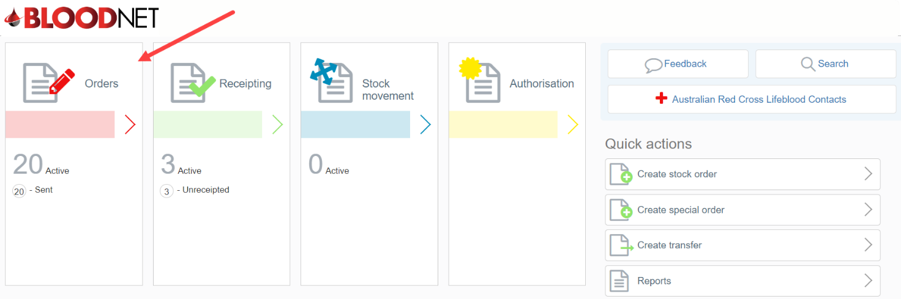
- Click on the ‘Draft orders’ hyperlink to view the list of draft orders. The number of draft orders in your facility is indicated by the number in the green circular icon.
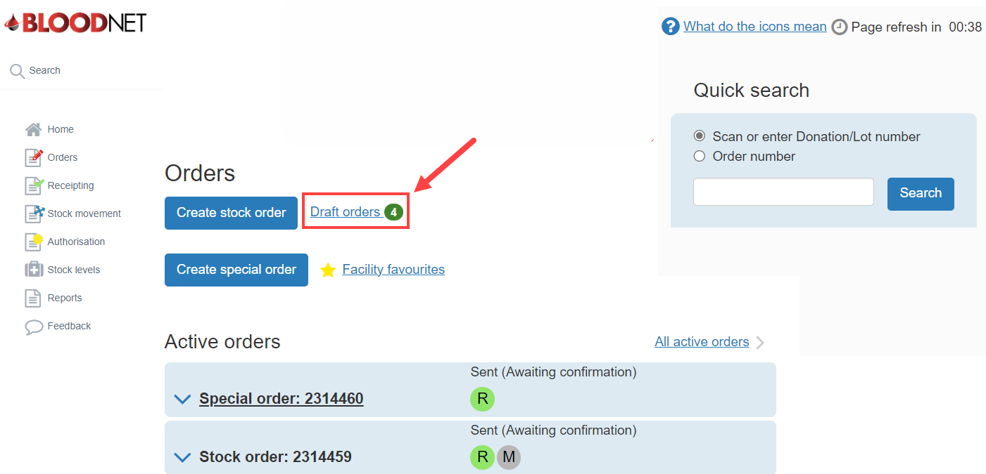

- Locate the draft order you would like to manage and either ‘Continue’ with a draft order or ‘Delete’ it by clicking on the corresponding hyperlink in the ‘Actions’ column.
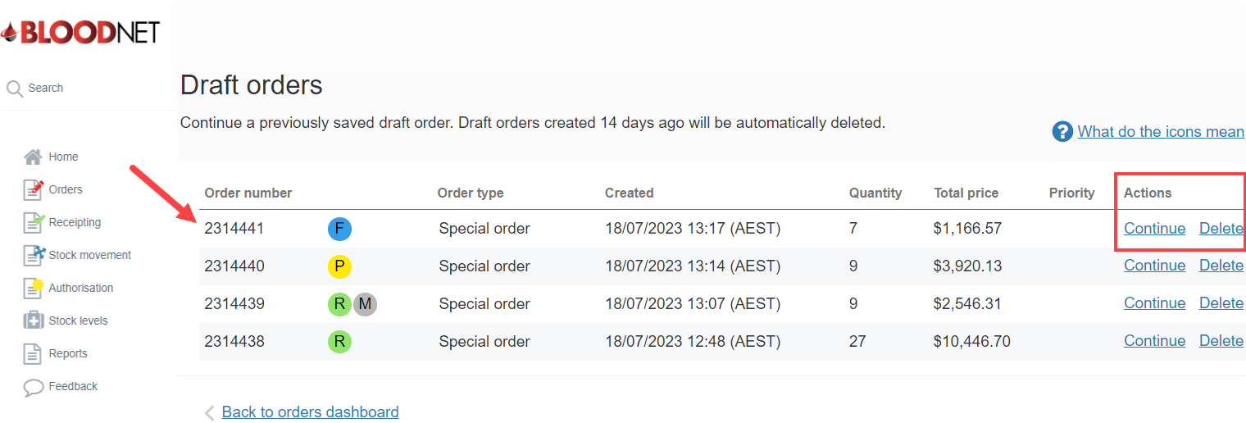

Editing Draft orders
- From the ‘Draft orders’ page click the ‘Continue’ hyperlink on the order you would like to amend. This will open the ‘Create stock order’ or ‘Create special order’ screen with the previously saved details pre-populated.
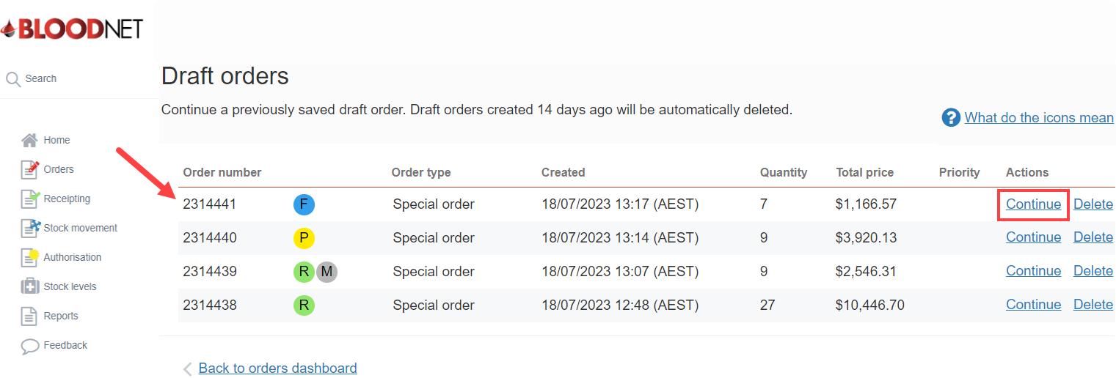
- Add components and/or products to the order by clicking the ‘Add component’ or ‘Add product’ button. ‘Edit’ or ‘Delete’ components/products on the order by clicking the links in the ‘Actions’ column.
- Click ‘Save as draft’ to save the order as a ‘Draft order’ or click ‘Next: delivery details’ to continue to the ‘Delivery Details’ page to proceed with placing your order.
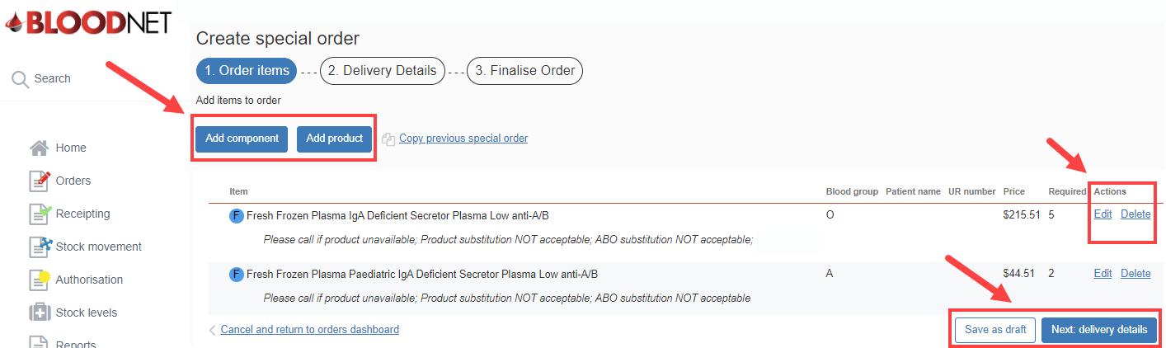
Please note: Refer to Creating a Special Order Tip sheet or Creating a Stock-Order Tip sheet for detailed information on the functions when placing an order.

Deleting Draft orders
- From the ‘Draft orders’ page, find the order you would like to delete and click the ‘Delete’ hyperlink in the ‘Actions’ column.
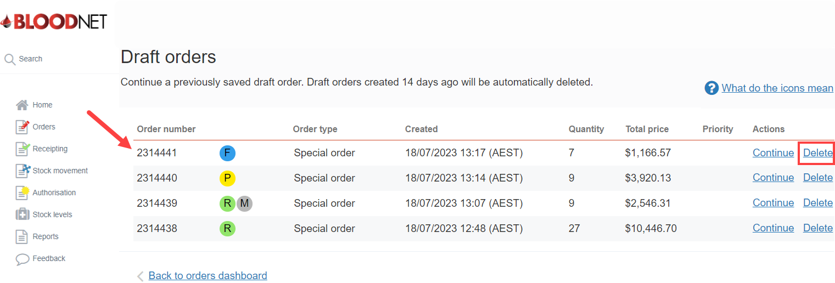
- Click ‘Yes’ on the ‘Delete draft’ pop up box to delete the draft order.
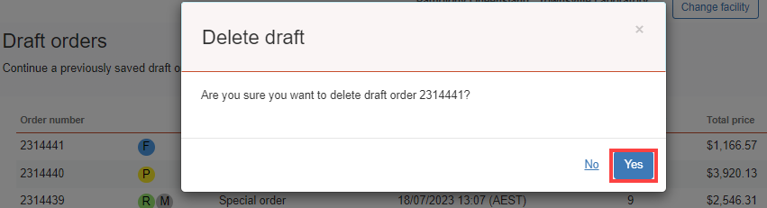
Please note: Once deleted, the draft order will be removed from the Draft orders screen. Any draft orders older than 14 days will be deleted.

