Tipsheet – BloodSTAR
Exporting a patient’s treatment plan to Excel
This tip sheet outlines how BloodSTAR users can export a patient's treatment plan to Excel. The export to Excel function is more accessible and readable than the function to export only to PDF. The patient’s treatment plan in Excel allows a better analysis by being able to use the Excel filter options for each of the treatment plan columns.
- First navigate to the patient’s record by either using:
  - the Authorised patients at this Facility search function
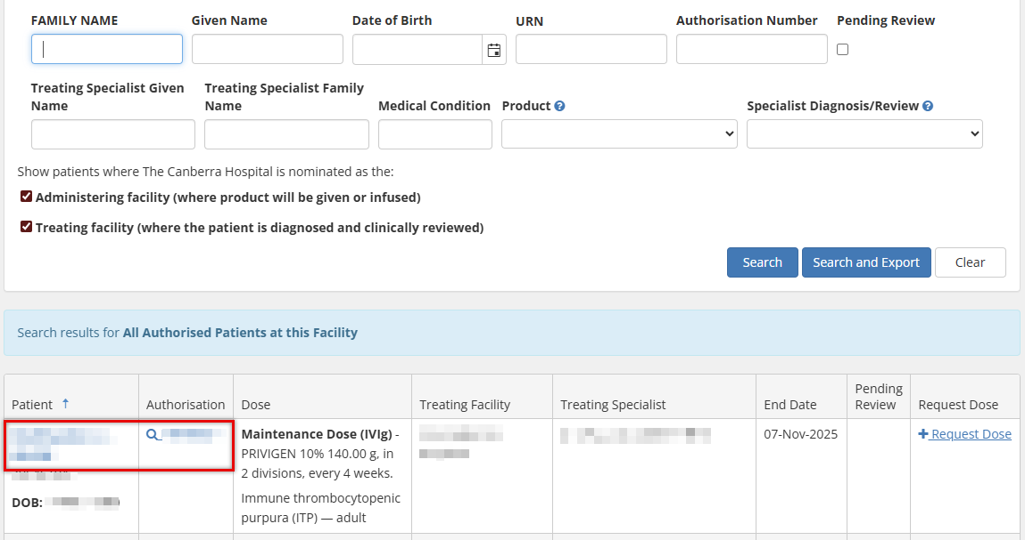
  - the Patient Search function in the Patients tab on the top ribbon.
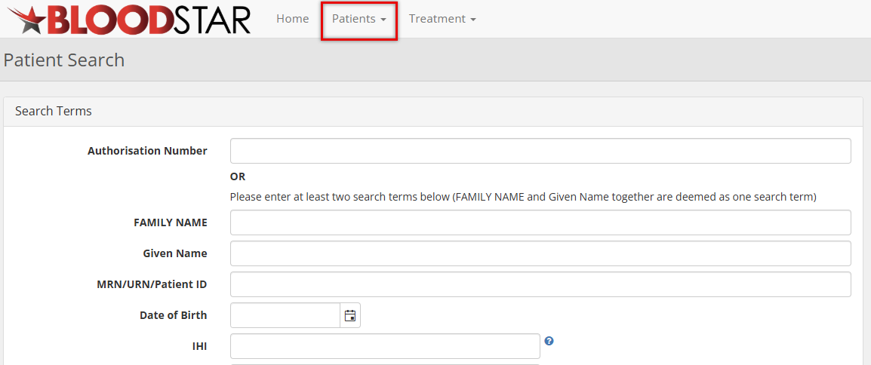

- There are two ways to export a treatment plan, either on the:
  - Patient Record page: scroll down to the Current Authorisation section and select the Export Treatment Plan to Excel hyperlink button.
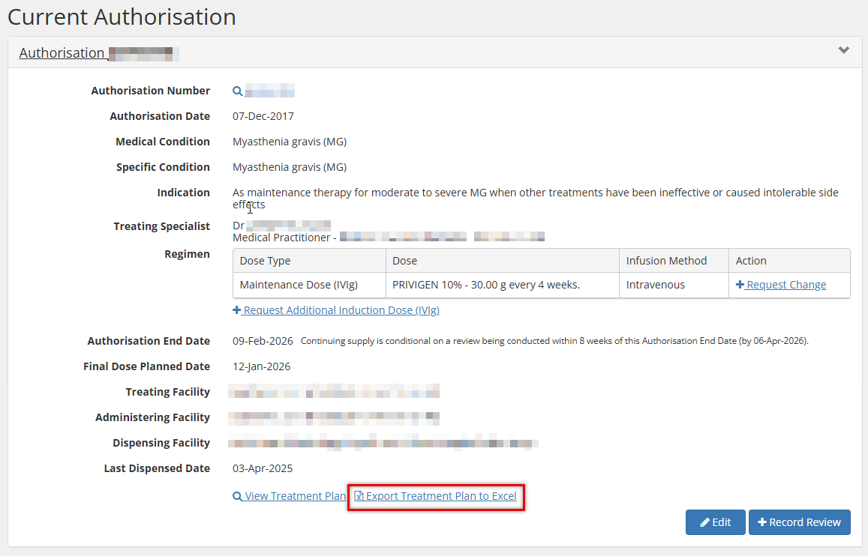

  - View Authorisation page: scroll down to the patient’s Treatment Plan and select the Export to Excel button.
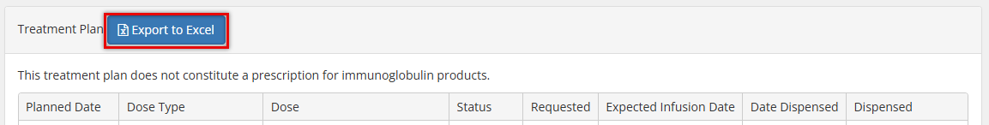
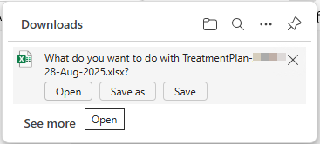
- Once the export button is selected, it will download in your web browser.

- You can then open the Excel file which will contain the following details:
  - Planned Date
  - Dose Type
  - Dose
  - Status
  - Requested (if the dose was requested, it will show as positive)
  - Expected Infusion Date
  - Date Dispensed
  - Dispensed
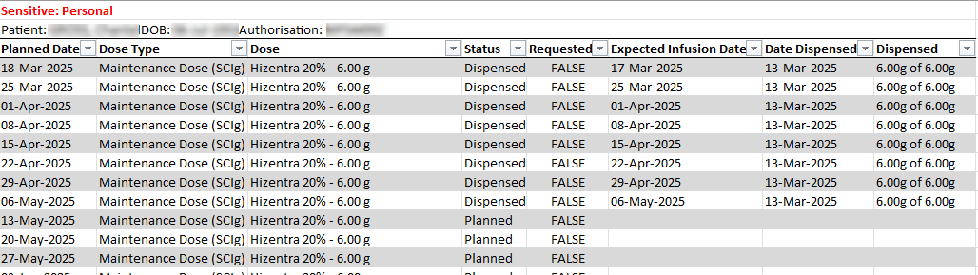
- From this file you can filter the information as required using the filter option next to each column title.

