
Australian
Bleeding
Disorders
Registry

Annual Report 2024-25



With the exception of any logos and registered trademarks, and where otherwise noted, all material presented in this document is provided under a Creative Commons Attribution 4.0 license (https://creativecommons.org/licenses/by/4.0/)
The details of the relevant license conditions are available on the Creative Commons website (accessible using the links provided) as is the full legal code for the CC BY 4.0 license (https://creativecommons.org/licenses/by/4.0/legalcode)
The content obtained from this document or derivative of this work must be attributed as:
Australian Bleeding Disorders Registry (ABDR) Annual Report 2024-25 published by the National Blood Authority.
ISSN 1839-0811 (online version)
This report is available online at https://www.blood.gov.au/australian-bleeding-disorders-registry-annual-report
Version: 7 November 2025



Locked Bag 8430
Canberra ACT 2601
Phone: 13 000 BLOOD (13000 25663)
Email: data@blood.gov.au
www.blood.gov.au
Table of Contents
Purpose of this document 4
2024-25 – Patients and Products Snapshot 5
2024-25 – Demand Snapshot 6
Treatment of bleeding disorders in Australia 7
The Australian Bleeding Disorders Registry (ABDR) 8
Patients 9
Products 10
Treatment 12
Appendix A: Bleeding Disorders 19
Appendix B: Haemophilia Treatment Centres 25
Appendix C: About ABDR 27
Appendix D: National Supply of Products 29
Appendix E: Glossary of terms 34

List of Tables
Table 1 - Major bleeding disorders and their cause 7
Table 2 - Severity and concentration of clotting factors 7
Table 3 - Number of patients in the registry and treated by broad diagnosis 9
Table 4 - Incidence statistics from World Federation of Hemophilia Global Survey 2024 9
Table 5 - Volume (IU) of product used by severity and treatment regimen in 2024-25 13
Table 6 - Detailed breakdowns for hereditary haemophilia A patients 14
Table 7 - Detailed breakdowns for hereditary haemophilia B patients 15
Table 8 - Detailed breakdowns for hereditary VWD patients 16
Table 9 - Volume (IU), patient counts and average IU/kg by product and treatment regimen 17
Table 10 - Patients with acquired and other bleeding disorders 18
Table 11 - Products used by patients with acquired and other bleeding disorders 18
Table 12 - Characteristics of rare clotting factor deficiencies 22
Table 13 - Product types and brand names used in this report 33

List of Figures
Figure 1 - Market share of recombinant FVIII issues 2020-21 to 2024-25 10
Figure 2 - Percentage of hereditary patients receiving product by severity for haemophilia A 12
Figure 3 - Percentage of hereditary patients receiving product by severity for haemophilia B 12
Figure 4 - Location of Haemophilia Treatment Centres 25
Figure 5 - National issues by product category 2024-25 29
Figure 6 - Expenditure on clotting factors and percentage of blood budget 2009-10 to 2024-25 30
Figure 7 - Issues of factor VIII products, 2020-21 to 2024-25 per ‘000 population 31
Figure 8 - Issues of factor IX products, 2020-21 to 2024-25 per ‘000 population 31
Figure 9 - Issues of recombinant factor VIIa products, 2020-21 to 2024-25 per ‘000 population 32
Figure 10 - Issues of FEIBA, 2020-21 to 2024-25 per ‘000 population 32
Figure 11 - Issues of emicizumab, 2020-21 to 2024-25 per ‘000 population 33

Purpose of this document

The Australian Bleeding Disorders Registry (ABDR) is a clinical registry for patients in Australia with bleeding disorders. It is used daily by clinicians in all Australian Haemophilia Treatment Centres (HTCs) to assist in managing the treatment of people with bleeding disorders and to gain a better understanding of the incidence and prevalence of bleeding disorders. Patients also contribute data to ABDR through the MyABDR app, which allows patients to record home treatments and bleeds.

This Annual Report summarises patient and product data from ABDR and other National Blood Authority (NBA) sources to provide a high-level overview of who has bleeding disorders, how they are treated and what products are used. This report may be of interest to clinicians providing care to patients, patient community organisations and government organisations.

For more information see www.blood.gov.au.

2024-25 – Patients and Products Snapshot
There were 8,487 patients active in ABDR as at 30 June 2025. Hereditary Von Willebrand Disease (VWD) and hereditary haemophilia A (haemophilia A) are the most prevalent disorders.

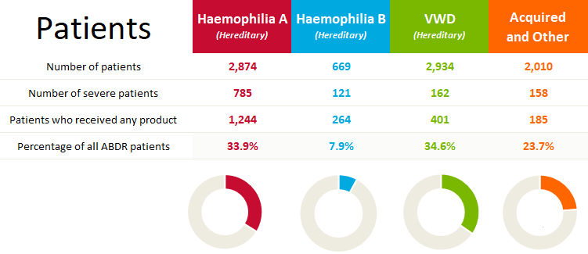

Bleeding disorder type and severity are the main determinants of whether a patient will require treatment with FVIII and FIX clotting factor products. In 2024-25, almost 59% of total FVIII product was used by patients with haemophilia A (decreased from 62% in 2023-24). Emicizumab use by patients with haemophilia A continued to increase, accounting for the ongoing decrease in FVIII use. Further details are provided later in this report.

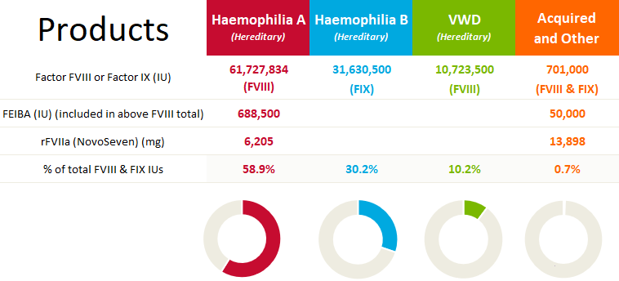

2024-25 – Demand Snapshot

 | Overall demand for clotting factors in 2024-25  9.9% of total cost of blood and blood products  - Increased by 0.2% of total cost from 2023-24  - Actual expenditure increased by $10.4m
 | Demand for factor VIII  Decreased by 4.2% from 2023-24  → Mostly due to increased use of emicizumab  - Recombinant VIII decreased by 7.9%  - Plasma derived FVIII increased by 16.1% from 2023-24
 | Demand for factor IX  Increased by 7.1% from 2023-24  - Recombinant FIX increased by 7.5%  - Plasma derived FIX demand has now ceased
 | Demand for emicizumab  Increased by 7.1% from 2023-24
Source: NBA Annual Report 2024-25

Additional information can be found in Appendix D.

Treatment of bleeding disorders in Australia
In Australia, and for the purposes of this report, bleeding disorders are grouped as set out in Table 1. There are also some patients with Fibrinogen and Vascular disorders. Patient numbers by disorder are provided later in this report. More detail on disorders and grouping is included at Appendix A: Bleeding Disorders.
Table 1 - Major bleeding disorders and their cause
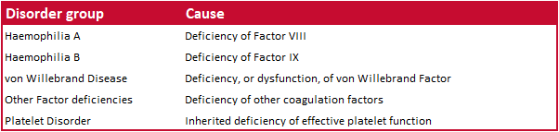
Types of haemophilia
- The most common type of haemophilia is haemophilia A. This means the person does not have enough clotting factor VIII (factor eight).
- Haemophilia B is less common. A person with haemophilia B does not have enough factor IX (factor nine). The symptoms are the same for people with haemophilia A and B; that is, they bleed for a longer time than normal.
Severity
Haemophilia A and B are classified according to their severity, as this informs the treatment regimens required. The definitions of severity that are applied within ABDR are listed in Table 2,. Definitions of severity for VWD and other coagulation factor deficiencies are not standardised.

Table 2 - Severity and concentration of clotting factors
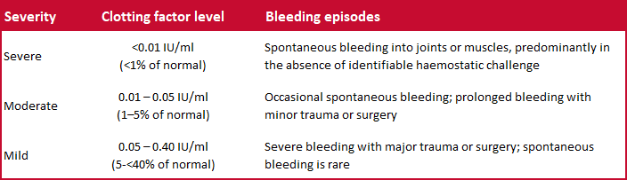
Mild conditions may require no treatment or treatment only under special circumstances, such as surgery. More severe conditions may require regular interventions. Treatment may occur in hospital or other medical facilities, or at home. The treatments may be regular and preventative (prophylaxis), or on demand (when a bleed occurs). In some patients, therapy is complicated when their body develops inhibitors that destroy the replacement clotting factors and other treatment is necessary.
Often the treatments involve providing replacement for the missing or defective clotting factors. Products used include plasma derived and recombinant clotting factors, cryoprecipitate and Desmopressin (1-desamino-8-D-arginine vasopressin; DDAVP) which can stimulate the release of factor VIII and von Willebrand Factor from stores in the body (this is not used in haemophilia B or factor IX deficiency).
Treatment of patients with bleeding disorders is managed through Haemophilia Treatment Centres (HTC). See Appendix B: Haemophilia Treatment Centres for details about the roles and services provided by HTCs.

The Australian Bleeding Disorders Registry (ABDR)
Patient details are captured in ABDR to enable health care and support staff to monitor and manage treatment over time from a single point of reference.
ABDR is subject to robust governance and privacy arrangements and has been endorsed by both the Haemophilia Foundation Australia (HFA) and the Australian Haemophilia Centre Directors’ Organisation (AHCDO).
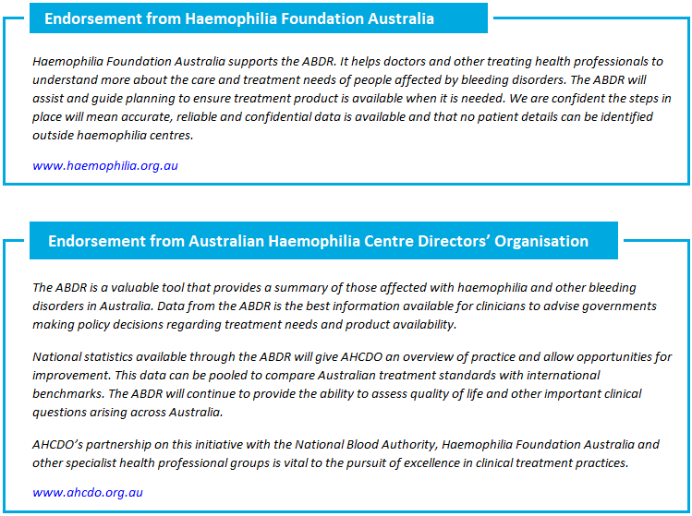
For more details about the history of ABDR and the privacy and governance arrangements which apply to data in ABDR, please see Appendix C: About ABDR.

Patients
Table 3 shows the numbers of patients in ABDR and the numbers of patients who received products during the years 2020-21 to 2024-25.
Table 3 - Number of patients in the registry and treated by broad diagnosis
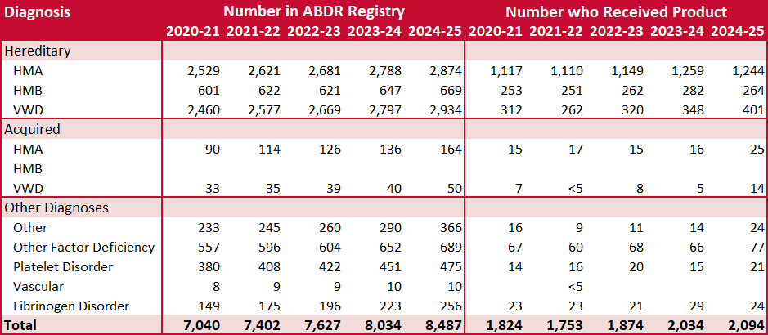
Notes: Included in the table are patients active as at 30 June 2025. ABDR allows for a diagnosis of ‘Other’ to be recorded for patients with rare and less prevalent disorders or difficult to classify disorders eg mild VWD.
Table 4 shows the incidence statistics for Australia compared with other countries from the World Federation of Hemophilia (WFH) Annual Global Survey 2024 published in 2025. The full survey can be found at https://wfh.org/research-and-data-collection/annual-global-survey/.
Table 4 - Incidence statistics from World Federation of Hemophilia Global Survey 2024
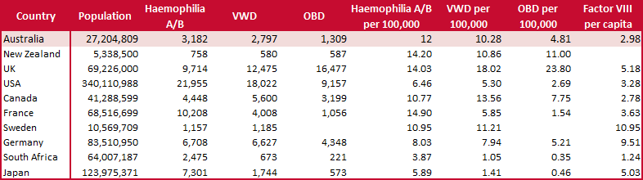
Notes: This data matches last year’s ABDR Annual Report, not this current report (excluding acquired and asymptomatic disorders).
OBD = Other Bleeding Disorders

Prevalence of haemophilia A varies considerably among countries, including among the wealthiest of countries7F. Prevalence data is extremely valuable information for planning by national healthcare agencies in setting priorities and allocating resources for the treatment of bleeding disorders.

Products
The NBA is charged with providing an adequate, safe, secure and affordable supply of blood products, blood-related products and blood-related services in Australia; and promoting safe, high-quality management and use of blood products, blood-related products and blood-related services in Australia.

A key element in ensuring security of supply of products for the treatment of bleeding disorders is the NBA’s role in developing, coordinating and monitoring the annual national supply plan and budget, including obtaining annual approval from health ministers. Details on national supply and demand trends over time can be found in Appendix D: National Supply of Products.

Figure 1 shows the total issues and market shares for recombinant FVIII products from 2020-21 to 2024-25 and illustrates the changes that have occurred during that period, including the impact of the introduction of emicizumab. The changes in the five years shown were brought about by new national supply arrangements, with extended half-life (EHL) products added to the mainstream product offering (these were previously trial products). New supply contracts commenced on 1 July 2020, providing further efficiencies in supply and cost. The introduction of emicizumab to the National Product Price List in November 2020 continues to have a significant impact on the use of FVIII products in 2024-25 as shown in Figure 1. Figure 6 in Appendix D shows expenditure on clotting factors from 2009-10 to 2024-25.

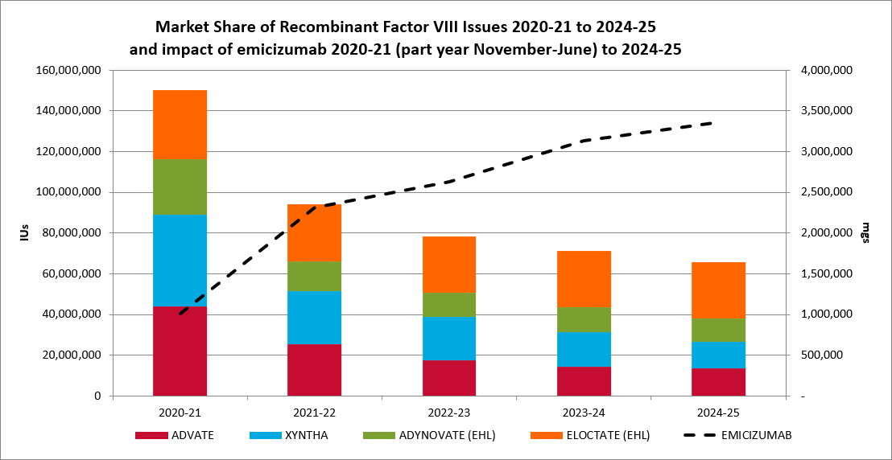
Figure 1 - Market share of recombinant FVIII issues 2020-21 to 2024-25

Inhibitor status
Inhibitors are immunoglobulins made by the body's immune system to react against replacement clotting factor proteins. This occurs when the immune system perceives the proteins as foreign or harmful to the body. When this happens, the inhibitors prevent the usual replacement factors (factor VIII or IX) from working properly to stop bleeding. The most challenging aspect of haemophilia A management is the development of FVIII inhibitors. Patients with severe haemophilia A with high-titre inhibitors are most at risk for recurrent bleeds and chronic haemarthroses.
FEIBA and recombinant factor VIIa (brand name NovoSeven) are both used to treat patients that have developed inhibitors. Predicting or interpreting changing demand trends is not possible with any accuracy, as the product is only used in a small number of patients each year. Use patterns will vary from year to year and will not only depend on the number of patients treated, but their severity of disease, the potency of inhibitors, whether secondary prophylaxis is practiced, the number and severity of spontaneous bleeds, and the amount of elective surgery undertaken in this patient group.
In 2024-25, there were 146 haemophilia A patients with inhibitors and 15 patients with other bleeding disorders who had inhibitors.

Treatment
The data in this section relates to patients who received treatment (products) during the 2024-25 financial year. Figure 2 shows the proportion of hereditary haemophilia A patients receiving treatment (1,244 patients in 2024-25) by severity. Figure 3 shows the proportion of hereditary haemophilia B patients receiving treatment (264 patients in 2024-25) by severity.
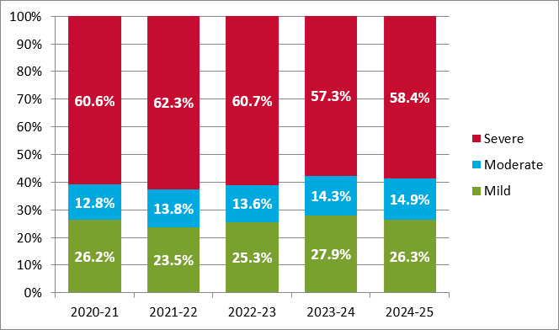
Figure 2 - Percentage of hereditary patients receiving product by severity for haemophilia A
Note: A very small number of patients have a severity recorded as Not Applicable or Unknown. These are not shown in the above chart.

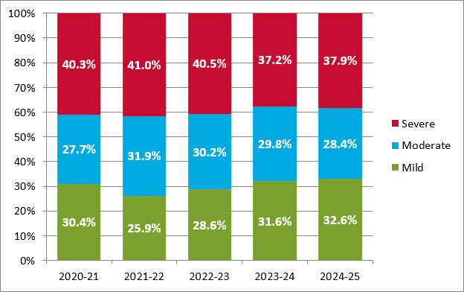
Figure 3 - Percentage of hereditary patients receiving product by severity for haemophilia B
Note: A very small number of patients have a severity recorded as Not Applicable or Unknown. These are not shown in the above chart.
In 2024-25, 77% (by volume) of FVIII products used by patients with hereditary haemophilia A were for patients with a severe disorder (no change from 2023-24) and around 60% (by volume) of FIX products used by patients with hereditary haemophilia B were for those with a severe disorder (compared with 59% in 2023-24). Table 5 shows the breakdowns by regimen. Around 34% of patients are diagnosed with haemophilia A (see Table 3), however, in 2024-25 these patients used around 59% of total factor products, a decrease from 62% in 2023-24.

As shown in Figure 1, the decrease in FVIII use is occurring in tandem with the increase in emicizumab use. Emicizumab is available to hereditary severe or moderate haemophilia A patients with or without inhibitors and to mild patients with inhibitors. In 2024-25, 82% (by volume) of emicizumab was used by patients with a severe disorder. A further 16% was used by moderate patients and the remaining 2% was used by patients with a mild disorder.

In relative terms, haemophilia A is the most important consideration for national supply planning, and the key factor is the issue of product to severe haemophilia A patients. The volume used for prophylactic treatment of severe haemophilia A is the single greatest determining factor for supply planning.

Table 5 - Volume (IU) of product used by severity and treatment regimen in 2024-25
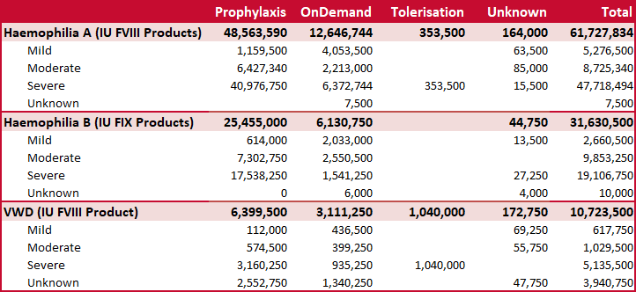
Unknown treatment regimen: represents a blank/not completed/empty field for the treatment regimen in ABDR.
Unknown severity: The severity of a patient’s condition is not always known at initial presentation. This table includes product used by patients with unknown severities.

Table 6, Table 7 and Table 8 show more detailed breakdowns by state, severity, gender, age range, regimen, IU/kg/year and product for haemophilia A, haemophilia B and VWD, the three largest groups of patients and for which most product is used.

Table 6 - Detailed breakdowns for hereditary haemophilia A patients
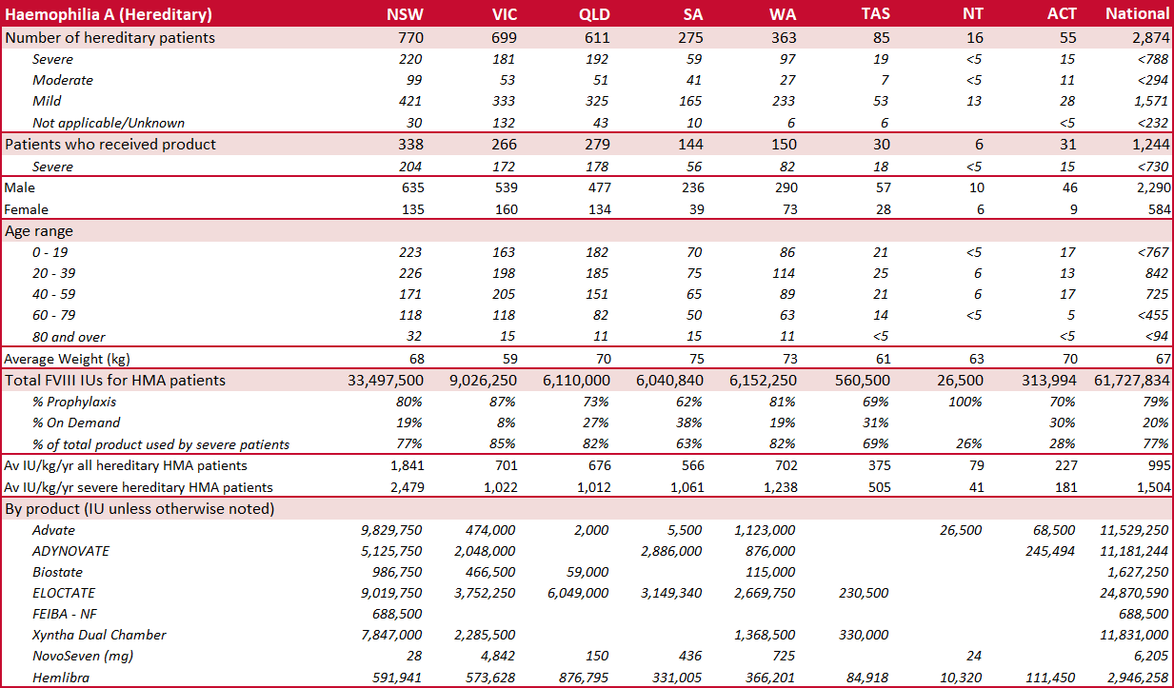

Table 7 - Detailed breakdowns for hereditary haemophilia B patients
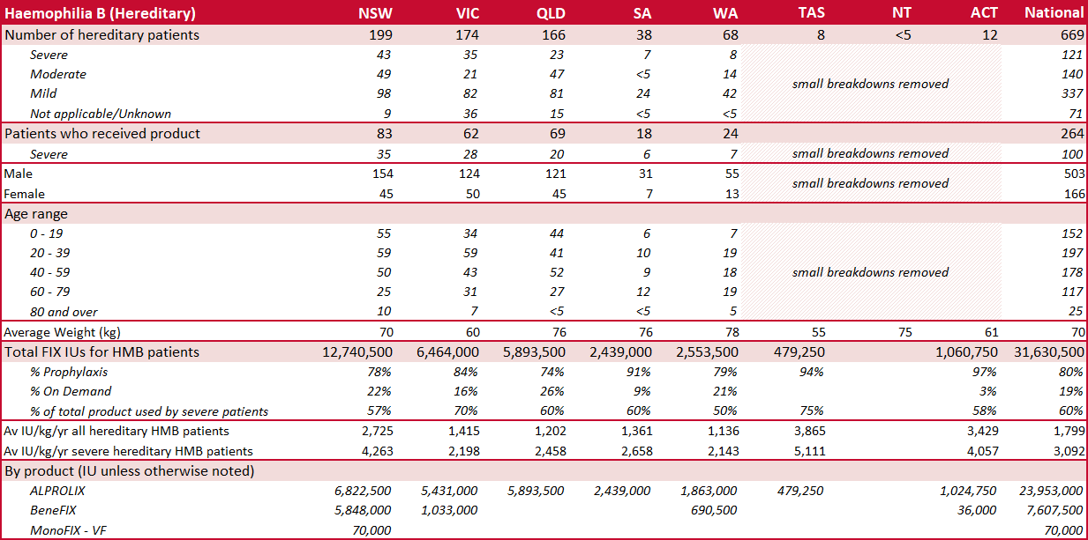Note: small patient number breakdowns have been removed to help protect patient privacy

Table 8 - Detailed breakdowns for hereditary VWD patients
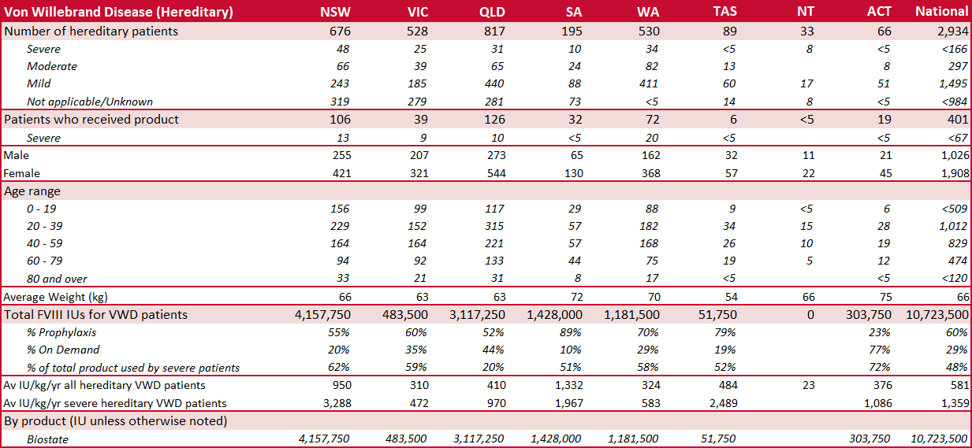

Table 9 shows, by treatment regimen, volume of product used, number of hereditary haemophilia A, haemophilia B and VWD patients and average IU/kg.

Note that average IU/kg in this table is calculated differently to that in Tables 6-8 above. The above tables show the average IU per kilo per year, whereas this table averages the IU/kg value at each order or treatment interaction. Average IU/kg for orders may be inflated due to orders covering amounts for a number of treatments.

Table 9 - Volume (IU), patient counts and average IU/kg by product and treatment regimen
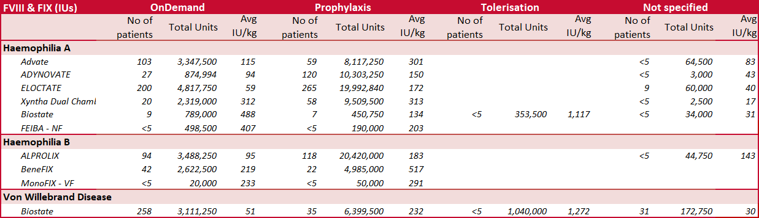

There are much smaller numbers of patients with acquired haemophilia A, haemophilia B and VWD. These are set out below, along with state breakdowns for patients with other bleeding disorders.

Table 10 - Patients with acquired and other bleeding disorders
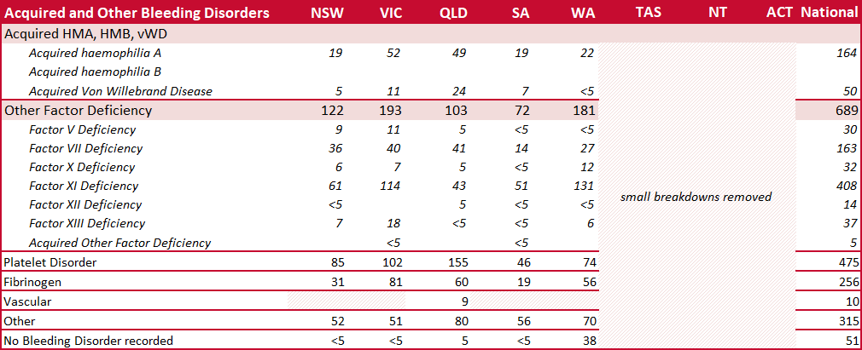Note: The ABDR allows for a diagnosis of 'Other' to be recorded for patients with rare, less prevalent or difficult to classify disorders eg mild VWD.

Table 11 - Products used by patients with acquired and other bleeding disorders
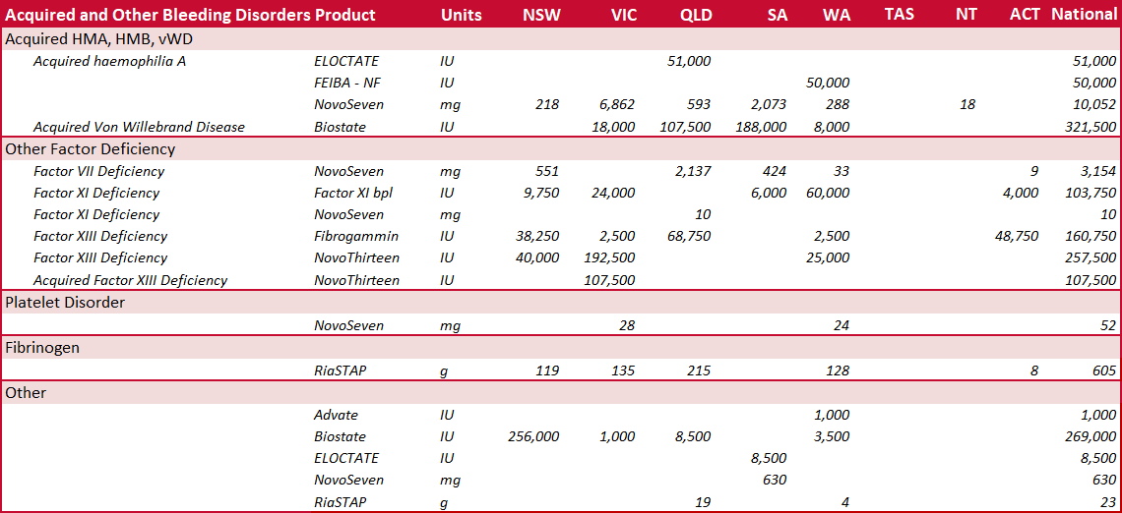

Appendix A: Bleeding Disorders
The information in this section has been drawn from the materials and websites of two peak bodies for haemophilia; the World Federation of Hemophilia (www.wfh.org) and Haemophilia Foundation Australia (HFA) (www.haemophilia.org.au).
In people with bleeding disorders, the clotting process doesn’t work properly. As a result, people with bleeding disorders can bleed for longer than normal, and some may experience spontaneous bleeding into joints, muscles, or other parts of their bodies.
Bleeding disorders are hereditary or acquired
Bleeding disorders are almost always hereditary or passed through families; they have a genetic basis and the genes responsible for the disorders are passed from parents to children. In haemophilia approximately one-third of cases develop from a spontaneous gene mutation in an egg or sperm cell during reproduction. The child conceived can then pass the gene mutation to their children. A person can also spontaneously develop a bleeding disorder, although this is rare. Acquired bleeding disorders are not inherited or passed through families. Most acquired bleeding disorders have an identifiable root cause.
Haemophilia
Haemophilia causes excessive bleeding following trauma or surgery and can be related to spontaneous haemorrhages into muscles and joints. People with haemophilia do not bleed any faster than normal, but they can bleed for a longer time.
Haemophilia is an X-linked disorder. These disorders typically affect males, whereas females are normally classified as carriers. However, in haemophilia, females can have bleeding symptoms and be classified as having haemophilia. Affected females will pass the haemophilia gene mutation to sons and daughters and affected males will pass on the haemophilia gene mutation to all of their daughters. Most carriers are asymptomatic. Approximately 20-30% of females who carry an F8 or F9 gene mutation have reduced factor levels and should be classified as having haemophilia, if their factor levels fall in the range for haemophilia. If a carrier is symptomatic, their bleeding manifestations may be commensurate with their degree of clotting factor deficiency but their factor levels do not always correlate with their bleeding phenotype. This is monitored over their lifetime and taken into account, particularly during menarche, trauma and surgery. Females with the haemophilia gene mutation are classified as having haemophilia, being symptomatic haemophilia carriers or asymptomatic haemophilia carriers in line with the International Society on Thrombosis and Haemostasis (ISTH) guidelines (www.isth.org).
Haemophilia fast facts
- The most common type of haemophilia is haemophilia A. This means the person does not have enough clotting factor VIII (factor eight).
- Haemophilia B is less common. A person with haemophilia B does not have enough factor IX (factor nine). The symptoms are the same for people with haemophilia A and B; that is, they bleed for a longer time than normal.
- Haemophilia occurs in 1 in 6,000-10,000 males internationally.
- Bleeding is most commonly internal into the joints and/or muscles. Less commonly, bleeding into internal organs can also occur. It can happen without an obvious cause (sometimes called ‘spontaneous’), or as a result of injury.
- Over time this internal bleeding into joints ('bleeds') can cause severe arthritis, chronic pain and disability.
- Specialised treatment is needed to help blood clot normally. With appropriate treatment haemophilia can be managed effectively.
- Haemophilia is a hereditary genetic condition and occurs in families. However, in 1/3 of cases it appears in families with no previous history of the disorder. The genetic alteration causing haemophilia is passed down from parent to child through generations. Men with haemophilia will pass the gene alteration on to their daughters but not their sons. Women who carry the gene alteration can pass it on to their sons and daughters. Sons with the gene alteration will have haemophilia.
- Most women and girls who carry the gene alteration do not have bleeding symptoms. However, approximately 20-30% have reduced factor levels and bleeding problems. They may have haemophilia, usually mild haemophilia. Some may have very low factor levels and have moderate or severe haemophilia, but this is rare.

Von Willebrand disorder/disease (VWD)
Von Willebrand disease is the most common type of bleeding disorder. People with VWD have a problem with von Willebrand Factor (VWF), a protein in their blood that would normally help control bleeding. When a blood vessel is injured and bleeding occurs, VWF helps cells in the blood, called platelets, adhere to damaged blood vessels and mesh together and form a clot to stop the bleeding. People with VWD do not have enough VWF, or it does not work the way it should. It takes longer for blood to clot and for bleeding to stop.
VWD is generally less severe than other bleeding disorders. Many people with VWD may not know that they have the disorder because their bleeding symptoms are very mild. For most people with VWD, the disorder causes little or no disruption to their lives except when there is a serious injury or need for surgery. However, with all forms of VWD, there can be bleeding problems. VWD is difficult to accurately diagnose as laboratory values can fluctuate and values in those with mild bleeding symptoms can overlap with normal laboratory values.
From some studies, it is estimated that up to 1% of the world’s population has VWD, but because many people have only very mild symptoms, only a small number of them are diagnosed. It is thought that approximately 1 in 1,000 will need medical treatment for their VWD in their lifetime. Research has shown that as many as 9 out of 10 people with VWD have not been diagnosed. It is estimated that VWD affects approximately 200,000 people in Australia, but symptomatic individuals possibly less.
Types of VWD
There are three main types of VWD. Bleeding symptoms can be quite variable within each type depending in part on the VWF activity. It is important to know which type of VWD a person has, because treatment is different for each type.
- Type 1 VWD is the most common form. People with Type 1 VWD have lower than normal levels of VWF. Symptoms are usually mild. Still, it is possible for someone with Type 1 VWD to have serious bleeding.
- Type 2 VWD involves a change in the VWF structure. The VWF protein does not work properly, causing lower than normal VWF activity. There are different Type 2 VWD changes. Severity of symptoms can vary.
- Type 3 VWD is usually the most serious form. People with Type 3 VWD have very little or no VWF. Symptoms are more severe. People with Type 3 VWD can have bleeding into muscles and joints, sometimes without injury.

Rare clotting factor deficiencies
Rare clotting factor deficiencies are a group of inherited bleeding disorders caused by a problem with one of several clotting factors other than factor VIII or factor IX. Clotting factors are proteins in the blood that control bleeding. Many different clotting factors work together in a series of chemical reactions to stop bleeding. This is called the clotting process.
Rare clotting factor deficiencies are bleeding disorders in which one of the other clotting factors (i.e., factors I, II, V, V+VIII, VII, X, XI, or XIII) is missing or not working properly. The World Federation of Hemophilia produced a summary (Table 12) of the characteristics of rare clotting factor deficiencies, the severity of bleeds associated with them, and the treatment typically required.
Table 12 - Characteristics of rare clotting factor deficiencies
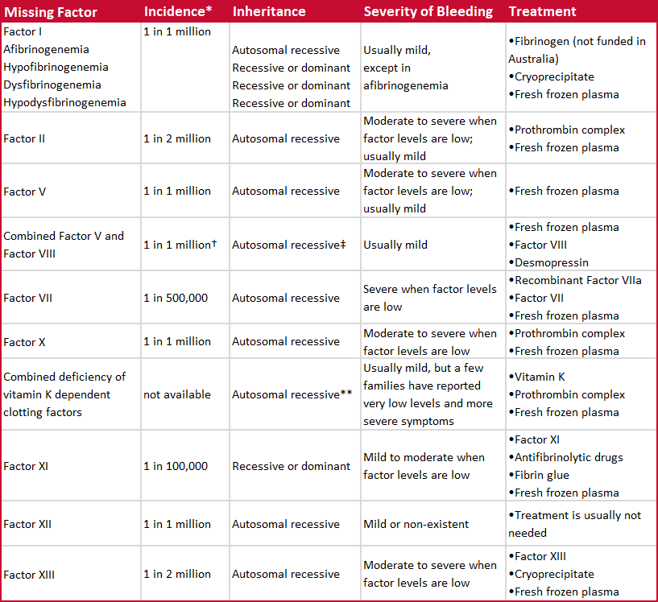
Note: Australian Prothrombin Complex Concentrate is not used for FVII deficiency
* Estimates only
† 1 in 100,000 in some populations, including Israel, Iran, and Italy
‡ Very rarely, factor VIII deficiency can be inherited separately from only one parent
** Can also be acquired later in life because of another medical condition, certain medications, etc
Table 12 is based on Table 1 from the World Federation of Hemophilia publication What are rare clotting factor deficiencies?, available at https://www1.wfh.org/publications/files/pdf-1337.pdf.

Platelet function disorders
Platelets are small parts of cells that circulate in the blood. They are involved in the formation of blood clots and the repair of damaged blood vessels.
When a blood vessel is injured, platelets stick to the damaged area and spread along the surface to stop the bleeding (this process is called adhesion). At the same time, chemical signals are released from small sacks inside the platelets called granules (this process is called secretion). These chemicals attract other platelets to the site of injury and make them clump together to form what is called a platelet plug (this process is called aggregation).
Sometimes the platelet plug is enough to stop the bleeding. However, if the wound is large, other proteins called clotting factors are recruited to the site of injury. These clotting factors work together on the surface of the platelets to form and strengthen the blood clot.
Platelet function disorders are conditions in which platelets don’t work the way they should, resulting in a tendency to bleed or bruise. Since the platelet plug does not form properly, bleeding can continue for longer than normal. Since platelets have many roles in blood clotting, platelet function disorders can lead to bleeding disorders of various intensities.
Special issues for girls and women
Women and girls with clotting factor deficiencies may have additional symptoms because of menstruation and childbirth. Girls may have especially heavy bleeding when they begin to menstruate. Women with clotting factor deficiencies may have heavier and/or longer menstrual flow, which can cause anaemia (with low levels of iron, which results in weakness and fatigue).
If females are suspected haemophilia carriers, a common time for genetic testing to confirm their carrier status is before they reach childbearing years. Women who are haemophilia carriers should receive genetic counselling about the risks of having an affected child well in advance of any planned pregnancies. When they suspect they are pregnant, they should contact their haemophilia treatment centre for advice on local obstetric services with experience of bleeding disorders. The obstetrician should work closely with the staff of the haemophilia treatment centre to provide the best care during pregnancy and childbirth and to minimize the potential complications for both the mother and the newborn child.
Women with certain rare factor deficiencies (such as factor XIII deficiency and afibrinogenemia) may be at greater risk of miscarriage and placental abruption (a premature separation of the placenta from the uterus that disrupts the flow of blood and oxygen to the foetus). Therefore, these women require treatment throughout the pregnancy to prevent these complications.
The main risk related to pregnancy is postpartum haemorrhage. All bleeding disorders are associated with a greater risk of increased bleeding after delivery. The risk and the severity of the bleeding can be reduced with appropriate treatment. This treatment is different for each woman and depends on her personal and family history of bleeding symptoms, the severity of the factor deficiency, and the mode of delivery (vaginal birth vs. caesarean section). Factor replacement may be necessary in some cases.

Bleeding disorder groups in this report
The bleeding disorders captured in ABDR have been summarised to higher level groups to enable this report to be more concise. The bleeding disorders included in each group are:
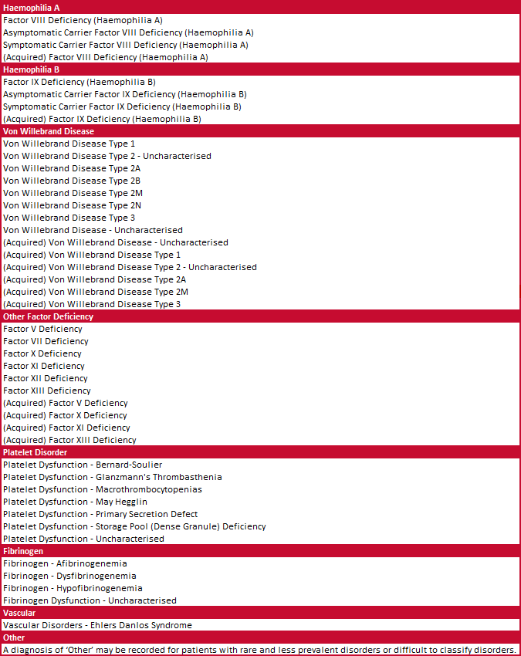
Note: Acquired disorders may be included in the group or shown separately depending on the table.

Appendix B: Haemophilia Treatment Centres
The majority of people with these conditions are treated at Haemophilia Treatment Centres (HTCs) which are specialist centres that provide comprehensive care to people with haemophilia and other bleeding disorders. The comprehensive care model ensures that preventative and general treatment on the complex aspects of haemophilia is given in a co-ordinated way by a multi-disciplinary team with specialised expertise within the one centre.
HTCs were established following a decision by Australian Health Ministers Advisory Council (AHMAC) in 1998. The locations of the HTCs in Australia are shown in Figure 4.
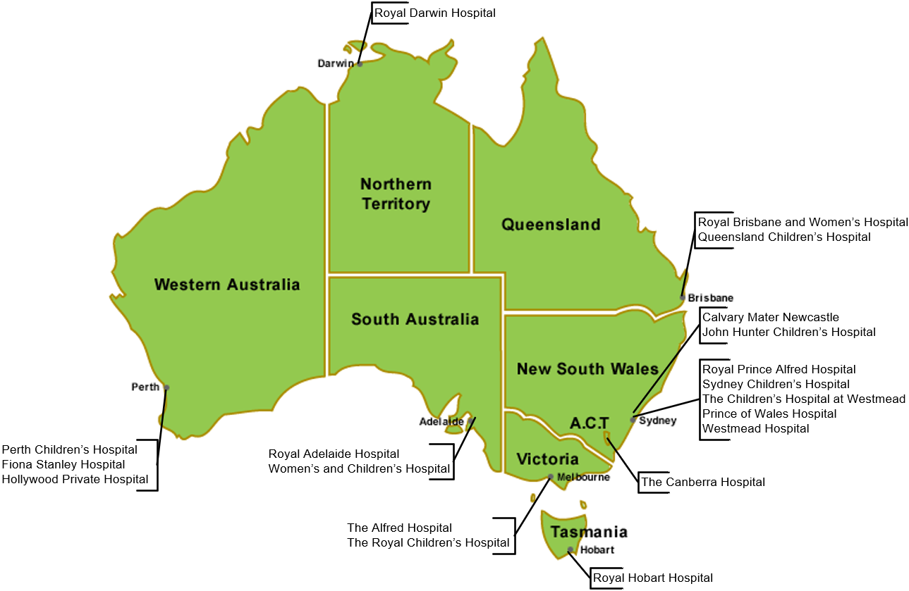
Figure 4 - Location of Haemophilia Treatment Centres
Haemophilia Treatment Centres coordinate and, where possible, integrate patient care, research and education to provide the optimal use of expertise and resources within hospitals and the community. The model for HTCs varies between jurisdictions in relation to centralisation of services, size and age of patient population. HTCs maintain on-going dialogue with the client group in each state and territory. The role of State and Territory Governments is to designate ‘Haemophilia Treatment Centres’ and negotiate the funding of the HTC including the purchase of therapeutic blood and recombinant products for distribution within states (or regions) and territories.

Haemophilia Centres provide:
- a single point of care for patients with bleeding disorders with responsibility for the coordination, allocation and distribution of therapeutic resources for the treatment of patients
- a clinical service by experienced staff for patients with bleeding disorders and their families at short notice at any time of the day or night
- organisation of home therapy programs by the centre or in collaboration with other haemophilia treatment facilities
- a counselling and advisory service for people with haemophilia and their families including genetic counselling and family planning
- specialist medical expertise, principally haematology, surgery (the surgeons would have to be accredited to the Haemophilia Centre), rheumatology, infectious diseases and dental services
- specialist allied health services to include physiotherapy, social work and podiatry
- a laboratory service able to carry out all investigations required for the accurate diagnosis of haemophilia and other inherited disorders of haemostasis and to have access, in association with other centres, to specialised testing facilities, for example gene typing
- records for all investigations, treatments, allocation of therapeutic products and adverse reactions, including data entry into ABDR
- a capability to participate in research including clinical trials
- educational programs and guidelines for medical staff, other personnel, patients and their families which promote care of patients with disorders of haemostasis
- an outreach service to isolated patients and treating medical services. The outreach service may include: a haemophilia treatment facility located in a hospital that does not provide all the specialist services and a designated supervising medical practitioner
- data management for ABDR, to aid in capturing data critical to HTC staff for the day-to-day management of people with bleeding disorders and for supply management and policy purposes.

Appendix C: About ABDR
ABDR is a database that is designed to collect all clinical information related to the treatment of people with inherited bleeding disorders. This includes information about patient diagnosis, viral status, treatment details, hospital admissions and administrative information as well as details on ordering, supply and use of clotting factor products. Information is entered into ABDR web enabled software by staff at HTCs.
ABDR provides health care teams and support staff with a record enabling them to monitor and manage treatment over time to improve patients’ quality of life. De-identified information from ABDR may be used for research purposes by authorised organisations to understand and improve treatment for bleeding disorders. ABDR also provides governments with information on total clotting factor product requirements to inform supply planning to meet the needs of all Australians with bleeding disorders.
The ABDR has been in existence since December 2008, building on the original registry which was first developed in 1988. In August 2012 the 4th generation ABDR was implemented. ABDR has evolved with improvements in technology and feedback from stakeholders. In 2014 ABDR entered a new phase with MyABDR, a secure app for smartphones (Android and iOS) and a web site for people with bleeding disorders or parents/caregivers to record home treatments and bleeds. MyABDR is an internet-based online system that gives patients a quick, easy and reliable way to:
- record treatments and bleeds
- manage treatment product stock
- share the information with a Haemophilia Treatment Centre through ABDR
- update contact and personal details.
A more in-depth history of the development of ABDR is available at Appendix D of the 2019-20 ABDR Annual Report, available from: https://www.blood.gov.au/australian-bleeding-disorders-registry-annual-report.
For more information about ABDR, including patient privacy, governance arrangements and support materials, see https://www.blood.gov.au/clinical-guidance/bleeding-disorders/australian-bleeding-disorders-registry.
ABDR management and governance
ABDR is managed under a robust governance framework by the NBA in accordance with the guidance and policy oversight provided by the ABDR Steering Committee. The Committee consists of representatives involved in the clinical management, advocacy and funding of treatment for people with bleeding disorders.
In 2024-25 the Steering Committee representatives were:
- A/Prof Chris Barnes (ABDR Steering Committee Chair) – AHCDO Executive Committee Member
- Dr Stephanie P’Ng – Chair, AHCDO Executive Committee
- Natashia Coco – Executive Director, Haemophilia Foundation Australia
- Ben Noyen – Deputy Chief Executive, National Blood Authority.
Governance is conducted according to the NBA’s Data and Information Governance Framework, in consultation with appropriate stakeholders depending on each specific data request or report.

Patient privacy and consent in ABDR and MyABDR
ABDR and MyABDR are provided by the NBA. The NBA is required to ensure that patient information in ABDR and MyABDR is collected and managed in a way which complies with the Commonwealth Privacy Act 1988. There are also parallel requirements which may apply under state and territory laws. Privacy requirements under the Privacy Act 1988 were tightened in 2014, and a new Privacy Policy for these systems was implemented from 26 January 2015.
A patient’s personal information may be entered into ABDR either at an HTC or when a patient enters data directly via MyABDR. This information becomes part of an electronic record about the patient’s bleeding disorder condition. Security protocols are embedded into the technical architecture of ABDR. These control access to personal data, so information is only accessible to treating health professionals and authorised support staff.
In accordance with the ABDR/MyABDR Privacy Policy, a patient’s consent is required to recording their data in ABDR (consent may be given by a parent, guardian or authorised representative where relevant). Where a patient does not consent then details will not be aggregated in this report, and therefore patient numbers and product use may be understated.
More information about the management of patient privacy in ABDR and MyABDR can be found at https://www.blood.gov.au/clinical-guidance/bleeding-disorders/australian-bleeding-disorders-registry, including a copy of the ABDR/MyABDR Privacy Policy together with further information, forms and other implementation resources.
Data quality issues
There are several historic data quality issues in ABDR. These include incomplete records with empty fields or entries. The data captured in some fields has also been inconsistent in some cases. Data quality has improved greatly over the years. Patient and product details have now been calculated consistently since 2015-16, however comparison with reports from before 2014-15 will be difficult. Improvements in data quality in other specific areas of the system continue to be made through data analysis and cleansing.
There are also some patients whose treatment is managed by clinicians who are not associated with an HTC. The proportion of product that is used in these circumstances varies across jurisdictions and there is some variability in the data capture for this activity between jurisdictions. Accordingly, data on total volume of products reported from ABDR may not be consistent with data from other sources.

Appendix D: National Supply of Products
The NBA is responsible for managing the national blood supply to ensure that healthcare providers have sustainable, reliable and efficient access to blood and blood products needed for patient care. To fulfil this role the NBA negotiates and manages blood supply contracts and arrangements with local and overseas suppliers. A key element of the NBA's role in ensuring security of supply is to develop, coordinate and monitor the annual national supply plan and budget, including obtaining annual approval from health ministers.
This is achieved by:
- developing a national estimate of product demand
- liaising with jurisdictions and stakeholders to refine the estimated demand for products
- collecting and distributing data on product issued and reporting variations to jurisdictions on the approved supply plan
- intensively managing products if they are in short supply.

Figure 5 illustrates the national supply by product category for 2024-25 and shows issues of clotting factor products was 6.7% of total issues. In 2024-25, emicizumab accounted for 3.3%. Total expenditure for clotting factors, including emicizumab, was 9.9% of expenditure ($175.5m).

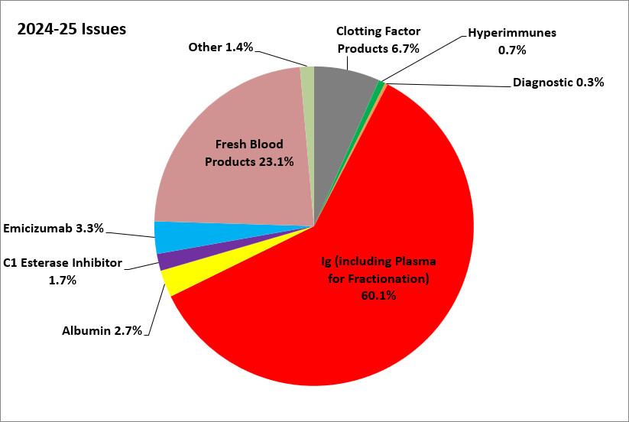
Figure 5 - National issues by product category 2024-25
Note: Plasma for Fractionation costs paid to the Blood Service for collection have been attributed to IVIg and Hyperimmunes.

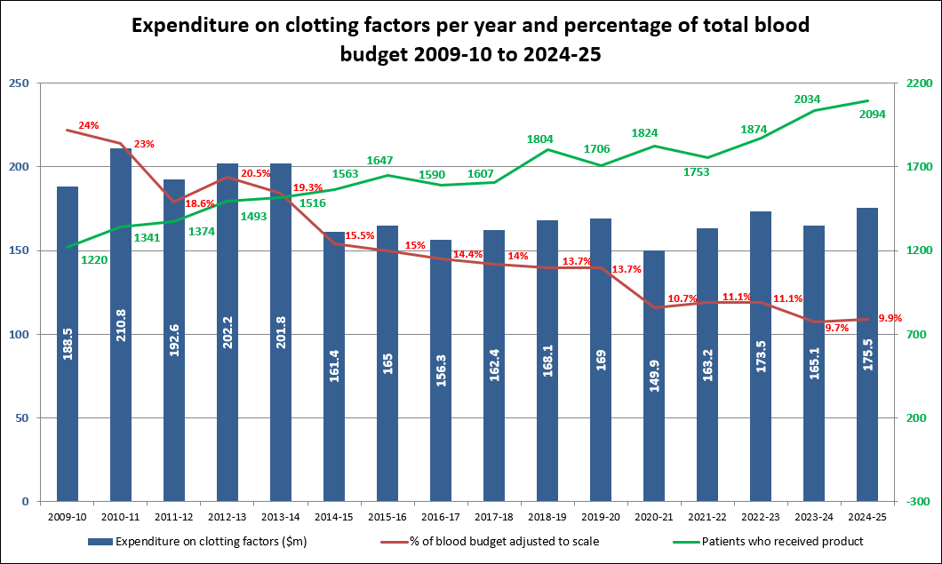
Figure 6 - Expenditure on clotting factors and percentage of blood budget 2009-10 to 2024-25
Note: emicizumab included from 2020-21 (part year).
Figure 6 illustrates the variations in total expenditure on clotting factors and the percentage of the blood and blood products budget clotting factor products comprised each year for 2009-10 to 2024-25. It also shows that the number of patients who received products has grown significantly over the 16 years to 2024-25. Overall expenditure has changed since the introduction of emicizumab, and increased in 2024-25, although still remains significantly lower than the earliest years shown in the chart.
Throughout 2024-25, products were supplied to meet clinical demand and supply risks were effectively managed. The approved budget for 2024-25, covering the supply and management of blood and blood products and services under contract, was $1,859 million, comprising $788 million for fresh blood products and plasma collection and $1,045 million for plasma derived and recombinant products. An additional $26.4 million was included for activities supporting the appropriate use and management of blood, blood products and blood-related services, such as printing and distributing Patient Blood Management (PBM) Guidelines, administering ABDR, maintaining the Australian Haemophilia Centre Directors' Organisation (AHCDO), funding BloodSafe eLearning, maintaining and enhancing blood sector ICT systems and maintaining the operations of the NBA.
Issues of clotting factors
Issues of clotting factor products are the products delivered from suppliers to all Australian Health Providers (AHPs) (including hospitals and HTCs) and home delivery of products to patients.

Figure 7 indicates that the demand for factor VIII products in 2024-25 decreased by 4.2 per cent when compared to 2023-24. The demand for recombinant factor VIII decreased by 7.9 per cent and demand for plasma derived factor VIII increased by 16.1 per cent from 2023-24 levels.

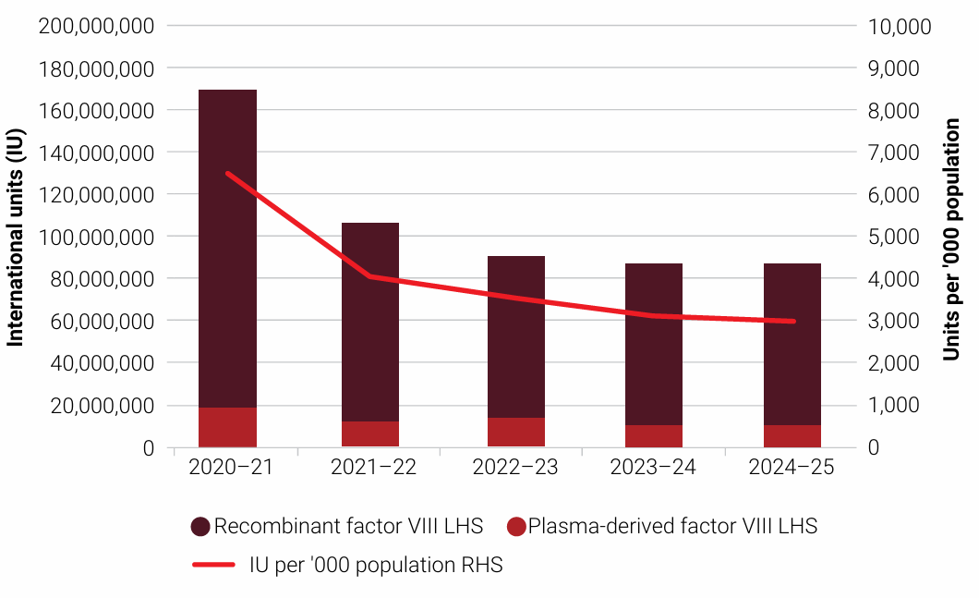
Figure 7 - Issues of factor VIII products, 2020-21 to 2024-25 per ‘000 population
Figure 8 indicates that demand for factor IX products increased by 7.1 per cent in 2024-25 compared to 2023-24. Plasma derived factor IX demand has ceased as all patients have transitioned to recombinant products. Demand for recombinant factor IX increased by 7.5 per cent.

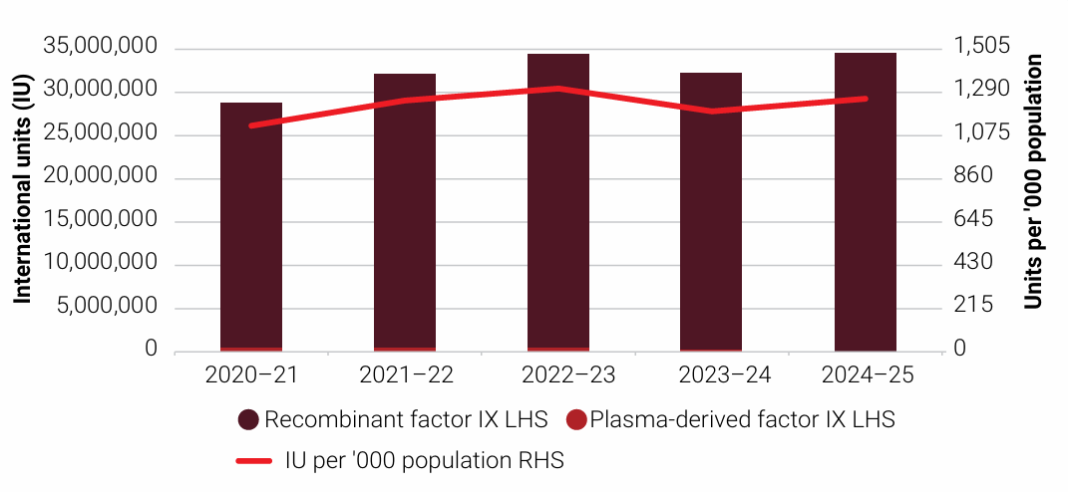
Figure 8 - Issues of factor IX products, 2020-21 to 2024-25 per ‘000 population
Figure 9 and Figure 10 show demand for recombinant factor VIIa increased by 25.2 per cent and demand for FEIBA reduced by 13.2 per cent compared with the unusually high 2023-24 demand. The increase for recombinant factor VIIa was due to the continued effect of the introduction of emicizumab. The decrease for FEIBA was a result of demand returning to previous patterns after a high number of acquired haemophilia A patients required treatment in 2022-23. Recombinant factor VIIa and FEIBA are generally used to treat inhibitor development in patients with severe and moderate haemophilia A, and the need for these products can be highly variable.

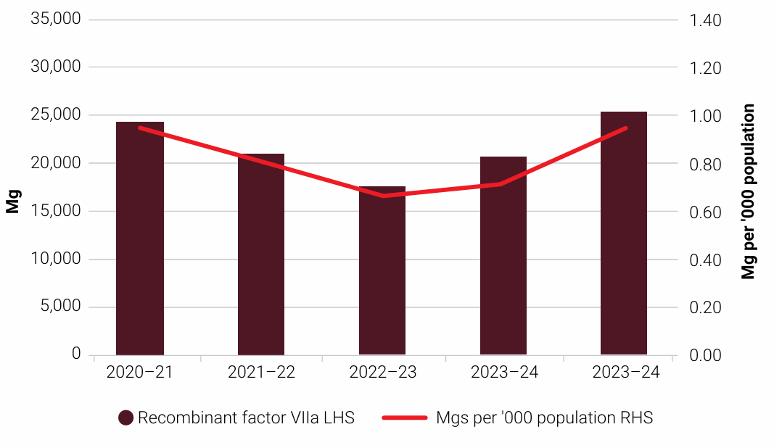
Figure 9 - Issues of recombinant factor VIIa products, 2020-21 to 2024-25 per ‘000 population

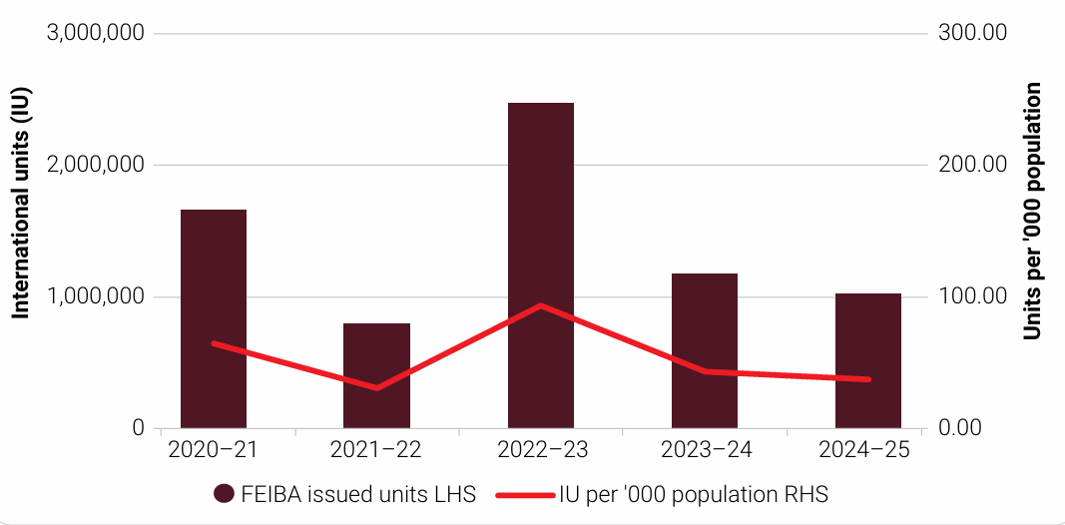
Figure 10 - Issues of FEIBA, 2020-21 to 2024-25 per ‘000 population
Figure 11 shows the demand for emicizumab since it was added to the national supply arrangements in November 2020. Emicizumab is a monoclonal product used to treat factor VIII deficiency ( haemophilia A). In 2024-25, demand increased by 7.1 per cent compared to 2023-24.

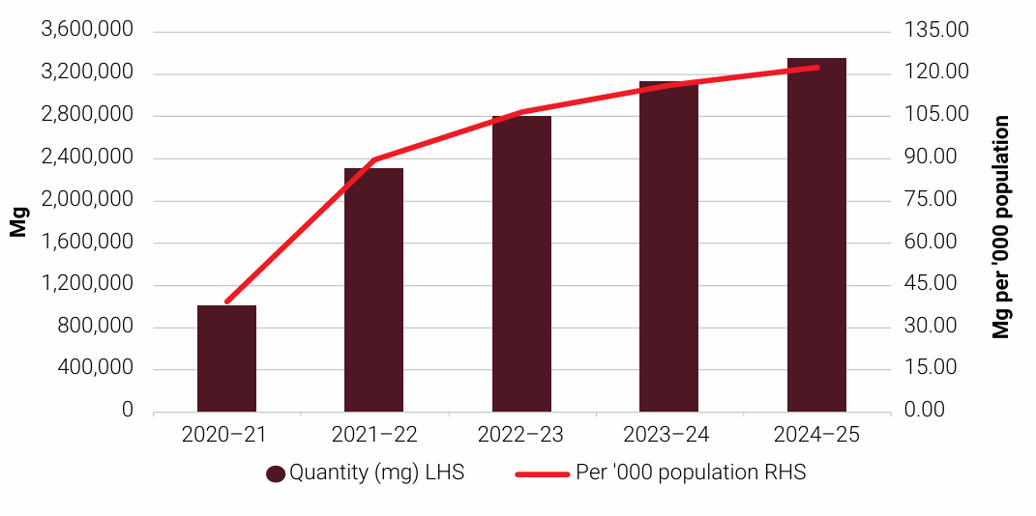
Figure 11 - Issues of emicizumab, 2020-21 to 2024-25 per ‘000 population
Figures 7 to 11 are sourced from the NBA Annual Report 2024-25: https://www.blood.gov.au/annual-report.

Terminology used in this report: Products
Table 13 shows the brand names of specific products and their product type. This report may refer to the types at a combined level (eg FVIII or FIX), may split them into recombinant and plasma derived (‘r’, ‘pd’), or may refer to them specifically by brand name in some instances.

Table 13 - Product types and brand names used in this report
Product Type | Brand names used in this report
rFVIII | Advate (SHL), Xyntha (SHL), Adynovate (EHL), Eloctate (EHL)
pdFVIII | Biostate
pdFVIII (APCC) | FEIBA
rFIX | BeneFIX (SHL), Alprolix (EHL)
pdFIX | MonoFIX
rFVIIa | NovoSeven
emicizumab | Hemlibra
pdFXI | Factor XI
rFXIII | NovoThirteen
pdFXIII | Fibrogammin
Fibrinogen concentrate | RiaSTAP

Appendix E: Glossary of terms

Term | Definition
ABDR | Australian Bleeding Disorders Registry
AHCDO | Australian Haemophilia Centre Directors’ Organisation
BU (BU/ml) | Bethesda unit (expressed as Bethesda units per millilitre)
DDAVP | Desmopressin (1-desamino-8-D-arginine vasopressin)
EHL | Extended half-life
emicizumab | a bi-functional monoclonal antibody product, used to treat factor VIII deficiency
FEIBA | Factor VIII Inhibitor Bypass Activity (Activated Prothrombin Complex Concentrate (APCC))
FIX | factor IX (nine)
FVIIa | factor VIIa (seven ‘a’)
FVIII | factor VIII (eight)
haemophilia A | Factor VIII deficiency
haemophilia B | Factor IX deficiency
HFA | Haemophilia Foundation Australia
HTC | Haemophilia Treatment Centre (see Appendix B for more information)
IDMS | The NBA’s Integrated Data Management System
IU | International Units
mg | milligrams
MyABDR | an app and web site for people with bleeding disorders to record home treatments and bleeds
NBA | National Blood Authority
OBD | Other bleeding disorders
pdFIX | Plasma derived factor IX, products used to treat factor IX deficiency
pdFVIII | Plasma derived factor VIII, products used to treat factor VIII and VWF deficiencies
rFIX | Recombinant factor IX, products used to treat factor IX deficiency
rFVIIa | Recombinant factor VIIa
rFVIII | Recombinant factor VIII, products used to treat factor VIII deficiency
SHL | Standard half-life
VWD | von Willebrand disease
VWF | von Willebrand factor
WFH | World Federation of Hemophilia

Srivastava A, Santagostino E, Dougall A, et al. WFH Guidelines for the Management of Hemophilia, 3rd edition. Haemophilia. 2020: 26(Suppl 6): 1-158. https://doi.org/10.1111/hae.14046
Normal concentration of factor VIII or IX is defined as 100% or one unit of factor VIII activity per ml of plasma - 100 U/dL (Kasper, CK 2004, Hereditary plasma clotting factor disorders and their management. Treatment of Hemophilia Monograph Series, No. 4, World Federation of Hemophilia, Montreal, Canada). Levels of FVIII above 40% are usually considered sufficient for normal haemostasis.
Stonebraker JS, Bolton-Maggs PHB, Soucie JM, Walker I, Brooker M. (2010). A study of variations in the reported hemophilia A prevalence around the world. Haemophilia 16(1): 20–32.

