

National Report on Fresh Blood Products

Annual Report
2024-25



With the exception of any logos and registered trademarks, and where otherwise noted, all material presented in this document is provided under a Creative Commons Attribution 3.0 Australia licence.
The details of the relevant licence conditions are available on the Creative Commons website (accessible using the links provided) as is the full legal code for the CC BY 3.0 AU licence.
The content obtained from this document or derivative of this work must be attributed as the National report on Fresh Blood Products ISSN 1839-1079 (online version)
This report is available online at https://www.blood.gov.au/data-and-research/data-and-reporting



Locked Bag 8430
Canberra ACT 2601
Phone: 13 000 BLOOD (13000 25663)
Email: data@blood.gov.au
www.blood.gov.au
Contents
Background 5
Introduction 6
Summary of Data Findings 7
Red Blood Cells 10
RBC Issues for 2015-16 to 2024-25 11
RBC Issues, transfers and discards for 2020-21 to 2024-25 12
RBC ABO issues and discards for 2020-21 to 2024-25 14
RBC Orders for 2020-21 to 2024-25 15
Platelets 17
Platelets Issues for 2015-16 to 2024-25 18
Platelets Issues, transfers and discards for 2020-21 to 2024-25 19
Platelets ABO issues and discards for 2020-21 to 2024-25 21
Platelets Orders for 2020-21 to 2024-25 22
Fresh Frozen Plasma 23
FFP Issues for 2015-16 to 2024-25 23
FFP Issues, transfers and discards for 2020-21 to 2024-25 24
FFP ABO issues and discards for 2020-21 to 2024-25 26
FFP Orders for 2020-21 to 2024-25 27
Attachment A — Key policies and events 29
Attachment B — About the Data 32
Data source 32
Caveats 32
Attachment C — RBC detailed data 34
Attachment D — Platelet detailed data 41
Attachment E — FFP detailed data 47
Attachment F — Glossary 53

Figures
  - Figures
Figure 1: RBC issues growth, 2003-04 to 2024-25 10
Figure 2: RBC issues and per 1,000 population, 2015-16 to 2024-25 11
Figure 3: RBC issues by Jurisdiction, 2015-16 to 2024-25 12
Figure 4: RBC issues, transfers, discards and DAPI, 2020-21 to 2024-25 12
Figure 5: RBC discard cost and DAPI, 2020-21 to 2024-25 13
Figure 6: Percentage of RBC issues, transfers and discards by public/private, 2020-21 to 2024-25 13
Figure 7: RBC discards and DAPI in the major cities and very remote areas, 2020-21 to 2024-25 14
Figure 8: ABO issues and discards as % of all RBC issues and discards, 2020-21 to 2024-25 14
Figure 9: Percentage of RBC orders by order priority, 2020-21 to 2024-25 16
Figure 10: Percentage of RBC orders by order type, 2020-21 to 2024-25 16
Figure 11: Platelet issues growth, 2003-04 to 2024-25 17
Figure 12: Platelet issues and per 1,000 population, 2015-16 to 2024-25 18
Figure 13: Platelet issues by Jurisdiction, 2015-16 to 2024-25 19
Figure 14: Platelet issues, transfers, discards and DAPI, 2020-21 to 2024-25 19
Figure 15: Platelet discard cost and DAPI, 2020-21 to 2024-25 20
Figure 16: Percentage of platelet issues, transfers and discards by public/private, 2020-21 to 2024-25 20
Figure 17: Platelet discards and DAPI in the major cities and remote areas, 2020-21 to 2024-25 21
Figure 18: ABO issues and discards as % of all platelet issues and discards, 2020-21 to 2024-25 21
Figure 19: Percentage of platelet orders by order priority, 2020-21 to 2024-25 22
Figure 20: Percentage of platelet orders by order type, 2020-21 to 2024-25 22
Figure 21: FFP issues and per 1,000 population, 2015-16 to 2024-25 23
Figure 22: FFP issues by Jurisdiction, 2015-16 to 2024-25 24
Figure 23: FFP issues, transfers, discards and DAPI, 2020-21 to 2024-25 24
Figure 24: FFP discard cost and DAPI, 2020-21 to 2024-25 25
Figure 25: Percentage of FFP issues, transfers and discards by public/private, 2020-21 to 2024-25 25
Figure 26: FFP discards and DAPI in the major cities and very remote areas, 2020-21 to 2024-25 26
Figure 27: ABO issues and discards as % of all FFP issues and discards, 2020-21 to 2024-25 27
Figure 28: Percentage of FFP orders by order priority, 2020-21 to 2024-25 27
Figure 29: Percentage of FFP orders by order type, 2020-21 to 2024-25 28

Background
Australia’s national blood supply is centrally coordinated to ensure adequate, safe, secure and affordable supply of fresh blood products. The Australian Red Cross Lifeblood (Lifeblood) is the sole provider of fresh blood products in Australia. The National Blood Authority (NBA) manages the supply and funding through a Deed of Agreement, which sets out the blood supply and funding arrangements between the NBA, on behalf of all governments, and Lifeblood.
All blood collected by Lifeblood is obtained through voluntary donation and is used for medical purposes.
Lifeblood collects donated whole blood, apheresis platelets and apheresis plasma. Plasma collected by Lifeblood is used for clinical purposes and is also supplied to CSL Behring for the manufacture of plasma-derived products.
Australia’s blood supply system remains resilient. Australia is nationally self-sufficient for fresh blood products and has maintained uninterrupted access to fresh blood products without the need to activate the National Blood Supply Contingency Plan. Despite continued post-COVID growth in clinical demand, national blood stewardship initiatives and wastage reduction strategies have delivered measurable improvements in efficiency, sustainability and cost control for fresh blood products.

Introduction
The NBA was established by the National Blood Authority Act 2003 following the signing of the original National Blood Agreement by all state and territory health ministers. The National Blood Agreement sets out the primary and secondary policy objectives of all Australian governments in relation to the Australian blood sector. The Australian Government, and state and territory governments, signed the agreement in 2002 and, in so doing, agreed to implement a coordinated national approach to policy setting, governance and management of the Australian blood sector, including administrative and financial arrangements.
The National Blood Agreement’s primary policy objectives are:
- to provide an adequate, safe, secure and affordable supply of blood products, blood-related products and blood-related services in Australia; and
- to promote safe, high-quality management and use of blood products, blood-related products and blood-related services in Australia.
To achieve these policy objectives the NBA has:
- implemented a range of national policies and programs as depicted in Attachment A. In addition to the achievements listed in Attachment A, the NBA has implemented the Statement of National Stewardship Expectation for the Supply of Blood and Blood Products (Stewardship Statement), NSQHS Blood Management Standard and six Patient Blood Management (PBM) Guidelines
- undertaken national information collection, reporting and publishing activities relating to blood and blood products and associated services.
This report forms part of the NBA national data collection, reporting and publishing activities. It aims to:
- provide accurate, informative and comprehensive information on Red Blood Cells (RBC), platelets and Fresh Frozen Plasma (FFP) in a single accessible document
- support the Australian governments in implementing national policies, standards and guidelines, and in improving practices related to fresh blood product management and wastage reduction.
More detail about the NBA can be found on the website www.blood.gov.au

Summary of Data Findings
This report data indicates that national blood stewardship strategies are effectively balancing rising demand for blood products with improved efficiency and reduced wastage. However, persistent challenges remain, particularly in remote and very remote locations. Ongoing pressure on O RhD negative supply also continues to pose a strategic risk to national supply security.
Key findings
- Sustained RBC demand continues, with issues exceeding 0.7 million units in 2024-25. Despite higher demand, RBC wastage fell to historically low levels, reflecting sustained improvements in inventory management and clinical practice. The financial impact of RBC wastage has continued to decline since 2020–21, delivering ongoing cost savings on wastage.
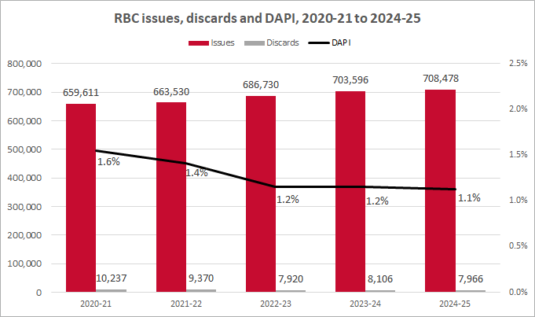
Note: DAPI = Discards as a percentage of issues
- Platelet demand reached its highest level over the five-year reporting period, at around 160,000 units in 2024-25. The extension of platelet shelf life to seven days in March 2021 has delivered enduring benefits from 2021-22 onwards, with wastage stabilising at lower levels and delivering ongoing cost savings on wastage.
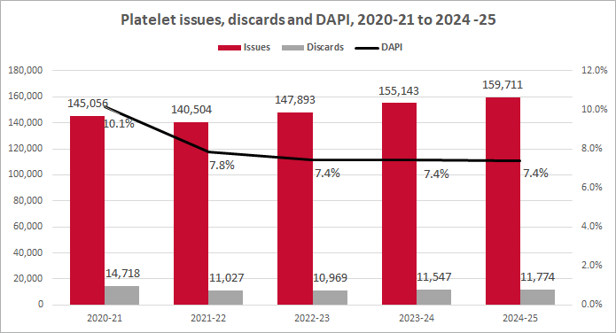
- FFP demand continued to increase, reaching nearly 90,000 units in 2024-25, while the wastage declined to 11%, resulting in sustained cost savings on wastage over the past five years.
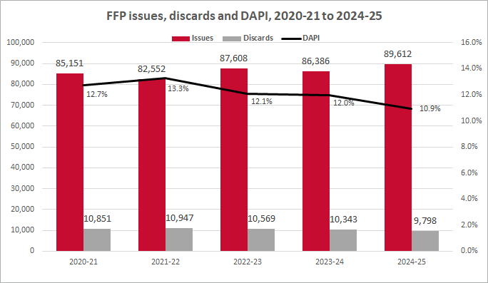
- Public hospitals continued to account for the majority of fresh blood product use and consistently achieved lower wastage rates across all product types compared with the private sector.
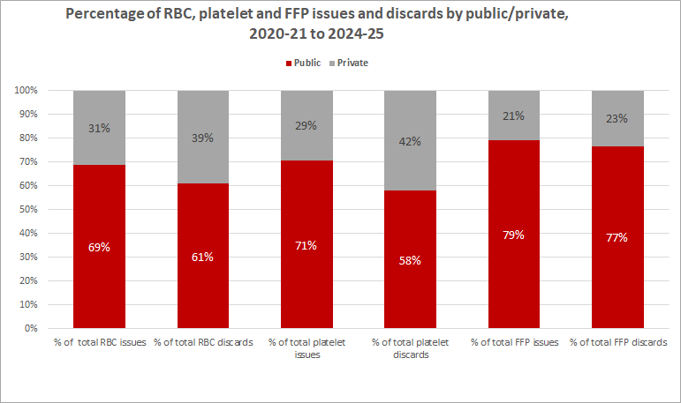
- Geographic remoteness remains the strongest determinant of high wastage rates. While absolute volumes are low, Remote and Very Remote areas face persistent challenges in inventory management and wastage reduction due to distance, demand variability and product shelf-life constraints. Refer to Attachment B for more information about remoteness.
- Routine orders continued to dominate across all product types, indicating stable and predictable supply arrangements. Growth in special orders for RBC reflects increasing demand for patient specific orders, with implications for future supply planning and inventory management.
For further information on the data sources and associated caveats, refer to Attachment B. Detailed data analyses are provided in the relevant RBC, Platelet, and FFP sections, with supporting data in Attachments C to E.

Red Blood Cells
RBC transfusions improve oxygen-carrying capacity by increasing the red cell count. Conditions that may need a red cell transfusion are anaemia caused by chemotherapy treatment, blood loss due to trauma/surgery, and inherited or acquired haematological disorders. RBC must be stored at 2ºC to 6ºC and have a variable shelf life from 14 days to 42 days. More information about RBC and safe transfusion can be found in the Blood Component Information 2025 and Blood Book 2020 on the Lifeblood website.
A key initiative implemented by the NBA has been the National Blood and Blood Product Wastage Reduction Strategy 2013-2017 (Wastage Strategy), which promoted ‘working smarter to minimise Blood and Blood product wastage’. The implementation of the Wastage Strategy, together with the National Inventory Management Framework, NSQHS standards, PBM Guidelines, and PBM Guideline Implementation Strategy, collectively contributed to a reduction in RBC issue growth between 2012-13 and 2017-18, as shown in Figure 1. Over the same period, wastage measured by DAPI (Discards as a percentage of issues) deceased substantially, from 5.1% in 2012-13 to 2.2% in 2017-18.
The National Blood Management Improvement Strategy 2018-2024 (2018-24 Strategy) builds on the achievements of the earlier Wastage Strategy. It was developed to improve management and reduce wastage of blood and blood products. The implementation of 2018-24 Strategy contributed to a sustained reduction of RBC wastage, decreasing from a DAPI of 1.9% in 2019-20 to 1.0 in 2024-25, despite increased demand for RBC following the COVID￼19 pandemic.
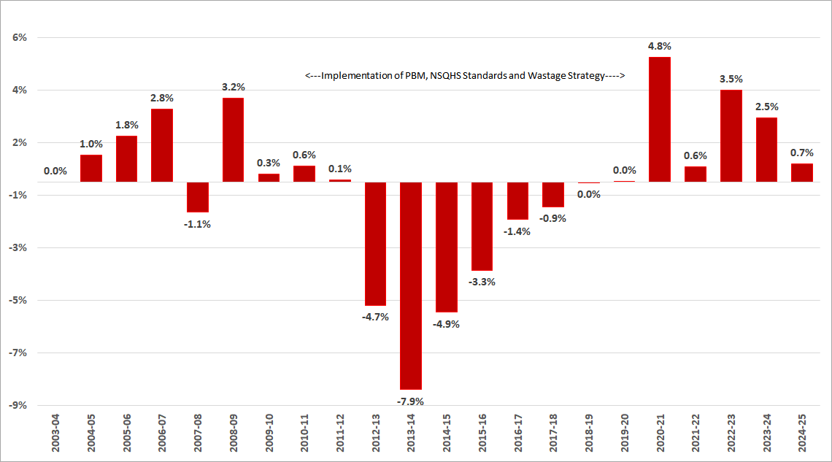
Figure 1: RBC issues growth, 2003-04 to 2024-25
The reduction in the growth of RBC issues, and wastage, would not have achieved without the concerted effort of jurisdictional programs, clinical and scientific champions and a willingness by healthcare professionals to adopt a patient focused approach rather than a product focused approach. This shift has supported the more appropriate and safer use of blood and blood products.
This section provides a high‑level overview of RBC issues over a ten‑year period from 2015–16 to 2024–25, along with detailed data and analysis of RBC issues, transfers and discards, and orders for the five‑year period from 2020–21 to 2024–25. RBC issues, transfers, and discards were also analysed by state, public/private, and remoteness to inform whether RBC supply was adequate and equitably distributed across the health system. Detailed data is provided in Attachment C.

RBC Issues for 2015-16 to 2024-25
The national issues of RBC, excluding paediatric RBC, had declined between 2015-16 and 2019-20, followed by an increase from 2020-21 onwards. The earlier decline reflects the sustained impact of national policies and programs at improving ordering, appropriate use and inventory management, as described previously. The subsequent increase is associated with the heightened demand for health services following the COVID-19 pandemic.
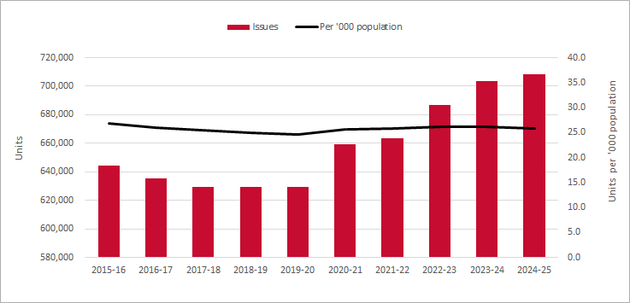
Figure 2: RBC issues and per 1,000 population, 2015-16 to 2024-25
There has been an increase in the total number of RBC issues across all jurisdictions over the past five years except in the Northern Territory (NT). This increase is largely attributed to increased demand for health services following COVID-19 related delays. In contrast, the rate of RBC issues per 1,000 population declined in New South Wales (NSW) and Queensland (QLD), reflecting population growth in these jurisdictions.
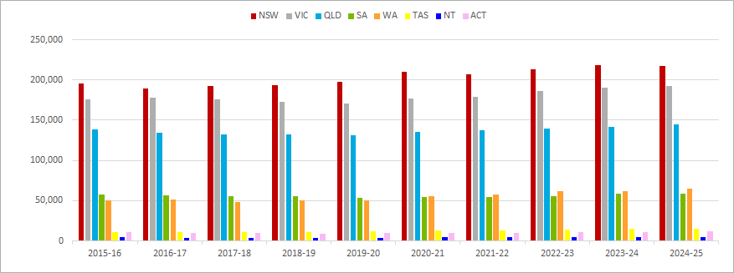
Figure 3: RBC issues by Jurisdiction, 2015-16 to 2024-25

RBC Issues, transfers and discards for 2020-21 to 2024-25
Demand for RBC has increased over the past five years, while wastage has declined. This reduction in wastage has led to lower costs to Australian governments associated with discarded RBC. In 2020–21, the cost of RBC discards was $3.9 million, with a DAPI of 1.6%. By 2024–25, this had decreased to $3.0 million, representing a saving of $0.9 million and a reduction in DAPI to 1.1%.
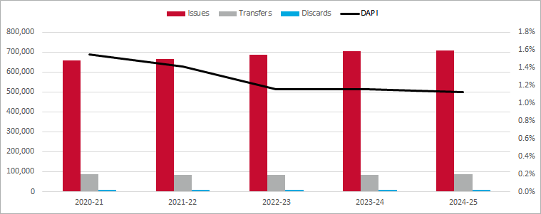
Figure 4: RBC issues, transfers, discards and DAPI, 2020-21 to 2024-25
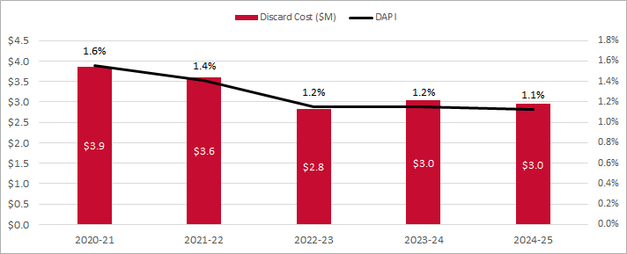
Figure 5: RBC discard cost and DAPI, 2020-21 to 2024-25
From 2020–21 to 2024–25, the public sector demonstrated higher demand for RBC, along with lower wastage and transfer rates, compared with the private sector. Approximately two‑thirds of RBC were issued to the public sector and one‑third to the private sector. The average DAPI over the five years was 1.1% for the public sector and 1.6% for the private sector. In 2024–25, the DAPI was lower in both sectors, at 1.0% for the public sector and 1.3% for the private sector.
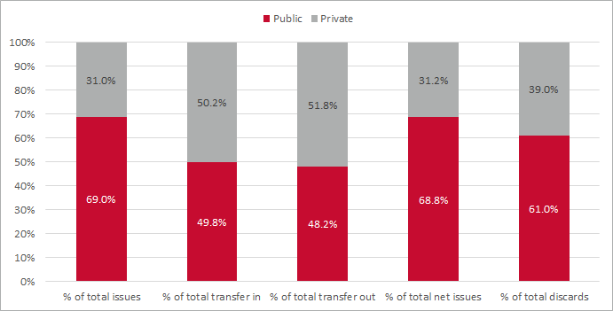
Figure 6: Percentage of RBC issues, transfers and discards by public/private, 2020-21 to 2024-25
Remoteness is a key factor in the volumes of issue, transfers and discards, and DAPI rates. Although the absolute number of discards in Remote and Very Remote areas is small, the comparatively high DAPIs highlight the ongoing challenges of managing inventory and minimising wastage in these areas. A certain level of discards of blood and blood products is both inevitable and appropriate, as it is necessary to ensure products are available where and when they are clinically required.
RBC DAPI rates in Very Remote areas have improved substantially, decreasing from 15.7% in 2020–21 to 4.1% in 2024–25, although they remain higher than in all other remoteness categories. Despite this, the actual volume of discards in Very Remote areas is low compared with Major Cities. In 2024–25, discards in Very Remote areas totalled 29 units (DAPI 4.1%), compared with 5,885 units in Major Cities (DAPI 1.0%).
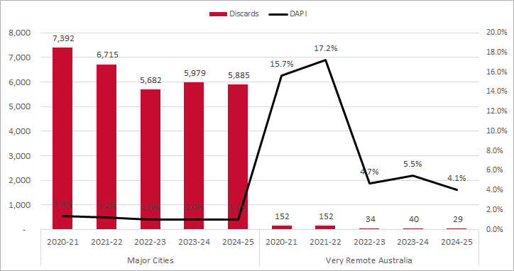
Figure 7: RBC discards and DAPI in the major cities and very remote areas, 2020-21 to 2024-25

RBC ABO issues and discards for 2020-21 to 2024-25
Group O RhD positive is the most common blood group in Australia, accounting for an estimated 38% of the population. From 2020–21 to 2024–25, group O RhD positive comprised an average of 40% of all RBC units issued. During the same period, group O RhD positive also accounted for an average of 29% of all RBC discards.
From 2020–21 to 2024–25, the average proportion of issued O RhD negative RBC was 16%, which is 9 per cent higher than the population estimate of 7%. Over the same period, O RhD negative RBC accounted for an average of 32% of all RBC discards.
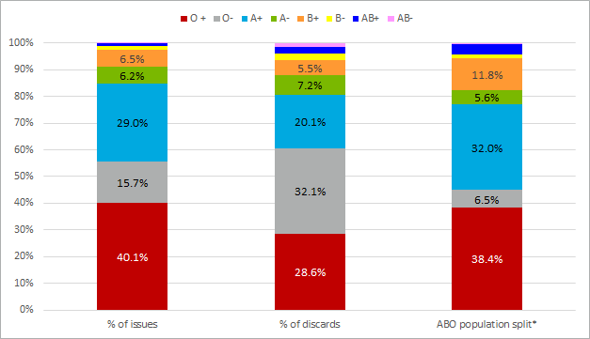
Figure 8: ABO issues and discards as % of all RBC issues and discards, 2020-21 to 2024-25
* Hirani, R., Weinert, N., Irving, DO. The distribution of ABO RhD blood groups in Australia, based on blood donor and blood sample pathology data. MJA 2022
The disproportionate issues of O RhD negative RBC to the population has placed significant pressure on Lifeblood and donors. To help address the pressure the NBA, National Blood Transfusion Committee (Australian Red Cross Lifeblood), Australian and New Zealand Society of Blood Transfusion, National Pathology Accreditation Advisory Council, Australian College of Rural and Remote Medicine and Australian College of Emergency Medicine, developed and published a joint national statement on the Emergency Use of Group O RBC. The National Statement for the Emergency Use of Group O Red Blood Cells was published in February 2023 and is available on the NBA website (Inventory management for blood and blood products | National Blood Authority).

RBC Orders for 2020-21 to 2024-25
Orders for RBC are placed through BloodNet, the online ordering and inventory management system. Orders can be of a type of stock or special orders and can be a priority of Life Threatening, Urgent or Routine.
The Australian Health Provider Blood and Blood Products Charter defines the order types, priorities and the associated service expectations.
Order priorities are defined in the Charter as follows:
- Life Threatening – Orders where there is a critical (life-threatening) need for immediate delivery of a product and delivery will be made by the most rapid transport mode available.
- Urgent – Orders where there is an unforeseen clinical need or likely clinical need for product prior to the next routine delivery and delivery will be made by the earliest available standard transport mode.
- Routine – Orders where the acceptable time for delivery is on the next scheduled delivery by standard transport mode.
Order types are defined as follows:
- Stock – Orders for replenishment of stocks, taking into account the health provider inventory levels
- Special – Patient specific orders, blood components of extended phenotype and/or which require special processing or calling in of donors, e.g. washed red cells, frozen-thawed red cells.
Over the five-year period 2020-21 to 2024-25, routine orders accounted for an average of 95% of all RBC orders by priority, while stock orders represented 81% of all RBC orders by type. Over the same period, special orders increased as a proportion of total orders, rising from 17% in 2020–21 to 19% in 2024–25.
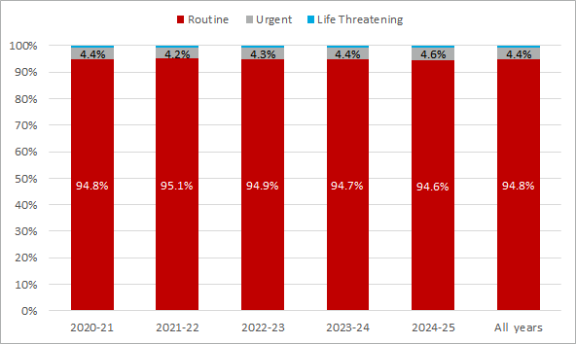Figure 9: Percentage of RBC orders by order priority, 2020-21 to 2024-25
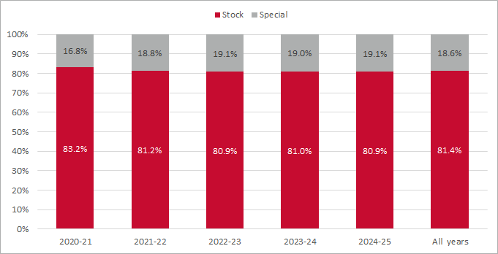Figure 10: Percentage of RBC orders by order type, 2020-21 to 2024-25

Platelets
Platelets prevent or stop bleeding by forming a plug that is held in place by clotting proteins. Patients may require platelet transfusions if they have a low platelet count or non-functional platelets. This could occur due to high-dose chemotherapy, bone marrow transplantation, major surgery while on platelet inhibiting drugs, liver disease requiring surgery, severe trauma, or leukaemia and bone marrow cancers. Platelets are kept at room temperature (20-24ºC). Transfusion of platelets should occur as soon as possible after issue Pathology Laboratory. More information about platelets and safe transfusion can be found in the Blood Component Information 2025 and Blood Book 2020 on the Lifeblood website.
The implementation of the Wastage Strategy, PBM and NSQHS standards have collectively contributed to a reduction in platelet issue growth between 2012-13 and 2017-18, as highlighted in Figure 11. Over the same period, the wastage rate decreased substantially, from 17.3% of DAPI in 2012-13 to 11.8% in 2017-18. The subsequent implementation of the 2018-24 Strategy contributed to a sustained reduction of platelet wastage afterwards.
In March 2021, following approval from the Therapeutic Goods Administration, Lifeblood implemented the supply of platelets with a 7-day shelf life to Australian Health Providers (AHPs), replacing the previous 5-day shelf life. Since this change, the platelet DAPI has decreased by 2.7 per cent, from 10.1% in 2020-2021 to 7.4% in 2022-23, and has remained stable at 7.4% thereafter. The combined impact of COVID-19 on donations and the extension of platelet shelf life may also have contributed to the decline in platelet issues in 2021–22.
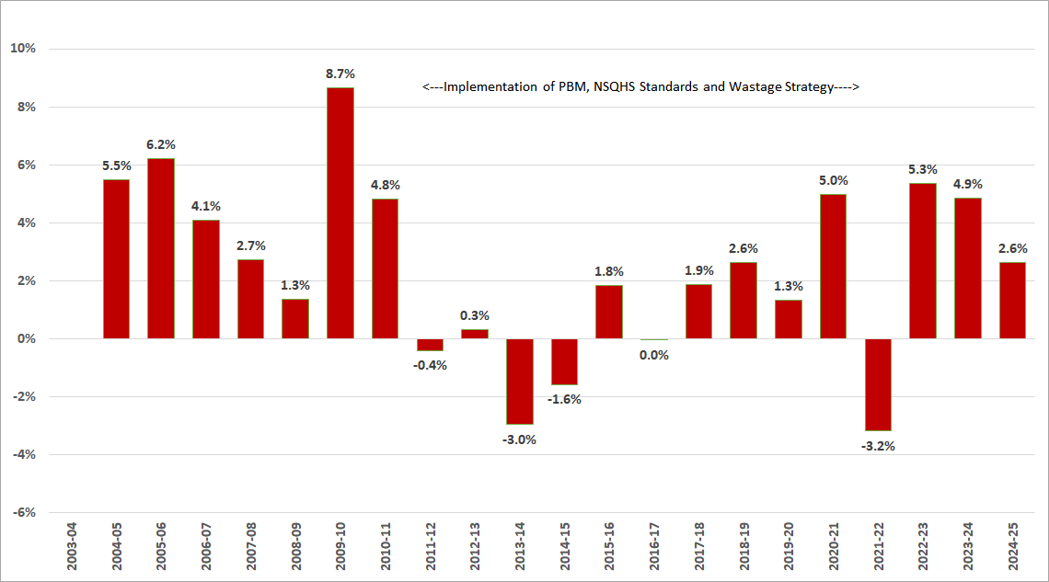Figure 11: Platelet issues growth, 2003-04 to 2024-25
This section provides a high‑level overview of platelet issues over a ten‑year period (2015–16 to 2024–25), along with detailed data and analysis of platelet issues, transfers and discards, and orders for the five‑year period from 2020–21 to 2024–25. Platelet issues, transfers, and discards were also analysed by state, public/private, and remoteness to inform whether platelet supply was adequate and equitably distributed across the health system. Detailed data is provided in Attachment D.

Platelets Issues for 2015-16 to 2024-25
The annual number of platelet issues (excluding paediatric platelets) averaged 141,692 units between 2015–16 and 2024–25. The platelet issues increased overall, peaking at 159,711 units in 2024–25, compared with a low of 130,507 units in 2015–16. Consistent with this trend, the rate of platelet issues per 1,000 population also increased over the ten-year period, from 5.4 in 2015–16 to 5.8 in 2024–25.
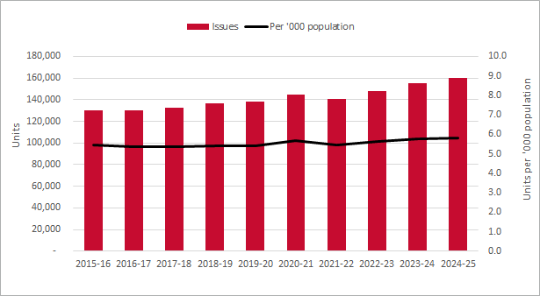Figure 12: Platelet issues and per 1,000 population, 2015-16 to 2024-25
At the individual jurisdiction level, all jurisdictions recorded higher total numbers of platelet issues in 2024–25 compared with 2015–16. Platelet issues per 1,000 population also increased over this period for all jurisdictions, except QLD, NT and the Australian Capital Territory (ACT).
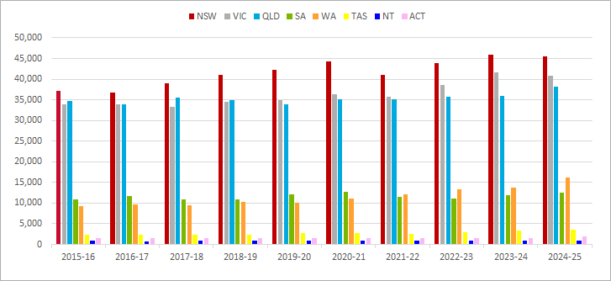Figure 13: Platelet issues by Jurisdiction, 2015-16 to 2024-25

Platelets Issues, transfers and discards for 2020-21 to 2024-25
Platelet demand has increased over the past five years, while wastage declined in 2021–22 and has remained stable since. This reduction in platelet wastage is attributed to the implementation of national wastage reduction policies and the extension of platelet shelf life from 5 to 7 days, as described previously.
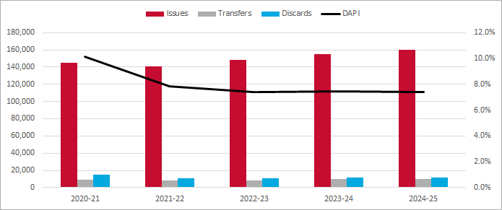
Figure 14: Platelet issues, transfers, discards and DAPI, 2020-21 to 2024-25
This reduction in wastage has also led to lower costs for governments. In 2020–21, platelet discards cost Australian governments $5.1 million; by 2024–25, this had decreased to $4.1 million, delivering savings of $1.0 million in that year.

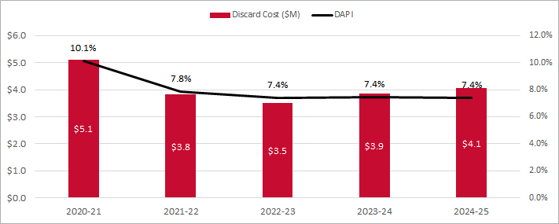
Figure 15: Platelet discard cost and DAPI, 2020-21 to 2024-25
From 2020–21 to 2024–25, the public sector demonstrated higher demand and transfers for platelets, along with lower wastage, compared with the private sector. More than 70% of platelets were issued to and transferred by the public sector during this period.
On average, the DAPI was 6.5% for the public sector and 11.8% for the private sector over the past five years. In 2024–25, the DAPI rate was 6.2% for the public sector, compared with 10.4% for the private sector.
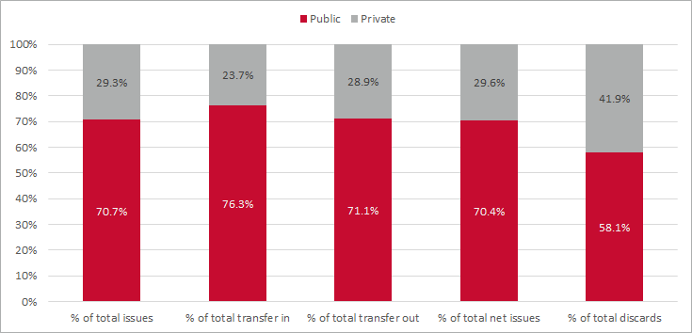
Figure 16: Percentage of platelet issues, transfers and discards by public/private, 2020-21 to 2024-25
Remoteness is a key factor in the volume of issues, transfer and discards, and DAPI rates. The number of actual discards for the remote areas (Remote and Very Remote) is small, and it highlights the challenge of managing wastage and inventory in those areas.
The DAPI rates in Remote areas remain well above all other areas. The actual volume of discards in Remote Australia is low at an average 138 units a year over the 5 years from 2020-21 to 2024-25. Major Cities had the highest actual volume of discards but had the lowest DAPI. In 2024-25, Major Cities discarded 6,996 platelets at a DAPI rate of 5%.
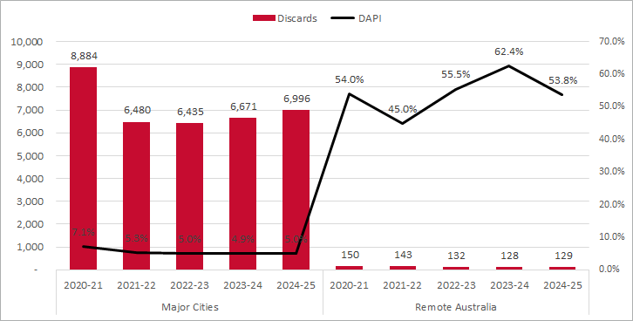
Figure 17: Platelet discards and DAPI in the major cities and remote areas, 2020-21 to 2024-25

Platelets ABO issues and discards for 2020-21 to 2024-25
The issued quantity of group O RhD positive has averaged 45% of all platelets issued from 2020-21 to 2024-25, higher than the population estimate of 38%. Over the same period, O RhD positive discards have averaged 48% of all discards.
From 2020–21 to 2024–25, the average proportion of issued O RhD negative was 16%, which is 9 per cent higher than the population estimate of 7%. Over the same period, O RhD negative platelet accounted for an average of 13% of all platelet discards.
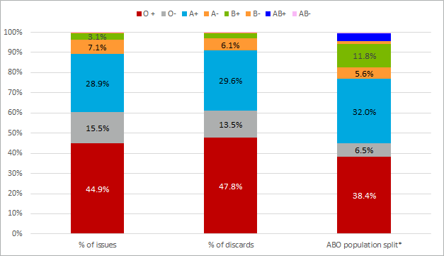
Figure 18: ABO issues and discards as % of all platelet issues and discards, 2020-21 to 2024-25
* Hirani, R., Weinert, N., Irving, DO. The distribution of ABO RhD blood groups in Australia, based on blood donor and blood sample pathology data. MJA 2022

Platelets Orders for 2020-21 to 2024-25
Orders for platelets are placed through BloodNet. Orders can be a type of stock or special orders and can be a priority of Life Threatening, Urgent or Routine. The definition of order type and priority can be found in the RBC section.
From 2020–21 to 2024–25, platelet ordering was dominated by routine and stock orders. On average, routine orders comprised 85% of all order priorities, while stock orders accounted for 70% of platelet types ordered. In contrast, special orders declined steadily over the period, falling from 37% of total orders in 2020–21 to 30% in 2024–25.
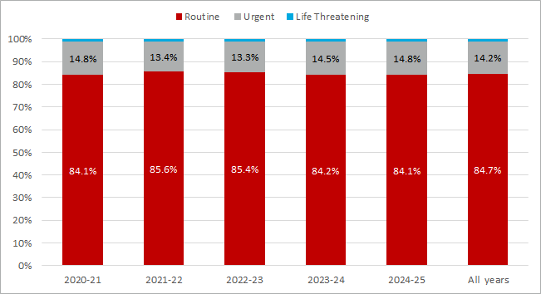
Figure 19: Percentage of platelet orders by order priority, 2020-21 to 2024-25
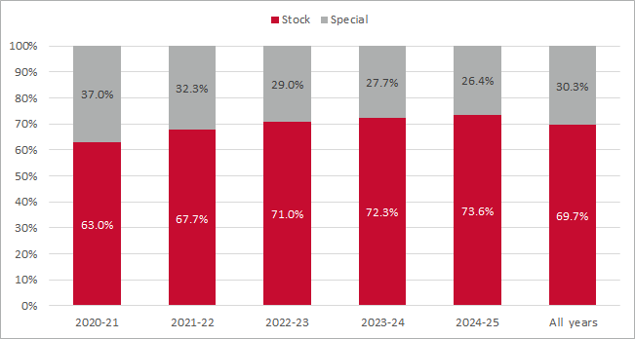
Figure 20: Percentage of platelet orders by order type, 2020-21 to 2024-25

Fresh Frozen Plasma
FFP transfusion is for the purpose of replacing clotting factors. This could be due to a massive transfusion, invasive surgery, acute disseminated intravascular coagulation or some anticoagulations. FFP is stored at -25 ºC or below for up to 12 months. Once thawed, FFP should be transfused immediately or stored at 2°C to 6°C for up to five days in accordance with the Australian and New Zealand Society of Blood Transfusion (ANZSBT) guidelines. More information about FFP and safe transfusion can be found in the Blood Component Information 2025 and Blood Book 2020 on the Lifeblood website.
This section provides a high‑level overview of FFP issues over a ten‑year period (2015–16 to 2024–25), along with detailed data and analysis of FFP issues, transfers and discards, and orders for the five‑year period from 2020–21 to 2024–25. FFP issues, transfers, and discards were also analysed by state, public/private sector, and remoteness to inform whether FFP supply was adequate and equitably distributed across the health system. Detailed data is provided in Attachment E.

FFP Issues for 2015-16 to 2024-25
National issues of FFP, excluding paediatric FFP, declined between 2015–16 and 2020–21, before increasing from 2022–23 onwards, as shown in Figure 21. The earlier decline reflects the sustained impact of national policies and programs aimed at improving ordering practices, appropriate use, and inventory management, as described in the last two sections. The subsequent increase is likely associated with increased demand for health services following the COVID-19 pandemic. This trend was also observed on a per population basis, with FFP issues peaking at 4.7 per 1,000 population in 2015–16 and declining to 3.2 per 1,000 population in 2021–23.
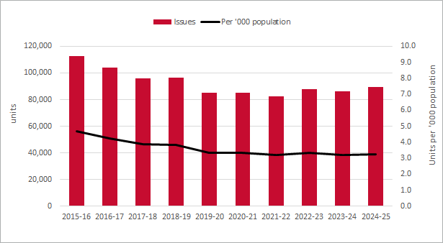
Figure 21: FFP issues and per 1,000 population, 2015-16 to 2024-25
All jurisdictions experienced a decline in FFP issues between 2015–16 and 2020–21. In 2021–22, Tasmania (TAS) recorded its highest volume of FFP issues over the ten-year period, with 2,976 issues. NT also recorded its highest volume in the same period, with 820 issues in 2021–22.
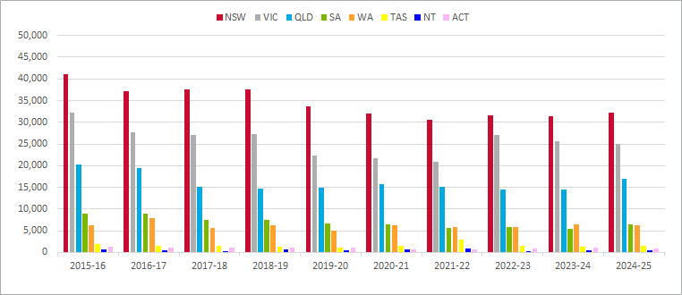
Figure 22: FFP issues by Jurisdiction, 2015-16 to 2024-25

FFP Issues, transfers and discards for 2020-21 to 2024-25
Over the past five years, FFP demand has increased while wastage has decreased. The implementation of the Wastage Strategy, followed by the 2018–24 Strategy, has contributed to this reduction in wastage.
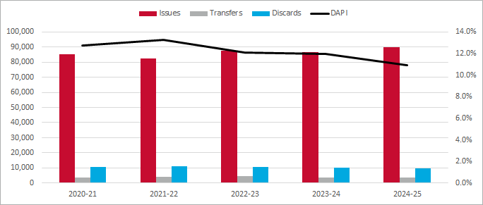
Figure 23: FFP issues, transfers, discards and DAPI, 2020-21 to 2024-25
FFP wastage was lowest in 2024–25 (9,798 units; 11% DAPI) due to fewer discards, and highest in 2021–22 (10,947 units; 13% DAPI) due to reduced issues and increased discards.
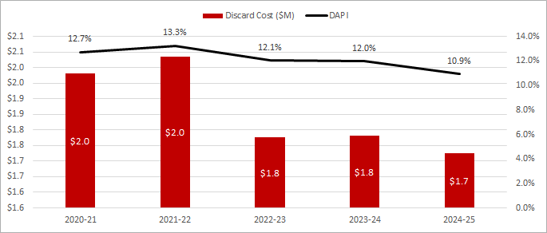
Figure 24: FFP discard cost and DAPI, 2020-21 to 2024-25
From 2020–21 to 2024–25, the public sector accounted for the majority of FFP demand and transfers (around 80%) and had lower wastage than the private sector. Over this period, the average DAPI was lower in the public sector (11.8%) than in the private sector (13.4%). In 2024-25, the DAPI declined to 10.7% for the public sector and 11.8% for the private sector.
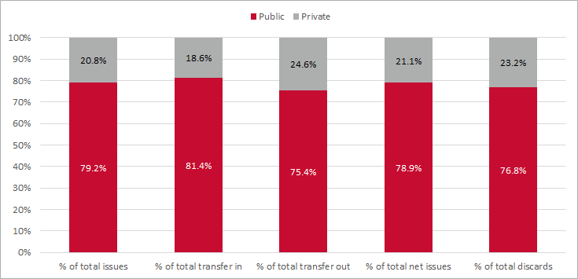
Figure 25: Percentage of FFP issues, transfers and discards by public/private, 2020-21 to 2024-25
Remoteness is a key factor in the volume of issues, transfer, discards and DAPI rates. The number of actual discards for the remote areas (Remote and Very Remote) are small, it highlights the challenge of managing wastage and inventory in those areas.

DAPIs in Remote and Very Remote areas have varied year on year. In 2024-25, DAPI was 45% in Remote areas and 66% in Very Remote areas, representing 107 and 44 units respectively. While Major Cities recorded the highest volume of FFP discards, they had the lowest DAPI. In 2024–25, Major Cities discarded 7,878 units of FFP, corresponding to a DAPI rate of 10%.
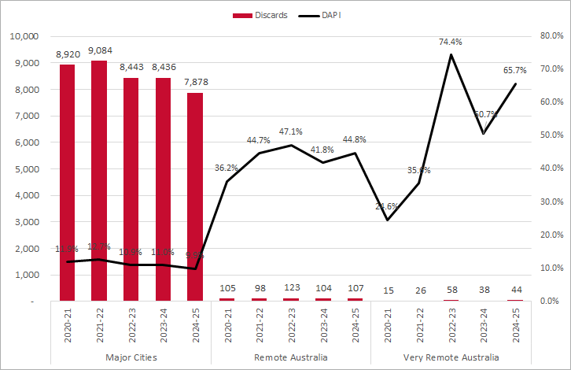
Figure 26: FFP discards and DAPI in the major cities and very remote areas, 2020-21 to 2024-25

FFP ABO issues and discards for 2020-21 to 2024-25
Over the five-year period from 2020–21 to 2024–25, the issues of group O RhD positive FFP accounted for an average of 25% of all issues, which is lower than the population estimate of 38%. During the same period, discards of O RhD positive represented an average of 20% of all FFP discards.
In contrast, the issues of O RhD negative FFP was higher than the population estimate, averaging 9% of all issues over the five-year period compared with a population estimate of 7%. Discards of O RhD negative FFP averaged 8% of total discards over the same period.

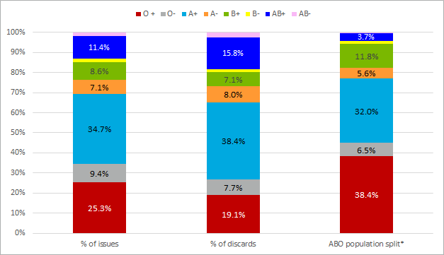
Figure 27: ABO issues and discards as % of all FFP issues and discards, 2020-21 to 2024-25
* Hirani, R., Weinert, N., Irving, DO. The distribution of ABO RhD blood groups in Australia, based on blood donor and blood sample pathology data. MJA 2022

FFP Orders for 2020-21 to 2024-25
Orders for FFP are placed through BloodNet. Orders can be a type of stock or special orders and can be a priority of Life Threatening, Urgent or Routine. The definition of order type and priority can be found in the RBC section.
Over the five-year period from 2020–21 to 2024–25, routine orders accounted for an average of 91% of all FFP priorities ordered, while stock orders accounted for 88% of all FFP types ordered. Limited use of special orders is appropriate for this product, given its shelf life of 12 months when frozen and up to 5 days once thawed, if stored correctly.
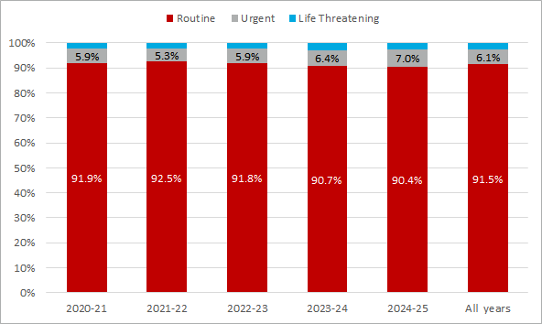
Figure 28: Percentage of FFP orders by order priority, 2020-21 to 2024-25
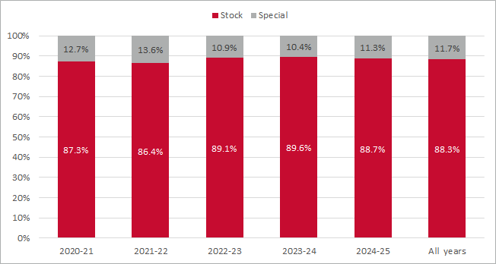
Figure 29: Percentage of FFP orders by order type, 2020-21 to 2024-25

Attachment A — Key policies and events
The timeline of key policies and events are available in the NBA Annual Reports and a summary of key events in NBA history is provided below.
2013-14
- Delivery of an uninterrupted supply that met clinical demand at a record saving of $138 million
- Inaugural Patient Blood Management (PBM) Conference held in Perth
- Published an arrange of best practice tools and case studies supporting the implementation of PBM and improved inventory management
2014-15
- Delivery of an uninterrupted supply that met clinical demand at a significant saving of $131 million
- Release of PBM Guidelines Module 5 Obstetrics and Maternity
- National Blood Symposium held in Brisbane, including the presentation of the inaugural National Blood Awards for Excellence in the Management of Blood
- Won ACT iAwards in three categories of innovation in the development of BloodNet interfaces with health provider laboratory information systems
- A reduction in red cell wastage from 4.9% to 3.9%
2015-16
- Delivery of an uninterrupted supply that met clinical demand at a significant saving of $90.6 million
- Release of PBM Guidelines Module 6 Neonatal and Paediatrics
- Commenced a new Deed of Agreement with the Red Cross Society for Lifeblood services
- National Blood Sector Research and Development Pilot commenced
- A reduction in red cell wastage from 3.9% to 2.8%
2016-17
- Delivery of an uninterrupted supply that met clinical demand at a significant saving of $49 million
- Round 2 of the National Blood Sector Research and Development Pilot commenced
- A reduction in red cell wastage from 2.8% to 2.3%
2017-18
- Delivery of an uninterrupted supply that met clinical demand at a significant saving of $60.8 million
- Celebrated the 10th anniversary of BloodSafe eLearning and the delivery of more than 1 million courses
- National Blood Sector Research and Development Program continued with two further funding rounds
- A reduction in red cell wastage from 2.3% to 2.2%
2018-19
- Delivery of an uninterrupted supply that met clinical demand at a significant saving of $68.9 million
- Implementation of redeveloped BloodNet on 1 July 2018
- National Blood Sector Research and Development Program continued and round four grant funding commenced
- A reduction in red cell wastage from 2.2% to 1.9%

2019-20
- Delivery of an uninterrupted supply that met clinical demand at a significant saving of $49 million
- Review of the efficiency of Australian Red Cross Lifeblood
- Dealt with the COVID-19 pandemic and its evolving impacts on NBA responsibilities and operations
- The NBA received three prestigious awards, including the Prime Minister’s Silver Award for Excellence in Public Sector Management
- Kept the level of red blood cell wastage at 1.9%
2020-21
- Delivery of an uninterrupted supply that met clinical demand, with net savings from the annual supply plan and budget approved by governments of $12.5 million
- Lifeblood approved to increase domestic plasma collection by approximately 10% annually to improve Australia’s domestic supply of plasma-derived products
- Close and effective partnership with suppliers of blood and blood products to manage national blood arrangements during COVID-19
- A reduction in red cell wastage from 1.9% to 1.6%
2021-22
- Delivery of an uninterrupted supply of blood and blood products that met clinical demand with no activation of the National Blood Supply Contingency Plan required
- Negotiated an Output Based Funding Model with Lifeblood, delivering savings of $160 million to governments
- Continued close and effective partnerships with suppliers of blood and blood products to manage blood arrangements during COVID-19
- Conducted a major review of processes to optimise the way the annual National Supply Plan and Budget is developed
- Released the National Blood Research and Development Strategic Priorities 2022-27
- A reduction in red cell wastage from 1.6% to 1.4%
2022-23
- Delivered an uninterrupted supply of blood and blood products that met clinical demand with no activation of the National Blood Supply Contingency Plan required
- Provided support for Lifeblood to increase the number of blood donors and achieve plasma growth
- Collaborated with the International Haemovigilance Network, the International Society of Blood Transfusion and the Australian and New Zealand Society of Blood Transfusion to deliver a series of four free, open-access online forums where scientists, haematologists, transfusion nurses, regulatory authorities and consumers came together to discuss safety and quality through data, the care and wellbeing of donors, and improving consumer engagement
- A reduction in red cell wastage from 1.4% to 1.2%
2023-24
- Maintained an uninterrupted supply of blood and blood products that met clinical demand without needing to activate the National Blood Supply Contingency Plan
- Continued strong and effective partnerships with suppliers of blood and blood products to manage blood arrangements in a challenging post pandemic environment
- Kept the level of red blood cell wastage at 1.2%
2024-25
- Maintained an uninterrupted supply of blood and blood products that met clinical demand without needing to activate the National Blood Supply Contingency Plan.
- Continued strong and effective partnerships with suppliers of blood and blood products to manage blood arrangements in a challenging environment.
- Finalised an extension of a Deed with Lifeblood for a further 3 years to ensure the ongoing safe and secure supply of blood products and services.
- Reduced the level of red blood cell wastage to 1.1%.

Attachment B — About the Data
This report presents the data and key results on issues, transfers, discards and order priorities for fresh blood products in a ten- year period (2015-16 to 2024-25) and five-year period (2020-21 to 2024-25). Fresh blood products included in this report are RBC, platelets and FFP. Paediatric fresh blood products, cryo-depleted plasma, cryoprecipitate, plasma for fractionation and serum eye drops are excluded.

Data source
The data in this report is from two primary sources:
- The issue and cost/expenditure data collected by the NBA for the fresh blood products issued to AHPs and purchased from Lifeblood. This data is held in the NBA Integrated Data Management System (IDMS).
- The order, issue, discard and transfer data collected by the NBA at AHP level through BloodNet. BloodNet is an online blood ordering and inventory management system. It is a web-based system that allows staff in health facilities across Australia to order blood and blood products in a standardised way and to do so quickly, easily, and securely from Lifeblood. Some pathology Laboratory Information Systems (LIS) are interfaced with BloodNet, which assists in eliminating the double-entry of data and enabling the near real time transfer of data between stakeholders in the blood sector.

Caveats
- The AHP remoteness data in this report is from the Australian Institute of Health and Welfare (AIHW) hospital peer groups 2016 which is based on the Australian Bureau of Statistics (ABS) Australian Standard Geographical Classification Remoteness Area (ASGS-RA) classification. ASGS-RA divides Australia into five classes of remoteness, including Major Cities of Australia, Inner Regional Australia, Outer Regional Australia, Remote Australia and Very Remote Australia.
- The state and national population statistics used in this report is from the ABS 3101.0 - Australian Demographic Statistics. The ABO population split data is from the Journal article The distribution of ABO RhD blood groups in Australia, based on blood donor and blood sample pathology data.
- The BloodNet issues are slightly higher than the IDMS issues in this report due to two reasons:
- return to stock/store and credit transactions actioned by Lifeblood not in BloodNet but in IDMS
- issues to universities and research institutions recorded in BloodNet but not in IDMS.
- This report covers the orders, issues, transfers and discards data for RBC, platelets and FFP only. Information on the other aspects of fresh blood products, such as the NBA’s product management, Lifeblood process and contract, and donor and patient safety, are outside the scope of this report and can be accessed through the following websites:
- Fresh blood product supply with Lifeblood
- Fresh blood products we manage for Australians
- Blood Book 2020
- Blood donations
- Blood transfusion
- Haemovigilance Reporting

Attachment C — RBC detailed data
Table 1: RBC issues and per 1,000 population, 2015-16 to 2024-25
 | 2015-16 | 2016-17 | 2017-18 | 2018-19 | 2019-20 | 2020-21 | 2021-22 | 2022-23 | 2023-24 | 2024-25
Issues | 644,487 | 635,364 | 629,463 | 629,377 | 629,609 | 659,611 | 663,530 | 686,730 | 703,596 | 708,478
Per '000 population | 26.9 | 26.1 | 25.4 | 25.0 | 24.7 | 25.7 | 25.8 | 26.1 | 26.1 | 25.9

Table 2: RBC issues by jurisdiction, 2015-16 to 2024-25
 | 2015-16 | 2016-17 | 2017-18 | 2018-19 | 2019-20 | 2020-21 | 2021-22 | 2022-23 | 2023-24 | 2024-25
NSW | 195,850 | 189,914 | 192,367 | 193,996 | 197,815 | 210,252 | 207,110 | 213,255 | 218,688 | 217,237
VIC | 176,428 | 177,760 | 175,558 | 173,340 | 170,799 | 176,808 | 178,703 | 186,672 | 190,868 | 192,050
QLD | 138,196 | 134,726 | 132,800 | 131,841 | 131,241 | 135,697 | 137,045 | 139,332 | 142,148 | 145,025
SA | 57,519 | 56,909 | 55,213 | 55,795 | 53,934 | 54,715 | 54,565 | 55,991 | 58,302 | 58,368
WA | 50,400 | 51,896 | 48,750 | 49,836 | 50,078 | 55,191 | 57,893 | 61,411 | 61,798 | 64,956
TAS | 11,354 | 10,520 | 11,374 | 11,355 | 12,375 | 12,564 | 13,153 | 14,434 | 15,358 | 14,832
NT | 4,206 | 4,022 | 3,988 | 4,014 | 3,918 | 4,322 | 4,956 | 5,145 | 5,111 | 4,463
ACT | 10,534 | 9,617 | 9,413 | 9,200 | 9,449 | 10,062 | 10,105 | 10,490 | 11,323 | 11,547

Table 3: RBC issues per 1,000 population by jurisdiction, 2015-16 to 2024-25
 | 2015-16 | 2016-17 | 2017-18 | 2018-19 | 2019-20 | 2020-21 | 2021-22 | 2022-23 | 2023-24 | 2024-25
NSW | 25.5 | 24.4 | 24.4 | 24.3 | 24.5 | 26.0 | 25.6 | 25.9 | 25.9 | 25.4
VIC | 29.0 | 28.5 | 27.6 | 26.8 | 25.9 | 26.9 | 27.2 | 27.8 | 27.6 | 27.4
QLD | 28.8 | 27.6 | 26.8 | 26.1 | 25.5 | 26.1 | 26.0 | 25.9 | 25.7 | 25.8
SA | 33.7 | 33.1 | 31.8 | 31.7 | 30.3 | 30.4 | 30.2 | 30.5 | 31.2 | 30.9
WA | 19.8 | 20.2 | 18.7 | 18.9 | 18.6 | 20.2 | 21.0 | 21.7 | 21.1 | 21.6
TAS | 22.0 | 20.1 | 21.3 | 20.8 | 22.1 | 22.2 | 23.1 | 25.3 | 26.7 | 25.8
NT | 17.2 | 16.3 | 16.1 | 16.2 | 15.8 | 17.3 | 19.9 | 20.6 | 20.2 | 17.0
ACT | 26.4 | 23.5 | 22.2 | 21.1 | 21.2 | 22.3 | 22.3 | 22.8 | 24.1 | 24.0

Table 4: RBC issues, transfers, discards, costs and DAPI, 2020-21 to 2024-25
 | Issues | Issues Cost ($M) | Transfers | Discards | Discard Cost ($M) | DAPI
2020-21 | 659,611 | $249.2 | 87,025 | 10,237 | $3.9 | 1.6%
2021-22 | 663,530 | $255.5 | 83,419 | 9,370 | $3.6 | 1.4%
2022-23 | 686,730 | $245.6 | 83,156 | 7,920 | $2.8 | 1.2%
2023-24 | 703,596 | $264.2 | 84,419 | 8,106 | $3.0 | 1.2%
2024-25 | 708,478 | $262.6 | 87,417 | 7,966 | $3.0 | 1.1%

Table 5: RBC issues, transfers, discards, costs and DAPI by public/private, 2020-21 to 2024-25
 | Issues | Issues Cost ($M) | Transfer Out | Transfer In | Net Issues | Discards | Discard Cost ($M) | DAPI
Public | 2,359,486 | $880.9 | 211,792 | 205,116 | 2,352,810 | 26,612 | $10.0 | 1.1%
2020-21 | 447,254 | $169.1 | 43,345 | 41,429 | 445,338 | 5,697 | $2.2 | 1.3%
2021-22 | 453,877 | $174.9 | 42,034 | 40,289 | 452,132 | 5,799 | $2.2 | 1.3%
2022-23 | 476,994 | $170.7 | 40,344 | 39,013 | 475,663 | 4,851 | $1.7 | 1.0%
2023-24 | 488,625 | $183.5 | 42,797 | 42,100 | 487,928 | 5,213 | $2.0 | 1.1%
2024-25 | 492,736 | $182.7 | 43,272 | 42,285 | 491,749 | 5,052 | $1.9 | 1.0%
Private | 1,062,459 | $396.3 | 213,644 | 220,320 | 1,069,135 | 16,987 | $6.3 | 1.6%
2020-21 | 212,357 | $80.2 | 43,680 | 45,596 | 214,273 | 4,540 | $1.7 | 2.1%
2021-22 | 209,653 | $80.7 | 41,385 | 43,130 | 211,398 | 3,571 | $1.4 | 1.7%
2022-23 | 209,736 | $74.9 | 42,812 | 44,143 | 211,067 | 3,069 | $1.1 | 1.5%
2023-24 | 214,971 | $80.6 | 41,622 | 42,319 | 215,668 | 2,893 | $1.1 | 1.3%
2024-25 | 215,742 | $79.9 | 44,145 | 45,132 | 216,729 | 2,914 | $1.1 | 1.3%

Table 6: RBC issues, transfer, discards, costs and DAPI by jurisdiction, 2020-21 to 2024-25
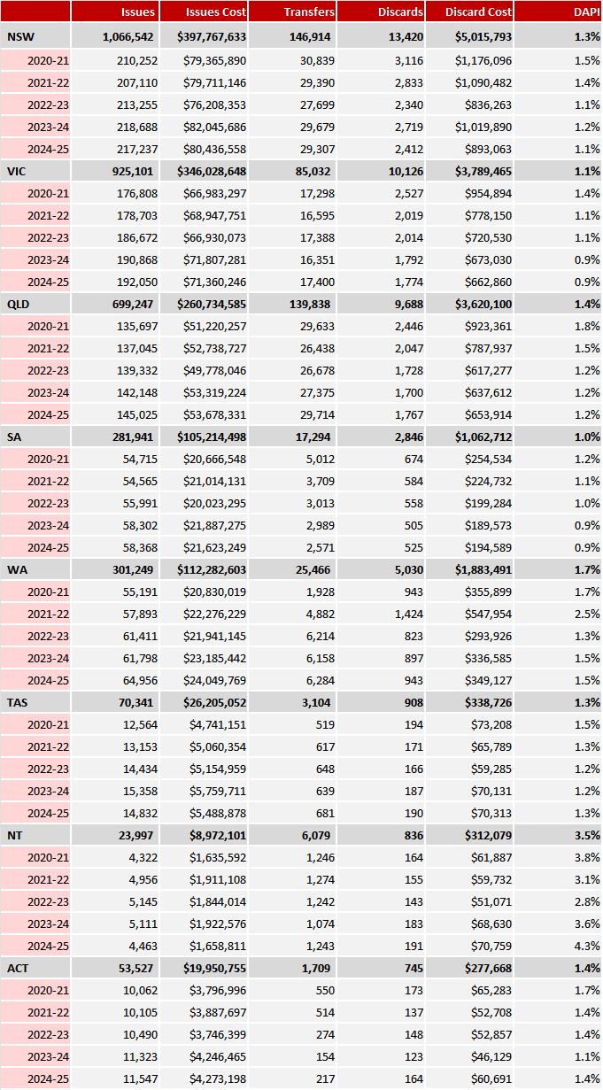
Table 7: RBC issues, transfers, discards and DAPI by Remoteness, 2020-21 to 2024-25
Remoteness/Year | Issues | Transfers Out | Transfers In | Net Issues | Discards | DAPI
Major Cities of Australia | 2,754,302 | 324,598 | 364,471 | 2,794,175 | 31,653 | 1.1%
2020-21 | 528,958 | 67,140 | 76,444 | 538,262 | 7,392 | 1.4%
2021-22 | 531,714 | 64,216 | 71,586 | 539,084 | 6,715 | 1.2%
2022-23 | 554,402 | 63,676 | 70,506 | 561,232 | 5,682 | 1.0%
2023-24 | 567,040 | 63,855 | 71,815 | 575,000 | 5,979 | 1.0%
2024-25 | 572,188 | 65,711 | 74,120 | 580,597 | 5,885 | 1.0%
Inner Regional Australia | 458,908 | 56,266 | 45,436 | 448,078 | 7,032 | 1.6%
2020-21 | 87,494 | 10,376 | 7,718 | 84,836 | 1,668 | 2.0%
2021-22 | 89,881 | 10,129 | 8,501 | 88,253 | 1,503 | 1.7%
2022-23 | 90,723 | 10,959 | 9,582 | 89,346 | 1,428 | 1.6%
2023-24 | 95,247 | 11,844 | 9,612 | 93,015 | 1,198 | 1.3%
2024-25 | 95,563 | 12,95 | 10,023 | 92,628 | 1,235 | 1.3%
Outer Regional Australia | 174,936 | 26,818 | 13,051 | 161,169 | 3,789 | 2.4%
2020-21 | 36,192 | 6,140 | 2,434 | 32,486 | 854 | 2.6%
2021-22 | 35,245 | 5,647 | 2,825 | 32,423 | 788 | 2.4%
2022-23 | 34,791 | 4,872 | 2,587 | 32,506 | 647 | 2.0%
2023-24 | 34,654 | 5,151 | 2,470 | 31,973 | 763 | 2.4%
2024-25 | 34,054 | 5,008 | 2,735 | 31,781 | 737 | 2.3%
Remote Australia | 24,094 | 10,367 | 589 | 14,316 | 718 | 5.0%
2020-21 | 5,029 | 2,127 | 90 | 2,992 | 171 | 5.7%
2021-22 | 4,869 | 2,167 | 120 | 2,822 | 212 | 7.5%
2022-23 | 4,794 | 2,045 | 119 | 2,868 | 129 | 4.5%
2023-24 | 4,722 | 1,975 | 131 | 2,878 | 126 | 4.4%
2024-25 | 4,680 | 2,053 | 129 | 2,756 | 80 | 2.9%
Very Remote Australia | 9,529 | 7,387 | 1,889 | 4,031 | 407 | 10.1%
2020-21 | 1,874 | 1,242 | 339 | 971 | 152 | 15.7%
2021-22 | 1,757 | 1,260 | 387 | 884 | 152 | 17.2%
2022-23 | 1,972 | 1,604 | 362 | 730 | 34 | 4.7%
2023-24 | 1,933 | 1,594 | 391 | 730 | 40 | 5.5%
2024-25 | 1,993 | 1,687 | 410 | 716 | 29 | 4.1%

Table 8: RBC ABO issued quantity and discards, 2020-21 to 2024-25
 | Year | O + | O- | A+ | A- | B+ | B- | AB+ | AB- | Total
Issued quantity | 2020-21 | 261,122 | 110,861 | 191,152 | 41,655 | 40,352 | 9,503 | 5,526 | 1,753 | 661,924
Issued quantity | 2021-22 | 265,374 | 105,831 | 194,931 | 42,008 | 41,802 | 9,311 | 5,358 | 1,609 | 666,224
Issued quantity | 2022-23 | 278,178 | 106,290 | 200,565 | 42,555 | 45,111 | 9,941 | 6,310 | 1,669 | 690,619
Issued quantity | 2023-24 | 284,961 | 107,819 | 205,048 | 43,842 | 47,131 | 10,040 | 6,686 | 1,640 | 707,167
Issued quantity | 2024-25 | 288,189 | 108,654 | 204,570 | 43,738 | 47,758 | 10,325 | 7,156 | 1,626 | 712,016
% of issued quantity | 2020-21 | 39.4% | 16.7% | 28.9% | 6.3% | 6.1% | 1.4% | 0.8% | 0.3% | 100%
% of issued quantity | 2021-22 | 39.8% | 15.9% | 29.3% | 6.3% | 6.3% | 1.4% | 0.8% | 0.2% | 100%
% of issued quantity | 2022-23 | 40.3% | 15.4% | 29.0% | 6.2% | 6.5% | 1.4% | 0.9% | 0.2% | 100%
% of issued quantity | 2023-24 | 40.3% | 15.2% | 29.0% | 6.2% | 6.7% | 1.4% | 0.9% | 0.2% | 100%
% of issued quantity | 2024-25 | 40.8% | 15.3% | 28.7% | 6.1% | 6.7% | 1.5% | 1.0% | 0.2% | 100%
Discards | 2020-21 | 2,875 | 3,253 | 2,016 | 785 | 580 | 312 | 269 | 147 | 10,237
Discards | 2021-22 | 2,654 | 3,076 | 1,901 | 663 | 440 | 247 | 223 | 166 | 9,370
Discards | 2022-23 | 2,249 | 2,577 | 1,581 | 565 | 399 | 196 | 241 | 112 | 7,920
Discards | 2023-24 | 2,324 | 2,685 | 1,633 | 540 | 437 | 207 | 176 | 104 | 8,106
Discards | 2024-25 | 2,349 | 2,390 | 1,632 | 569 | 554 | 167 | 194 | 111 | 7,966
% of discards | 2020-21 | 28.1% | 31.8% | 19.7% | 7.7% | 5.7% | 3.0% | 2.6% | 1.4% | 100%
% of discards | 2021-22 | 28.3% | 32.8% | 20.3% | 7.1% | 4.7% | 2.6% | 2.4% | 1.8% | 100%
% of discards | 2022-23 | 28.4% | 32.5% | 20.0% | 7.1% | 5.0% | 2.5% | 3.0% | 1.4% | 100%
% of discards | 2023-24 | 28.7% | 33.1% | 20.1% | 6.7% | 5.4% | 2.6% | 2.2% | 1.3% | 100%
% of discards | 2024-25 | 29.5% | 30.0% | 20.5% | 7.1% | 7.0% | 2.1% | 2.4% | 1.4% | 100%
ABO population split* |  | 38.4% | 6.5% | 32.0% | 5.6% | 11.8% | 1.5% | 3.7% | 0.5%
Note: * Hirani, R., Weinert, N., Irving, DO. The distribution of ABO RhD blood groups in Australia, based on blood donor and blood sample pathology data. MJA 2022

Table 9: RBC ABO issued quantity, transfer and discards by jurisdiction, 2024-25
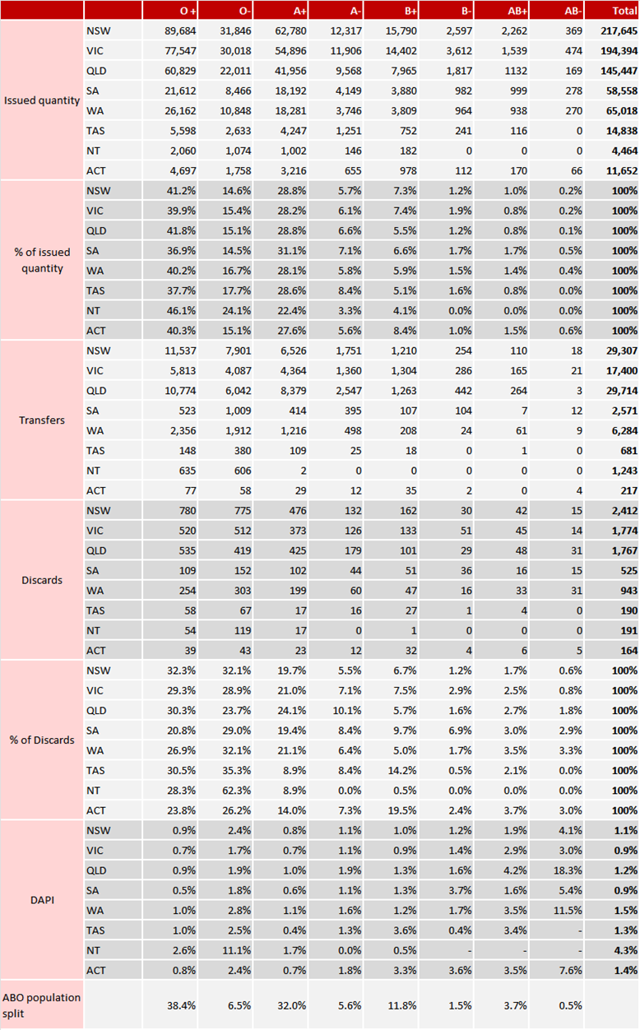

Table 9: Quantity of RBC ordered by order priority and type, 2020-21 to 2024-25
Priority | Order Type | 2020-21 | 2021-22 | 2022-23 | 2023-24 | 2024-25
Life Threatening | Special | 2,270 | 2,439 | 2,498 | 2,673 | 2,364
Life Threatening | Stock | 2,770 | 2,636 | 3,241 | 3,572 | 3,761
Life Threatening | Sub total | 5,040 | 5,075 | 5,739 | 6,245 | 6,125
Urgent | Special | 14,723 | 14,970 | 16,201 | 15,969 | 15,637
Urgent | Stock | 14,880 | 13,855 | 14,435 | 16,064 | 17,569
Urgent | Sub total | 29,603 | 28,825 | 30,636 | 32,033 | 33,206
Routine | Special | 95,161 | 112,008 | 117,789 | 119,357 | 120,627
Routine | Stock | 536,314 | 544,115 | 560,017 | 566,791 | 564,164
Routine | Sub total | 631,475 | 656,123 | 677,806 | 686,148 | 684,791
All priorities | Total | 666,118 | 690,023 | 714,181 | 724,426 | 724,122
All priorities | Annual change (%) | - | 3.6% | 3.5% | 1.4% | 0.0%
 |  | As percentage of total orders quantity
Life Threatening | All order types | 0.8% | 0.7% | 0.8% | 0.9% | 0.8%
Urgent | All order types | 4.4% | 4.2% | 4.3% | 4.4% | 4.6%
Routine | All order types | 94.8% | 95.1% | 94.9% | 94.7% | 94.6%
All priorities | Special | 16.8% | 18.8% | 19.1% | 19.0% | 19.1%
All priorities | Stock | 83.2% | 81.2% | 80.9% | 81.0% | 80.9%
Note: order data includes dispatched and finalised orders

Attachment D — Platelet detailed data
Table 1: Platelet issues and per 1,000 population, 2015-16 to 2024-25
 | 2015-16 | 2016-17 | 2017-18 | 2018-19 | 2019-20 | 2020-21 | 2021-22 | 2022-23 | 2023-24 | 2024-25
Issues | 130,507 | 130,523 | 132,930 | 136,446 | 138,210 | 145,056 | 140,504 | 147,893 | 155,143 | 159,711
Per '000 population | 5.4 | 5.4 | 5.4 | 5.4 | 5.4 | 5.7 | 5.5 | 5.6 | 5.8 | 5.8

Table 2: Platelet issues by jurisdiction, 2015-16 to 2024-25
 | 2015-16 | 2016-17 | 2017-18 | 2018-19 | 2019-20 | 2020-21 | 2021-22 | 2022-23 | 2023-24 | 2024-25
NSW | 37,152 | 36,753 | 39,016 | 41,007 | 42,155 | 44,387 | 41,082 | 43,793 | 45,838 | 45,491
VIC | 33,963 | 33,963 | 33,299 | 34,613 | 35,018 | 36,433 | 35,791 | 38,573 | 41,596 | 40,763
QLD | 34,641 | 33,960 | 35,536 | 34,884 | 33,861 | 35,173 | 35,121 | 35,789 | 36,021 | 38,256
SA | 10,856 | 11,685 | 10,891 | 10,970 | 12,026 | 12,745 | 11,420 | 11,019 | 11,906 | 12,610
WA | 9,196 | 9,636 | 9,497 | 10,342 | 10,043 | 11,167 | 12,197 | 13,246 | 13,798 | 16,218
TAS | 2,257 | 2,266 | 2,292 | 2,360 | 2,747 | 2,658 | 2,509 | 3,049 | 3,435 | 3,547
NT | 818 | 731 | 851 | 824 | 837 | 982 | 921 | 976 | 955 | 856
ACT | 1,624 | 1,529 | 1,548 | 1,446 | 1,523 | 1,511 | 1,463 | 1,448 | 1,594 | 1,970

Table 3: Platelet issues per 1,000 population by jurisdiction, 2015-16 to 2024-25
 | 2015-16 | 2016-17 | 2017-18 | 2018-19 | 2019-20 | 2020-21 | 2021-22 | 2022-23 | 2023-24 | 2024-25
NSW | 4.8 | 4.7 | 4.9 | 5.1 | 5.2 | 5.5 | 5.1 | 5.3 | 5.4 | 5.3
VIC | 5.6 | 5.4 | 5.2 | 5.3 | 5.3 | 5.6 | 5.5 | 5.8 | 6.0 | 5.8
QLD | 7.2 | 7.0 | 7.2 | 6.9 | 6.6 | 6.8 | 6.7 | 6.7 | 6.5 | 6.8
SA | 6.4 | 6.8 | 6.3 | 6.2 | 6.7 | 7.1 | 6.3 | 6.0 | 6.4 | 6.7
WA | 3.6 | 3.7 | 3.6 | 3.9 | 3.7 | 4.1 | 4.4 | 4.7 | 4.7 | 5.4
TAS | 4.4 | 4.3 | 4.3 | 4.3 | 4.9 | 4.7 | 4.4 | 5.3 | 6.0 | 6.2
NT | 3.4 | 3.0 | 3.4 | 3.3 | 3.4 | 3.9 | 3.7 | 3.9 | 3.8 | 3.3
ACT | 4.1 | 3.7 | 3.7 | 3.3 | 3.4 | 3.3 | 3.2 | 3.1 | 3.4 | 4.1

Table 4: Platelet issues, transfer, discards, costs and DAPI, 2020-21 to 2024-25
 | Issues | Issues Cost ($M) | Transfers | Discards | Discard Cost ($M) | DAPI
2020-21 | 145,056 | $55.2 | 8,788 | 14,718 | $5.1 | 10.1%
2021-22 | 140,504 | $52.2 | 8,167 | 11,027 | $3.8 | 7.8%
2022-23 | 147,893 | $49.8 | 8,543 | 10,969 | $3.5 | 7.4%
2023-24 | 155,143 | $54.3 | 9,667 | 11,547 | $3.9 | 7.4%
2024-25 | 159,711 | $56.9 | 9,538 | 11,774 | $4.1 | 7.4%
Table 5: Platelet issues, transfers, discards, costs and DAPI by public/private, 2020-21 to 2024-25
 | Issues | Issues Cost ($M) | Transfer Out | Transfer In | Net Issues | Discards | Discard Cost ($M) | DAPI
Public | 537,510 | $191.8 | 33,499 | 32,786 | 536,797 | 35,048 | $12.2 | 6.5%
2020-21 | 102,622 | $39.0 | 6,706 | 6,248 | 102,164 | 8,545 | $3.0 | 8.4%
2021-22 | 100,431 | $36.9 | 6,281 | 6,027 | 100,177 | 6,216 | $2.2 | 6.2%
2022-23 | 107,814 | $36.1 | 6,255 | 6,108 | 107,667 | 6,396 | $2.1 | 5.9%
2023-24 | 112,410 | $39.2 | 7,342 | 7,381 | 112,449 | 6,839 | $2.4 | 6.1%
2024-25 | 114,233 | $40.6 | 6,915 | 7,022 | 114,340 | 7,052 | $2.5 | 6.2%
Private | 210,797 | $76.5 | 11,204 | 11,917 | 211,510 | 24,987 | $8.1 | 11.8%
2020-21 | 42,434 | $16.2 | 2,082 | 2,540 | 42,892 | 6,173 | $2.1 | 14.4%
2021-22 | 40,073 | $15.2 | 1,886 | 2,140 | 40,327 | 4,811 | $1.6 | 11.9%
2022-23 | 40,079 | $13.7 | 2,288 | 2,435 | 40,226 | 4,573 | $1.4 | 11.4%
2023-24 | 42,733 | $15.0 | 2,325 | 2,286 | 42,694 | 4,708 | $1.5 | 11.0%
2024-25 | 45,478 | $16.2 | 2,623 | 2,516 | 45,371 | 4,722 | $1.6 | 10.4%

Table 6: Platelet issues, transfer, discards, costs and DAPI by Jurisdiction, 2020-21 to 2024-25
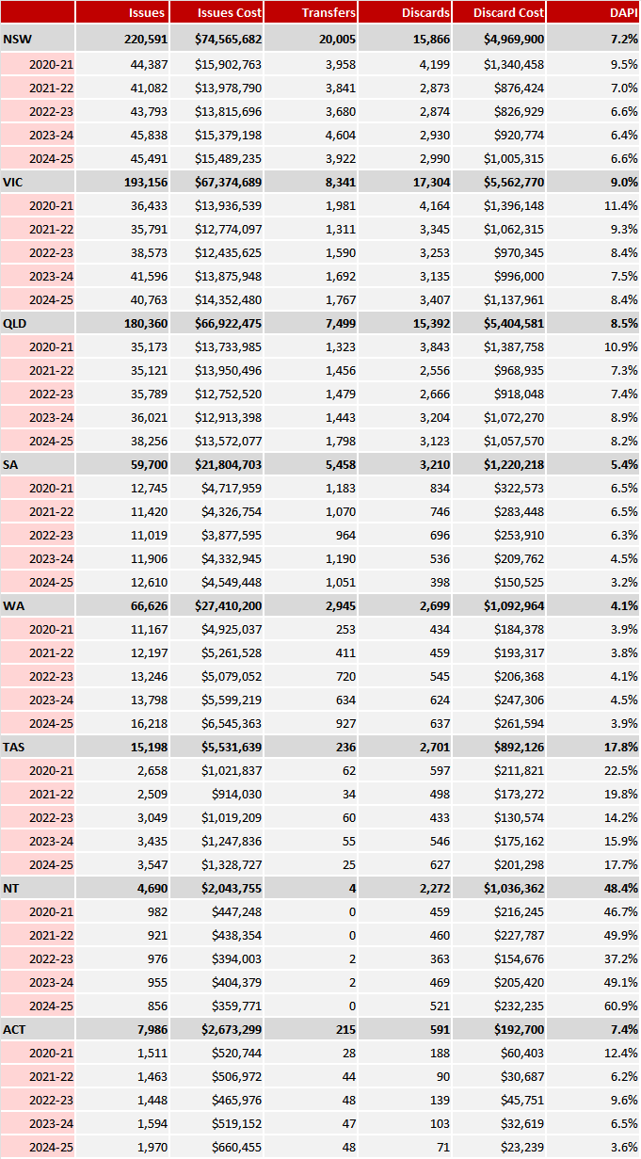

Table 7: Remoteness platelets issues, transfer, discards and DAPI, 2020-21 to 2024-25
 | Issues | Transfers Out | Transfers In | Net Issues | Discards | DAPI
Major Cities of Australia | 647,854 | 39,754 | 40,225 | 648,325 | 35,466 | 5.5%
2020-21 | 125,177 | 7,997 | 7,988 | 125,168 | 8,884 | 7.1%
2021-22 | 121,218 | 7,332 | 7,367 | 121,253 | 6,480 | 5.3%
2022-23 | 127,838 | 7,575 | 7,622 | 127,885 | 6,435 | 5.0%
2023-24 | 134,990 | 8,630 | 8,758 | 135,118 | 6,671 | 4.9%
2024-25 | 138,631 | 8,220 | 8,490 | 138,901 | 6,996 | 5.0%
Inner Regional Australia | 68,503 | 4,296 | 3,594 | 67,801 | 17,011 | 25.1%
2020-21 | 13,391 | 618 | 587 | 13,360 | 4,487 | 33.6%
2021-22 | 12,784 | 655 | 513 | 12,642 | 3,260 | 25.8%
2022-23 | 13,317 | 829 | 675 | 13,163 | 3,044 | 23.1%
2023-24 | 14,126 | 939 | 820 | 14,007 | 3,175 | 22.7%
2024-25 | 14,885 | 1,255 | 999 | 14,629 | 3,045 | 20.8%
Outer Regional Australia | 30,650 | 637 | 873 | 30,886 | 6,875 | 22.3%
2020-21 | 6,213 | 168 | 205 | 6,250 | 1,197 | 19.2%
2021-22 | 6,175 | 172 | 287 | 6,290 | 1,144 | 18.2%
2022-23 | 6,497 | 138 | 245 | 6,604 | 1,357 | 20.5%
2023-24 | 5,813 | 98 | 87 | 5,802 | 1,573 | 27.1%
2024-25 | 5,952 | 61 | 49 | 5,940 | 1,604 | 27.0%
Remote Australia | 1,287 | 16 | 8 | 1,279 | 682 | 53.3%
2020-21 | 275 | 5 | 8 | 278 | 150 | 54.0%
2021-22 | 326 | 8 | 0 | 318 | 143 | 45.0%
2022-23 | 239 | 1 | 0 | 238 | 132 | 55.5%
2023-24 | 207 | 2 | 0 | 205 | 128 | 62.4%
2024-25 | 240 | 0 | 0 | 240 | 129 | 53.8%
Very Remote Australia | 13 | 0 | 3 | 16 | 1 | 6.3%
2020-21 | 0 | 0 | 0 | 0 | 0 | -
2021-22 | 1 | 0 | 0 | 1 | 0 | 0.0%
2022-23 | 2 | 0 | 1 | 3 | 1 | 33.3%
2023-24 | 7 | 0 | 2 | 9 | 0 | 0.0%
2024-25 | 3 | 0 | 0 | 3 | 0 | 0.0%

Table 8: Platelet ABO issued quantity and discards, 2020-21 to 2024-25
 | Year | O + | O- | A+ | A- | B+ | B- | AB+ | AB- | Total
Issued quantity | 2020-21 | 65,113 | 22,927 | 41,756 | 10,646 | 4,204 | 631 | 77 | 12 | 145,366
Issued quantity | 2021-22 | 62,508 | 22,175 | 40,436 | 10,480 | 4,457 | 625 | 38 | 0 | 140,719
Issued quantity | 2022-23 | 66,400 | 23,091 | 42,316 | 10,600 | 4,965 | 693 | 27 | 5 | 148,097
Issued quantity | 2023-24 | 69,802 | 23,783 | 45,333 | 10,852 | 4,872 | 632 | 7 | 2 | 155,283
Issued quantity | 2024-25 | 72,924 | 24,357 | 46,602 | 10,687 | 4,901 | 399 | 7 | 0 | 159,877
% of issued quantity | 2020-21 | 44.8% | 15.8% | 28.7% | 7.3% | 2.9% | 0.4% | 0.1% | 0.0% | 100%
% of issued quantity | 2021-22 | 44.4% | 15.8% | 28.7% | 7.4% | 3.2% | 0.4% | 0.0% | 0.0% | 100%
% of issued quantity | 2022-23 | 44.8% | 15.6% | 28.6% | 7.2% | 3.4% | 0.5% | 0.0% | 0.0% | 100%
% of issued quantity | 2023-24 | 45.0% | 15.3% | 29.2% | 7.0% | 3.1% | 0.4% | 0.0% | 0.0% | 100%
% of issued quantity | 2024-25 | 45.6% | 15.2% | 29.1% | 6.7% | 3.1% | 0.2% | 0.0% | 0.0% | 100%
Discards | 2020-21 | 6,800 | 2,187 | 4,481 | 900 | 289 | 49 | 11 | 1 | 14,718
Discards | 2021-22 | 5,354 | 1,470 | 3,190 | 719 | 245 | 44 | 5 | 0 | 11,027
Discards | 2022-23 | 5,321 | 1,458 | 3,087 | 739 | 309 | 51 | 3 | 1 | 10,969
Discards | 2023-24 | 5,613 | 1,499 | 3,395 | 637 | 369 | 33 | 1 | 0 | 11,547
Discards | 2024-25 | 5,627 | 1,462 | 3,628 | 688 | 356 | 13 | 0 | 0 | 11,774
% of discards | 2020-21 | 46.2% | 14.9% | 30.4% | 6.1% | 2.0% | 0.3% | 0.1% | 0.0% | 100%
% of discards | 2021-22 | 48.6% | 13.3% | 28.9% | 6.5% | 2.2% | 0.4% | 0.0% | 0.0% | 100%
% of discards | 2022-23 | 48.5% | 13.3% | 28.1% | 6.7% | 2.8% | 0.5% | 0.0% | 0.0% | 100%
% of discards | 2023-24 | 48.6% | 13.0% | 29.4% | 5.5% | 3.2% | 0.3% | 0.0% | 0.0% | 100%
% of discards | 2024-25 | 47.8% | 12.4% | 30.8% | 5.8% | 3.0% | 0.1% | 0.0% | 0.0% | 100%
ABO population split* |  | 38.4% | 6.5% | 32.0% | 5.6% | 11.8% | 1.5% | 3.7% | 0.5%
Note: * Hirani, R., Weinert, N., Irving, DO. The distribution of ABO RhD blood groups in Australia, based on blood donor and blood sample pathology data. MJA 2022

Table 9: Quantity of platelets ordered by order priority and type, 2020-21 to 2024-25
Priority | Order Type | 2020-21 | 2021-22 | 2022-23 | 2023-24 | 2024-25
Life Threatening | Special | 890 | 823 | 934 | 925 | 768
Life Threatening | Stock | 782 | 657 | 930 | 1,047 | 978
Life Threatening | Sub total | 1,672 | 1,480 | 1,864 | 1,972 | 1,746
Urgent | Special | 11,700 | 9,055 | 8,893 | 9,228 | 8,524
Urgent | Stock | 9,697 | 9,502 | 10,571 | 13,069 | 15,187
Urgent | Sub total | 21,397 | 18,557 | 19,464 | 22,297 | 23,711
Routine | Special | 40,927 | 34,884 | 32,684 | 32,441 | 33,030
Routine | Stock | 80,712 | 83,801 | 92,508 | 96,896 | 101,756
Routine | Sub total | 121,639 | 118,685 | 125,192 | 129,337 | 134,786
All priorities | Total | 144,708 | 138,722 | 146,520 | 153,606 | 160,243
All priorities | Annual change (%) | - | -4.1% | 5.6% | 4.8% | 4.3%
 |  | As percentage of total orders quantity
Life Threatening | All order types | 1.2% | 1.1% | 1.3% | 1.3% | 1.1%
Urgent | All order types | 14.8% | 13.4% | 13.3% | 14.5% | 14.8%
Routine | All order types | 84.1% | 85.6% | 85.4% | 84.2% | 84.1%
All priorities | Special | 37.0% | 32.3% | 29.0% | 27.7% | 26.4%
All priorities | Stock | 63.0% | 67.7% | 71.0% | 72.3% | 73.6%
Note: order data includes dispatched and finalised orders

Attachment E — FFP detailed data
Table 1: FFP issues and per 1,000 population, 2015-16 to 2024-25
 | 2015-16 | 2016-17 | 2017-18 | 2018-19 | 2019-20 | 2020-21 | 2021-22 | 2022-23 | 2023-24 | 2024-25
Issues | 112,531 | 103,898 | 95,996 | 96,264 | 85,314 | 85,151 | 82,552 | 87,608 | 86,386 | 89,612
Per '000 population | 4.7 | 4.3 | 3.9 | 3.8 | 3.3 | 3.3 | 3.2 | 3.3 | 3.2 | 3.3
Table 2: FFP issues by jurisdiction, 2015-16 to 2024-25
 | 2015-16 | 2016-17 | 2017-18 | 2018-19 | 2019-20 | 2020-21 | 2021-22 | 2022-23 | 2023-24 | 2024-25
NSW | 41,098 | 37,082 | 37,537 | 37,504 | 33,625 | 32,057 | 30,584 | 31,584 | 31,406 | 32,277
VIC | 32,238 | 27,586 | 27,143 | 27,226 | 22,281 | 21,699 | 20,911 | 27,127 | 25,701 | 25,067
QLD | 20,308 | 19,362 | 15,080 | 14,798 | 14,829 | 15,683 | 15,173 | 14,585 | 14,448 | 16,923
SA | 8,880 | 8,976 | 7,560 | 7,520 | 6,721 | 6,440 | 5,564 | 5,884 | 5,410 | 6,365
WA | 6,308 | 7,831 | 5,707 | 6,290 | 5,115 | 6,316 | 5,890 | 5,788 | 6,525 | 6,154
TAS | 1,848 | 1,441 | 1,590 | 1,262 | 1,150 | 1,531 | 2,976 | 1,448 | 1,241 | 1,504
NT | 620 | 499 | 219 | 613 | 517 | 639 | 820 | 331 | 584 | 405
ACT | 1,231 | 1,121 | 1,160 | 1,051 | 1,076 | 786 | 634 | 861 | 1,071 | 917
Table 3: FFP issues per 1,000 population by jurisdiction, 2015-16 to 2024-25
 | 2015-16 | 2016-17 | 2017-18 | 2018-19 | 2019-20 | 2020-21 | 2021-22 | 2022-23 | 2023-24 | 2024-25
NSW | 5.4 | 4.8 | 4.8 | 4.7 | 4.2 | 4.0 | 3.8 | 3.8 | 3.7 | 3.8
VIC | 5.3 | 4.4 | 4.3 | 4.2 | 3.4 | 3.3 | 3.2 | 4.0 | 3.7 | 3.6
QLD | 4.2 | 4.0 | 3.0 | 2.9 | 2.9 | 3.0 | 2.9 | 2.7 | 2.6 | 3.0
SA | 5.2 | 5.2 | 4.4 | 4.3 | 3.8 | 3.6 | 3.1 | 3.2 | 2.9 | 3.4
WA | 2.5 | 3.0 | 2.2 | 2.4 | 1.9 | 2.3 | 2.1 | 2.0 | 2.2 | 2.0
TAS | 3.6 | 2.8 | 3.0 | 2.3 | 2.1 | 2.7 | 5.2 | 2.5 | 2.2 | 2.6
NT | 2.5 | 2.0 | 0.9 | 2.5 | 2.1 | 2.6 | 3.3 | 1.3 | 2.3 | 1.5
ACT | 3.1 | 2.7 | 2.7 | 2.4 | 2.4 | 1.7 | 1.4 | 1.9 | 2.3 | 1.9

Table 4: FFP issues, transfer, discards, costs and DAPI, 2020-21 to 2024-25
 | Issues | Issues Cost ($M) | Transfers | Discards | Discard Cost ($M) | DAPI
2020-21 | 85,151 | $15.3 | 3,755 | 10,851 | $2.0 | 12.7%
2021-22 | 82,552 | $14.9 | 4,003 | 10,947 | $2.0 | 13.3%
2022-23 | 87,608 | $14.6 | 4,394 | 10,569 | $1.8 | 12.1%
2023-24 | 86,386 | $14.6 | 3,809 | 10,343 | $1.8 | 12.0%
2024-25 | 89,612 | $15.5 | 3,870 | 9,798 | $1.7 | 10.9%
Table 5: FFP issues, transfers, discards, costs and DAPI by public/private, 2020-21 to 2024-25
 | Issues | Issues Cost ($M) | Transfer Out | Transfer In | Net Issues | Discards | Discard Cost ($M) | DAPI
Public | 341,613 | $59.4 | 16,138 | 14,944 | 340,419 | 40,313 | $7.1 | 11.8%
2020-21 | 66,917 | $12.0 | 3,254 | 2,764 | 66,427 | 8,155 | $1.5 | 12.3%
2021-22 | 64,061 | $11.6 | 3,425 | 2,969 | 63,605 | 8,460 | $1.6 | 13.3%
2022-23 | 69,532 | $11.6 | 3,509 | 3,251 | 69,274 | 8,083 | $1.4 | 11.7%
2023-24 | 68,742 | $11.6 | 2,991 | 2,929 | 68,680 | 7,849 | $1.3 | 11.4%
2024-25 | 72,361 | $12.6 | 2,959 | 3,031 | 72,433 | 7,766 | $1.4 | 10.7%
Private | 89,696 | $15.4 | 3,693 | 4,887 | 90,890 | 12,195 | $2.2 | 13.4%
2020-21 | 18,234 | $3.2 | 501 | 991 | 18,724 | 2,696 | $0.5 | 14.4%
2021-22 | 18,491 | $3.3 | 578 | 1,034 | 18,947 | 2,487 | $0.5 | 13.1%
2022-23 | 18,076 | $3.0 | 885 | 1,143 | 18,334 | 2,486 | $0.4 | 13.6%
2023-24 | 17,644 | $3.0 | 818 | 880 | 17,706 | 2,494 | $0.4 | 14.1%
2024-25 | 17,251 | $3.0 | 911 | 839 | 17,179 | 2,032 | $0.4 | 11.8%

Table 6: FFP issues, transfer, discards, costs and DAPI by Jurisdiction, 2020-21 to 2024-25
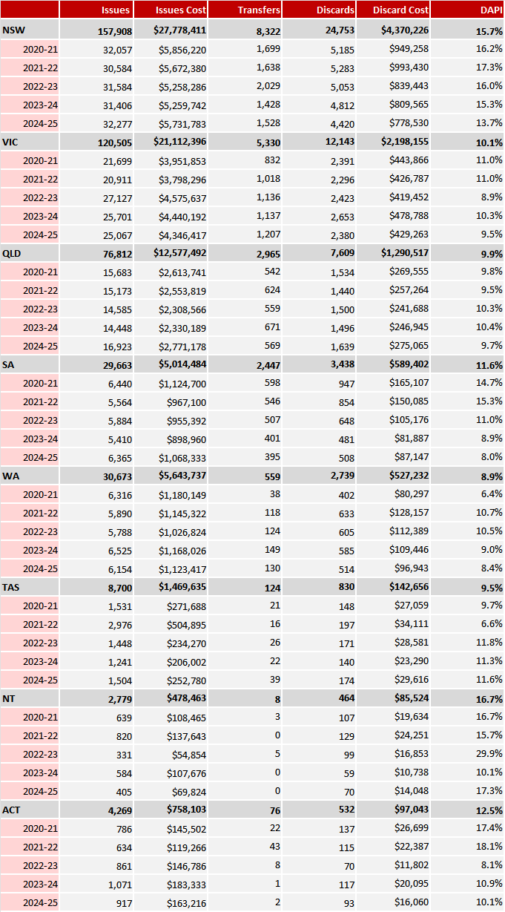
Table 7: Remoteness FFP issues, transfer, discards and DAPI, 2020-21 to 2024-25
Remoteness/Year | Issues | Transfers Out | Transfers In | Net Issues | Discards | DAPI
Major Cities of Australia | 378,670 | 16,090 | 18,057 | 380,637 | 42,761 | 11.2%
2020-21 | 74,861 | 3,079 | 3,396 | 75,178 | 8,920 | 11.9%
2021-22 | 71,323 | 3,245 | 3,663 | 71,741 | 9,084 | 12.7%
2022-23 | 76,730 | 3,446 | 3,934 | 77,218 | 8,443 | 10.9%
2023-24 | 76,450 | 3,178 | 3,528 | 76,800 | 8,436 | 11.0%
2024-25 | 79,306 | 3,142 | 3,536 | 79,700 | 7,878 | 9.9%
Inner Regional Australia | 38,258 | 2,478 | 1,360 | 37,140 | 6,851 | 18.4%
2020-21 | 7,225 | 445 | 285 | 7,065 | 1,384 | 19.6%
2021-22 | 8,120 | 473 | 218 | 7,865 | 1,323 | 16.8%
2022-23 | 8,180 | 681 | 387 | 7,886 | 1,495 | 19.0%
2023-24 | 7,283 | 410 | 207 | 7,080 | 1,368 | 19.3%
2024-25 | 7,450 | 469 | 263 | 7,244 | 1,281 | 17.7%
Outer Regional Australia | 12,585 | 1,083 | 395 | 11,897 | 2,178 | 18.3%
2020-21 | 2,694 | 205 | 65 | 2,554 | 427 | 16.7%
2021-22 | 2,787 | 265 | 122 | 2,644 | 416 | 15.7%
2022-23 | 2,309 | 225 | 71 | 2,155 | 450 | 20.9%
2023-24 | 2,293 | 181 | 70 | 2,182 | 397 | 18.2%
2024-25 | 2,502 | 207 | 67 | 2,362 | 488 | 20.7%
Remote Australia | 1,391 | 148 | 15 | 1,258 | 537 | 42.7%
2020-21 | 305 | 22 | 7 | 290 | 105 | 36.2%
2021-22 | 232 | 13 | 0 | 219 | 98 | 44.7%
2022-23 | 294 | 33 | 0 | 261 | 123 | 47.1%
2023-24 | 278 | 33 | 4 | 249 | 104 | 41.8%
2024-25 | 282 | 47 | 4 | 239 | 107 | 44.8%
Very Remote Australia | 382 | 32 | 4 | 354 | 181 | 51.1%
2020-21 | 63 | 4 | 2 | 61 | 15 | 24.6%
2021-22 | 80 | 7 | 0 | 73 | 26 | 35.6%
2022-23 | 85 | 9 | 2 | 78 | 58 | 74.4%
2023-24 | 82 | 7 | 0 | 75 | 38 | 50.7%
2024-25 | 72 | 5 | 0 | 67 | 44 | 65.7%

Table 8: FFP ABO issued quantity and discards, 2020-21 to 2024-25
 | Year | O + | O- | A+ | A- | B+ | B- | AB+ | AB- | Total
Issued quantity | 2020-21 | 21,881 | 8,961 | 28,264 | 5,924 | 7,156 | 1,398 | 9,964 | 1,628 | 85,176
Issued quantity | 2021-22 | 21,381 | 8,456 | 27,678 | 5,789 | 6,703 | 1,259 | 9,745 | 1,577 | 82,588
Issued quantity | 2022-23 | 22,364 | 7,889 | 29,697 | 6,034 | 8,024 | 1,498 | 10,501 | 1,645 | 87,652
Issued quantity | 2023-24 | 20,539 | 7,111 | 31,689 | 6,515 | 7,582 | 1,616 | 9,784 | 1,589 | 86,425
Issued quantity | 2024-25 | 23,019 | 7,955 | 32,241 | 6,541 | 7,782 | 1,536 | 9,220 | 1,364 | 89,658
% of issued quantity | 2020-21 | 25.7% | 10.5% | 33.2% | 7.0% | 8.4% | 1.6% | 11.7% | 1.9% | 100%
% of issued quantity | 2021-22 | 25.9% | 10.2% | 33.5% | 7.0% | 8.1% | 1.5% | 11.8% | 1.9% | 100%
% of issued quantity | 2022-23 | 25.5% | 9.0% | 33.9% | 6.9% | 9.2% | 1.7% | 12.0% | 1.9% | 100%
% of issued quantity | 2023-24 | 23.8% | 8.2% | 36.7% | 7.5% | 8.8% | 1.9% | 11.3% | 1.8% | 100%
% of issued quantity | 2024-25 | 25.7% | 8.9% | 36.0% | 7.3% | 8.7% | 1.7% | 10.3% | 1.5% | 100%
Discards | 2020-21 | 2,120 | 933 | 4,071 | 872 | 751 | 145 | 1,686 | 273 | 10,851
Discards | 2021-22 | 2,057 | 883 | 4,151 | 835 | 837 | 149 | 1,761 | 274 | 10,947
Discards | 2022-23 | 2,179 | 856 | 3,968 | 813 | 690 | 161 | 1,626 | 276 | 10,569
Discards | 2023-24 | 1,807 | 680 | 4,092 | 832 | 801 | 168 | 1,707 | 256 | 10,343
Discards | 2024-25 | 1,857 | 692 | 3,878 | 839 | 636 | 139 | 1,542 | 215 | 9,798
% of discards | 2020-21 | 19.5% | 8.6% | 37.5% | 8.0% | 6.9% | 1.3% | 15.5% | 2.5% | 100%
% of discards | 2021-22 | 18.8% | 8.1% | 37.9% | 7.6% | 7.6% | 1.4% | 16.1% | 2.5% | 100%
% of discards | 2022-23 | 20.6% | 8.1% | 37.5% | 7.7% | 6.5% | 1.5% | 15.4% | 2.6% | 100%
% of discards | 2023-24 | 17.5% | 6.6% | 39.6% | 8.0% | 7.7% | 1.6% | 16.5% | 2.5% | 100%
% of discards | 2024-25 | 19.0% | 7.1% | 39.6% | 8.6% | 6.5% | 1.4% | 15.7% | 2.2% | 100%
ABO population split * |  | 38.4% | 6.5% | 32.0% | 5.6% | 11.8% | 1.5% | 3.7% | 0.5%
Note: * Hirani, R., Weinert, N., Irving, DO. The distribution of ABO RhD blood groups in Australia, based on blood donor and blood sample pathology data. MJA 2022

Table 9: Quantity of FFP ordered by order priority and type, 2020-21 to 2024-25
Priority | Order Type | 2020-21 | 2021-22 | 2022-23 | 2023-24 | 2024-25
Life Threatening | Special | 541 | 626 | 619 | 756 | 719
Life Threatening | Stock | 1,304 | 1,227 | 1,396 | 1,739 | 1,652
Life Threatening | Sub total | 1,845 | 1,853 | 2,015 | 2,495 | 2,371
Urgent | Special | 1,253 | 947 | 1,449 | 1,259 | 1,047
Urgent | Stock | 3,791 | 3,450 | 3,793 | 4,395 | 5,204
Urgent | Sub total | 5,044 | 4,397 | 5,242 | 5,654 | 6,251
Routine | Special | 9,006 | 9,736 | 7,606 | 7,107 | 8,408
Routine | Stock | 69,413 | 67,162 | 73,951 | 72,511 | 72,832
Routine | Sub total | 78,419 | 76,898 | 81,557 | 79,618 | 81,240
All priorities | Total | 85,308 | 83,148 | 88,814 | 87,767 | 89,862
All priorities | Annual change (%) | - | -2.5% | 6.8% | -1.2% | 2.4%
 |  | As percentage of total orders
Life Threatening | All order types | 2.2% | 2.2% | 2.3% | 2.8% | 2.6%
Urgent | All order types | 5.9% | 5.3% | 5.9% | 6.4% | 7.0%
Routine | All order types | 91.9% | 92.5% | 91.8% | 90.7% | 90.4%
All priorities | Special | 12.7% | 13.6% | 10.9% | 10.4% | 11.3%
All priorities | Stock | 87.3% | 86.4% | 89.1% | 89.6% | 88.7%
Note: order data includes dispatched and finalised orders

Attachment F — Glossary
ABS | Australian Bureau of Statistics
AHP | Australian Health Provider
AIHW | Australian Institute of Health and Welfare
ANZSBT | Australian and New Zealand Society of Blood Transfusion
BloodNet | BloodNet is Australia's online blood ordering and inventory management system. It is a web-based system that allows staff in health facilities across Australia to order blood and blood products in a standardised way and to do so quickly, easily, and securely from Lifeblood.
DAPI | Discard as percentage of issue for a particular blood and blood product.
FFP | Fresh Frozen Plasma
IDMS | NBA’s supplier contract management and supply planning tool. The application is used to manage contract and product information, reporting obligations, pricing, supply plans and payment information for the contracts under which blood, blood products and related services are purchased and distributed.
Lifeblood | The Australian Red Cross Lifeblood
Life Threatening order | Orders are where there is a critical (life-threatening) need for immediate delivery of a product and delivery will be made by the most rapid transport mode available. Note: Assistance from emergency services may be sought to facilitate rapid delivery. Misuse of this order priority is not acceptable.
LIS | Laboratory Information System
National Blood Agreement | The National Blood Agreement sets out the primary and secondary policy objectives of all Australian governments in relation to the Australian blood sector.
NBA | The National Blood Authority (NBA) is a statutory agency within the Australian Government Health portfolio that manages and coordinates arrangements for the supply of blood and blood products and services on behalf of the Australian Government and state and territory governments.
PBM | Patient Blood Management
RBC | Red Blood Cell
Routine order | Orders are where the acceptable time for delivery is on the next scheduled delivery by standard transport mode.
Special order | Patient specific orders, blood components of extended phenotype and/or which require special processing or calling in of donors e.g. washed red cells, frozen-thawed red cells, HLA-matched platelets, autologous serum eye drops, other specific modifiers, and plasma-derived products not held in inventory (including IVIg).
Standard 7 | National Safety and Quality Health Service (NSQHS) Standard 7: Blood and blood products.
Stewardship Statement | Statement of National Stewardship Expectation for the Supply of Blood and Blood Products
Stock order | Orders for replenishment of stocks taking into account the agreed health provider inventory levels.
TGA | Therapeutic Goods Administration
The Charter | Australian Health Provider Blood and Blood Products Charter
Urgent order | Orders are where there is an unforeseen clinical need or likely clinical need for product prior to the next routine delivery and delivery will be made by the earliest available standard transport mode.



