

AUSTRALIAN
HAEMOVIGILANCE
REPORT

Data for 2023-24

With the exception of any logos and registered trademarks, and where otherwise noted, all material presented in this document is provided under a Creative Commons Attribution 4.0 license (Deed - Attribution 4.0 International - Creative Commons)
The details of the relevant license conditions are available on the Creative Commons website (accessible using the links provided) as is the full legal code for the CC BY 4.0 license (Legal Code - Attribution 4.0 International - Creative Commons)
The content obtained from this document or derivative of this work must be attributed as:
Australian Haemovigilance Report, Data for 2023-24 published by the National Blood Authority.
ISSN 1838-1790
This report is available online at Haemovigilance Reporting | National Blood Authority
Contact officer:

Haemovigilance
Locked Bag 8430
Canberra ACT 2601
Phone: +61 2 6151 5000
Email: haemovigilance@blood.gov.au
Website: Home | National Blood Authority
Contents
AT A GLANCE 3
SECTION 1 7
Australian Haemovigilance Data 7
Introduction 7
Collection and reporting process 8
Caveats and Assumptions 10
Hospital participation in haemovigilance reporting 11
Results for all adverse events, 2019-20 to 2023-24 13
Results for all adverse events, 2023-24 17
Recommendations 22
Appendix 1: Trend Data for 2019-20 to 2023-24 23
Appendix 2: Data for 2023-24 31
Appendix 3: Description of adverse events from 2015 AHMDS 33
SECTION 2 37
Donor Safety Report 37
Executive summary 38
Overview of total event rates by donation type 39
General trends for more common events by donation type 40
General trends for vasovagal subtype events 40
Outside medical care 41
Conclusion 41
APPENDIX 42
ANNEX 1 - State/territory haemovigilance process improvement 44
ANNEX 2 - Abbreviations 46
ANNEX 3 – Acknowledgements List 47

AT A GLANCE
The National Blood Authority (NBA) has been collecting haemovigilance data from states and territories and publishing reports under the National Blood Agreement since 2008. All states and territories have participated in the national haemovigilance reporting since 2015-16. There are some quality issues in relation to data completeness, standardisation and relevance. The use of different haemovigilance reporting processes across the jurisdictions, may lead to data inconsistencies.
A sentinel event is a particular type of serious incident that is wholly preventable and has caused serious harm to, or the death of, a patient. Refer to the NBA website at Transfusion-related adverse events | National Blood Authority for further information. In 2023-24 there were no sentinel events reported.
All adverse events in this report are reported adverse events regardless of imputability scores and outcome severities.
A transfusion-related serious adverse event (SAE) in this report is an adverse event classified as ‘possible’, ‘likely/probable’ or ‘confirmed/certain’ to be related to blood transfusion and results in ‘severe morbidity’ or a ‘life-threatening’ or ‘death’ to a patient. SAE is a subset of all adverse events.
Figure 1 shows all transfusion adverse events and SAEs reported to the national haemoviglance program from 2014-15 to 2023-24. One in ten (643 out of 6,475) of all reported transfusion adverse events are SAEs. The percentage of reported life-threatening and SAEs has dropped from 14% in 2016-17 to 9% in 2023-24.
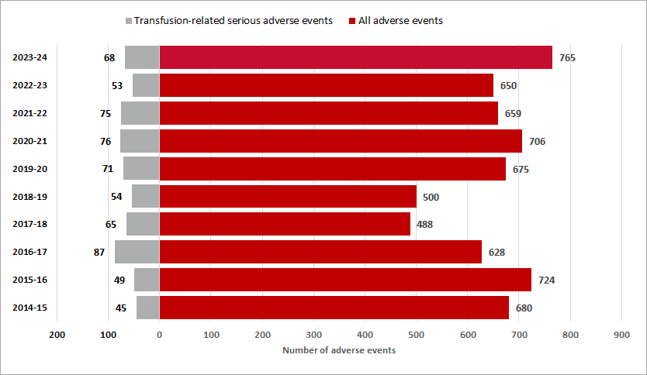
Figure 1: All reported adverse events and transfusion-related serious adverse events, 2014-15 to 2023-24

Figure 2 shows the percentage of all reported adverse events by year from 2019-20 to 2023-24. Febrile non-haemolytic transfusion reaction (FNHTR) and allergic reactions accounted for 62.3% of all reported adverse events (2,153 of 3,455). Transfusion-associated circulatory overload (TACO) and anaphylactic reactions accounted for 10.7% (369 of 3,455) and 3.1% (107 of 3,455) of all adverse events respectively. Refer to Appendix 1 Table 3 for detailed adverse event data from 2019-20 to 2023-24.
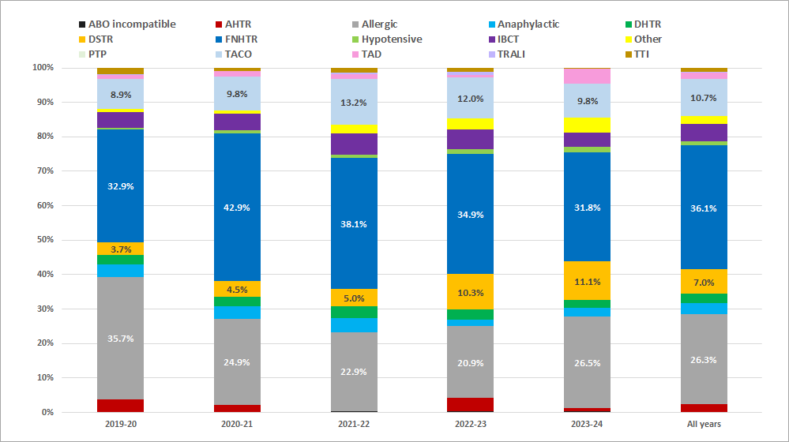
Figure 2: Percentage of all reported adverse events by year, 2019-20 to 2023-24
Figure 3 shows that TACO and anaphylactic reactions accounted for 52.8% of total transfusion-related SAEs (181 of 343). FNHTR and allergic reactions accounted for 28.9% of total transfusion-related SAEs (99 of 343). Refer to Appendix 1 Table 4 for detailed transfusion-related SAE data from 2019-20 to 2023-24.
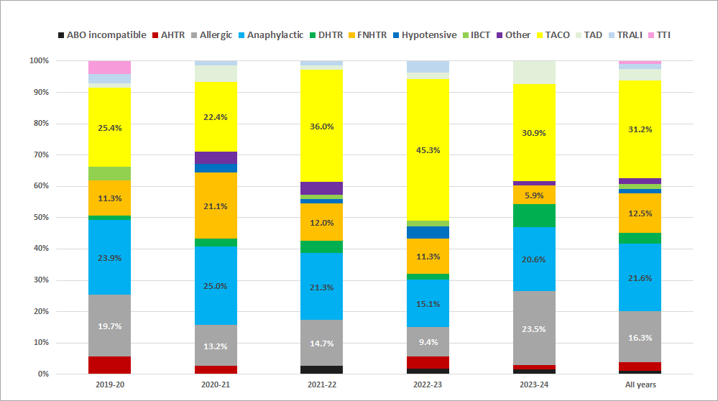
Figure 3: Percentage of transfusion-related serious adverse events by year, 2019-20 to 2023-24
Figure 4 shows the number of all reported adverse events by hospital type from 2019-20 to 2023-24. Public hospitals reported 88% of adverse events (3,032 of 3,455), compared with 12% reported by private hospitals (423 of 3,455).
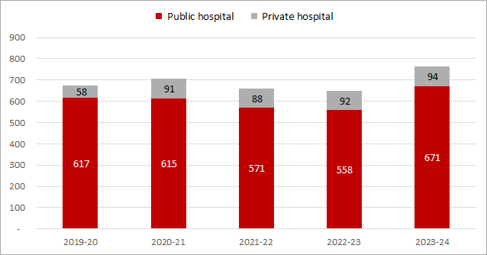
Figure 4: All reported adverse events by hospital type, 2019-20 to 2023-24
Figure 5 shows all reported adverse events and SAEs by state and territory from 2019-20 to 2023-24. Queensland (QLD) reported the most adverse events (1,459 of 3,455 or 42%). Victoria (VIC) reported the most SAEs (113 of 343 or 33%).
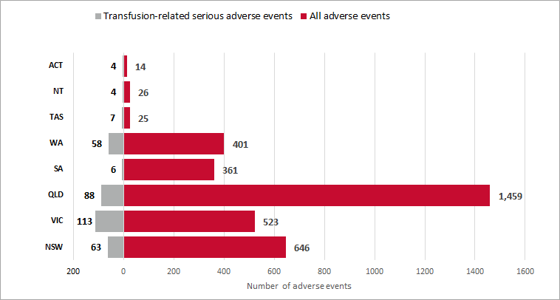
Figure 5: Number of adverse events and transfusion-related serious adverse events by state and territory, 2019-20 to 2023-24

TACO is the leading cause of SAEs in Australia and is responsible for most deaths in the United Kingdom (UK). The UK Serious Hazards of Transfusion (SHOT) has developed a TACO checklist (also known as the pre-transfusion risk assessment), to help identify patients at risk of developing TACO during or after a blood transfusion. It involves assessing various risk factors and clinical signs to determine the likelihood of TACO. The checklist image below is taken from the 2024 Annual SHOT Report.
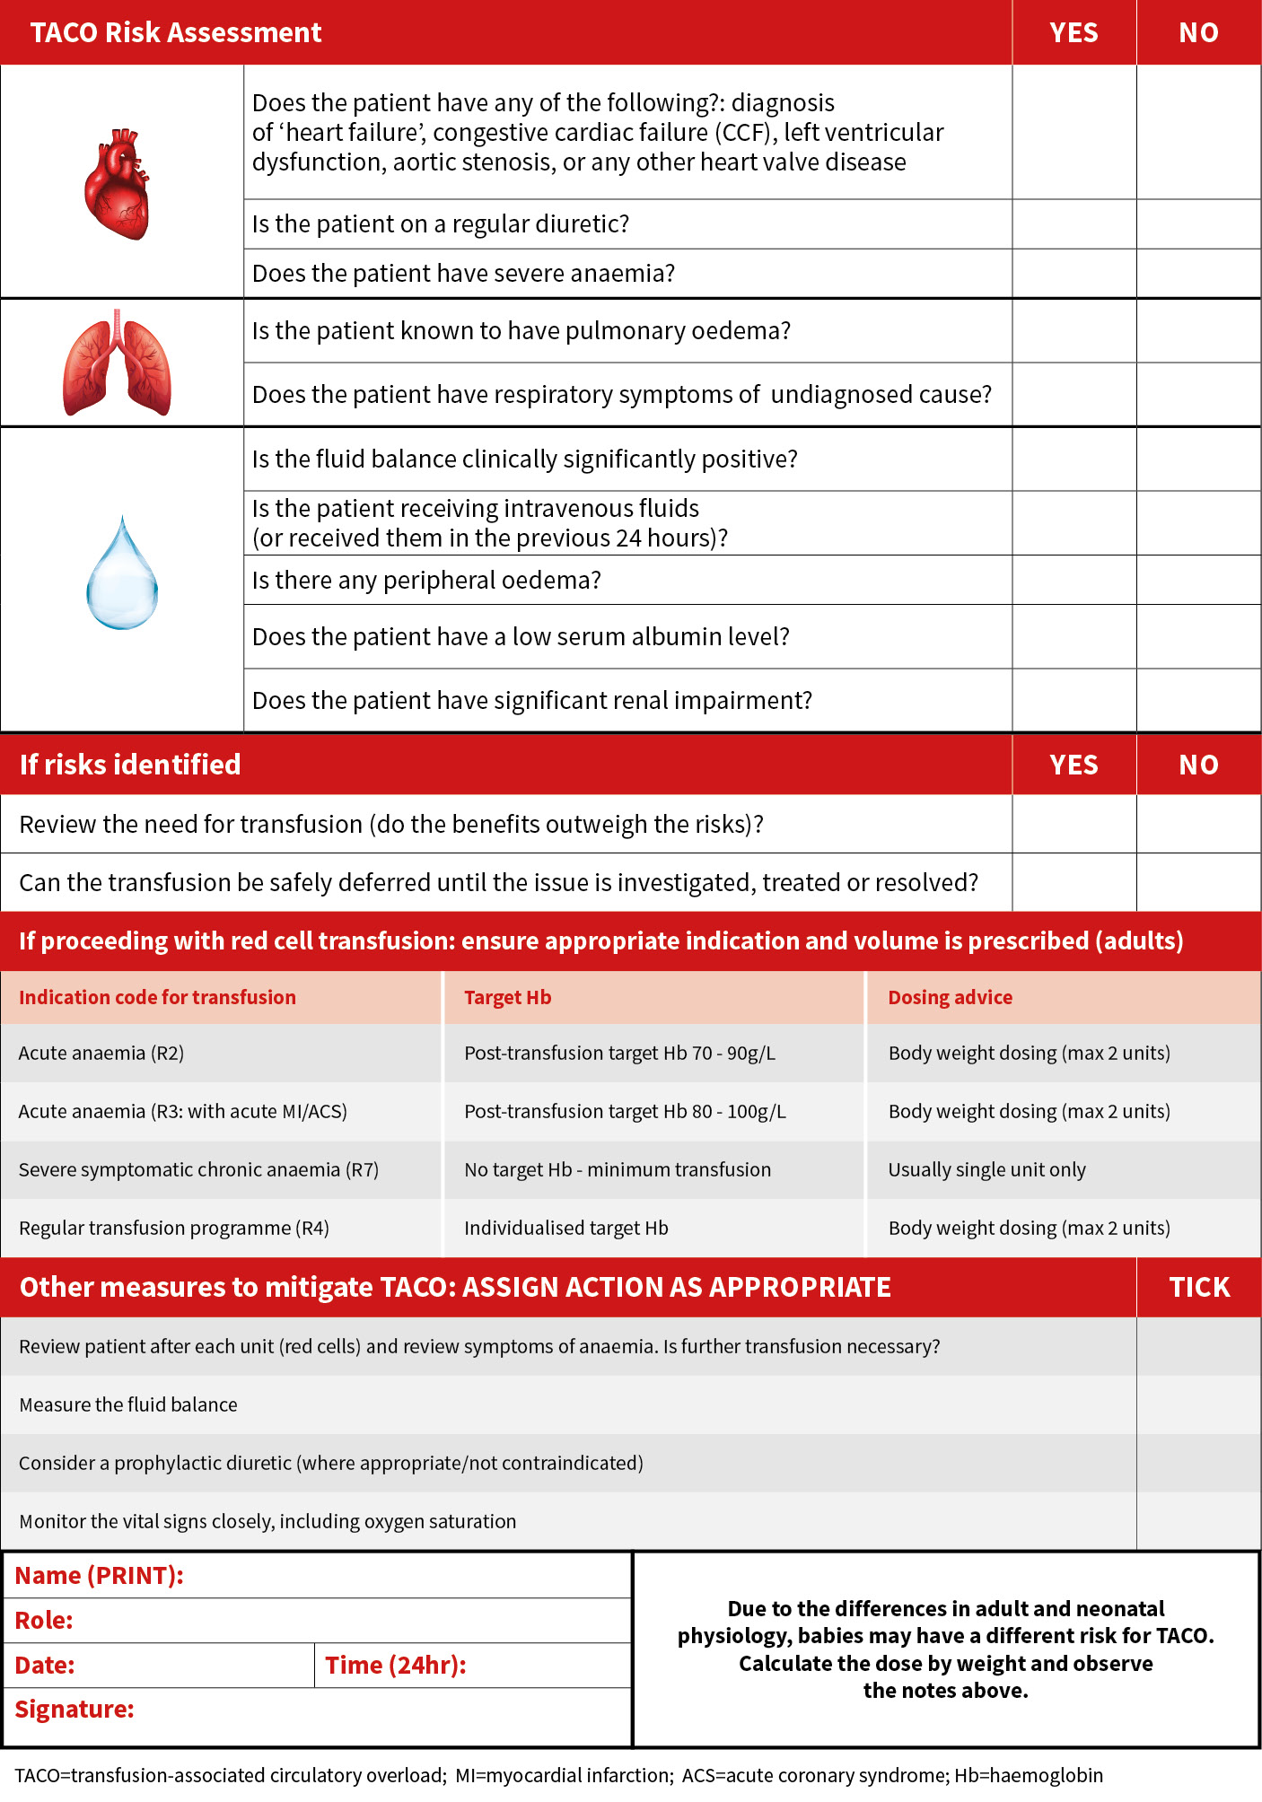

SECTION 1

Australian Haemovigilance Data

Introduction
From 2019-20 to 2023-24, there were around one million units of fresh blood products issued in Australia each year. Red blood cells (RBC) and platelets accounted for around 65% and 14% of all issues respectively. RBCs are associated with the highest number of adverse events, followed by platelets and fresh frozen plasma (FFP).
Table 1: Issues by fresh blood products, 2019-20 to 2023-24
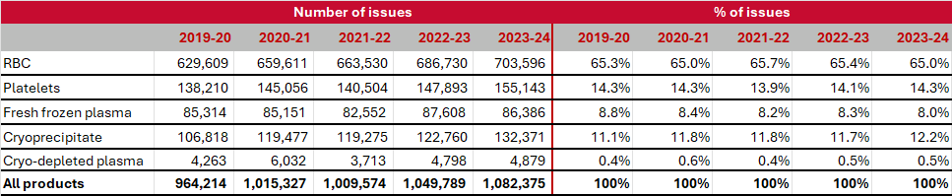
Note: Data from Australian Red Cross Lifeblood for fresh blood products issued to Australian
Health Providers under contract to the NBA
The national haemovigilance program receives reports from states and territories for adverse events related to the transfusion of fresh blood products. States and territories use different haemovigilance reporting processes which may lead to inconsistencies in reporting and recording of adverse events in the national haemovigilance program.
Aggregated haemovigilance data, supplied through State and Territory Departments of Health, are analysed for national trends and other indicators. Reports also refer to the national data in the context of previous national haemovigilance data. The function of national haemovigilance reports is to identify the incidence and causes of voluntarily reported adverse transfusion events and make recommendations for national quality and safety investments that can lead to genuine improvements in patient safety outcomes in Australia. National haemovigilance reports are issued by the NBA after advice from the Haemovigilance Advisory Committee (HAC). It is desirable to publish national reports annually.
The report presents the data and analysis for all adverse events for five years from 2019-20 to 2023-24, and for 2023-24 only.

Collection and reporting process
In Australia, haemovigilance is undertaken at hospital, local health network or state/territory level, supported by a national data collection and reporting process. Data is collected at the hospital, local health network or state/territory level, and they are responsible for the review of reported incidents to assess the validity and imputability of the incident, the seriousness of the incident, and assessment of the cause of the incident being related to the transfusion.
The roles and responsibilities within Australia are depicted below in Figure 6, together with the data collection and reporting obligations at each level.
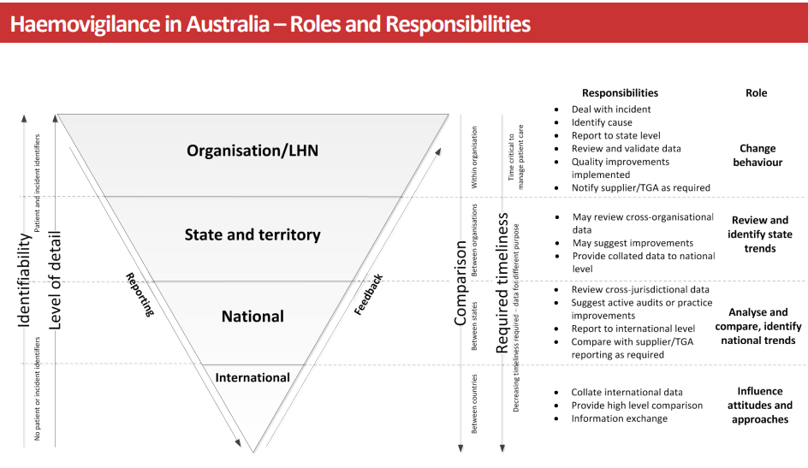
Figure 6: Haemovigilance in Australia – Roles and Responsibilities
Northern Territory (NT), ACT, VIC and Tasmania (TAS) provide their data to STIR (Serious Transfusion Incident Reporting system managed by Blood Matters in Victoria) to conduct this review, while others manage this process themselves, or do not do a review outside of the local level. Following review, the data is validated in line with the AHMDS before providing the data to the NBA as shown in Figure 7.
Figure 7: Reporting adverse events and haemovigilance in Australia
Note: NSQHS – National Safety and Quality Health Service, TGA – Therapeutic Goods Administration

Caveats and Assumptions
Reporting of haemovigilance data to the national haemovigilance program is voluntary and data validation is not performed in all instances in Australia. When using the data from this report it is important to note that there are quality issues in relation to data completeness, standardisation, and relevance. Notwithstanding these limitations, the NBA is publishing this data as an aid to relevant analysis and to maintain the time series of data published during the last fourteen years.
- All states and territories except QLD reported the data in line with the NBA Australian Haemovigilance Minimum Data Set (AHMDS) 2015. QLD uses the NBA National Haemovigilance Data Dictionary (NHDD) 2010 except for the imputability scores which are based on the 2015 AHMDS.
- The definitions for the adverse events in Appendix 3 of the 2010 NHDD and 2015 AHMDS align with those used by the International Haemovigilance Network (IHN) and International Society Blood Transfusion (ISBT) unless otherwise stated.
- All states and territories have contributed data to the NBA since 2015-16. However, the level of details and data provided vary across years and between states and territories.
- The use of different haemovigilance reporting processes across the jurisdictions may lead to data inconsistencies.
- Near misses and denominator data (number of transfusions) are not collected and reported at a national level.
- All the 2023-24 transfusion-transmitted infection (TTI) data have been verified with the states and territories.
- STIR system reports serious adverse events and excludes non-transfusion related adverse events.
- The number of adverse events per transfusion rate is unavailable as the number of transfusions is not reported.
- QLD has consistently reported a disproportionately higher number of transfusion-related adverse events, particularly FNHTRs, compared to other Australian jurisdictions. This difference stems primarily from QLD's comprehensive haemovigilance reporting coverage across both its public and private hospital sectors, and its inclusive practice of reporting non-serious FNHTRs. The AHMDS does not explicitly prohibit the submission of non-serious FNHTRs for national reporting. Other jurisdictions typically limit their national reporting to only serious FNHTRs.

Hospital participation in haemovigilance reporting
Since 2019-20, the NBA has been collecting data from states and territories on participating and reporting hospitals.
- A participating hospital is a hospital that participates in state or territory haemovigilance reporting that reports zero or more adverse events.
- A reporting hospital is a participating hospital that reports one or more adverse events.
Figure 8 illustrates the differences in participation and reporting between public and private hospitals at the national level. The majority of participating and reporting hospitals are public. Private hospitals continue to under report transfusion adverse events in Australia. The NBA is collaborating with HAC to engage with the private sector in haemovigilance reporting through a consultancy initiative as part of the NBA’s broad private sector engagement strategy.
In Australia there are 1,335 declared facilities to be a hospital, consistent with Section 121 of the Private Health Insurance Act 2007. Of this there are 636 private hospitals and 699 public hospitals. Some of these hospitals receive blood and blood products, directly from our suppliers, through pathology providers and through transfer arrangements. Further work on determining the number of hospitals that receive and transfuse blood and blood products is being undertaken.
Refer to Appendix 1 Table 6 and Table 7 for further information for the state and public/private differences.
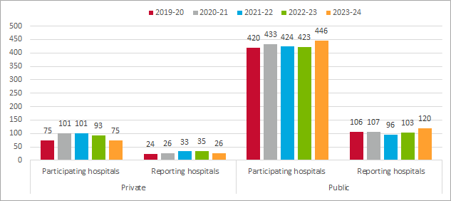
Figure 8: Number of participating and reporting hospitals by public/private and state/territory, 2019-20 to 2023-24
Figure 9 presents hospital participating and reporting data for states and territories in 2023-24. A total of 521 hospitals participated in national haemovigilance reporting, including 446 public hospitals and 75 private hospitals. Of these, 28% of participating hospitals (146 hospitals) reported adverse events, comprising 120 public hospitals and 26 private hospitals. Four states (VIC, QLD, WA and TAS) reported adverse events for private hospitals. QLD had the highest number of reporting and participating hospitals for private hospitals. However, private hospitals in NSW and SA did not participate in national haemovigilance reporting. Nationally, 5.2 adverse events per hospital were reported for 2023-24. This varied between states and territories, ranging from 1.0 in NT to 6.5 in QLD in Figure 10.
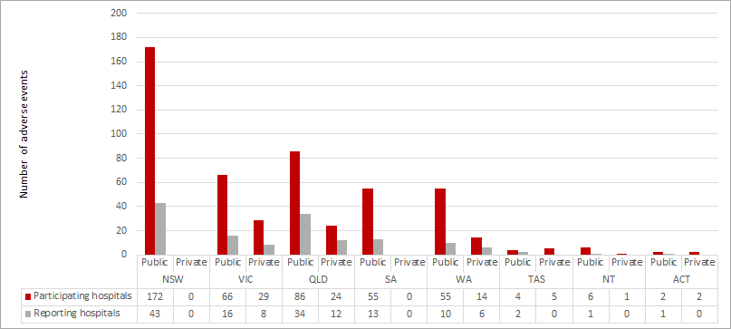
Figure 9: Number of participating and reporting hospitals by public/private and state/territory,
2023-24
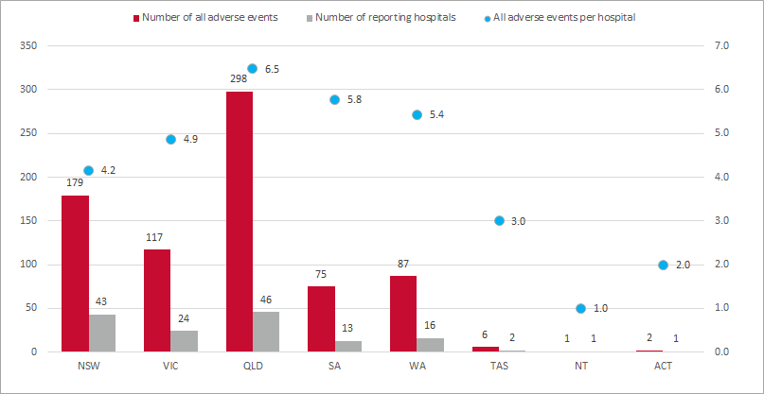
Figure 10: Number of adverse events per hospital by state/territory, 2023-24

Results for all adverse events, 2019-20 to 2023-24
This section presents the data and key results for all reported adverse events between 2019-20 and 2023-24.
Eight states and territories reported 3,455 transfusion adverse events of 15 different types to the National Haemovigilance Program events between 2019-20 and 2023-24.
Figure 11 shows that QLD had reported the most adverse events over five years, followed by NSW and VIC. Refer to Appendix 1 Table 8 for detailed state data from 2019-20 to 2023-24 and Appendix 2 Table 17 for the detailed state adverse event data for 2023-24.
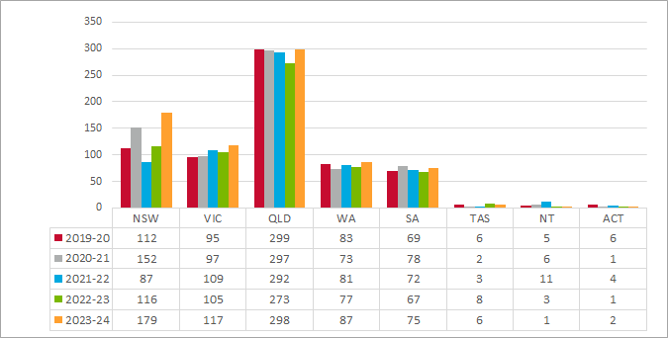
Figure 11: All adverse events by state, 2019-20 to 2023-24
Figure 12 illustrates that adverse events reported for female patients increased from 267 in 2019-20 to 418 in 2023-24, while those for unknown sex declined from 87 in 2019-20 to 5 in 2023-24.
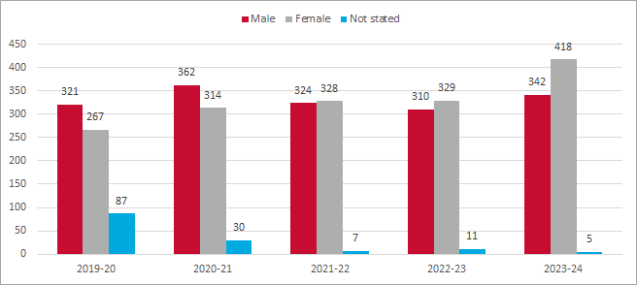
Figure 12: All adverse events by sex, 2019-20 to 2023-24

Thirty per cent (1,021 of 3,455) of reported adverse events were linked to overnight transfusions in Figure 13. Various reactions are equally likely to occur at different times of day but more likely to be detected during better staffed hours. Some outcomes are under reported as they happen after a patient leaves hospital and the total transfusion rates are not reported. Refer to Appendix 1 Table 9 Part 1 and 2 for further information for detailed transfusion time data from 2019-20 to 2023-24.
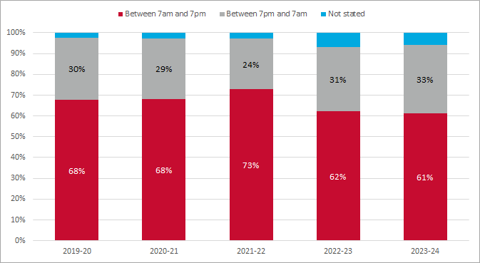
Figure 13: All adverse events by transfusion time, 2019-20 to 2023-24
Figure 14 presents that 22% (754 of 3,455) of reported adverse events occurred during weekend transfusions. Refer to Appendix 1 Table 10 for detailed transfusion weekday/weekend data from 2019-20 to 2023-24.
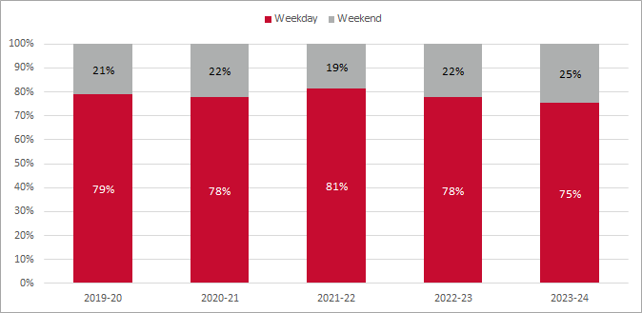
Figure 14: All adverse events by weekday/weekend, 2019-20 to 2023-24

Figure 15 shows that 76% (2,622 of 3,455) of reported adverse events occurred in major cities across Australia. Refer to Appendix 1 Table 11 Parts 1 to 3 detailed remoteness data from 2019-20 to 2023-24.
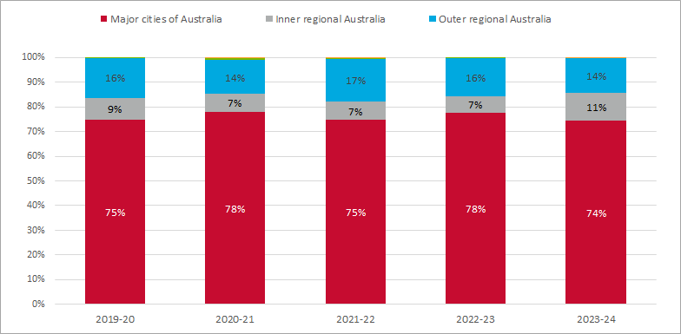
Figure 15: All adverse events by remoteness, 2019-20 to 2023-24
Figure 16 shows that the proportion of reported blood transfusion adverse events (imputability = definite, probable, possible) increased from 75% in 2022-23 to 86% in 2023-24. Refer to Appendix 1 Table 13 Parts 1 to 3 for detailed imputability score data from 2019-20 to 2023-24.
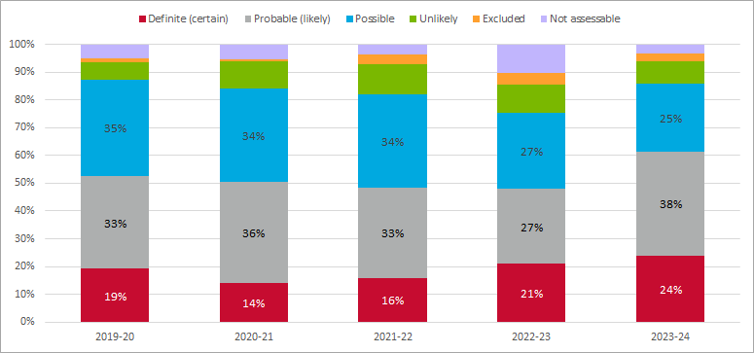
Figure 16: All adverse events by imputability score, 2019-20 to 2023-24
On average, death, life-threatening conditions, and severe morbidity events accounted for 11.2% of all reports in Figure 17. The percentage of life-threatening and severe morbidity cases was at its lowest in 2022-23, compared to the other four years. 0.3% (12 of 3,455) reported adverse events were related to death. Refer to Appendix 1 Table 14 Parts 1 to 3 for detailed clinical outcome severity data from 2019-20 to 2023-24.
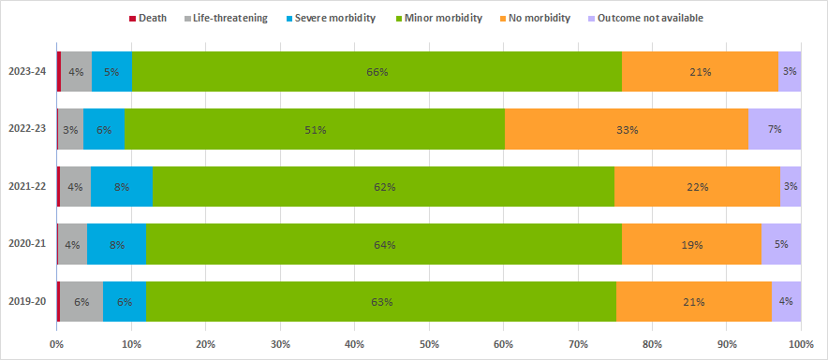
Figure 17: All adverse events by clinical outcome severity, 2019-20 to 2023-24
Figure 18 illustrates that the percentage of RBC transfusion adverse events reported increased over four years from 2019-20 to 2022-23. In contrast, platelet and FFP transfusion adverse events declined during the same period. On average, the proportion of RBC and FFP transfusion adverse events aligns closely with the corresponding percentage of issues in Table 1. However, the proportion of platelet transfusion adverse events exceeds the percentage of issues. Refer to Appendix 1 Table 16 for detailed product data from 2019-20 to 2023-24.
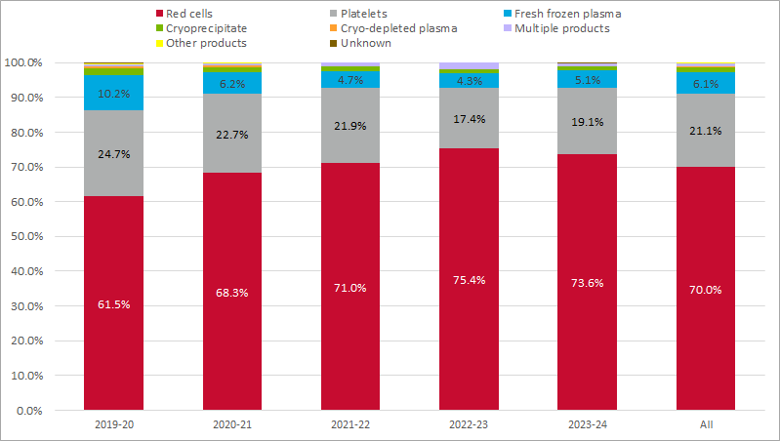
Figure 18: All adverse events by product, 2019-20 to 2023-24
Further 5-year trend data (2019-20 to 2023-24) is presented in Appendix 1. States and territories report data on factors contributing to each adverse event where applicable.
One adverse event might be associated with more than one contributory factors.

Results for all adverse events, 2023-24
This section presents the data and key results for all reported adverse events for 2023-24. There were 765 total reported adverse events for 2023-24 spanning 13 different event types, across 146 hospitals.
Figure 19 and Figure 20 show:
- more adverse events were reported for females than males except in the 55 to 74 age groups
- 22% (76 cases) more adverse events were reported for females than males
- 13 more reports of Delayed serologic transfusion reactions (DSTR) and 12 more reports of allergic reaction and Transfusion-Associated Dyspnoea (TAD) were reported for female patients
- transfusion rates are not reported as part of the data set
- limitations in haemovigilance reporting for children under 18 exist due to the broad Australian Bureau of Statistics (ABS) age group classifications.
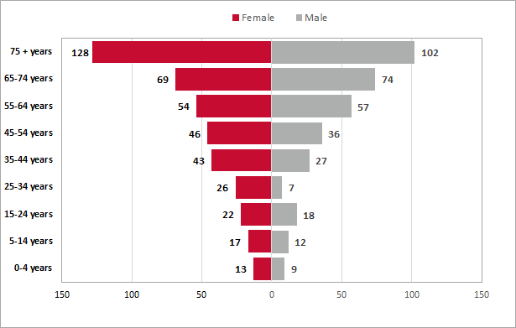
Figure 19: All adverse events by age and sex, 2023-24
Note: The data excludes unspecified sex

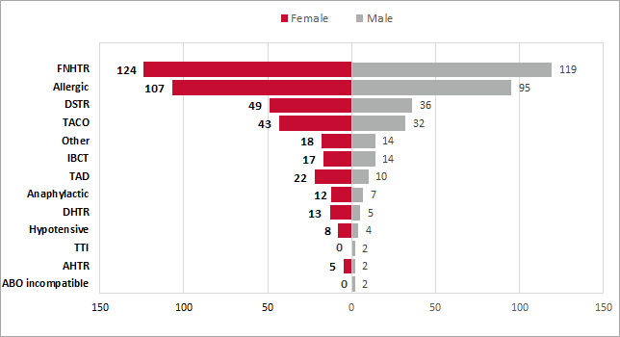
Figure 20: All adverse events by sex, 2023-24
Note: The data excludes unspecified sex
Figure 21 presents the proportion of adverse events across different age groups for 2023–24. Allergic reactions were the most reported adverse events in the 5 to 44 age groups. In contrast, FNHTR is the most reported in the remaining age groups. TACO was notably more prevalent in the under-five (18%) and over 75 age groups (16%) compared to other age groups. DSTR accounted for 16% of reported adverse events in the 65-74 age group. Refer to Appendix 2 Table 18 for detailed age group data for 2023-24.
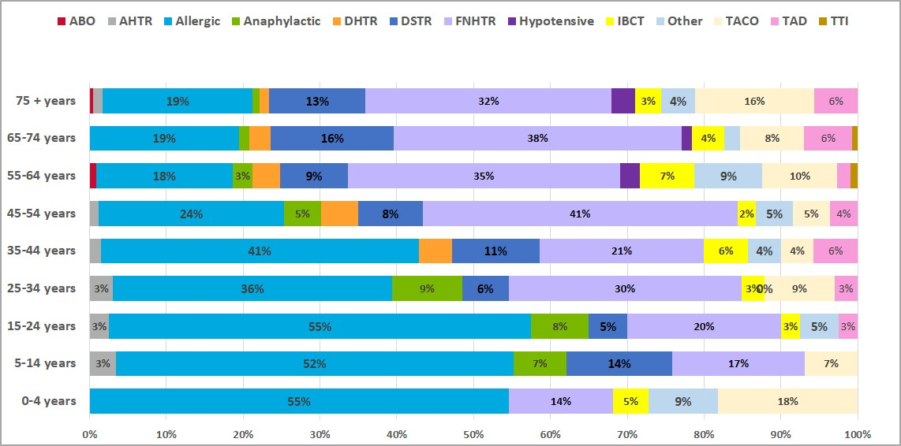
Figure 21: Percentage of all adverse events by age group, 2023-24
Figure 22 and Figure 23 show:
- one third (252 of 765) of adverse events occurred during overnight transfusions (7pm to 7am)
- more TACO, Incorrect blood component transfused (IBCT) and ‘Other’ adverse events occurred during overnight transfusions compared to daytime
- one in four (189 of 765) adverse events took place over weekends, with 33% of TACO and TAD and 39% of DSTR cases occurring during weekends.
Refer to Appendix 1 Table 9 and Table 10, and Appendix 2 Table 19 for detailed transfusion time and day data for 2023-24.
ANZSBT Guideline for the Administration of Blood Products (3rd Edition) recommends that ‘Transfusion must only take place when it is appropriately resourced; that is, where enough trained staff are available to monitor the patient, the patient can be observed and emergency medical support is readily available. Overnight or out-of-hours transfusion should be avoided unless clinically indicated.’
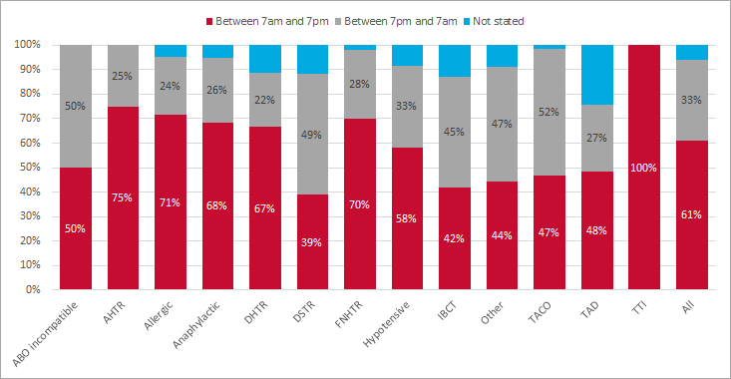
Figure 22: All adverse events by transfusion time, 2023-24
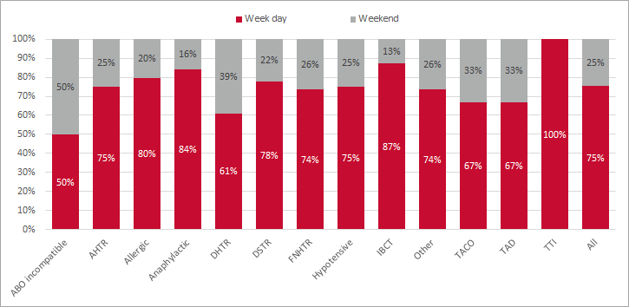
Figure 23: All adverse events by weekday/weekend, 2023-24

Figure 24 shows that 569 of 765 (74.4%) reported adverse events occurred in major cities, while only 0.2% occurred in remote areas. Refer to Appendix 1 Table 11 for detailed remoteness data for 2023-24.
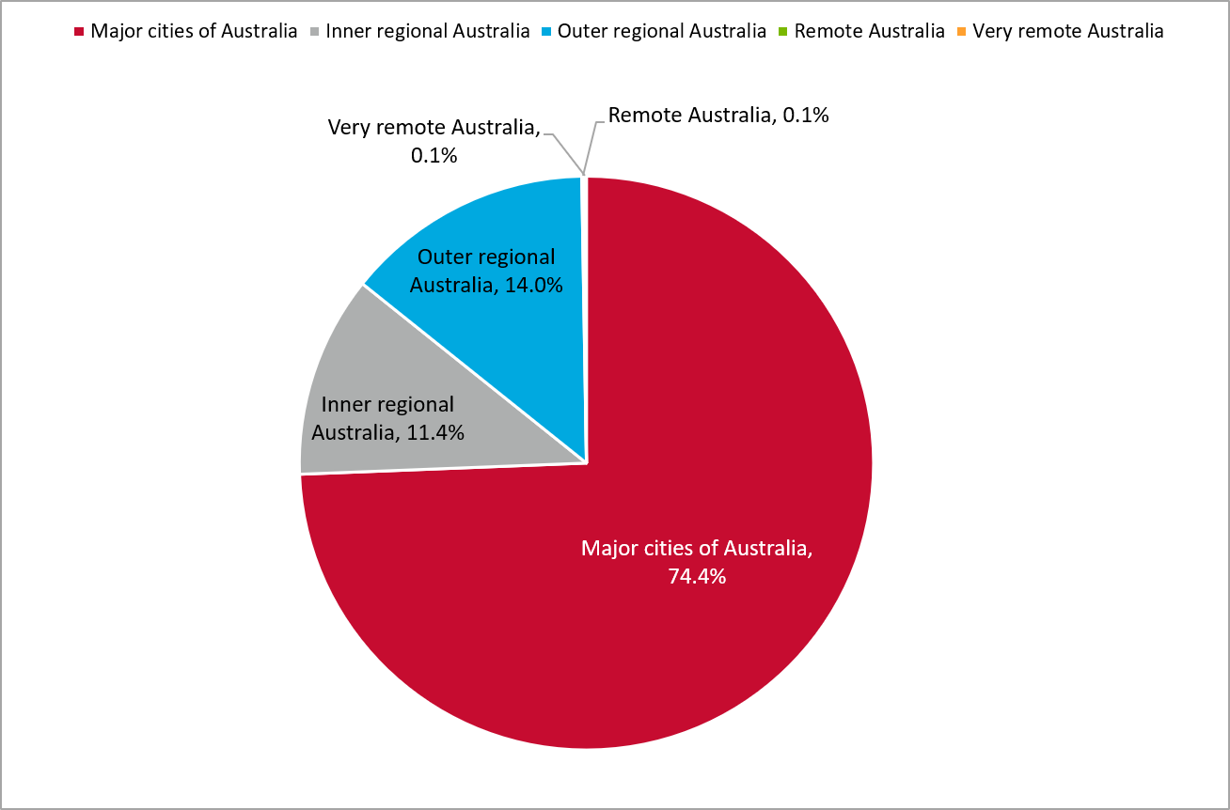
Figure 24: Percentage of adverse events by remoteness, 2023-24
Figure 25 shows that 86% (658 of 765) of reported adverse events were definitely, probably, or possibly related to blood transfusions for 2023-24.
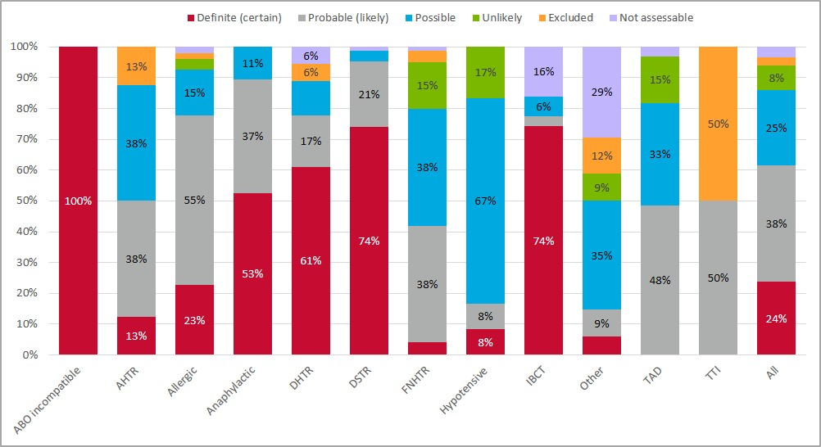
Figure 25: Percentage of adverse events by imputability score, 2023-24
Refer to Appendix 1 Table 13 for detailed imputability score data for 2023-24.
A breakdown of adverse events by clinical outcome severity in Table 2 shows:
- two hypotensive, one TAD and one ‘Other’ related deaths were reported
- life-threatening and severe morbidity adverse events accounted for 10% of total reports
- 87% of reported adverse events related to minor or no morbidity.
Table 2: All adverse events by clinical outcome severity, 2023-24
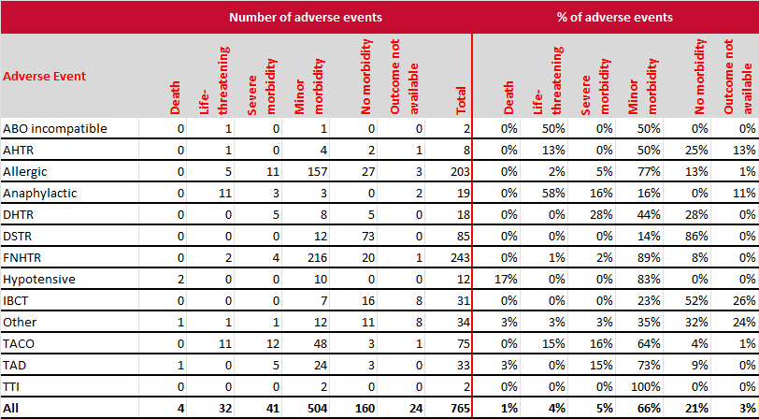
Figure 26 highlights that
- 38.2% of RBC transfusion adverse events and 16.4% of platelet transfusion adverse events were FNHTRs.
- 67.8% of platelet-related adverse events and 71.8% of FFP-related adverse events were allergic reactions
- 15.1% of RBC transfusion adverse events were DSTR cases.
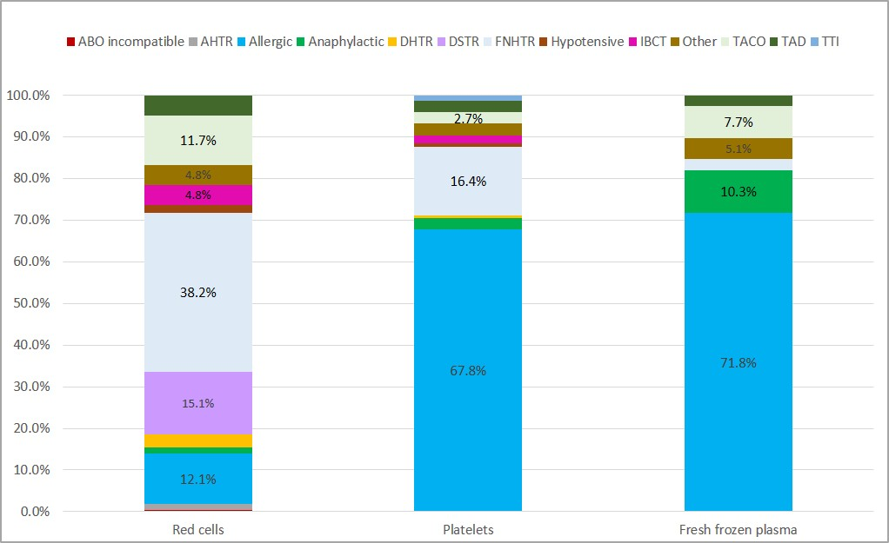
Figure 26: Percentage of products by adverse event, 2023-24

Recommendations
This report restates the five recommendations made in the 2021-22 report. Further work is being undertaken to understand the barriers and incentives to national haemovigilance in Australia that will inform future recommendations.

Guideline development
- Publish the revised AHMDS.
- Publish new Guidance on Investigation and Management of Acute Transfusion Reactions.

National tools and resources
- Develop case studies for identified clinical priorities.
- Update the haemovigilance reporting forms in line with the new version of AHMDS when released.

Education and training
- Identify training needs for haemovigilance at AHP level.

Private sector engagement
- Engage with the private sector in haemovigilance reporting through a consultancy initiative.
The National Blood Research and Development Strategic Priorities 2022-27 highlights the need for research in haemovigilance and in particular “Priority 3: Reduce donor and patient adverse events”.

Appendix 1: Trend Data for 2019-20 to 2023-24
This section presents further data for adverse events from 2019-20 to 2023-24, in support of the data in the previous sections.
Table 3: Number of all adverse events, 2019-20 to 2023-24
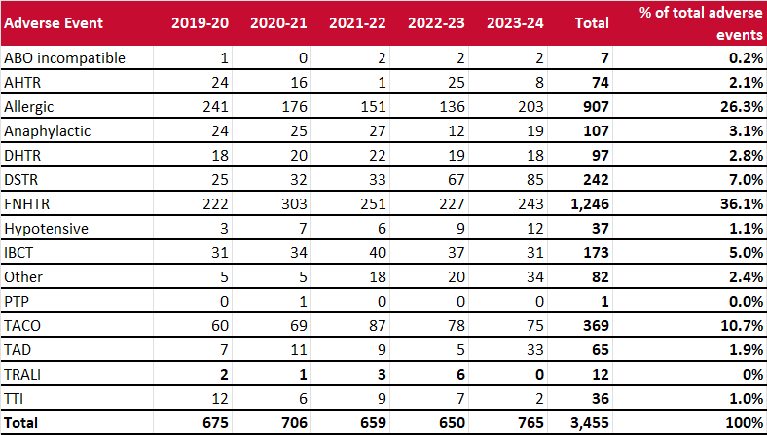
Table 4: Number of transfusion-related serious adverse events, 2019-20 to 2023-24
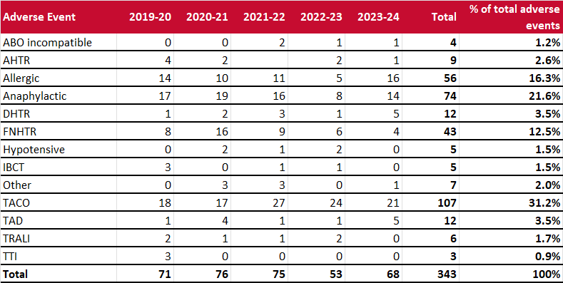
Note: The use of different haemovigilance reporting processes across the jurisdictions may lead to data inconsistencies.

Table 5 shows that 88% of events were reported by public hospitals. There was an increase in reporting from both public and private hospitals in 2023-24. Table 6 and Table 7 show the number of private and public participating and reporting hospitals. Refer to the Hospital participation in haemovigilance reporting section for the definitions and information about participating and reporting hospitals.
Table 5: All adverse events by hospital type, 2019-20 to 2023-24
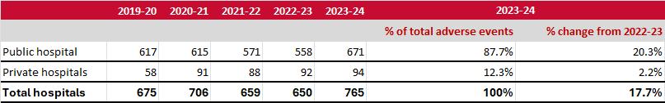
Table 6: Number of private participating and reporting hospitals by state/territory,
2019-20 to 2023-24
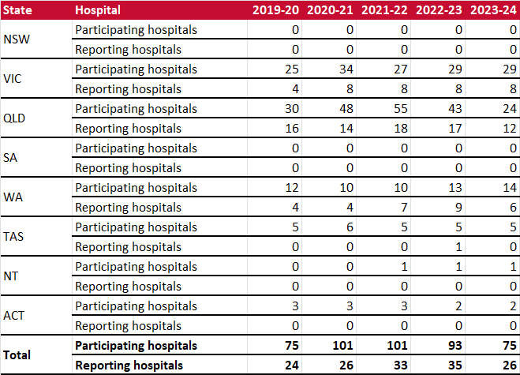
Table 7: Number of public participating and reporting hospitals by state/territory,
2019-20 to 2023-24
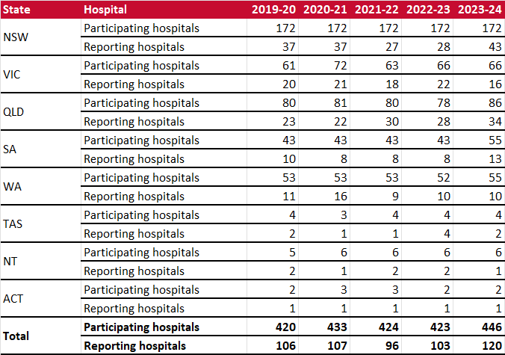
Table 8: All adverse events by state/territory, 2019-20 to 2023-24
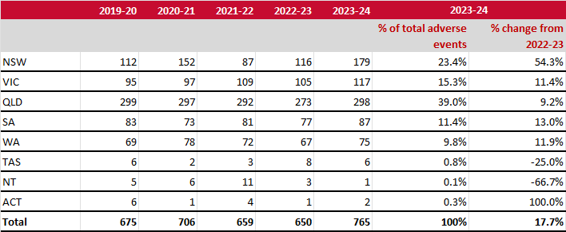
Table 9: All adverse events by time, 2019-20 to 2023-24 – Part 1
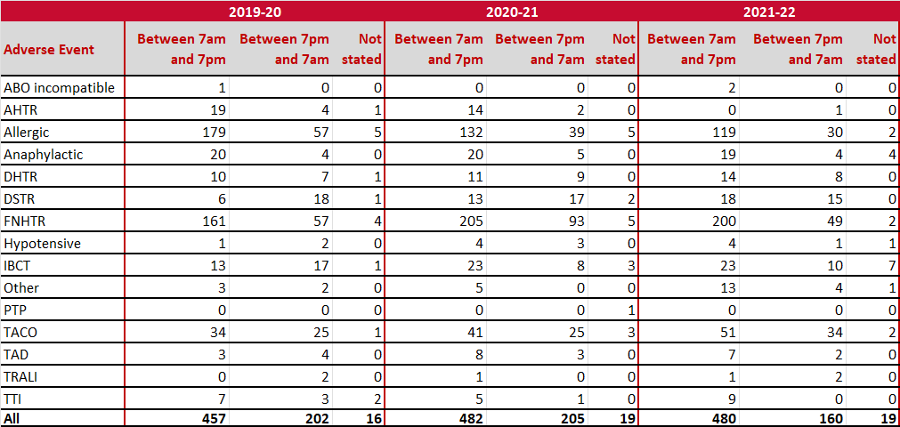
Table 9: All adverse events by transfusion time, 2019-20 to 2023-24 – Part 2
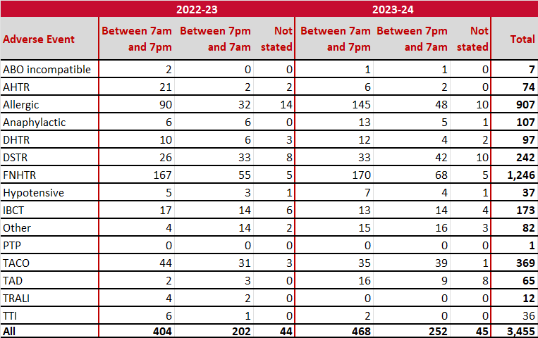

Table 10: All adverse events by weekday/weekend, 2019-20 to 2023-24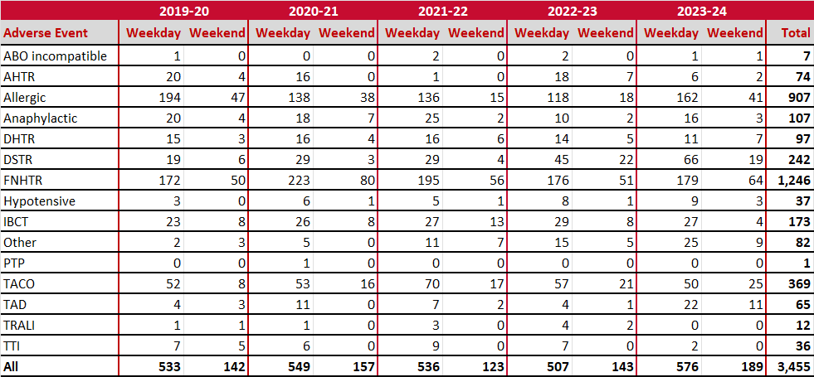
Table 11: All adverse events by remoteness, 2019-20 to 2023-24 – Part 1
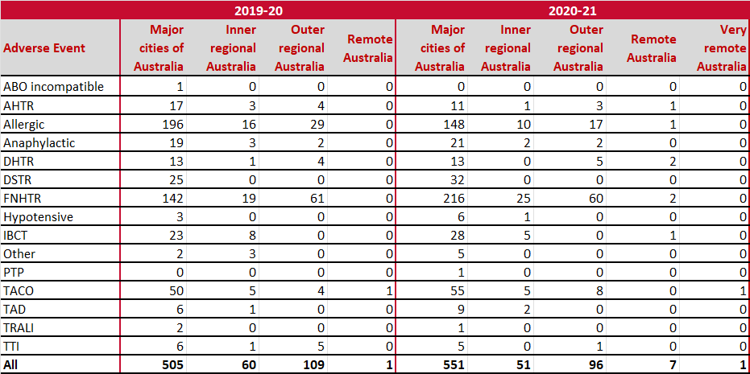
Table 11: All adverse events by remoteness, 2019-20 to 2023-24 – Part 2
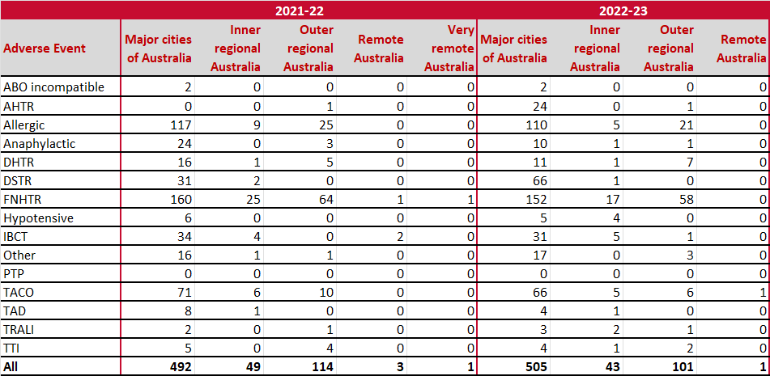
Table 11: All adverse events by remoteness, 2019-20 to 2023-24 – Part 3
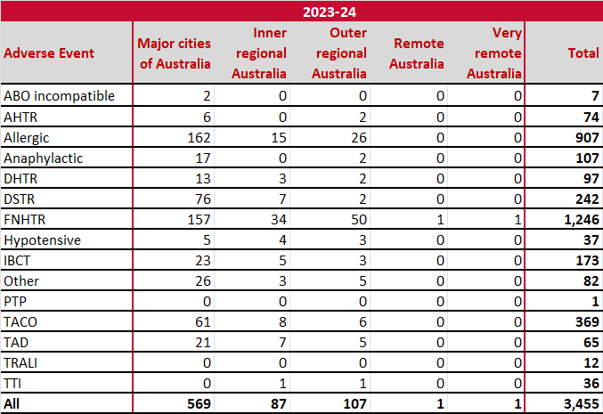
Table 12: Issues by fresh blood product and remoteness, 2019-20 to 2023-24 – Part 1
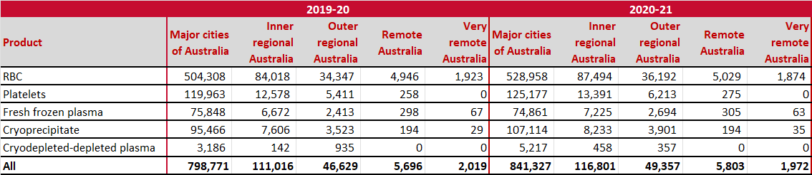
Table 12: Issues by fresh blood product and remoteness, 2019-20 to 2023-24 – Part 2
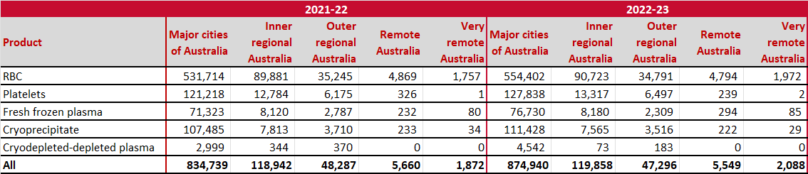
Table 12: Issues by fresh blood product and remoteness, 2019-20 to 2023-24 – Part 3
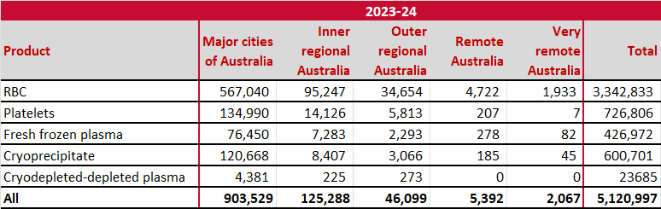
Table 13: All adverse events by imputability score, 2019-20 to 2023-24 – Part 1
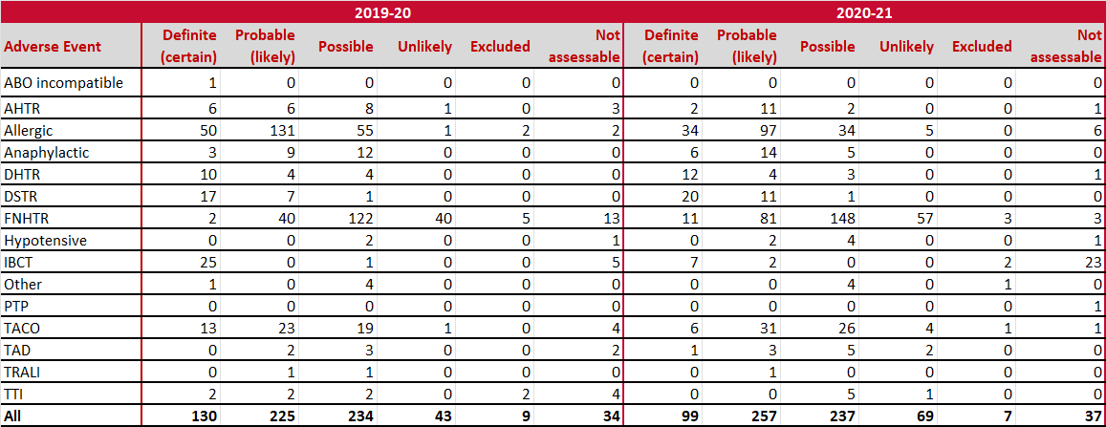
Table 13: All adverse events by imputability score, 2019-20 to 2023-24 – Part 2
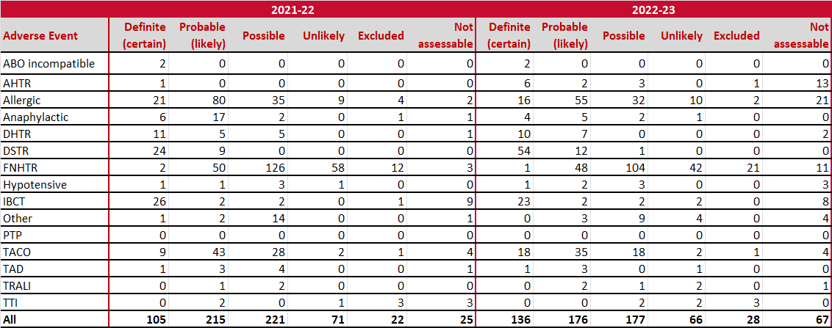
Table 13: All adverse events by imputability score, 2019-20 to 2023-24 – Part 3
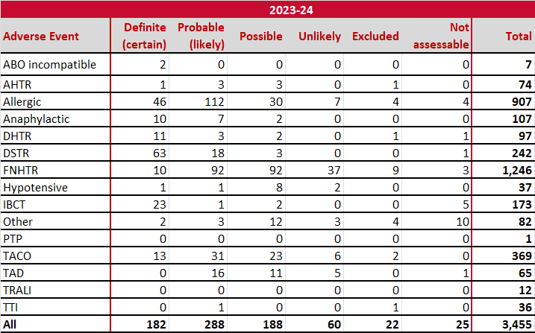

Table 14: All adverse events by clinical outcome severity, 2019-20 to 2023-24 – Part 1
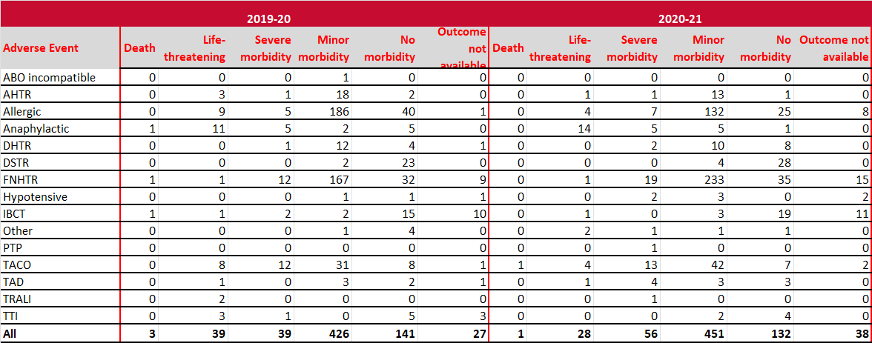
Table 14: All adverse events by clinical outcome severity, 2019-20 to 2023-24 – Part 2
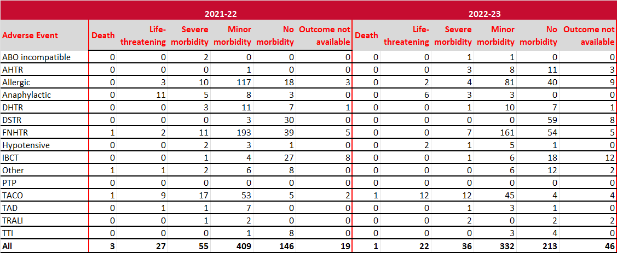
Table 14: All adverse events by clinical outcome severity, 2019-20 to 2023-24 – Part 3
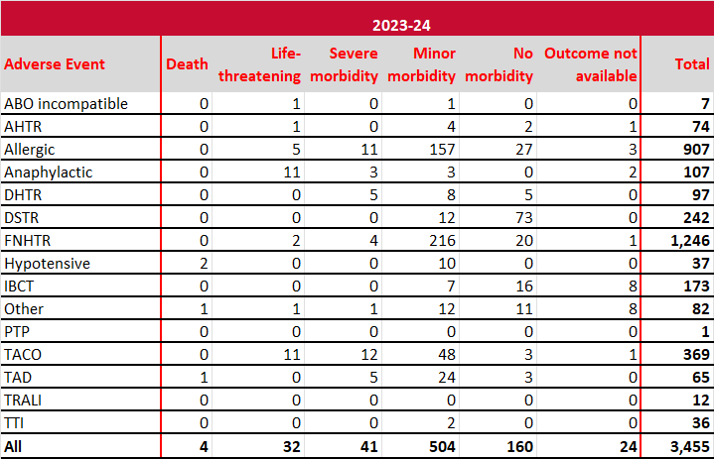

Table 15 highlights from 2019-20 to 2023-24 that:
- 44.5% (1,077 of 2,418) of RBC transfusion adverse events and 20.5% (150 of 730) of platelet transfusion adverse events were FNHTRs
- 56.6% (413 of 730) of platelet-related adverse events, 72.5% (153 of 211) of FFP-related adverse events, 65.2% (30 of 46) cryoprecipitate transfusion adverse events and 87.5% (7 of 8) cryo-depleted plasma transfusion adverse events were allergic reactions
- 13.6% (329 of 2,418) of RBC transfusion adverse events were TACOs
- 12.8% (27 of 211) of FFP transfusion adverse events were anaphylactic reactions.
Table 15: All adverse events by product, 2019-20 to 2023-24
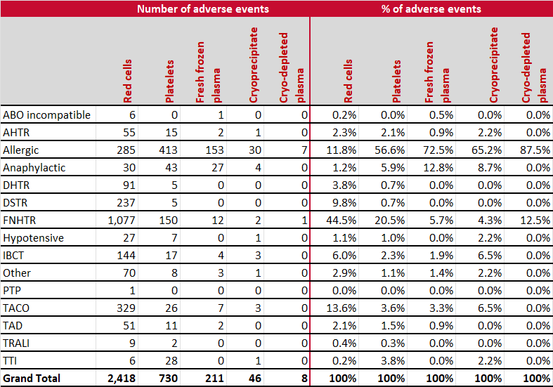
Table 16: All adverse events by product and year, 2019-20 to 2023-24
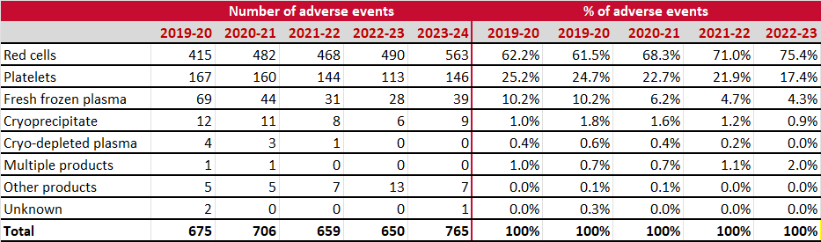

Appendix 2: Data for 2023-24
Table 17 shows that the percentages of RBC issued by Lifeblood are reasonably consistent with the population percentage for each state and territory. In contrast, QLD reported a much higher percentage of adverse events (39%) when compared with the population percentage and RBC issue percentage. This is due to reported FNHTRs events of 176. The use of different haemovigilance reporting processes across the jurisdictions may lead to these data inconsistencies.
Table 17: All adverse events by state, 2023-24
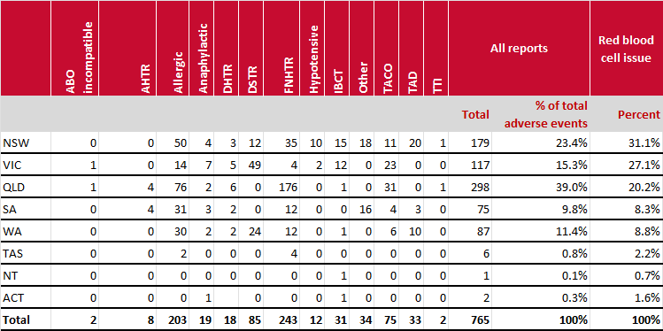
Table 18: All adverse events by age group, 2023-24
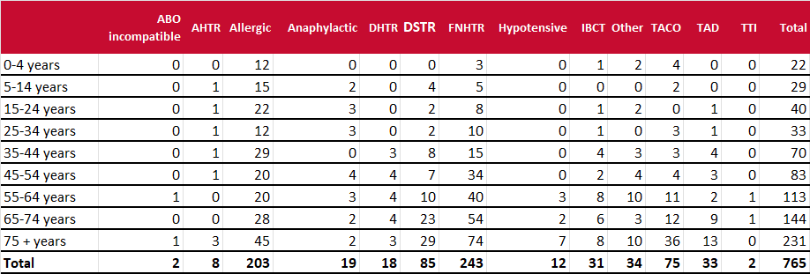

Table 19: All adverse events by transfusion day and time, 2023-24
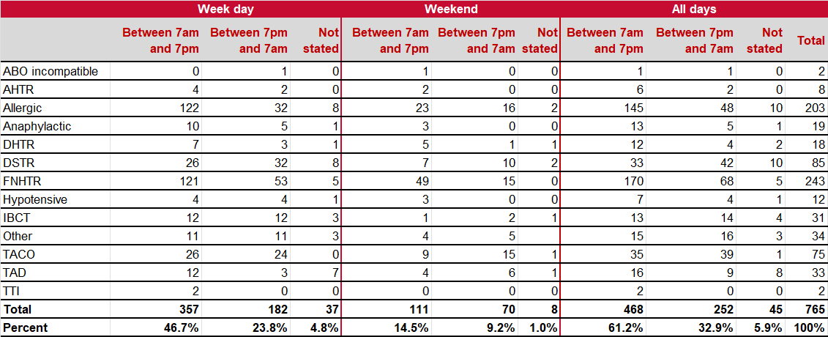
Table 20: All adverse events by blood product, 2023-24
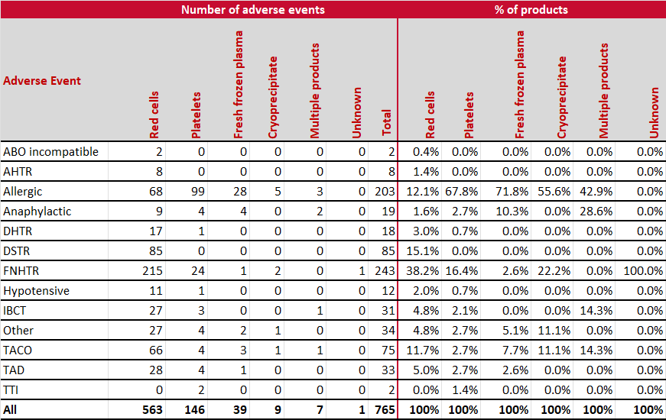
Table 21: Contributory factors by adverse event and by clinical outcome severity, 2023-24
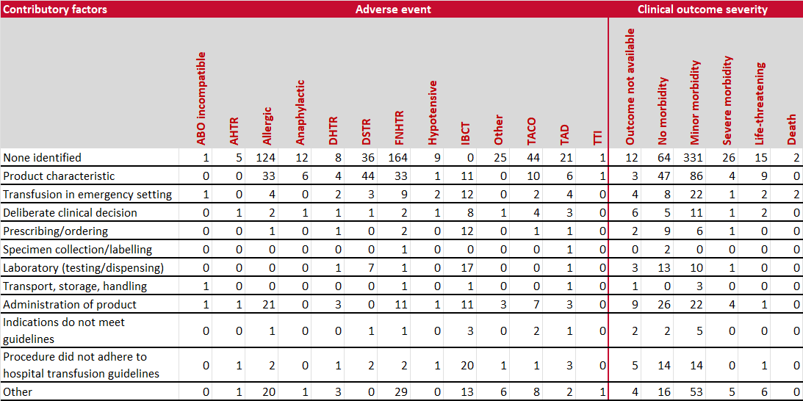
Note: One adverse event can be associated with more than one contributory factor

Appendix 3: Description of adverse events from 2015 AHMDS
Adverse Event | Definition – Where possible this is the ISBT Definition
ABO incompatibility (ABO) | All cases where a blood component was transfused which was (unintentionally) ABO incompatible. Include all such events  - even if only a small quantity of blood was transfused, and/or  - if no adverse reaction occurred  All cases are to be included, whether the first error occurred during specimen collection, in the transfusion laboratory or during administration in clinical areas.  Note that these are a subgroup of the IBCT category.  Transfusion of ABO incompatible products to a patient is considered a ‘sentinel event’ and is also subject to other reporting channels outside of the National Haemovigilance Program.
Acute haemolytic transfusion reaction (other than ABO incompatibility) (AHTR) | An AHTR has its onset within 24 hours of a transfusion. Clinical or laboratory features of haemolysis are present.  Common signs of AHTR are fever, chills/rigors, facial flushing, chest pain, abdominal pain, back/flank pain, nausea/vomiting, diarrhoea, hypertension, pallor, jaundice, oligoanuria, diffuse bleeding and dark urine.  Common laboratory features are hemoglobinaemia, haemoglobinuria, decreased serum haptoglobin, unconjugated hyperbilirubinaemia, increased LDH and AST levels and decreased haemoglobin levels.  Not all clinical or laboratory features are present in case of AHTR.
Allergic reaction (Allergic) | An allergic reaction may present only with mucocutaneous signs and symptoms during or within 4 hours of transfusion:  - morbilliform rash with itching  - urticaria  - localised angioedema  - oedema of lips, tongue and uvula  - periorbital pruritus, erythema and oedema  - conjunctival oedema  This type of allergic reaction is called ‘minor allergic reaction’ in some haemovigilance systems.
Anaphylactoid or anaphylactic reaction (Anaphylactic) | An allergic reaction can also involve respiratory and/or cardiovascular systems and present like an anaphylactic reaction. It is an anaphylactic reaction when, in addition to mucocutaneous symptoms, there is airway compromise or severe hypotension requiring vasopressor treatment (or associated symptoms like hypotonia, syncope). The respiratory signs and symptoms may be laryngeal (tightness in the throat, dysphagia, dysphonia, hoarseness, stridor) or pulmonary (dyspnoea, cough, wheezing/bronchospasm, hypoxemia). Such a reaction usually occurs during or very shortly after transfusion.
Delayed haemolytic transfusion reaction (DHTR) | A DHTR usually manifests between 24 hours and 28 days after a transfusion and clinical or laboratory features of haemolysis are present. Signs and symptoms are similar to AHTR but are usually less severe. DHTR may sometimes manifests as an inadequate rise of post-transfusion haemoglobin level or unexplained fall in haemoglobin after a transfusion. Blood group serology usually shows abnormal results.
Delayed serologic reaction (DSTR) | There is a DSTR when, after a transfusion, there is demonstration of clinically significant antibodies against red blood cells which were previously absent (as far as is known) and when there are no clinical or laboratory features of haemolysis. This term is synonymous with alloimmunisation.
Febrile non-haemolytic transfusion reaction (FNHTR) | Presents with one or more of the following during or within 4 hours of transfusion without any other cause such as haemolytic transfusion reaction, bacterial contamination or underlying condition:  - fever (≥38ºC oral or equivalent and a change of ≥1ºC from pre-transfusion value)  - chills  - rigors  This may be accompanied by headache and nausea.  FNHTR could be present in absence of fever (if chills or rigors without fever).  For the purpose of national and international comparison, only the most serious cases of FNHTR defined below should be reported to the National Haemovigilance Program:  - fever (≥39ºC oral or equivalent and a change of ≥2ºC from pre-transfusion value and chills/rigors
Hypotensive transfusion reaction (Hypotensive) | This reaction is characterized by hypotension defined as a drop in systolic blood pressure of ≥30 mm Hg occurring during or within one hour of completing transfusion and a systolic blood pressure ≤ 80 mm Hg.
Incorrect blood component transfused (IBCT) | All reported episodes, where a patient was transfused with a blood component that did not meet the appropriate requirements or that was intended for another patient. Include even if  - the component was ABO compatible and/or  - only a small quantity of blood was transfused and/or  - there was no adverse reaction.
Other types of adverse events (other) | Other types of adverse events not defined in this AHMDS but defined and published by the ISBT at  http://www.isbtweb.org/working-parties/haemovigilance/
Post-transfusion purpura (PTP) | PTP is characterised by thrombocytopenia arising 5-12 days following transfusion of cellular blood components with findings of antibodies in the patient directed against the Human Platelet Antigen (HPA) system.
Transfusion-associated circulatory overload (TACO) | TACO is characterised by any 4 of the following:  - acute respiratory distress  - tachycardia  - increased blood pressure  - acute or worsening pulmonary oedema on frontal chest radiograph  - evidence of positive fluid balance  Occurring within 6 hours of completion of transfusion. An elevated BNP is supportive of TACO.
Transfusion Associated Dyspnoea (TAD) | TAD is characterised by respiratory distress within 24 hours of transfusion that does not meet the criteria of TRALI, TACO, or allergic reaction. Respiratory distress should be the most prominent clinical feature and should not be explained by the patient’s underlying condition or any other known cause.
Transfusion associated graft-versus-host disease (TA-GVHD) | TA-GVHD clinically features the following 1–6 weeks post transfusion, with no other apparent cause:  - fever  - rash  - liver dysfunction  - diarrhoea  - pancytopenia  TA-GVHD is confirmed by GVHD-typical biopsy and genetic analysis to show chimerism of donor and recipient lymphocytes.
Transfusion-related acute lung injury (TRALI) | In patients with no evidence of acute lung injury (ALI) prior to transfusion, TRALI is diagnosed if a new ALI is present (all five criteria should be met) during or within 6 hours of completion of transfusion:  - Acute onset  - Hypoxemia  - Pa0₂ / Fi0₂ < 300 mm Hg or  - Oxygen saturation is < 90% on room air or  - Other clinical evidence  - Bilateral infiltrates on frontal chest radiograph  - No evidence of left atrial hypertension (i.e. circulatory overload)  - No temporal relationship to an alternative risk factor for ALI, during or within 6 hours of completion of transfusion.  Alternate risk factors for ALI are:  - Direct Lung Injury  - Aspiration  - Pneumonia  - Toxic inhalation  - Lung contusion  - Near drowning  - Indirect lung injury  - Severe sepsis  - Shock  - Multiple trauma  - Burn injury  - Acute pancreatitis  - Cardiopulmonary bypass  - Drug overdose  TRALI should be indicated with a possible imputability to transfusion if it presents a temporal relationship to an alternative risk factor for ALI as described above.  TRALI is therefore a clinical syndrome and neither presence of anti-HLA or anti-HNA antibodies in donor(s) nor confirmation of cognate antigens in recipient is required for diagnosis
Transfusion transmitted infection (TTI) | The recipient had evidence of infection following transfusion of blood components and there was no evidence of infection prior to transfusion and no evidence of an alternative source of infection.  Transfusion transmitted bacterial infection  Transfusion transmitted bacterial infection should be clinically suspected if:  - fever >39°C or a change of >2°C from pre transfusion value and  - rigors and  - tachycardia >120 beats/min or a change of >40 beats/min from pre transfusion value or a rise or drop of 30mmHg in systolic blood pressure within 4 hours of transfusion are present  Possible transfusion transmitted bacterial infection:  - detection of bacteria by approved techniques in the transfused blood component but not in the recipient’s blood or  - detection of bacteria in the recipient’s blood following transfusion but not in the transfused blood component and no other reasons are ascertainable for the positive blood culture  Confirmed transfusion transmitted bacterial infection:  - detection of the same bacterial strain in the recipient’s blood and in the transfused blood product by approved techniques  Transfusion transmitted viral infection  Following investigation, the recipient has evidence of infection post transfusion and no clinical or laboratory evidence of infection prior to transfusion and either, at least one component received by the infected recipient was donated by a donor who had evidence of the same infection, or at least one component received by the infected recipient was shown to have been contaminated with the virus. Reports should at least consider HIV, Hepatitis B, Hepatitis C and CMV.  Transfusion transmitted parasitic infection  Detection of the same parasite in the recipient’s blood and parasite or specific antibodies in the donor blood.




19 December 2022
Australian Red Cross Lifeblood | Donor safety report 2021-22
0

SECTION 2

Donor Safety Report
2023–24

Executive summary
Lifeblood’s donor vigilance system monitors adverse events in blood donors that have a temporal relationship to blood donation. This report provides an overview of donor adverse event rates for the 2023-24 financial year, with data from the three previous years included for comparison. Events registered within 30 days of each reporting period are included in the analysis. The denominator cohort includes any donation where a needle-in attempt was registered in the National Blood Management System (NBMS), regardless of whether the donation was successful. In 2023-24 there were 1,673,410 donations meeting criteria for inclusion.
The analysis includes commentary on whether rate differences are statistically significant (p<0.05) from previous reporting periods. A statistical difference does not necessarily translate to a clinically significant change. Lifeblood’s reporting process is very sensitive; the large cohort sizes enable even small differences to be detected. To assist in the interpretation of whether a statistical difference has clinical or operational significance, the analysis includes unadjusted and standardised¹ rates, the number of donations for one additional (or one less) event and trend data.
In 2023-24, approximately 3.64% of donations (n=60,870) were associated with at least one donor adverse event. Standardised analysis shows that the total adverse event rate for all donation types have generally improved or remained stable since 2022-23. With regard to unique events, there has been a significant reduction in haematoma and painful arm. The infiltration rate for plasmapheresis collections has increased with an additional event occurring every 1,844 donations. The rate of infiltration events requiring outside medical care is not significantly different, suggesting the increase is in more minor events.
Events that require outside medical care are considered a surrogate for more severe reactions. The unadjusted and standardised rate for outside medical care for both whole blood and plasma were significantly increased in 2023-24 compared with 2022-23. There were increases in outside medical care rates for both Vasovagal rates (VVRs) and non-apheresis phlebotomy-related events. Based on the three-year monthly trend data, the increase is considered a normal variation.

1 The unadjusted rate is the crude (actual) frequency observed in the reporting period and reflects the actual donor population contributing to collections in that period. Standardised rates1 are based on a set reference population (in this report, it is based on the July 2021 donor population) and adjust for factors that are known to influence the risk of adverse events, such as donor gender, age and donation experience. Whilst standardising does not fully adjust for all possible variables, standardised rates allow for a more accurate comparison between time periods.

Overview of total event rates by donation type
In 2023-24, approximately 3.64% of donations (n=60,870) were associated with at least one donor adverse event. Unadjusted figures showed that the total donor adverse event rate for each of the donation types in 2023-24 were significantly lower than in 2022-23 [Table 1]. Standardised data showed a significant reduction in the overall rate for whole blood and plasmapheresis, and no significant difference for plateletpheresis [Table 2, Figure 1]. The rate of unique events by donation type are provided in the Appendix [Tables 1 and 2].
Table 1: Unadjusted total adverse event rates per 10,000 donations
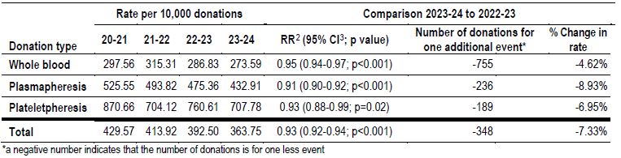

Table 2: Standardised* total adverse event rates per 10,000 donations
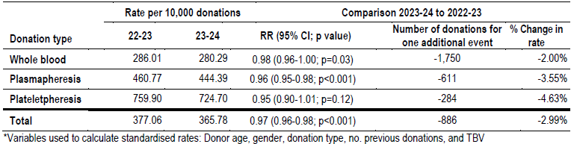

Figure 1: Plot graph for quarterly standardized rates for total adverse events per 10,000 donations
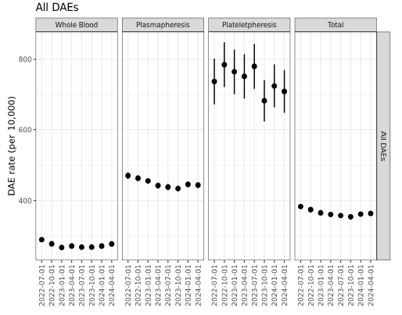

2 Relative Risk
3 Confidence Interval

General trends for more common events by donation type
Whole blood (n=773,015)
The reduction in the unadjusted total rate for whole blood is primarily attributed to reductions in rates for vasovagal (174.1 vs 181.9 per 10,000), haematoma (72.5 vs 76.4 per 10,000) and painful arm (18.33 vs 20.6 per 10,000) Standardising demonstrated a significant relative risk reduction for haematoma and painful arm only, translating to one less event for every 3,059 and 5,194 whole blood donations respectively.
Plasmapheresis (n=873,395)
The reduction in the unadjusted total rate for plasmapheresis was a net effect of the rate reduction for vasovagal reactions (100.4 vs 112.7 per 10,000), haematoma (121.9 vs 132.1 per 10,000), painful arm (46.2 vs 55.8 per 10,000), nerve injury (17.1 vs 19.3 per 10,000) and mild citrate reactions (91.5 vs 110.3 per 10,000). This reduction was offset to a small degree by a rate increase in infiltration (86.03 vs 80.61 per 10,000). After standardising there were only significant rate reductions for haematoma, painful arm and mild citrate reactions, translating to one less event for every 1,285, 1,412 and 1,049 plasmapheresis donations respectively. The infiltration rate remained significantly higher in the standardised analysis (85.6 vs 78.4 per 10,000 donations), translating to one additional event for every 1,383 donations. The rate of infiltration events requiring outside medical care was not significantly different (0.77 vs 0.71 per 10,000) and suggests an increase in more minor events.
Plateletpheresis (n=27,000)
In 2023-24 there were rate reductions for vasovagal (106.3 vs 121.5 per 10,000), haematoma (188.5 vs 216.3 per 10,000), painful arm (27.4 vs 46.8 per 10,000) and mild citrate reactions (298.9 vs 319.4 per 10,000). This was offset to some degree by rate increases for nerve injury (12.6 vs 9.1 per 10,000) and infiltration (118.2 vs 100.3 per 10,000). On standardising, there were significant rate reductions for haematoma and painful arm, translating to one less event every 364 and 522 plateletpheresis donations respectively. The total infiltration rate did not reach significance when standardising (116.6 vs 98.6 per 10,000; p=0.05).

General trends for vasovagal subtype events
Figure 2 shows the two-year adjusted rates by donation type for (1) all vasovagal events, (2) those that occurred offsite and (3) those associated with Loss of consciousness (LOC). The only significant change was a reduction in offsite (delayed) VVRs associated with plateletpheresis (5.14 vs 10.29 per 10,000). VVRs requiring outside medical care, which is considered an indicator of a more serious event is discussed in the following section. | Figure 2: Unadjusted VVR rates by subgroup, donation type  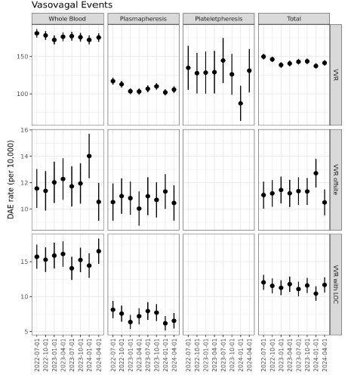

Outside medical care
The rate for events requiring outside medical care is a surrogate for more serious events. Approximately 0.06% of donations had an event requiring external care (n=1,084). The total unadjusted and standardised rates were significantly higher for whole blood and plasma [Table 3 and 4]. The analysis of unique events was limited to unadjusted rates due to the small number of events requiring outside care. The main event contributing to this increase, was VVRs (4.06 vs 3.25 per 10,000; RR 1.25 95% CI: 1.11-1.40; p<0.001), noting that the effect was largest in whole blood, translating to an extra VVR event requiring outside medical care every 8,479 whole blood donations. There was also a significant increase in the proportion of phlebotomy-related events requiring outside medical care (0.95% vs 0.75% per 10,000; p=0.01).
Of events requiring outside medical care, 35.8% required a hospital attendance, 50.2% visited the GP and 10.7% received in-centre ambulance assessment. This represented a percentage point change of -5.4, -0.5 and +5.2 from 2022-23 respectively. Of the 1,084 events reported, vasovagal was reported in 62.6%, nerve injury in 10.1%, haematoma in 7.0%, infiltration in 6.3%, and chest pain in 6.3%.
With improved access to healthcare after the COVID pandemic, an increase in outside medical care could be expected. There is however, no definitive evidence this is occurring, with the Australian Healthcare index (August 2024) indicating that the community is cutting down on GP visits due to the rising cost of living. Based on the three-year monthly trend data the overall increase this year is consistent with a normal variation.
Table 3: Unadjusted adverse event rates for all events requiring outside medical care
Table 3: Unadjusted adverse event rates for all events requiring outside medical care
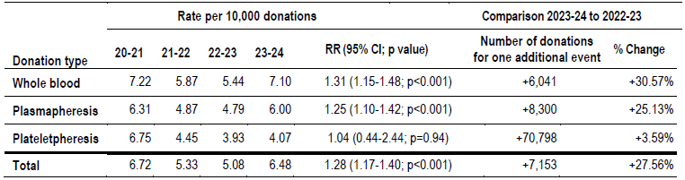

Table 4: Standardised* total adverse event rates for all events requiring outside medical care
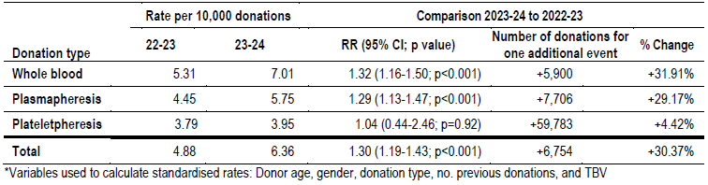

Conclusion
Overall, except for infiltration, unique adverse event rates are similar to, or improved, from the previous year. The rate for outside medical care significantly increased in 2023-24, particularly for VVR and (non-apheresis) phlebotomy events, translating to one additional event requiring outside medical care every 7,153 donations. It should be noted that the monthly trend data shows the two peaks coincided with two of our most significant marketing campaigns and suggests that donors may be more likely to come underprepared and/or the experience in centre is different at times of increased workflow. Strengthening messaging on preparation at times of large campaigns may help reduce this effect. With expected improved access to healthcare after the COVID pandemic, an increase in the outside medical care rate could occur. There is however no definitive evidence that this is a reset effect after restricted access to healthcare during the pandemic, and the overall increase in the outside medical care rate this year is consistent with a normal variation.

APPENDIX
Table 1: Unique adverse event rates for 2023-24 per 10,000 donations and unit change from 2022-23
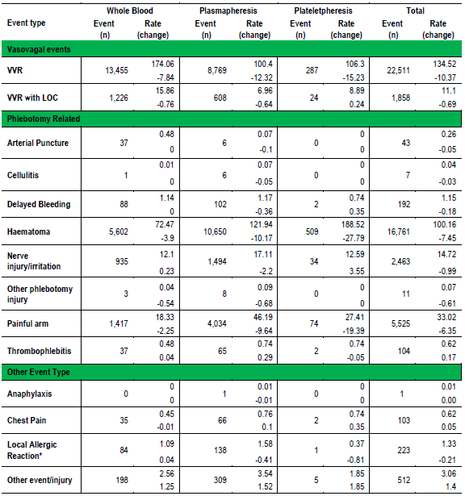
Table 2: Unique apheresis-specific adverse event rates for 2023-24 per 10,000 donations and unit change from 2022-23
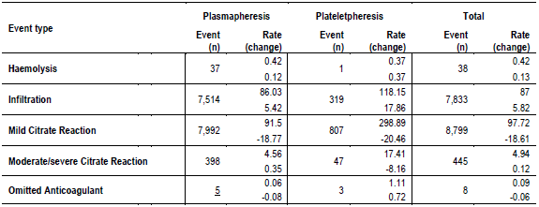

ANNEX 1 - State/territory haemovigilance process improvement
In 2023-24, state/territory departments of health continue to improve their process for haemovigilance data collection and reporting.

NSW
Brief description (one or two paragraphs) of the jurisdiction’s progress since the last report and strategies moving forward.
Wrong Blood In Tube (WBIT) incidents:
- NSW Health mandated a new standardised pre-transfusion testing form in January 2024. Data from January – June 2024 demonstrates a decrease in the number of WBIT incidents reported since the new form was mandated.
- Further analysis will be undertaken to measure whether this represents a decrease in the rate of these incidents.
- As opportunities to refine the NSW Health incident management system for blood and blood products, Blood Watch will advocate for changes that support compliance with AHMDS.

VIC
Continue to provide Bulletins covering transfusion related issues, that come to light from data and the network, to help improve practice.
An annual report of all validated investigations is developed each financial year. This report contains case studies and recommendations for improved practice.
Currently reviewing many of our reporting forms to ensure we have the best information available and can meet AHMDS data requirements, without making the forms onerous for reporters to complete.
Ambulance Victoria are now one of the services that can report incidents and reactions to STIR. No reports at this time.

QLD
Haemovigilance strategies continue to be embedded in local processes, with a focus on sustaining improvements and maintaining engagement across relevant clinical and support teams. At the state level, a Patient Safety Communique will shortly be published and disseminated across Hospital and Health Services, related to ABO-incompatible transfusion incidents. The purpose of this Communique is to highlight the criticality of positive patient identification prior to commencing a blood transfusion, and to summarise lessons from blood transfusion-related clinical incidents (ABO-incompatible adverse events).

SA
There are currently several haemovigilance-related activities underway that are focused on system, education and quality improvement:
- The Department has been monitoring the utilisation of red blood cells by inpatients since 2006 through the SA Blood Utilisation Study. The information from this study has been incorporated into a Reporting Tool which allows major metropolitan hospitals to better understand their red cell usage patterns.
- The implementation of the Enterprise Patient Administration System (EPAS) across SA Health required the development of clinician friendly blood and blood product transfusion order sets that meet current national transfusion guidelines and legislative requirements.
- The BloodSafe Transfusion Nurse Consultants conduct regular audits to monitor variability in ordering practices and compliance with NSQHS Standard 7 haemovigilance activities.
- The review of Safety Learning System (SLS) to ensure it remains in line with the AHMDS involved the development of a detailed topic guide to educate transfusion nurses on the changes. The guide included detailed definitions, tips for accurate reporting, information for managers and a section on the reporting requirements for transfusion reactions that are Sentinel events or require internal and/or external reporting.
- The SA Blood Management Council has recommended that all medical, nursing, and support staff complete training provided by BloodSafe eLearning Australian with the aim of improving the recognition and reporting of transfusion-related adverse events.

WA
With introduction of new AHMDS in July 2025, WA Haemovigilance Program reporting via REDCap will be aligned with AHMDS 2025 allowing for simplified data extraction for NBA data requests.

TAS
The Tasmanian Health Service Safety Learning and Reporting System records and ensures safety events, including blood safety events, are followed up and appropriately actioned.

NT
The occurrence of reported transfusion reactions has decreased from 3 in the 2022 – 23 period (1 x TACO and 2 x FNHTR) to 1 in the 2023-24 period (1 x IBCT).
All reported transfusion reactions are investigated and reviewed at the Transfusion Incident Review Group (TIRG) meetings, and when deemed appropriate, at the NT Transfusion Committee (NTTC) meetings. NT is part of the Blood Matters STIR reporting group. The above-mentioned transfusion incident was reported to STIR.
Staff and facility education and support remains paramount in accordance with NSQHS Standard 7, which assists in keeping the number of adverse events to a minimum within this jurisdiction.

ACT
ACT Health is preparing to roll out its ACT-wide Haemovigilance Framework (Framework) mid 2025. The Framework outlines the requirements for Haemovigilance reporting in the ACT and will be provided to each of the ACT’s hospitals with an invitation to each hospital to formally contribute to the ACT’s existing reporting process into the national haemovigilance program.

ANNEX 2 - Abbreviations
ABO The human red cell ABO blood group system
ACT Australian Capital Territory
AHMDS Australian Haemovigilance Minimum Data Set
AHTR Acute haemolytic transfusion reaction (other than ABO incompatibility)
Allergic Allergic reaction
ATR Acute transfusion reactions
CI Confidence interval
CNC Transfusion Clinical Nurse Consultant
DAE Donor adverse event
DHTR Delayed haemolytic transfusion reaction
DSTR Delayed serologic reaction
EPAS Enterprise Patient Administration System
FNHTR Febrile non-haemolytic transfusion reaction
FY Financial year
GP General Practitioner
HAC Haemovigilance Advisory Committee
IBCT Incorrect blood component transfused
IHN International Haemovigilance Network
Lifeblood Australian Red Cross Lifeblood
ISBT International Society for Blood Transfusion
LOC Loss of consciousness
NBA National Blood Authority
Non-SAE Non-serious adverse event
NHDD National Haemovigilance Data Dictionary
NSQHS National Safety and Quality Health Service
NSW New South Wales
NT Northern Territory
PTP Post transfusion purpura
QLD Queensland
RBC Red blood cell
RR Relative risk
SA South Australia
SAE Serious adverse event
SHOT Serious Hazards of Transfusion
STIR Serious Transfusion Incident Reporting
TACO Transfusion-associated circulatory overload
TAD Transfusion associated dyspnoea
TAS Tasmania
TIRG Transfusion Incident Review Group
TRALI Transfusion-related acute lung injury
TTI Transfusion-transmitted infection
VIC Victoria
VVR Vasovagal rate
WA Western Australia
WBIT Wrong Blood In Tube

ANNEX 3 – Acknowledgements List
This report is published on behalf of the states and territories who voluntarily provided data to the national program. The NBA thanks them for their contributions and ongoing commitment to haemovigilance. Appreciation is also extended to the members of the Haemovigilance Advisory Committee (HAC) for their advice on improvements in adverse event reporting and analysis of the data for this report. For further information refer to the NBA Website or strategic-framework-for-national-haemovigilance-program.pdf.
National Blood Authority Haemovigilance Advisory Committee (HAC)
Members
Professor Erica Wood NBA appointed HAC Chair
Mr Brett Aitken Australian Private Hospitals Association
Mr Geoffrey Bartle Consumer Representative
Ms Clare Hennessy VIC Health
Ms Maria Burgess ACT Health
Dr James Daly Australian Red Cross Lifeblood
Dr Chris Hogan Non-affiliated Haematologist
Ms Penny O’Beid NSW Health
Dr Sharon Nowrojee WA Health
Bradley Webster WA Health
Professor David Roxby Australian and New Zealand Society of Blood Transfusion
Dr Neil Everest Commonwealth Department of Health
Associate Professor Lilon Bandler NBA Patient Blood Management Advisory Committee Chair
Expert Advisors
Dr Heather Buchan Australian Commission on Safety and Quality in Health Care
Dr Angela Gowland Therapeutic Goods Administration
Dr Adrian Webster Australian Institute of Health and Welfare
National Blood Authority
Adjunct Professor Adrian Platona Chief Executive
Ms Sandra Cochrane Senior Adviser, Data and Blood Services
Ms Suzie Cong Senior Data Analyst, Data and Blood Services
Ms Leia Earnshaw Assistant Director, Haemovigilance, Patient Blood Management
Australian Government and State and Territory contributors
NSW Health Clinical Excellence Commission Blood Watch Program
VIC Department of Health and Human Services Blood Matters Program
QLD Health
SA Health BloodSafe Program
WA Department of Health
TAS Department of Health and Human Services
ACT Health
NT Department of Health
SECTION 2 – DONOR SAFETY REPORT was contributed by the Australian Red Cross Lifeblood



