Australian  
Bleeding  
Disorders  
Registry

Annual Report 2016-17



With the exception of any logos and registered trademarks, and where otherwise noted, all material presented in this document is provided under a Creative Commons Attribution 4.0 license (https://creativecommons.org/licenses/by/4.0/)

The details of the relevant license conditions are available on the Creative Commons website (accessible using the links provided) as is the full legal code for the CC BY 4.0 license (https://creativecommons.org/licenses/by/4.0/legalcode)

The content obtained from this document or derivative of this work must be attributed as:

Australian Bleeding Disorders Registry (ABDR) Annual Report 2016-17 published by the National Blood Authority.

ISSN 1839-0811 (online version)

This report is available online at <http://www.blood.gov.au/data-analysis-reporting>

Version: 30 December 2018



Locked Bag 8430

Canberra ACT 2601

Phone: 13 000 BLOOD (13000 25663)

Email: [data@blood.gov.au](mailto:data@blood.gov.au)

[www.blood.gov.au](http://www.blood.gov.au)

Table of Contents

List of Tables 5

List of Figures 6

Purpose of this document 7

Key findings 8

Background 9

What are bleeding disorders? 9

Bleeding disorders are inherited or acquired 9

Haemophilia 9

Types of haemophilia 10

Haemophilia fast facts 10

Von willebrand disorder/disease (VWD) 10

Types of VWD 11

Rare clotting factor deficiencies 11

Special issues for girls and women 11

Inherited platelet disorders 12

What are platelet function disorders? 12

Severity 12

Treatment of bleeding disorders 13

Treatment of bleeding disorders in Australia 14

The Australian Bleeding Disorders Registry (ABDR) 15

ABDR management and governance 15

Patient privacy in ABDR and MyABDR 16

Data governance 16

Data quality issues 16

ABDR system 17

Comparing data from previous ABDR annual reports 17

Consistent application of diagnoses and definitions 17

Von willebrand disease 17

Treatments not included in the ABDR 17

Consent 17

Supply of products for treatment 18

ABDR patient demographics 19

Diagnoses 19

Patients with multiple bleeding disorders 20

Age, diagnosis and severity 23

By age group and detailed diagnosis 26

By location 28

By gender and age distribution 29

Inhibitor status 39

Incidence of major disorders 42

Patient Treatment in 2016-17 43

Products issued to patients 43

Volume (IU) of products issued for HMA and HMB 46

Volume of products issued and patient counts by treatment regimen, severity, product and state 50

Appendix A Characteristics of Rare Clotting Factor Deficiencies 59

Appendix B Haemophilia Treatment Centres 60

The objectives of HTCs 60

Operating concept 60

Data quality of HTC data collections 61

List of HTCs 62

Appendix C National Supply of Products 63

National supply plan and budget 63

Issues of clotting factors 64

CHRONOLOGY OF PRODUCTS SUPPLIED 66

Appendix D History of the ABDR 67

Benefits of the 4th generation ABDR 68

Current position of the development of the ABDR 68

Appendix E Patient Registration Form 69

Acronyms and glossary of terms 72

Acronyms 72

Glossary of terms 72

## List of Tables

Table 1 - Major bleeding disorders and their cause 9

Table 2 - Severities and the concentration of clotting factors0F 12

Table 3 - Number of people in the registry and treated by broad diagnosis 19

Table 4 - Number of people in the registry with multiple bleeding disorders 20

Table 5 - Number of people in the registry and treated by detailed diagnosis 21

Table 6 - Number of adult patients in the registry and treated by broad diagnosis and severity for HMA, HMB 24

Table 7 - Number of paediatric and adolescent patients in the registry and treated by broad diagnosis and severity for HMA, HMB 25

Table 8 - Number of people in the registry diagnosed with HMA or HMB by age group and disease classification 26

Table 9 - Number of people in the registry diagnosed with VWD by age group and disease classification 27

Table 10 - Numbers of patients with severe HMA and HMB by location 28

Table 11 – VWD patients breakdown by type and gender 39

Table 12 - Description of inhibitor status used in ABDR 40

Table 13 - Patient inhibitor status numbers 41

Table 14 - Incidence statistics from World Federation of Hemophilia Global Survey 2016 42

Table 15 - IU of product issued for HMA, HMB and VWD patients, by severity and treatment regimen in 2016‑17 - hereditary bleeding disorders 44

Table 16 - IU of product issued for HMA, HMB and VWD patients, by severity and treatment regimen in 2016-17 - acquired bleeding disorders 45

Table 17 - IU of products issued for other patients, by severity and treatment regimen in 2016-17 - other diagnoses 45

Table 18 - Volume of products issued in 2016-17 by treatment regimen - hereditary bleeding disorders 51

Table 19 - Volume (IU) of products issued in 2016-17 by treatment regimen – other diagnoses 52

Table 20 - Number of patients for Hereditary HMA, HMB and VWD by state 53

Table 21 - Volume of product issued for HEREDITARY HMA, HMB and VWD by state 54

Table 22 - Volume, patient counts and IU or mg/kg/year of products issued in 2016-17 by treatment regimen - acquired 55

Table 23 - IU Volume of product issued and patient counts for hereditary HMA and HMB by severity and regimen type 56

Table 24 - Volume of product issued and patient counts for hereditary HMA, HMB and VWD by regimen type and product 57

Table 25 - Characteristics of rare clotting factor deficiencies 59

Table 26 - Haemophilia treatment centres 62

## List of Figures

Figure 1 - Location of haemophilia treatment centres 14

Figure 2 - Market share of recombinant FVIII issues 2012-13 to 2016-17 18

Figure 3 - Numbers of active patients in the Registry as at 30 June 2017 28

Figure 4 - Distribution of hereditary female HMA patients by age in 2016-17 29

Figure 5 - Distribution of hereditary female HMB patients by age in 2016-17 30

Figure 6 - Distribution of hereditary male HMA patients and hereditary male HMA severe patients by age in 2016-17 31

Figure 7 - Distribution of hereditary male HMB patients and hereditary male HMB severe patients by age in 2016-17 33

Figure 8 - Distribution of hereditary female VWD patients and hereditary female VWD severe patients by age in 2016-17 35

Figure 9 - Distribution of hereditary male VWD patients and hereditary male VWD severe patients by age in 2016-17 37

Figure 10 - Percentage of patients receiving product by severity for HMA - hereditary bleeding disorders 43

Figure 11 - Percentage of patients receiving product by severity for HMB - hereditary bleeding disorders 44

Figure 12 - FVIII Product usage (IU/kg/year) in severe HMA patients on prophylaxis 46

Figure 13 - FVIII Product usage (IU/kg/year) in severe HMA patients on demand 47

Figure 14 - FIX Product usage (IU/kg/year) in severe HMB patients on prophylaxis 48

Figure 15 - FIX Product usage (IU/kg/year) in severe HMB patients on demand 49

Figure 16 - National issues by product category 2016-17 63

Figure 17 - Issues of factor VIII products, 2012-13 to 2016-17 per ‘000 population 64

Figure 18 - Issues of factor IX products, 2012-13 to 2016-17 per ‘000 population 65

Figure 19 - Issues of recombinant factor VIIa products, 2012-13 to 2016-17 per ‘000 population 65

Figure 20 - Issues of FEIBA, 2012-13 to 2016-17 per ‘000 population 66

# Purpose of this document

The intention of this document is to present the reader with an integrated view of current clinical and demographic information on people with inherited bleeding disorders in Australia and the resultant demand for clotting factor products. It draws on data from the Australian Bleeding Disorders Registry (ABDR) and other National Blood Authority (NBA) supply and contract sources. Some international data comparisons have also, where meaningful, been included.

The Australian Bleeding Disorders Registry (ABDR) is a clinical registry for patients in Australia with bleeding disorders. It is used on a daily basis by clinicians in all Australian Haemophilia Treatment Centres (HTCs) to assist in managing the treatment of people with bleeding disorders and to gain a better understanding of the incidence and prevalence of bleeding disorders. This information will also be used by the NBA to understand demand for, and to facilitate ordering of, clotting factor product.

This document will be used by people involved in providing care for patients with bleeding disorders, and may also be useful for patient advocacy groups and those in administrative and government positions.

# Key findings

The data contained in this reports shows:

* There were 6,155 patients in the Australian Bleeding Disorders Registry (ABDR) in 2016-17
* Of these patients 5,070 were recorded as having common hereditary bleeding disorders
  + 2,365 patients with Haemophilia A (666 patients with severe Haemophilia A)
  + 564 patients with Haemophilia B (106 patients with severe Haemophilia B)
  + 2,141 patients with von Willebrand Disease
* A total of 94 patients were registered as acquired Haemophilia A, Haemophilia B or von Willebrand bleeding disorders
* 1,590 patients with hereditary bleeding disorders received product in 2016-17, 1,009 Haemophilia A patients, 218 Haemophilia B patients, 248 von Willebrand Disease patients and 94 patients with other diagnoses. Of these, 21 patients had acquired bleeding disorders
* 160,598,764 IU of Factor VIII products were used by hereditary Haemophilia A patients in 2016-17
  + Prophylactic use by Haemophilia A patients accounted for 129,124,996 IU, or 80.4 per cent of the volume issued
* 26,632,580 IU of Factor IX products were used by hereditary Haemophilia B patients in 2016‑17
  + Prophylactic use by Haemophilia B patients accounted for 18,326,000 IU, or 68.8 per cent of the volume issued
* Demand for Factor VIII products increased by 1.5 per cent when compared to 2015-16 (NBA Annual Report)
  + Recombinant FVIII decreased by 0.5 per cent (NBA Annual Report)
  + Plasma derived FVIII increased by 18.9 per cent (NBA Annual Report)
* Demand for Factor IX increased by 1.6 per cent compared to 2015-16 (NBA Annual Report)
  + Plasma derived FIX decreased by 15.6 per cent due to a reduction in specific patient requirements
  + Recombinant FIX increased 1.6 per cent compared to 2015-16 (NBA Annual Report)
* Clotting factors comprise 14.4 per cent of total blood and blood product expenditure by cost and by product category in 2016-17 (NBA Annual Report)

# Background

The information in this section has been drawn from the materials and websites of two peak bodies for haemophilia; the World Federation of Hemophilia ([www.wfh.org](http://www.wfh.org)) and the Haemophilia Foundation of Australia ([www.haemophilia.org.au](http://www.haemophilia.org.au)).

## What are bleeding disorders?

In people with bleeding disorders, the clotting process doesn’t work properly. As a result, people with bleeding disorders can bleed for longer than normal, and some may experience spontaneous bleeding into joints, muscles, or other parts of their bodies.

## Bleeding disorders are inherited or acquired

Bleeding disorders are almost always inherited or passed through families; they have a genetic basis and the genes responsible for the disorders are passed from parents to children. However, a person can also spontaneously develop a bleeding disorder, although this is rare.

Acquired bleeding disorders are not inherited or passed through families. Most acquired bleeding disorders have an identifiable root cause. Men and women are equally likely to be affected by an acquired bleeding disorder, and the potential for problems is high.

Table 1 - Major bleeding disorders and their cause

| Disorder group | Cause |
| --- | --- |
| Haemophilia A | Deficiency of Factor VIII |
| Haemophilia B | Deficiency of Factor IX |
| von Willebrand Disease | Deficiency, or dysfunction, of von Willebrand Factor |
| Other Factor deficiencies | Deficiency of other coagulation factors |
| Platelet Disorder | Inherited deficiency of effective platelet function |

## Haemophilia

Haemophilia causes excessive bleeding following trauma or surgery and can be related to spontaneous haemorrhages into muscles and joints. People with haemophilia do not bleed any faster than normal, but they can bleed for a longer time.

Haemophilia is an X-linked disorder that typically affects males, whereas females are normally classified as carriers. However, affected males will pass on the haemophilia gene to their daughters, and women carrying a F8 or F9 gene mutation may have reduced factor levels and should therefore be classified as having haemophilia. Most carriers are asymptomatic. Carriers with clotting factor levels in the haemophilia range may be symptomatic, with bleeding manifestations commensurate with their degree of clotting factor deficiency, particularly during trauma and surgery. Symptomatic carriers are classified as haemophilia in line with the World Federation of Haemophilia ([www.wfh.org](http://www.wfh.org)) guidelines.

### Types of haemophilia

* The most common type of haemophilia is called Haemophilia A. This means the person does not have enough clotting Factor VIII (factor eight).
* Haemophilia B is less common. A person with Haemophilia B does not have enough Factor IX (factor nine). The symptoms are the same for people with Haemophilia A and B; that is, they bleed for a longer time than normal.

### Haemophilia fast facts

* Haemophilia occurs in 1 in 6,000-10,000 males internationally.
* Currently in Australia there are 2,998 people with Haemophilia A and B, (including 69 with Acquired Haemophilia) with varied degrees of severity, in the Australian Bleeding Disorders Registry (ABDR).
* Bleeding is most commonly internal into the joints and/or muscles. Less commonly, bleeding into internal organs can also occur. It can happen without an obvious cause (sometimes called ‘spontaneous’), or as a result of injury.
* Over time this internal bleeding into joints ('bleeds') can cause severe arthritis, chronic pain and disability.
* Specialised treatment is needed to help blood clot normally. With appropriate treatment haemophilia can be managed effectively.
* Haemophilia is an inherited condition and occurs in families; however in 1/3 of cases it appears in families with no previous history of the disorder. The haemophilia gene is passed down from parent to child through generations. Men with haemophilia will pass the gene on to their daughters but not their sons. Women who carry the haemophilia gene can pass the haemophilia gene on to their sons and daughters. Sons with the gene will have haemophilia. Some women and girls who carry the gene may also experience bleeding problems.

## Von willebrand disorder/disease (VWD)

Von Willebrand disease (VWD) is the most common type of bleeding disorder. People with VWD have a problem with von Willebrand Factor (VWF), a protein in their blood that would normally help control bleeding. When a blood vessel is injured and bleeding occurs, VWF helps cells in the blood, called platelets, adhere to damaged blood vessels and mesh together and form a clot to stop the bleeding. People with VWD do not have enough VWF, or it does not work the way it should. It takes longer for blood to clot and for bleeding to stop.

VWD is generally less severe than other bleeding disorders. Many people with VWD may not know that they have the disorder because their bleeding symptoms are very mild. For most people with VWD, the disorder causes little or no disruption to their lives except when there is a serious injury or need for surgery. However, with all forms of VWD, there can be bleeding problems. VWD is difficult to accurately diagnose as laboratory values can fluctuate and values in those with mild bleeding symptoms can overlap with normal laboratory values.

From some studies, it is estimated that up to 1% of the world’s population has VWD, but because many people have only very mild symptoms, only a small number of them are diagnosed. Research has shown that as many as 9 out of 10 people with VWD have not been diagnosed. It is estimated that VWD affects approximately 200,000 people in Australia, but symptomatic individuals possibly less. Currently there are 2,166 people with VWD in the ABDR including 25 with acquired VWD.

### Types of VWD

There are three main types of VWD. Within each type, the disorder can be mild, moderate, or severe. Bleeding symptoms can be quite variable within each type depending in part on the VWF activity. It is important to know which type of VWD a person has, because treatment is different for each type.

* Type 1 VWD is the most common form. People with Type 1 VWD have lower than normal levels of VWF. Symptoms are usually mild. Still, it is possible for someone with Type 1 VWD to have serious bleeding.
* Type 2 VWD involves a defect in the VWF structure. The VWF protein does not work properly, causing lower than normal VWF activity. There are different Type 2 VWD defects. Severity of symptoms can vary.
* Type 3 VWD is usually the most serious form. People with Type 3 VWD have very little or no VWF. Symptoms are more severe. People with Type 3 VWD can have bleeding into muscles and joints, sometimes without injury.

## Rare clotting factor deficiencies

Rare clotting factor deficiencies are a group of inherited bleeding disorders caused by a problem with one of several clotting factors. Clotting factors are proteins in the blood that control bleeding. Many different clotting factors work together in a series of chemical reactions to stop bleeding. This is called the clotting process.

Problems with Factor VIII and Factor IX are known as Haemophilia A and B, respectively. Rare clotting factor deficiencies are bleeding disorders in which one of the other clotting factors (i.e. factors I, II, V, V+VIII, VII, X, XI, or XIII) is missing or not working properly. The World Federation of Haemophilia produced a summary (Table 25 of the characteristics of rare clotting factor deficiencies, the severity of bleeds associated with them, and the treatment typically required.

## Special issues for girls and women

Women with clotting factor deficiencies may have additional symptoms because of menstruation and childbirth. Girls may have especially heavy bleeding when they begin to menstruate. Women with clotting factor deficiencies may have heavier and/or longer menstrual flow, which can cause anaemia (with low levels of iron, which results in weakness and fatigue). Women with clotting factor deficiencies should receive genetic counselling about the risks of having an affected child well in advance of any planned pregnancies and should see an obstetrician as soon as they suspect they are pregnant. The obstetrician should work closely with the staff of the haemophilia/bleeding disorder treatment centre in order to provide the best care during pregnancy and childbirth and to minimize the potential complications for both the mother and the newborn child.

Women with certain rare factor deficiencies (such as Factor XIII deficiency and afibrinogenemia) may be at greater risk of miscarriage and placental abruption (a premature separation of the placenta from the uterus that disrupts the flow of blood and oxygen to the foetus). Therefore, these women require treatment throughout the pregnancy to prevent these complications.

The main risk related to pregnancy is postpartum haemorrhage. All bleeding disorders are associated with a greater risk of increased bleeding after delivery. The risk and the severity of the bleeding can be reduced with appropriate treatment. This treatment is different for each woman and depends on her personal and family history of bleeding symptoms, the severity of the factor deficiency, and the mode of delivery (vaginal birth vs. caesarean section). Factor replacement may be necessary in some cases.

## Inherited platelet disorders

Platelets are small parts of cells that circulate in the blood. They are involved in the formation of blood clots and the repair of damaged blood vessels.

When a blood vessel is injured, platelets stick to the damaged area and spread along the surface to stop the bleeding (this process is called adhesion). At the same time, chemical signals are released from small sacks inside the platelets called granules (this process is called secretion). These chemicals attract other platelets to the site of injury and make them clump together to form what is called a platelet plug (this process is called aggregation).

Sometimes the platelet plug is enough to stop the bleeding. However if the wound is large, other proteins called clotting factors are recruited to the site of injury. These clotting factors work together on the surface of the platelets to form and strengthen the blood clot.

### What are platelet function disorders?

Platelet function disorders are conditions in which platelets don’t work the way they should, resulting in a tendency to bleed or bruise. Since the platelet plug does not form properly, bleeding can continue for longer than normal. Since platelets have many roles in blood clotting, platelet function disorders can lead to bleeding disorders of various intensities.

## Severity

Haemophilia A and B are classified according to their severity, as this informs the treatment regimens required. The definitions of severity that are applied within the ABDR are listed in Table 2. Definition of severity of VWD and other coagulation factor deficiencies is not standardised but variable.

Table 2 - Severities and the concentration of clotting factors0F[1]

| Severity | Concentration of Clotting Factor | Typical Bleeding Picture |
| --- | --- | --- |
| Severe | <0.01 IU/ml  (<1% of normal†) | Frequent bleeding episodes common, predominantly into joints & muscles. Bleeding can occur spontaneously or after minor injury. |
| Moderate | 0.01 – 0.05 IU/ml  (1–5% of normal) | Can bleed after minor injury. May have joint bleeding. Severe bleeding with trauma, surgery, invasive procedures. |
| Mild | >0.05 – 0.40 IU/ml  (5-40% of normal)‡ | Spontaneous bleeding does not occur. Bleeding with major trauma, surgery, invasive procedures. |

Notes † Normal concentration of Factor VIII or IX is defined as 100% or one unit of Factor VIII activity per ml of plasma - 100 U/dL (Kasper, CK 2004, Hereditary plasma clotting factor disorders and their management. Treatment of Hemophilia Monograph Series, No. 4, World Federation of Hemophilia, Montreal, Canada)  
‡ Levels of FVIII above 40% are usually considered sufficient for normal haemostasis

## Treatment of bleeding disorders

Mild conditions may require no treatment or treatment only under special circumstances, such as surgery. More severe conditions may require regular interventions. Treatment may occur in hospital or other medical facilities, or at home. The treatments may be regular and preventative (prophylaxis), or on demand (when a bleed occurs). In some patients, therapy is complicated when their body develops inhibitors that destroy the replacement clotting factors and other treatment is necessary.

Often the treatments involve providing replacement for the missing or defective clotting factors. Products used include plasma derived and recombinant clotting factors, cryoprecipitate and Desmopressin (1-desamino-8-D-arginine vasopressin; DDAVP) which can stimulate the release of Factor VIII and VWF from stores in the body (this is not used in Haemophilia B or Factor IX deficiency).

# Treatment of bleeding disorders in Australia

The majority of people with these conditions are treated at HTCs which are specialist centres that provide comprehensive care to people with haemophilia and other bleeding disorders. The comprehensive care model ensures that preventative and general treatment on the complex aspects of haemophilia are given in a co-ordinated way by a multi-disciplinary team with specialised expertise within the one centre.

HTCs were established following a decision by Australian Health Ministers Advisory Council (AHMAC) in 1998, to provide a leadership role within their hospital, city and outlying areas to ensure optimal care and an equitable distribution of professional and therapeutic resources, together with responsible record-keeping. The roles, aims and governance of these Centres are defined in Appendix B. The locations of the HTCs in Australia are shown in Figure 1.



Figure 1 - Location of haemophilia treatment centres

The model for HTCs varies between jurisdictions in relation to centralisation of services, size and age of patient population.

There are also some patients whose treatment is managed by clinicians who are not associated with a HTC. The proportion of product that is used in these circumstances varies across jurisdictions and there is some variability in the data capture for this activity between jurisdictions. Accordingly, data on total volume of products recorded from the ABDR may not be consistent with data from other sources.

# The Australian Bleeding Disorders Registry (ABDR)

***Endorsement from Haemophilia Foundation Australia***

*Haemophilia Foundation Australia supports the ABDR. It helps doctors and other treating health professionals to understand more about the care and treatment needs of people affected by bleeding disorders. The ABDR will assist and guide planning to ensure treatment product is available when it is needed. We are confident the steps in place will mean accurate, reliable and con­fidential data is available and that no patient details can be identifi­ed outside haemophilia centres.*

[*www.haemophilia.org.au*](http://www.haemophilia.org.au)

***Endorsement from Australian Haemophilia Centre Directors’ Organisation***

*The ABDR is a valuable tool that provides a summary of those affected with haemophilia and other bleeding disorders in Australia. Data from the ABDR is the best information available for clinicians to advise governments making policy decisions regarding treatment needs and product availability.*

*National statistics available through the ABDR will give AHCDO an overview of practice and allow opportunities for improvement. This data can be pooled to compare Australian treatment standards with international benchmarks. The ABDR will continue to provide the ability to assess quality of life and other important clinical questions arising across Australia.*

*AHCDO’s partnership on this initiative with the National Blood Authority, Haemophilia Foundation Australia and other specialist health professional groups is vital to the pursuit of excellence in clinical treatment practices.*

[*www.ahcdo.org.au*](http://www.ahcdo.org.au)

The Australian Bleeding Disorders Registry (ABDR) is a database that is designed to collect all clinical information related to the treatment of people with inherited bleeding disorders. This includes information about patient diagnosis, viral status, treatment details, hospital admissions and administrative information as well as details on ordering, supply and use of clotting factor products. Information is entered into the ABDR web enabled software by staff at HTCs. The current version of the ABDR has been in existence since December 2008 and background on the development of the system is at Appendix D History of the ABDR. In August 2012 the 4th generation ABDR was implemented.

The ABDR provides health care teams and support staff with a record enabling them to monitor and manage treatment over time to improve patients’ quality of life. De-identified information from the ABDR may be used for research purposes by authorised organisations to understand and improve treatment for bleeding disorders. Considerations for the release of any information for research are made under specific governance arrangements. The ABDR also provides governments with information on total clotting factor product requirements to inform supply planning to meet the needs of all Australians with bleeding disorders.

The ABDR has evolved and improved with improvements in technology and feedback from stakeholders. In 2014 the ABDR entered a new phase with MyABDR - a secure app for smartphones (Android and iOS) and a web site for people with bleeding disorders or parents/caregivers to record home treatments and bleeds. It is an internet-based online system that gives patients a quick, easy and reliable way to:

* Record treatments and bleeds
* Manage treatment product stock
* Share the information with a Haemophilia Treatment Centre through the Australian Bleeding Disorders Registry (ABDR)
* Update contact and personal details.

## ABDR management and governance

The ABDR is managed on a day to day basis by the National Blood Authority (NBA) in accordance with the guidance and policy oversight provided by the ABDR Steering Committee. The Committee consists of representatives of the key stakeholders involved in the clinical management, advocacy and funding of treatment for people with bleeding disorders.

In 2016-17 the Steering Committee representatives were:

* Dr John Rowell (Chair) – Australian Haemophilia Centre Directors’ Organisation
* Dr Simon McRae – Chair of Australian Haemophilia Centre Directors’ Organisation
* Ms Sharon Caris – Executive Director, The Haemophilia Foundation Australia
* Mr Michael Furey, VIC Health – Jurisdictional Blood Committee nominee
* Mr Ian Kemp – National Blood Authority

## Patient privacy in ABDR and MyABDR

The ABDR and MyABDR are provided by the National Blood Authority (NBA). The NBA is required to ensure that patient information in ABDR and MyABDR is collected and managed in a way which complies with the Commonwealth *Privacy Act 1988*. There are also parallel requirements which may apply under state and territory laws. Privacy requirements under the *Privacy Act* were tightened in 2014, and a new Privacy Policy for these systems was implemented from 26 January 2015.​

More information about the management of patient privacy in ABDR and MyABDR can be found at <http://www.blood.gov.au/privacy-info-abdr-myabdr>, including a copy of the ABDR/MyABDR Privacy Policy together with further information, forms and other implementation resources.

In order to maintain the anonymity of individual patients and health providers, small cell data published or released, showing less than five (5) may be suppressed or aggregated if there is a potential to re-identify or exceptions are agreed between national and state/territory data custodians.

## Data governance

There is an extremely robust governance framework that oversees the management and operation of the ABDR. An AHCDO member chairs the Steering Committee tasked with these responsibilities. The Steering Committee also includes the Executive Director of Haemophilia Foundation Australia to ensure patient needs are met. Patient privacy and confidentiality are paramount to these arrangements.

In addition, there is stringent security protocols embedded into the technical architecture of the ABDR. These effectively control access to personal data ensuring this information is only accessible to treating health professionals and authorised support staff.

The database provides a capability for all HTC staff to enter data on the interactions with patients to provide treating clinicians with a comprehensive picture of the health and wellbeing of patients. The database provides for both real time ordering of product and retrospective collection of data to provide national clotting factor usage data to inform and assist planning and funding. The system also provides for inclusion of information on physiotherapy and social work interactions with patients.

To ensure appropriate management of the information, the NBA has instigated a detailed governance framework for data use and release.

## Data quality issues

There are a number of data quality issues in the ABDR. These include incomplete records with empty fields or entries. The data entered into some fields has also been characterised by a lack of consistency. This issue in the interpretation of specific fields has been addressed with the development of data standards for users. Application of the data standards will improve data quality. The ABDR Steering Committee has initiated strategies to improve the data quality and over time the reporting from the ABDR has become more robust. However, there is still some data quality issues that impact the data presented in this report and review of these issues continues to be addressed.

### ABDR system

The 4th Generation ABDR was successfully implemented on 13 August 2012. System enhancements are ongoing and approved by the ABDR Steering Group to enhance performance and ease of use.

### Comparing data from previous ABDR annual reports

Comprehensive automated and manual data cleansing and validation processes (that occurred as part of the implementation of the new system) enhanced the ABDR data accuracy and consistency presented in this report. This will make it difficult to undertake comparisons with data published in previous reports particularly in regards to multiple diagnoses, treatment plans, ages and dates of death. In 2014-15 historical data was refreshed for the four previous years. Continued work on the data integrity of the registry has been undertaken in 2016-17.

### Consistent application of diagnoses and definitions

The application of definitions for bleeding disorders (e.g. VWD subtypes) varies between HTCs, and work will continue to ensure consistent approaches are used, including alignment of the severity ratings and treatment regimens for some patient records.

Commencing 2014-15 the data has been categorised by hereditary and acquired.

### Von willebrand disease

Not all patients with VWD are treated through HTCs and the figures in this report do not represent the total number of VWD patients in Australia.

The diagnosis of VWD subtypes and the assignment of a severity rating to the disorder can vary between HTCs. Often the treatments for VWD involve providing replacement for the missing or defective clotting factors, and use of these products is included in this report.

### Treatments not included in the ABDR

The treatments for bleeding disorders often involve providing replacement for the missing or defective clotting factors. The use of commercially produced clotting factors is the subject of this report.

However, there are other clinically appropriate treatments for bleeding disorders which are not counted in this report. Other products used include cryoprecipitate (a fresh blood product), platelets (a fresh blood product) and Desmopressin (1-desamino-8-D-arginine vasopressin, abbreviated as DDAVP).

Mild cases of HMA, HMB and VWD are often treated with DDAVP. Platelet disorders may be treated with DDAVP, platelet infusion or FVIIa.

### Consent

Patient information in the Australian Bleeding Disorders Registry (ABDR) and MyABDR is collected and managed in a way which complies with the Commonwealth *Privacy Act 1988* and parallel requirements under state and territory laws. Privacy requirements under the *Privacy Act* were tightened in 2014, and a new ABDR/MyABDR Privacy Policy applied from 26 January 2015.

A patient’s personal information may be entered into the ABDR, either at a Haemophilia Treatment Centre (HTC) or when a patient enters data directly via MyABDR, and becomes part of an electronic record about the patient’s bleeding disorder condition.

In accordance with the ABDR/[MyABDR Privacy Policy](https://www.blood.gov.au/privacy-info-abdr-myabdr), a patient’s consent is required for the recording of their data in ABDR (consent may be given by a parent, guardian or authorised representative where relevant). Where a patient does not consent then details will not be aggregated in this report, and therefore patient numbers and product use may be understated.

# Supply of products for treatment

A key element in ensuring security of supply of products for the treatment of bleeding disorders is the NBA’s role in developing, coordinating and monitoring the annual national supply plan and budget, including obtaining annual approval from health ministers. Further details on national supply and demand trends can be found in Appendix C.

The range of products available to clinicians has changed over the years. Figure 2 shows the total issues and market shares for recombinant products from 2012-13 to 2016-17.

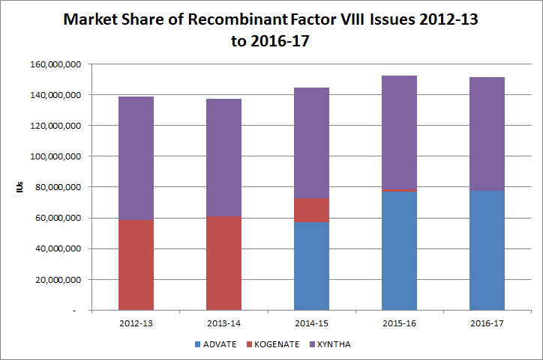

Figure 2 - Market share of recombinant FVIII issues 2012-13 to 2016-17

Figure 2 illustrates the changes that occurred during 2012 to 2017, brought about by new national supply arrangements, with a transition away from Kogenate and Recombinate, an increase in the issue of Xyntha and the introduction of Advate. In 2014-15 the NBA implemented new contracts for the supply of Recombinant Factor VIII and IX. The new supply arrangements have provided high level national efficiencies without detriment to the patient population. Advate accounted for approximately 51 per cent and Xyntha for 49 per cent of the market share of Recombinant FVIII issues during 2016‑17.

The most challenging aspect of HMA management is the development of FVIII inhibitors; previously untreated patients are at the highest risk for inhibitor formation.

Patient participation in company clinical trials for Extended Half Life recombinant Factor VIII and Factor IX products continues to contribute to the variability of year-to-year product growth.

# ABDR patient demographics

This section of the report presents the key patient demographic data collected in the ABDR.

## Diagnoses

The following tables present the numbers of patients in the ABDR and the numbers of patients who received therapeutic products during the years 2012-13 to 2016-17. As noted in the section on *Data quality issues* (page 16) comprehensive automated and manual data cleansing and validation processes that occurred as part of the 4th Generation ABDR Redevelopment project released in August 2012 and the continuation in 2016-17 enhanced the ABDR data accuracy and consistency presented in this report. This may make it difficult to undertake comparisons with data published in previous reports.

Table 3 shows the number of people in the registry and the number treated by latest broad diagnosis for the years 2012-13 to 2016-17. Table 5 expands the data in Table 3 to show the number of people in the registry and the number treated by detailed diagnosis for the years 2012-13 to 2016-17.

Table 3 - Number of people in the registry and treated by broad diagnosis

| Diagnosis | Number in ABDR Registry* | | | | | Number who Received Product during the year | | | | |
| --- | --- | --- | --- | --- | --- | --- | --- | --- | --- | --- |
|  | **2012-13** | **2013-14** | **2014-15** | **2015-16** | **2016-17** | **2012-13** | **2013-14** | **2014-15** | **2015-16** | **2016-17** |
| **Hereditary** |  |  |  |  |  |  |  |  |  |  |
| HMA | 2,091 | 2,155 | 2,158 | 2,301 | 2,365 | 984 | 964 | 992 | 1,022 | 1,009 |
| HMB | 517 | 532 | 530 | 548 | 564 | 206 | 205 | 218 | 219 | 218 |
| VWD | 1,921 | 2,013 | 2,012 | 2,092 | 2,141 | 222 | 249 | 255 | 287 | 248 |
| **Acquired** |  |  |  |  |  |  |  |  |  |  |
| HMA | 40 | 49 | 59 | 74 | 68 | 10 | 9 | 23 | 13 | 11 |
| HMB |  |  |  |  | <5 |  |  |  | <5 |  |
| VWD | 13 | 18 | 19 | 22 | 25 | 5 | 5 | <5 | 8 | 10 |
| **Other Diagnoses** |  |  |  |  |  |  |  |  |  |  |
| Other‡ | 191 | 201 | 193 | 179 | 193 | 7 | 13 | 11 | 15 | 14 |
| Other Factor Deficiency | 295 | 328 | 344 | 391 | 427 | 36 | 46 | 36 | 52 | 50 |
| Platelet Disorder | 225 | 245 | 255 | 271 | 288 | 15 | 18 | 15 | 19 | 10 |
| Vascular | 7 | 7 | 7 | 7 | 9 |  |  |  |  |  |
| Fibrinogen Disorder | 34 | 41 | 49 | 62 | 74 | 8 | 7 | 10 | 11 | 20 |
| **Total** | **5,334** | **5,589** | **5,626** | **5,947** | **6,155** | **1,493** | **1,516** | **1,563** | **1,647** | **1,590** |

Note: Includes asymptomatic carriers in Hereditary

* As noted in the section *Data quality issues* (p15) the data has improved since previous ABDR Annual Reports. The figures presented here represent the most accurate data currently available. The census date for number of people in the registry is 30 June, the last day of the financial year.

‡The ABDR allows for a diagnosis of ‘Other’ to be recorded for patients with rare and less prevalent disorders or difficult to classify disorders eg mild VWD

### Patients with multiple bleeding disorders

Individual patients may have more than one bleeding disorder, and will be registered with more than one diagnosis. There are patients with multiple diagnoses in the registry for 2016-17. In these cases, a patient may be counted more than once in the data in this report (e.g. if a patient has two bleeding disorders, that patient may be counted in the totals for each disorder).

In 2016-17 there were 98 patients with two diagnoses and <5 patients with three diagnoses. Of the patients with more than one diagnosis 24 patients received product.

Table 4 - Number of people in the registry with multiple bleeding disorders

|  |  |  |  |  |  |
| --- | --- | --- | --- | --- | --- |
| **Diagnosis** | **Patients Numbers in ABDR Registry\*** | | | | **Number of Patient with Multiple Disorders who Received Product during the year** |
|  | Bleeding Disorder 1 | Bleeding Disorder 2 | Bleeding Disorder 3 |  | | |
| HMA | 2,433 | 44 | <5 | 17 | | |
| HMB | 565 | <5 |  |  | | |
| VWD | 2,166 | 18 | <5 | <5 | | |
| Other‡ | 193 | <5 |  | <5 | | |
| Other Factor Deficiency | 427 | 19 |  |  | | |
| Platelet Disorder | 288 | 11 |  | <5 | | |
| Vascular | 9 | <5 |  |  | | |
| Fibrinogen Disorders | 74 |  |  |  | | |
| **Total** | **6,155** | **98** | **<5** | **24** | | |

Note: Includes Acquired and Hereditary disorders

* As noted in the section *Data quality issues* (p15) the data has improved since previous ABDR Annual Reports. The figures presented here represent the most accurate data currently available. The census date for number of people in the registry is 30 June, the last day of the financial year.

‡The ABDR allows for a diagnosis of ‘Other’ to be recorded for patients with rare and less prevalent disorders or difficult to classify disorders eg mild VWD

Table 5 - Number of people in the registry and treated by detailed diagnosis

|  | Number in ABDR Registry* | | | | | Number who Received Product during the year | | | | |
| --- | --- | --- | --- | --- | --- | --- | --- | --- | --- | --- |
|  | 2012-13 | 2013-14 | 2014-15 | 2015-16 | 2016-17 | 2012-13 | 2013-14 | 2014-15 | 2015-16 | 2016-17 |
| **Hereditary** |  |  |  |  |  |  |  |  |  |  |
| **HMA** |  |  |  |  |  |  |  |  |  |  |
| Asymptomatic Carrier Factor VIII Deficiency (HmA) | 218 | 241 | 190 | 226 | 235 | 7 | <5 | 6 | <5 | <5 |
| Factor VIII Deficiency (HmA) | 1,723 | 1,752 | 1,793 | 1,972 | 2,085 | 962 | 942 | 972 | 1,011 | 1,005 |
| Symptomatic Carrier Factor VIII Deficiency (HmA) | 150 | 162 | 175 | 103 | 45 | 15 | 18 | 14 | 9 | <5 |
| **HMB** |  |  |  |  |  |  |  |  |  |  |
| Asymptomatic Carrier Factor IX Deficiency (HmB) | 49 | 54 | 47 | 47 | 53 |  |  |  | <5 |  |
| Factor IX Deficiency (HmB) | 418 | 424 | 426 | 471 | 489 | 197 | 199 | 209 | 213 | 216 |
| Symptomatic Carrier Factor IX Deficiency (HmB) | 50 | 54 | 57 | 30 | 22 | 9 | 6 | 9 | 5 | <5 |
| **VWD** |  |  |  |  |  |  |  |  |  |  |
| von Willebrand Disease – Uncharacterised | 313 | 318 | 279 | 219 | 180 | 10 | 14 | 13 | 8 | 9 |
| von Willebrand Disease Type 1 | 1,175 | 1,236 | 1,233 | 1,328 | 1,387 | 113 | 130 | 127 | 137 | 115 |
| von Willebrand Disease Type 2 | 392 | 417 | 459 | 502 | 533 | 69 | 73 | 84 | 108 | 94 |
| von Willebrand Disease Type 3 | 41 | 42 | 41 | 43 | 41 | 30 | 32 | 31 | 34 | 30 |
| **Hereditary Total** | **4,530** | **4,701** | **4,700** | **4,941** | **5,070** | **1,412** | **1,418** | **1,465** | **1,528** | **1,475** |
| **Acquired** |  |  |  |  |  |  |  |  |  |  |
| HMA | 40 | 49 | 59 | 74 | 68 | 10 | 9 | 23 | 13 | 11 |
| HMB |  |  |  |  | <5 |  |  |  | <5 |  |
| VWD | 13 | 18 | 19 | 22 | 25 | 5 | 5 | <5 | 8 | 10 |
| **Acquired Total** | **52** | **66** | **78** | **96** | **<97** | **15** | **14** | **<27** | **<25** | **21** |
| **Other Factor Deficiency** |  |  |  |  |  |  |  |  |  |  |
| Factor V Deficiency | 11 | 10 | 11 | 17 | 15 | <5 | <5 | <5 | <5 | <5 |
| Factor VII Deficiency | 53 | 54 | 61 | 67 | 73 | 10 | 9 | 8 | 7 | 9 |
| Factor X Deficiency | 17 | 17 | 17 | 20 | 19 | 5 | <5 | 5 | <5 | 6 |
| Factor XI Deficiency | 178 | 206 | 217 | 249 | 273 | 12 | 20 | 14 | 24 | 18 |
| Factor XII Deficiency† | 20 | 16 | 17 | 17 | 18 | <5 | <5 | <5 | <5 |  |
| Factor XIII Deficiency | 15 | 18 | 19 | 21 | 24 | 9 | 10 | 6 | 11 | 14 |
| **Platelet Disorder** |  |  |  |  |  |  |  |  |  |  |
| Platelet - Bernard-Soulier | 5 | 5 | 5 | 5 | 7 |  |  |  | <5 |  |
| Platelet - Glanzmann's Thrombasthenia | 16 | 17 | 18 | 21 | 22 | <5 | <5 | <5 | 8 | 6 |
| Platelet - Macrothrombocytopenias | 10 | 10 | 12 | 13 | 13 | <5 |  |  |  |  |
| Platelet - May Hegglin | <5 | <5 | <5 | <5 | <5 | <5 |  |  | <5 |  |
| Platelet - Primary Secretion Defect | 7 | 9 | 10 | 10 | 9 | <5 | <5 | <5 |  | <5 |
| Platelet - Storage Pool (Dense Granule) Deficiency | 31 | 37 | 43 | 46 | 52 | <5 | <5 |  | <5 | <5 |
| Platelet – Uncharacterised | 153 | 164 | 164 | 173 | 182 | 8 | 10 | 10 | 7 | <5 |
| **Vascular** |  |  |  |  |  |  |  |  |  |  |
| Vascular Disorders - Ehlers Danlos Syndrome | 7 | 7 | 7 | 7 | 9 |  |  |  |  |  |
| **Fibrinogen** |  |  |  |  |  |  |  |  |  |  |
| Fibrinogen – Afibrinogenemia | 6 | 7 | 7 | 7 | 7 | <5 | 5 | 5 | <5 | 5 |
| Fibrinogen – Dysfibrinogenemia | 22 | 24 | 29 | 36 | 45 | <5 | <5 | <5 | <5 | 9 |
| Fibrinogen – Hypofibrinogenemia | 5 | 9 | 12 | 17 | 19 |  |  | <5 | <5 | 6 |
| Fibrinogen Dysfunction - Uncharacterised | <5 | <5 | <5 | <5 | <5 |  |  |  |  |  |
| **Other (Including Unclassified)** | 191 | 201 | 193 | 179 | 198 | 7 | 13 | 11 | 15 | 14 |
| **Other Diagnoses Total** | **752** | **822** | **848** | **910** | **991** | **66** | **84** | **72** | **97** | **94** |
| **Total** | **5,334** | **5,589** | **5,626** | **5,947** | **6,155** | **1,493** | **1,516** | **1,563** | **1,647** | **1,590** |

* As noted in the section *Data quality issues* (p15) the data has been improved since previous ABDR Annual Reports. The figures presented here represent the most accurate data currently available. The census date for number of people in the registry is 30 June, the last day of the financial year.

†Factor XII Deficiency does not require treatment with products, but is included as a diagnostic category.

## Age, diagnosis and severity

In the following tables patients are categorised as either Adult (aged 18 years and over) or Paediatric and Adolescent (aged under 18 years).[2]

Table 6 and Table 7 detail the numbers of patients in the registry who received product (therapeutic treatment) during the period 2012-13 to 2016-17; by age group, broad diagnosis and by severity.

Table 8 and Table 9 set out age group and detailed diagnosis for patients with HMA, HMB and VWD.

The majority of patients receiving treatment for bleeding disorders have HMA, specifically those patients with severe HMA.

There are some discrepancies in the data regarding the coding of severity when a patient receives treatment, and data cleansing and patient record updates are continuing. This will improve the forecasting for the national supply plan and budget for future years. It should be noted that the national forecasting and supply management process continue to perform very well.

Whilst the data discrepancies affect the analysis for this annual report, there is minimal impact on patient care as Haemophilia Treatment Centre staff have full access to their patient records for the provision of care and treatment.

In 2016-17 the results show variations. The patterns indicate that the implemented strategies are improving data quality, completeness and accuracy. This will make it difficult to undertake comparisons with data published in previous reports particularly in regards to multiple diagnoses. Continued work on the data integrity of the registry has been undertaken again in 2016-17.

Table 6 - Number of adult patients in the registry and treated by broad diagnosis and severity for HMA, HMB

|  | Number in ABDR Registry* | | | | | Number who Received Product during the year | | | | |
| --- | --- | --- | --- | --- | --- | --- | --- | --- | --- | --- |
| **Adult (aged 18 years and over)** | **2012-13** | **2013-14** | **2014-15** | **2015-16** | **2016-17** | **2012-13** | **2013-14** | **2014-15** | **2015-16** | **2016-17** |
| **Hereditary** |  |  |  |  |  |  |  |  |  |  |
| **HMA** |  |  |  |  |  |  |  |  |  |  |
| Mild | 939 | 961 | 996 | 1,040 | 1,007 | 220 | 205 | 208 | 227 | 220 |
| Moderate | 151 | 148 | 145 | 159 | 157 | 85 | 78 | 94 | 99 | 88 |
| Severe | 348 | 364 | 374 | 385 | 392 | 316 | 327 | 327 | 340 | 355 |
| **HMB** |  |  |  |  |  |  |  |  |  |  |
| Mild | 229 | 234 | 235 | 240 | 227 | 53 | 41 | 55 | 53 | 54 |
| Moderate | 92 | 93 | 97 | 96 | 98 | 46 | 49 | 49 | 54 | 52 |
| Severe | 56 | 58 | 56 | 60 | 63 | 45 | 49 | 47 | 50 | 51 |
| **Total Hereditary** | **1,815** | **1,858** | **1,903** | **1,980** | **1,944** | **765** | **749** | **780** | **823** | **820** |
| Total Acquired HMA | 32 | 40 | 44 | 23 | 22 | 7 | 6 | 13 | <5 | <5 |
| **Total** | **1,847** | **1,898** | **1,947** | **2,003** | **1,966** | **772** | **755** | **793** | **<828** | **<825** |

* As noted in the section *Data quality issues* (p15) the data has been improved since previous ABDR Annual Reports. The figures presented here represent the most accurate data currently available. The census date for number of people in the registry is 30 June, the last day of the financial year. Patients can have their severity categorised as ‘unknown’ or ‘not applicable’ during the initial diagnosis procedures, and these figures are not shown in this table. Excludes those severities recorded as *Unknown, Not Applicable and Blank*.

Table 7 - Number of paediatric and adolescent patients in the registry and treated by broad diagnosis and severity for HMA, HMB

|  | Number in ABDR Registry* | | | | | Number who Received Product* | | | | |
| --- | --- | --- | --- | --- | --- | --- | --- | --- | --- | --- |
| **Paediatric and Adolescent (aged less than 18 years)** | **2012-13** | **2013-14** | **2014-15** | **2015-16** | **2016-17** | **2012-13** | **2013-14** | **2014-15** | **2015-16** | **2016-17** |
| **Hereditary** |  |  |  |  |  |  |  |  |  |  |
| **HMA** |  |  |  |  |  |  |  |  |  |  |
| Mild | 169 | 171 | 183 | 205 | 206 | 54 | 50 | 54 | 56 | 49 |
| Moderate | 67 | 69 | 68 | 66 | 70 | 55 | 50 | 56 | 52 | 48 |
| Severe | 263 | 265 | 266 | 275 | 274 | 250 | 252 | 249 | 247 | 246 |
| **HMB** |  |  |  |  |  |  |  |  |  |  |
| Mild | 47 | 52 | 51 | 54 | 47 | 9 | 17 | 14 | 13 | 12 |
| Moderate | 19 | 20 | 21 | 21 | 19 | 14 | 14 | 16 | 13 | 15 |
| Severe | 40 | 39 | 41 | 42 | 43 | 39 | 35 | 37 | 35 | 34 |
| **Total Hereditary** | **605** | **616** | **630** | **663** | **659** | **421** | **418** | **426** | **416** | **404** |
| **Total Acquired HMA** | **<5** | **<5** | **<5** | **<5** | **<5** |  | **<5** | **<5** |  |  |

* As noted in the section *Data quality issues* (p15) the data has been improved since previous ABDR Annual Reports. Patients can have their severity categorised as ‘unknown’ or ‘not applicable’ during the initial diagnosis procedures, and these figures are not shown in this table. The figures presented here represent the most accurate data currently available. The census date for number of people in the registry is 30 June, the last day of the financial year. Excludes those severities recorded as *Unknown, Not Applicable and Blank*.

## By age group and detailed diagnosis

Table 8 - Number of people in the registry diagnosed with HMA or HMB by age group and disease classification

|  |  |  |  |  |  |  |  |  |  |  |
| --- | --- | --- | --- | --- | --- | --- | --- | --- | --- | --- |
|  | **Number in ABDR Registry\*** | | | | | **Number who Received Product during the year** | | | | |
|  | **2012-13** | **2013-14** | **2014-15** | **2015-16** | **2016-17** | **2012-13** | **2013-14** | **2014-15** | **2015-16** | **2016-17** |
| **Hereditary** |  |  |  |  |  |  |  |  |  |  |
| **HMA – Adult (aged 18 years and over)** |  |  |  |  |  |  |  |  |  |  |
| Asymptomatic Carrier Factor VIII Deficiency | 211 | 232 | 181 | 216 | 223 | 7 | <5 | 6 | <5 |  |
| Factor VIII Deficiency | 1,239 | 1,264 | 1,293 | 1,441 | 1,536 | 604 | 592 | 615 | 658 | 662 |
| Symptomatic Carrier Factor VIII Deficiency ** | 133 | 141 | 154 | 86 | 38 | 13 | 16 | 11 | 7 | <5 |
| **HMA – Paediatric (aged less than 18 years)** |  |  |  |  |  |  |  |  |  |  |
| Asymptomatic Carrier Factor VIII Deficiency | 7 | 9 | 9 | 10 | 12 |  |  |  |  | <5 |
| Factor VIII Deficiency | 484 | 488 | 500 | 531 | 549 | 358 | 350 | 357 | 353 | 343 |
| Symptomatic Carrier Factor VIII Deficiency | 17 | 21 | 21 | 17 | 7 | <5 | <5 | <5 | <5 |  |
| **HMB – Adult (aged 18 years and over)** |  |  |  |  |  |  |  |  |  |  |
| Asymptomatic Carrier Factor IX Deficiency | 46 | 49 | 42 | 44 | 48 |  |  |  | <5 |  |
| Factor IX Deficiency | 319 | 322 | 321 | 360 | 382 | 136 | 133 | 142 | 152 | 155 |
| Symptomatic Carrier Factor IX Deficiency | 43 | 47 | 51 | 25 | 18 | 8 | 6 | 9 | 5 | <5 |
| **HMB – Paediatric (aged less than 18 years)** |  |  |  |  |  |  |  |  |  |  |
| Asymptomatic Carrier Factor IX Deficiency | <5 | 5 | 5 | <5 | 5 |  |  |  |  |  |
| Factor IX Deficiency | 99 | 102 | 105 | 111 | 107 | 61 | 66 | 67 | 61 | 61 |
| Symptomatic Carrier Factor IX Deficiency | 7 | 7 | 6 | 5 | <5 | <5 |  |  |  |  |
| **Acquired** |  |  |  |  |  |  |  |  |  |  |
| **HMA – Adult (aged 18 years and over)** | 39 | 47 | 57 | 73 | 67 | 10 | 7 | 22 | 13 | 11 |
| **HMA – Paediatric (aged less than 18 years)** | <5 | <5 | <5 | <5 | <5 |  | <5 | <5 |  |  |
| **HMB – Adult (aged 18 years and over)** |  |  |  |  | <5 |  |  |  | <5 |  |

* As noted in the section *Data quality issues* (p15) the data has been improved since previous ABDR Annual Reports. The figures presented here represent the most accurate data currently available. The census date for number of people in the registry is 30 June, the last day of the financial year.

** Symptomatic carriers transitioned to asymptomatic carriers and Haemophilia Factor VIII Deficiency patients, accounts for ongoing data quality changes in patient counts in 2016-17.

Table 9 - Number of people in the registry diagnosed with VWD by age group and disease classification

|  |  |  |  |  |  |  |  |  |  |  |
| --- | --- | --- | --- | --- | --- | --- | --- | --- | --- | --- |
|  | **Number in ABDR Registry\*** | | | | | **Number who Received Product during the year** | | | | |
|  | **2012-13** | **2013-14** | **2014-15** | **2015-16** | **2016-17** | **2012-13** | **2013-14** | **2014-15** | **2015-16** | **2016-17** |
| **Hereditary** |  |  |  |  |  |  |  |  |  |  |
| **VWD – Adult (aged 18 years and over)** |  |  |  |  |  |  |  |  |  |  |
| von Willebrand Disease - Uncharacterised | 255 | 263 | 231 | 176 | 149 | 6 | 11 | 9 | 6 | 9 |
| von Willebrand Disease Type 1 | 958 | 1,016 | 1,023 | 1,123 | 1,184 | 96 | 108 | 107 | 116 | 99 |
| von Willebrand Disease Type 2 | 296 | 320 | 354 | 394 | 427 | 56 | 60 | 68 | 86 | 75 |
| von Willebrand Disease Type 3 | 32 | 34 | 35 | 35 | 32 | 24 | 24 | 26 | 27 | 24 |
| **VWD – Paediatric (aged less than 18 years)** |  |  |  |  |  |  |  |  |  |  |
| von Willebrand Disease - Uncharacterised | 58 | 55 | 48 | 43 | 31 | <5 | <5 | <5 | <5 |  |
| von Willebrand Disease Type 1 | 217 | 220 | 210 | 205 | 203 | 17 | 22 | 20 | 21 | 16 |
| von Willebrand Disease Type 2 | 96 | 97 | 105 | 108 | 106 | 13 | 13 | 16 | 22 | 19 |
| von Willebrand Disease Type 3 | 9 | 8 | 6 | 8 | 9 | 6 | 8 | 5 | 7 | 6 |
| **Acquired** |  |  |  |  |  |  |  |  |  |  |
| **VWD – Adult (aged 18 years and over)** | 12 | 17 | 19 | 22 | 25 | 5 | 5 | <5 | 8 | 10 |
| **VWD – Paediatric (aged less than 18 years)** | <5 | <5 |  |  |  |  |  |  |  |  |

* As noted in the section *Data quality issues* (p15) the data has been improved since previous ABDR Annual Reports. The figures presented here represent the most accurate data currently available. The census date for number of people in the registry is 30 June, the last day of the financial year.

## By location

Figure 3 depicts the geographic distribution of patients in the ABDR. Patient distribution is largely in line with the distribution of the general population. However, a more detailed analysis of geographic distribution could be expected to reveal the clustering effects often associated with the distribution of genetic disorder. Excluded from Figure 3 are 15 patients that have unknown locations (down from 33 in 2015-16).



Figure 3 - Numbers of active patients in the Registry as at 30 June 2017

Table 10 shows the numbers of patients with severe hereditary HMA and HMB, acquired HMA and the numbers of male patients with severe HMA and HMB by state and territory.

Table 10 - Numbers of patients with severe HMA and HMB by location

|  | HMA | | | HMB | |
| --- | --- | --- | --- | --- | --- |
| State/Territory | Severe Hereditary | Severe Hereditary Males | Severe Acquired | Severe Hereditary | Severe Hereditary Males |
| ACT | 13 | 13 |  | <5 | <5 |
| NSW | 197 | 195 | 8 | 36 | 36 |
| NT | <5 | <5 | <5 |  |  |
| QLD | 150 | 149 |  | 21 | 21 |
| SA | 51 | 51 | <5 | <5 | <5 |
| TAS | 17 | 17 |  | <5 | <5 |
| VIC | 164 | 164 |  | 32 | 32 |
| WA | 71 | 71 | <5 | 9 | 8 |
| **Total** | **<668** | **<665** | **<20** | **106** | **105** |

As noted in the section *Data quality issues* (p15) the data has been improved since previous ABDR Annual Reports. The figures presented here represent the most accurate data currently available. The census date for number of people in the registry is 30 June, the last day of the financial year. This table excludes patients with an unknown location.

## By gender and age distribution

The figures in this section present the gender and age distribution of patients in the ABDR in 2016-17, compared to the general Australian population5F[3].

Figure 4 and Figure 5 chart the distribution of all female hereditary HMA and HMB patients against the female population. The tables next to each figure show the numbers and percentages used in the charts.



Figure 4 - Distribution of hereditary female HMA patients by age in 2016-17

Table (FIg 4) – Distribution of hereditary female HMA patients by age in 2016-17

|  |  |  |  |  |
| --- | --- | --- | --- | --- |
| Age group | 2016 Australian Female Population | % 2016 Australian Female Population | HMA female patients | % HMA female patients |
| 0–4 | 765,994 | 6.3% | 5 | 1.1% |
| 5–9 | 762,928 | 6.3% | 16 | 3.4% |
| 10–14 | 696,325 | 5.7% | 14 | 3.0% |
| 15–19 | 720,085 | 5.9% | 11 | 2.3% |
| 20–24 | 830,358 | 6.8% | 23 | 4.9% |
| 25–29 | 908,879 | 7.5% | 25 | 5.3% |
| 30–34 | 903,259 | 7.4% | 53 | 11.3% |
| 35–39 | 806,038 | 6.6% | 66 | 14.0% |
| 40–44 | 820,061 | 6.7% | 54 | 11.5% |
| 45–49 | 820,203 | 6.7% | 52 | 11.1% |
| 50–54 | 787,079 | 6.5% | 41 | 8.7% |
| 55–59 | 753,160 | 6.2% | 26 | 5.5% |
| 60–64 | 667,824 | 5.5% | 29 | 6.2% |
| 65–69 | 604,480 | 5.0% | 27 | 5.7% |
| 70+ | 1,352,290 | 11.1% | 28 | 5.7% |
| **All ages** | **12,198,963** |  | **470** |  |



Figure 5 - Distribution of hereditary female HMB patients by age in 2016-17

Table (FIg 5) – Distribution of hereditary female HMB patients by age in 2016-17

|  |  |  |  |  |
| --- | --- | --- | --- | --- |
| Age group | 2016 Australian Female Population | % 2016 Australian Female Population | HMB female patients | % HMB female patients |
| 0–4 | 765,994 | 6.3% | <5 | <5 |
| 5–9 | 762,928 | 6.3% | <5 | <5 |
| 10–14 | 696,325 | 5.7% | 8 | 6.2% |
| 15–19 | 720,085 | 5.9% | 9 | 7.0% |
| 20–24 | 830,358 | 6.8% | 8 | 6.2% |
| 25–29 | 908,879 | 7.5% | 8 | 6.2% |
| 30–34 | 903,259 | 7.4% | 10 | 7.8% |
| 35–39 | 806,038 | 6.6% | 9 | 7.0% |
| 40–44 | 820,061 | 6.7% | 14 | 10.9% |
| 45–49 | 820,203 | 6.7% | 13 | 10.1% |
| 50–54 | 787,079 | 6.5% | 9 | 7.0% |
| 55–59 | 753,160 | 6.2% | 5 | 3.9% |
| 60–64 | 667,824 | 5.5% | 7 | 5.4% |
| 65–69 | 604,480 | 5.0% | 6 | 4.7% |
| 70+ | 1,352,290 | 11.1% | 17 | 13.2% |
| **All ages** | **12,198,963** |  | **129** |  |

Figure 6 and 6.1 chart the distribution of all male hereditary HMA patients and all male severe hereditary HMA patients against the male population. The disorder is genetically linked to a patient’s gender, and usually affects males. There are a relatively lower number of older patients (from the age grouping of 75-79 years onwards). The life expectancy of HMA patients has improved dramatically6F[4] in recent decades. The younger cohorts can expect to survive longer, which will increase the overall patient population and the demand for product in the future.

The number of acquired HMA severe male patients totalled 9.

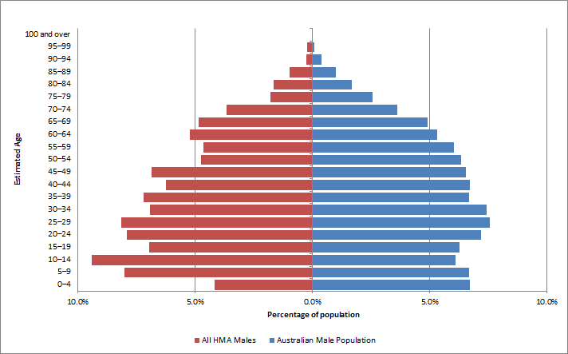

Figure 6 - Distribution of hereditary male HMA patients by age in 2016-17

Table (FIg 6) – Distribution of hereditary male HMA patients by age in 2016-17

|  |  |  |  |  |
| --- | --- | --- | --- | --- |
| Age group | 2016 Australian Male Population | % 2016 Australian Male Population | HMA male patients | % HMA male patients |
| 0–4 | 808,109 | 6.7% | 79 | 4.2% |
| 5–9 | 804,159 | 6.7% | 152 | 8.0% |
| 10–14 | 735,400 | 6.1% | 178 | 9.4% |
| 15–19 | 755,917 | 6.3% | 132 | 7.0% |
| 20–24 | 866,128 | 7.2% | 150 | 7.9% |
| 25–29 | 909,656 | 7.6% | 154 | 8.1% |
| 30–34 | 892,953 | 7.4% | 131 | 6.9% |
| 35–39 | 802,100 | 6.7% | 136 | 7.2% |
| 40–44 | 808,149 | 6.7% | 118 | 6.2% |
| 45–49 | 786,139 | 6.5% | 130 | 6.9% |
| 50–54 | 763,717 | 6.4% | 90 | 4.7% |
| 55–59 | 724,403 | 6.0% | 88 | 4.6% |
| 60–64 | 638,275 | 5.3% | 99 | 5.2% |
| 65–69 | 589,768 | 4.9% | 92 | 4.9% |
| 70+ | 1,126,973 | 9.4% | 166 | 8.5% |
| **All ages** | **12,011,846** |  | **1,895** |  |

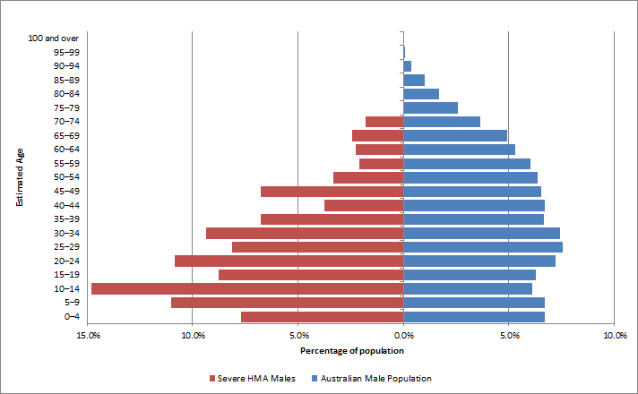

Figure 6.1 - Distribution of hereditary male HMA severe patients by age in 2016-17

Table (FIg 6.1) – Distribution of hereditary male HMA severe patients by age in 2016-17

|  |  |  |  |  |
| --- | --- | --- | --- | --- |
| Age group | 2016 Australian Male Population | % 2016 Australian Male Population | HMA severe male patients | % HMA severe male patients |
| 0–4 | 808,109 | 6.7% | 51 | 7.7% |
| 5–9 | 804,159 | 6.7% | 73 | 11.0% |
| 10–14 | 735,400 | 6.1% | 98 | 14.8% |
| 15–19 | 755,917 | 6.3% | 58 | 8.7% |
| 20–24 | 866,128 | 7.2% | 72 | 10.9% |
| 25–29 | 909,656 | 7.6% | 54 | 8.1% |
| 30–34 | 892,953 | 7.4% | 62 | 9.4% |
| 35–39 | 802,100 | 6.7% | 45 | 6.8% |
| 40–44 | 808,149 | 6.7% | 25 | 3.8% |
| 45–49 | 786,139 | 6.5% | 45 | 6.8% |
| 50–54 | 763,717 | 6.4% | 22 | 3.3% |
| 55–59 | 724,403 | 6.0% | 14 | 2.1% |
| 60–64 | 638,275 | 5.3% | 15 | 2.3% |
| 65–69 | 589,768 | 4.9% | 16 | 2.4% |
| 70+ | 1,126,973 | 9.4% | 13 | 1.8% |
| **All ages** | **12,011,846** |  | **663** |  |

Figure 7 and Figure 7.1 chart the distribution of all male hereditary HMB patients and all male severe hereditary HMB patients against the male population. As with HMA, HMB is also genetically linked to a patient’s gender, and usually affects males. The observed male severe HMB population does not conform to the same pattern as the general male population, however there are low patient numbers (n=105) in this group and no conclusions should be drawn.

There were no acquired HMB severe male patients.

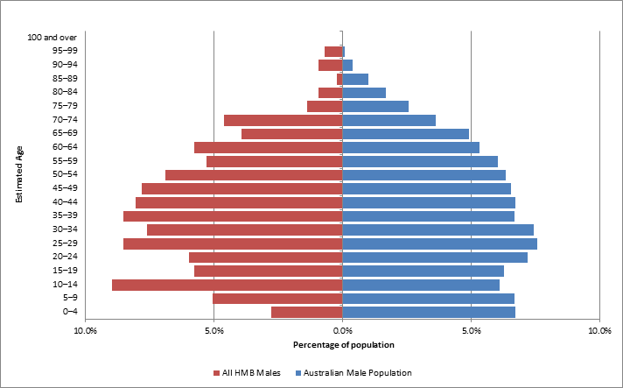

Figure 7 - Distribution of hereditary male HMB patients by age in 2016-17

Table (FIg 7) – Distribution of hereditary male HMB patients by age in 2016-17

|  |  |  |  |  |
| --- | --- | --- | --- | --- |
| Age group | 2016 Australian Male Population | % 2016 Australian Male Population | HMB male patients | % HMB male patients |
| 0–4 | 808,109 | 6.3% | 12 | 2.8% |
| 5–9 | 804,159 | 6.3% | 22 | 5.1% |
| 10–14 | 735,400 | 5.7% | 39 | 9.0% |
| 15–19 | 755,917 | 5.9% | 25 | 5.7% |
| 20–24 | 866,128 | 6.8% | 26 | 6.0% |
| 25–29 | 909,656 | 7.5% | 37 | 8.5% |
| 30–34 | 892,953 | 7.4% | 33 | 7.6% |
| 35–39 | 802,100 | 6.6% | 37 | 8.5% |
| 40–44 | 808,149 | 6.7% | 35 | 8.0% |
| 45–49 | 786,139 | 6.7% | 34 | 7.8% |
| 50–54 | 763,717 | 6.5% | 30 | 6.9% |
| 55–59 | 724,403 | 6.2% | 23 | 5.3% |
| 60–64 | 638,275 | 5.5% | 25 | 5.7% |
| 65–69 | 589,768 | 5.0% | 17 | 3.9% |
| 70+ | 1,126,973 | 9.4% | 40 | 8.7% |
| **All ages** | **12,011,846** |  | **435** |  |

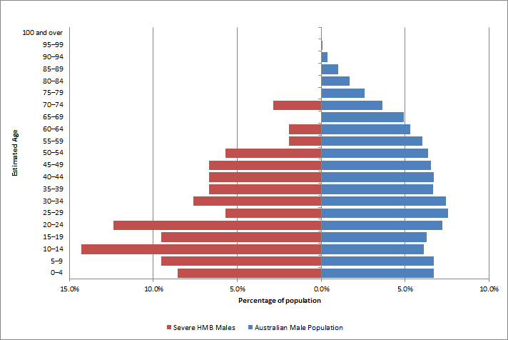

Figure 7.1 - Distribution of hereditary male HMB severe patients by age in 2016-17

Table (FIg 7.1) – Distribution of hereditary male HMB severe patients by age in 2016-17

|  |  |  |  |  |
| --- | --- | --- | --- | --- |
| Age group | 2016 Australian Male Population | % 2016 Australian Male Population | HMB severe male patients | % HMB severe male patients |
| 0–4 | 808,109 | 6.3% | 9 | 8.6% |
| 5–9 | 804,159 | 6.3% | 10 | 9.5% |
| 10–14 | 735,400 | 5.7% | 15 | 14.3% |
| 15–19 | 755,917 | 5.9% | 10 | 9.5% |
| 20–24 | 866,128 | 6.8% | 13 | 12.4% |
| 25–29 | 909,656 | 7.5% | 6 | 5.7% |
| 30–34 | 892,953 | 7.4% | 8 | 7.6% |
| 35–39 | 802,100 | 6.6% | 7 | 6.7% |
| 40–44 | 808,149 | 6.7% | 7 | 6.7% |
| 45–49 | 786,139 | 6.7% | 7 | 6.7% |
| 50–54 | 763,717 | 6.5% | 6 | 5.7% |
| 55–59 | 724,403 | 6.2% | <5 | <5 |
| 60–64 | 638,275 | 5.5% | <5 | <5 |
| 65–69 | 589,768 | 5.0% |  | 0.0% |
| 70+ | 1,126,973 | 9.4% | <5 | <5 |
| **All ages** | **12,011,846** |  | **105** |  |

Figure 8, Figure 8.1, Figure 9 and Figure 9.1 chart the distribution of all female and male VWD patients and female and male severe VWD patients against the female and male populations.



Figure 8 - Distribution of hereditary female VWD patients by age in 2016-17

Table (FIg 8) – Distribution of hereditary female VWD patients by age in 2016-17

|  |  |  |  |  |
| --- | --- | --- | --- | --- |
| Age group | 2016 Australian Female Population | % 2016 Australian Female Population | VWD female patients | % VWD female patients |
| 0–4 | 765,994 | 6.3% | 8 | 0.6% |
| 5–9 | 762,928 | 6.3% | 29 | 2.2% |
| 10–14 | 696,325 | 5.7% | 47 | 3.5% |
| 15–19 | 720,085 | 5.9% | 60 | 4.5% |
| 20–24 | 830,358 | 6.8% | 126 | 9.4% |
| 25–29 | 908,879 | 7.5% | 117 | 8.8% |
| 30–34 | 903,259 | 7.4% | 126 | 9.4% |
| 35–39 | 806,038 | 6.6% | 124 | 9.3% |
| 40–44 | 820,061 | 6.7% | 130 | 9.7% |
| 45–49 | 820,203 | 6.7% | 133 | 9.9% |
| 50–54 | 787,079 | 6.5% | 98 | 7.3% |
| 55–59 | 753,160 | 6.2% | 86 | 6.4% |
| 60–64 | 667,824 | 5.5% | 61 | 4.6% |
| 65–69 | 604,480 | 5.0% | 65 | 4.9% |
| 70+ | 1,352,290 | 11.1% | 127 | 9.3% |
| **All ages** | **12,198,963** |  | **1,337** |  |



Figure 8.1 - Distribution of hereditary female VWD severe patients by age in 2016-17

Table (FIg 8.1) – Distribution of hereditary female VWD severe patients by age in 2016-17

|  |  |  |  |  |
| --- | --- | --- | --- | --- |
| Age group | 2016 Australian Female Population | % 2016 Australian Female Population | VWD severe female patients | % VWD severe female patients |
| 0–4 | 765,994 | 6.3% | <5 | <5 |
| 5–9 | 762,928 | 6.3% | <5 | <5 |
| 10–14 | 696,325 | 5.7% | <5 | <5 |
| 15–19 | 720,085 | 5.9% | <5 | <5 |
| 20–24 | 830,358 | 6.8% | 5 | 7.4% |
| 25–29 | 908,879 | 7.5% | 6 | 8.8% |
| 30–34 | 903,259 | 7.4% | 5 | 7.4% |
| 35–39 | 806,038 | 6.6% | 9 | 13.2% |
| 40–44 | 820,061 | 6.7% | 8 | 11.8% |
| 45–49 | 820,203 | 6.7% | <5 | <5 |
| 50–54 | 787,079 | 6.5% | 5 | 7.4% |
| 55–59 | 753,160 | 6.2% | 7 | 10.3% |
| 60–64 | 667,824 | 5.5% | <5 | <5 |
| 65–69 | 604,480 | 5.0% | 6 | 8.8% |
| 70+ | 1,352,290 | 11.1% | <5 | <5 |
| **All ages** | **12,198,963** |  | **68** |  |

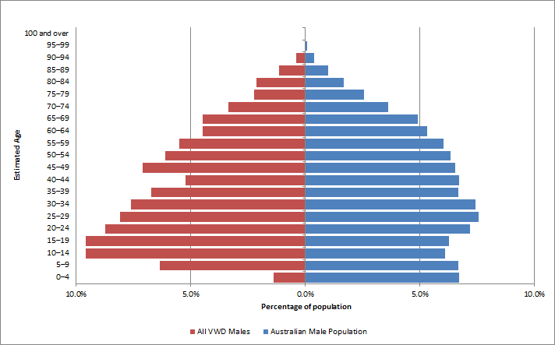

Figure 9 - Distribution of hereditary male VWD patients by age in 2016-17

Table (FIg 9) – Distribution of hereditary male VWD patients by age in 2016-17

|  |  |  |  |  |
| --- | --- | --- | --- | --- |
| Age group | 2016 Australian Male Population | % 2016 Australian Male Population | VWD male patients | % VWD male patients |
| 0–4 | 808,109 | 6.3% | 11 | 1.4% |
| 5–9 | 804,159 | 6.3% | 51 | 6.3% |
| 10–14 | 735,400 | 5.7% | 77 | 9.6% |
| 15–19 | 755,917 | 5.9% | 77 | 9.6% |
| 20–24 | 866,128 | 6.8% | 70 | 8.7% |
| 25–29 | 909,656 | 7.5% | 65 | 8.1% |
| 30–34 | 892,953 | 7.4% | 61 | 7.6% |
| 35–39 | 802,100 | 6.6% | 54 | 6.7% |
| 40–44 | 808,149 | 6.7% | 42 | 5.2% |
| 45–49 | 786,139 | 6.7% | 57 | 7.1% |
| 50–54 | 763,717 | 6.5% | 49 | 6.1% |
| 55–59 | 724,403 | 6.2% | 44 | 5.5% |
| 60–64 | 638,275 | 5.5% | 36 | 4.5% |
| 65–69 | 589,768 | 5.0% | 36 | 4.5% |
| 70+ | 1,126,973 | 9.4% | 74 | 9.2% |
| **All ages** | **12,011,846** |  | **804** |  |

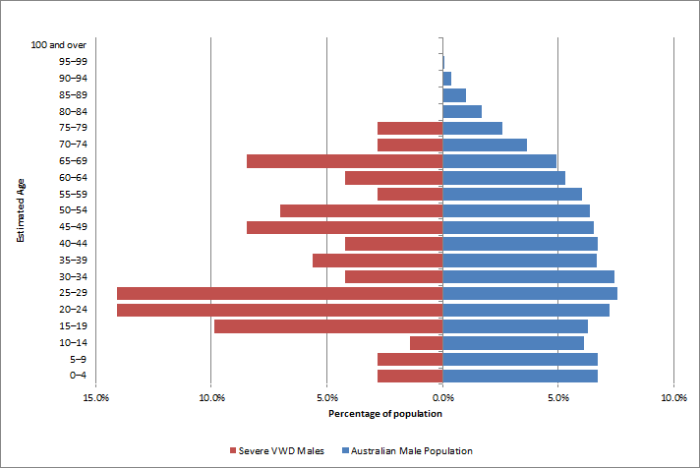

Figure 9.1 - Distribution of hereditary male VWD severe patients by age in 2016-17

Table (FIg 9.1) – Distribution of hereditary male VWD severe patients by age in 2016-17

|  |  |  |  |  |
| --- | --- | --- | --- | --- |
| Age group | 2016 Australian Male Population | % 2016 Australian Male Population | VWD severe male patients | % VWD severe male patients |
| 0–4 | 808,109 | 6.3% | <5 | <5 |
| 5–9 | 804,159 | 6.3% | <5 | <5 |
| 10–14 | 735,400 | 5.7% | <5 | <5 |
| 15–19 | 755,917 | 5.9% | 7 | 9.9% |
| 20–24 | 866,128 | 6.8% | 10 | 14.1% |
| 25–29 | 909,656 | 7.5% | 10 | 14.1% |
| 30–34 | 892,953 | 7.4% | <5 | <5 |
| 35–39 | 802,100 | 6.6% | <5 | <5 |
| 40–44 | 808,149 | 6.7% | <5 | <5 |
| 45–49 | 786,139 | 6.7% | 6 | 8.5% |
| 50–54 | 763,717 | 6.5% | 5 | 7.0% |
| 55–59 | 724,403 | 6.2% | <5 | <5 |
| 60–64 | 638,275 | 5.5% | <5 | <5 |
| 65–69 | 589,768 | 5.0% | 6 | 8.5% |
| 70+ | 1,126,973 | 9.4% | 7 | 5.6% |
| **All ages** | **12,011,846** |  | **71** |  |

Table 11 sets out a breakdown by gender for the different types of VWD.

Table 11 – VWD patients breakdown by type and gender

|  |  |  |  |
| --- | --- | --- | --- |
| **VWD Type** | **Female** | **Male** | **Total** |
| Von Willebrand Disease - Uncharacterised | 101 | 79 | 180 |
| Von Willebrand Disease Type 1 | 917 | 470 | 1,387 |
| Von Willebrand Disease Type 2 - Uncharacterised | 61 | 48 | 109 |
| Von Willebrand Disease Type 2A | 70 | 61 | 131 |
| Von Willebrand Disease Type 2B | 33 | 31 | 64 |
| Von Willebrand Disease Type 2M | 109 | 81 | 190 |
| Von Willebrand Disease Type 2N | 27 | 12 | 39 |
| Von Willebrand Disease Type 3 | 19 | 22 | 41 |
| **Total** | **1,337** | **804** | **2,141** |

## Inhibitor status

Table 12 provides a description of the inhibitor status used in the ABDR. Table 13 shows the status of inhibitors for patients as at 30 June 2017. Inhibitors are immunoglobulins made by the body's immune system to react against replacement clotting factor proteins. This occurs when the immune system perceives the proteins as foreign or harmful to the body. When this happens, the inhibitors prevent the usual replacement factors (Factor VIII or IX) from working properly to stop bleeding.

Inhibitor detection is conducted using the Bethesda assay, with or without the Nijmegen modification (Verbruggen et al. 1995), and results are expressed in Bethesda units (BU)[5]. If the inhibitor titre is high (>5 BU/ml), factor replacement therapy is ineffective and bleeding persists. With low titre inhibitor (<5 BU/ml), haemostasis may be achieved with higher doses. Patients with severe Haemophilia A with high-titre inhibitors are most at risk for recurrent bleeds and chronic haemarthroses.

FEIBA and Recombinant Factor VIIa (brand name NovoSeven) are both used to treat patients that have developed inhibitors. In the setting of managing inhibitors for haemophilia, the drivers for clinical demand for FEIBA are similar to those for NovoSeven. Predicting or interpreting changing demand trends is not possible with any accuracy, as the product is only used in a small number of patients each year. Use patterns will vary from year to year and will not only depend on the number of patients treated, but their severity of disease, the potency of inhibitors, whether secondary prophylaxis is practiced, the number and severity of spontaneous bleeds, and the amount of elective surgery undertaken in this patient group.

Table 12 - Description of inhibitor status used in ABDR

| Inhibitor Event Type | Screening or Inhibitor Status |
| --- | --- |
| Initial Inhibitor Status | * *Inhibitor Testing Not Performed -* No inhibitor test has ever been performed for this patient * *Unknown* – Used if a patient has been tested but the results are unknown (i.e. transferred from overseas) |
| Screening Test Result | * *Negative -* Patient has a negative screening test result (then enter Inhibitor Status) * *Equivocal -* Not determined * *Present -* Patient has a positive screening test result |
| Screening Test (Result is Negative) or Inhibitor Test | * *Currently present – not on ITI -* Patient has an inhibitor but is not currently on ITI therapy * *Never Present –* No inhibitor detected for this test or previous tests performed * *Previously present – high responder (>5 BU/mL) –* Patient is negative this occasion but previously had a high inhibitor level to FVIII / FIX where the titre level is greater than 5 BU/mL * *Previously present – low responder (<5 BU/mL) –* Patient is negative this occasion but previously had a low inhibitor level to FVIII / FIX where the titre level less than 5 BU/mL * *On ITI –* Patient is on Immune Tolerance Induction (ITI) therapy or Tolerisation * *Unknown* – recorded as blank * *Present –* Patient has a positive inhibitor test result (Migrated data from previous version of ABDR and can no longer be used) * *Historic* - Patient does not currently have an inhibitor but has previously had one (Migrated data from previous version of ABDR and can no longer be used) * *Tolerised* - Patient has previously had an inhibitor in the past and been successfully tolerised (Migrated data from previous version of ABDR and can no longer be used) previous titre eg high or low responder – not known |

Table 13 - Patient inhibitor status numbers

|  | **30-Jun-16** | **30-Jun-17** |
| --- | --- | --- |
| **HMA** | **2,298** | **2,433** |
| Currently Present - Not on ITI | 37 | 47 |
| Equivocal | 5 | 5 |
| Historic | <5 | <5 |
| Inhibitor Testing Not Performed | 846 | 848 |
| Negative | 6 | 9 |
| Never Present | 1,209 | 1,277 |
| On ITI | 17 | 24 |
| Present | 7 | 12 |
| Previously Present - High Responder (>=5 BU/mL) | 70 | 104 |
| Previously Present - Low Responder (<5 BU/mL) | 99 | 104 |
| Tolerised | <5 | <5 |
| **HMB** | **547** | **565** |
| Currently Present - Not on ITI | <5 | <5 |
| Equivocal |  | <5 |
| Inhibitor Testing Not Performed | 278 | 268 |
| Negative | <5 | 5 |
| Never Present | 259 | 283 |
| On ITI | <5 | <5 |
| Previously Present - High Responder (>=5 BU/mL) | <5 | <5 |
| Previously Present - Low Responder (<5 BU/mL) | <5 | <5 |
| **VWD** | **2,081** | **2,166** |
| Currently Present - Not on ITI |  | <5 |
| Inhibitor Testing Not Performed | 2,035 | 2,094 |
| Never Present | 53 | 63 |
| On ITI | <5 | <5 |
| Present | <5 | <5 |
| Previously Present - High Responder (>=5 BU/mL) | <5 | <5 |
| Previously Present - Low Responder (<5 BU/mL) |  | <5 |

* As noted in the section *Data quality issues* (p15) the data has been improved since previous ABDR Annual Reports. The figures presented here represent the most accurate data currently available. The census date for number of people in the registry is 30 June, the last day of the financial year.

## Incidence of major disorders

When we consider the incidence of bleeding disorders in global terms we see great variety in data and the reported prevalence. Table 14 details the incidence statistics from the World Federation of Hemophilia (WFH) global survey 2016 released in 2017.

Table 14 - Incidence statistics from World Federation of Hemophilia Global Survey 2016

| Country | Population | HMA/HMB | VWD | OBD | HMA/HMB per 100,000 | VWD per 100,000 | OBD per 100,000 | Factor VIII per capita | Factor IX per capita |
| --- | --- | --- | --- | --- | --- | --- | --- | --- | --- |
| **Australia** | 24,127,159 | 2,576 | 2,092 | 722 | 10.68 | 8.67 | 2.99 | 6.69 | 1.09 |
| New Zealand | 4,692,700 | 447 | 230 | 68 | 9.53 | 4.90 | 1.45 | 5.41 | 0.80 |
| UK | 65,637,239 | 8,031 | 10,627 | 7,981 | 12.24 | 16.19 | 12.16 | 8.67 | 1.45 |
| USA | 323,127,513 | 16,949 | 11,118 | 5,147 | 5.25 | 3.44 | 1.59 | 9.53 | 1.66 |
| Canada | 36,286,425 | 3,893 | 4,437 | 1,932 | 10.73 | 12.23 | 5.32 | 8.04 | 1.51 |
| France | 66,896,109 | 7,205 | 2,055 | 864 | 10.77 | 3.07 | 1.29 | 7.31 | 1.15 |
| Sweden * | 9,798,871 | 1,068 | 1,512 | 513 | 10.90 | 15.43 | 5.24 | 8.97 | 1.79 |
| Germany | 82,667,685 | 4,358 | 3,930 |  | 5.27 | 4.75 |  | 7.08 | 0.84 |
| South Africa | 55,908,865 | 2,206 | 632 | 223 | 3.95 | 1.13 | 0.40 | 1.05 | 0.17 |
| Japan | 126,994,511 | 6,200 | 1,222 | 367 | 4.88 | 0.96 | 0.29 | 5.77 | 1.01 |

Abbreviations; OBD - other bleeding disorders; defined in the WFH Global Survey 2016 as “rare factor deficiencies, and inherited platelet disorders” (i.e. not HMA, HMB, VWD)

* Sweden’s figures are from the 2015 Annual Survey updated for population, France’s Factor VIII and Factor IX per capita figures are from the 2015 Annual Survey

In 2010, Stonebreaker *et al*7F*[6]* reported on HMA prevalence data for 106 countries from the WFH annual global surveys and the literature. They found that the reported HMA prevalence varied considerably among countries, even among the wealthiest of countries. Prevalence data reported from the WFH compared well with prevalence data from the literature, but patient registries (such as the ABDR) generally provided the highest quality prevalence data.

In 2011, the same group reported on the prevalence of Haemophilia B8F[7]. Data was reported for 105 countries from the WFH annual global surveys. They reported that the prevalence varied considerably among countries, even among the wealthiest of countries.

Prevalence data is extremely valuable information for the planning efforts of national healthcare agencies in setting priorities and allocating resources for the treatment of bleeding disorders.

# Patient Treatment in 2016-17

The data in this section relates to patients who received treatment (products) during the 2016-17 financial year. Figure 10 and Figure 11 show data for the period 2012-13 to 2016-17, and chart the relative volume of therapeutic products issued according to patient severity. Patients with greater severity of bleeding disorders received more products.

## Products issued to patients

Figure 10 shows the proportion of hereditary HMA patients receiving treatment (1,009 patients in 2016-17) by severity. For the five financial years, around 60% (by volume) of all FVIII products issued were for patients with severe HMA.

Figure 11 shows the proportion of hereditary HMB patients receiving treatment (218 patients in 2016-17) by sever**i**ty. For the five financial years, around 40% (by volume) of all FIX products issued were for patients with severe HMB. There are far fewer HMB patients in the registry than there are HMA patients.

Around 40% of the patients in the ABDR are diagnosed with HMA (see Table 3). In relative terms, HMA is the most important consideration for national supply planning, and the key factor is the issue of product to severe HMA patients.

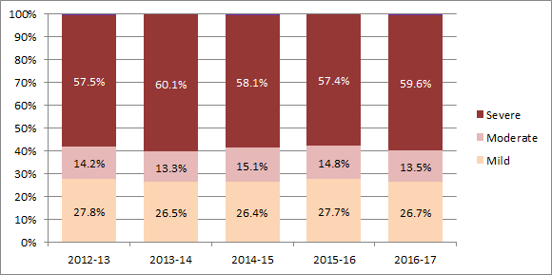

Figure 10 - Percentage of patients receiving product by severity for HMA - hereditary bleeding disorders

Note: A very small number of patients have a severity recorded as Not Applicable or Unknown. These are not shown in the above chart.

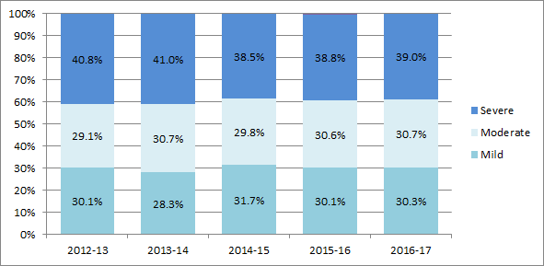

Figure 11 - Percentage of patients receiving product by severity for HMB - hereditary bleeding disorders

Note: Proportion of patients receiving product by severity for HmB – Acquired bleeding disorders are too small to present in graphical format. A very small number of patients have a severity recorded as Not Applicable or Unknown. These are not shown in the above chart.

Table 15, Table 16 and Table 17 detail the volume (IU) of product issued for HMA, HMB, VWD and other diagnosis patients in 2016-17. The volumes are subdivided by severity and treatment regimen as stated in the ABDR record. The largest and most important sectors are products for severe HMA patients for *on demand* and *prophylactic* treatment regimens. The volume issued for prophylactic treatment of severe HMA is the single greatest determining factor for supply planning.

Table 15 - IU of product issued for HMA, HMB and VWD patients, by severity and treatment regimen in 2016‑17 - hereditary bleeding disorders

|  | Mild | Moderate | Severe | Unknown** | Total** |
| --- | --- | --- | --- | --- | --- |
| **HMA (IU FVIII Products)†** | **5,359,250** | **15,435,750** | **135,886,760** | **20,000** | **156,701,760** |
| On Demand | 4,446,500 | 5,487,000 | 14,344,500 | 20,000 | 24,298,000 |
| Prophylaxis | 807,000 | 9,877,000 | 115,528,002 |  | 126,212,002 |
| Tolerisation |  |  | 4,806,000 |  | 4,806,000 |
| Unknown* | 105,750 | 71,750 | 1,208,250 |  | 1,385,750 |
| **HMB (IU FIX Products)‡** | **2,279,250** | **8,472,000** | **15,880,650** |  | **26,631,900** |
| On Demand | 1,937,750 | 3,372,500 | 2,635,500 |  | 7,945,750 |
| Prophylaxis | 240,500 | 4,905,500 | 13,180,000 |  | 18,326,000 |
| Tolerisation |  |  | 54,000 |  | 54,000 |
| Unknown* | 101,000 | 194,000 | 11,150 |  | 306,150 |
| **VWD (IU FVIII Product) ++** | **364,500** | **344,750** | **3,952,000** | **2,073,000** | **6,734,250** |
| On Demand | 273,000 | 305,750 | 1,268,000 | 726,000 | 2,572,750 |
| Prophylaxis | 31,250 |  | 2,133,000 | 1,053,000 | 3,217,250 |
| Tolerisation |  |  | 543,000 |  | 543,000 |
| Unknown* | 60,250 | 39,000 | 8,000 | 294,000 | 401,250 |

† FVIII Products included are Advate, Biostate and Xyntha ‡ FIX Products included are BeneFIX, MonoFIX and Rixubis

++ FVIII Products include Advate and Biostate * This represents a blank/not completed/empty field for the treatment regimen in the ABDR

** The total in this table combines the values for patients with mild, moderate and severe conditions. The severity of a patient’s condition is not always known at initial presentation. This table includes product issues to patients with unknown severities.

Table 16 - IU of product issued for HMA, HMB and VWD patients, by severity and treatment regimen in 2016-17 - acquired bleeding disorders

|  | Mild | Moderate | Severe | Unknown** | Total** |
| --- | --- | --- | --- | --- | --- |
| **HMA (IU FVIII Products)†** |  |  | **10,000** | **45,000** | **55,000** |
| On Demand |  |  |  |  |  |
| Unknown* |  |  | 10,000 | 45,000 | 55,000 |
| **VWD (IU FVIII Product) ++** |  |  | **9,000** | **333,000** | **342,000** |
| On Demand |  |  | 9,000 | 187,000 | 196,000 |
| Unknown* |  |  |  | 146,000 | 146,000 |

† FVIII Products included are Advate, Benefix, Biostate and Xyntha

++ FVIII Products include Advate and Biostate

* This represents a blank/not completed/empty field for the treatment regimen in the ABDR

** The total in this table combines the values for patients with mild, moderate and severe conditions. The severity of a patient’s condition is not always known at initial presentation. This table includes product issues to patients with unknown severities.

Table 17 - IU of products issued for other patients, by severity and treatment regimen in 2016-17 - other diagnoses

|  | Mild | Moderate | Severe | Unknown** | Total** |
| --- | --- | --- | --- | --- | --- |
| **Other Factor Deficiency** | **53,328** | **59,004** | **204,114** | **15,750** | **332,196** |
| On Demand | 47,117 | 4,004 | 2,004 | 2,250 | 55,375 |
| Prophylaxis | 4,210 | 28,000 | 197,610 | 12,000 | 241,820 |
| Unknown* | 2,001 | 27,000 | 4,500 | 1,500 | 35,001 |
| **Other** | **1,500** |  |  | **113,750** | **115,250** |
| On Demand | 1,500 |  |  |  | 1,500 |
| Prophylaxis |  |  |  | 112,000 | 112,000 |
| Unknown* |  |  |  | 1,750 | 1,750 |

* This represents a blank/not completed/empty field for the treatment regimen in the ABDR

** The total in this table combines the values for patients with mild, moderate and severe conditions. The severity of a patient’s condition is not always known at initial presentation. This table includes product issues to patients with unknown severities.

## Volume (IU) of products issued for HMA and HMB

Severe haemophilia requires lifelong treatment with expensive products. Clotting factor consumption is often expressed in IU/kg/year, and the ranges reported vary by population.9F[8],10F[9] Figure 12 shows the clotting factor consumption of FVIII during 2016-17 for severe HMA patients on prophylaxis. There is a wide range of use across these age groups, which are not normally distributed. Median values for each age bracket are listed below. Note there are significant outliers which require further investigation.

|  |  |  |  |  |  |
| --- | --- | --- | --- | --- | --- |
| Median IU/Kg/year | 0-4 years | 5-9 years | 10-14 years | 15-17 years | Adult |
| 2016-17 | 5,253 | 4,411 | 4,175 | 2,649 | 3,274 |

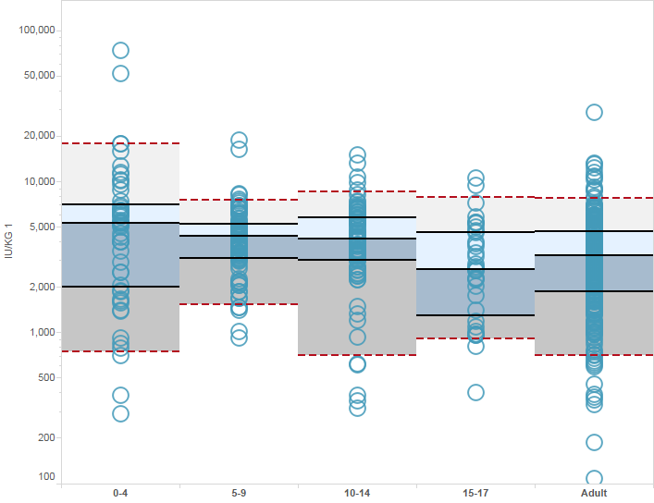

Figure 12 - FVIII Product usage (IU/kg/year) in severe HMA patients on prophylaxis

Figure 13 shows the clotting factor consumption of FVIII during 2016-17 for severe HMA patients on demand regimen. As in previous years there is a wide range of use across the paediatrics (includes adolescents) and adult age groups, which are not normally distributed.

|  |  |  |
| --- | --- | --- |
| Median IU/Kg/year | Paediatric | Adult |
| 2016-17 | 477 | 1,165 |

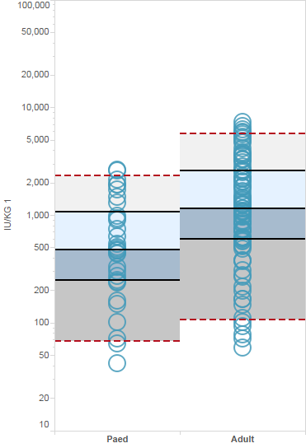

Figure 13 - FVIII Product usage (IU/kg/year) in severe HMA patients on demand

Figure 14 shows the clotting factor consumption during 2016-17 for severe HMB patients on prophylaxis regimen.

|  |  |  |  |  |  |
| --- | --- | --- | --- | --- | --- |
| Median IU/Kg/year | 0-4 years | 5-9 years | 10-14 years | 15-17 years | Adult |
| 2016-17 | 3,885 | 4,397 | 2,905 | 2,358 | 3,255 |

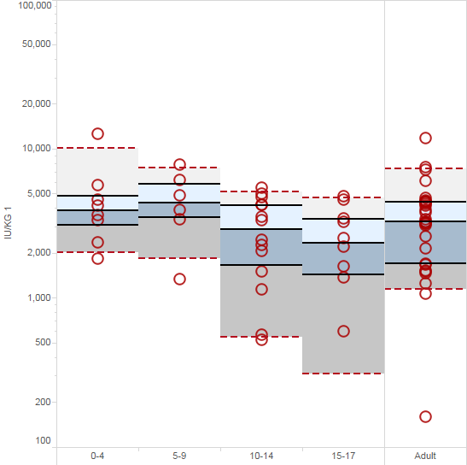

Figure 14 - FIX Product usage (IU/kg/year) in severe HMB patients on prophylaxis

Figure 15 shows the clotting factor consumption during 2016-17 for severe HMB patients on demand regimen.

|  |  |  |
| --- | --- | --- |
| Median IU/Kg/year | Paediatric | Adult |
| 2016-17 | 333 | 826 |

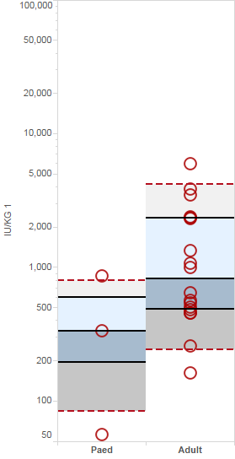

Figure 15 - FIX Product usage (IU/kg/year) in severe HMB patients on demand

These figures are higher than some of those reported in the literature for adult patients, but reflect the shift in treatment practice towards regular prophylactic infusions to prevent bleeds, especially in children. Recent theoretical work allowed for the comparison of different treatment strategies, ranging from long-term on demand therapy to different prophylactic strategies.11F[10] In time the ABDR data should provide further insight into these issues.

## Volume of products issued and patient counts by treatment regimen, severity, product and state

Table 18 and Table 19 show the volumes issued by product and treatment regimen, for hereditary HMA, HMB, VWD and other diagnoses. In both the adult and paediatric (includes adolescents) age groups the majority of product is issued for patients on prophylactic treatment regimens. The ABDR product issues data contains records where the treatment regimen is blank, unknown and not specified.

Table 20 and Table 21 show the number of patients and volumes issued by product and state. The totals are distinct counts of patients who received product. A patient may be counted more than once under each state as they may have received product from more than one state throughout the year. This applies to both hereditary and acquired HMA, HMB and VWD.

Table 22 shows the number of patients, volume issued and IU or mg/kg/year of products issued in 2016-17 by treatment regimen for acquired HMA, HMB and VWD.

Table 23 shows the number of patients and IUs issued by severity and regimen type for hereditary HMA and HMB. Values in this table exclude products issued to patients with unknown severity classification or treatment regimen, so they will vary from those figures shown in other parts of this report. Also, patients may receive more than one regimen type and may therefore be counted multiple times.

Table 24 shows the number of patients and volume of products issued by regimen type and product for hereditary HMA, HMB and VWD. Values in this table exclude products issued to patients with unknown treatment regimen, so they may vary from those figures shown in other parts of this report. Also, patients may receive more than one regimen type and may therefore be counted multiple times.

Table 18 - Volume of products issued in 2016-17 by treatment regimen - hereditary bleeding disorders

|  |  |  |  |  |  |  |  |  |  |  |
| --- | --- | --- | --- | --- | --- | --- | --- | --- | --- | --- |
|  | **Adult** | | | | | **Paediatric** | | | | |
|  | On Demand | Prophylaxis | Tolerisation | Not specified | **Adult Total\*** | On Demand | Prophylaxis | Tolerisation | Not specified | **Paediatric Total\*** |
| **HMA (IUs)** | **23,536,510** | **82,579,994** | **195,000** | **1,015,250** | **107,326,754** | **1,387,000** | **46,545,002** | **4,969,508** | **370,500** | **53,272,010** |
| Advate | 11,807,750 | 35,525,500 | 195,000 | 506,000 | 48,034,250 | 1,139,250 | 23,066,750 | 1,579,500 | 47,250 | 25,832,750 |
| Biostate | 1,106,500 | 3,264,500 |  | 12,500 | 4,383,500 | 31,250 | 4,778,500 | 2,558,008 | 37,500 | 7,405,258 |
| FEIBA (Units) | 624,500 | 220,000 |  |  | 844,500 |  | 1,045,500 | 358,500 |  | 1,404,000 |
| **NovoSeven (mgs) | 3,670 | 2,972 |  |  | 6,642 | 503 | 558 | 502 |  | 1,563 |
| Prothrombinex (IUs) | 0 | 729,500 |  |  | 729,500 |  |  |  |  |  |
| Trial Material | 10 | 908,994 |  |  | 909,004 | 1,000 | 9,000 |  |  | 10,000 |
| Xyntha | 9,997,750 | 41,931,500 |  | 496,750 | 52,426,000 | 215,500 | 17,645,252 | 473,500 | 285,750 | 18,620,002 |
| **HMB (IUs)** | **7,111,500** | **12,553,500** | **54,000** | **284,000** | **20,003,000** | **834,930** | **5,772,500** | **0** | **22,150** | **6,629,580** |
| BeneFIX | 6,637,500 | 12,071,500 |  | 281,000 | 18,990,000 | 772,250 | 5,754,500 |  | 22,150 | 6,548,900 |
| MonoFIX | 30,000 | 38,000 | 54,000 |  | 122,000 |  |  |  |  |  |
| **NovoSeven (mgs) | 234 | 121 |  |  | 355 |  |  |  |  |  |
| Rixubis | 444,000 | 444,000 |  | 3,000 | 891,000 | 62,000 | 18,000 |  |  | 80,000 |
| Trial Material |  |  |  |  |  | 680 |  |  |  | 680 |
| **VWD (IUs)** | **2,464,500** | **2,406,250** | **0** | **387,250** | **5,258,000** | **108,250** | **811,000** | **543,000** | **14,000** | **1,476,250** |
| Advate |  |  |  |  |  | 2,000 |  |  |  | 2,000 |
| Biostate | 2,464,500 | 2,406,250 |  | 387,250 | 5,258,000 | 106,250 | 811,000 | 543,000 | 14,000 | 1,474,250 |
| **NovoSeven (mgs) |  |  |  |  |  | 26 |  |  |  | 26 |

* The total in this table combines the values for patients with mild, moderate and severe conditions. The severity of a patient’s condition is not always known at initial presentation. This table includes product issues to patients with unknown/not specified treatment regimens. All products listed above are in IUs unless stated.

**IUs sums all the products except NovoSeven

Table 19 - Volume (IU) of products issued in 2016-17 by treatment regimen – other diagnoses

|  |  |  |  |  |  |  |  |  |
| --- | --- | --- | --- | --- | --- | --- | --- | --- |
|  | **Adult** | | | | **Paediatric** | | | |
|  | **On Demand** | **Prophylaxis** | **Not specified** | **Adult Total \*** | **On Demand** | **Prophylaxis** | **Not specified** | **Paediatric Total \*** |
| **Other Factor Deficiency** | **50,775** | **165,650** | **3,501** | **219,926** | **4,600** | **76,170** | **31,500** | **112,270** |
| Factor X P Behring |  |  |  |  |  | 2,420 |  | 2,420 |
| Factor XI bpl | 12,025 | 900 | 3,501 | 16,426 | 2,600 |  |  | 2,600 |
| Fibrogammin | 36,250 | 28,250 |  | 64,500 | 2,000 | 44,000 | 31,500 | 77,500 |
| Fibrogammin P |  | 12,500 |  | 12,500 |  | 9,750 |  | 9,750 |
| **NovoSeven (mgs) | 458 | 540 | 11 | 1,009 | 14 | 205 |  | 219 |
| Prothrombinex - VF | 2,500 | 124,000 |  |  |  | 20,000 |  | 20,000 |
| **Platelet Disorder** | **32** |  |  | **32** | **30** |  | **1** | **31** |
| **NovoSeven (mgs) | 32 |  |  | 32 | 30 |  | 1 | 31 |
| **Fibrinogen** | **63** | **243** | **7** | **313** | **14** | **116** |  | **130** |
| Human Fibrinogen RiaSTAP (gms) | 63 | 243 | 7 | 313 | 14 | 116 |  | 130 |
| **Other** | **1,500** | **112,000** | **1,750** | **115,250** |  |  |  |  |
| Biostate | 1,500 |  | 1,750 | 3,250 |  |  |  |  |
| Ceprotin |  | 112,000 |  | 112,000 |  |  |  |  |

* The total in this table combines the values for patients with mild, moderate and severe conditions. The severity of a patient’s condition is not always known at initial presentation. This table includes product issues

to patients with unknown/not specified treatment regimens. All products listed above are in IUs unless stated.

**IUs sums all the products except NovoSeven

Table 20 - Number of patients for Hereditary HMA, HMB and VWD by state

|  |  |  |  |  |  |  |  |  |  |
| --- | --- | --- | --- | --- | --- | --- | --- | --- | --- |
|  | **Number of Patients who received product during the year** | | | | | | | | |
|  | **ACT** | **NSW** | **NT** | **QLD** | **SA** | **TAS** | **VIC** | **WA** | **Total\*** |
| **HMA** |  |  |  |  |  |  |  |  |  |
| Advate | 10 | 188 | 5 | 147 | 88 | 11 | 100 | 43 | **584** |
| Biostate |  | 23 |  | 17 | <5 | <5 | 9 | 9 | **62** |
| FEIBA |  | <5 |  | <5 |  | <5 | 5 | <5 | **16** |
| NovoSeven |  | 5 |  | 7 | 5 | <5 | 17 | <5 | **39** |
| Prothrombinex |  |  |  | <5 |  |  |  |  |  |
| Xyntha | <5 | 99 | <5 | 47 | 23 | 12 | 111 | 62 | **351** |
| **HMB** |  |  |  |  |  |  |  |  |  |
| BeneFIX | <5 | 70 | <5 | 59 | 16 | <5 | 42 | 16 | **202** |
| MonoFIX | <5 | <5 |  | <5 |  |  |  | <5 |  |
| NovoSeven |  | <5 |  |  |  |  | <5 |  |  |
| Rixubis |  | <5 |  | <5 | <5 |  | <5 | 6 | **13** |
| **VWD** |  |  |  |  |  |  |  |  |  |
| Advate |  |  |  |  |  |  | <5 |  |  |
| Biostate | <5 | 52 | <5 | 65 | 26 | 5 | 25 | 45 | **221** |
| NovoSeven |  |  |  |  |  |  | <5 |  |  |

* The Totals are distinct counts of Patients who received product and may be counted more than once under each state or across different states as they may have received more than one product or been treated in more than one state throughout the year.

Table 21 - Volume of product issued for HEREDITARY HMA, HMB and VWD by state

|  |  |  |  |  |  |  |  |  |  |
| --- | --- | --- | --- | --- | --- | --- | --- | --- | --- |
|  | **Volume of Product Issued through the year** | | | | | | | | |
|  | **ACT** | **NSW** | **NT** | **QLD** | **SA** | **TAS** | **VIC** | **WA** | **Total\*** |
| **HMA (IUs)** | **1,185,750** | **53,653,758** | **692,500** | **38,982,000** | **15,719,500** | **4,543,250** | **28,196,252** | **16,849,750** | **159,822,760** |
| Advate | 820,750 | 25,284,750 | 642,000 | 20,158,750 | 10,147,500 | 1,236,500 | 11,433,250 | 4,143,500 | 73,867,000 |
| Biostate |  | 5,015,758 |  | 5,984,250 | 7,000 | 89,500 | 476,250 | 261,000 | 11,833,758 |
| FEIBA |  | 495,500 |  | 929,000 |  | 196,000 | 652,000 | 64,000 | 2,336,500 |
| **NovoSeven (mgs) |  | 305 |  | 1,567 | 636 | 390 | 4,206 | 3,379 | 10,483 |
| Prothrombinex |  |  |  | 729,500 |  |  |  |  | 729,500 |
| Xyntha | 365,000 | 22,857,750 | 50,500 | 11,180,500 | 5,565,000 | 3,021,250 | 15,634,752 | 12,381,250 | 71,056,002 |
| **HMB (IUs)‡** | **145,500** | **12,076,900** | **8,000** | **5,362,000** | **2,219,000** | **599,000** | **4,395,000** | **1,826,500** | **26,631,900** |
| BeneFIX | 91,500 | 12,015,900 | 8,000 | 5,184,000 | 1,775,000 | 599,000 | 4,315,000 | 1,550,500 | 25,538,900 |
| MonoFIX | 54,000 | 58,000 |  | 4,000 |  |  |  | 6,000 | 122,000 |
| **NovoSeven (mgs) |  | 121 |  |  |  |  | 234 |  | 355 |
| Rixubis |  | 3,000 |  | 174,000 | 444,000 |  | 80,000 | 270,000 | 971,000 |
| **VWD (IUs)** | **35,250** | **3,640,250** | **3,000** | **1,629,750** | **319,000** | **25,250** | **303,750** | **1,120,000** | **7,076,250** |
| Advate |  |  |  |  |  |  | 2,000 |  | 2,000 |
| Biostate | 35,250 | 3,640,250 | 3,000 | 1,629,750 | 319,000 | 25,250 | 301,750 | 1,120,000 | 7,074,250 |
| **NovoSeven (mgs) |  |  |  |  |  |  | 26 |  | 26 |

* The total in this table combines the values for patients with mild, moderate and severe conditions. The severity of a patient’s condition is not always known at initial presentation. This table includes product issues to patients with unknown/not specified treatment regimens. All products listed above are in IUs unless stated.

**IUs sums all the products except NovoSeven

Table 22 - Volume, patient counts and IU or mg/kg/year of products issued in 2016-17 by treatment regimen - acquired

|  |  |  |  |  |  |  |  |
| --- | --- | --- | --- | --- | --- | --- | --- |
|  | **Adult** | | | | | | |
|  | On Demand | Prophylaxis | Tolerisation | Not specified | **Adult Total \*** | **Patient Counts** | **IU or mg/kg/Year** |
| **HMA (IUs)** | **88,000** |  |  | **55,000** | **143,000** |  | **1,650** |
| Biostate |  |  |  | 45,000 | 45,000 | <5 | 503 |
| FEIBA | 88,000 |  |  |  | 88,000 | <5 | 1,132 |
| **NovoSeven  (mgs) | 441 |  |  | 1,837 | 2,278 | 8 | 15 |
| Xyntha |  |  |  | 10,000 | 10,000 | <5 |  |
| **VWD (IUs)** | **196,000** |  |  | **146,000** | **342,000** |  | **2,736** |
| Biostate | 196,000 |  |  | 146,000 | 342,000 | 10 | 2,736 |

* The total in this table combines the values for patients with mild, moderate and severe conditions. The severity of a patient’s condition is not always known at initial presentation. This table includes product issues to patients with unknown/not specified treatment regimens. All products listed above are in IUs unless stated.

**IUs sums all the products except NovoSeven

Table 23 - IU Volume of product issued and patient counts for hereditary HMA and HMB by severity and regimen type

|  |  |  |  |  |  |
| --- | --- | --- | --- | --- | --- |
|  |  | **Haemophilia A** | | **Haemophilia B** | |
| **Severity\*** | **Regimen type\*\*** | **Total IUs** | **Number of patients** | **Total IUs** | **Number of patients** |
| Adult - Mild | On demand | 4,191,750 | 192 | 1,578,500 | 49 |
| Prophylaxis | 329,500 | 5 | 36,000 | <5 |
| Adult - Moderate | On demand | 4,808,500 | 60 | 2,910,500 | 38 |
| Prophylaxis | 6,756,000 | 27 | 3,972,000 | 13 |
| Adult - Severe | On demand | 13,891,760 | 95 | 2,622,500 | 18 |
| Prophylaxis | 75,274,494 | 259 | 8,545,500 | 29 |
| Tolerisation | 195,000 | <5 | 54,000 | <5 |
| **Adult - Total** |  | **105,447,004** |  | **19,719,000** |  |
| Paediatric - Mild | On demand | 254,750 | 41 | 359,250 | 11 |
| Prophylaxis | 477,500 | 6 | 204,500 | <5 |
| Paediatric - Moderate | On demand | 678,500 | 28 | 462,000 | 11 |
| Prophylaxis | 3,369,000 | 20 | 933,500 | 6 |
| Paediatric - Severe | On demand | 453,750 | 32 | 13,680 | <5 |
| Prophylaxis | 41,653,002 | 229 | 4,634,500 | 33 |
| Tolerisation | 4,611,008 | 18 |  |  |
| **Paediatric - Total** |  | **51,497,510** |  | **6,607,430** |  |

* Values in this table exclude products issued to patients with unknown severity classification or treatment regimen, so they will vary from those figures shown previously.

**Patients may receive more than one regimen type and may therefore be counted multiple times.

Table 24 - Volume of product issued and patient counts for hereditary HMA, HMB and VWD by regimen type and product

|  |  |  |  |  |  |  |  |  |  |  |  |  |
| --- | --- | --- | --- | --- | --- | --- | --- | --- | --- | --- | --- | --- |
|  |  |  | **Advate** | | **BeneFIX** | | **Biostate** | | **FEIBA** | | **MonoFIX - VF** | |
| **Bleeding Disorder** | **Paediatric / Adult** | **Regimen type\*** | **Total IUs** | **Number of patients**  **\*\*** | **Total IUs** | **Number of patients**  **\*\*** | **Total IUs** | **Number of patients**  **\*\*** | **Total Units** | **Number of patients**  **\*\*** | **Total IUs** | **Number of patients**  **\*\*** |
| Haemophilia A | Adult | On demand | 11,807,750 | 240 |  |  | 1,106,500 | 27 | 624,500 | 7 |  |  |
| Prophylaxis | 35,525,500 | 129 |  |  | 3,264,500 | 7 | 220,000 | <5 |  |  |
| Tolerisation | 195,000 | <5 |  |  |  |  |  |  |  |  |
| Paediatric | On demand | 1,139,250 | 83 |  |  | 31,250 | 5 |  |  |  |  |
| Prophylaxis | 23,066,750 | 146 |  |  | 4,778,500 | 17 | 1,045,500 | 6 |  |  |
| Tolerisation | 1,579,500 | 9 |  |  | 2,558,008 | 9 | 358,500 | <5 |  |  |
| **Total** |  | **73,313,250** |  |  |  | **11,738,758** |  | **2,248,500** |  |  |  |
| Haemophilia B | Adult | On demand |  |  | 6,637,500 | 97 |  |  |  |  | 30,000 | <5 |
| Prophylaxis |  |  | 12,071,500 | 41 |  |  |  |  | 38,000 | <5 |
| Tolerisation |  |  |  |  |  |  |  |  | 54,000 | <5 |
| Paediatric | On demand |  |  | 772,250 | 24 |  |  |  |  |  |  |
| Prophylaxis |  |  | 5,754,500 | 41 |  |  |  |  |  |  |
| **Total** |  |  |  | **25,235,750** |  |  |  |  |  | **122,000** |  |
| Von Willebrand Disease | Adult | On demand |  |  |  |  | 2,464,500 | 125 |  |  |  |  |
| Prophylaxis |  |  |  |  | 2,406,250 | 14 |  |  |  |  |
| Paediatric | On demand | 2,000 | <5 |  |  | 106,250 | 29 |  |  |  |  |
| Prophylaxis |  |  |  |  | 811,000 | 6 |  |  |  |  |
| Tolerisation |  |  |  |  | 543,000 | <5 |  |  |  |  |
| **Total** |  | **2,000** |  |  |  | **6,331,000** |  |  |  |  |  |

*Values in this table exclude products issued to patients with unknown treatment regimen, so they will vary from those figures shown previously.  
**Patients may receive more than one regimen type and may therefore be counted multiple times.

table 24 continued - Volume of product issued and patient counts for hereditary HMA, HMB and VWD by regimen type and product

|  |  |  |  |  |  |  |  |  |  |  |  |  |
| --- | --- | --- | --- | --- | --- | --- | --- | --- | --- | --- | --- | --- |
|  |  |  | **NovoSeven** | | **Prothrombinex - VF** | | **Rixubis** | | **Trial Material** | | **Xyntha** | |
| **Bleeding Disorder** | **Paediatric / Adult** | **Regimen type\*** | **Total mgs** | **Number of patients \*\*** | **Total IUs** | **Number of patients**  **\*\*** | **Total IUs** | **Number of patients**  **\*\*** | **Total IUs** | **Number of patients**  **\*\*** | **Total IUs** | **Number of patients**  **\*\*** |
| Haemophilia A | Adult | On demand | 3,670 | 14 |  |  |  |  | 10 | <5 | 9,997,750 | 89 |
| Prophylaxis | 2,972 | <5 | 729,500 | <5 |  |  | 908,994 | 7 | 41,931,500 | 154 |
| Tolerisation |  |  |  |  |  |  |  |  |  |  |
| Paediatric | On demand | 503 | 7 |  |  |  |  | 1,000 | <5 | 215,500 | 15 |
| Prophylaxis | 558 | 8 |  |  |  |  | 9,000 | <5 | 17,645,252 | 96 |
| Tolerisation | 502 | 6 |  |  |  |  |  |  | 473,500 | <5 |
| **Total** |  | **8,205** |  | **729,500** |  |  |  | **919,004** |  | **70,263,502** |  |
| Haemophilia B | Adult | On demand | 234 | <5 |  |  | 444,000 | 8 |  |  |  |  |
| Prophylaxis | 121 | <5 |  |  | 444,000 | <5 |  |  |  |  |
| Tolerisation |  |  |  |  |  |  |  |  |  |  |
| Paediatric | On demand |  |  |  |  | 62,000 | <5 | 680 | <5 |  |  |
| Prophylaxis |  |  |  |  | 18,000 | <5 |  |  |  |  |
| **Total** |  | **355** |  |  |  | **968,000** |  | **680** |  |  |  |
| Von Willebrand Disease | Adult | On demand |  |  |  |  |  |  |  |  |  |  |
| Prophylaxis |  |  |  |  |  |  |  |  |  |  |
| Paediatric | On demand | 26 | <5 |  |  |  |  |  |  |  |  |
| Prophylaxis |  |  |  |  |  |  |  |  |  |  |
| Tolerisation |  |  |  |  |  |  |  |  |  |  |
| **Total** |  | **26** | **5** |  |  |  |  |  |  |  |  |

*Values in this table exclude products issued to patients with unknown treatment regimen, so they will vary from those figures shown previously.

**Patients may receive more than one regimen type and may therefore be counted multiple times. Patient totals are the total number of distinct patients, excluding patients which are counted multiple times, so may not match the individual values.

# Appendix A Characteristics of Rare Clotting Factor Deficiencies

Table 25 - Characteristics of rare clotting factor deficiencies

| Missing Factor | Incidence* | Inheritance | Severity of Bleeding | Treatment |
| --- | --- | --- | --- | --- |
| Factor I  Afibrinogenemia  Hypofibrinogenemia  Dysfibrinogenemia | 5 in 10 million  not available  1 in 1 million | Autosomal recessive  Recessive or dominant  Recessive or dominant | Usually mild,  except in  afibrinogenemia | •Fibrinogen conc. (Not funded in Australia)  •Cryoprecipitate  •Fresh frozen plasma |
| Factor II | 1 in 2 million | Autosomal recessive | Moderate to severe when factor levels are low; usually mild | •Prothrombin complex conc.  •Fresh frozen plasma |
| Factor V | 1 in 1 million | Autosomal recessive | Moderate to severe when factor levels are low; usually mild | •Fresh frozen plasma |
| Combined Factor V and Factor VIII | 1 in 1 million† | Autosomal recessive‡ | Usually mild | •Fresh frozen plasma  •Factor VIII conc.  •Desmopressin |
| Factor VII | 1 in 500,000 | Autosomal recessive | Severe when factor levels are low | •Recombinant Factor VIIa conc.  •Factor VII conc.  •Fresh frozen plasma |
| Factor X | 1 in 1 million | Autosomal recessive | Moderate to severe when factor levels  are low | •Prothrombin complex conc.  •Fresh frozen plasma |
| Combined deficiency of  vitamin K‑dependent  clotting factors | not available | Autosomal recessive | Usually mild, but a few families have  reported very low levels and more  severe symptoms | •Vitamin K  •Prothrombin complex conc.  •Fresh frozen plasma |
| Factor XI | 1 in 100,000 | Recessive or dominant | Mild to moderate when factor levels  are low | •Factor XI concentrate  •Antifibrinolytic drugs  •Fibrin glue  •Fresh frozen plasma |
| Factor XIII | 1 in 3 million | Autosomal recessive | Moderate to severe when factor levels are low | •Factor XIII conc.  •Cryoprecipitate  •Fresh frozen plasma |

*Note: Australian Prothrombin Complex Concentrate is not used for FVII deficiency*

* Estimates only

† 1 in 100,000 in some populations, including Israel, Iran, and Italy

‡ Very rarely, Factor VIII deficiency can be inherited separately from only one parent

# Appendix B Haemophilia Treatment Centres

## The objectives of HTCs

Haemophilia Treatment Centres provide comprehensive care for people with haemophilia. Their roles include:

* Compilation and distribution of guidelines for best practice directed toward optimal care of patients with disorders of haemostasis
* Providing protocols for the accurate diagnosis of patients with bleeding disorders
* Providing protocols for the regular review of infectious disease markers in patients and their families
* The allocation and distribution of therapeutic blood and recombinant products together with advice regarding the use of blood and recombinant products, at a state and national level
* The establishment of review programs to assess outcomes of therapies
* Provision of regularly updated data to the national Haemophilia Registry (ABDR)
* Participation in basic and clinical research

## Operating concept

Haemophilia Treatment Centres coordinate and, where possible, integrate patient care, research and education to provide the optimal use of expertise and resources within hospitals and the community. One collaborative centre for each state and territory may suffice but this must include adult and paediatric type centres.

Haemophilia Centres provide:

* a single point accountability for the care of patients with bleeding disorders with responsibility for the coordination, allocation and distribution of therapeutic resources for the treatment of patients, i.e. coagulation products derived either from blood donors or recombinant technologies
* a clinical service by experienced staff for patients with bleeding disorders and their families at short notice at any time of the day or night
* organisation of home therapy programs by the centre or in collaboration with other haemophilia treatment facilities
* a counselling and advisory service for people with haemophilia and their families including genetic counselling and family planning
* specialist medical expertise, principally haematology, surgery (the surgeons would have to be accredited to the Haemophilia Centre) rheumatology, infectious diseases and dental services
* specialist allied health services to include physiotherapy, social work and podiatry
* a laboratory service able to carry out all investigations required for the accurate diagnosis of haemophilia and other inherited disorders of haemostasis and to have access, in association with other centres, to specialised testing facilities, for example gene typing
* a system of record for all investigations, treatments, allocation of therapeutic products and adverse reactions
* a capability to participate in research including clinical trials
* educational programs for medical staff, other personnel, patients and their families which promote care of patients with disorders of haemostasis
* an outreach service to isolated patients and treating medical services. The outreach service may include:-
  + A haemophilia treatment facility located in a hospital that does not provide all the specialist services
  + Designated supervising medical practitioner
* data management to facilitate the use of an information system database, such as the Australian Bleeding Disorders Registry, used in the clinical environment to aid in the capturing of data critical to HTC staff for the day to day management of people with bleeding disorders and for supply management and policy purposes.

All isolated patients (where care is managed in an outreach program) should be registered at, and be reviewed regularly by, a Haemophilia Treatment Centre which would arrange delivery of and monitor the supply of therapeutic coagulation products.

The HTC must maintain on-going dialogue with the client group in each state and territory. The role of State and Territory Governments is to designate ‘Haemophilia Treatment Centres’ and negotiate the funding of the HTC including the purchase of therapeutic blood and recombinant products for distribution within states (or regions) and territories. In some states committees have been established to consider and schedule elective surgery.

## Data quality of HTC data collections

The following organisations are represented at various HTCs nationally:

* Australian Haemophilia Nurses Group (AHNG)
* Australia/New Zealand Haemophilia Social Workers’ and Counsellors’ Group (ANZHSWCG)
* Australia/New Zealand Physiotherapist Group (ANZHPG)
* Haemophilia Foundation of Australia (HFA).

These member representatives have provided input into the initial design of the ABDR and continue to provide input from their respective areas of specialty.

The Data Managers at each HTC are members of the Data Managers’ Group (DMG). DMG Co‑Chairs are elected and coordinate teleconferences, between all Data Managers, on a regular basis. The DMG Co‑Chairs also have the functionality of raising issues, to the NBA, on behalf of their group. AHCDO has a major role in providing support to ABDR Data Managers through the funded model for Data Managers.

The advantages of this model of Haemophilia Data Co-ordination are:

* Accurate and complete data entry
* Dedicated and focused data management
* Regular reporting and analysis of collated information
* New product initiation of unresolved haemophilia care related questions
* Clinical audit of current policies and monitoring of agreed national standards.

A number of ongoing data quality initiatives were first implemented in 2010-11, including:

* Regular teleconferences for ABDR DMG
* ‘Advanced Search’ functionality of the ABDR whereby Data Managers are able to extract information from the ABDR on an ad hoc basis
* Reviews of data definitions undertaken by DMG Co Chairs
* NBA financial support, through AHCDO funding, for HTC Data Managers
* The ABDR Update is a functional tool in the form of a Newsletter. This provides an update on issues such as changes to the ABDR and functionality enhancements. This update is a means of keeping all ABDR stakeholders informed.

Comprehensive automated and manual data cleansing and validation processes that occurred as part of the 4th Generation ABDR Redevelopment project released in August 2012 enhanced the ABDR data accuracy and consistency presented in this report. The 4th Generation ABDR was successfully implemented on 13 August 2012.

However, there are still some data quality issues that impact the data presented in this report. Some post migration tasks for Data Managers to clean the data include:

* Verify patients with more than one diagnosis
* Duplicate diagnoses to be deleted and Inhibitor Tests to be combined under the persisting diagnosis
* Verify severity ratings and treatment regiments for some patient records
* There are also a number of low level data verification activities.

## List of HTCs

Table 26 - Haemophilia treatment centres

| Hospital | Haemophilia Treatment Centre | State |
| --- | --- | --- |
| The Canberra Hospital | Haemophilia Clinic | ACT |
| Calvary Mater Newcastle | Haemophilia Treatment Centre | NSW |
| Royal Prince Alfred Hospital | Haemophilia Treatment Centre | NSW |
| Sydney Children’s Hospital | Centre for Children's Cancer and Blood Disorders | NSW |
| The Children’s Hospital at Westmead | Haemophilia Treatment Centre | NSW |
| Prince of Wales Hospital | Bleeding Disorders Clinic | NSW |
| Westmead Hospital | Bleeding Disorders Clinic | NSW |
| Royal Darwin Hospital | Haemophilia Treatment Centre | NT |
| Royal Brisbane and Women’s Hospital | Queensland Haemophilia Centre | QLD |
| Lady Cilento Children’s Hospital | Queensland Haemophilia Centre Child and Adolescent Service | QLD |
| Royal Adelaide Hospital | South Australia Haemophilia Treatment Centre | SA |
| Women’s and Children’s Hospital | South Australia Haemophilia Treatment Centre | SA |
| Royal Hobart Hospital | Tasmanian Haemophilia Treatment Centre | TAS |
| The Alfred Hospital | Ronald Sawyers Haemophilia Centre | VIC |
| Royal Children’s Hospital | Henry Ekert Haemophilia Treatment Centre | VIC |
| Princess Margaret Hospital | Paediatric Haemophilia Centre | WA |
| Hollywood Private Hospital | Hollywood Hospital Haemophilia Treatment Centre | WA |
| Fiona Stanley Hospital | Adult Haemophilia Centre | WA |

# Appendix C National Supply of Products

It is the responsibility of the NBA to manage the national blood supply to ensure that healthcare providers have sustainable, reliable and efficient access to blood and blood products needed for patient care. The NBA ensures blood supply security by working with states and territories to determine and manage an annual supply plan and budget and negotiating and managing blood supply contracts and arrangements with local and overseas suppliers.

National supply plan and budget

A key element of the NBA's role in ensuring security of supply is to develop, coordinate and monitor the annual national supply plan and budget, including obtaining annual approval from health ministers.

This is achieved by:

* developing a national estimate of product demand
* liaising with jurisdictions and stakeholders to refine the estimated demand for products
* collecting and distributing data on product issued and reporting variations to jurisdictions on the approved supply plan
* intensively managing products if they are in short supply.

Figure 16 illustrates the national supply by product category for 2016-17, and shows issues of clotting factor products was 14.4% ($156.3 million).

Figure 16 - National issues by product category 2016-17

Note: Plasma for Fractionation costs paid to the Blood Service for collection has been attributed to IVIg and Hyperimmunes

Throughout 2016–17, products were supplied to meet clinical demand and supply risks were effectively managed. The approved budget for 2016–17 covering the supply and management of blood and blood products and services under contract was $1,153.17 million, comprising $614.63 million for fresh blood products and plasma collection and $519.04 million for plasma and recombinant products The remaining $19.49 million included items such as support for the publication of PBM Guidelines, maintenance of the Australian Haemophilia Centre Directors' Organisation (AHCDO) and administration of the Australian Bleeding Disorders Registry (ABDR).

## Issues of clotting factors

Issues of clotting factor products represent those deliveries from suppliers to all Australian Health Providers, including hospitals and Haemophilia Treatment Centres.

Figure 17 indicates that the demand for Factor VIII products in 2016-17 increased by 1.5 per cent when compared to 2015-16. The demand for recombinant Factor VIII decreased by 0.5 per cent over 2015-16. Plasma derived Factor VIII demand increased by 18.9 per cent. Patient participation in company clinical trials for recombinant Factor VIII products continues to contribute to the variability of year-to-year product growth.

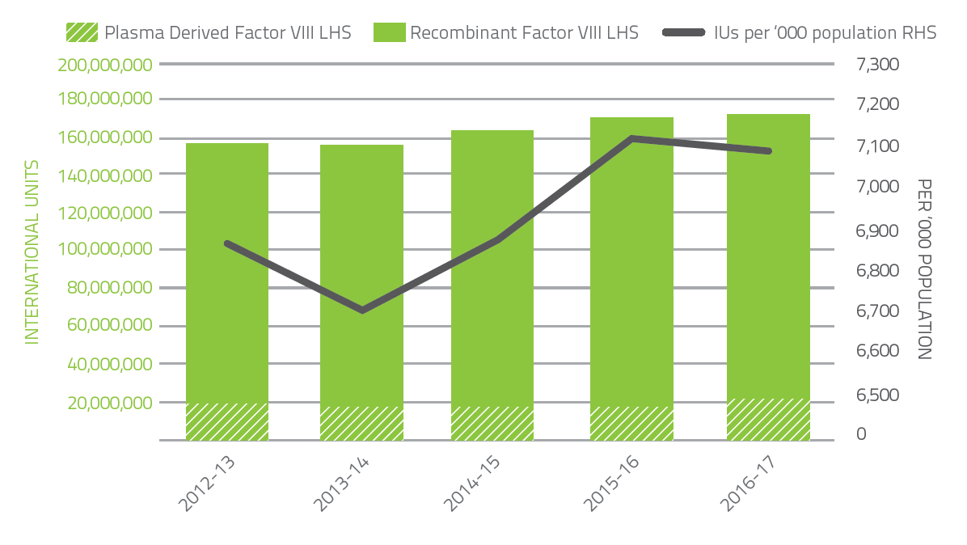

Figure 17 - Issues of factor VIII products, 2012-13 to 2016-17 per ‘000 population

Figure 18 indicates that demand for Factor IX products in 2016-17 increased by 1.6 per cent compared to 2015-16. Plasma derived Factor IX demand decreased by 15.6 per cent in 2016-17 due to a reduction in specific patient requirements. Demand for Recombinant Factor IX increased by 1.6 per cent in 2016-17. Patient participation in company clinical trials for recombinant Factor IX products continues to contribute to the variability of year-to-year product growth.

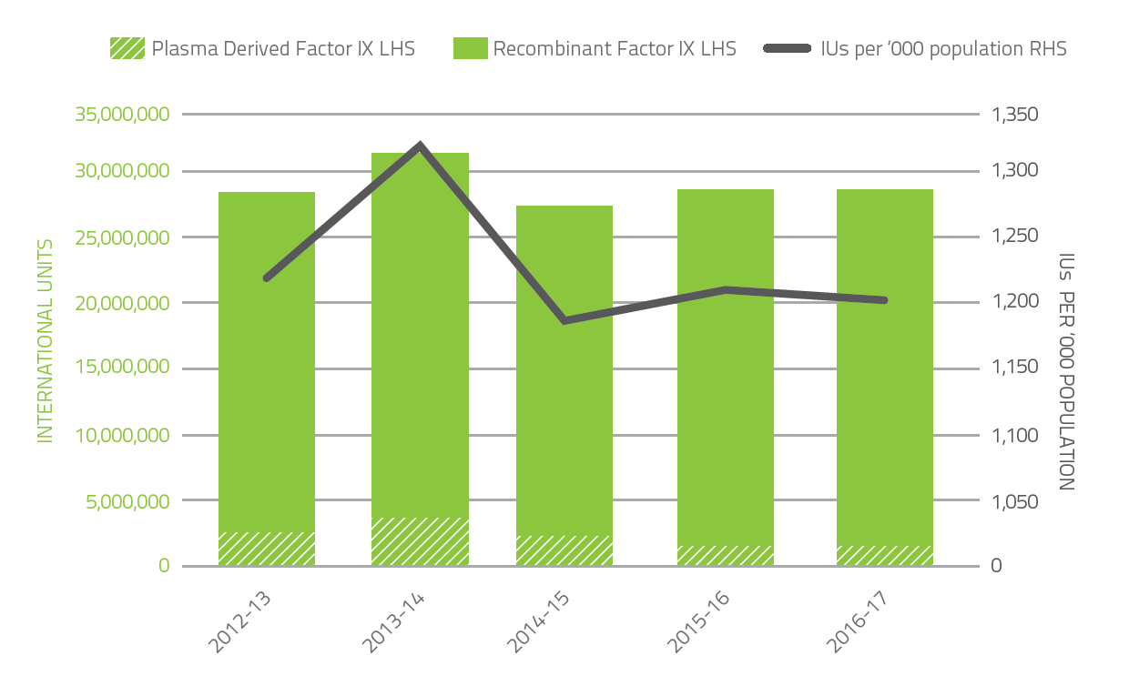

Figure 18 - Issues of factor IX products, 2012-13 to 2016-17 per ‘000 population

Figure 19 and Figure 20 show demand for Recombinant Factor VIIa decreased by 34.4 per cent and 45.2 per cent for FEIBA compared to 2015-16. Demand for Recombinant Factor VIIa and FEIBA can change significantly from year to year as a result of the variable needs of a small number of patients.

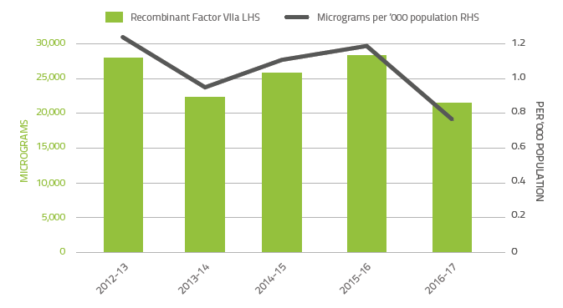

Figure 19 - Issues of recombinant factor VIIa products, 2012-13 to 2016-17 per ‘000 population

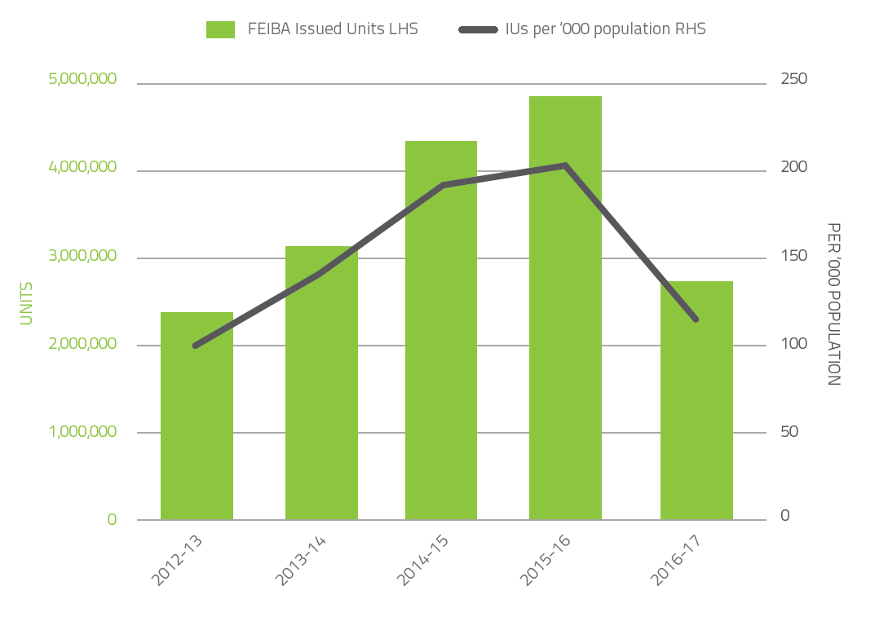

Figure 20 - Issues of FEIBA, 2012-13 to 2016-17 per ‘000 population

## CHRONOLOGY OF PRODUCTS SUPPLIED

Various products have been supplied through national arrangements. Since 2009-10 the following arrangements for the supply of products have occurred.

|  |  |
| --- | --- |
| 2011-12 | Commenced supply of Kogenate |
| 2012-13 | Ceased supply of Recombinate and Advate |
| 2014-15 | Commenced supply of Advate and Rixubus |
| 2015-16 | Ceased supply of Factor VII Concentrate  Commenced supply of RiaSTAP |
| 2016-17 | Ceased supply of Kogenate FS |

# Appendix D History of the ABDR

The ABDR was first established in 1988 using a ‘Paradox’ database at each Haemophilia Treatment Centre in Australia. The aims of the ABDR were to provide a clinical tool for improved management and national demographics of patients with haemophilia and other inherited bleeding disorders.

The first demographic Haemophilia registry was established by the Haemophilia Foundation of Australia (HFA), under auspices of the Medical Advisory Panel (MAP), in 1991 with an initial survey of Haemophilia Treatment Centres (HTC) established in Australia. Following on this initial survey the MAP took on responsibility for developing an ongoing registry and database associated with a University. The registry was based on a Paradox database with a comprehensive data collection including demographics, factor usage and bleed data. It was intended that software would be updated regularly by circulation of floppy disc updates and annual reports produced. Issues identified included no dedicated data entry staff, variability of IT support in institutions, unstable database requiring significant maintenance, time for data entry, and complexity. Unfortunately the registry did not progress.

In view of issues identified, in 2000 a new database using Access was developed with a single initial page collecting demographic and basic clinical data – ‘medical registry’. Financial support was provided for data entry. Identification was by a code including multiple initials of name and date of birth as used by National HIV registries in Australia. Duplicate entries were identified and individual HTCs were asked to resolve differences based on activity of PWH and HTC. Initial demographics and diagnoses were provided for an annual report – initially to Department of Health and Aging, subsequently to National Blood Authority and presented at various forums. Data was vital for identifying product needs of the PWH community at a time of introduction of recombinant products. The ABDR achieved Quality Assurance status with the Commonwealth to assist with concerns about privacy. Ongoing issues identified were related to privacy, data collection (with one state not being involved) and coverage of the database, and it appeared total product usage was not complete.

The National Blood Authority (NBA) was established in 2003 and in 2007 it was proposed to develop the ABDR further with a web based clinical registry. Funding from the NBA allowed updating of the database. Widespread consultation was undertaken with HTCs to draw up specifications for a clinical database. The project was tendered to a commercial provider to enable ‘third party custody’ of data. The ABDR was to be capable of ordering products in ‘real time’ at HTCs. Governance of the development and operation was by a steering committee consisting of Australian Haemophilia Centre Directors Organisation (AHCDO), HFA, NBA and jurisdictional representatives.

An internet-based, standardised data entry database involving all states was introduced in December 2008. But the database highlighted significant resource and IT issues in HTCs and hospitals with slow response and significant variation of practice within HTCs. This hampered complete data collection with lack of feedback to HTCs, inability to provide ad hoc reporting for HTCs and nationally available reports. Annual reports only provided broad information with NBA providing figures for factor usage. The commercial provider was unable to address these issues.

Issues with existing software and support by the commercial provider necessitated a different approach. Further funding from the NBA enabled redevelopment of the ABDR using industry standard software in a ‘Like for like’ development. Data is now being held within NBA – requiring strict security protocols and separation of staff analysing data from those managing the system. Deficiencies of previous software were addressed with development of online reports to assist HTC management. Further expansion to include data from physiotherapy and social work, counselling pages and adverse events were developed. The 4th generation ABDR was released on August 13, 2012.

The ABDR has evolved with improvements in technology and feedback from stakeholders. In 2014 the ABDR entered a new phase with MyABDR – a smartphone application to enable patient input of bleed data and factor usage directly to the ABDR. The ABDR project has improved communication between HTCs for transfers and knowledge of ‘travellers’.

The NBA delivered a number of updates and improvements to the Registry in 2014-15 to enhance the functionality and the user experience with MyABDR. The innovation delivered by the patient portal to ABDR, MyABDR, was recognised by the ICT industry through the receipt of two national iAwards merits in the Health and Government categories in August 2014 and through ITnews naming the NBA’s Chief Information Officer as ‘Healthcare CIO of the Year’ in February 2015.

There has been further identification of PWH and opportunity for standardisation of terminology. There is wide involvement of other professionals – nursing, physiotherapy, social workers/counselling. Adverse event reporting has commenced. Benchmarking between HTCs is possible with improvement in data recoding enabling opportunities for improvement.

## Benefits of the 4th generation ABDR

The NBA redeveloped the ABDR and deployed the 4th generation ABDR on August 13, 2012. It provides the following benefits:

* Single point of access for clinicians for treatment of patients
* Patient information relating to all clinical information associated with the treatment of haemophilia
* Information exchange between states and Haemophilia Treatment Centres
* National demographic information (age, gender etc.) of persons with bleeding disorders
* National data on inhibitor incidence and outcomes of treatment
* Allied health (physiotherapy and social work) monitoring and outcomes
* Recording of personal usage of factor replacement for clinical monitoring
* Data for forward planning and funding of factor concentrates on a national basis
* MyABDR is a secure app for smartphones and web site for people with bleeding disorders or parents/caregivers to record home treatments and bleeds. As an alternative, there is also a MyABDR paper-based treatment diary.

## Current position of the development of the ABDR

Today the Australian Bleeding Disorders Registry and MYABDR are fully operational. The ABDR Steering committee continues to oversee the project.

The National Blood Authority’s role continues around provision of resources to maintain ABDR operations and to ensure timely and accurate reporting from the ABDR through provision of support to Data Managers. Data Managers, funded and supported by AHCDO, are located at HTCs across Australia.

# Appendix E Patient Registration Form

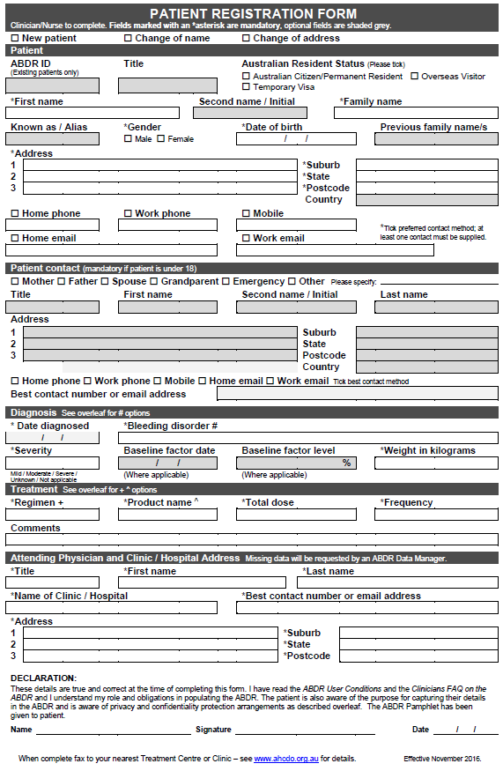

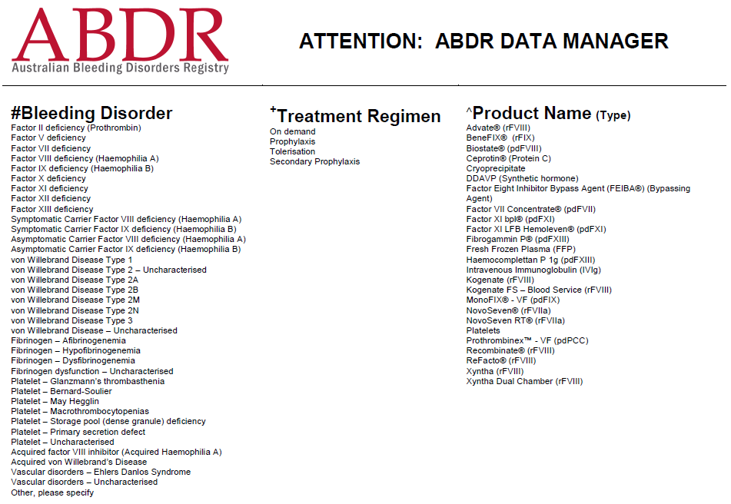

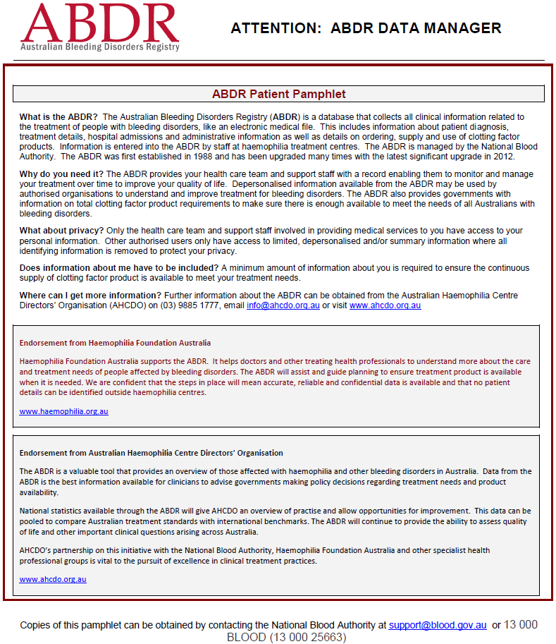

# Acronyms and glossary of terms

## Acronyms

|  |  |
| --- | --- |
| ABDR | Australian Bleeding Disorders Registry |
| AHCDO | Australian Haemophilia Centre Directors’ Organisation |
| BU (BU/ml) | Bethesda unit (expressed as Bethesda units per millilitre) |
| DDAVP | Desmopressin (1-desamino-8-D-arginine vasopressin) a derivative of the antidiuretic hormone, used to treat patients with von Willebrand disease. It does not come under the national blood agreement funding arrangements and its use is often not recorded in the NBA’s issues database. |
| FEIBA | Factor VIII Inhibitor Bypassing Activity |
| FVIIa / rFVIIa | Factor VIIa (seven ‘a’) / Recombinant Factor VIIa |
| FVIII / rFVIII | Factor VIII (eight) / Recombinant Factor VIII |
| HFA | Haemophilia Foundation Australia |
| HMA | Haemophilia A (Factor VIII deficiency) |
| HMB | Haemophilia B (Factor IX deficiency) |
| HTC | Haemophilia Treatment Centre – A specialist centre at certain hospitals where comprehensive care is undertaken for people with haemophilia. Non HTCs are other hospitals who are encouraged to work with HTCs in their region. |
| IDMS | The NBA’s Integrated Data Management System |
| IU | International Units |
| MyABDR | A secure app for smartphones (Android and iOS) and a web site for people with bleeding disorders or parents/caregivers to record home treatments and bleeds. |
| NBA | National Blood Authority |
| OBD | Other bleeding disorders |
| PWH | People with Haemophilia |
| VWD | von Willebrand disease |
| WFH | World Federation of Hemophilia |

## Glossary of terms

|  |  |
| --- | --- |
| bleeding disorders | Diseases that cause abnormal or exaggerated bleeding and poor blood clotting |
| blood products | Products manufactured from donated blood |
| fractionation | Blood plasma fractionation refers to the general processes of separating the various components of blood plasma |



1. Modified from Srivastava A, Brewer AK, Mauser-Bunschoten EP, Key NS, Kitchen S, Llinas A, Ludlam CA, Mahlangu JN, Mulder K, Poon MC, Street A; Treatment Guidelines Working Group on Behalf of The World Federation Of Hemophilia (2013). Guidelines for the management of hemophilia, Haemophilia 19(1):e1-47.
2. In ABDR Annual Reports prior to 2011-12 the threshold age between paediatric and adult patients was 20 years of age. This threshold has been adjusted in subsequent reports to better reflect the manner in which patients are treated in HTCs.
3. Australian Bureau of Statistics, Australian Demographic Statistics, Cat. No. 3101.0 Released March 2017 (Table 59)
4. Oldenburg J, Dolan G, Lemm G (2009).Haemophilia care then, now and in the future. Haemophilia 15, S1: 2-7.
5. Bethesda units (BU) = a measure of inhibitor activity – the amount of inhibitor that inactivates 50% or

   0.5 units of a coagulation factor during the incubation period
6. Stonebraker JS, Bolton-Maggs PHB, Soucie JM, Walker I, Brooker M. (2010). A study of variations in the reported hemophilia A prevalence around the world. Haemophilia 16(1): 20–32.
7. Stonebraker JS, Bolton-Maggs PHB, Soucie JM, Walker I, Brooker M. (2011). A study of variations in the reported hemophilia B prevalence around the world. Haemophilia 18(3): 1-4.
8. Schramm W, Royal S, Kroner B, Berntorp E, Giangrande P, Ludlam CA, et al. (2002). Clinical outcomes and resource utilization associated with haemophilia care in Europe. Haemophilia 8(1): 33-43.
9. Aledort LM, Haschmeyer RH, Pettersson H (1994) A longitudinal study of orthopaedic outcomes for severe factor-VIII-deficient haemophiliacs. The Orthopaedic Outcome Study Group. J Intern Med. 236(4): 391-399.
10. Fischer K, Pouw ME, Lewandowski D, Janssen MP, van den Berg HM, van Hout BA (2011). A modelling approach to evaluate long-term outcome of prophylactic and on demand treatment strategies for severe hemophilia A. Haematologica 96(5): 738-743.