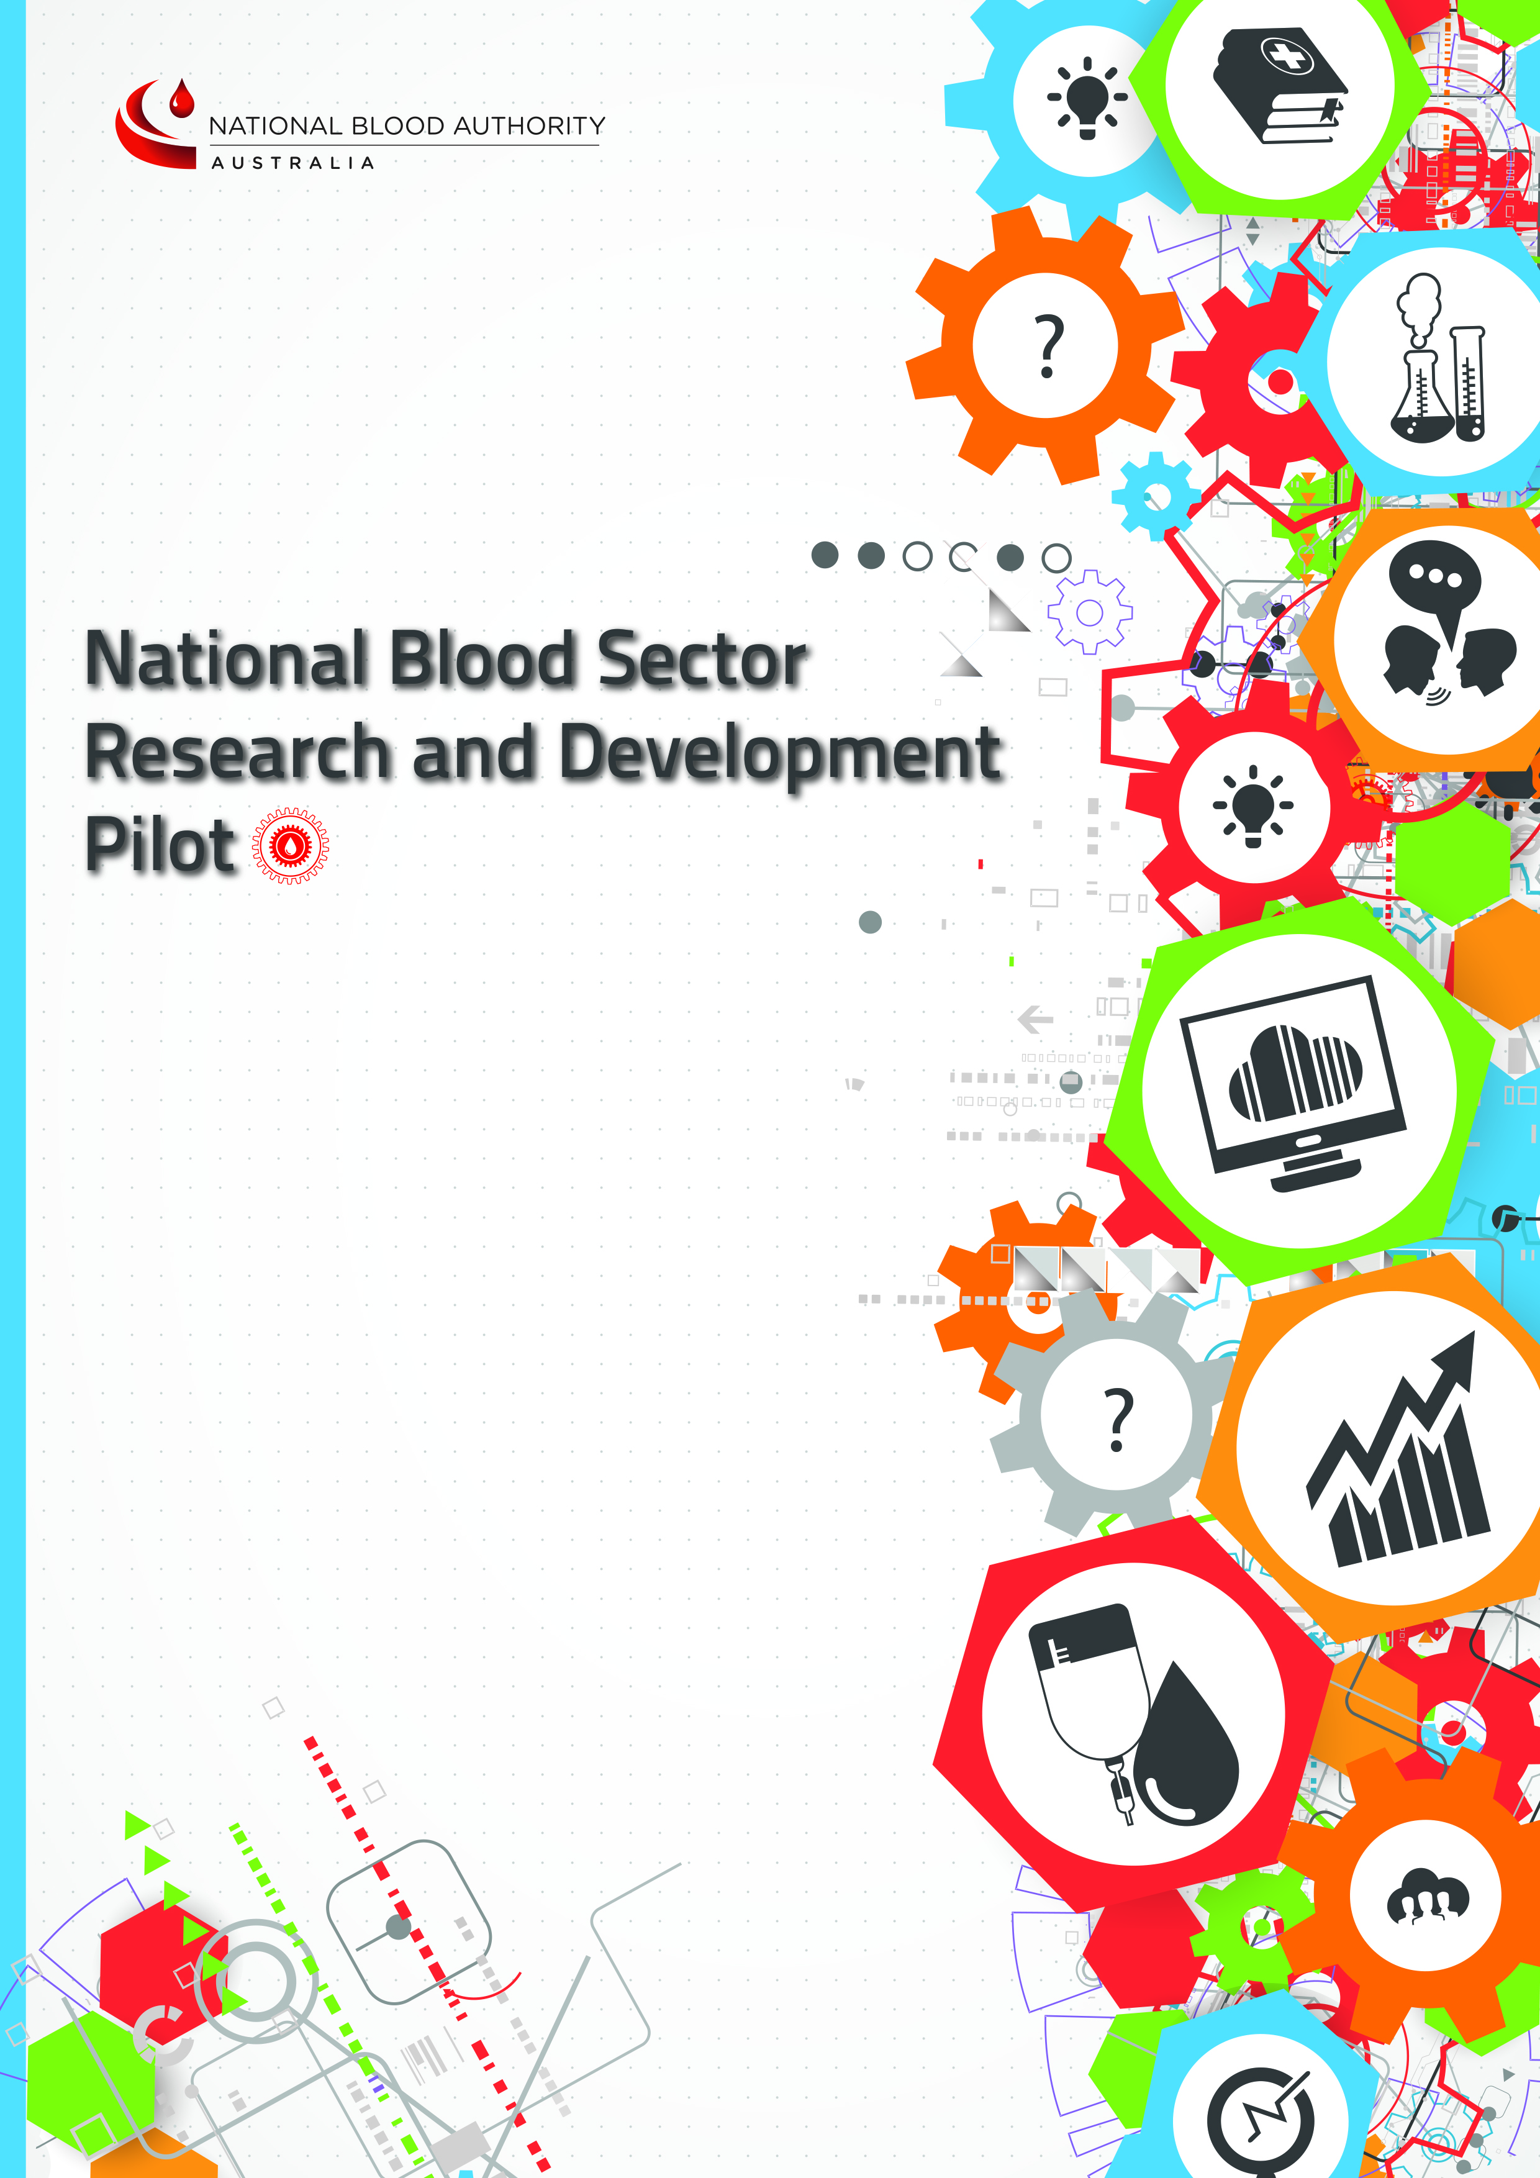
>
>
This booklet should be consulted when completing applications for a National Blood Sector Research and Development Pilot Grant

Round 2- Deadline for Applications:
10am 10 February 2017
Australian Eastern Daylight Time (AEDT)

Information for
Applicants Booklet

Contents
Round 2- Deadline for Applications: 10am 10 February 2017 1
Information for Applicants Booklet 1
Vision and Objectives of R&D Pilot 1
Vision 1
Objectives 1
Objectives of the Blood Sector R&D Framework 1
Objectives of the Pilot 1
Focus and Scope of the Pilot 2
Patient Blood Management 2
Immunoglobulin 2
Transparency 3
Grant Types 3
Grant rounds and funding timeframes 4
Call for Grant Applications 4
Duration of Funding Agreements 4
Grant Round 1 4
Grant Round 2 4
Eligibility 5
Approval to publish on the NBA website 5
Lodgement Requirements 5
Evaluation of Applications 5
Compliance Assessment 6
Management of Conflicts of Interest 6
Expert Evaluation 6
Grant Evaluation Panel Review and Recommendations 7
CEO Approval 7
Grant funding rules 7
Reporting Requirements 7
Interim Reports and Advice to the NBA 7
End of Research Grant Report to the NBA 8

Vision and Objectives of R&D Pilot

Vision
To facilitate world-class research and development in Australia that contributes to optimising the use, management and administration of blood products, and improves patient outcomes.

Objectives

Objectives of the Blood Sector R&D Framework
The overarching objectives of the Blood Sector Research and Development (R&D) Framework are to:
- Enhance the sustainability and affordability of the national supply of blood products, including through increased efficiency and reduced blood product usage and wastage
- Identify appropriate use and reduce inappropriate use of blood products
- Maintain or enhance clinical outcomes for patients
by providing evidence or new knowledge to:
- Understand the biological action of blood products
- Identify optimum treatment, dosing or indications for the use for blood products, and
- Compare the use of blood products with alternative strategies and treatments.
It is proposed that pursuing these objectives will enhance opportunities for blood sector specific research and build research capacity through:
- Encouraging priority-driven research related to the use and management of blood products
- Funding research aimed at addressing gaps in evidence, including where that will inform policy development and program implementation
- Fostering collaboration between researchers and other stakeholders to build Australia’s research capacity relating to the use and management of blood products
- Facilitating translation of research to improve patient outcomes and cost effectiveness.

Objectives of the Pilot
The objectives of the R&D Pilot are to:
- Confirm that a potential blood sector specific R&D Program will be able to deliver on its stated objectives
- Develop and test administrative processes to support various research components, including potential Program documentation and promotion, application rounds, evaluation of applications, funding of projects, and contract management and reporting
- Develop and test governance processes for oversight of research application and funding programs.

Focus and Scope of the Pilot
The Pilot will be focussed on research areas that have been identified by pre-existing strategic programs of the National Blood Authority (NBA) and governments in the blood sector.
- Patient Blood Management (PBM) evidence gaps, as identified in each module of the PBM Guidelines; and
- Efficient and effective use of immunoglobulin products, as highlighted through the Ig Governance Program.

Patient Blood Management
The PBM guidelines have resulted from exhaustive systematic reviews of the published evidence. These reviews have identified a large number of areas where additional research is required. These research gaps are articulated in each of the six Modules of the PBM Guidelines with the ‘Future Directions’ chapter The PBM guidelines and the extensive systematic reviews are available for researchers to access on the NBA website at http://www.blood.gov.au/pbm-guidelines.

Immunoglobulin
The priority areas for immunoglobulin research were identified through consultation with Ig governance groups including multiple Specialist Working Groups and the National Immunoglobulin Advisory Committee. This consultation resulted in the suggestion of a number of areas for research that are considered to be of higher priority by the members of these groups. This list is not intended to be exclusive, but rather, to assist prospective applicants to identify high priority research topics. The topics can be broadly categorised into three broad themes:
- Dosing and administration:
  - Pharmacokinetic studies – minimal effective dosing including lean body weight dosing;
  - Approaches to dosing including frequency and titration of Ig therapy;
  - Weaning off/cessation of Ig therapy; and
  - Relative effectiveness of routes of administration.

- Use of alternative or concurrent therapies that reduce reliance on Ig therapy.

- Predictors relating to:
  - Selecting patients for/responders to Ig therapy; and
  - Achieving long term remission.

Transparency
The NBA will maintain transparent processes by providing clear but concise advice on its website including:
- Information for grant applicants (this ‘Information For Applications Booklet’)
- Information about grant round outcomes provided on the NBA website.
Grant recipients will be required (as applicable) to:
- Register their research in the relevant research register such as but not limited to:
  - International prospective register of systematic reviews (for non-Cochrane Reviews);
  - Cochrane Database of Systematic Reviews if funding is to complete this type of review; and
  - Australian and New Zealand Clinical Trials registry for clinical trials.
- Publish research outcomes; and
- Acknowledge the NBA as the funding source.

Grant Types
While the NBA will provide funding under three different grant categories (see table below), the research approach in each of these categories may encompass a wide range of activities including but not limited to clinical trials, surveys, secondary research, translational research, epidemiological investigations etc.
Type | Indicative $ amount | Duration | Description
Project Grant | Typically $30-150k per annum | Expended over period up to 3 years | Entire, discrete research project proposal
Seed Grant | Typically under $50k | Expended over period up to 1 year | Seed funding for early stages of innovative new research effort  Generation of preliminary data needed to support future grant application
Scholarship | Typically $25-30k per annum for post graduate students and postdoctoral research fellows | Expended over period up to 1 year | Intended to support medical researcher in attainment of PhD or Master’s degree or postdoctoral research fellow research

Grant rounds and funding timeframes

Call for Grant Applications
Applicants will be provided a period of minimum six weeks, from announcement of the grant round, to submit their application.
Two grant rounds will be held during the Pilot.

Duration of Funding Agreements
Funding duration:
- Can be for any period up to but not exceeding:
  - 3 years for Project Grants
  - 1 year for Seed Grants
  - 1 year for Scholarships
- Grants allocated in round 1 must be completed by 31 December 2019
- Grants allocated in round 2 must be completed by 31 December 2020
The duration of funding will not ordinarily be extended beyond the period agreed in the Funding Agreement. Extension will only be considered in exceptional circumstances which could not reasonably have been avoided or mitigated, and the NBA reserves the right to approve or not approve an extension at its discretion

Grant Round 1
Applications for Round 1 will be sought in February 2016. A six week period will be allowed for submission of applications. Evaluation of applications will occur during April and May 2016 with a final decision in early June 2016. Funding Agreements will be negotiated at the earliest convenience and commence anytime during the Round 1 funding period so long as the grant is fully expended by the end of the Round 1 Funding period. The funding period for Grand Round 1 is 1 July 2016 to 31 December 2019.
Applications  sought | Applications evaluated | Funding decision | Round 1 Funding Period 1 July 2016 to 31 December 2019
Feb-Mar 16 | Apr-May 16 | Jun 16 | 1 Jul 16 31 Dec 19

Grant Round 2
Applications for Round 2 will be sought in December 2016. An eleven week period will be allowed for submission of round 2 applications. Evaluation of applications will occur during March 2017 with a final decision in early June 2017. Funding Agreements will be negotiated at the earliest convenience and commence anytime during the Round 2 funding period so long as the grant is fully expended by the end of the Round 2 Funding period. The funding period for Grand Round 2 is 1 July 2017 to 31 December 2020.
Applications  sought | Applications evaluated | Funding decision | Round 2 Funding Period 1 July 2017 to 31 December 2020
Dec 16 -Feb 17 | Feb -Mar 17 | Jun 17 | 1 Jul 17 | 31 Dec 20

Eligibility
Institutions responsible for administering a grant must be listed as an NHMRC Administering Institution. This policy is available at:
https://www.nhmrc.gov.au/_files_nhmrc/file/grants/funding/2015/2015_nhmrc_administering_institution_policy_16032015_3.pdf
The list of NHMRC registered Administering Institutions can be found at: https://www.nhmrc.gov.au/grants-funding-administering-grants as at 13 October 2016.
The Australian Red Cross Blood Service (the Blood Service) is provided funding for research and development activities determined under a Blood Service Research and Development Framework, agreed under a Deed of Agreement between the Blood Service and the NBA on behalf of all Australian governments. Research applications from the Blood Service or Blood Service Personnel or associates, or in connection with projects being conducted, for research purposes within the scope of that Framework will be ineligible under this R & D Pilot.
Research already funded by the NBA under an existing contractual agreement will not be considered eligible under this Research and Development Pilot.
Project and Seed Grants require the Principal Chief Investigator to be an Australian Citizen or a Permanent Australian Resident. Scholarships require the scholar to be an Australian Citizen or a Permanent Australian Resident.
The research must be conducted primarily within Australia.

Approval to publish on the NBA website
The following information about successful applicants will be uploaded on to the NBA website.
- Research Aim
- Recipient(s) (by name)
- Administering institution
- Value
- Approval Date
- Grant Term (months)
- Grant Funding Location
Applicants will be required to consent to this information being made available on the NBA website in order to receive a grant.

Lodgement Requirements
Applications must:
- be submitted by email; and
- be lodged by the closing date and time, as advised on the front cover of this booklet.
Applications not received by this time will be considered invalid.

Evaluation of Applications
A multi-stage process will be used to evaluate applications as follows.

Compliance Assessment
A compliance check will be undertaken by NBA officers on all grant applications to ensure all key information is present. If all key information is not present and in the required form such applications may be considered invalid and may not be considered further.
The compliance check will seek to ensure that the application:
- checks topic against PBM and Ig evidence gaps
- is completed in English in a usable electronic form
- uses the correct Application Form for the type of grant being sought
- provides attachments as requested within the Application Form,
- NOTE ethics applications do not suffice for Letters of Support.
- includes completed and signed Conflict of Interest Forms as required in the Application Form
- provides contact details as required in the Application Form
- includes ALL signatures and approvals as required in the Application Form
- addresses the evaluation criteria as required in the Application Form
- confirms that the administering institution is registered under the NHMRC Administering Institutions policy 2015 (https://www.nhmrc.gov.au/_files_nhmrc/file/grants/funding/2015/2015_nhmrc_administering_institution_policy_16032015_3.pdf)
- confirms the PI is affiliated with an NHMRC administration Institution
- confirms that the research will be completed within the required timeframes
- confirms that the research will be conducted predominately within Australia
- confirms that the Principal Chief Investigator (for Project and Seed Grants) and Applicant (for Scholarships) are Australian citizens or have permanent Australian resident status.

Management of Conflicts of Interest
Expert Reviewers involved in the evaluation of Grant Applications are required to declare conflicts of interest. In addition to the general declaration process, the NBA also requires Expert Reviewers to consider and declare any relationships with any of the Applications’ individual institutions or chief investigators. The Chair of the Expert Reviewer group will be asked to consider the declarations and rate them as either high or low. If considered to be ‘high’, the Expert Reviewer will not be allocated as a ‘primary’ or ‘secondary’ reviewer for that application and will be asked to leave the room during deliberations of that particular application. This process will be used for all Expert Reviewers where a ‘high’ conflict of interest is found to exist. It will not preclude the Expert Reviewer from participating in the review of other applications.

Expert Evaluation
Clinical experts with clinical content expertise will independently assess each application against explicit criteria
These expert reviewers will consider all valid applications, in order to:
- Identify and advise on the quality of applications against the evaluation criteria by type of grant (i.e. project, seed and scholarships) and funding stream (PBM and Ig streams);
- Rank applications within each grant type and stream; and
- Provide advice to the NBA on the best combination and balance of projects to be funded giving consideration to the funding streams, the types of grants applied for, the quality of each grant application and the available funds
- Part of the advice from the Expert Evaluation on the projects may be a recommendation to combine research applications.

Grant Evaluation Panel Review and Recommendations
A small Grant Evaluation Panel will consider the advice from the expert evaluation phase and provide recommendations for the NBA’s General Manager (GM). Members of the GEP will include NBA and other government representatives as appropriate.

CEO Approval
The NBA is responsible for making the final decision on grant offers. A Grant Evaluation Report will be provided to the CEO for decision. His/her decision is final.

Grant funding rules
Applicants are required to provide information on all current grants and concurrent grant applications.
The NBA must be assured that the funding request is unique to the research requirements contained within the submitted application. Salaries from concurrent grants should not exceed an individual’s full time salary.
Funding will not be provided for an NBA scholarship if the applicant is receiving an existing personal scholarship.
For Project grants, funding will only be provided for direct research costs. The principles below should be applied to determine if a cost is a ‘Direct Research Cost’.
- The cost must be integral to achieving the objectives and outcomes of the Research Activity as set out in the Application for Funding for that Research Activity;
- The cost must be directly related to the grant proposal as set out in the Application for Funding for that Research Activity; and
- The cost must not be for a facility or an administrative cost that would be provided by an institution in the normal course of undertaking and supporting health and medical research.
Applicants and Administering Institutions are required to indicate their full or partial agreement with the draft Funding Agreement. Scholarship applicants are also required to complete a Scholar Acknowledgement form if successful.
The draft Funding Agreement is available | Here
The Scholar Acknowledgement Form is available | Here

Reporting Requirements
The NBA requires administering organisation to monitor research progress in accordance with the NHMRC National Statement on Ethical Conduct in Human Research (2007) (Updated May 2015).

Interim Reports and Advice to the NBA
Interim reports may or may not be required depending upon the timeframe of the funding period. Reporting requirements will be agreed at the time of negotiation of the grant Funding Agreement.
Regardless of whether or not interim reporting is required, the NBA must be advised as soon as possible, by the contact officer of the following:
- changes to nominated research personnel, or research supervisors
- withdrawal of resources, or a substantive research partner or organisation
- changes to project timelines
- substantive changes to the research aims, objectives or approach
- cessation of research (as soon as known by the researchers)
- advice of any media releases (in advance of the release of the media release)
- advice of any unplanned publicity (within one day of the publicity)

End of Research Grant Report to the NBA
A Completion Report must be provided within 3 months of completion of the research project.
- Research performance:
  - Degree to which the research aims/objectives and outcomes were attained
  - Key research findings
  - Publications/presentations
- Project Management performance:
  - Management of Governance and Ethics
  - Contributions from the research team and partner organisations
  - Risk management - summary of risks and how they were managed
  - Performance against project timelines
  - Final expenditure against budget

