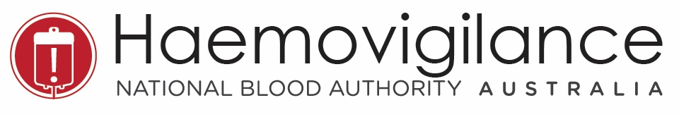
AUSTRALIAN HAEMOVIGILANCE DATA AT A GLANCE IN 2018-19
The National Blood Authority (NBA) has been collecting haemovigilance data from states and territories and publishing reports under the National Blood Agreement since 2008. The following data was derived from the 10th Australian Haemovigilance Report (2018-19). All adverse events are reported events and it should be noted that there are some quality issues in relation to data completeness, standardisation and relevance.
Fresh blood product and blood transfusion have become increasingly safe in Australia. From 2014-15 to 2018-19, states and territories reported 300 serious adverse events to the national haemoviglance program.

Key findings include:
- all states and territories have participated in the national haemovigilance reporting since 2015-16
- more than 50% of the reported adverse events are transfusion associated circulatory overlaod (TACO) and anaphylactic reactions
- the three deaths reported are probably or likely to be related to blood transfusion
- 52 out of 111 reported life threatening cases are anaphylactic reactions.

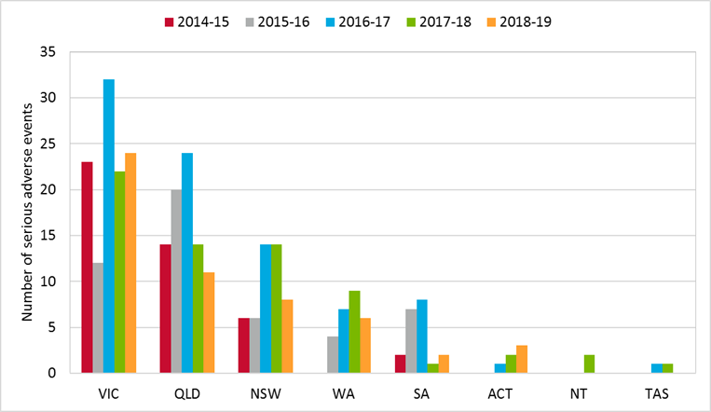  Figure 1: Serious adverse events by state, 2014-15 to 2018-19 | 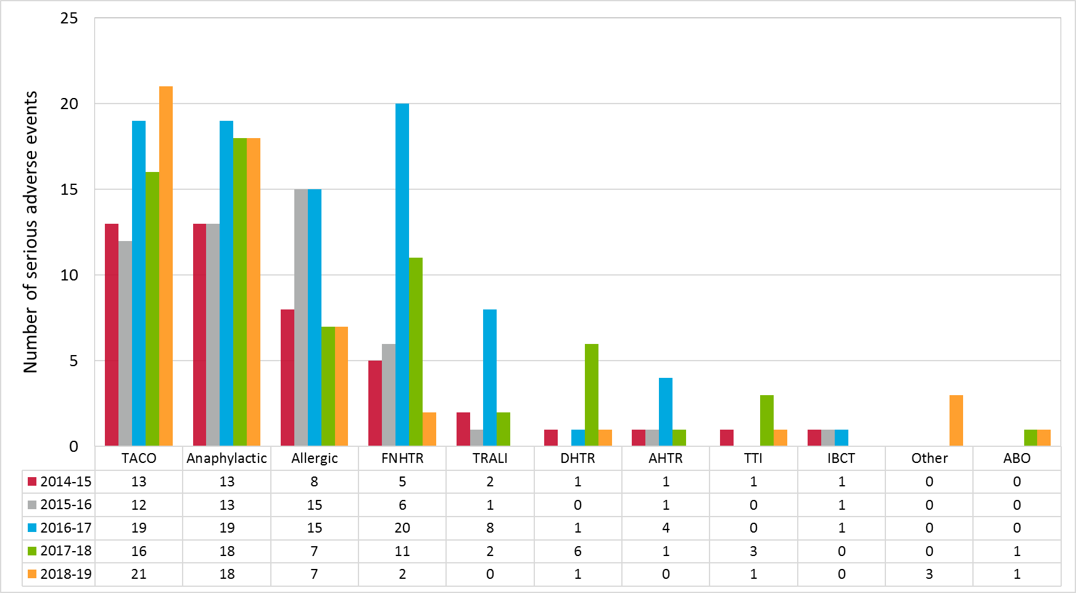  Figure 2: Serious adverse events in Australia, 2014-15 to 2018-19
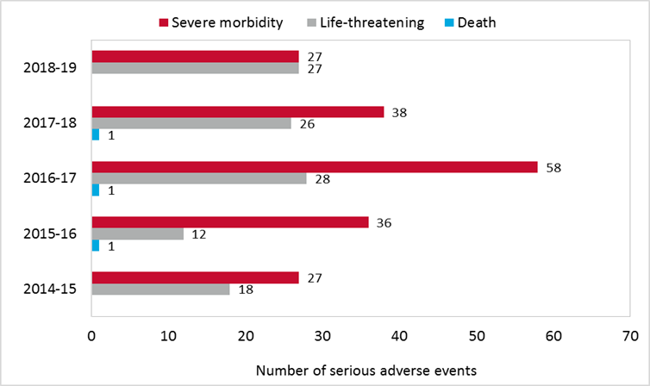  Figure 3: Death, life-threatening and severe morbidity, 2014-15 to 2018-19 | 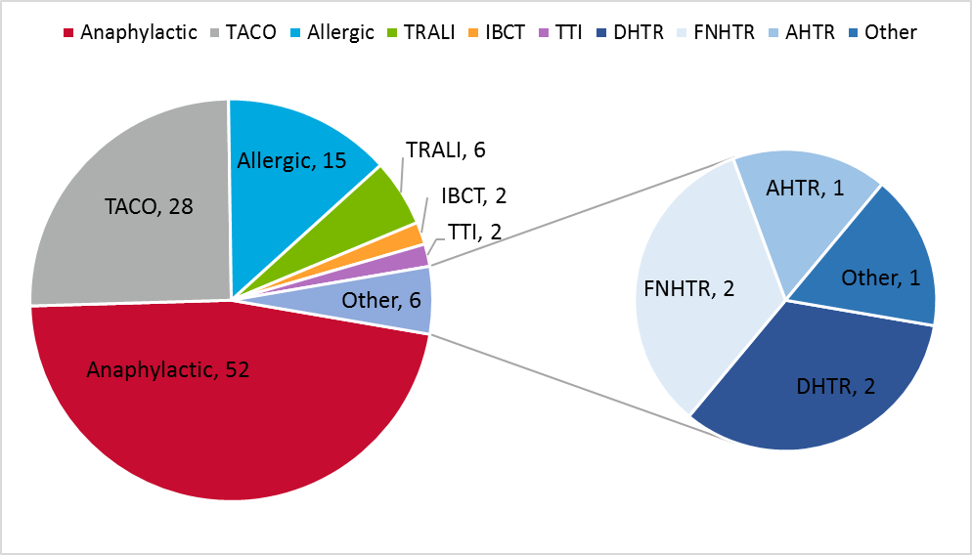  Figure 4: Life-threatening adverse events in Australia, 2014-15 to 2018-19

- A serious adverse event is an event which is possible or likely/probable, or confirmed/certain to be related to the blood transfusion and results in severe morbidity or a life-threatening outcome or death to a patient.
- ABO= ABO Incompatibility; AHTR= Acute Haemolytic Transfusion Reaction; Anaphylactic=Anaphylactic Reaction; Allergic=Allergic Reaction; FNHTR= Febrile Non-Haemolytic Transfusion Reaction; DHTR=Delayed Haemolytic Transfusion Reactoin; IBCT=Incorrect Blood Component Transfused; Other=Other Reation; TACO=Transfusion-Associated Circulatory Overload; TRALI= Transfusion-Related Acute Lung Injury; TTI= Transfusion Transmitted Infection

The haemovigilance data has been collected based on the Australian Haemovigilance Minimum Data Set (AHMDS 2015) and the National Haemovigilance Data Dictionary 2010.
For more information, please visit the NBA website. https://www.blood.gov.au/haemovigilance https://www.blood.gov.au/haemovigilance-reporting
TACO is one of the major causes of death associated with transfusions. In 2019, the Haemovigilance Advisory Committee (HAC) working group finalised two TACO case studies developed by staff from Lifeblood and the Blood Matters Program. Blood Matters also developed swing tags and posters on TACO identifying at-risk patients, how to prevent TACO, what to monitor, and how to treat TACO.

