Authorisation Search Tip Sheet

Patients with approved Intravenous and Subcutaneous Immunoglobulin have authorisation numbers which are linked the to National Blood Authority’s BloodSTAR system. This tip sheet will demonstrate how to search for approved patient authorisations.

- You can search for a patient’s authorisation directly from your home page by clicking on the ‘Authorisation’ box.

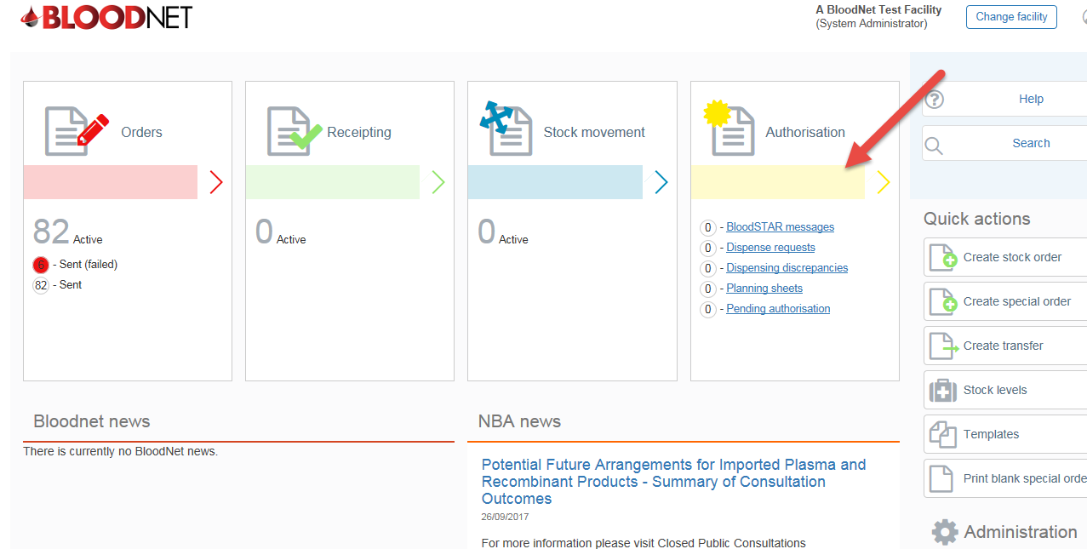

- Once you are directed to the authorisation search page you will have two options to search for the patient’s authorisation- by clicking on the ‘Authorisation number’ or the ‘Authorised patient’.

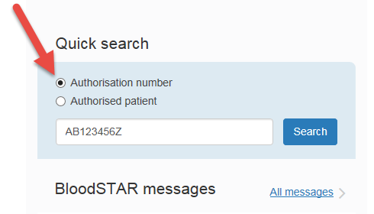

If you search by patient name you will also have the option to search for patients at your facility, state wide or nationally.
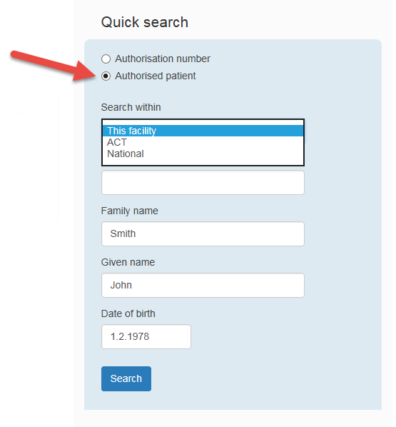

The patient’s authorisation will be displayed as below.

