Dispensing from an In-System Product Request
There are two ways of submitting dispense requests to BloodNet for Immunoglobulin (Ig). The first is to submit the request in-system via a dispense request or planning sheet in BloodSTAR, and the second is to place an out-of-system request, such as by paper or external system. This tip sheet explains how to action requests received in-system via an individual dispense request or a planning sheet.
Dispensing against an individual dispense request
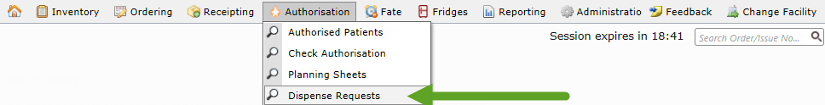
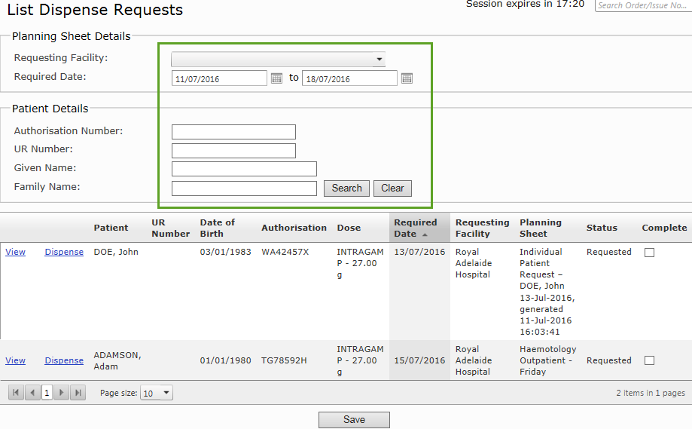
- When a dispense request is received from BloodSTAR, go to Authorisation and click on Dispense Requests.
- The List Dispense Requests page will automatically display only the dispense requests that are required in the next calendar week. You can change the filter or search any of the fields available above the dispense list.
To dispense product against a dose request, click Dispense.
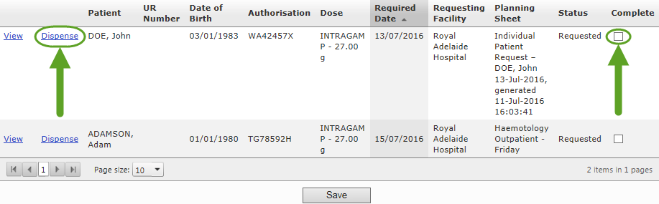

Please Note: If a dose has been requested but is no longer required you need to remove the request from the list without dispensing product against it. Tick the box under the Complete column and then click Save. This will save the dispense request as actioned without assigning any product to it and the dose will then be available for a clinician to request again.

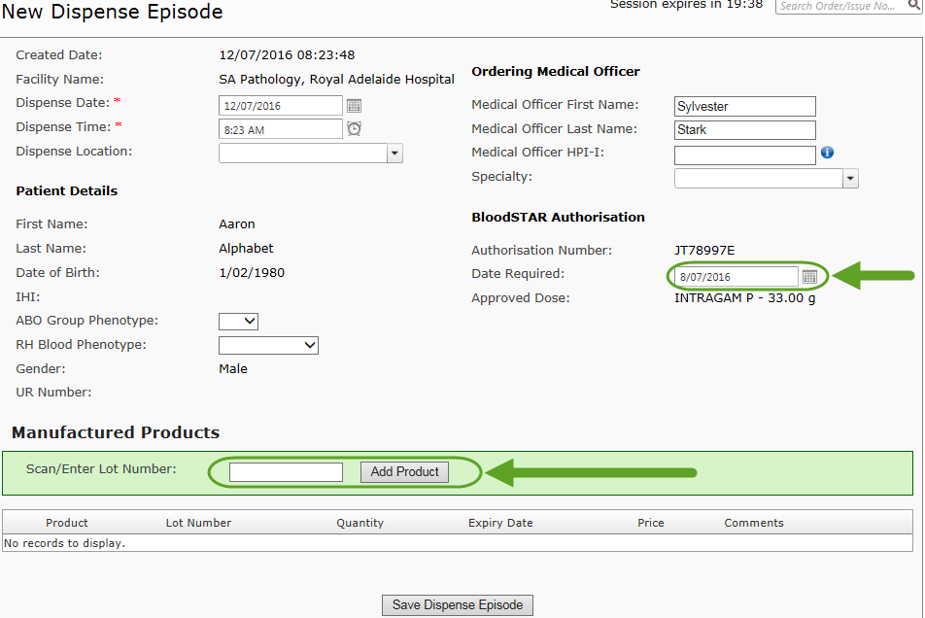
- Clicking Dispense from the Dispense List page will create a dispense episode with the patient, dose and Medical Officer details already populated.
Type or scan the product you are dispensing into the episode, and if necessary edit the defaulted dispense date/time. The Date Required will be defaulted off the patient’s treatment plan; you can edit this if required. Once all product has been scanned and the details confirmed, click Save Dispense Episode.
Please note: if you do not dispense the full requested amount of product, you will be able to dispense the full dose at a later date from the patient’s View Authorisation screen. The status of the dose requested will be entered as Partially Dispensed.
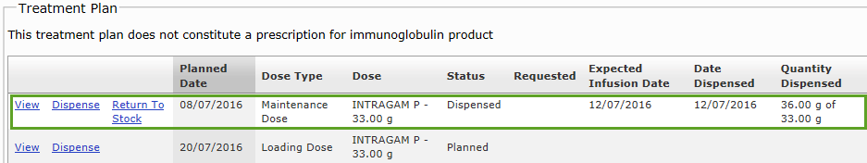
- Once a Dispense Episode has been successfully created, the status of that dose will be recorded as “dispensed” under Treatment Plan in the View Authorisation page and on the Treatment Plan in BloodSTAR.

Dispensing against a planning sheet
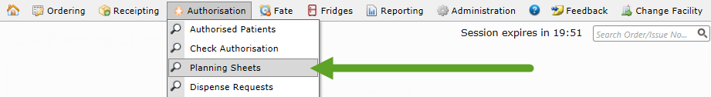
- To view all site planning lists, go to Authorisation and click Planning Sheets.
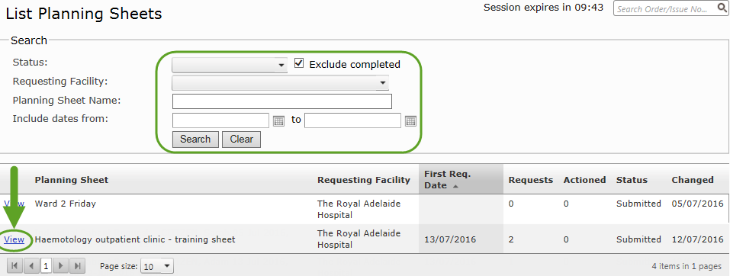
- The List Planning Sheets page will automatically be set to show only sheets that have not been completely actioned. To show all planning sheets for a site, or to specify which sheets you want to see by status or within a date range, enter these values into the Search box from the available options. Once you have located the planning sheet you want to dispense against, click View.
- On the View Planning Sheet page you will be able to see all doses requested by the clinical staff on that planning sheet. To dispense against a dose, click Dispense and you will be taken to a new dispense episode with patient details prepopulated.

Type or scan the product you are dispensing into the episode, and if required edit the dispense date/time. The Date Required will be defaulted off the patient’s treatment plan; you can edit this if required. Once all product has been scanned and the details confirmed, click Save Dispense Episode.
- Enter the required details and click Save Dispense Episode. Once this is done, click Return to Planning Sheet.
Please Note: if you do not dispense the full requested amount of product, you will be able to dispense the full dose at a later date from the patient’s View Authorisation screen. The status of the dose requested will be entered as Partially Dispensed.
- The dose requested will now have a status of Dispensed. If only part of the product was dispensed against the dose, the status will be at Partially Dispensed. Action each of the dispense requests one by one on the planning sheet and then click Save.
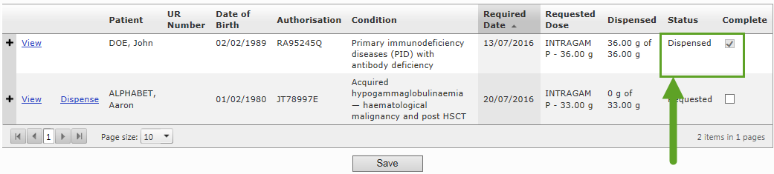
Please Note: If a dose is no longer necessary and you need to remove the request from the list without dispensing product against it, tick the Complete box next to the dispense request and then click Save. This will save the dispense request as actioned without assigning any product to it, and the dose will then be available for a clinician to request again.

- The completed planning sheet will now appear with a status of Completed on the List Planning Sheets page.

