Dispensing for an Out-of-System Dispense Request
This tip sheet explains how to action a dispense request received external to BloodSTAR, such as a paper- or external system-based request.
Dispensing for a dispense request placed outside of BloodSTAR
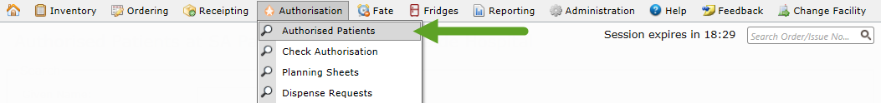
- If you are the nominated dispenser for the patient, navigate to the patient’s authorisation by going to Authorisation and clicking on Authorised Patients.
From there, locate the patient on the list or by searching for the specific patient. Click on their Authorisation ID to go to the View Authorisation page.
If the patient is not in your Authorised Patients list go to Check Authorisation and enter the patient’s full name and date of birth or their authorisation ID into the search fields. If there is a match, it will automatically take you to the View Authorisation page.
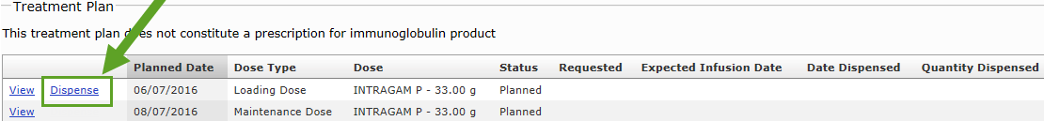
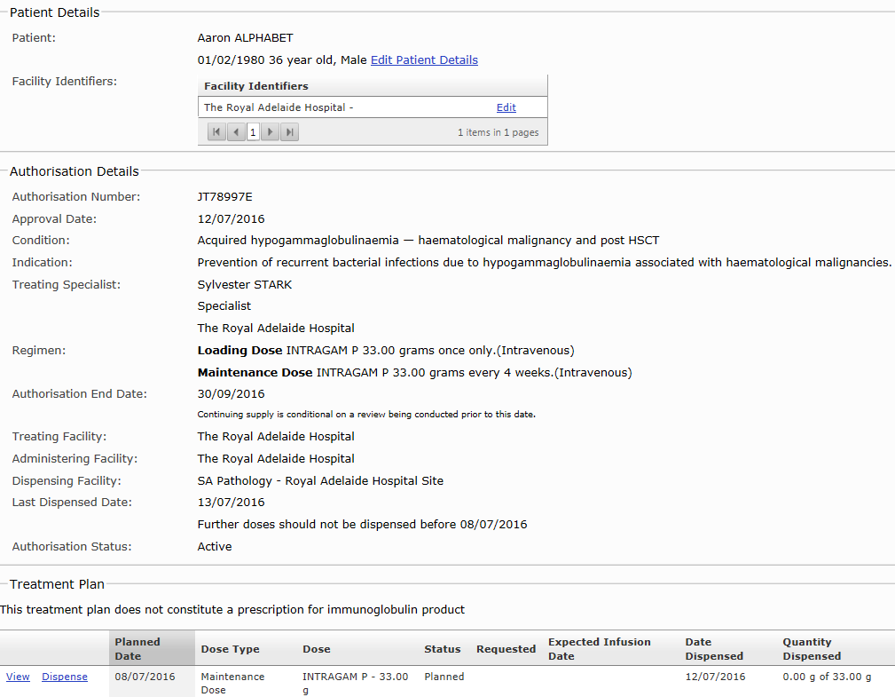
- To create a dispense episode against this authorisation, click Dispense against the dose being actioned. The next available dose will have the ability to click Dispense against it. Once you dispense that dose, the next dose will have the Dispense button available to action.

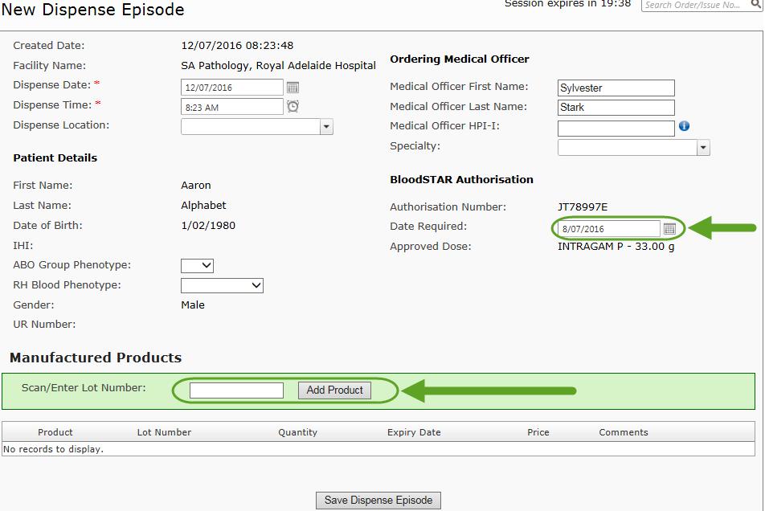
- When you click on the dispense button you will open a new dispense episode with the patient and ordering Medical Officer details automatically populated.
- Scan the barcode of the product(s) you are dispensing into the episode. The Date Required field will be the day it is actioned by default. You can edit this if required and back-date in the case of retrospective dispense episodes. Once product has been added and pre-populated details confirmed, click Save Dispense Episode.
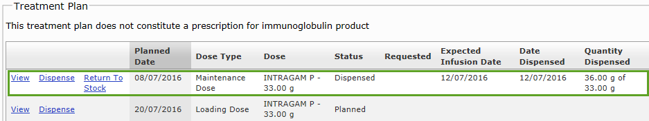
- When a Dispense Episode has been successfully created, the status of that dose will be record as “dispensed” under Treatment Plan in the View Authorisation page and on the Treatment Plan in BloodSTAR.

