Ordering to Maintain Immunoglobulin Stock Levels
After the Go-Live date for BloodSTAR in your State/Territory, the ordering process for Immunoglobulin (Ig) will no longer be done via Special Orders in BloodNet, and will instead be done as Stock Order to hold Ig as a stock for your authorised patients.
Ordering to maintain stock levels
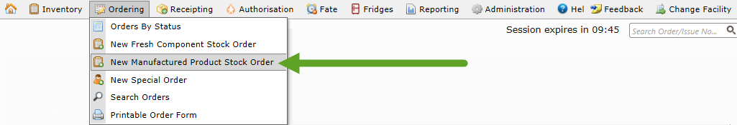
- To enter a new Ig order, go to Ordering and click New Manufactured Product Stock Order.
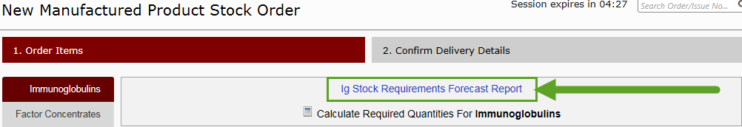
- All manufactured products that have been added to your site’s stock ordering templates will be visible on the ordering screens. To see how much Ig you will need for your next ordering period, you can use the Ig Stock Requirements Forecast Report by clicking the link at the top of the page.
To use this report, select how far in advance you are planning to order Ig for and whether the report is for Intravenous Immunoglobulin (IvIg) or Subcutaneous Immunoglobulin (SCIg).
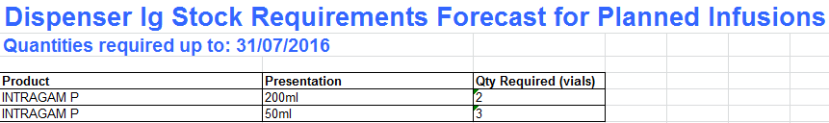
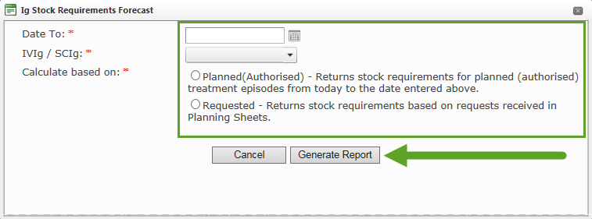
You will also need to select whether to check against Planned OR Requested Ig. “Planned (Authorised)” will display all stock requirements based on authorisations against your site, while “Requested” will show only the doses that have been specifically requested in-system. This report will run in Microsoft Excel format, and an example is shown below.

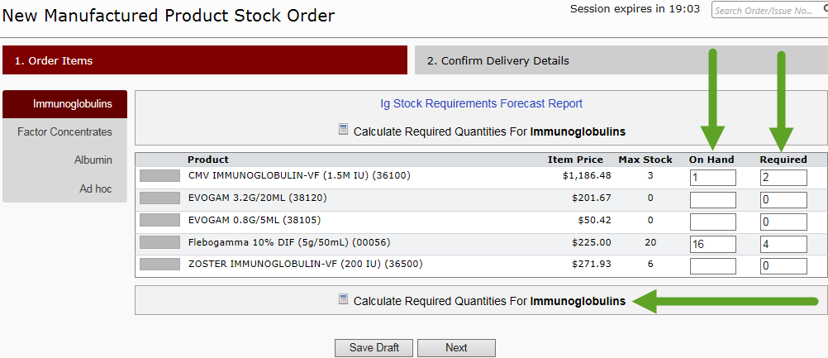
- Important: the Ig Forecast Report does not take into account product already receipted at your site. Enter your current inventory levels in the On Hand field and press Calculate Required Quantities. This will auto-fill the Required column for all products.
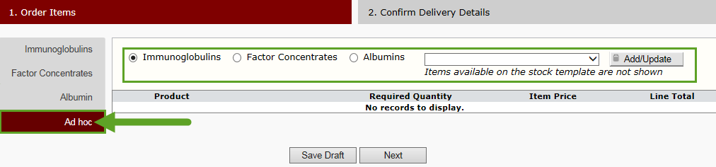
- If you need to order Ig that is not included on your stock template, any items can be added to any stock order by clicking Ad hoc on the left and then selecting the type of product you would like to add to the order.
- Once all ordering quantities have been added, click Next.
- Add any relevant order comments/delivery instructions and double-check that all product quantities are accurate. Then click Send Order to finalise the order.

