Create a Discard Episode
Discard episodes should be recorded in BloodNet when a product has been damaged or expired.
- To access the discard module, click on the Stock movement tile from the home page.

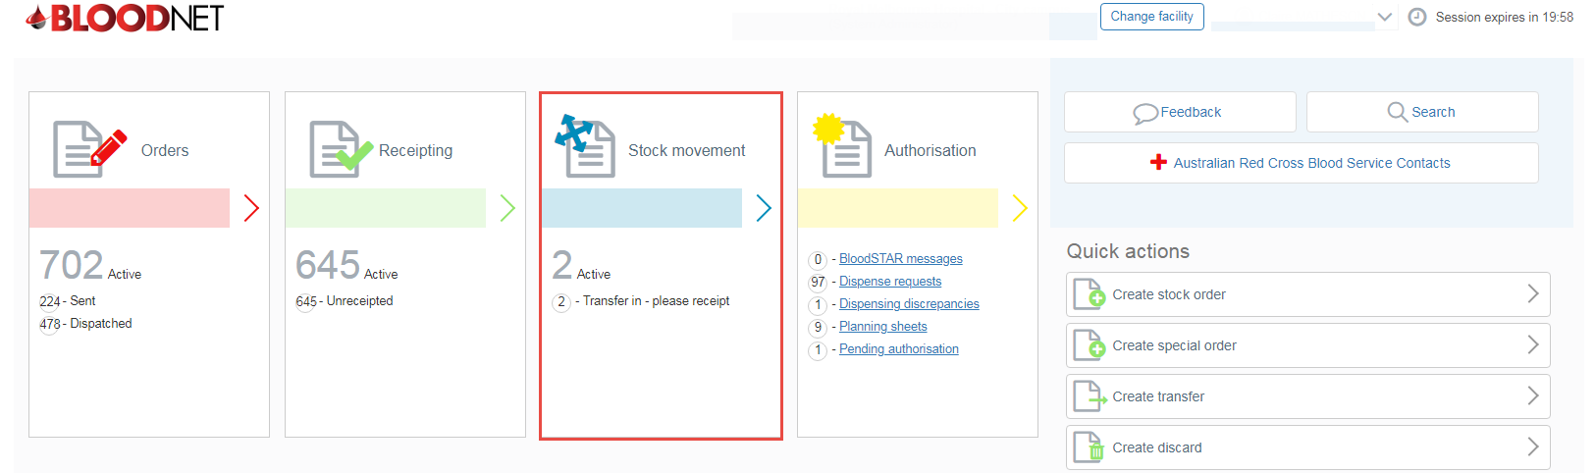

- From the Stock movement dashboard click on the Create discard button.

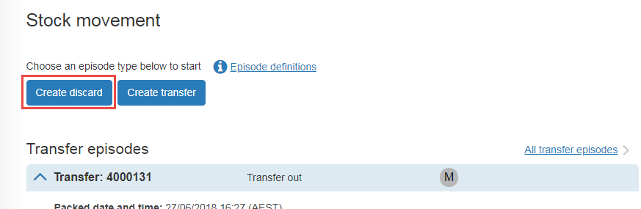
- On the ‘New discard episode‘ screen scan/enter the donation or lot number into the Donation/Lot number field, specify the quantity and click on the Add Item button. You can add multiple products to a single discard episode.
- Select the location and reason for the discard from the drop down menus.
- Click the Save discard episode button to finalise the episode.

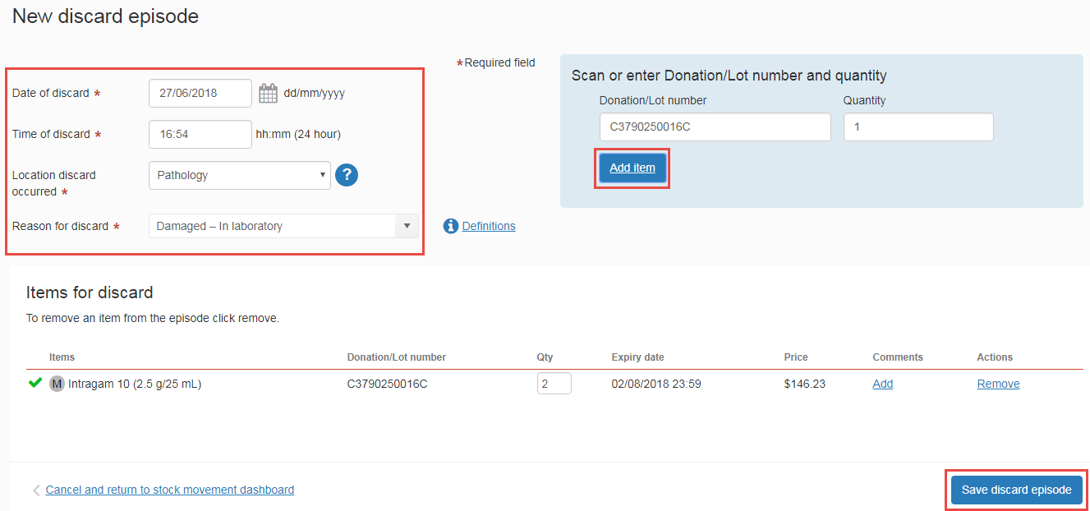
- You will be directed back to the Stock Movement dashboard where you will see a green dialogue box at the top of your screen with the discard confirmation. The discard episode with appear at the top of the Recent discard episodes list. You can view the details of the episode by clicking on the Discard number or edit it (add or remove items) by clicking on the Edit button. Please note: The Edit link is only visible for Facility Administrators.
