The Orders Dashboard

The Orders Dashboard provides BloodNet users with an overview of their most recent active, finalised and cancelled orders as well as access to various order related functions including the Create stock order and Create Special order functions.
The Orders Dashboard can be located by clicking the Orders tile located towards the top left of the homepage. You will notice that the Orders tile lists the number of active orders at your facility. Active orders are orders that have been sent and/or dispatched but not yet receipted and finalised.

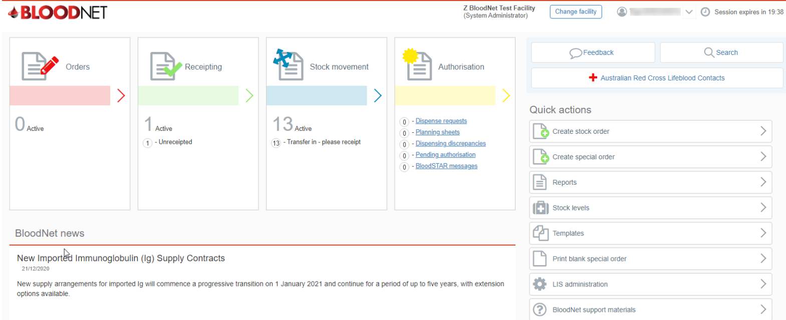

The Orders Dashboard has 5 main headings; Orders, Active orders, Recent finalised orders, Recent cancelled orders and Quick search.

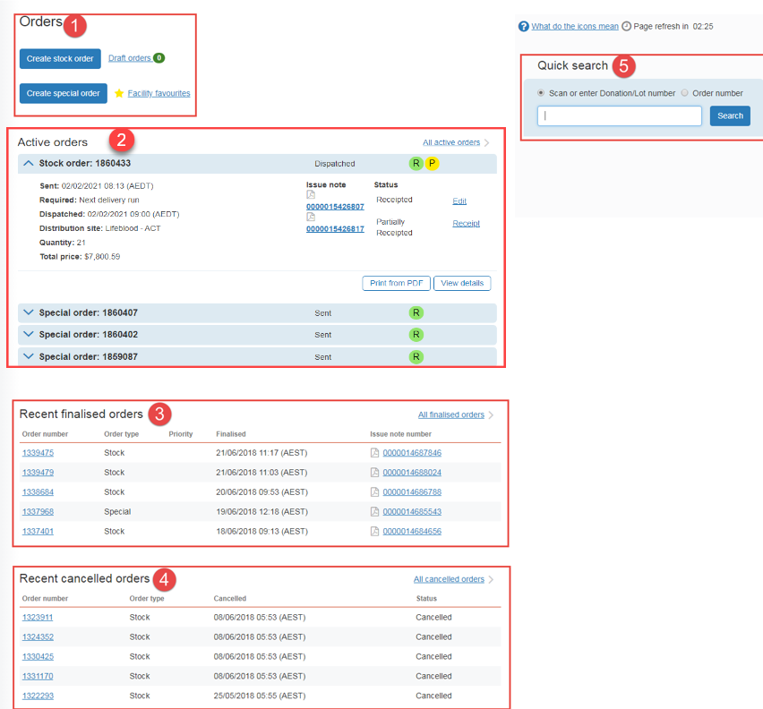

- Orders
This section provides links to create stock or special orders, locate Draft Orders and orders that have been saved as Facility favourites (if any).
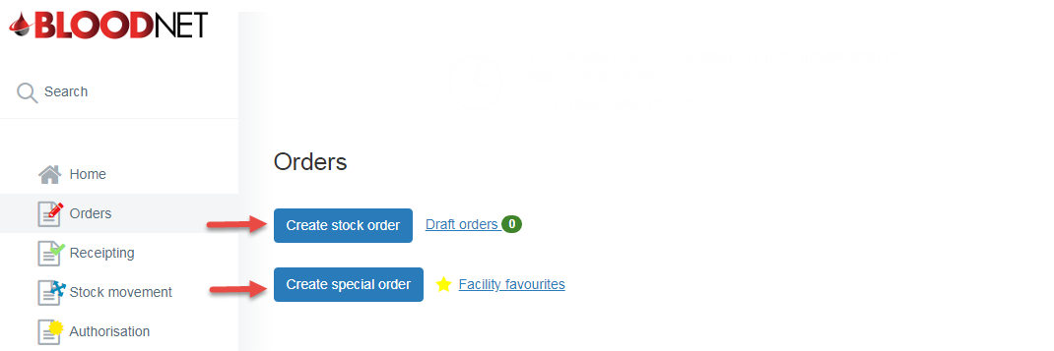

- Active Orders
This section displays up to 20 orders that have been sent but not finalised / receipted in BloodNet.
- Active orders have the status of Sent, Sent (Awaiting confirmation), Sent (Failed) and Dispatched.
- The latest order is displayed by default in an expanded view.
- Each of the orders can be expanded by clicking the drop down arrow or the order number.
- The expanded view shows options to Cancel, Print or View additional details of the order.
- The Add to facility favourites option is available for special orders and only if the special order has not been previously added to facility favourites.

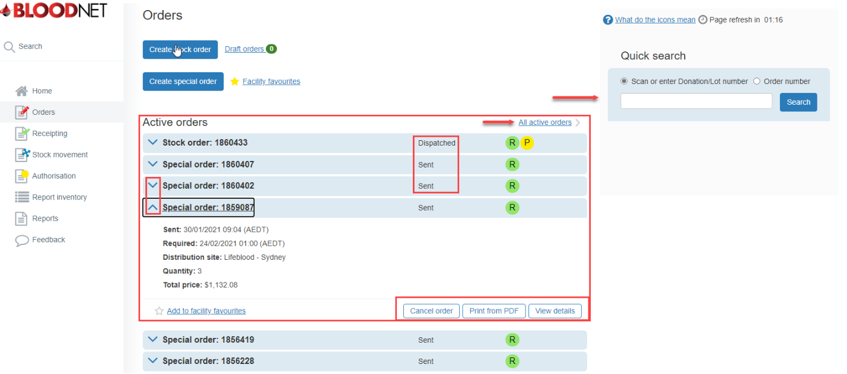

- Recent finalised orders
This section displays up to five of the most recent finalised orders. More information for a particular order can be viewed by clicking on the Order Number link.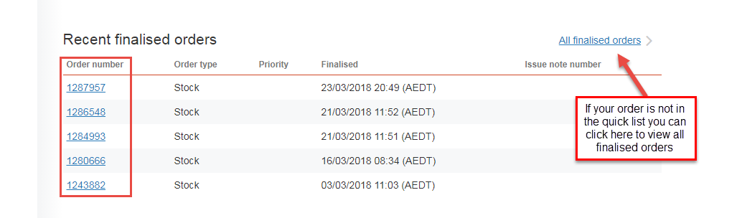

- Recent Cancelled Orders
This section displays up to five of the most recent Cancelled Orders. More information for a particular order can be viewed by clicking on the Order Number link.
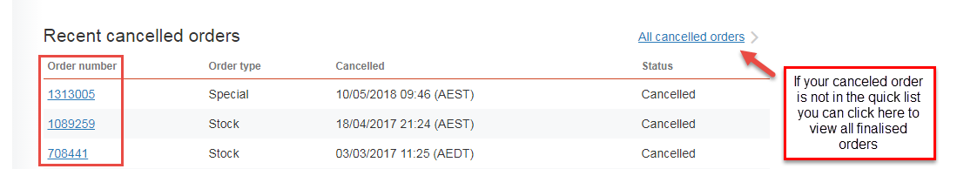

- Quick search
The quick search box allows users to search for a donation/lot number or order number and perform various functions such as viewing an order or receipting a product directly from the dashboard. The search options are displayed as radio button options, where donation/lot number is the defaulted selection.

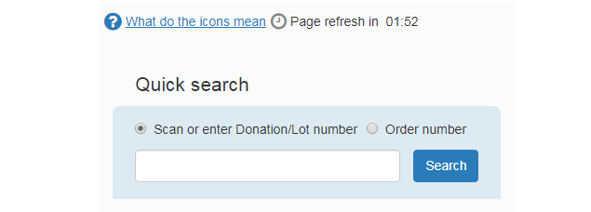
You can hover over ‘what do the icons mean’ for a breakdown of the product/components icons.

Overdue receipting notification
Finally, if your facility has issue notes that have note been receipted within 72 hour the system will display a notifaction of the outstanding issue notes at the top of the dashboard. Users can click on the issue note link to go to the Receipt issue note page and receipt the issue note which will remove the issue note from the notification.

