Actioning Unmatched Episodes
(BloodNet/BloodSTAR LIS enabled facilities only)

Unmatched episodes are created when a dispense or return to stock episode entered in a Laboratory Information System (LIS) cannot be accurately matched to an authorised patient’s planned dose in BloodSTAR. This can be caused by spelling errors with the patient’s name in BloodSTAR, a mismatch between the URN/MRN recorded in LIS and BloodSTAR, the episode details (product, dose or frequency) could be different to what is approved on the authorisation or a combination of these causes.
Unmatched episodes are also created if an episode for a patient is approved under a Jurisdictional Direct Order (JDO) or other supply arrangements and it must also be actioned. Please note: Only imported products are available under JDO or other supply arrangements.
Unmatched episodes must be actioned in BloodNet promptly to ensure patients’ treatment plans are up to date and reflect patients are receiving treatment within the constraints of their authorisation.
To action unmatched episodes in BloodNet please take the following steps:

- Click on the Authorisation tile from your BloodNet home page.
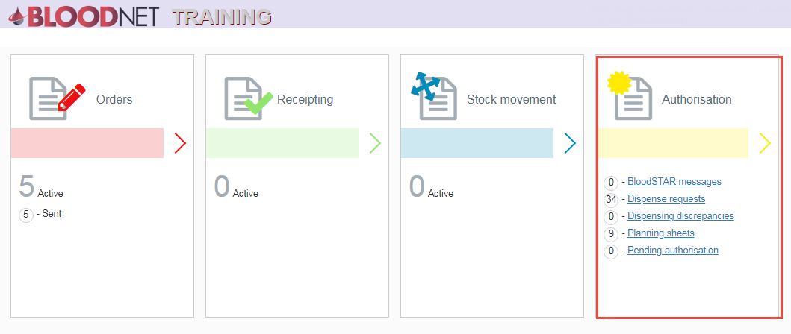

- Click on the Unmatched episodes link.
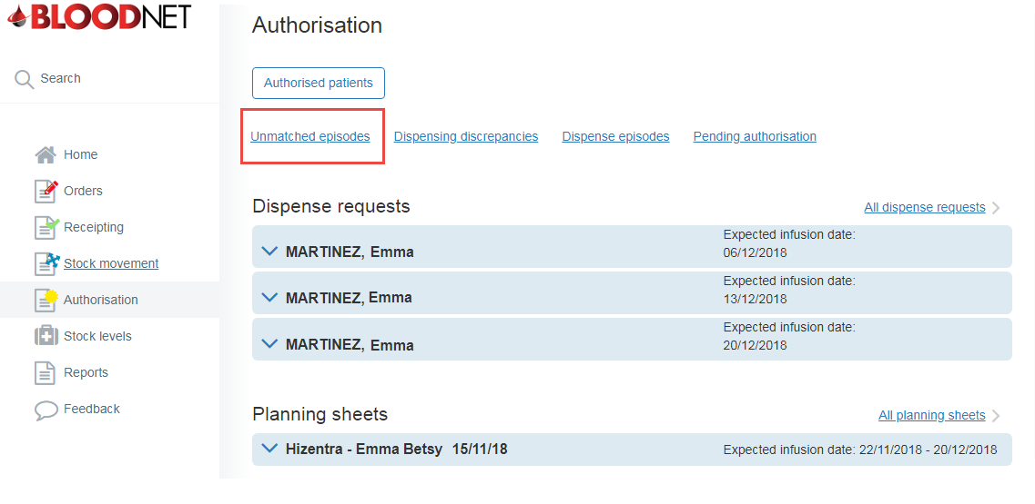

A list of all unmatched episodes is displayed with the options to View, Find and Resolve. Any resulting episodes with potential matches will have a green tick listed in the Potential matches identified column.

Clicking View will display the specific Dispense Episode number and all its details. When finished viewing, click Back to unmatched episodes to return to the Unmatched episodes screen.
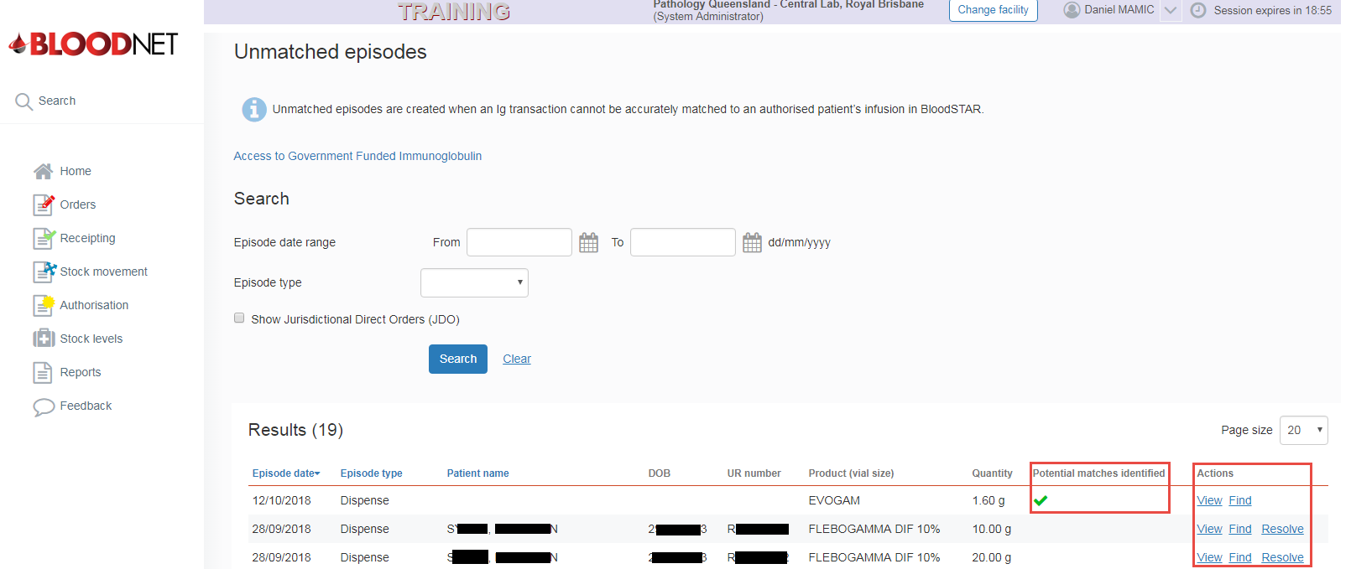

- If you are able to locate the matching patient/dose click Find to be taken to the Find patient to match screen.

- If the unmatched episode is a JDO, click Resolve and then Yes on the Confirmation screen to confirm. This will mark the episode as a JDO and complete Episode Matching.
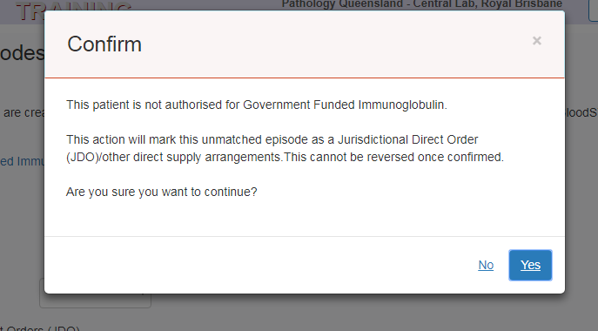

- For unmatched episodes authorised in BloodSTAR click Find to be taken to the Find patient to match page to initiate the matching process. LIS episodes, search details and Potential Matches (if any) will be displayed.

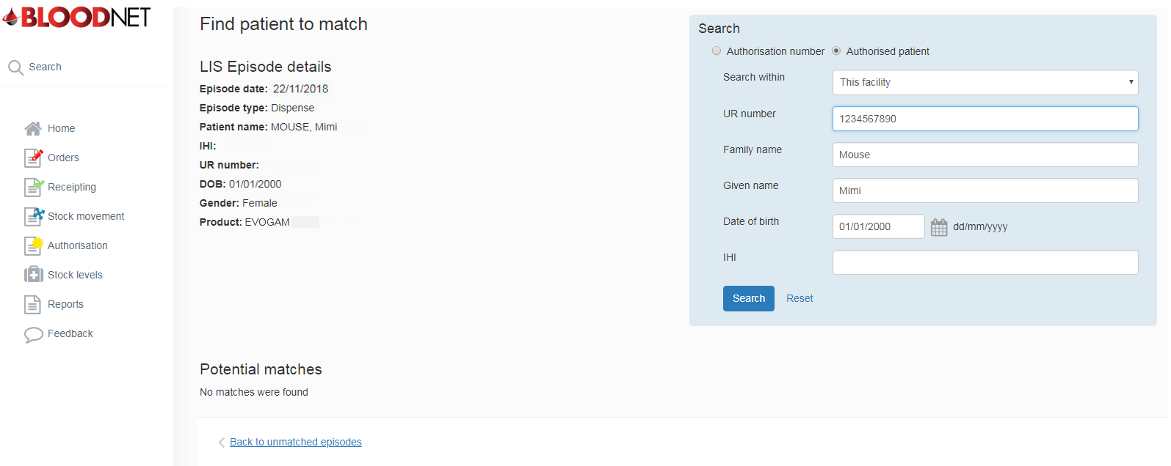
If, after the initial Find search, no matches are found, you can keep broadening the search until successful. One example is to try again by removing one of the patient identifiers (i.e. URN) in the search box in the top right of the screen as an example.

- If the system is able to locate a potential matching patient/dose the LIS Episode details screen will appear. To match the episode with the Potential Matches identified click the Match link in the Action column on the right of the page.

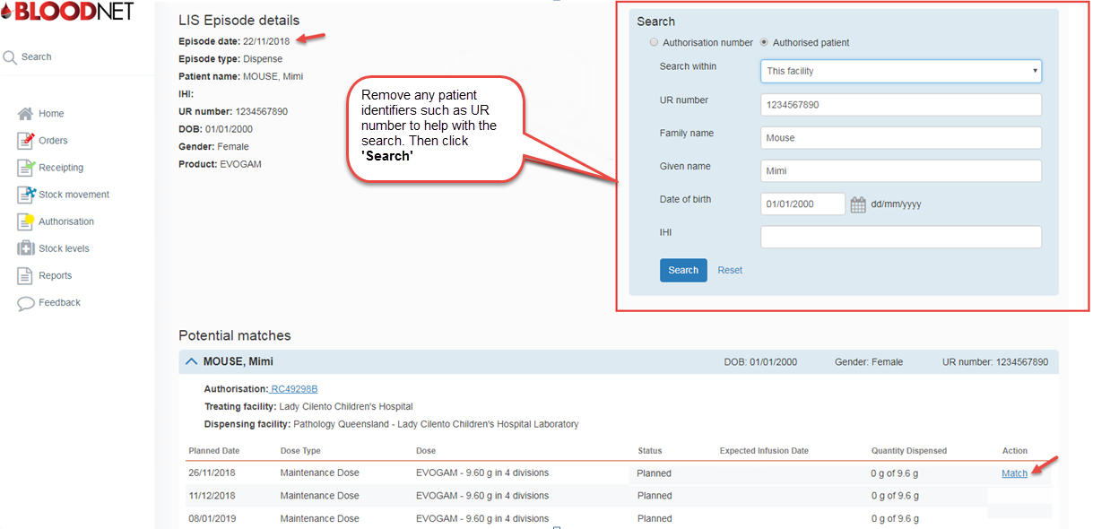

- A confirmation box will appear and the episode will be removed from the Unmatched episodes page.
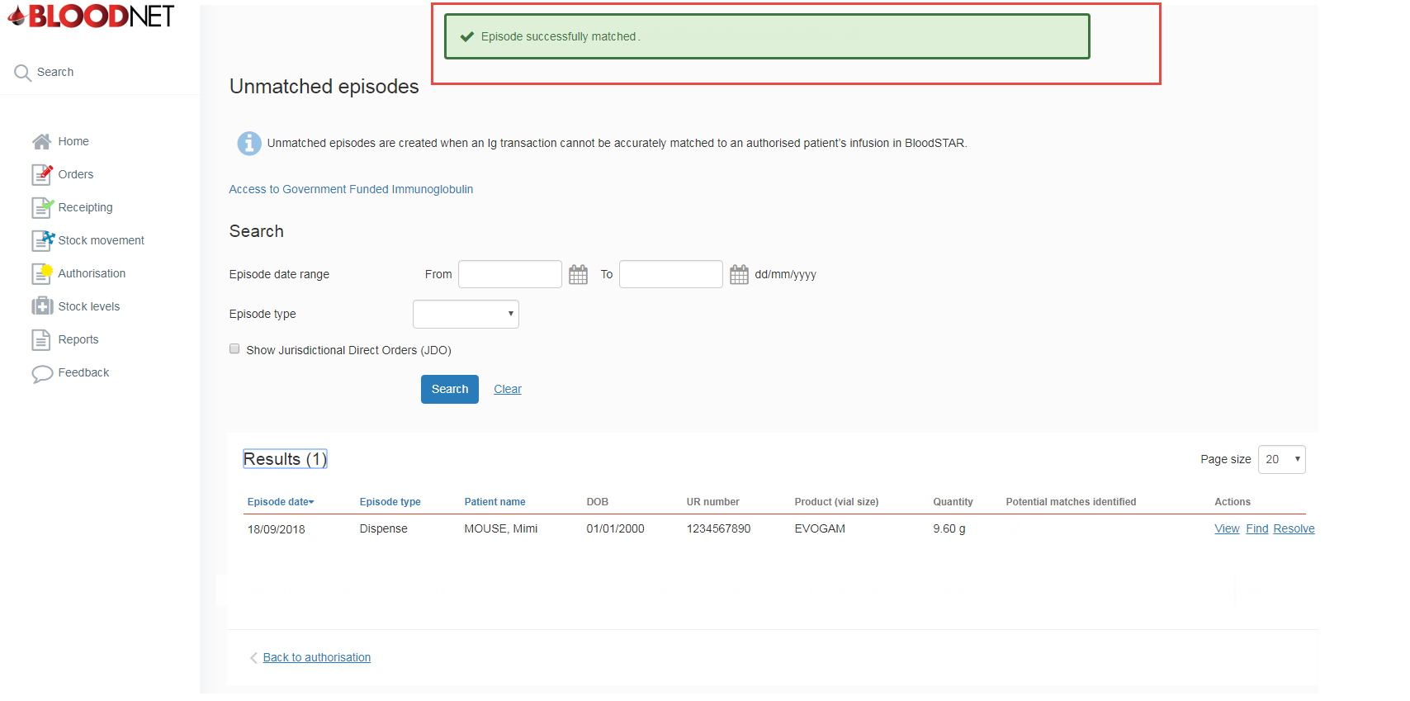

Please Note: In the unlikely event you exhaust all options and there are no potential matches, please contact NBA Support for further advice.
Also, if there is a mismatch with a patient’s name or URN/MRN please ensure the patient’s details are updated in BloodNet/BloodSTAR. BloodNet Dispensers can update a patient’s name, gender, DOB and patient URN/MRN from the View authorisation page in BloodNet.
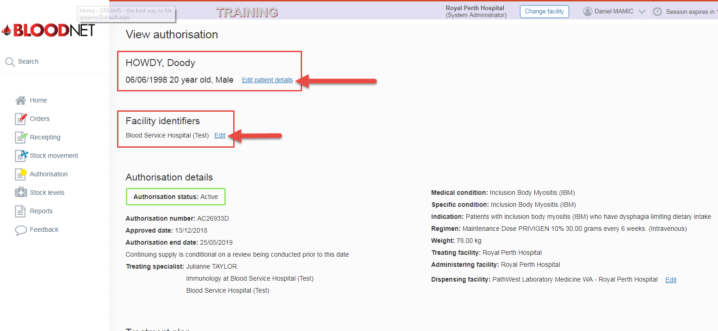
Importantly, updating the patient’s details will ensure future episodes are automatically matched to the patient’s authorisation.

