Create a Transfer Episode
Transfer episodes should be created when a product is moved to or from your facility.
- To access the transfer module, click on the Stock movement tile from the home page.
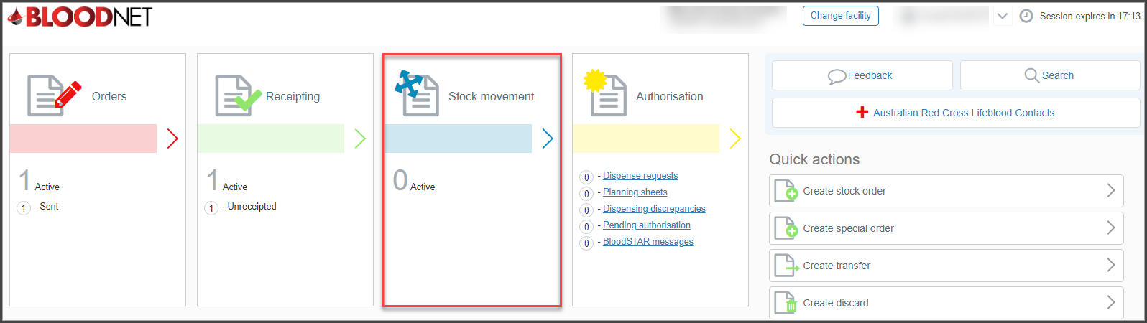

- From the Stock movement dashboard click on the Create transfer button.

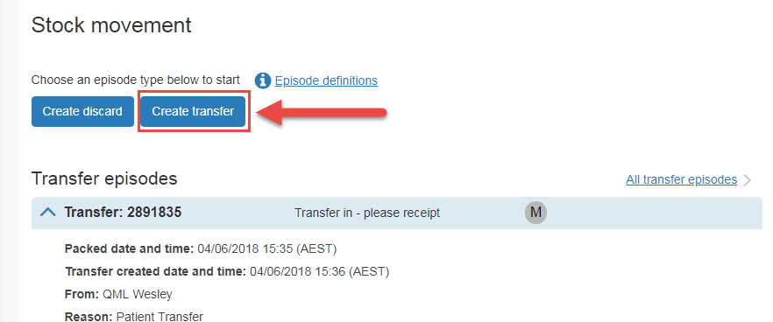

- On the New transfer episode screen choose either to transfer From my facility or To my facility.
- Select the sending or receiving facility.
- Enter the date and time that the transfer was packed.
- Scan / enter the donation or lot number into the Donation/Lot number field, specify the quantity and click on the Add Item button. You can add multiple items to a single transfer episode.
- Once all items have been added click the Save transfer episode button.

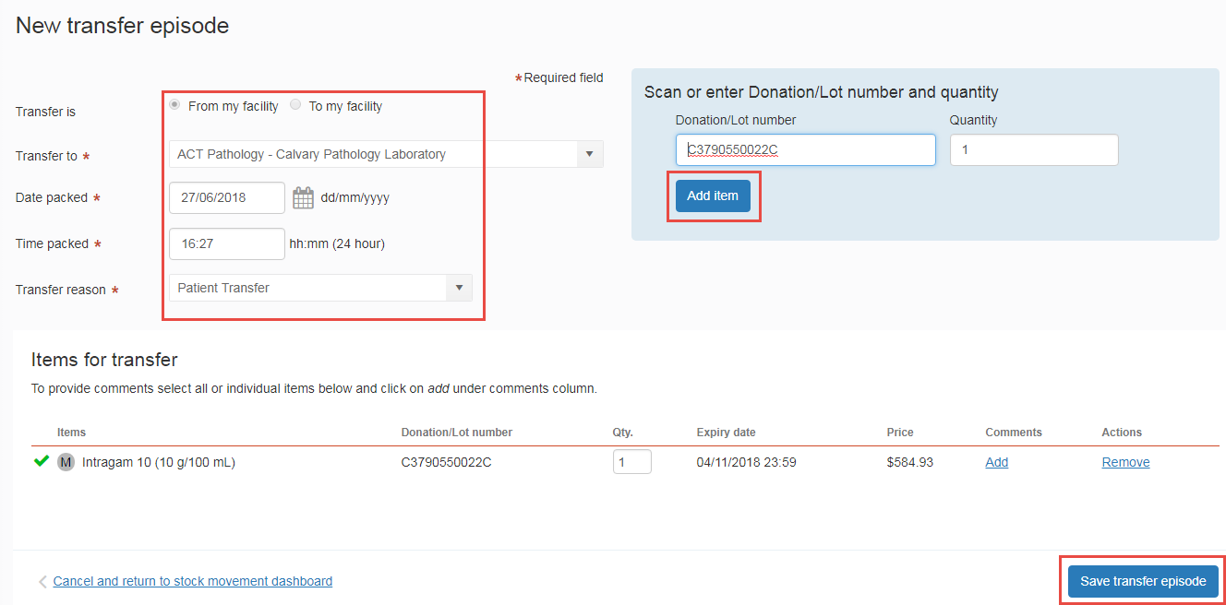

You will be directed back to the Stock Movement dashboard. You will see a green dialogue box at the top of your screen with the transfer confirmation. The new transfer episode with appear at the top of the Transfer episodes list in the expanded view. You can Print from PDF, View, Edit or Cancel the transfer episode.

