BloodSTAR Medical Officer Homepage
There are three parts to the BloodSTAR home page. These can be separated into the following sections:
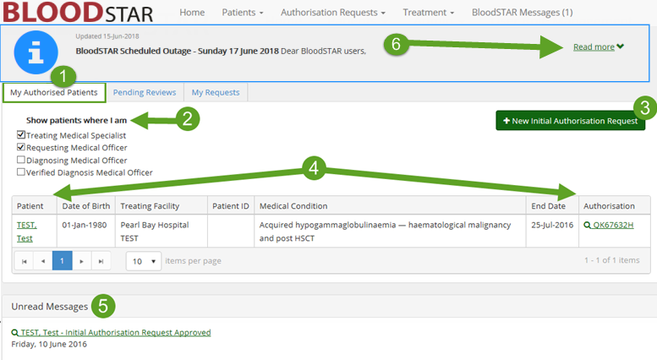

Homepage - My Authorised Patients
- My Authorised Patients Tab
This tab contains all your patients who have current and approved Immunoglobulin (Ig) Authorisations, for both Intravenous and Subcutaneous Ig. From here, you can enter into all current authorisations to check details or enter patient profiles.
- Patient Filter Options
Select from these options to filter your list of patients. Your options include listing only patients for whom you are the Treating or Requesting Medical Officer, which will be selected by default. You also have the additional options of seeing authorisations in which you diagnosed or verified the diagnosis of the patient.
- New Initial Authorisation Request
This button will open a new Initial Authorisation Request. This does not take you to a Continuing Authorisation Request, which must be actioned from an existing request in the Pending Reviews tab.
- Patient View
The Patient Display will list all current approved Ig Authorisations. Clicking on the name of the patient will take you to view their patient record where you can edit any entered details, while clicking on the Authorisation ID will take you to view the View Authorisation page for the current authorisation details.
- Unread Messages
This area will have a list of all your unread BloodSTAR messages, as well as their subjects, and will list five messages before creating a second message tab. The messages can be accessed by clicking on the subject or by choosing BloodSTAR Messages from the headings at the top of the page, and will remain until they are
read or, if necessary, actioned.

- BloodSTAR Messages
This area will display all BloodSTAR system messages, such as outages. Click on the “Read More” to expand the message for more information.

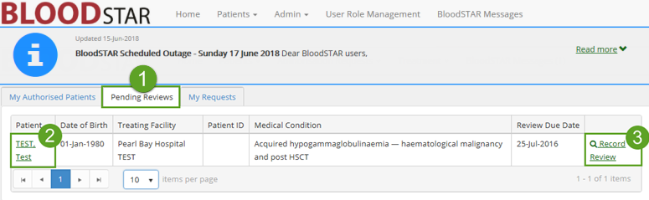

Pending Reviews
- Pending Reviews Tab
The Pending Reviews tab will display all authorisations which are scheduled for review within 8 weeks, or whose review period has been exceeded by less than 8 weeks.
- View Patient
Clicking the patient’s name will take you to View/Edit Patient to the patient’s profile as entered in-system.
- Record Review
Record Review will take you to a page to enter the results of the patient’s review, allowing you to perform a continuing authorisation request or to conclude the patient’s treatment period.
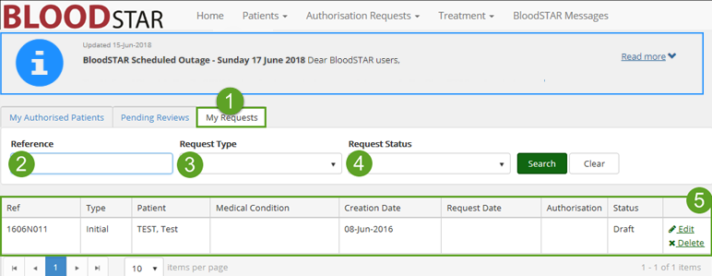

My Requests
- My Requests Tab
The My Requests tab will display all authorisations for which you are/have been responsible. It is also the page from which you can edit, submit or delete draft authorisations, as well as recalling any submitted requests not currently under review by an Authoriser.
- Reference ID Search
Enter the Authorisation ID of the desired authorisation here to quickly bring up the relevant record.

- Request Type
To limit the visible authorisation requests by type, you can select from the options in this list.
- Request Status
To view only requests of a certain status, select from the options here to refine your list.
- Patient View
This display will list the basic details of all patients you currently have authorisation requests created against, and the status of those requests. For draft requests, this pane will show the Edit and Delete functions. For requests of all other statuses, only the View button will be visible.

