In This Issue:
- User Registration – Open Now!
- Important process changes at BloodSTAR go live
- Training for BloodSTAR
- What action is required now?
- What is happening next?

User Registration – Open Now!
Prescribers and nurses who manage patients receiving Immunoglobulin (Ig) products must register before their State/Territory go live date.
Registering now will help to make the transition and go live of BloodSTAR as smooth as possible.
If you are a Treating Medical Specialist your currently authorised patients will be entered into BloodSTAR for you if:
- you register at least 8 weeks prior to your State/Territory go live for BloodSTAR,
- your patients have provided BloodSTAR consent (and a copy has been provided to the Australian Red Cross Blood Service)
- your patients have authorisation beyond the go live date, and
- the treating facility is registered for BloodSTAR.
*Prescribers and Nurses working in NSW Health facilities do not need to register at this time.

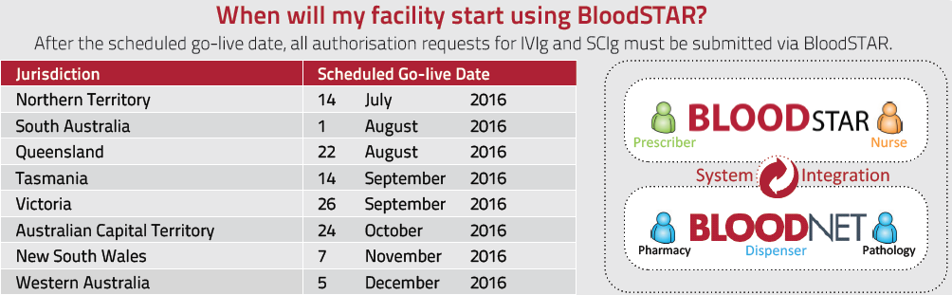

How do I register for BloodSTAR?
Registering is a two-step process:
- Login to BloodPortal or create a BloodPortal account by clicking on New User? Create an account at https://portal.blood.gov.au.
- Click on the BloodSTAR tile, Request Role, enter in your information, Save, accept the terms and conditions and Submit. (Complete step 2 for each facility at which you work)
For detailed tip sheets on how to register as a future user of BloodSTAR go to https://www.blood.gov.au/system/files/BloodSTAR-User-Tip-Sheet-Registration%20-and-Role-Requests.pdf. For any questions or support while registering contact the NBA Support team on 13 000 BLOOD (13 000 25663) or support@blood.gov.au.

Important process changes at BloodSTAR go live
There will be process change requirements at go live of BloodSTAR that users must be aware of and implement. These will be outlined in detail before go live. Some key changes include:
- Review Letter from the Blood Service – will no longer be provided to treating medical specialists as a reminder of the patients ending Ig authorisation. A patient’s authorisation to receive Ig will cease on the authorisation end date, as detailed within their BloodSTAR record, unless their treating clinician records review outcomes for the patient and submits an authorisation request for continuing treatment to the Australian Red Cross Blood Service (Blood Service) authorisers via BloodSTAR. Treating clinicians will be notified by email of their patient’s approaching authorisation end date and the requirement to submit review outcomes in BloodSTAR at 8 and 4 weeks before, on the authorisation end date and 2 weeks after expiry.

- Paper based Ig authorisation requests - from a State/Territory go live date onwards, paper based requests will not be accepted for new, continuing, or changes to existing authorisation requests. If a paper based form is submitted to the Blood Service, the person who submitted the form will be contacted and instructed how to submit that information via BloodSTAR.

- Dose change request - if a patient with ongoing authorisation requires an increase in their Ig dose, a prescriber must submit a dose change request for that patient via BloodSTAR for authorisation by the Blood Service. This functionality will be available for all patients with a current authorisation.

Training for BloodSTAR
The BloodSTAR Transition team will be traveling to each State/Territory twice before your go live date.
The training will consist of:

- BloodSTAR Demonstration will be 2 hour sessions open to all key stakeholders to give an overview of the system and discuss key business changes that will need to be addressed before the go live date.
- BloodSTAR Go Live Training will be multiple 2 hours sessions, with each session specifically open for one stakeholder group: prescribers, nurses or dispensers. These sessions will go through the system in depth and discuss the functionality available from go live date onwards.
Current confirmed schedule:
South Australia Demonstration – 16 May 2016 Queensland Demonstration – 23 to 26 May
Northern Territory Go Live Training – 20 to 22 June South Australia Go Live Training – 4 to 6 July
Queensland Go Live Training – 25 to 27 July
The NBA is continuing to work with all jurisdictions to set up and finalise dates for BloodSTAR demonstrations and training and we will communicate these via our website and email as details become available. If you are interested in BloodSTAR training or would like to find out more detail about the current schedule please contact the NBA on 13 000 BLOOD (13 000 25663) or support@blood.gov.au.

What action is required now?
- Facility registration for BloodSTAR and set up of facility administrators is required now!
If you are a prescriber of IVIg or SCIg or a nurse who manages patients receiving IVIg or SCIg you must also register now for BloodSTAR.

Details available at https://www.blood.gov.au/bloodstar-support-materials.

The BloodSTAR User Support Materials page has more information on;
- How to register
- How to approve or reject a user, as a facility administrator
- Tip sheets on what BloodSTAR will mean to prescribers, nurses and dispensers
- Videos demonstrating;
  - An Initial Authorisation request
  - Reviewing user access requests
The BloodSTAR user support materials page will be continuously updated with more tip sheets and information so refer back to this page as your State/Territory go live date becomes closer, https://www.blood.gov.au/bloodstar-support-materials.
Facility Administrators must keep up to date with user registrations before BloodSTAR go live. This is particularly important for treating clinicians with currently authorised patients. The Blood Service cannot enter patients into BloodSTAR prior to go live unless the clinician has registered for BloodSTAR AND they have been approved by the relevant facility administrator. For more information on how to approve or reject user requests, please refer to either the tip sheet or video available at https://www.blood.gov.au/bloodstar-support-materials.

What is happening next?
Follow up on Facility Administrators
Thank you to all those facilities that have registered and nominated their facility administrators.
In order to support user registration, the NBA has entered into BloodSTAR the details of those facilities that have received Ig product in the last 12 months but have NOT yet self-registered. It is important to note, however, that until each of these facilities nominates at least one facility administrator, staff working within the facilities will not be able to be granted access to the system.
The NBA will be following up with all facilities without facility administrators to ensure they register at least one facility administrator well before their State/Territory go live.
Confirmation of Patients with Current Authorisation for Entry into BloodSTAR
If you are the treating clinician of patients who have authorisation to receive Ig beyond your State/Territory go live date, the Blood Service will be writing to you to request confirmation of your patients’ details for entry into BloodSTAR and to advise, for each patient, whether the Blood Service has a copy of the patients’ BloodSTAR consent on file or that a copy needs to be provided. To avoid unnecessary interruption to your patients’ Ig treatment during the BloodSTAR go live period, please take the time to carefully review the contents of the Blood Service letter, complete the required information and return it to the Blood Service by the requested date.
Reminders and To-Do-Lists
- User registrations must be completed now so you are ready for your State/Territory go live.
- Be familiar with the changes relevant to you – read the documents and action the check list for your role. Documents available for:
Prescribers - https://www.blood.gov.au/system/files/documents/im-a-Prescriber-What-does-BloodSTAR-mean-for-me.pdf.
Nurses - https://www.blood.gov.au/system/files/documents/im-a-Nurse-What-does-BloodSTAR-mean-for-me.pdf.
Dispensers - https://www.blood.gov.au/system/files/documents/im-a-Dispenser-What-does-BloodSTAR-mean-for-me.pdf
- Sign up for this newsletter - create a BloodPortal account at https://portal.blood.gov.au and from the home page click on ‘My Subscriptions’ and ‘Subscribe’ to Immunoglobulin.
Further information on BloodSTAR is available online at http://www.blood.gov.au/bloodstar or by contacting the NBA on 13 000 BLOOD (13 000 25663) or support@blood.gov.au.

