User Tip Sheet – Medical Officer and Nurse/Midwife roles

User Registration and Role Request

BloodSTAR User Registration is a two part process comprised of:
- BloodPortal User Registration – Creating a single username and password for all NBA systems, and
- BloodSTAR Role Request – Requesting a role and location for access to your facility

If you require your login credentials for an existing BloodPortal account please click Forgot Username?, Forgot password?, or contact NBA Support.
1. Go to www.blood.gov.au and click on Blood Portal at the top right of your screen. You may wish to bookmark this page.
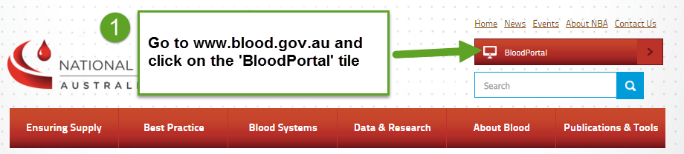
2. Login with your BloodPortal Username and Password. If you do not have an account already, please select the New User? Create an account link below the Sign in button.
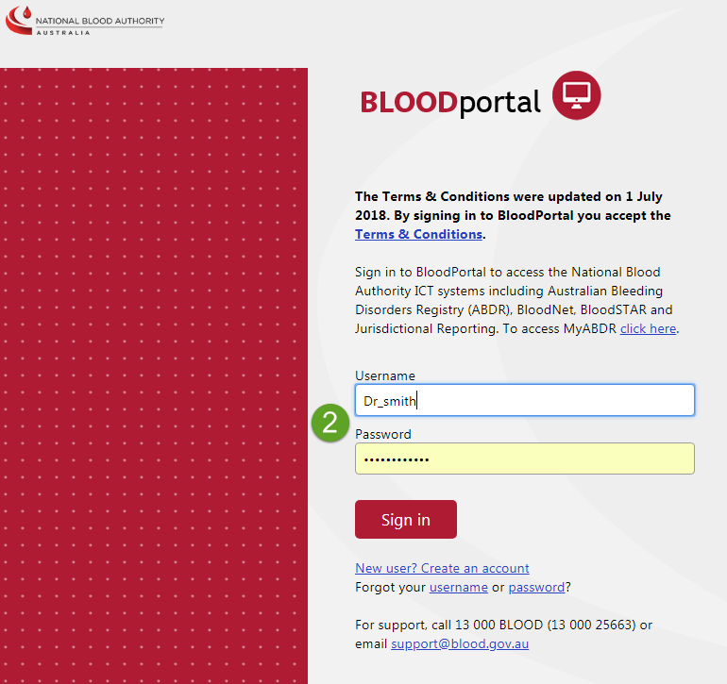

If you are creating a new account, please remember:
- You only need one BloodPortal account (covering all NBA systems) – if you practice in multiple locations, you can apply for access to specific applications at multiple locations using the one BloodPortal account.
- Your mobile phone number and email address are used for automated password resets and must be unique.
- If you are unable to register using your preferred email or mobile number it may be because you have an existing BloodPortal account. Please call Support for a password reset
3. Click on the BloodSTAR tile.
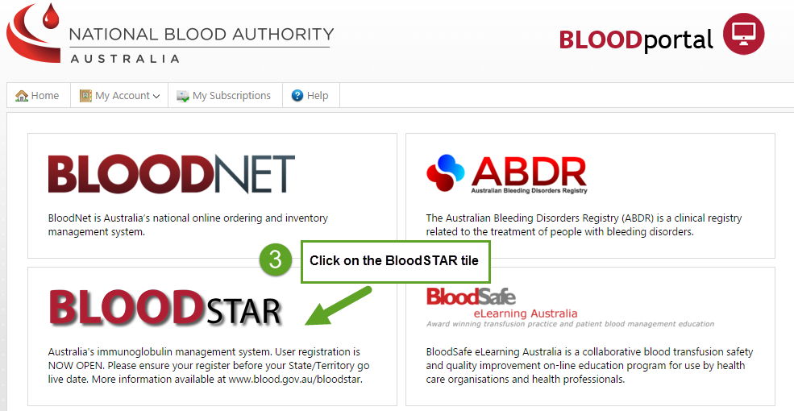

4. Click on Request Additional Access from the My Account drop-down menu.
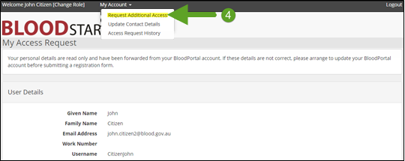

5. Click the Add role to Access Request button and complete all of the mandatory fields of the form. Click the Save button.
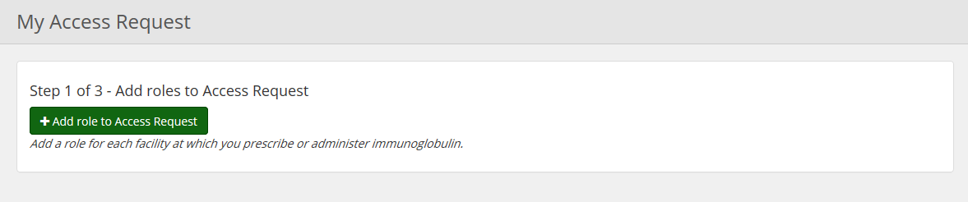
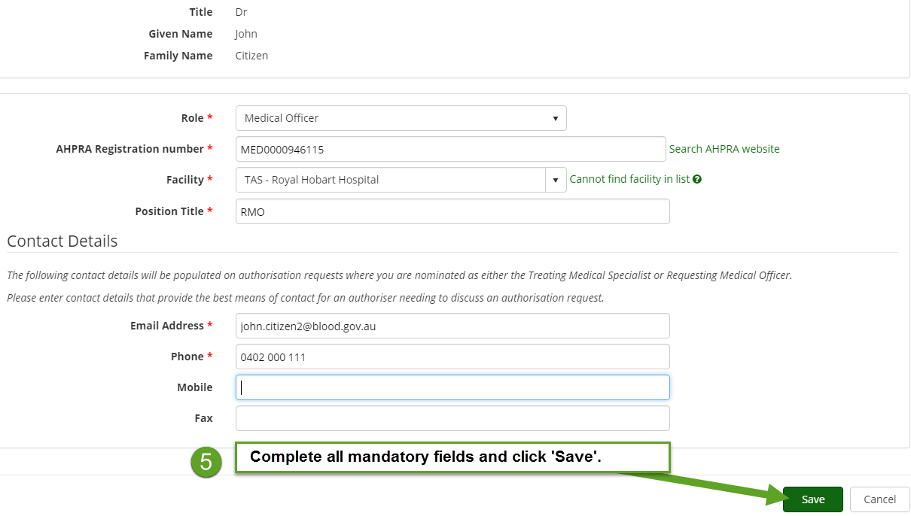
Important Note for users who work at multiple locations:
- If you work at more than one facility, you can repeat the steps above for each location you require access to.

6. Step 2 of 3 will appear. Click the green button to view the terms and conditions. If you agree to the terms and conditions click the Accept button. Please note, if you do not agree to the terms and conditions you will not be able to progress any further with your access request.

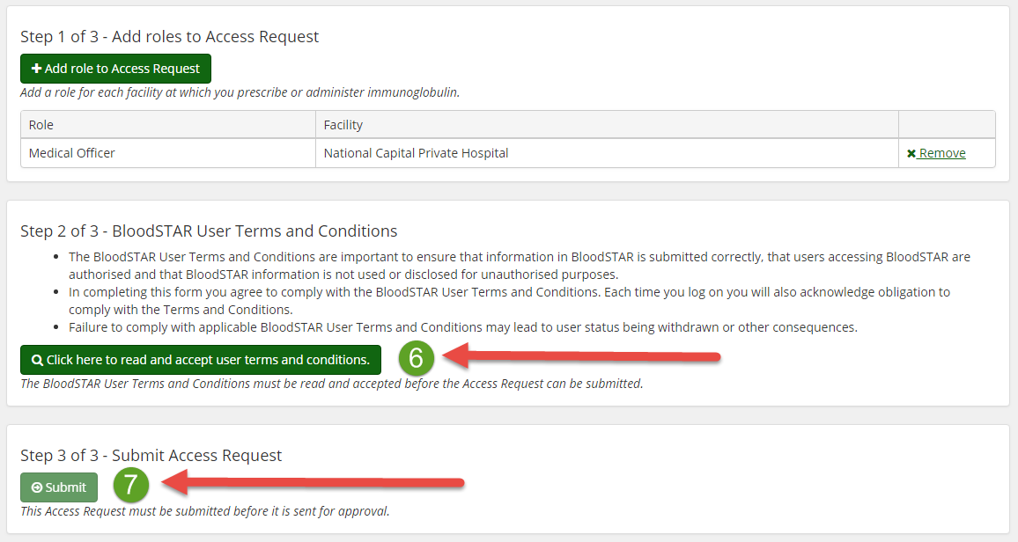
7. Click the Submit button.
8. The Access Request is now complete pending the approval of your Facility Administrator. You will receive an email when your request has been approved.
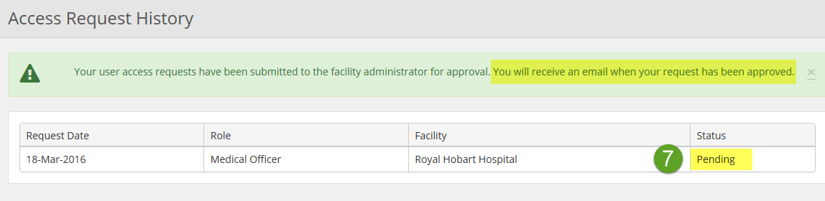
Note: If you are unable to follow up your request with your Facility Administrator, please call Support on 13 000 BLOOD (13 000 25663) for assistance with this process.

