Submitting Immunoglobulin Authorisation Requests while Access to your Facility is Pending
Medical Officers can gain provisional access to BloodSTAR for 14 days while awaiting approval of their full access.

Provisional access will allow users to complete the following functions only:
  - Complete and submit New Initial Authorisation requests.
  - Recall, Edit and resubmit New Initial Authorisation requests.
  - View probable matches when completing a patient search to reduce the chance of creating a duplicate record.

Please Note: you will not be able to see all patients at your facility, as that access is restricted to approved users. However, you can view any patients for whom you are listed as the Requesting or Treating Medical Officer at other facilities.
Your provisional access will be removed after 14 days if not approved by the facility administrator.

For details on how to request access please see the Tip Sheet BloodSTAR Registration and Role Request https://www.blood.gov.au/bloodstar-support-materials .

Submitting a New Initial Authorisation Request while access to your facility is pending
- No other role in BloodSTAR
- Once your access request has been submitted, you will be taken to the Access Request History page where you will see information regarding your access request and a link to New Initial Authorisation Request
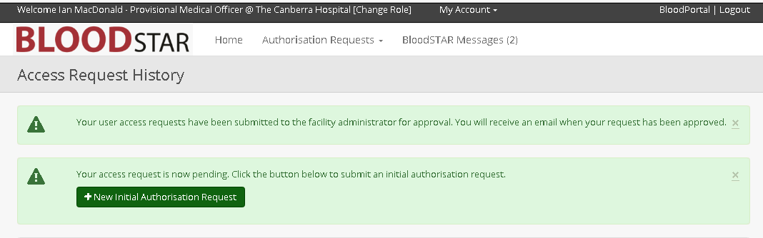

- Click on the New Initial Authorisation Request button.
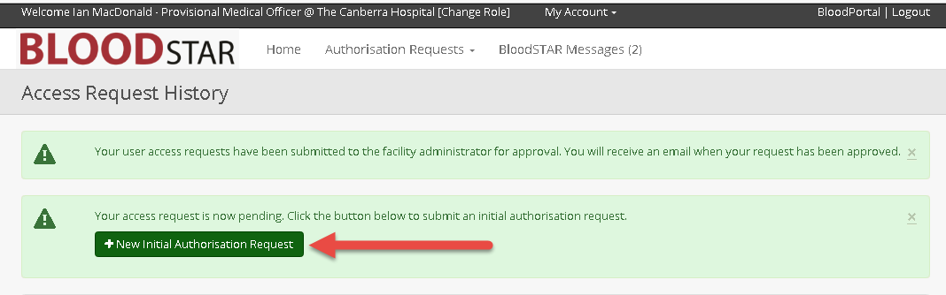
- You will then be navigated to a New Initial Authorisation Request form, which you will be able to complete and submit as per the normal process. For more details on submitting an Initial Authorisation Request, see the BloodSTAR - Initial Authorisation Request Tipsheet at https://www.blood.gov.au/medical-officer.
Please Note: You can submit an emergency, serious or standard authorisation request. Emergency requests will be assessed within two hours, Serious within one business day and Standard within two business days. Authorisation requests that have a status of ‘Emergency’ must be accompanied by a call to your State/Territory Authorisers.

To edit, recall and resubmit initial authorisation requests, see our Tipsheet Recalling and/or Resubmitting an Authorisation Request at https://www.blood.gov.au/medical-officer
B. Already have another role in BloodSTAR
- Once your new access request has been submitted, you will need to navigate to the home page by clicking on Home.

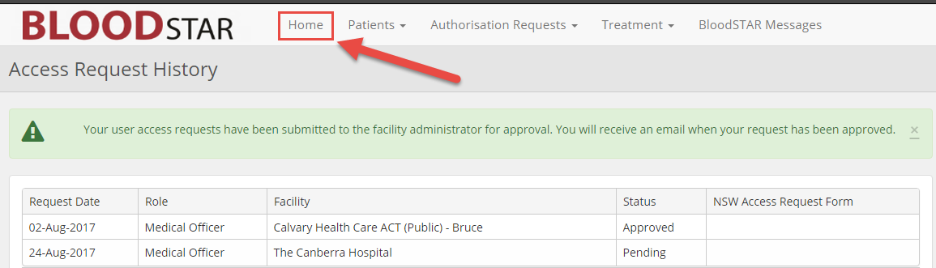

- You will see and be able to select the role or facility you want.

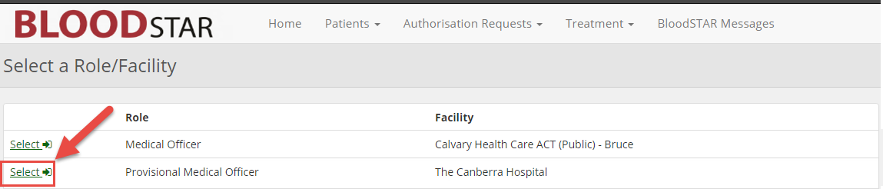

- You can then start your initial authorisation request by clicking the Authorisation Requests tab then
New Initial Authorisation Request

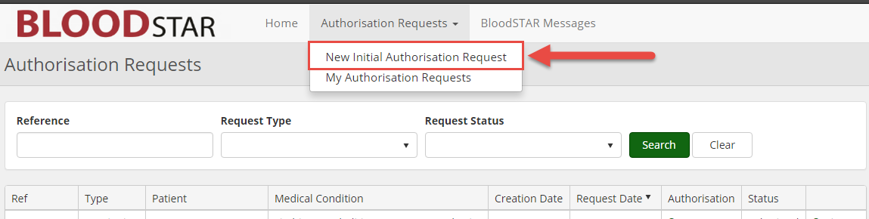

- A warning will appear, specifying that you have only been granted a 14 day provisional access until
approved by the facility administrator. During this time you can:
a. complete and submit your initial authorisation requests,
b. edit, recall and resubmit initial authorisation requests, if required

- You will then be navigated to a new Initial Authorisation Request, which you will be able to complete
and submit as per the normal process. For more details on submitting an Initial Authorisation
Request, see our Tipsheet at https://www.blood.gov.au/medical-officer.

Please Note: You can submit an emergency, serious or standard authorisation request. Emergency requests will be assessed within two hours, Serious within one business day and Standard within two business days. Authorisation requests that have a status of ‘Emergency’ must be accompanied by a call to your State/Territory Authorisers.
To edit, recall and resubmit initial authorisation requests, see our Tipsheet Recalling and/or Resubmitting an Authorisation Request at https://www.blood.gov.au/medical-officer.

