Submitting Review Outcomes and Creating a Continuing Authorisation Request
Once an approved Immunoglobulin (Ig) Authorisation is nearing or has just exceeded its expiry date, BloodSTAR will notify Medical Officers involved with the authorisation and prompt them to submit review outcomes and will provide the option to submit a Continuing Authorisation Request.

Recording Review Outcomes
There are two ways of recording patient review outcomes.
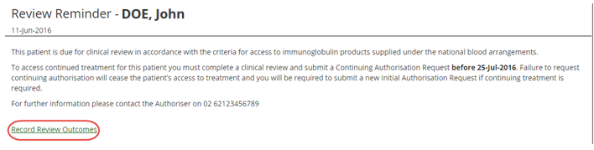
- Option one: click on the link in your emailed notification and you will be automatically directed to the relevant BloodSTAR message in the BloodSTAR Messages tab. Within that relevant message, click the link Record Review Outcomes at the bottom.
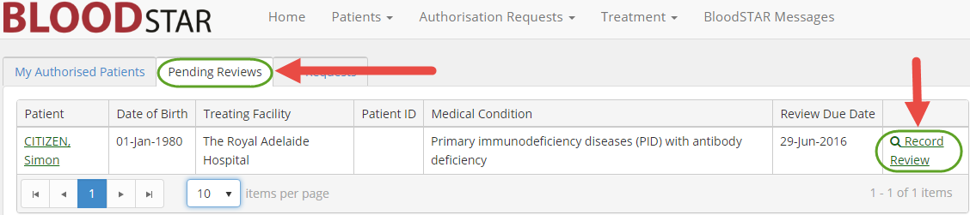
Option two: once you are logged in as a Medical Officer select the Pending Reviews tab. This will display all authorisations that require review in the next 8 weeks or those that have expired in the last 8 weeks. Locate the patient you want to record a review for and click Record Review.
- On the Review Outcome Form, confirm that all patient details are correct and, if necessary, change or update them by selecting Edit Patient Details.
- Scroll down, enter the review date and nominate the Reviewing Medical Officer.
- Under Review Criteria, select all applicable options for the Qualifying Criteria according to your patient’s condition and fill in all relevant Supporting Evidence details. These options are dependent on the original diagnosis and, if selected, will create fields for you to enter more information about the patient.
- In Review Outcome, select the overall review outcome from the available options, which can be broadly separated into two categories:
- Either of these options will prompt for the Ig Authorisation status to continue, either through putting in a request for a continuation of the patient’s current authorisation or the creation of a new authorisation request under a different indication.
- Any of these three options will end the current Ig Authorisation, either immediately or at the expiry date, and will not provide a Continuing Authorisation Request or immediately prompt a New Initial Authorisation request.
If you elect to end the current authorisation you will be prompted to enter a Cessation Date if it is to end immediately. Enter the date if earlier than the current authorisation end date and click Submit.
If you have chosen to seek authorisation under a different indication, click Submit and then begin a New Initial Authorisation.
Creating a Continuing Authorisation Request
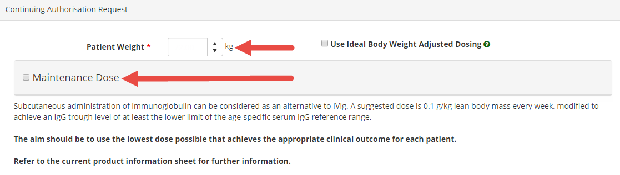
- If you selected Request Continuing Treatment under Review Outcomes, a section labelled Continuing Authorisation Request will appear. Enter your patient’s weight and the dosing regimen you would like to submit for authorisation.
- Once these details are entered, click the checkbox next to the Terms and Conditions and click Submit.

