**User Tip Sheet –Granting access to another Facility Administrator**

**Providing Access to Facility Administrators in BloodSTAR**

BloodSTAR Facility Administrators are designated staff members within each facility who approve BloodSTAR access requests for Medical Officers and Nurses.

**What is the Facility Administrators main role?**

* Approve access requests for Medical Officers and Nurses at your facility.
* Review and reject access for those who are no longer undertaking the Authorisation role.

**Important Point:** Before being able to grant any access a facility administrator must first collect the following details from the user;

* 1. the user’s BloodPortal username,
  2. the user’s position title, and
  3. the user’s best phone number.

**How to provide access to other Facility Administrators:**

* 1. Go to <https://www.bloodstar.blood.gov.au/> and Login with your BloodPortal Username and Password. Alternatively go to [www. blood.gov.au](http://www.bloodstar.blood.gov.au) and click on ‘Blood Portal’.

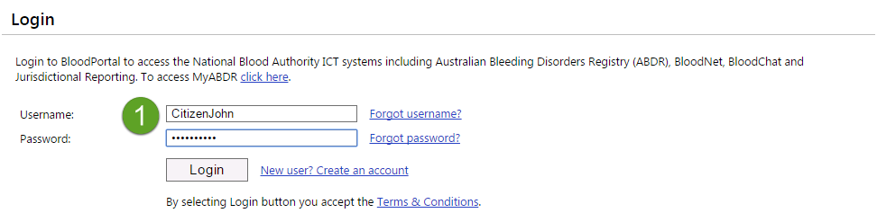

1. Go to change role at the top of the page and select ‘Facility Administrator – *Relevant facility name’* to enter the system as that role.

**Please note: the facility you choose must be the facility you are providing access to for the user.**

1. To provide any user with any level of access select ‘User Role Management’.
2. From the Role Management page select from the drop down list ‘Facility Administrator’ and click ‘Add Role’.

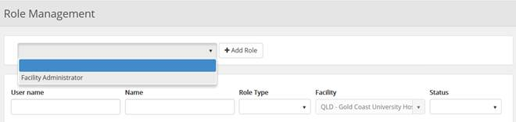

1. Enter in the user’s BloodPortal user name and click ‘Find’, this will return the information against that users registration.

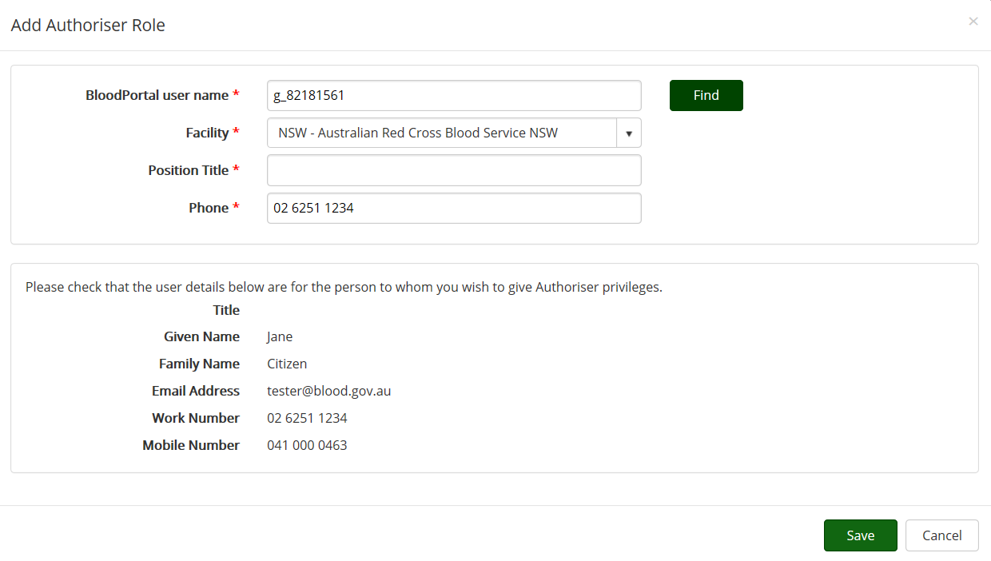

1. Check the returned information is correct, add in the user’s position title and check their contact number is correct from their returned BloodPortal registration details.
2. Click ‘Save’ and the user will have access as a facility administrator. They will receive an email notification to let them know they now have access in that role in BloodSTAR.

**Editing or Deactivate Access for an active user:**

1. Under the ‘User Role Management’ page filter to find the person you would like to view.
2. To deactivate the user click on ‘View’ next to the user’s name, you will be navigated to the View user role page, click on ‘Deactivate’ at the bottom of the screen.
3. To edit the user’s position title, email or phone number click on ‘Edit’ next to the user’s name, edit the relevant field and click ‘Save’.