Dispensing Subcutaneous Immunoglobulin (SCIg)
In the current version of BloodSTAR (version 2.1 – Aug 2016), all dosing is set up using an intravenous immunoglobulin (IVIg) model. To dispense SCIg, some additional action is required to ensure correct dosing is accurately represented.
The next BloodSTAR update (version 2.2), will introduce subcutaneous immunoglobulin (SCIg) dose modelling to simplify the process for managing SCIg patients.

To dispense multiple SCIg doses at once
- Most dispense requests for SCIg will come to the laboratory or pharmacy via a planning sheet. To action these select Planning Sheets from the Authorisation menu in BloodNet.
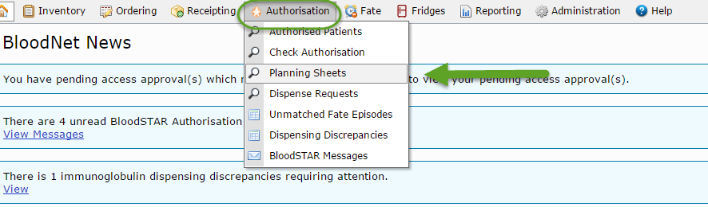

- Search for your planning sheet by name or find it on the list and select View.
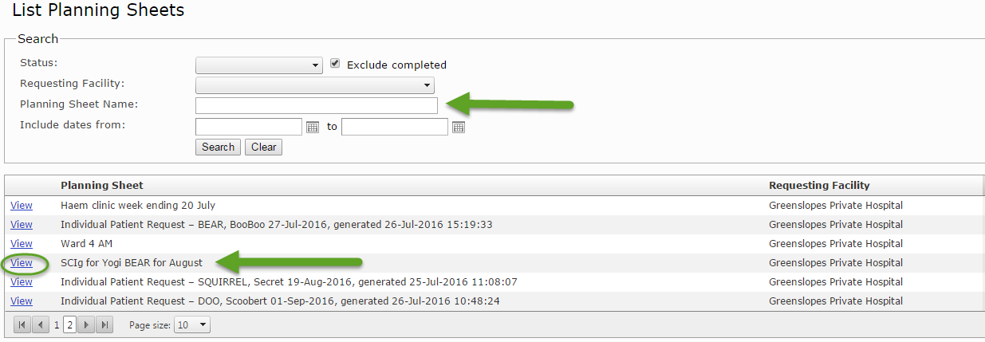

- Select dispense to record the dispense episode. The reason for an early dose is ‘SCIg Patient’.
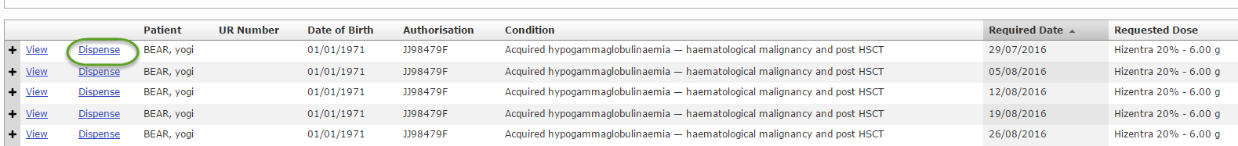
- Click Return to the planning sheet, select the next dose, and repeat step 3 until all required doses are dispensed.
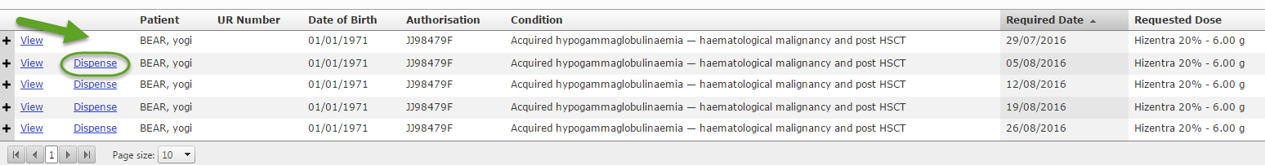

- Once complete, select Save to complete the planning sheet.

