Subcutaneous Immunoglobulin (SCIg) Product Dosing
In the current version of BloodSTAR (version 2.1 – Aug 2016), all dosing is set up in system using an intravenous immunoglobulin (IVIg) model.
To request SCIg in version 2.1, some additional action is required to ensure correct dosing is accurately represented.

The next BloodSTAR update (version 2.2), will introduce subcutaneous immunoglobulin (SCIg) dose modelling to simplify the process for managing SCIg patients.

If you need to request Subcutaneous Immunoglobulin in BloodSTAR v2.1:
- If entering an initial authorisation request, complete all of the details as required, until the dosing section is reached. You can follow the instructions on the BloodSTAR – Initial Authorisation Request Tip Sheet.
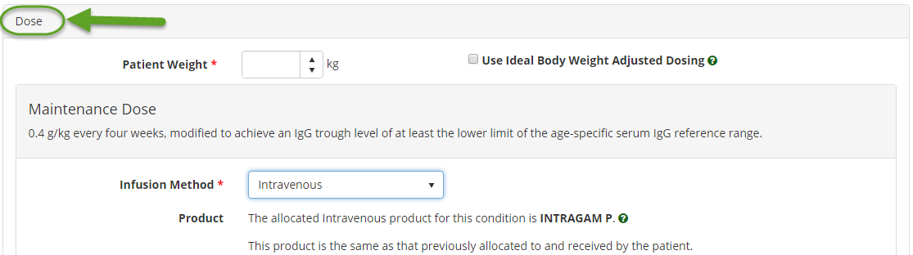
- If entering a dose change request, follow the instructions on the BloodSTAR – Product or Dose Change Request until you reach the dose section of the form.

- Enter the patient’s weight and choose Subcutaneous as the Infusion Method.

You will need be logged into a hospital participating in the National SCIg program to request ‘Subcutaneous’ dosing. The facility list is available at https://www.blood.gov.au/SCIg.

- Enter the Preferred Product, Dose / Kg, Frequency and Date Required for the first dose.
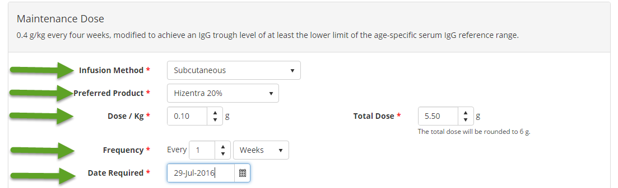

- As the SCIg dose controlling has not been set in Version 2.1 of the BloodSTAR system, you may be presented with a system alert message, advising you that the dose and/or frequency you have selected in outside what has been set out in the criteria for use. You will need to provide a reason in the free text Reason field provided e.g. “SCIg dosing requirements”
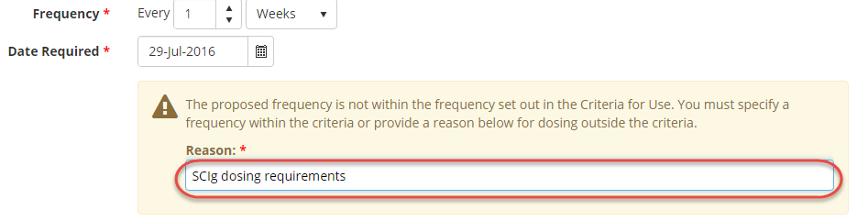
- Once all required details have been entered, confirm your contact details and tick the box to indicate all information submitted is true and accurate to the best of your knowledge and then click Submit.

- Your request will be assessed by the Australian Red Cross Blood Service authorisers as normal. You will receive an email and in-system notification when the request has been actioned.

