User Tip Sheet – Dispenser role

Actioning Dispense Discrepancies and

Unmatched Fate Episodes
Purpose
This document describes how to reconcile IVIg and SCIg dispense episodes that the system has flagged as outside the patient’s authorisation.
- Part A - How to review and action a dispense discrepancy
- Part B – How to review and action an unmatched fate episode

Part A - How to action a Dispense Discrepancy
Dispensing discrepancies are raised when product is dispensed for a patient outside the constraints of the patient’s authorisation for immunoglobulin treatment. A dispensing discrepancy may be rectified by returning incorrectly dispensed product to stock. When the incorrectly dispensed product cannot be returned to stock, please provide written justification for each of these discrepancies.
Please Note: Dispense discrepancies are flagged at the time of dispensing and this will trigger a justification reason pop-up box (See Step 4). If this is actioned at the time the product is dispensed, no further action is required.
- Login to BloodNet and select Authorisation -> Dispensing Discrepancies
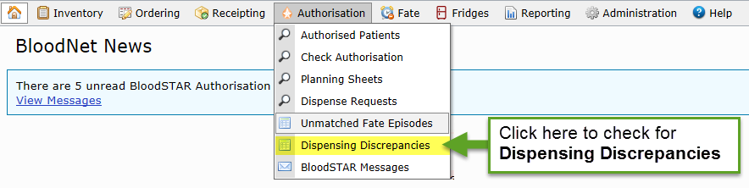

- Dispense Discrepancies appear red and there are three possible causes:
- Quantity Dispensed is larger than authorised e.g. 39.00 g of 33.00 g
- Dispensed Product is different to authorisation e.g. Privigen authorised, Intragam given
- Early Infusion Date (>7 days early for monthly) e.g. Infusion 21 days early
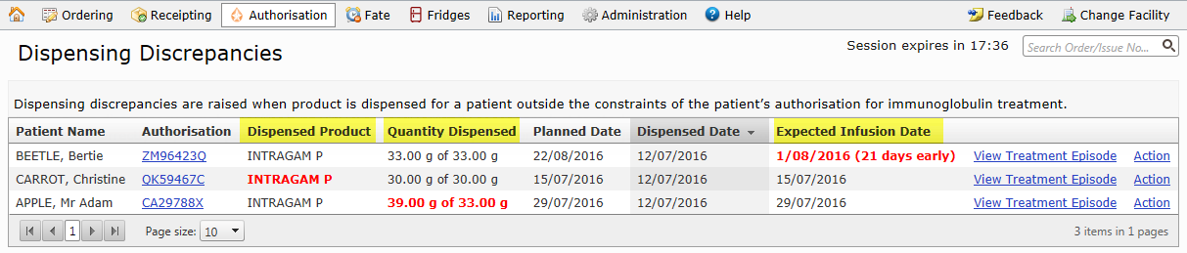

- Reconcile as follows:
  - To fix a dispense error - Click on the patient’s authorisation and complete a return to stock.
Or
  - To justify a discrepancy - Click on action to record a reason for dispensing outside the authorisation.
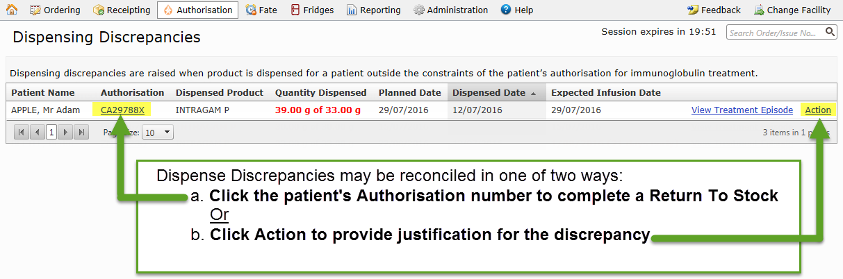
Please Note: If a different product, increased dose or more frequent dose is required on an ongoing basis, the patient’s specialist should be asked to complete a Dose Change Request.
- Click ‘Action’ to open the Reconcile Dispense Discrepancy pop-up window. Please enter written justification in the reason box and click ‘OK’.
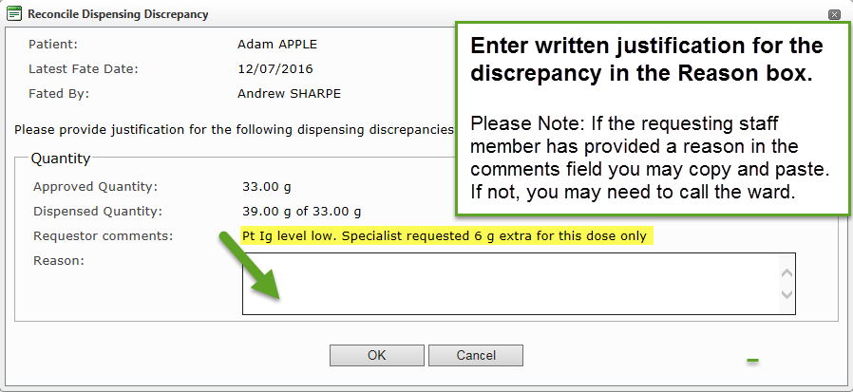
Repeat these steps to action any other Dispense Discrepancies. You may also wish to check for unmatched fate episodes (See Part B – How to review and action an Unmatched Fate Episode).

Part B – How to review and action an Unmatched Fate Episode
Unmatched Fate Episodes are created when a fate episode cannot be accurately matched to an authorised patient in BloodSTAR. When fate episodes are not accurately matched to authorisation records BloodNET is unable to assist you in determining whether a patient is receiving treatment within the constraints of the authorisation.
- Login to BloodNet and select Authorisation -> Unmatched Fate Episodes
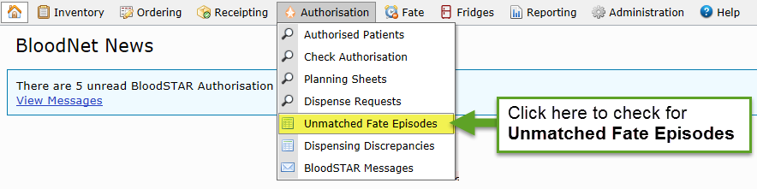
- Click ‘Match’ to action an Unmatched Fate Episode
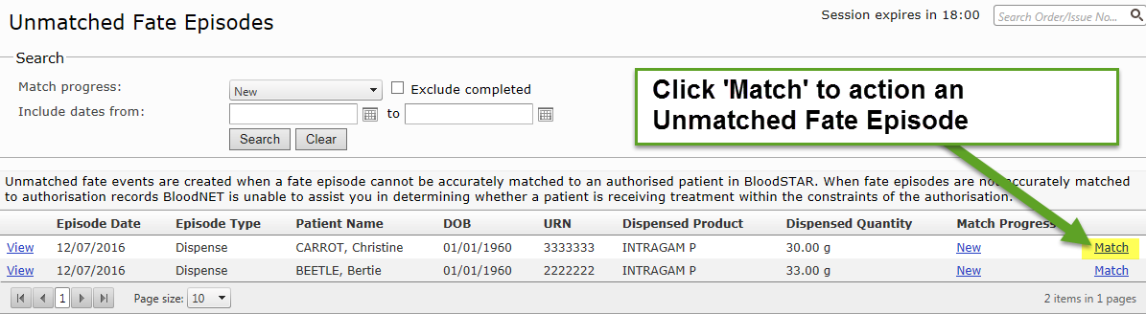
- Enter three patient identifiers or authorisation number and click search
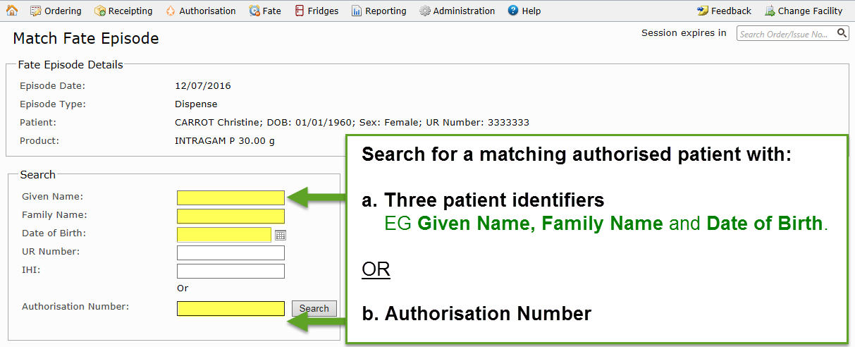

- Did the search identify a patient dose with matching details?
  - Yes – Click ‘Match’ to link the BloodNet Fate Episode to the matching BloodSTAR Dose
OR
  - No – Contact NBA Support at support@blood.gov.au or 13 000 BLOOD (13 000 25663)

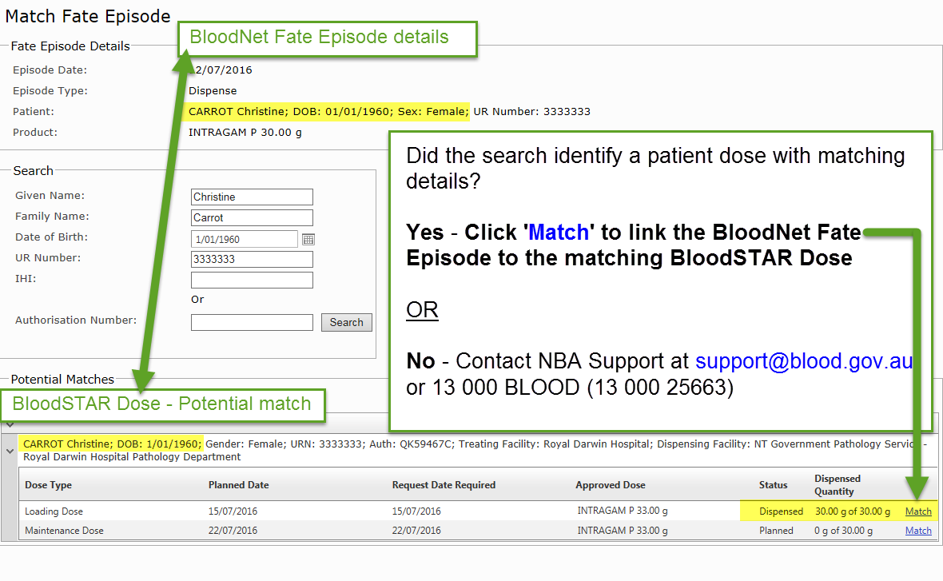
Please Note: In the unlikely event that there are no potential matches, please contact NBA Support. It may be necessary to follow up with the patient’s specialist or a jurisdictional representative to complete this action.

