Bulk Dispensing of SCIg

Bulk dispensing of Subcutaneous Immunoglobulin (SCIg) refers to the BloodNet functionality to dispense all the requested doses for a patient in one dispense episode off a single BloodSTAR planning sheet. This functionality allocates product to all the requested doses as a bulk dispense. This function is only available for requests that satisfy the following requirements:

- All of the dispense requests are for the same authorisation number;
- The infusion method on the authorised dose is SCIg;
- At least two of the consecutive dispense requests are 'Requested’

To action a bulk dispense of SCIg in BloodNet please take the following steps:
- On the BloodNet home page click on the ‘Authorisation’ tile
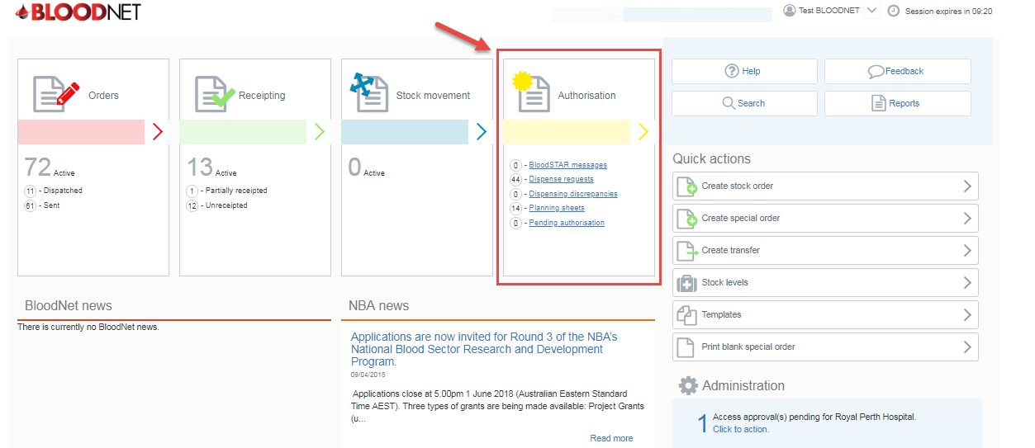

- From the ‘Authorisation’ dashboard click on the ‘Planning sheets’ button.
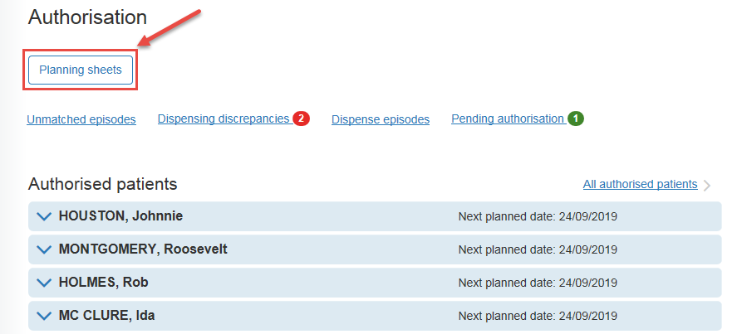

- From the ‘All planning sheets’ page, search and locate the planning sheet you would like to dispense against and click on the planning sheet name.

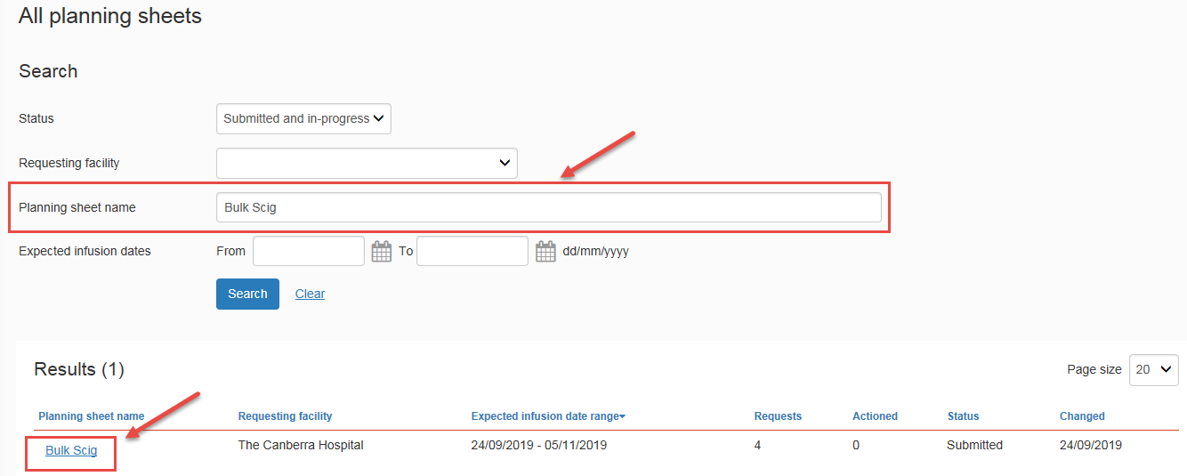

- From the ‘View planning sheet’ page, under ‘Requests’ click on ‘Dispense’ link against the first dose.

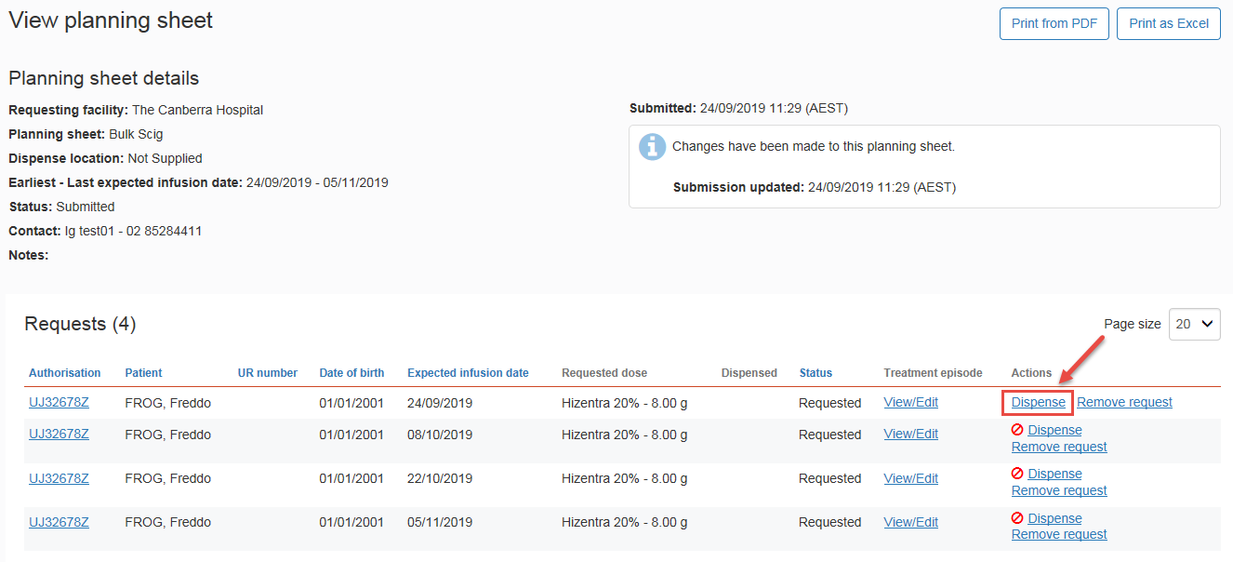

- The ‘Select multiple dispense requests’ page will appear with all the doses that have been requested. Please confirm the number of dispense requests you would like to dispense using the dropdown arrow and click ‘Continue’. Please note: when dispensing SCIg, a maximum of two months’ supply can be dispensed as per the requirements in the National Policy: Access to Government Funded Immunoglobulin Products in Australia.

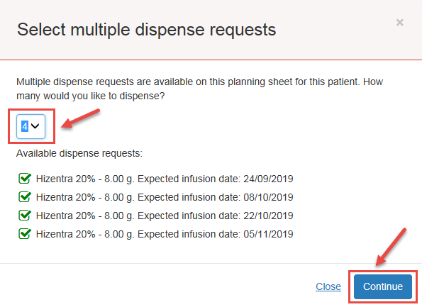

- The ‘New bulk dispense episode’ page will appear. ‘Scan or enter a lot number and quantity’ then click ‘Add item’.

Please Note:
- The system will distribute product evenly between the requests. For example, if 32 vials of 1g product are dispensed against 4 dispense requests then 8g of product will appear against each dispense request.
- Where product cannot be evenly distributed the remainder will be added to the first request.
- To move or remove product please refer to the legend at the bottom left side of the ‘New bulk dispense episode’ page
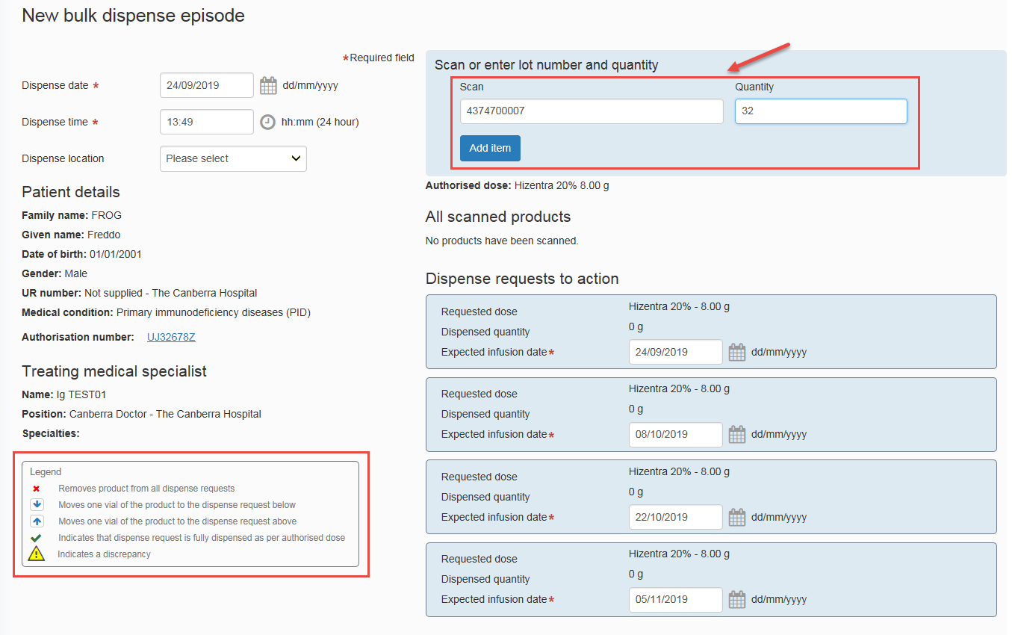

- Once all product(s) have been added and requests are fulfilled, click the ‘Save Dispense episode’ button.
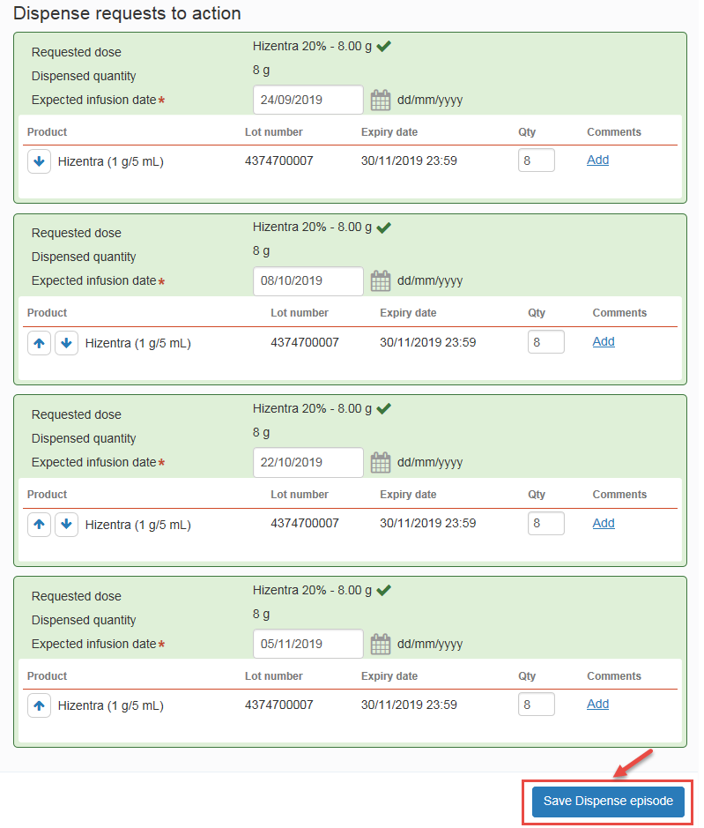

- You have now successfully saved all Dispense episodes.

