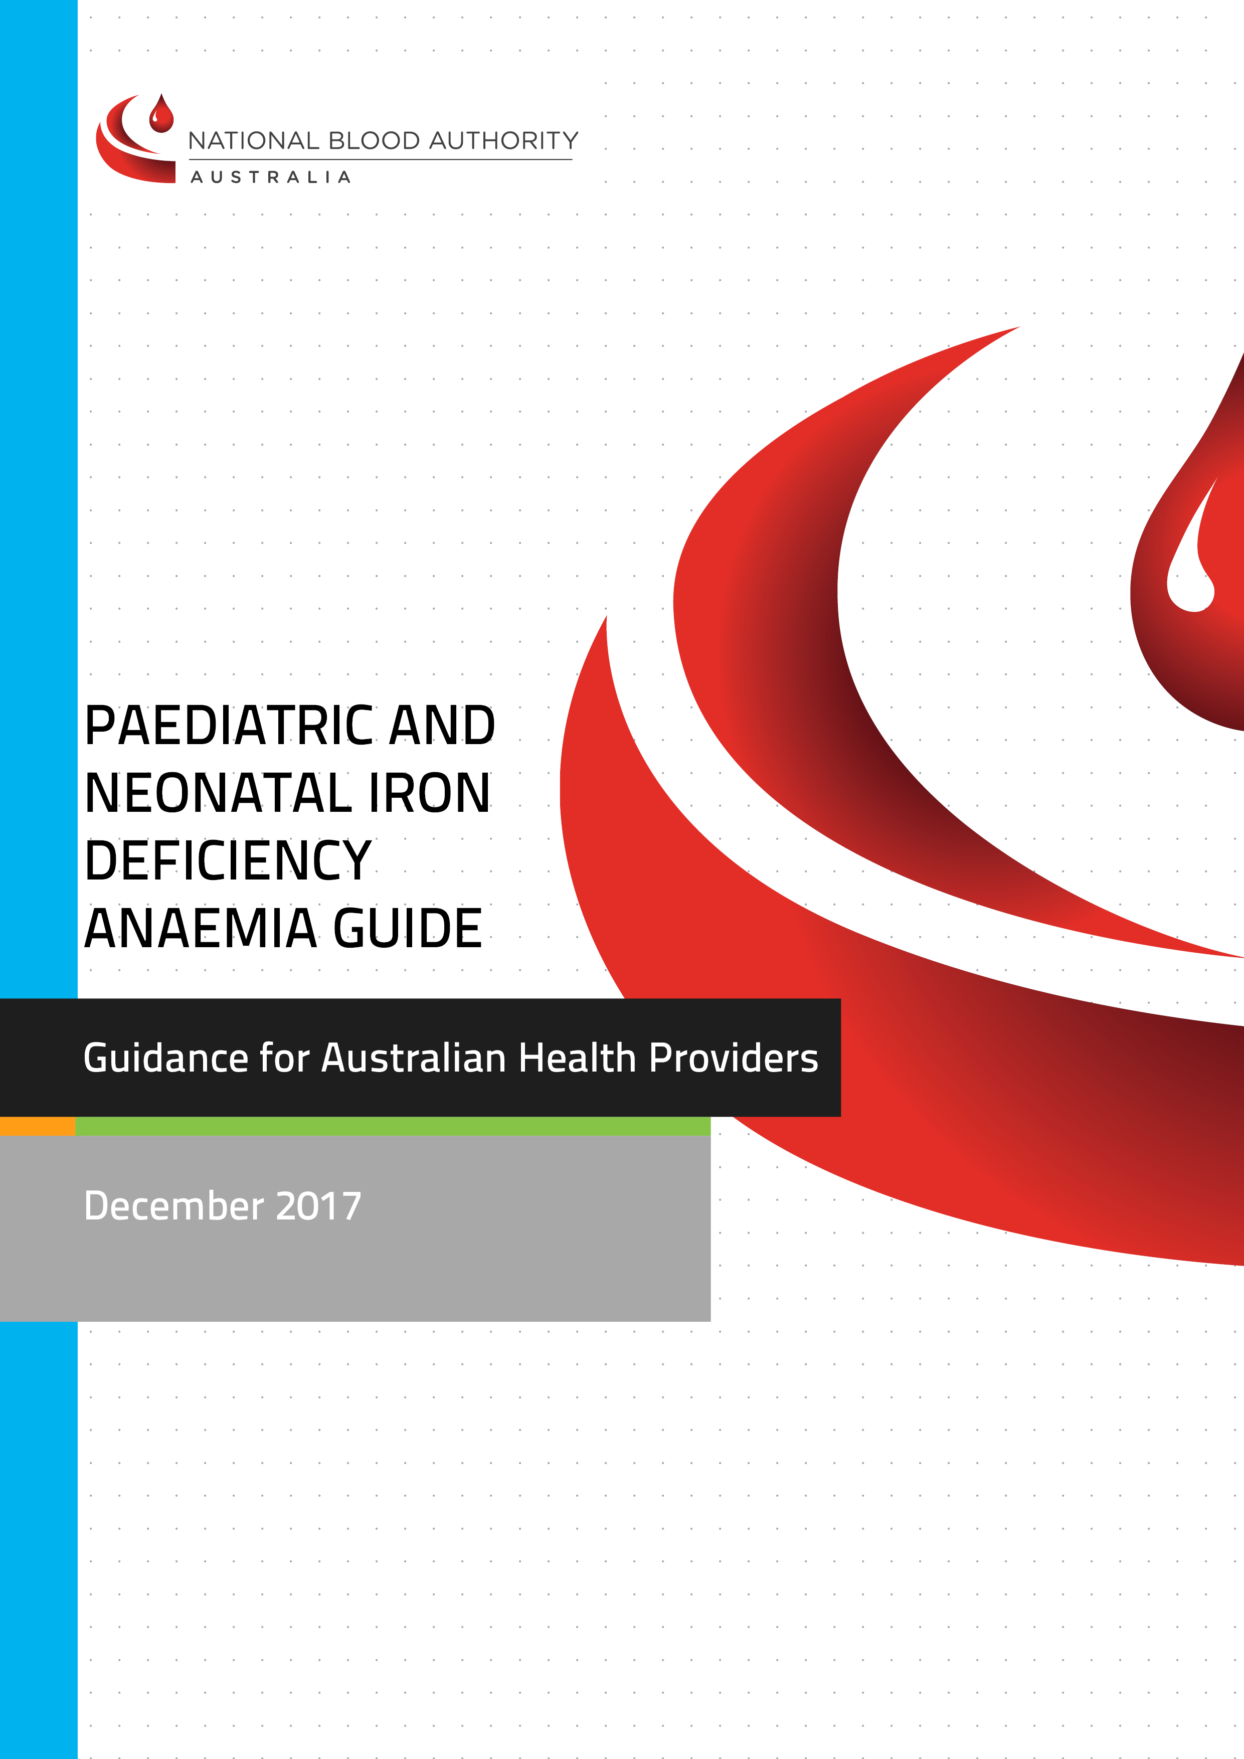
With the exception of any logos and registered trademarks, and where otherwise noted, all material presented in this document is provided under a Creative Commons Attribution 3.0 Australia (http:// creativecommons.org/ licenses/by/3.0/au/) licence.
The details of the relevant licence conditions are available on the Creative Commons website (accessible using the links provided) as is the full legal code for the CC BY 3.0 AU license (http:// creativecommons.org/licenses/by/3.0/au/legalcode).
The content obtained from this document or derivative of this work must be attributed as the
Paediatric and Neonatal Iron Deficiency Anaemia Guide.
© National Blood Authority, 2017. ISBN 978-0-9944061-8-7
This report is available online at: www.blood.gov.au
For more information: Patient Blood Management National Blood Authority
Locked Bag 8430 Canberra ACT 2601
Phone: 13000 BLOOD (13 000 25663)
Email: patientbloodmanagement@blood.gov.au www.blood.gov.au
Acknowledgement
The NBA has commissioned the development of a suite of patient blood management (PBM) tools by various stakeholders as outlined by the PBM Guideline Implementation Strategy. The tools are intended to be used as a resource for health professionals to use in implementing the recommendations and practice points in the PBM Guidelines.

The Paediatric and Neonatal Iron Deficiency Anaemia Guide is intended to assist healthcare professionals in assessing and managing Paediatric and Neonatal Iron Deficiency Anaemia. Addressing Iron Deficiency Anaemia is a key component of patient blood management strategies to optimise blood volume and red cell mass.

Disclaimer

This document is a general guide to appropriate practice, to be followed subject to the circumstances, clinician’s judgement and patient’s preferences in each individual case. It is designed to provide information to assist decision making. The relevance and appropriateness of the information and recommendations in this document depend on the individual circumstances. Moreover, the recommendations and guidelines are subject to change over time.

Each of the parties involved in developing this document expressly disclaims and accepts no responsibility for any undesirable consequences arising from relying on the information or recommendations contained herein.

Contents
Paediatric and Neonatal Iron Deficiency Anaemia 4
Background 4
Iron requirements in infants and children 4
Iron deficiency in infants and children 5
Paediatric haemoglobin and optimisation template 6
Iron therapy in infants, children and adolescents 8
NOTE(precaution for use in children) 9
Appendix 1: Paediatric appropriate oral iron therapy and dose 10
Appendix 2: Intravenous (IV) Iron Preparations 11
Appendix 3: Resources 16
References 17

Paediatric and Neonatal Iron Deficiency Anaemia
This guide has been developed to assist clinicians determine the appropriate formulation and dosage for addressing Paediatric and Neonatal Iron Deficiency Anaemia (IDA). The information contained in this guide has been sourced from Patient Blood Management Guidelines: Module 6 Neonatal and Paediatrics - Background question 5, Appendix H and Appendix I.

Background
In Australia, the prevalence of anaemia in children under the age of 5 years is about 8%, corresponding to over 100 000 preschool children.⁽¹⁾ Iron deficiency is the largest contributing factor to anaemia in all paediatric age groups.⁽²⁾
The prevalence of IDA in children from remote Indigenous communities is high⁽³⁾ A retrospective cohort study found that 68% of Indigenous infants from remote northern Australia were anaemic^{.(4)} The Early Childhood Nutrition and Anaemia Prevention Project found that nearly 90% of Indigenous infants and young children were anaemic at least once between 6 months and 2 years of age.⁽⁵⁾
Factors that put children at risk of developing IDA include maternal iron deficiency, late or insufficient introduction of iron-rich solids, increased iron requirements, poor intestinal iron absorption and increased loss of iron due to blood loss.

Iron requirements in infants and children
Term infants
Term infants generally have sufficient iron stores to meet their requirements for the first 4–6 months of life ^{(6, 7)} by which time they should be receiving iron-rich solids. Exclusively breast fed term infants require no iron supplementation in the first 6 months of life, provided their mother has sufficient dietary intake. Formula-fed infants should receive an iron-fortified formula.

Preterm and low birth weight infants
Neonatal iron stores are largely laid down during the third trimester of pregnancy;⁽⁸⁾ therefore, most preterm infants are at risk of subsequent iron deficiency. Iron supplementation should begin in infants born before 32 weeks gestation by 4 weeks of chronological age, once enteral feeds have been established.⁽⁹⁾ Preterm infants have a daily requirement of 2–3 mg/kg/day of elemental iron, which can usually be met by iron supplementation until there is adequate dietary iron intake.⁽⁹⁾
Regardless of gestational age, low birth weight infants, particularly those weighing <1800 g, have inadequate iron stores at birth,^{(9, 10)} and should receive iron supplementation until 6 months of age (corrected for gestation at birth).
Iron requirements in infants
From 6 months of age, all infants and toddlers should receive iron-rich solids.^{(6, 7)} If there is a delay in starting iron-rich solids, low-dose oral iron supplementation (1 mg/kg/day) is recommended until appropriate dietary sources are introduced.⁽⁷⁾
Iron requirements in neonates and infants
Age | Iron requirement | Feeding | Supplementation
Term; 0–6 months | AI  0.2 mg per day | Breast milk | Not routinely required
 |  | Iron-fortified formula
Term; 6–12 months | RDI  11 mg per day | Breast milk then iron-rich foods | Not routinely required
 |  | Formula then iron-rich foods
Preterm (<32 weeks) or low birth weight infants;  from 1–12 months | 2–3 mg per day provided as either of the feeding options given in the next column | Iron-fortified formula with iron-rich foods from appropriate age | 1–2 mg/kg/day of elemental iron until adequate daily iron intake ~6–12 months (corrected for gestation)
 |  | Breast milk, with iron-rich foods from appropriate age | 2-3 mg/kg/day of elemental iron until adequate daily iron intake ~6–12 months (corrected for gestation)
AI, adequate intake; RDI, recommended daily intake
Based on guidelines^{(7, 9, 11)}

Children and adolescents
Iron requirements are highest during periods of rapid growth (e.g. in the first 2 years of life and in adolescence). Routine iron supplementation is generally not required in children >1 year of age.

Iron deficiency in infants and children
Infants and children with IDA typically present with a subacute or chronic history of progressive pallor, fatigue, irritability, pica, reduced feeding, decreased activity, poor concentration or worsened school performance. Evaluation of a child with iron deficiency should include assessment of possible causes.

Diagnosis of iron deficiency anaemia
Anaemia is defined as a haemoglobin (Hb) concentration below the lower limit of the normal reference range, and varies according to age and sex. Laboratory diagnosis of IDA in paediatric patients must take into consideration age-specific reference ranges for full blood count and serum ferritin. It is not appropriate to use adult reference ranges.
Patients with iron deficiency will typically have a reduced mean corpuscular volume (MCV) and mean corpuscular Hb (MCH). A similar hypochromic microcytosis (with or without anaemia) may also be seen in carriers of beta thalassaemia; therefore, microcytosis should not be used in isolation to diagnose iron deficiency.
Serum ferritin is the most useful screening test to assess iron stores; a reduced serum ferritin (<20 µg/L) indicates inadequate iron stores.⁽¹²⁾ Serum iron levels are highly variable and should not be used to diagnose iron deficiency.
Serum ferritin is an acute-phase reactant, and a normal result does not exclude iron deficiency in the presence of coexisting infection, inflammation or liver disease. Concurrent assessment of the C-reactive protein can be useful to exclude concurrent inflammation. Serum ferritin levels of <50 µg/L should raise suspicion of iron deficiency in children with chronic disease and in high-risk populations such as Indigenous Australians.⁽¹³⁾

Paediatric haemoglobin and optimisation template
ANAEMIAª
Hb below reference range for age, sex and gestation
Ferritin <20 mcg/L  Iron deficiency anaemia | Ferritin 20–50 mcg/L  Possible iron deficiency anaemia | Ferritin >50 mcg/L  Unlikely iron deficiency anaemia
Review clinical history and identify cause  (see Table 1 below)  Start treatment:  - oral iron 3–6 mg/kg/day  Address causes of dietary iron deficiency:  - increase dietary iron  - if <1 year of age, cease cow’s milk and use an infant formula  - if 1–2 years of age, reduce cow’s milk to  <500 mL daily  Assess haematological response within 2-4 weeks  Continue treatment for 3 months after Hb recovery  If oral iron is ineffective or is not tolerated, consider other causes of anaemia (see Column 3) and use of IV iron | Review and address any causes of iron deficiency  (see Column 1)  Correlate with MCV/MCH and CRP  Consider therapeutic trial of iron:  - oral iron 3 mg/kg/day  Assess haematological response within 2–4 weeks  If anaemia persists, consider other causes  (see Column 3) | Correlate with MCH/MCV and CRP Ferritin may be elevated in the setting of inflammation. However, iron deficiency may still be present, particularly where TSAT <20%.  Consider alternative causes of anaemia:  - Thalassaemia and other haemoglobinpathies  - anaemia of chronic disease  - haemolytic anaemia  - B12 deficiency  - folate deficiency  - other

ª This algorithm applies to all patients, including those undergoing procedures in which substantial blood loss is anticipated.
The reference ranges are based on criteria from the Royal College of Pathologists of Australasia⁽¹²⁾, and they may require local adaptation.
CRP, C reactive protein; Hb, haemoglobin; IV, intravascular; MCH, mean corpuscular haemoglobin; MCV, mean corpuscular volume; TSAT, transferrin saturation

Table 1 Age-specific differential diagnoses in children with iron deficiency

INFANTS | CHILDREN | ADOLESCENT
Inadequate dietary iron  - Late introduction of iron-rich solids  - Early introduction (i.e. <12 months)  of cow’s milk  - Vegetarian or vegan diet | Inadequate dietary iron  - Vegetarian or vegan diet | Inadequate dietary iron  - Vegetarian or vegan diet
Increased iron requirements  - Catch-up growth if premature or low birth weightª  - Rapid growth period | Increased iron requirements  - Rapid growth period | Increased iron requirements  - Rapid growth period  - Pregnancy  - Extreme athletes
Intestinal blood loss  - Cow’s milk protein intolerance  - Meckel’s diverticulum  - Inflammatory bowel disease  - Parasitic infection  Other chronic blood loss such as epistaxis, or renal or pulmonary blood loss | Intestinal blood loss  - Meckel’s diverticulum  - Inflammatory bowel disease  - Parasitic infection^{b}  Other chronic blood loss such as epistaxis, or renal or pulmonary blood loss | Intestinal blood loss  - Inflammatory bowel disease  - Parasitic infection  - Menorrhagia  Other chronic blood loss such as epistaxis, or renal or pulmonary blood loss
Reduced absorption  - Coeliac disease  - Inflammatory bowel disease  - Gastric or intestinal surgeries  - Helicobacter pylori infection | Reduced absorption  - Coeliac disease  - Inflammatory bowel disease  - Gastric or intestinal surgeries  - Helicobacter pylori infection | Reduced absorption  - Coeliac disease  - Inflammatory bowel disease  - Gastric or intestinal surgeries  - Helicobacter pylori infection  - Dietary factor (tannins)
ª Antenatal risk factors that predispose an infant to iron deficiency include maternal iron deficiency, maternal diabetes mellitus, smoking and multiple pregnancies. Perinatal factors that predispose an infant to iron deficiency include low birth weight, prematurity, feto-maternal haemorrhage, twin-to-twin transfusion or other blood loss including placental abruption, subgaleal haemorrhage or iatrogenic blood loss
. ^{b} Giardia and hookworm infection

Iron therapy in infants, children and adolescents
There is a lack of RCTs on the treatment of IDA in the paediatric population. Trials that are focused on the iron formulation, dose, adverse effects, adherence and total length of therapy are needed to better inform treatment decisions. ⁽¹⁴⁾
Red Blood Cell transfusion is rarely indicated solely for treatment of IDA, and should be limited to cases with haemodynamic compromise. All patients with IDA, whether or not transfused, should have iron supplementation, to both correct anaemia and replenish body stores. ⁽¹⁵⁻¹⁷⁾

Iron supplement options
Dietary therapy
Iron deficiency in infants and toddlers is primarily a nutritional disorder.⁽⁷⁾ Hence, measures to improve dietary intake of iron-rich foods are fundamental.^{(7, 18)} Dietary changes alone are usually inadequate to treat IDA.⁽¹⁶⁾
Standard cow’s milk, goat’s milk and soy milk have a low iron content and should not be offered as the main milk drink to infants under 12 months of age.⁽⁶⁾ From 12 months of age, cow’s milk intake should not exceed 500 mL per day.⁽⁶⁾ In non-breast fed infants in the first 2 years of life, iron-fortified formula can play a role in the prevention and treatment of IDA.⁽⁷⁾
Oral iron therapy
Oral iron therapy is safe and effective as first-line therapy in most patients with iron deficiency or IDA.⁽¹⁶⁾ The recommended dose for the treatment of IDA in children is 3–6 mg/kg/day of elemental iron.^{(7, 16, 19)} The dose of iron should take into account the degree of anaemia and weight of the child.
See appendix 1 for paediatric appropriate oral iron therapy and dose calculations
Intramuscular iron therapy
Use of intramuscular (IM) iron is discouraged. ^{(16, 17)} IM iron is effective but painful, may be associated with permanent skin staining and is no safer than IV infusion.⁽¹⁶⁾
Intravenous (IV) iron therapy
IV iron should be considered in the following circumstances: ^{(7, 16, 20)}
- persistent iron deficiency despite oral therapy
- contraindications to oral iron, or serious issues with compliance or tolerance (adverse effects)
- comorbidities affecting absorption (e.g. intestinal mucosal disorders and short gut syndrome) or bone marrow response
- patients receiving ESAs
- ongoing blood loss that exceeds iron absorptive capacity
- requirement for rapid iron repletion (e.g. prevention of physiological decompensation, or preoperatively for non-deferrable surgery)
- genetic disorders of iron transport.
The iron preparations available in Australia are:
- ferric carboxymaltose: Ferinject®
- iron sucrose: Venofer®
- iron polymaltose: Ferrosig®.
See Appendix 2 for intravenous iron therapies and dose calculation.
NOTE
The use of Ferinject and Venofer in children constitutes an “off label” use of these products. Product Information approved by the Australian Therapeutic Goods Administration for Ferinject and Venofer lists the following precautions in relation to paediatric use:
- the use of Ferinject has not been studied in children and therefore is not recommended in children under 14 years; and
- the safety and efficacy of Venofer in children has not been established.
However, the information in these Guidelines refers to high quality evidence⁽²¹⁾ ⁽²²⁾ and best practice protocols⁽²³⁾ ⁽²⁴⁾ that support the safety and efficacy of these products for paediatric use. When considering these Guidelines, clinicians should use their professional judgement to consider this evidence, taking into account the preferences of the individual or their carer.

Appendix 1: Paediatric appropriate oral iron therapy and dose

Oral therapy
Name | Image of product | Formulation | Elemental iron content | Notes
Ferro-Liquid | 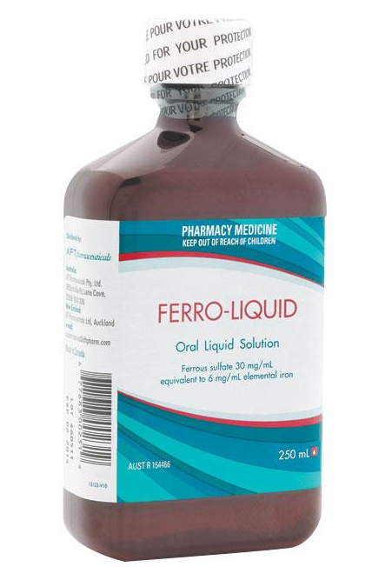 | Ferrous sulfate oral liquid | 6 mg/mL | Maximum daily dose 1 mL/kg
Fefol® | 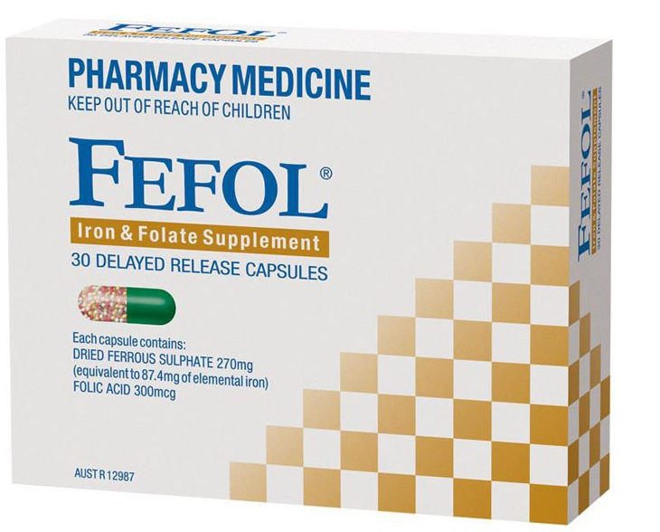 | Ferrous sulfate delayed release capsules or spansules (270 mg) | 87.4 mg | Spansules can be opened and sprinkled on food to give lower doses  They should not be crushed or chewed
Ferro-Gradumet | 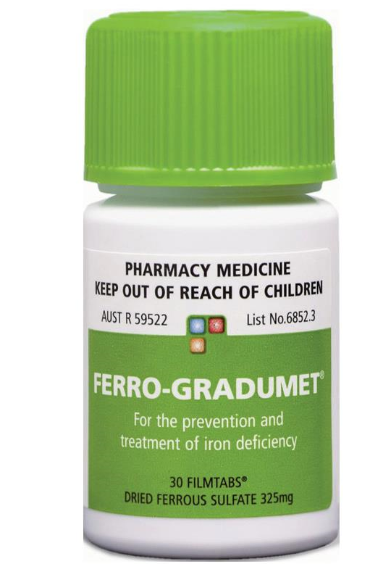 | Ferrous sulfate (325 mg) | 105 mg | May be appropriate and tolerated by the older child or adolescent
Adapted from Royal Children’s Hospital, Melbourne
Quick dose reference to provide 3 mg/kg/day (for severe iron deficiency anaemia, consider 6 mg/kg/day)
Weight (kg) | Ferro-Liquid  (30 mg/5 mL) | Fefol® delayed release capsules ‘spansules’  87.4 mg | Ferro-Gradumet
<10 | 0.5 mL/kg/day | NA | NA
10–19 kg | 5 mL per day | Half spansule 5 days/week | NA
20–29 kg | 10 mL per day | Whole spansule 5 days/week | NA
30–39 kg | 15 mL per day | Whole spansule daily | 1 tablet/day
>40 | 20 mL per day | 1.5 spansules daily | 1–2 tablets/day
Adapted from Royal Children’s Hospital, Melbourne

Considerations
each oral iron preparation contains a different elemental iron dose
- over-the-counter multivitamin or mineral supplements should not be used to treat IDA because the iron content is low
compliance and tolerability of iron preparations may be an issue with children:⁽⁷⁾
- lower doses or intermittent dosing may be as effective and better tolerated^{(7, 16)}
- daily iron dose may be divided into 2–3 doses^{(7, 25)}
- oral iron is best absorbed on an empty stomach, ideally 1 hour before or 2 hours after food
- consider giving iron preparation with vitamin C (e.g. orange juice) to improve absorption
- gastrointestinal upset may be reduced by taking iron with food or at night and increasing the dose gradually
- oral iron is best avoided in patients with inflammatory bowel disease due to side effects, poor absorption and exacerbation of inflammation⁽²⁶⁾
- iron formulations can cause temporary staining of the teeth; brushing teeth with baking soda may ameliorate this
response and compliance should be monitored by measuring Hb and reticulocyte count
oral iron should be continued for 3 months after anaemia has been corrected, to replenish stores^{(15, 16)}

Appendix 2: Intravenous (IV) Iron Preparations
(based on practice guidelines from the Royal Children’s Hospital, Melbourne)
IV iron should be administered according to a protocol relevant to the specific product used. IV iron sucrose has been shown to be a safe and effective means to treat iron deficiency in children who cannot receive or do not respond to oral iron because of intolerance, poor adherence or iron malabsorption.⁽²¹⁾
A retrospective observational study reported that ferric carboxymaltose was well tolerated and effective in correcting IDA in children aged 0–18 years with inflammatory bowel disease.⁽²²⁾
The necessary dose of IV iron is calculated based on the patient’s estimated total body iron deficit. Total iron dose per infusion differs among iron products. Hence, the iron dose per infusion should take into account the degree of anaemia, the patient’s weight and the type of IV iron preparation.
Allergic and anaphylactic reactions to IV iron (especially to iron polymaltose) are widely reported.^{(15, 16)} Therefore, IV iron should always be administered in an appropriate health-care setting with medical personnel and resuscitation facilities on site. Premedication with steroids and antihistamine may be considered. Drug extravasation has been reported in the paediatric setting as a result of iron infusion, and can cause irreversible skin staining.⁽²⁷⁾

Procedure
- Check for previous adverse reactions to IV iron before commencing infusion.
- Refer to package insert to ensure familiarity with adverse event profile for the specific product.
- Ensure that child and parent understand procedure:
  - obtain verbal consent to procedure
  - ensure that child and parent are aware of possible adverse reactions.
- Ensure that medication and treatment orders are correctly written up by the medical officer.
- Ensure that oxygen and resuscitation equipment are in working order.
- Ensure that there is an order for PRN adrenaline 0.01 mg/kg intramuscular (IM) 1:1000 in the event of anaphylaxis.
- Establish patient IV access and ensure that the IV is working well.
- Take blood specimens as requested.
- Commence infusion and observations as per protocol.
- Monitor for any local or systemic adverse reactions.
- If there are signs of an adverse reaction or anaphylaxis, cease the infusion immediately.
- Contact the treating medical officer or call the medical emergency team (MET).
- Treat symptomatically, and administer oxygen, IV fluids and adrenaline as required.

Precautions
- Ensure that all staff are familiar with MET criteria and can recognise when to initiate a MET call.
- Do not administer iron infusions out of hours unless they are urgently required and staffing levels are appropriate.
- Place the patient in a clinical area where the patient can be closely monitored throughout the duration of the infusion.
- Ensure that patients undergoing iron infusions are not on oral iron therapy, and that they do not recommence oral iron therapy until 1 week after the last dose of parenteral therapy.
- For iron sucrose and iron polymaltose:
- consider premedications:
  - ceterizine (0.125 mg/kg oral; maximum 10 mg)
  - hydrocortisone (2–4 mg/kg IV; maximum 100 mg)
- be aware that concomitant therapy with an angiotensin-converting enzyme (ACE) inhibitor may increase the incidence of adverse effects.
Contraindications
- Previous allergic reactions to iron therapy.
- Severe liver dysfunction.
- Iron overload.
Observations
- Baseline weight.
- Baseline temperature, respiratory rate, pulse and blood pressure.
- Direct observation for the first 15 minutes.
- For the remainder of the infusion, observe:
  - blood pressure every 15 minutes
  - heart rate for 60 minutes then hourly.
- Monitor for signs of anaphylaxis, headache, nausea, hypotension, joint and muscle pain or signs of extravasation.
Discharge
- Ensure patient meets discharge criteria.
ALERT
- Check prescription and vials carefully as there are many different forms of IV iron preparations.
- Iron formulations have different iron concentrations, maximum doses, dilutions and rates of administration and are not interchangeable with regard to dose, dilution and rates of administration.

Iron carboxymaltose (Ferinject®) dose⁽²³⁾

Presentation
Two ampoule sizes:
- 100 mg/2 mL
- 500 mg/10 mL.

Maximum dose
Total or cumulative dose – may need to be administered over several doses at weekly intervals.
Maximum dose – 20 mg/kg capped at 1000 mg/week.

Administration
Dilute using 0.9% sodium chloride:
maximum concentration 5 mg/mL
minimum concentration 2 mg/mL.
For children under 14 years of age, use a maximum dose of 20 mg/kg/week, and round down to the nearest ampoule (to a maximum of 1000 mg/week).
Administer over at least 15 minutes.

Total dose (mg of IV iron carboxymaltose) based on Hb concentration and body weight
Doses are in mg | Body weight (kg)
Hb (g/L) | 35 | 40 | 45 | 50 | 55 | 60 | 65 | 70 | 75 | 80
60 | 1200 | 1300 | 1400 | 1500 | 1600 | 1700 | 1900 | 2100 | 2200 | 2300
75 | 1100 | 1200 | 1300 | 1400 | 1400 | 1500 | 1600 | 1800 | 1900 | 2000
90 | 1000 | 1000 | 1100 | 1200 | 1200 | 1300 | 1400 | 1600 | 1600 | 1700
105^{b} | 800 | 900 | 900 | 1000 | 1000 | 1100 | 1200 | 1300 | 1400 | 1400
Maximum dose/  weekª | 700 | 800 | 900 | 1000 | 1000 | 1000 | 1000 | 1000 | 1000 | 1000
Hb, haemoglobin; IV, intravenous
ª Maximum dose is 20 mg/kg (to a maximum of 1000 mg/week).
^{b} Pink shading indicates that the infusion can be given in a single dose; in all other instances, the dose needs to be split over more than 1 week.
Source: Royal Children’s Hospital (2013)⁽²³⁾
The use of Ferinject in children constitutes an “off label” use of this product. Product Information approved by the Australian Therapeutic Goods Administration for Ferinject provides that the use of Ferinject has not been studied in children and therefore is not recommended in children under 14 years. However, the information in these Guidelines refers to best available evidence⁽²²⁾ and current clinical practice protocols⁽²³⁾ that support the safety and efficacy of this product for paediatric use. When considering these Guidelines, clinicians should use their professional judgement to consider this evidence, taking into account the preferences of the individual or their carer.

Iron sucrose (Venofer®) dose⁽²⁴⁾
Presentation
Ampoule of 5 mL is equivalent to 100 mg of iron (i.e. 20 mg/mL).
Maximum dose
Maximum dose per infusion is 7 mg/kg of iron (0.35 mL/kg) capped at 300 mg (15 mL).⁽²¹⁾
This maximum dose is suitable for iron deficiency anaemia, lower doses may be appropriate in maintenance therapy in chronic kidney disease.

Total dose (mL of IV iron sucrose) based on Hb concentration and body weight
Doses are in mL (20 mg/mL solution) |  | Body weight (kg)
Hb (g/L) |  | 5 | 10 | 15 | 20 | 25 | 30 | 35 | 40 | 45 | 50 | 55 | 60 | 65 | 70
60 |  | 8 | 16 | 24 | 32 | 40 | 48 | 63 | 68 | 74 | 79 | 84 | 90 | 95 | 101
75 |  | 7 | 14 | 21 | 28 | 35 | 42 | 57 | 61 | 66 | 70 | 75 | 79 | 84 | 88
90 |  | 6 | 12 | 19 | 25 | 31 | 37 | 50 | 54 | 57 | 61 | 65 | 68 | 72 | 75
105 |  | 5 | 11 | 16 | 21 | 26 | 32 | 44 | 47 | 49 | 52 | 55 | 57 | 60 | 63
Max dose/  infusionª | mL | 1.75 | 3.5 | 5.25 | 7.0 | 8.75 | 10.5 | 12.25 | 14 | 15 | 15 | 15 | 15 | 15 | 15
 | mg | 35 | 70 | 105 | 140 | 175 | 210 | 245 | 280 | 300 | 300 | 300 | 300 | 300 | 300
Hb, haemoglobin; IV, intravenous
ª Maximum dose per infusion is 7 mg/kg (to a maximum of 300 mg).⁽²¹⁾
Source: Royal Children’s Hospital (2012)⁽²⁴⁾Administration
Administration
To calculate the number of doses to be given, divide the total dose of IV iron sucrose in the upper part of the table by the maximum dose of IV iron sucrose per infusion (in mL) in the lower part of the table. Do not give more than three doses per week.
Children (>1 month of age):
For body weight 5–10 kg, dilute doses <100 mg 1:1 with normal saline, infuse over 30 minutes.
For body weight 15–25 kg, dilute doses 100–200 mg in 200 mL normal saline, infuse over 60 minutes.
For body weight 30–70 kg, dilute doses 200–300 mg in 300 mL normal saline, infuse over 90 minutes.

The use of Venofer in children constitutes an “off label” use of this product. Product Information approved by the Australian Therapeutic Goods Administration for Venofer provides that the safety and efficacy of Venofer in children has not been established. However, the information in these Guidelines refers to best available evidence⁽²¹⁾ and current clinical protocols⁽²⁴⁾ that support the safety and efficacy of this product for paediatric use. When considering these Guidelines, clinicians should use their professional judgement to consider this evidence, taking into account the preferences of the individual or their carer.

Iron polymaltose (Ferrosig) dose⁽²⁸⁾

Presentation
Ampoule = 2 mL of iron polymaltose = 100 mg of iron.
Dose
See Table I.3. None of the doses in the table exceed the recommended maximum dose of 2500 mg/infusion.

Administration
Dilute with 0.9% sodium chloride to a maximum concentration of 5 mg/mL.
Standard infusion (500 mL 0.9% saline):
commence infusion at 40 mL/hour for 75 minutes (50 mL)
then increase by 20 mL/hour 15 minutely to a maximum rate of 120 mL/hour.
For smaller patients or fluid restricted (250 mL 0.9% saline):
commence infusion at 20 mL/hour for 75 minutes (25 mL)
- then grade up by 10 mL/hour to a maximum rate of 60 mL/hour.

Dose (mL of IV iron polymaltose) based on Hb concentration and body weight
Doses are in mL (100mg/2mL or 50mg/mL solution)ª | Body weight (kg)
Hb (g/L) | 5 | 10 | 15 | 20 | 25 | 30 | 35 | 40 | 45 | 50 | 55 | 60 | 65 | 70
60 | 3 | 6 | 10 | 13 | 16 | 19 | 25 | 27 | 30 | 32 | 34 | 36 | 38 | 40
75 | 3 | 6 | 9 | 11 | 14 | 17 | 23 | 24 | 26 | 28 | 30 | 32 | 33 | 35
90 | 3 | 5 | 7 | 10 | 12 | 15 | 20 | 22 | 23 | 24 | 26 | 27 | 29 | 30
105 | 2 | 4 | 6 | 8 | 11 | 13 | 18 | 19 | 20 | 21 | 22 | 23 | 24 | 25
Hb, haemoglobin; IV, intravenous
ª Maximum dose 2500 mg/infusion
Source: Royal Children’s Hospital (2012)⁽²⁸⁾

Administration
Use Hb closest to patient’s Hb.
Doses coloured blue may be diluted in 250 mL of 0.9% sodium chloride.
Doses coloured red may be diluted in 500 mL of 0.9% sodium chloride.
- Doses coloured purple need dilution in 1000 mL of 0.9% sodium chloride

Place the patient in a clinical area where the patient can be closely monitored throughout the duration of the infusion.
Ensure that patients undergoing iron infusions are not on oral iron therapy, and that they do not recommence oral iron therapy until 1 week after the last dose of parenteral therapy.
For iron sucrose and iron polymaltose:
consider premedications:
      - ceterizine (0.125 mg/kg oral; maximum 10 mg)
      - hydrocortisone (2–4 mg/kg IV; maximum 100 mg)
- be aware that concomitant therapy with an angiotensin-converting enzyme (ACE) inhibitor may increase the incidence of adverse effects.

Appendix 3: Resources

Iron deficiency anaemia guidelines/references:
Pasricha SR, Flecknoe-Brown SC, Allen KJ, Gibson PR, McMahon LP, Olynyk JK, et al. (2010). Diagnosis and management of iron deficiency anaemia: a clinical update, Med J Aust 193(9):525-532. http://www.ncbi.nlm.nih.gov/pubmed/21034387

Iron Deficiency anaemia education/information/tools:
BloodSafe eLearning Australia:
- Iron deficiency anaemia algorithm app (iPhone, iPad, Android)
- Iron deficiency anaemia course
Available at: https://www.bloodsafelearning.org.au
Australian Red Cross Blood Service information about Iron deficiency anaemia:
- Treatment Options for Iron Deficiency Anaemia
- Major Reasons for Inadequate Response to Oral Iron Therapy
- Oral Iron Therapy Interactions and Management
- Oral Iron Therapy Side Effects and Management
- Spectrum of iron deficiency
Available at: http://www.transfusion.com.au
Intravenous iron references
Product information for intravenous iron preparations available in Australia:
- Ferric carboxymaltose: Ferinject®
- Iron polymaltose: Ferrosig®
- Iron sucrose: Venofer®
Available at: http://www.ebs.tga.gov.au
Healthcare professional resources
- Dieticians Association of Australia
Available at: http://daa.asn.au/

- Patient Blood Management Guidelines
Module 6 Neonatal and Paediatrics
Available at: http://www.blood.gov.au

References
1. WHO. Worldwide prevalence of anaemia 1993–2005: WHO global database on anaemia. Geneva: World Health Organization (WHO); 2008.
2. Kassebaum NJ, Jasrasaria R, Naghavi M, Wulf SK, Johns N, Lozano R, et al. A systematic analysis of global anemia burden from 1990 to 2010. Blood. 2014 Jan 30;123(5):615-24. PubMed PMID: 24297872. PMCID: 3907750.
3. Brewster DR. Iron deficiency in minority groups in Australia. J Paediatr Child Health. 2004 Aug;40(8):422-3. PubMed PMID: 15265180. Epub 2004/07/22. eng.
4. Bar-Zeeve SJ, Kruske SG, Barclay LM, Bar-Zeev N, Kildea SV. Adherence to management guidelines for growth faltering and anaemia in remote dwelling Australian Aboriginal infants and barriers to health service delivery. BMC Health Serv Res. 2013;13(250):1-12.
5. Aquino D, Marley JV, Senior K, Leonard D, Helmer J, Joshua A, et al. Early Childhood Nutrition and Anaemia Prevention Project: Executive summary. Darwin: The Fred Hollows Foundation, Indigenous Australia Program; 2013.
6. Domellof M, Braegger C, Campoy C, Colomb V, Decsi T, Fewtrell M, et al. Iron requirements of infants and toddlers. Journal of pediatric gastroenterology and nutrition. 2014 Jan;58(1):119-29. PubMed PMID: 24135983.
7. Grant CC, Wall CR, Brewster D, Nicholson R, Whitehall J, Super L, et al. Policy statement on iron deficiency in pre-school-aged children. J Paediatr Child Health. 2007 Jul-Aug;43(7-8):513-21. PubMed PMID: 17635678. Epub 2007/07/20. eng.
8. European Society of Paediatric Gastroenterology Nutrition. Nutrition and feeding of preterm infants. Committee on Nutrition of the Preterm Infant, European Society of Paediatric Gastroenterology and Nutrition. Acta Paediatr Suppl. 1987;336:1-14.
9. Agostoni C, Buonocore G, Carnielli VP, De Curtis M, Darmaun D, Decsi T, et al. Enteral nutrient supply for preterm infants: commentary from the European Society of Paediatric Gastroenterology, Hepatology and Nutrition Committee on Nutrition. Journal of pediatric gastroenterology and nutrition. 2010 Jan;50(1):85-91. PubMed PMID: 19881390.
10. Cormack B. Neonatal and Infant Nutrition Handbook. Auckland: Auckland District Health Board; 2003.
11. NHMRC and MoH. Nutrient Reference Values for Australia and New Zealand Including Recommended Dietary Intakes: Australian National Health and Medical Research Council (NHMRC) and New Zealand Ministry of Health (MoH); 2006.
12. Iron studies standardised reporting protocol. Royal College of Pathologists of Australasia; 2013.
13. Ritchie B, McNeil Y, Brewster DR. Soluble transferrin receptor in Aboriginal children with a high prevalence of iron deficiency and infection. Tropical Medicine & International Health. 2004;9(1):96-105.
14. Powers JM, Buchanan GR. Diagnosis and management of iron deficiency anemia. Hematology/oncology clinics of North America. 2014 Aug;28(4):729-45, vi-vii. PubMed PMID: 25064710. Epub 2014/07/30. eng.
15. Goddard AF, James MW, McIntyre AS, Scott BB. Guidelines for the management of iron deficiency anaemia. Gut. 2011 Oct;60(10):1309-16. PubMed PMID: 21561874. Epub 2011/05/13. eng.
16. Pasricha SR, Flecknoe-Brown SC, Allen KJ, Gibson PR, McMahon LP, Olynyk JK, et al. Diagnosis and management of iron deficiency anaemia: a clinical update. The Medical journal of Australia. 2010 Nov 1;193(9):525-32. PubMed PMID: 21034387.
17. Australia GSo. Clinical update: Iron deficiency, First Edition. Digestive Health Foundation, Sydney. 2008.
18. Infant feeding guidelines. NHMRC; 2012.
19. Pediatrics AAo. Point-of-care quick reference: Iron deficiency anemia.
20. (NBA) NBA. Patient Blood Management Guidelines: Module 2 – Perioperative. NBA, Canberra, Australia. 2012.
21. Crary SE, Hall K, Buchanan GR. Intravenous iron sucrose for children with iron deficiency failing to respond to oral iron therapy. Pediatric blood & cancer. 2011;56(4):615-9.
22. Laass MW, Straub S, Chainey S, Virgin G, Cushway T. Effectiveness and safety of ferric carboxymaltose treatment in children and adolescents with inflammatory bowel disease and other gastrointestinal diseases. BMC gastroenterology. 2014;14:184. PubMed PMID: 25326048. PMCID: PMC4286929. Epub 2014/10/19. eng.
23. Day Medical Unit – Treatment protocol: Administration of iron carboxymaltose (Ferinject);Version 4. Melbourne, Australia: Royal Children's Hospital; 2013.
24. Day Medical Unit – Treatment protocol: Administration of iron sucrose (Venofer). Melbourne, Australia: Royal Children's Hospital; 2012.
25. Paediatric Pharmacopoiea. Pocket prescriber (13th Edition). 13th ed ed: Pharmacy Department, The Royal Children's Hospital; 2002.
26. National Blood Authority (NBA). Patient Blood Management Guidelines: Module 2 – Perioperative. Canberra, Australia: NBA; 2012.
27. Pinsk V, Levy J, Moser A, Yerushalmi B, Kapelushnik J. Efficacy and safety of intravenous iron sucrose therapy in a group of children with iron deficiency anemia. Isr Med Assoc J. 2008;10(5):335-8.
28. Day Medical Unit – Treatment protocol: Administration of iron polymaltose (Ferrosig). Melbourne, Australia: Royal Children's Hospital; 2012.

