Creating a Special Order - Tip Sheet
Special Orders are placed when a fresh product is required to have specific modifier(s), antigen requirements or if there is a need for it to be provided to you from the Blood Service for a specific patient. Manufactured products can be ordered as special orders if there is a requirement to have the patient name on the order.
Please note: Patient information is not a mandatory requirement and should only be included if absolutely necessary for the order.
- Click the ‘Orders’ tile located at the top left of the home page screen.
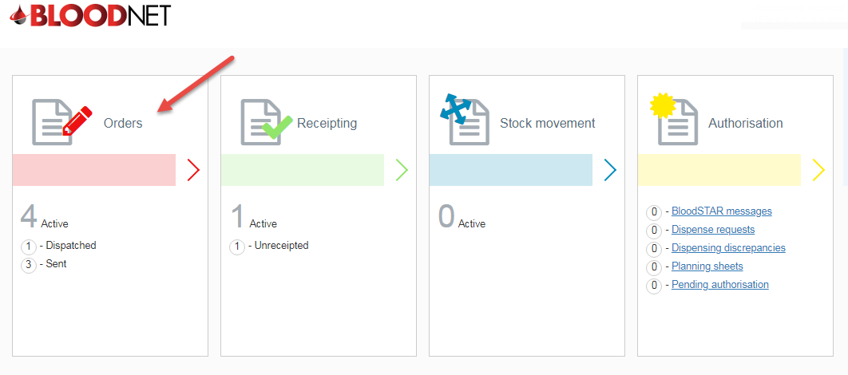
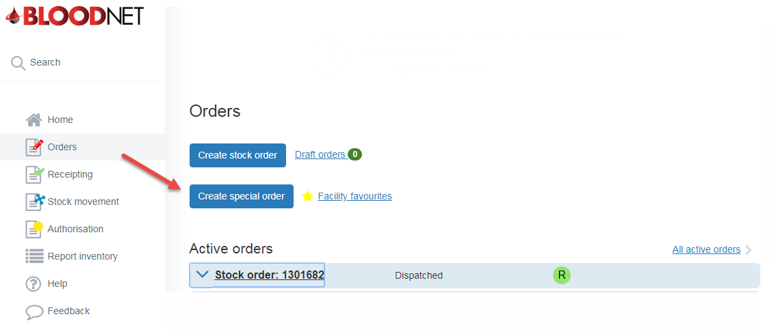
- Click the ‘Create Special Order’ button.

- Select the required urgency/priority of the order and add the required items by clicking ‘Add Component’ or ‘Add product’.
Please note: Fresh products are located in ‘Add component’ and manufactured products are located in ‘Add Product’.
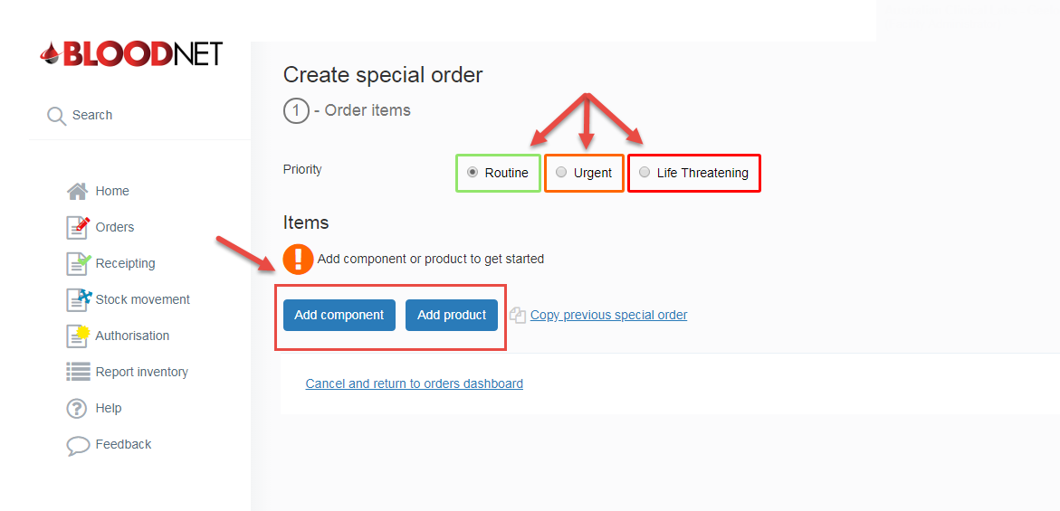
- Once the component/product is selected, fill in all the required information and click either ‘Save Component/Product’ or ‘Save or add another component/product’ if more items are required.
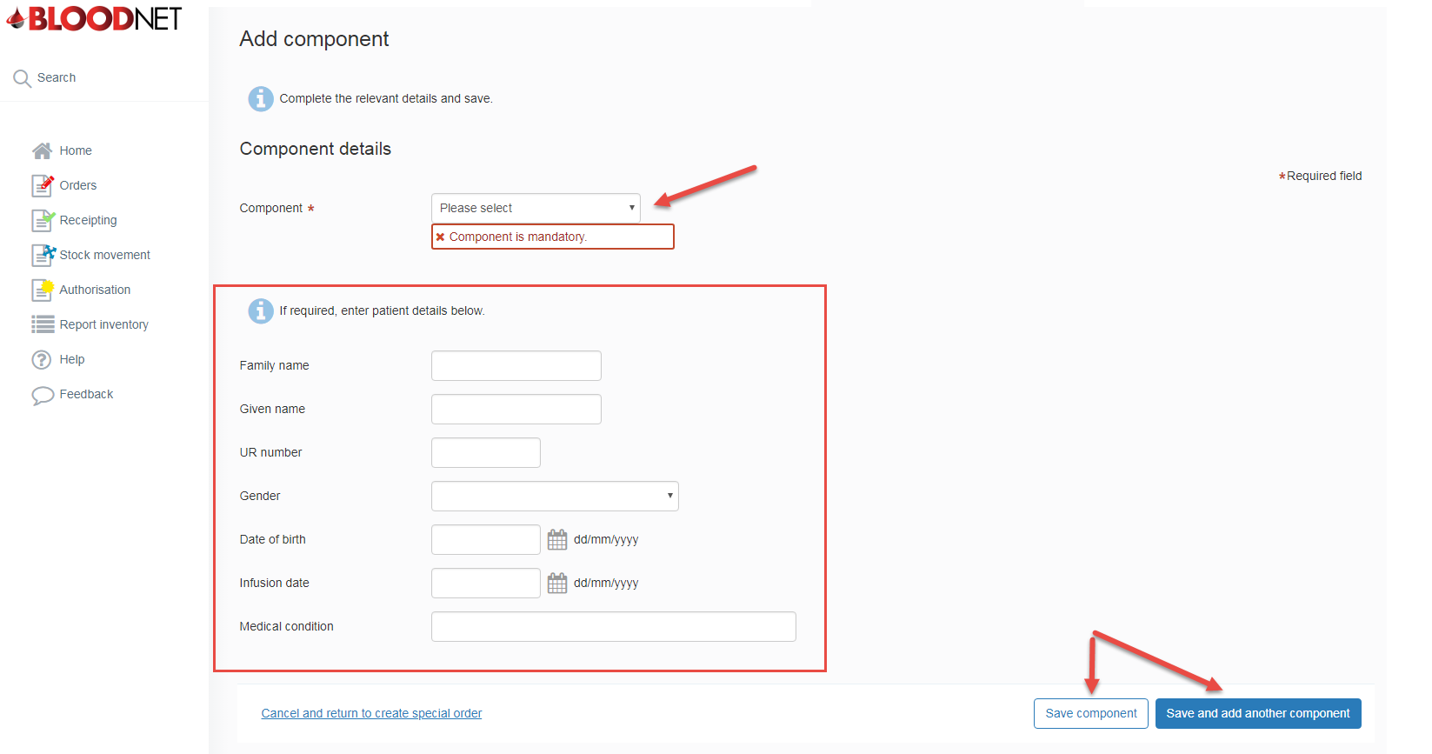

- Review the order details and edit or delete as required and then click ‘Next: confirm delivery details’.
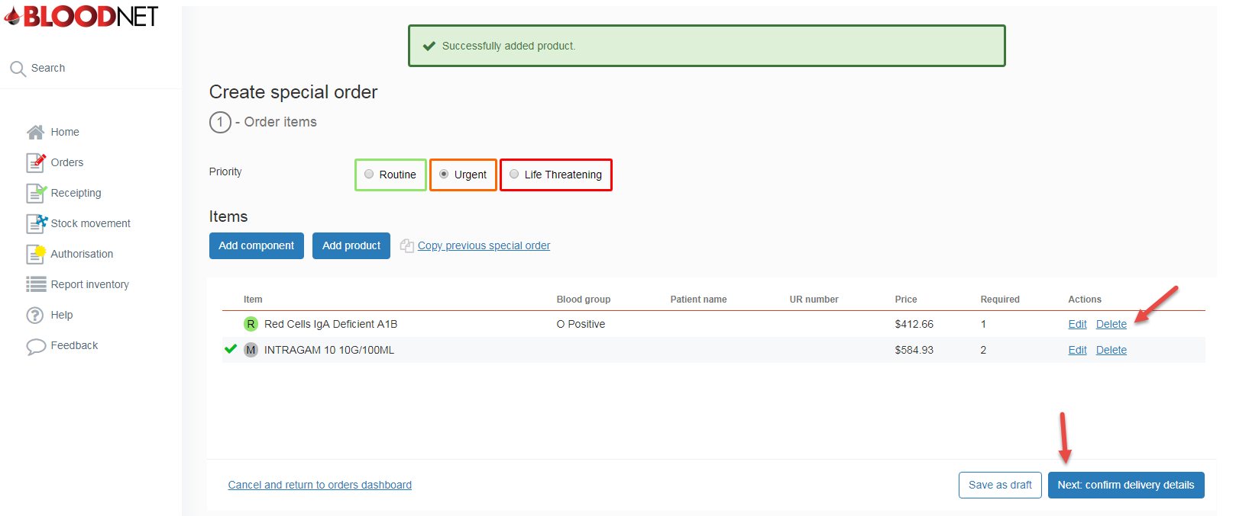
- Enter the delivery details, add any relevant order/delivery comments and ensure the order details are correct.
Please note: If you wish to edit the order, click on ‘Back to order items’ and amend the order as necessary.
- Click ‘Send order/Accept priority terms and send order’ to finalise and send the order to the Australian Red Cross Lifeblood. 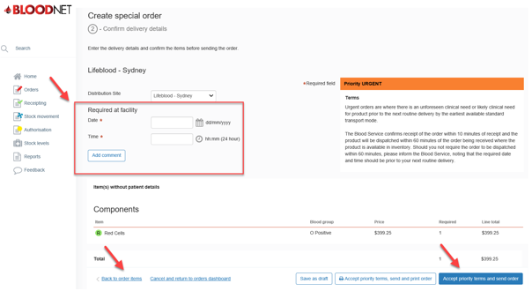
Important: If your order is Urgent or Life Threatening, you MUST select the appropriate priority in step 3. Do not write the priority in the comments box. All Urgent or Life threatening orders MUST be followed up with a phone call to your local Lifeblood Customer Delivery. Contact details are located on the top right of the BloodNet homepage.

