Creating a Stock Order Template - Tip sheet
Stock order templates provide a predefined list of components and manufactured products that can be ordered by a facility. A facility may have more than one template to facilitate creation of stock orders.
Please note: Only Facility Administrators have the ability to create templates.
- From the home page select ‘Templates’ located in the ‘Quick actions’ bar on the right side of the screen.
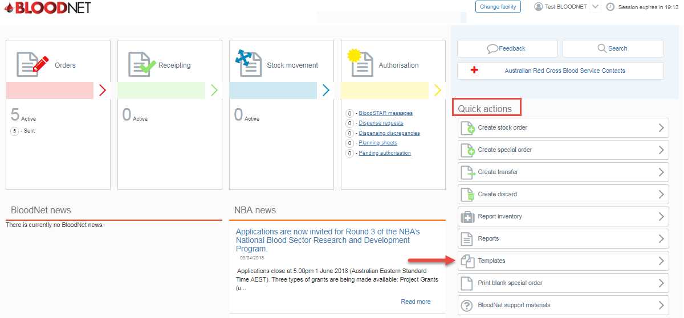
- You will find a list of your current templates which you can edit, print or delete by clicking on the links in the ‘Actions’ column.
Please note: You cannot delete your default template.
- Click ‘Create Template’ to proceed with your new template.
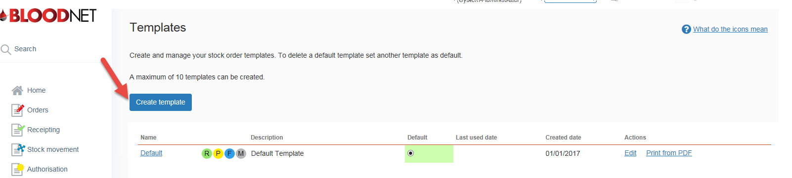

- Enter the ‘Name’ and ‘Description’ of your template in the template details section and select a ‘Distribution site’ if applicable.
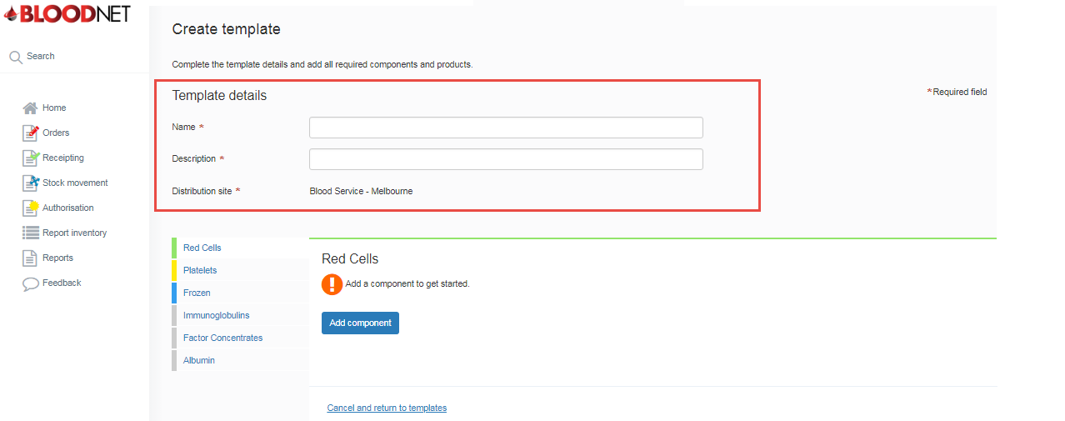
- Click on the type of product/component you would like to add to your template from the menu on the left of the screen. Once you have selected the product type click on the ‘Add component/add product’ button.
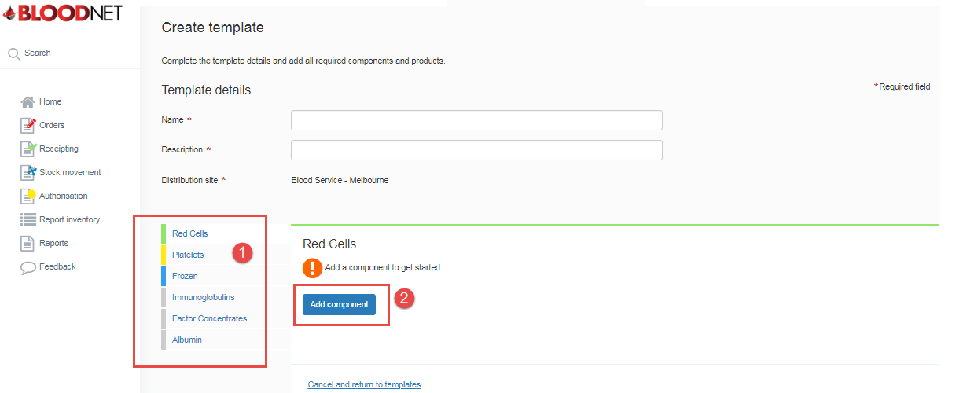
- Select the specific product/component you require from the available options and fill in all mandatory fields.
- You can now set your Max stock level, Minimum order quantity and Stock level alert (LIS facilities ONLY), however these fields are not mandatory.
- Click the ‘Save and add another component’ button to add more of the same product type to your template. Once you have added all the details of the product you want you can either click the ‘Save Component’ button to return to the create template page and finalise, or add other product types to your template.

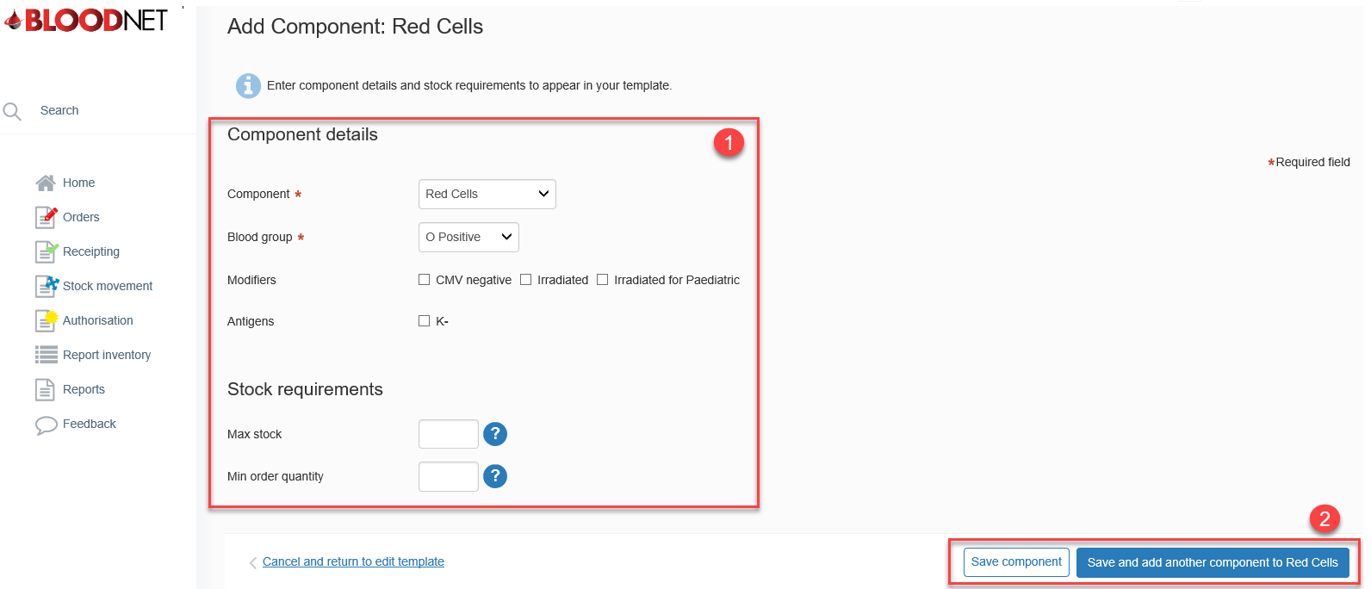

- Review your required product/components by clicking on the product/component type.
- You can change the order in which the items appear on the template by clicking on the up or down arrows.
- Click ‘Save template’ to finalise your template.
