Subcutaneous Immunoglobulin (SCIg) Product Dosing Request
Subcutaneous administration of immunoglobulin can be considered as an alternative to IVIg. The Criteria for Clinical Use of Immunoglobulin in Australia (Criteria) should be referred to for Medical Conditions/Indications that offer this method.
- If entering an initial authorisation request, complete all of the details as required, until the dosing section is reached. You can follow the instructions on the BloodSTAR – Initial Authorisation Request Tip Sheet.

- If entering a dose change request, follow the instructions on the BloodSTAR – Product or Dose Change Request until you reach the dose change request details section.

Please note:
The patient’s treating and/or administering facility will need to be listed as a SCIg approved facility in BloodSTAR to request subcutaneous dosing. Listing requirements, along with the facility list is available at https://www.blood.gov.au/SCIg.

- Enter the patient’s weight. If subcutaneous dosing is available for the chosen medical condition/indication, Subcutaneous Doses will be displayed below the Intravenous Doses section. Select the required dose by checking the box next to the dose name.
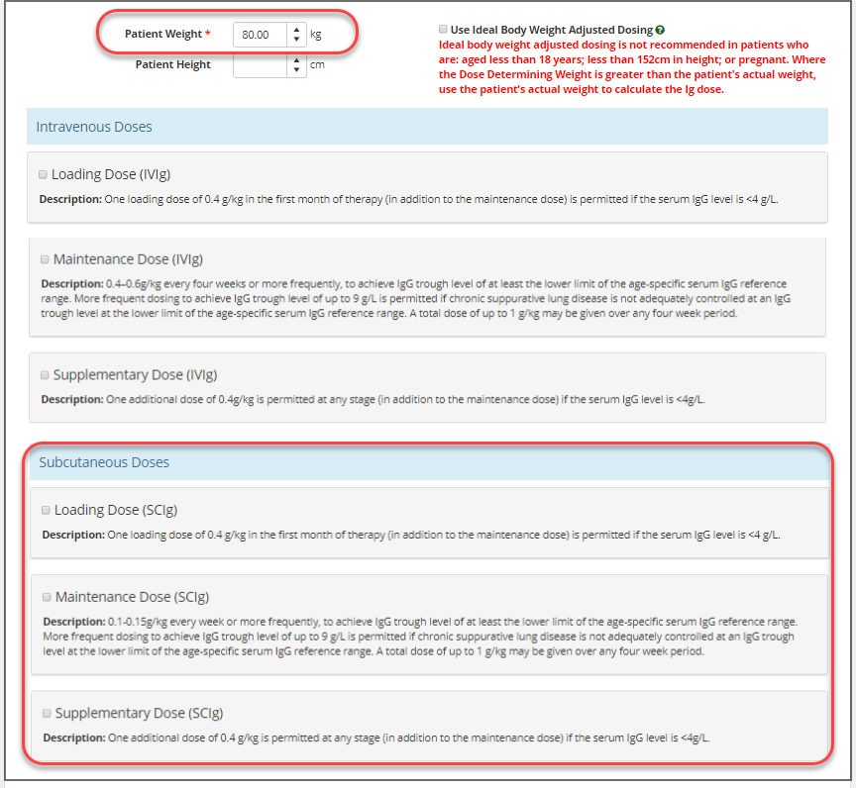

- Enter the relevant information for the Preferred Product, Dose / Kg, Frequency and Date Required.
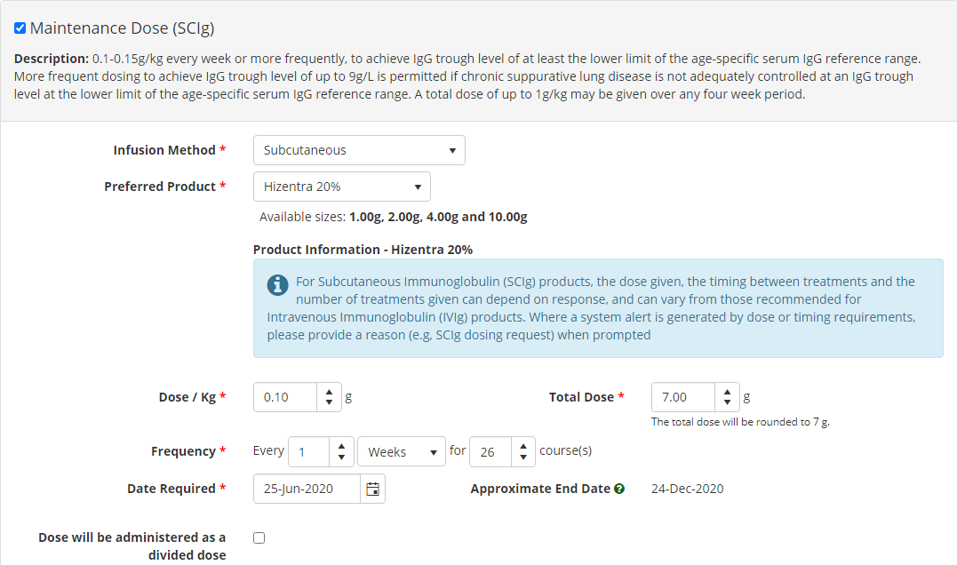
Tip: SCIg doses have helpful text below the Dose Name (e.g. Maintenance Dose (SCIg)) to assist with determining the dose and its frequency.
- If the dose and/or frequency you have selected is outside that allowed in the Criteria, you may be presented with a system alert message.
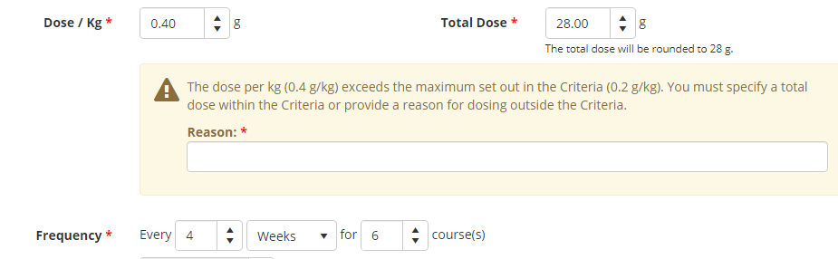
You will need to enter your required dose in weekly or fortnightly format to avoid this warning message. This also allows ease of dispensing.
Example:
A patient weighing 70kg requires a dose of 0.4g/kg every four weeks. To get the weekly dose, divide the dose per kg by four e.g. 0.4g/4 = 0.1g. This will give you the weekly dose per kg (i.e. enter 0.1g Every 1 week) and BloodSTAR will calculate the total dose (7g).

Tip: BloodSTAR also allows the total dose to be administered in divisions if the patient requires their weekly dose to be administered over several days.
- Once all required details have been entered, confirm your contact details and tick the box to indicate all information submitted is true and accurate to the best of your knowledge and then click Submit.

- Your request will be submitted to the Australian Red Cross Lifeblood authorisers for assessment. You will receive an email and an in-system notification when the request has been actioned.

