BloodSTAR - Management of Patients Moving or Travelling Interstate During BloodSTAR Transition

BloodSTAR will be rolled out progressively across the country between 14 July 2016 and 5 December 2016.
This document provides advice regarding what to do and/or who to contact when patients who have continuing authorisation to receive government funded immunoglobulin products travel or move between States and/or Territories where BloodSTAR may or may not have been implemented.

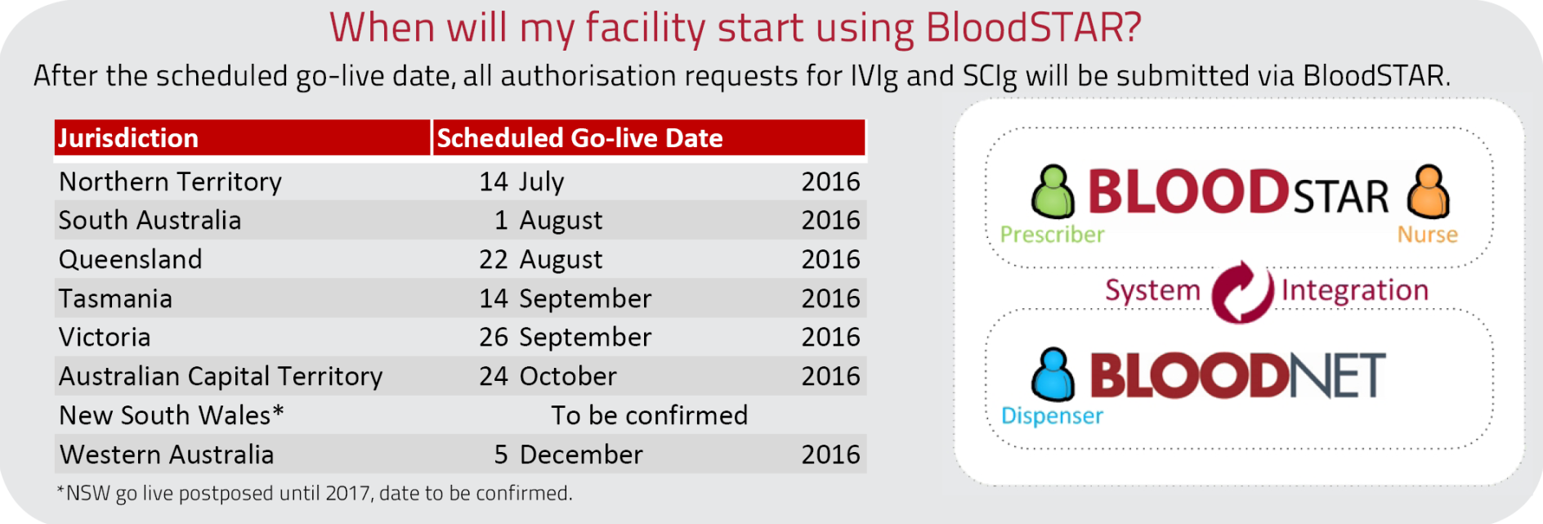

 | BloodSTAR LIVE State/Territory | BloodSTAR NON-LIVE State/Territory
Patient is currently in BloodSTAR State/Territory and travels to: | This patient’s Ig is easily managed in BloodSTAR and dispense recorded in BloodNET. Information available at www.blood.gov.au/bloodstar. | See process 1 of this tip sheet for how to manage this patient’s Ig treatment.
Patient is currently in a State/Territory not yet on BloodSTAR and travel to: | See process 2 of this tip sheet for how to manage this patient’s Ig treatment. | Existing processes for patient’s Ig treatment are followed.

Process 1:
Patient has travelled from a State/Territory which is already using BloodSTAR.
Step 1: Confirm that the patient has an active authorisation in BloodSTAR.
- If you are a Nurse or Medical Officer, contact:
  - your facility’s dispenser and ask them to search for the patient: OR
    - Dispensers in all State and Territories (regardless of the State/Territory BloodSTAR implementation status) can search for patients in BloodNet under Authorisation > Check Authorisation.
  - your local Australian Red Cross Blood Service (Blood Service) on the contact details listed below
- If you are a dispenser, search for the patient in BloodNet under Authorisation > Check Authorisation; this functionality is available even if your state or territory has not yet implemented BloodSTAR.

Step 2: Action the patient’s Ig request according to the following guidance in the table below.
Patient authorisation status | Patient is temporarily visiting | Patient is permanently moving
Active authorisation confirmed in BloodSTAR | Nurses/Medical Officers can find out required dosing information from the Dispenser or the Blood Service.  Dispenser will need to dispense the product using the Authorisation tab in BloodNet. A form outlining actions to take in BloodNet is available from the Blood Service. | Nurses/Medical officers should in the short term find out required dosing information from their Dispenser or the Blood Service. For long term planning for the patient they should contact the Blood Service for further advice on how to manage the patient’s authorisation for all future dispenses. Management of the patient’s authorisation record will depend on the scheduled BloodSTAR go-live date for your state or territory.  The outcome of if the patient will continue to be managed in BloodSTAR or not will need to be communicated to the Dispenser by the Blood Service.  Dispenser  1. If the patient is not going to be managed in BloodSTAR, follow your current process to dispense product.  2. If the patient is to be managed in BloodSTAR, you will need to dispense the product using the authorisation tab in BloodNet. A form outlining actions to take in BloodNet is available from the Blood Service.
No active authorisation in BloodSTAR | Medical Officer submits a new authorisation request as per the current process (for non-Live BloodSTAR Authorisation requests) using a paper-based form. Available at the National Blood Authority website (https://www.blood.gov.au/Ig-forms)

Process 2:
Patient has travelled from a State/Territory which is not yet usingBloodSTAR.
Note: A patient may have travelled in and out of a State/Territory currently using BloodSTAR during the staged roll out of the system. Medical Officers/Nurses should first check BloodSTAR to see whether the patient has an active authorisation. Dispensers (regardless of their State/Territory BloodSTAR implementation status) can search for authorised patients in BloodNet under Authorisation > Check Authorisation

Step 1: If the patient does not appear in BloodSTAR, contact your local Blood Service as patient may still have an active authorisation recorded in the Blood Service system (STARS).

Step 2: Action the patients Ig request according to the following guidance in the table below.
Patient authorisation status | Patient is temporarily visiting | Patient is permanently moving
Active authorisation confirmed in BloodSTAR | Use the patient’s existing BloodSTAR authorisations.  Medical Officers to submit any dose change requests and/or review outcomes.  Nurses to manage the patient’s infusion schedule and submit dispense requests.  Dispensers to dispenser product against the patient’s authorisation in BloodNet.
Active authorisation confirmed in STARS | Dispenser should contact their local Blood Service to obtain authorisation details for this patient. The dispenser will need to dispense product to the patient using their laboratory information system (LIS) only, not in BloodNet. | Medical Officer should contact their local Blood Service for further advice. The patient’s existing authorisation record will need to be entered into BloodSTAR by the Blood Service.
No active authorisation for the patient | Submit a new authorisation request using BloodSTAR.

AUSTRALIAN RED CROSS BLOOD SERVICE CONTACT DETAILS
STATE | FOR ENQUIRIES | FAX TO:
NSW | 1300 478 348 (After Hours: 1300 478 348) | 02 9234 2050
ACT | 1300 478 348 (After Hours: 0411 095 344) | 02 9234 2050
NT | 08 8928 5116 (After Hours: 08 8223 6090) | 08 8927 5461
QLD | 07 3838 9223 (After Hours: 07 3838 9010) | 07 3838 9421 (8:30am-4:30pm) or 07 3838 9400
SA | 08 8112 1341 (After Hours: 08 8223 6090) | 08 8223 5833 (After Hours: 08 8232 5741)
TAS | 03 6215 4122 (After Hours: 08 8223 6090) | 03 6215 4197
VIC | 03 9694 0200 (After Hours: 03 9694 0200) | 03 9694 0245
WA | 08 9421 2377 (After Hours: 08 9325 3030) | 08 9221 1215

National Blood Authority contact details:
Phone: 13000 BLOOD (13000 25663)
Email: support@blood.gov.au

