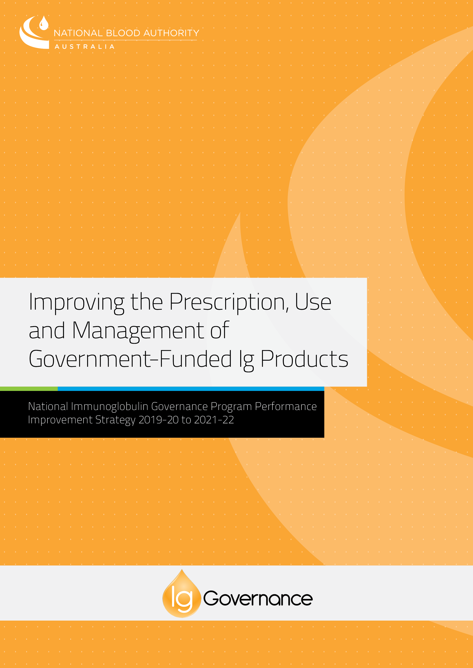

**CONTENTS**

1. INTRODUCTION 3

2. BACKGROUND 4

2.1 The Need for Ig Governance in Australia 4

2.2 Framework for Access to Ig 5

2.3 Accessing Government-Funded Ig 7

2.4 Effect of Ig Governance 8

3. A STRATEGY TO DRIVE IMPROVEMENT 10

4. PATHWAYS TO PERFORMANCE MANAGEMENT 12

4.1 Education and Support 12

4.2 Communications and Relationships 13

4.3 Program Assurance and Policy Compliance 14

4.4 Knowledge Development 16

4.5 Enhancing Current Policy and Access Arrangements 18

5. ROLES AND RESPONSIBILITIES OF STAKEHOLDERS 20

6. TIMING 21

7. PRIORITISATION OF ACTIVITIES 21

8. MEASURING PROGRESS AGAINST THE PERFORMANCE AREAS 22

REFERENCES 23

1. INTRODUCTION

The national Immunoglobulin (Ig) Governance Program was introduced in 2014 and is now firmly established in Australia. Over the past four years, major policy and processes have been developed and implemented as part of this program, and the Criteria have been systematically updated for promulgation using the national system BloodSTAR. The National Blood Authority (NBA) is now focussing efforts to systematically and comprehensively evaluate the effectiveness of program measures, assess compliance with policy requirements, identify areas where improvements can be made, and undertake activities to drive improvement.

This document describes a strategy to improve the prescription, use and management of government-funded Ig products accessed through the National Ig Governance Program (Performance Improvement Strategy). It has been developed to communicate the NBA’s intended approach to enhance various aspects of the National Ig Governance Program and improve performance through focussed activities. Five pathways are described in this document, each comprising projects and activities which will be implemented in an effort to meet objectives in five performance areas.

The approach outlined in this document will further strengthen governance, drive improvement in the prescription, use and management of government-funded Ig products and support the program to continue to deliver against agreed objectives over the coming years.

|  |
| --- |
| Acknowledgement  The NBA wishes to acknowledge the valuable contributions and feedback provided by our stakeholder groups, clinicians and patients and thanks them for their ongoing contribution to the use and management of Ig. |

2. BACKGROUND

2.1 The Need for Ig Governance in Australia

Ig products offer significant therapeutic benefit to people with various chronic and acute medical conditions where immune replacement or immune modulation therapy is indicated. However Ig is a high cost blood product and the demand for use in Australia, per capita is amongst the highest in the world (see **Figure 1**).

Demand for Ig in Australia has been growing at an average 11% for at least the last ten years (see **Figure 2**)1. Ig products account for the largest component of the blood budget and increasing product use is expected in the future. This rate of increase is disproportionate to other health care costs. In 2017-18, a total of 6.13 million grams of Ig was issued in Australia representing a cost of $582.3 million (including the cost of plasma collection) which represents 49% of the national budget for blood products (see **Figure 3**) 1.

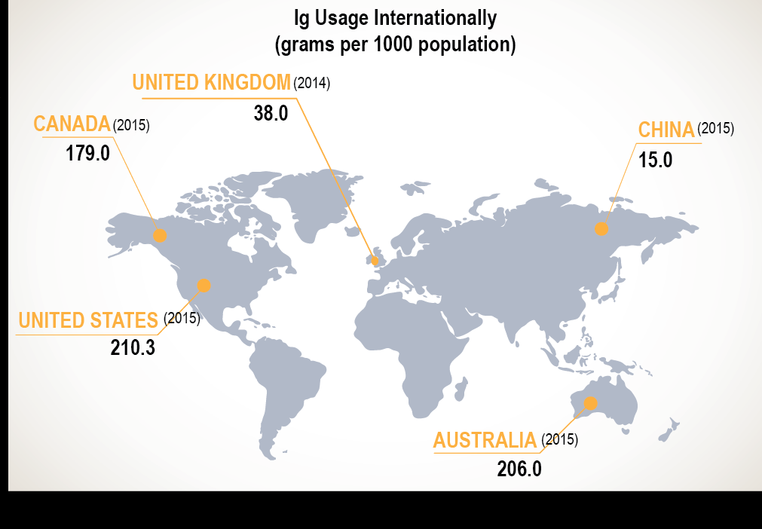

**Figure 1: Snapshot of Ig usage internationally2**

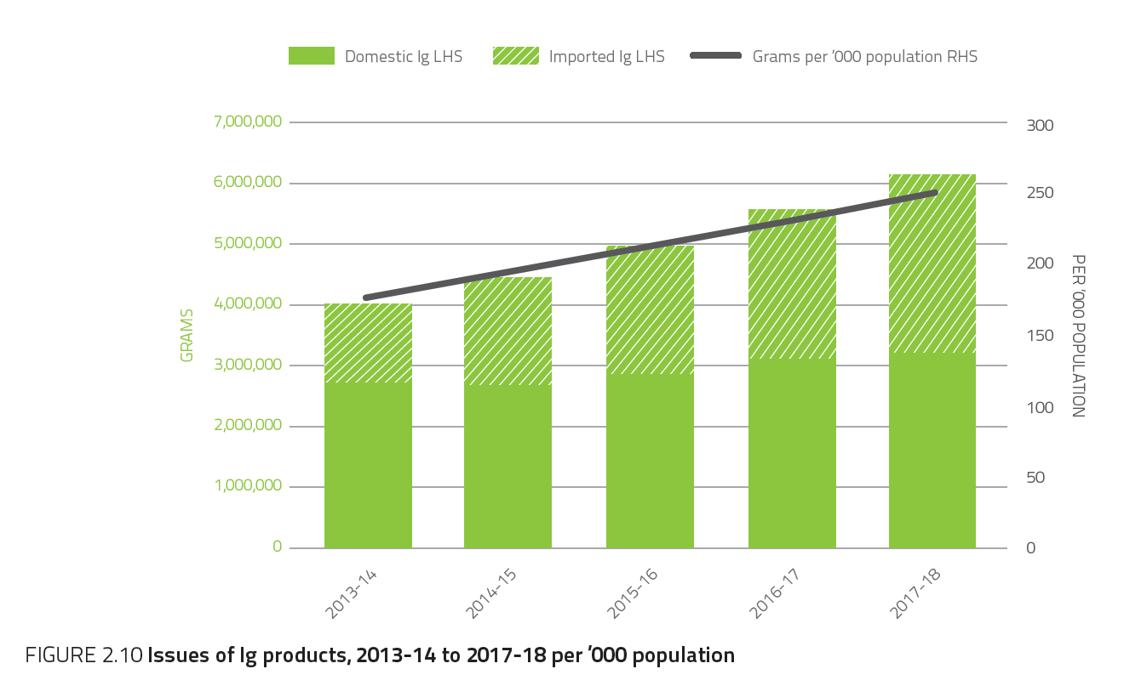

**Figure 2: Issues of Ig products per 1000 population1**



**Figure 3: Ig component of the national blood budget 2017-183**

While national supply arrangements have ensured Ig availability for those who need it, to safeguard sustainability well into the future, Australian governments have endorsed a program of activities focused on improving the governance and management of government-funded Ig products. This approach is consistent with the approach taken for many other high cost treatments in Australia.

Managed by the National Blood Authority, the national Ig Governance Program was introduced in 2014 to pursue governments’ objectives for Ig products funded and supplied under the national blood arrangements, namely to:

* ensure Ig product use and management reflects appropriate clinical practice and represents efficient, effective and ethical expenditure of government funds, in accordance with relevant national safety and quality standards for health care;
* ensure that access to Ig products is consistent with the criteria for access determined by governments; and
* improve the capture of information of the need for, use of, and outcomes of treatment with Ig products to inform future decisions.

The objective of the National Ig Governance Program is to ensure government-funded Ig products are directed to patients who are most likely to benefit based on reliable evidence, using the lowest effective dose, and where alternative therapies are limited. Driven by sustainability objectives, robust governance processes have been established to achieve this objective and promote consistency in access across Australia. Where eligibility criteria are met and the prescription, use and management of Ig are consistent with national policy requirements, Ig products are supplied at no direct cost to the patient. Instead, the cost of these products is met by all Australian governments under the national blood arrangements.

Patients that do not meet eligibility criteria may be able to access Ig products through local arrangements, otherwise known as a [Jurisdictional Direct Order](https://www.blood.gov.au/Intravenous-Ig#2. Direct order and other supply arrangements) depending on their situation. Where this occurs, the cost is met by the jurisdiction, the local health service, insurer, or the individual in accordance with local policies and procedures.

2.2 Framework for Access to Ig

The NBA is responsible for administering the National Ig Governance Program which includes the development and maintenance of a national framework to access government-funded Ig. The current framework comprises a National Policy, Criteria for access, and BloodSTAR, a national online system (see **Figure** **4**).

Jurisdictions have agreed to the framework developed by the NBA and in accordance with the National Blood Agreement, have a role in implementation. State and Territory Governments are each responsible for managing the day to day activities related to Ig products in their jurisdiction, including ensuring Ig products are prescribed, dispensed and used in accordance with legislated state or territory requirements. Within each jurisdiction, all individuals and facilities involved in the process of prescribing, requesting, authorising, supplying, dispensing, and administering Ig products have allocated roles and responsibilities introducing stakeholder accountability into the process of managing Ig products.

**Access Framework Components**

**Figure 4: Framework of the National Ig Governance Program**

#### The National Policy

The *National Policy: Access to Government-Funded Immunoglobulin Products in Australia* (National Policy) sets out the process that must be followed and describes the rules and requirements that must be complied with to access government-funded Ig products in Australia. The National Policy supports all those involved in the prescription, use and management of Ig to understand their roles and responsibilities under the governance arrangements.

#### The Criteria

The *Criteria for the clinical use of Immunoglobulin* *in Australia* (the Criteria) identify the conditions and circumstances for which the use of Ig is considered to be clinically appropriate and for which Ig products are able to be accessed under the National Policy.

Developed by the NBA in collaboration with specialist clinicians in the areas of neurology, immunology, haematology and transplant medicine, the Criteria are based upon a systematic review of the evidence available and expert opinion. The Criteriawere first published in 2007 and undergo regular review. The most recent revision was released in October 2018 and is referred to as Version 3 of the Criteria.

#### BloodSTAR

Introduced in 2016, BloodSTAR (**Blood** **S**ystem for **T**racking **A**uthorisations and **R**eviews) was developed by the NBA on behalf of all Australian Governments to serve the needs of health providers and support users to meet their obligations under the National Policy.

Through BloodSTAR, Prescribers can request patient authorisation for access to government-funded Ig. Under the governance arrangements, Dispensers may only dispense product to patients with an active authorisation in BloodSTAR. Nurses and Midwives can request product from Dispensers through BloodSTAR (see **Figure 5**).

BloodSTAR streamlines the authorisation process, reduces variability and standardises prescribing practices, and increases efficiency and transparency while strengthening decision-making and improving data capture.

2.3 Accessing Government-Funded Ig

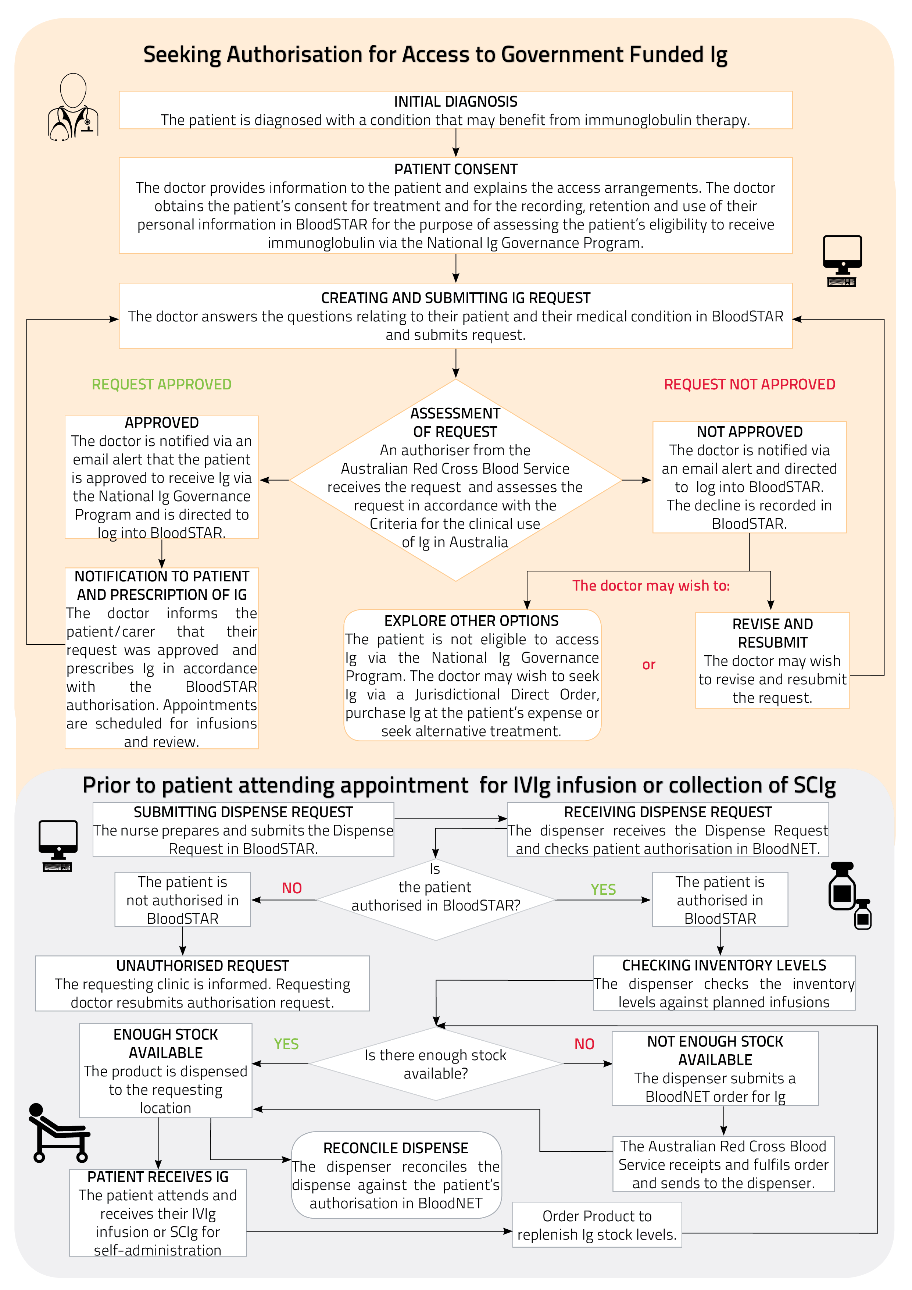**Figure 5: Outline of process to access government-funded Ig**

2.4 Effect of Ig Governance

Since its establishment, the National Ig Governance Program has undertaken a range of activities in an effort to meet program objectives and improve the governance and management of government-funded Ig. A timeline of key activities that have been delivered since the introduction of the program are outlined in **Figure 6**.



**Figure 6: Timeline of achievements through the National Ig Governance Program**

Robust policies and processes govern the prescription, use and management of government-funded Ig and have been developed through transparent processes. These established mechanisms provide confidence that Ig is directed consistently across Australia, to patients most likely to benefit based on reliable evidence, using the lowest effective dose, and where alternative therapies are limited. However assurance of policy and process compliance is necessary and a mechanism to evaluate this is needed. The development of educational tools and resources is one of a several activities proposed in the Performance Improvement Strategy that are expected to promote compliance.

The Criteria have been developed to clearly describe the diagnostic and eligibility requirements to access government-funded Ig. Based on current evidence and expert opinion, the Criteria will need to undergo continuous evolution in response to emerging research outcomes on the effectiveness of Ig therapy. Enhancements to the Criteria will continue to be made through clear and transparent processes.

There are currently approximately 12,000 registered users of BloodSTAR, and this number is continually growing. System enhancements and upgrades will continue and improve user experience, ensure the system is fit for purpose and continues to support the National Ig Governance Program. Through BloodSTAR, the NBA now has the ability to capture better quality data which will inform future planning and policy development, and provide those responsible for supporting Ig governance compliance with information that will identify, for example:

* differences in treatment between conditions, hospitals, clinicians and jurisdictions;
* accurate stock level requirements; and
* consistency of Ig use across conditions, hospitals, clinicians and jurisdictions.

The development of enhanced reporting capability is necessary to maximise the benefits of this improved data and ensure nationwide transparency.

3. A STRATEGY TO DRIVE IMPROVEMENT

The National Immunoglobulin Governance Program Performance Improvement Strategy 2019‑20 to 2021‑22 (the Strategy) has been developed by the NBA to strengthen Ig governance, drive improvement in the prescription, use and management of Ig products and support the National Ig Governance Program to continue to deliver against agreed objectives (see **Figure 7**).

The Strategy promotes a nationally consistent approach to monitoring performance and identifying obstacles and challenges to performance. As part of the Strategy, the NBA will develop tools and mechanisms to promote continuous improvement amongst all those involved in the prescription, management and use of government-funded Ig products. Where issues are identified, the NBA will develop and implement solutions. The centralised governance of Ig at a national level, together with the ability to capture robust data through BloodSTAR provides a sound foundation to progress the activities identified.

The 5 key performance management areas which set the objectives for this strategy are as follows:

1. Provision of Ig reflects appropriate clinical practice
2. Uniform compliance with the National Policy
3. Local Ig governance arrangements are robust and align with relevant standards, guidelines and legislative requirements
4. Service delivery provided to support appropriate management and use of Ig (by the NBA and agencies contracted by the NBA) is efficient and effective
5. Collection of data supports future work

The pathways that will drive improvement across the performance areas listed above are as follows:

1. Education and Support
2. Communications and Relationships
3. Program Assurance and Policy Compliance
4. Knowledge Development
5. Enhancement of Policy and Access Arrangements

Within each pathway, discrete projects and tasks have been identified and include specific deliverables that will be reported on. Each of the tasks identified align with the goals of the Performance Improvement Strategy through one or more of the performance areas. The NBA aims to undertake these tasks in three stages, according to priority, available resourcing, and sequential dependency, commencing immediately and continuing through to June 2022. The strategy will by dynamic and iterative and will be adapted to reflect progress throughout.

In line with this process, the timing indicated against each of the activities within the pathways, is intended to represent a general order in which they may be addressed, and is a result of high level planning against a number of dependencies (such as staffing and data availability). The timing may change where opportunities arise and in relation to the progression of any related activities or dependencies.

3.1 Overview of the Performance Improvement Strategy

**Figure 7: Description of Performance Improvement Strategy Performance Areas and Pathways**

4. PATHWAYS TO PERFORMANCE MANAGEMENT

A number of pathways exist to facilitate improvement in each of the key performance management areas. The NBA will work collaboratively with all Australian governments and other stakeholders to progress a number of activities within each pathway.

4.1 Education and Support

**Table 1** outlines the education tools and materials that will be developed and implemented to support health professionals that are involved in the prescription, use and management of Ig to patients, and whom have specified roles and responsibilities stipulated in the National Policy. Delivery will be via a range of different platforms to promote uptake including but not limited to online learning, electronic resources, information sheets, conference presentations, and journal publications.

**Table 1: Education and support activities to be progressed as part of the Performance Improvement Strategy**

|  |  |  |  |  |
| --- | --- | --- | --- | --- |
| **Activities** | | **2019-20** | **2020-21** | **2021-22** |
| General Education | Online education module on Ig governance arrangements | × |  |  |
| Webinars on Ig governance and BloodSTAR | × |  |  |
| BloodSTAR user videos |  | × |  |
| Tailored Education | Conference presentations and posters | × | × | × |
| Publications in specialist medical journals |  | × | x |
| Educational pop-up slides in BloodSTAR |  | × | x |
| Ig therapy case studies |  | × |  |
| Guidance on compliance with Ig governance and NSQHS Standards | × |  |  |
| Prescribing and dispensing to reduce unnecessary waste | × |  |  |
| Support Materials | Patient information sheets | × |  |  |
| Conversation tools for clinicians and nursing staff (when providing information to patients) | × |  |  |
| Patient notification of authorisation end date | × |  |  |
| Collaboration with Suppliers in development of support materials | x | x | x |

Through this element of the Strategy, the NBA aims to promote awareness and understanding of Ig governance arrangements including why such an approach is necessary in Australia, and the processes that must be followed for a patient to access Ig products under national blood arrangements. A thorough understanding of the roles and responsibilities of those involved in Ig governance and current access arrangements will be a key learning objective. Support materials will be developed to promote compliance with particular policy requirements and ensure effective understanding of the roles and responsibilities of those involved in processes.

General education and training material will be developed for a wider audience and will primarily focus on current Ig usage trends, the objectives of the Ig Governances Program, and the shared responsibility of policy makers, hospital and health facility management, health professionals, product suppliers and the general public to contribute to achieving a sustainable supply of Ig in Australia.

Tailored education and training material will be developed to support particular health professionals to fulfil their roles and responsibilities or to support particular aspects of Ig governance and access arrangements identified as needing a separate approach. The following aspects have been identified as requiring a tailored approach and will be progressed initially under the Performance Improvement Strategy:

* appropriate dose reduction of Ig dose, weaning and trial cessation of treatment – education and support for clinicians and patients;
* seeking informed consent from patients for treatment and to collect personal and sensitive information for the purposes of assessing eligibility – education and support for clinicians and patients; and
* accordance with National Safety and Quality Health Service Standards, in particular the Blood Management Standard – education and training for health professionals.

Support materials will be developed for prescribers specifically as well as those for clinicians and nursing staff to provide to patients. Patient information materials can be used to complement information provided during consultations. Enabling patient notification of authorisation end dates, by generating a printable patient treatment plan from BloodSTAR, will empower patients on long term Ig therapy to be proactive about managing appointments with their specialists.

The NBA will draw on the expertise available through the network of committees to develop education and training tools and support material. The membership of the network of committees includes medical specialists, nurses, dispensers, authorisers and patient representatives. The NBA may also outsource some of this work through contractual arrangements with experienced educators. The NBA will collaborate with and support Suppliers in the development of their own customer support materials.

4.2 Communications and Relationships

Over the next three years, the NBA will undertake planned communication activities to enhance awareness and understanding of Ig governance arrangements amongst health professionals and patients, convey key messages to stakeholders, strengthen current relationships and broaden international networks (see **Table 2**).

Communication activities progressed through this program of work will focus on three key stakeholder groups:

* health professionals that are involved in the prescription, use and management of Ig to patients (working in both the public and private sectors);
* policy makers, hospital and health facility management, and government representatives responsible for implementing and supporting Ig governance policy; and
* patients and their representatives.

Communication activities that aim to enhance awareness and understanding of Ig governance arrangements will encompass a range of different formats including written communications such as newsletters and publications, visual communications such as charts and graphs, and verbal communications such as engaging with stakeholders at conferences and meetings.

Campaigns will also be designed and implemented to target specific groups of health service organisations and draw attention to, and drive changes in behaviour for specific issues. These campaigns will be undertaken in collaboration with state and territory governments and other stakeholders where relevant.

**Table 2: Communications and relations to be progressed as part of the Performance Improvement Strategy**

|  |  |  |  |  |
| --- | --- | --- | --- | --- |
| **Activities** | | **2019-20** | **2020-21** | **2021-22** |
| Raise awareness and understanding of Ig Governance and communicate key messages | Newsletters on Ig governance, access arrangements, and other news | x | x | x |
| Website material reviewed and updated regularly | x | x | x |
| Promote education, training and support materials developed in pathway 1 | x | x |  |
| Conference attendance, presentations and posters | x | x | x |
| Publish usage data and statistics on Ig use on website and in relevant medical journals | x | x | x |
| Promote Ig Governance campaigns targeting specific issues | x | x | x |
| Build and maintain relationships | Initiate communications with international counterparts to develop new relationships | x |  |  |
| Support the network of committees | x | x | x |
| Strengthen current relationships and build new relationships with stakeholders involved in the management and use of Ig nationally | x |  |  |
| Strengthen current relationships with jurisdictions | x |  |  |
| Attend conferences and meetings | x | x | x |
| Encourage stakeholder feedback and respond to enquiries and issues in a timely manner | x | x | x |

Several key messages have been identified as a priority for initial communication activities.

These include:

* Australia is the second highest user per capita in the world2;
* Ig is a high cost blood product and therefore governments need assurance through good governance that expenditure is justified;
* the National Policy and access arrangements have been put in place to provide that assurance;
* all Ig product must be traceable and accounted for and mechanisms to reduce unnecessary wastage must be identified; and
* the reporting of treatment outcomes in BloodSTAR is important to facilitate ongoing patient treatment and informing future Criteria revisions and access arrangements.

In addition to key messages already identified through various stakeholder engagement activities, additional messages are expected to be identified via various projects and will be prioritised accordingly.

The NBA will work in collaboration with the Ig Governance Program’s network of committees when developing these communications. The network comprises community representatives, medical officers and medical specialists, nurses (including midwives), dispensers and representatives from the Blood Service and other suppliers and state and territory governments. Collaborating with these representatives will support the development of high quality communications using formats and styles that are both appealing and easy for the intended audience to absorb.

Members of the Ig Governance Program’s National Immunoglobulin Governance Advisory Committee and Specialist Working Groups will play a particularly important role in the delivery of some communication activities. For example, committee members who are medical specialists and nurses will partner with the NBA to present at national conferences, champion key messages, and support targeted campaigns rolled out to address specific issues.

Solid working relationships with key stakeholders can drive successful outcomes, and the NBA intends to focus efforts on strengthening current relationships as well as developing new relationships as part of this strategy. NBA presence at relevant conference and meetings will support this work together with a commitment to communicating openly with stakeholders and responding to enquiries in a timely manner. The NBA will continue to support the network of committees and strengthen its relationship with governments responsible for implementing Ig policy in Australia by communicating openly and regularly, and working collaboratively to identify, understand and resolve issues relating to Ig governance as they arise.

The NBA is establishing relationships and communication channels with international agencies and governments to develop a network of international connections and facilitate discussion, awareness and understanding of the challenges encountered by agencies responsible for developing Ig guidelines and managing Ig programs globally.

4.3 Program Assurance and Policy Compliance

Activities to be progressed through this pathway (shown in **Table 3**) aim to provide assurance that the Ig Governance Program is successfully directing government-funded Ig products to patients that benefit, policy principles are complied with and that the program represents efficient, effective and ethical expenditure of government funds. The availability of robust data and high quality data analysis will guide this work.

Through data evaluation activities, the impact of the Ig Governance Program can be quantified and the NBA can be assured that program goals, including the objectives of the Performance Improvement Strategy are being achieved. Data collection and evaluation will also identify further areas where the program can be strengthened.

Over the next three years, the NBA will continue to collect information via BloodSTAR and BloodNET and identify additional data requirements that can be captured through these systems. The collection of quantitative data through these systems will continue to provide the information required to determine usage and identify usage trends, identify variations in usage, evaluate the effect of policy changes and the impact of the program more generally.

**Table 3: Program assurance and policy compliance activities to be progressed as part of the Performance Improvement Strategy**

|  |  |  |  |  |
| --- | --- | --- | --- | --- |
| **Activities** | | **2019-20** | **2020-21** | **2021-22** |
| Data collection | Continue to collect data on Ig usage via the NBA Blood Sector Systems (e.g. BloodSTAR and BloodNet) | x | x | x |
| Support prescribers to report on patient outcomes and effectiveness of Ig treatment via BloodSTAR | x |  |  |
| Identify additional data needed to support the Ig Governance Program |  | x |  |
| Design and implement surveys and audit tools to collect additional data |  | x |  |
| Design and implement changes to BloodSTAR to collect additional data |  | x |  |
| Analyse data | Analyse usage data to evaluate effect of policy changes, identify trends, understand variation in practice, and inform supply planning | x | x | x |
| Analyse outcome data and use it to inform future policy improvements |  | x |  |
| Analyse data to provide assurance of compliance with the National Policy and Access Arrangements | x | x | x |
| Analyse data to provide assurance of progress towards Strategy goals and to inform future Ig Governance Program improvements |  | x | x |
| Analyse data for benchmarking and assessment of performance indicators | x | x | x |
| Reporting | Continue to develop an annual report with detailed statistics on Ig usage in Australia | x | x | x |
| Report on a small subset of Ig usage statistics monthly via the NBA website | x | x | x |
| Design and develop additional internal and external user reports to promote visibility of program impact and success | x | x | x |
| Design and develop reports to promote visibility and transparency of current prescribing practices | x | x | x |
| Support stakeholders to resolve compliance issues | Identify areas of high performance and communicate these to jurisdictions/stakeholders as appropriate |  | x | x |
| Identify areas for improvement and communicate these to jurisdictions/stakeholders as appropriate |  | x | x |
| Work with jurisdictions/stakeholders to address issues | x | x | x |
| Develop tools and resources to support performance improvement | x | x | x |
| Review areas where improvement is required and provide feedback on progress | x | x | x |

Collection of data will inform the early development of national benchmarking and performance indicators, to be published iteratively as an addendum to this document, and can inform future policy improvements including revisions to the Criteria. This can be achieved in part by circulation of nationally consistent reports, and analyses based on identified performance indicators, to multiple levels of stakeholders. Additional data, particularly data of a qualitative nature may need to be collected through other mechanisms including but not limited to, reports, surveys, questionnaires and audits to understand trends observed in the data and evaluate policy compliance. The NBA will continue to focus efforts on enhancing reporting activities to promote transparency, increase awareness and promote interest in monitoring Ig usage and trends. A framework of cascading reports will be developed to support monitoring and review of program outcomes, and to highlight current prescribing practices. Reports will draw out similarities and differences between comparable health providers with the view to informing benchmarking activities.

Following the collection and analysis of data generated through the program, areas of high performance and excellence in compliance will be identified and communicated to stakeholders. Where performance is found to require improvement, or compliance with policy is found to be poor, the NBA will support jurisdictions and other relevant stakeholders to actively address these issues.

4.4 Knowledge Development

Knowledge development activities will support further policy development in the future, promoting a sustainable Ig Governance program and enabling the program to be responsive to change, including in response to new advances in research (see **Table 4**).

Activities that will be progressed over the next three years will focus on identifying knowledge gaps, actively working to close knowledge gaps where this aligns with the remit of the NBA, keeping abreast of advances in research and policy nationally and internationally, and assessing new knowledge to determine whether changes to policy and practice are warranted.

To identify knowledge gaps, the NBA will continue to work with the national network of committees established to support the Ig Governance Program and with governments and key stakeholders. The specialist members appointed to the Specialist Working Groups in particular, are well placed to identify areas or questions where further knowledge is needed to support informed decision making both at the clinician level and the system-wide management level. A number of knowledge gaps have already been identified through the Specialist Working Groups and will be explored further to determine whether there is a role for the NBA to address these.

Having identified knowledge gaps, the NBA can actively work to close these gaps where it aligns with the remit of the NBA. For example, where research is identified as a mechanism necessary to fill a knowledge gap, the NBA may be able to provide research support to skilled and experienced researchers through its Research and Development Program. Other gaps in knowledge may be filled through consultation with relevant groups or through data collection, analysis and reporting. Where necessary and appropriate, these tasks may be undertaken by the NBA or outsourced through contractual arrangements.

The first knowledge gap to be progressed under this strategy is to better understand current variations in Ig usage in Australia and to determine whether these variations are acceptable or whether there is a need for the NBA to take action to reduce the variation. The NBA will engage with state and territory governments as well as private sector clinics to better understand these variations in the first instance.

**Table 4: Knowledge development activities to be progressed as part of the Performance Improvement Strategy**

|  |  |  |  |  |
| --- | --- | --- | --- | --- |
| **Activities** | | **2019-20** | **2020-21** | **2021-22** |
| Identify knowledge gaps | Work with governments, the network of committees and key stakeholders to identify research needed to support Ig Governance |  | x | x |
| Work with governments, the network of committees and key stakeholders to identify research translation activities needed to support Ig Governance |  | x | x |
| Work with governments, and the network of committees to identify knowledge and information needed to support Ig Governance |  | x | x |
| Close knowledge gaps | Continue to fund research through the NBA’s National Blood Sector Research and Development Program | x | x | x |
| Work with key stakeholders to better understand variations in Ig use | x | x | x |
| Design, implement and contribute to activities to close identified knowledge gaps | x | x | x |
| Keep abreast of advances in research and policy | Enhance Horizon Scanning activities to gather news and information on Ig | x |  |  |
| Use communication channels to gather news and information on Ig | x | x | x |
| Monitor Australian policy and trends | x | x | x |
| Monitor international policy and trends | x | x | x |
| Monitor research outputs | x | x | x |
| Identify new knowledge relevant to current Ig policy an practice | x | x | x |
| Consider and assess new knowledge | Evaluate and consider research outcomes |  | x | x |
| Evaluate and consider new knowledge |  | x | x |
| Discuss new knowledge with relevant stakeholders to determine whether changes to policy and practice are warranted |  | x | x |

Keeping abreast of policy developments both nationally and internationally will be supported by the development of strong relationships. Maintaining good communications with Australian governments and agencies responsible for health policy including the management of blood products will be central to keeping abreast of developments within Australia. Internationally, it will be important to monitor outputs from agencies responsible for developing Ig usage guidelines, managing Ig programs, and supplying Ig products to patients. The development of a network of international connections as outlined in section 2 (Communications and Relations) is expected to facilitate this work.

Current horizon scanning activities will be enhanced to gather a broad range of news and information and ensure the NBA are aware of upcoming issues, trends, advancements, ideas, and events in relation to the use and management of Ig products both locally and internationally. A key focus of enhanced horizon scanning will be to monitor research outputs and consider against current policy.

Where new knowledge becomes available, the NBA will work with jurisdiction, key stakeholders and the Ig Governance Program’s network of committees to consider and assess the new knowledge including whether it may warrant changes to current policy and practice.

Ig Governance policy including access Criteria is based on the best available research and expert onion. New findings in research may therefore enhance support for current policy where it provides stronger evidence for a policy position or highlight the need to change policy for example, where a new therapy is shown to be more effective than Ig in the treatment of condition currently captured within the Criteria. Where newly published research conflicts with the Criteria, the research will be assessed for quality and the NBA will seek advice from the program’s Specialist Working Groups to determine whether the research warrants a change to the Criteria/National Policy.

4.5 Enhancing Current Policy and Access Arrangements

To promote sustainability and support the Ig Governance Program to deliver against goals and objectives, governance arrangements should be able to adapt and respond to change efficiently and effectively. As outlined in **Table 5**, knowledge development activities, together with other activities described in this strategy will generate new knowledge which will sometimes require translation into policy and process. Other changes to policy and process may be warranted as a result of planned system upgrades or to improve performance and usability. All changes deemed necessary will aim to strengthen the governance, management and use of government-funded Ig products and deliver positive changes to benefit the thousands of Australians reliant on this product.

Through this element of the Performance Improvement Strategy, the NBA will undertake activities to enhance each of the key components of the Ig Governance Program namely the National Policy and Access Arrangements, the Criteria, and BloodSTAR. In addition, the NBA will contribute to the development and review of other policies and processes, including those external to the NBA to further support enhanced use and management of government-funded Ig products.

The National Policy: Access to Government-Funded Immunoglobulin Products in Australia (National Policy) and Access Arrangements aim to set out the processes and describe the rules and requirements that must be complied with to access government-funded Ig products in Australia. Should new knowledge become available and warrant a change, the document will be reviewed and updated accordingly. Widespread communications will alert stakeholders where changes are made.

Evolution of the Criteria will be made via one of two approaches, through either a progressive or programmed change. Progressive changes include clarification, refinement and/or correction to existing conditions funded under the national blood arrangements. This includes administrative changes. Programmed changes encompass a process for formal review of existing and new conditions requiring significant resource allocation. A detailed benefit, risk and impact analysis of the change would be undertaken including the potential for impact on health services, Ig demand and budgets. A work plan to undertake progressive and programmed changes will be developed prior to commencing this work.

**Table 5: Policy and access enhancements to be progressed as part of the Performance Improvement Strategy**

|  |  |  |  |  |
| --- | --- | --- | --- | --- |
| **Activities** | | **2019-20** | **2020-21** | **2021-22** |
| National Policy and Access Arrangements | Review and update if necessary | x |  |  |
| Communicate changes broadly | x |  |  |
| The Criteria | Develop a work plan to undertake programmed and progressive changes | x |  |  |
| Undertake work for progressive changes as necessary | x |  |  |
| Commence work for programmed changes |  | x | x |
| BloodSTAR | Work with governments, the network of committees and key stakeholders to identify system enhancements | x | x | x |
| Encourage user feedback | x | x | x |
| Identify and prioritise system enhancements | x | x | x |
| Develop, implement and test critical enhancements urgently, as necessary | x | x | x |
| Develop, implement and test routine enhancements in accordance with work plan | x | x | x |
| Work with key stakeholders to test system enhancements | x | x | x |
| Additional policies and processes | Work with governments, the network of committees and key stakeholders to identify policies and processes that have relevance to the Ig Governance Program | x | x | x |
| Monitor policies and processes that have relevance to the Ig Governance Program | x | x | x |
| Contribute to the development of policies and processes that have relevance to the Ig Governance Program | x | x | x |

Following the release of BloodSTAR v3.0, work will continue to identify system enhancement for BloodSTAR including bug fixes, functionality and usability. Enhancements will be assessed for urgency and planned to coincide with system upgrades accordingly. Critical and time sensitive enhancements will be progressed urgently, as required. The NBA will work in collaboration with the Ig Governance Program’s network of committees to identify and test system enhancements. The network comprises medical officers and medical specialists, nurses (including midwives), dispensers and representatives from the Blood Service. These representatives each have defined roles in either BloodSTAR or BloodNet and are well placed to provide feedback and advice on system enhancements from a usability perspective. Collaborating with these representatives to identify potential enhancements and test proposed changes will support the continued development of a high quality outputs.

5. ROLES AND RESPONSIBILITIES OF STAKEHOLDERS

Whilst the NBA is responsible for driving the activities described in this strategy, in accordance with the National Blood Agreement and the National Stewardship Expectations for the Supply of Blood and Blood Products there is an expectation that stakeholders contribute to ensure maximum outcomes are achieved. The NBA will collaborate with the Commonwealth, jurisdictions, and the NBA’s wider network of committees as appropriate to undertake the work described in this strategy.

The NBA will also engage with individuals as well as groups that represent those involved in the prescription, management and use of Ig. This includes doctors who prescribe Ig therapy, patients who receive Ig therapy and their carers, nurses and midwives who administer treatment, dispensers of Ig products, and those involved in hospital administration and management including governance committees. The roles and responsibilities of various stakeholders are described in **Table 6**.

**Table 6: Roles and Responsibilities of Stakeholders in Relation to Education and Support Activities**

|  |  |  |
| --- | --- | --- |
| **State and Territory Governments** | **Hospitals and Health Facilities** | **Individuals involved in the prescription, management  and use of Ig** |
| Promote uptake of tools and materials developed by the NBA within jurisdictions  Support communication activities and continue to communicate openly and regularly with the NBA  Promote compliance with policy  Support data collection and analysis activities undertaken by the NBA and work with the NBA to resolve issues including poor performance and non-compliance  Communicate new knowledge and support NBA processes for evaluation and decision-making  Promote awareness and uptake of policy and practice changes | Encourage use of tools and materials within facilities including setting optimistic completion rates for online education modules  Support communication activities and continue to communicate openly and regularly with the NBA  Develop systems to support compliance with policy and identify areas for improvement  Support data collection and analysis activities undertaken by the NBA and work with the NBA to resolve issues including poor performance and non-compliance  Communicate new knowledge and support NBA processes for evaluation and decision-making  Promote awareness and uptake of policy and practice changes | Contribute to the development of tools and materials (where input is sought)  Use tools and materials when available and provide feedback to inform future development of other resources  Be receptive to communications  Engage with the NBA and communicate issues, concerns and new knowledge either directly or via a member of the national network of committees  Work with hospital or health facility to comply with policy  Identify areas for improvement and address issues as they arise  Be receptive to changes and modify practice accordingly |

6. TIMING

The program of work outlined in this document comprises many different activities. It is anticipated that all of these activities will occur within a three year period from July 2019 to June 2022. Some of these activities may commence before July 2019. Where relevant, an indication of when the activity is expected to commence has been indicated. Some of the activities are expected to continue beyond December 2022.

There may be a requirement to include additional activities in this program of work, or modify the activities proposed to commence after the first year, therefore this strategy will be reviewed annually and may be updated if necessary.

7. PRIORITISATION OF ACTIVITIES

The prioritisation of activities will be determined at a project level. Interdependencies amongst activities exist and will influence prioritisation as will the availability of resources.

8. MEASURING PROGRESS AGAINST THE PERFORMANCE AREAS

Various indicators will be used to measure progress against the performance areas. The progress will be reported on annually, and a comprehensive evaluation will be undertaken at the end of the strategy period.

Annual reporting will identify the individual activities undertaken during the financial year within each pathway and report on the success of those activities. Annual reporting will also include achievement within the five performance areas identified for this strategy. Measures of success for each of the performance areas are identified in **Table 7**.

Table 7: Performance Measures for the Performance Improvement Strategy

|  |  |  |
| --- | --- | --- |
| **Performance Area** | **Measure of Success** | **Method of Measurement** |
| Provision of Ig reflects appropriate clinical practice | Data analysis and reporting accurately describes current clinical practice  Variations in prescribing practices across Australia are well understood  Inappropriate variations in prescribing practices are addressed appropriately | Quality and availability of reports developed by the NBA  Rigour of analysis of data  Appropriate consultation and stakeholder engagement  Active management of issues identified |
| Uniform compliance with the National Policy | Data analysis and reporting accurately describes level of compliance with the National Policy  Strong compliance is identified and celebrated  Poor compliance is identified and addressed appropriately | Quality and availability of reports developed by the NBA  Rigour of analysis of data  Appropriate consultation and stakeholder engagement  Active management of issues identified |
| Local Ig governance arrangements are robust and align with relevant standards, guidelines and legislative requirements | Local Ig governance arrangements are reviewed and well understood  Inconsistencies with relevant standards, guidelines and legislative requirements are identified  Changes are implemented to ensure inconsistencies are resolved | Rate of review  Rigour of review  Appropriate consultation and stakeholder engagement  Active management to resolve inconsistencies |
| Service delivery provided to support appropriate management and use of Ig (by the NBA and agencies contracted by the NBA) is efficient and effective | Systems and services provided by the NBA and agencies contracted by the NBA are evaluated  Review of systems and services identifies strengths and weaknesses  Changes are implemented to address weaknesses | Rate of evaluation  Rigour of evaluation  Appropriate consultation and stakeholder engagement  Active management to address weaknesses |
| Collection of data supports future work | Data collected through current processes is accurate and can be used to support future work  Additional data needs are identified and well understood  Additional data is collected and supports future work | Quality of data collected  Active engagement with stakeholders to improve poor data quality |

At the completion of this strategy, an evaluation will be undertaken to provide an overall assessment of improvement in the prescription, use and management of government-funded Ig products. The outcomes of this evaluation will inform the development of the next set of strategies.

REFERENCES

1. National Blood Authority Australia. (2018). *National Blood Authority Annual Report 2017-18*. Canberra, Australia
2. Nova Scotia Health Authority. (2018). *IVIG and SCIG Utilization in the Atlantic Provinces in FY 2017/8*. Nova Scotia, Canada
3. National Blood Authority Australia. (2017). *National Report on the Issue and Use of Immunoglobulin – Annual Report 2015-16.* Canberra, Australia

