Submitting an Ig dispense request for individual patients in BloodSTAR (Prescribers)

How do I request a dose of Ig for my patients?
This tip sheet outlines how prescribers can request Immunoglobulin (Ig) doses to be dispensed for individual patients.
- View ‘Authorised Patients at this facility’ via the ‘Patients’ tab
- Click on the ‘+ Request Dose’ link next to the patient you wish to request a dose for.
- Review details – confirm dispenser and edit infusion date and dose as necessary.
- ‘Submit’ request when ready.

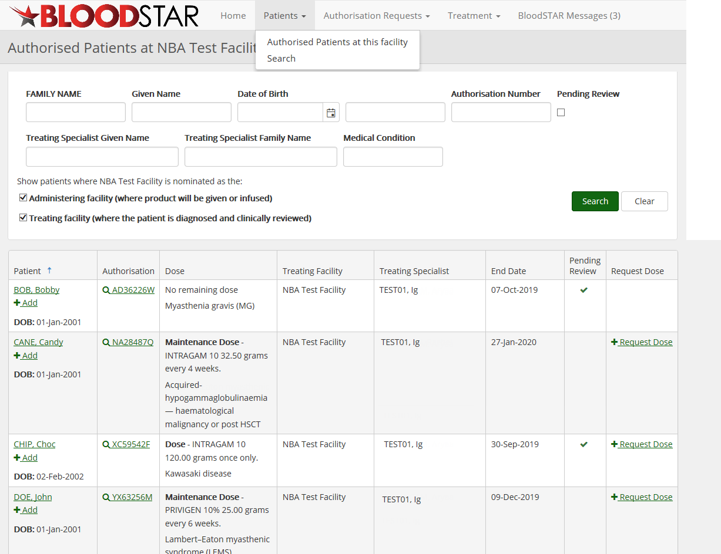
2
Click on the ‘+ Request Dose’ link next to the patient you wish to request a dose for.

View ‘ Authorised Patients at this facility’ under the ‘Patients’ tab.

1

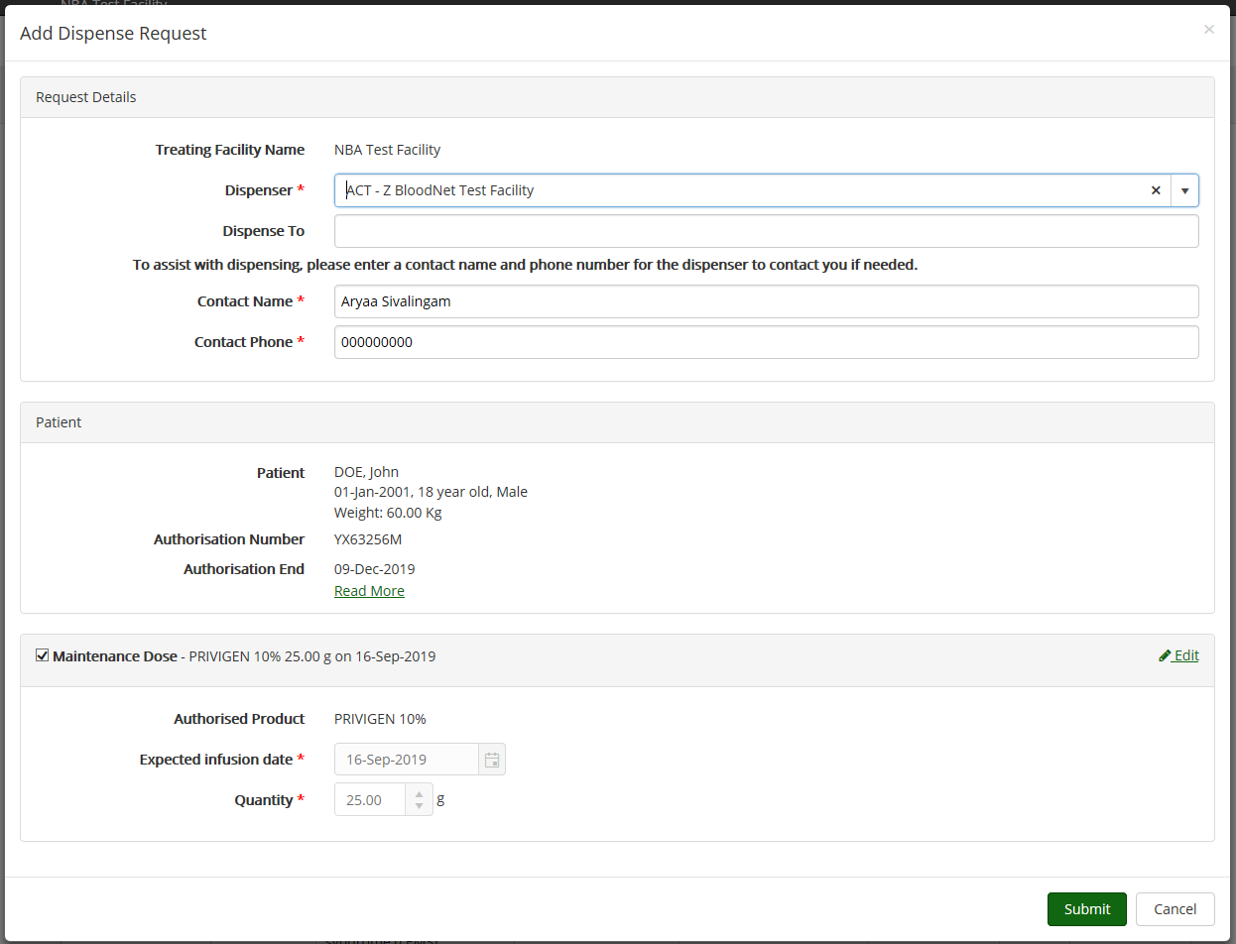
If necessary, select ‘Edit’ to change expected infusion date or dose

Confirm correct dispenser selected

3
4
‘Submit’ when ready

Note: Dispense requests and dose requests are terms used interchangeably.
You may need to provide a reason for editing details of dose request (e.g. if requesting more than the authorised dose).
If you wish to request a different product, please submit a ‘Dose Change Request’.

