

BloodNet Discard Tip Sheet

A Discard Episode should be recorded in BloodNet when a product is discarded for any reason such as expired, damaged and including recalls from The Blood Service.

### Discarding a product in Fate

* 1. **From the *Fate* menu, select *New* *Fate Episode*. From here, select *Discard*.**

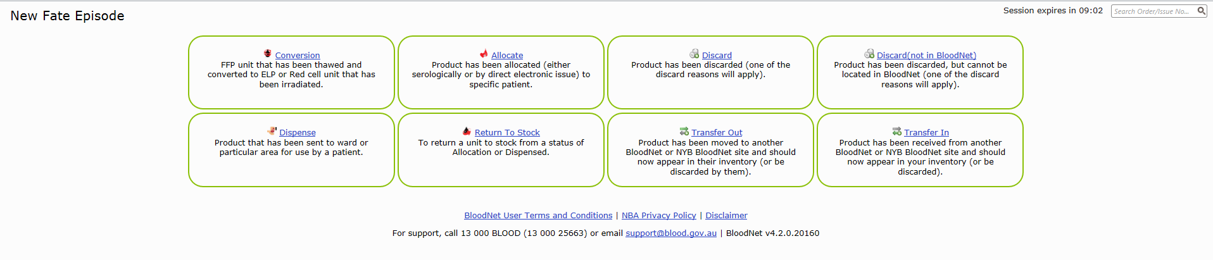

* 1. 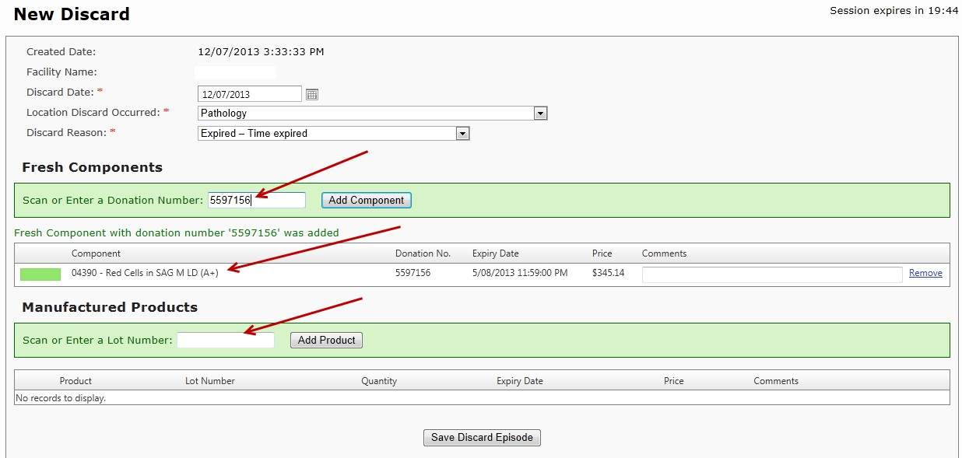**On the episode page, fill in the required mandatory fields and scan the donation or lot number into the highlighted box. This will automatically enter the product into the discard episode.**

NOTE:

1. If more than one product/component is required, additional lines will be added as each is scanned.
2. Manufactured Products and Fresh components can be added to the same discard episode only if they are being discarded for the same reason.
   1. **Click ‘Save Discard Episode’ to complete the discard. You will now have the option to print a receipt for the Discard episode before returning to the main menu.**

### What to do if the item is not found at your facility

If the donation number is not found at your facility, you will need to search for it. The message, ‘The item with the donation number 5640007 is not located at the current facility’, will be displayed.

* 1. **Please click the ‘**[**Search for item across all Facilities**](http://www.blood.gov.au/bloodnet-support-materials)**’ link.**

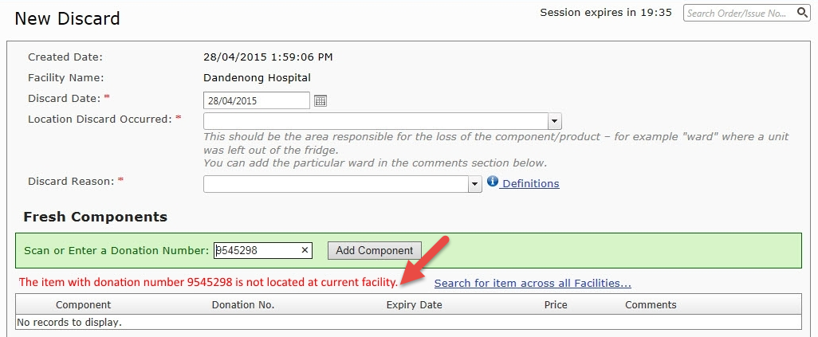

* 1. **This will bring up the window below. Click ‘**[**Transfer In**](http://www.blood.gov.au/bloodnet-support-materials)**’ to begin the transfer.**

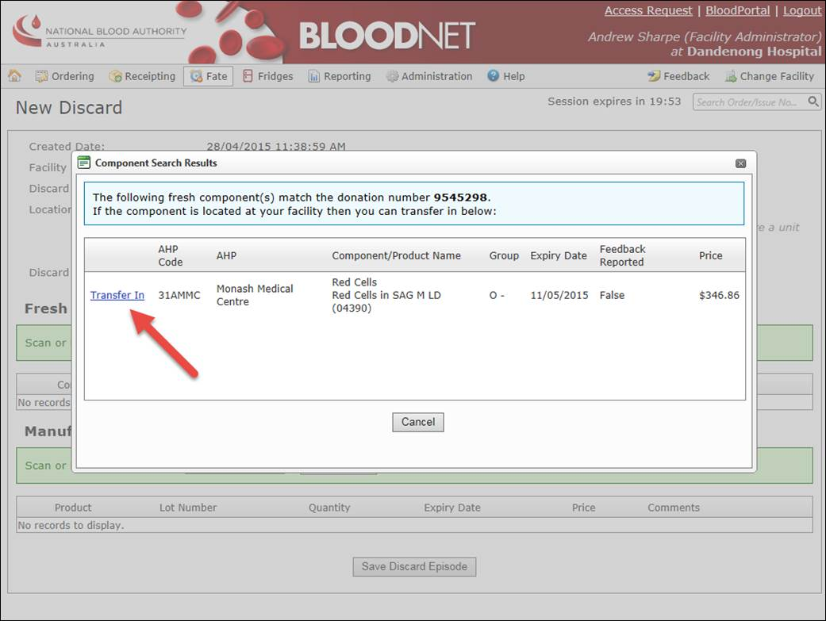

* 1. **Complete the fields below and click ‘Save’ to complete the transfer.**

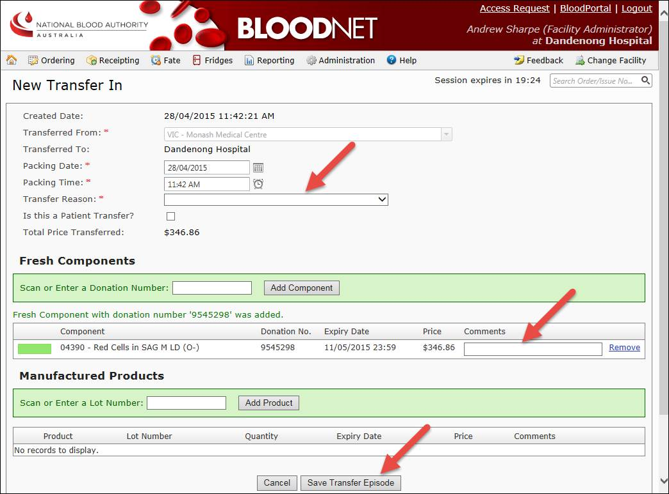

* 1. **This will take you back to the original New Discard screen.**

Important: If you have multiple items to discard, click back into the ‘Scan or Enter a Donation Number:’ box and add additional items.

* 1. **Click ‘Save Discard Episode’ to complete the discard. You will now have the option to print a receipt for the Discard episode before returning to the main menu.**

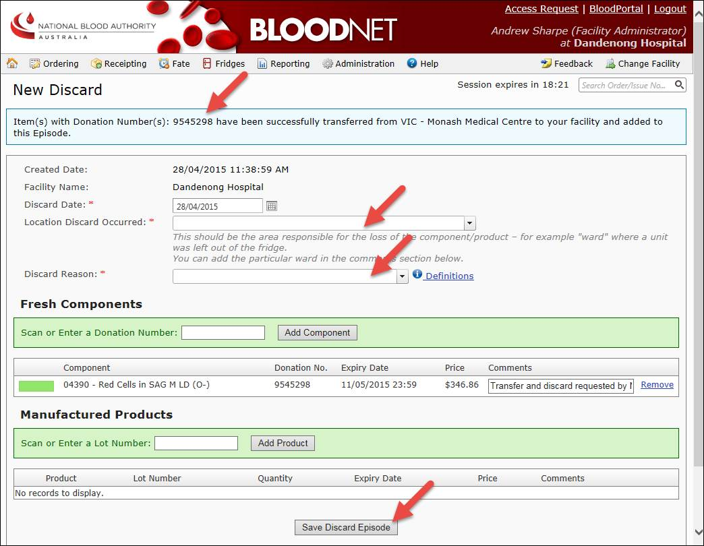

### How to manage your custom discard locations

For non-LIS enabled sites, the drop-down values in the ‘Location Discard Occurred’ field can be updated from the Administration menu. ‘Manage Discard Location’ has been incorporated to add/edit /delete custom discard locations.

Clicking on ‘Manage Discard Locations’ under the administration menu provides the option to add custom discard locations that will be available in the drop-down list of ‘Location Discard Occurred’ field under ‘New Discard Episode’.

