Receipting Issue Notes
Receipting is the final step in the ordering process and should be completed upon physical receipt of the items ordered from BloodNet.

- The Receipting tile on the BloodNet home page will show a notification of the number of orders that have not been receipted. Click on the Receipting tile on the home page.
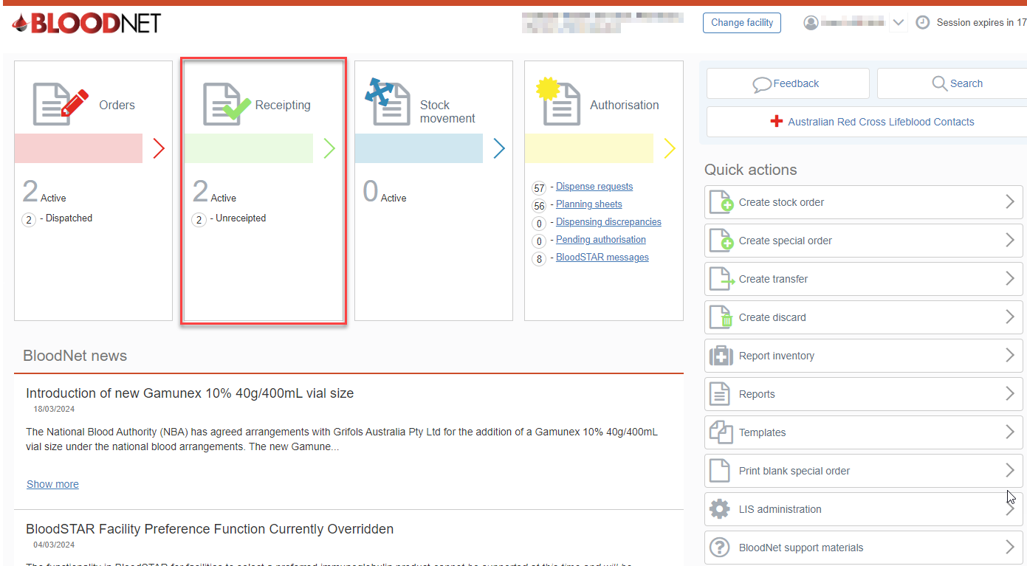
- The Receipting dashboard will display numerous functions:
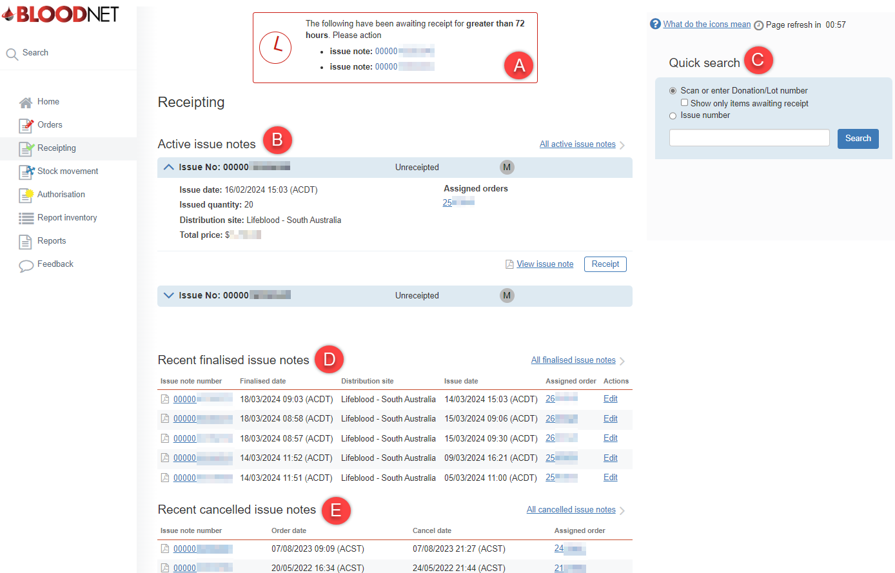
- A red box at the top of the screen appears for issue notes older than 72 hours.
- All active issue notes will appear here once Lifeblood have acknowledged the order and sent the order out for delivery.
- On the right-hand side is a Quick Search tool with two filters:
- Scan or enter Donation/Lot Number: A check box option to show only items awaiting receipt can be selected to filter the search. Scan or type the Donation or Lot number and this will show the matching issue note(s) underneath the Search field. Click on the ‘Receipt’ button beside the correct issue note to receipt the item.
- Issue number: Type or paste the issue note number and it will display the issue note and the status. This status will show if it has been receipted or unreceipted. Click on the issue note to see more information.
- Recent finalised issue notes will show the last 5 finalised issue notes. To view all past issue notes, select the All finalised issue notes link.
- Recent cancelled issue notes will display the last 5 cancelled issue notes. Select View cancelled issue notes to see all cancelled issue notes history.

- There are multiple ways of receipting an order on the Receipting page:
Option A: Drop down the active issue note to see more details and select Receipt which will take you to the Receipt issue note page.
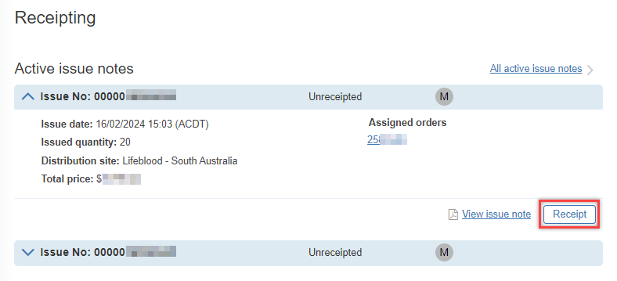
Option B: Using the Quick Search tool, scan or enter the donation/lot number and tick the checkbox for Show only items awaiting receipt then select Search. It will then show the order with the Unreceipted/Receipted status. Click Receipt to proceed to the Receipt issue note page. 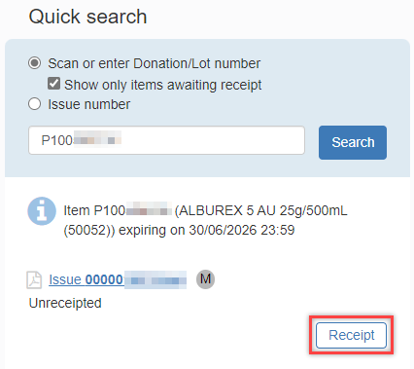
- The Receipt issue note page will display the order details and items for receipting.
Note: Before receipting the items, select View issue note which will open a new window of the issue note made by Lifeblood.
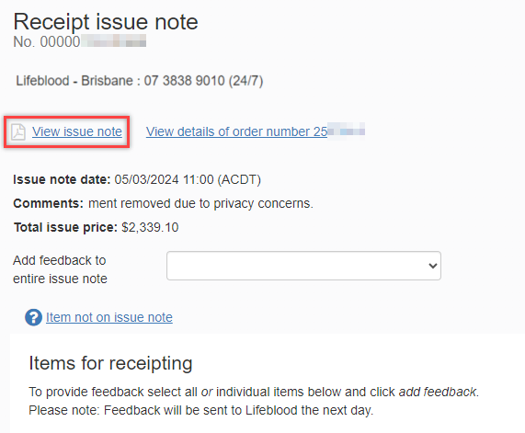

Confirm the following details to verify the issue note is with the correct order.
- Order ref. number matches the Order number in BloodNet
- Comments have been acknowledged (if comments made when ordered)
- Items and quantity ordered are accurate (lot numbers, blood or blood product, vial size, etc.)
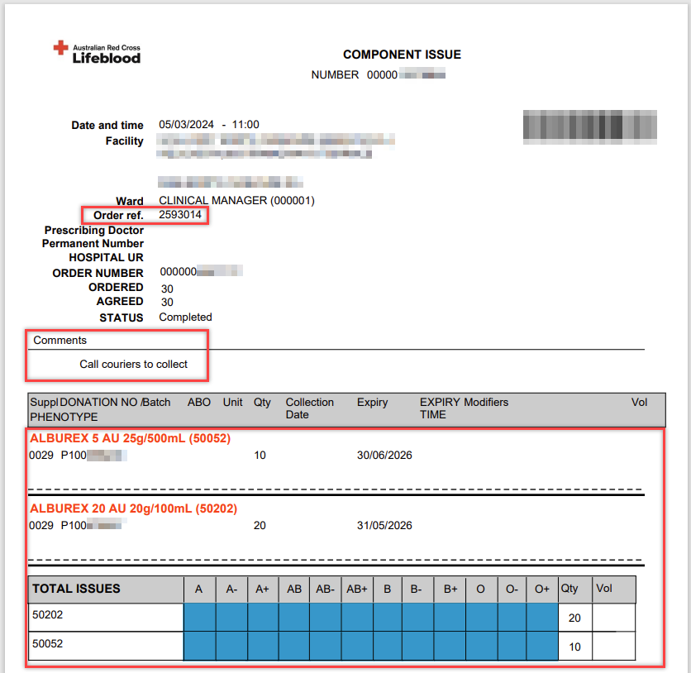

Note: If any of the above details are incorrect, please contact your Lifeblood Customer Service Delivery (CSD) centre by calling the number at the top of the Receipting Issue Note Page.
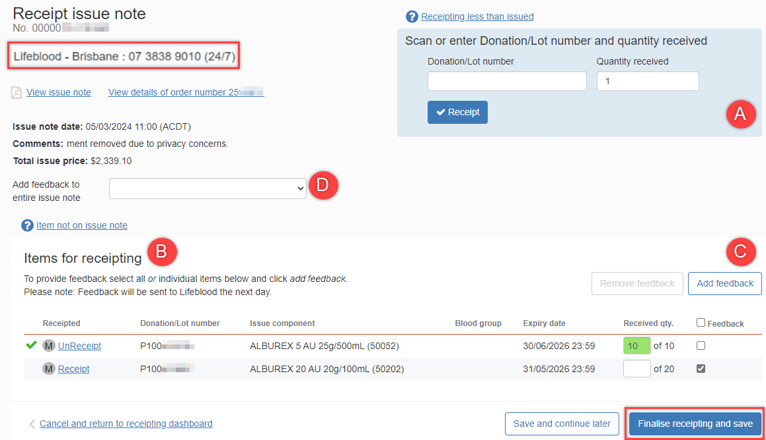

- Change the Quantity received amount then select the Donation/Lot number field and scan or type the donation/Lot number which will then receipt the item.
- Find the item in the Items for receipting list and select the Receipt hyperlink in the Receipted column which will set the Received qty. to the issued quantity.
- If the item received does not contain the same quantity as specified on the issue note, or there is something wrong with item, you need to provide feedback by selecting the Feedback checkbox and selecting Add feedback to add a reason. You can also contact your Lifeblood Customer Service Delivery (CSD) Centre by calling the number at the top of the Receipting Issue Note Page.
- If the whole order received does not contain the same quantity as specified on the issue note, or there is something wrong with the order, you need to provide feedback by selecting the drop down menu next to Add feedback to entire issue note. You can also contact your Lifeblood Customer Service Delivery (CSD) Centre by calling the number at the top of the Receipting Issue Note Page.
- Once everything has been filled in, select the Save and continue later button to finalise receipting the order later or select Finalise receipting and save to receipt order and redirect to the Receipting page.

- A green alert will show at the top of the screen to notify the issue note has been successfully receipted.
