BloodNet Transfer Tip Sheet

The FATE module in BloodNet provides a vessel for transferring and discarding of Blood and Blood Products from your BloodNet site.
Transfers should be recorded when a product moves out of your laboratory into another whether it is a routine distribution or emergency requirement or even a patient transfer. A transfer episode can be created in 4 steps.
- Hover over the word “FATE” and select “New Fate Episode”

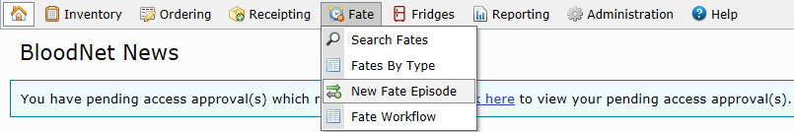

- If you are the facility sending the units to another facility select “Transferred Out”.
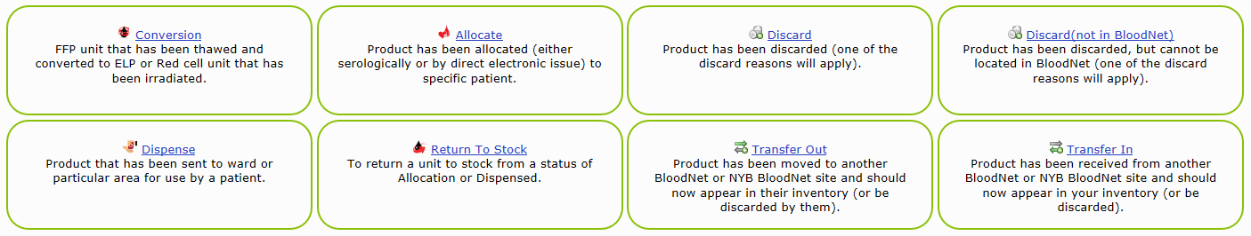
If you are the facility that has received the units, select “Transferred In”.

Note: only one facility should create a Fate episode. If the sending facility has created a Transferred Out episode, do not create a Transferred in episode, and vice-versa.

- Fill in the mandatory transfer details and scan in the donation or lot number into the highlighted fields, this will automatically add the scanned unit onto the transfer episode.

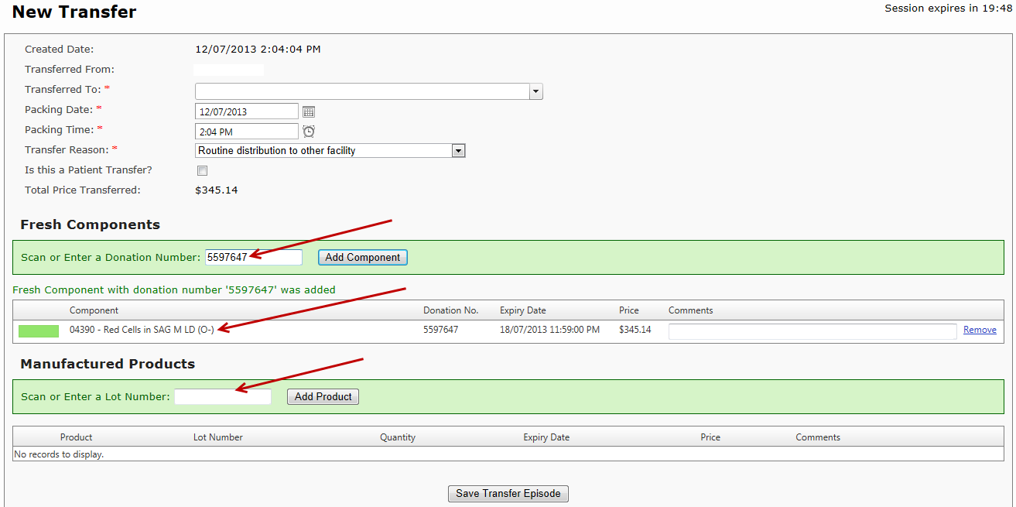
- Click “Save Transfer Episode” at the bottom of the screen to view the “Transfer Receipt”. If you are the transferring out facility print this receipt and put it in the shipper with the products being transferred.
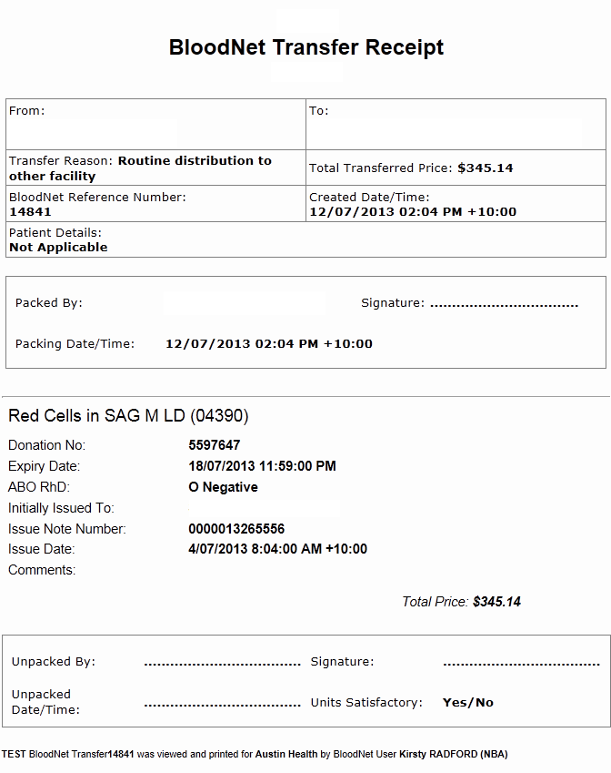
5. Click “Back to Fate Summary”. This completes the Transfer Episode.

