Checking Patient Authorisations for both

Regular and Travelling Patients
This tip sheet will outline how to check the details of a patient who is authorised to receive Immunoglobulin product.
Please note: Checking that the patient you are dispensing product to has a current authorisation is now the responsibility of the dispenser, this is no longer undertaken by the Australian Red Cross Blood Service.
Checking a patient authorisation you are the nominated dispenser for
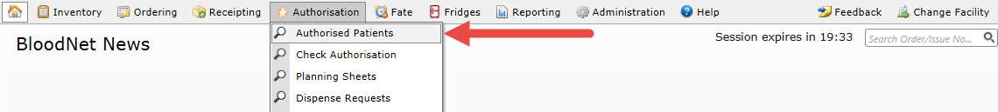
- To check on the authorisation of a patient for whom you are the nominated dispenser, go to the Authorisation tab and click Authorised Patients. Note: only approved patients will appear.
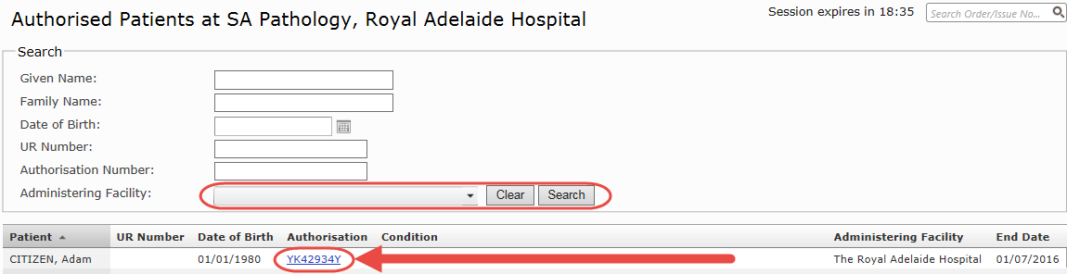
- To view the authorisation of a patient you are nominated as the dispenser for, locate them on the Authorised Patients list and click on the Authorisation ID.
- The View Authorisation screen includes the details of the patient, the status of their authorisation, their treatment plan, authorisation period and any current dispense requests or available doses.
Checking on a patient authorisation for a travelling patient or for a patient not usually dispensed for by your site
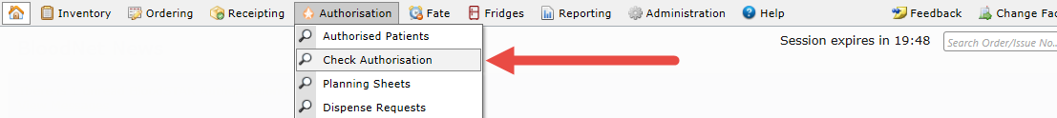
- To view an authorisation for a patient who has travelled from another site and requires treatment, or who is usually dispensed for by another site, go to the Authorisation tab and click Check Authorisation.
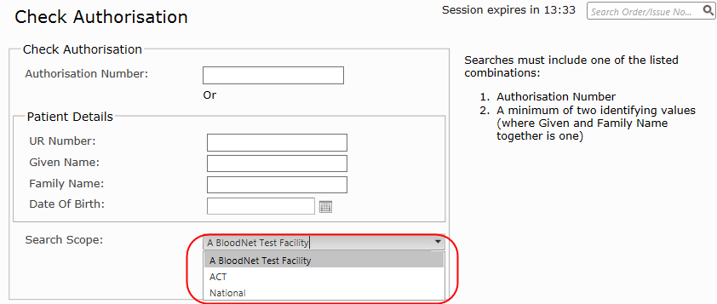
- On the Check Authorisation page, you will be presented with a search function for specific patient authorisations. Searches must include either Authorisation Number or a minimum of two identifying values (where Given and Family Name together is one). The search will only provide a returned result for exact matches and will not return results for incomplete or partial matches. Once you have entered enough information, select the scope of the search: facility, State/Territory or National.

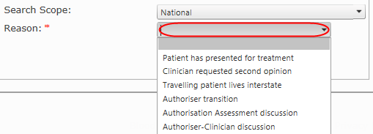
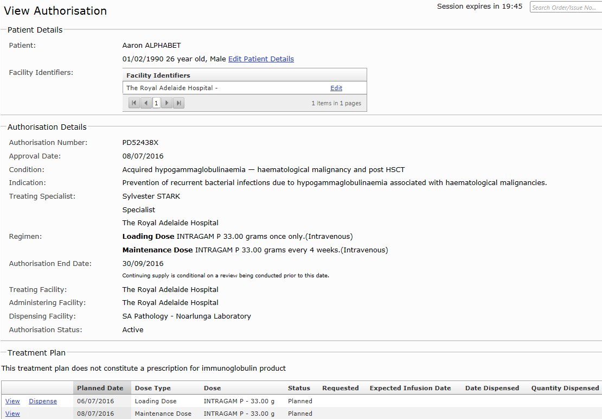
Note: If searching at either a State/Territory or National level, you will be asked to provide a reason for searching across patient details outside your facility. Nominate the reason from the drop down list and click search.
Once a matching record has been found, the active authorisation for that patient will automatically appear on-screen as the View Authorisation page. This will include their treatment plan and dispensing history, as well as any current dispense requests placed.

