BloodNet Special Ordering Tip Sheet
New Special Order
New Special Orders should be placed when the Australian Red Cross Blood Service requires the patient details for the order. To place an order for items not on your stock list, see the BloodNet Ordering Tip Sheet and follow the steps to add an Ad hoc item to your stock order.

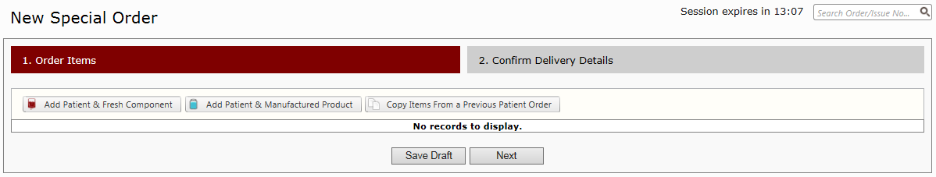
- To place a named patient order hover over the word ‘Ordering’ in the menu bar at the top of the screen and select ‘New Special Order’. Click on either ‘Add patient & Fresh Component’, ‘Add Patient & Manufactured Product’ or ‘Copy Items from a previous patient order’.
1

If placing a new order for a previous patient, you can click on the copy button to copy the details of previous orders for a patient, which can then be edited before reviewing and confirming the order.
- Enter the patient details and click on the drop-down box for product. All products of the selected type (ie: Fresh Component) will appear as options from this menu. Select the correct product, enter the quantity and choose priority of order, then press ‘Add’. Please note that this is where the Urgent status for the product can be selected.
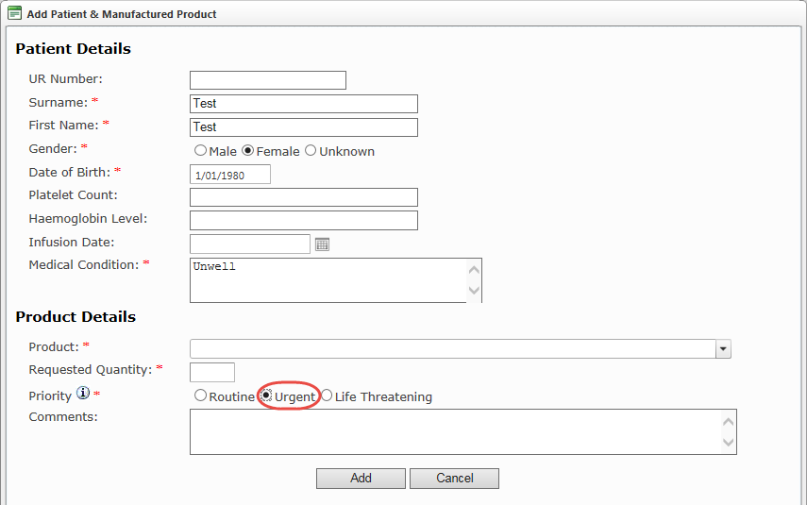
Important: If your order is urgent, please do not just enter ‘urgent’ in the comments; select ‘Urgent’ from the priority options shown below. All urgent and life threatening orders MUST be followed up with a phone call to your local Blood Service Customer Service Delivery
- If more than one product/component is required, after adding a patient and product, click ‘Add Fresh Component’ or ‘Add Manufactured Product’. Once all patients and their required products are entered click ‘Next’.

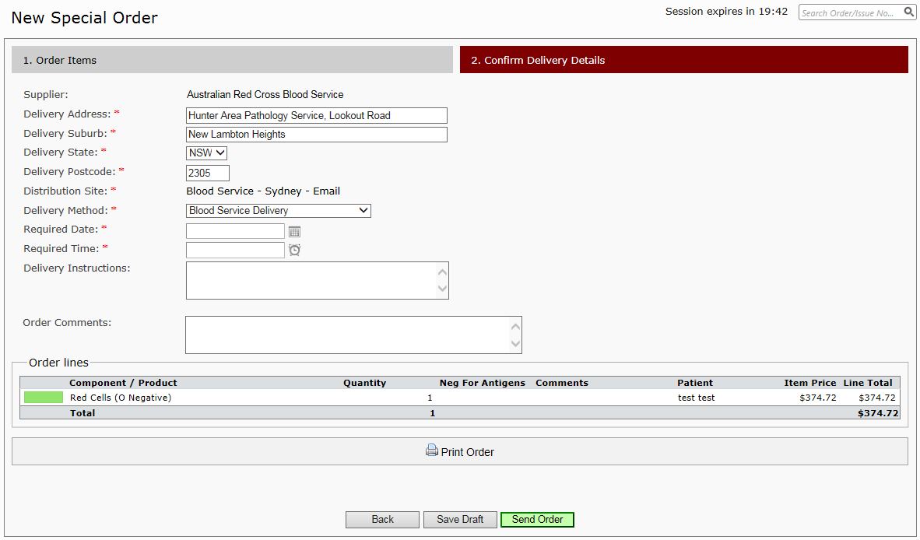
- Confirm all details are correct, add any relevant order comments/delivery instructions and double-check that all quantities are accurate. Click ‘Send Order’ to finalise the ordering process.

Support
Phone: 13 000 BLOOD (13 000 25663)
email: support@blood.gov.au

