New User – Creating a BloodPortal Account
This tip sheet is designed for people who wish to access the National Blood Authority (NBA) BloodPortal.
Users can create a single username and password to access:
- Blood Sector Systems home menu (BloodSTAR, BloodNet and ABDR)
- NBA subscriptions (Australian blood sector newsletters and updates)

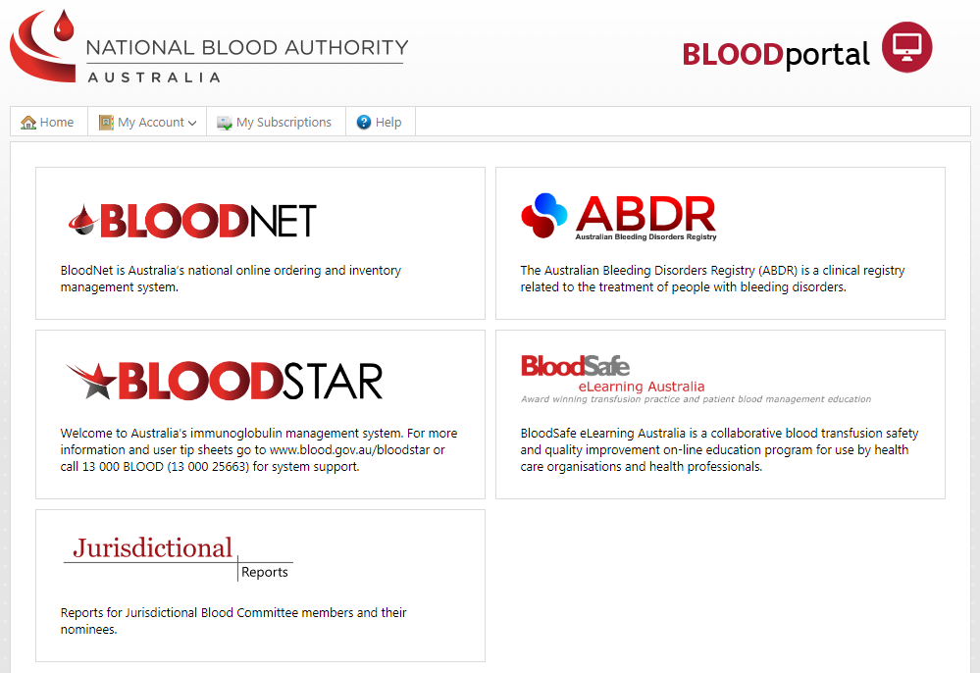
If you have forgotten your username or require a password reset, please click on the Forgot your username or password on the BloodPortal log in page. If you require access to an existing account, please call NBA Support on 13 000 BLOOD (1300 025 663) or email support@blood.gov.au.

Step 1
Navigate in a web browser to https://portal.blood.gov.au and click on New User? Create an account as highlighted below.
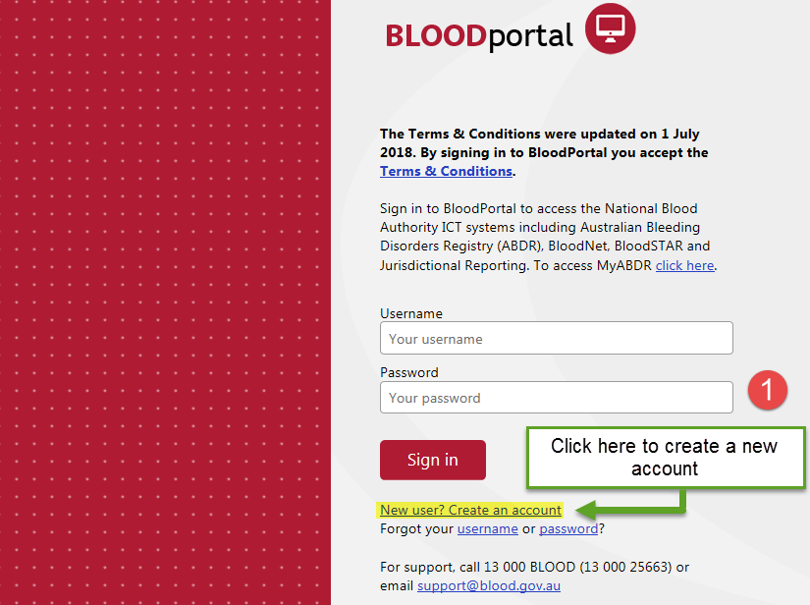
Step 2
Complete all mandatory fields - marked with a red asterisk*.
Note: All users are required to create their own account to access Blood Sector Systems. The temporary password for your new account will be sent to your nominated email address and mobile phone number. These mandatory contact details and your username must be unique to this account.

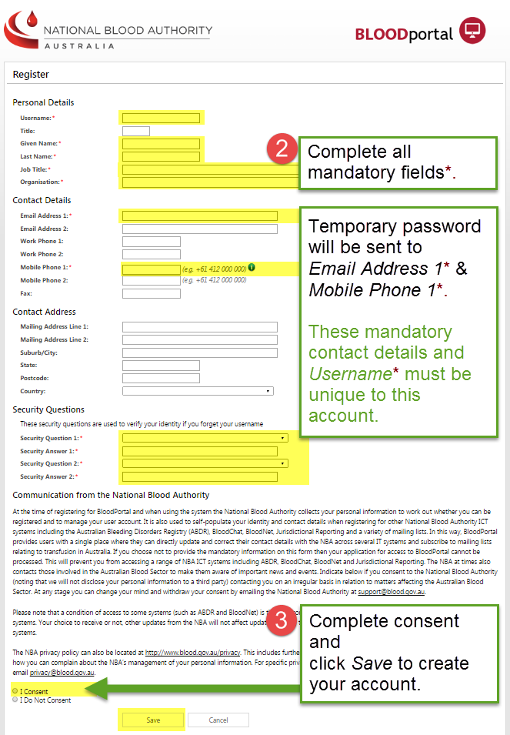
Step 3
Complete consent and click Save to continue.

Step 4
If Step 3 is successful you will be taken to the Account Registered screen, indicating that your account has been registered. A temporary password will be sent to your nominated email address and mobile phone number within 30 seconds.
The first time you login with your Username and Temporary Password, you will be prompted to create a new password. Click the link on the screen or login at https://portal.blood.gov.au and change your password.

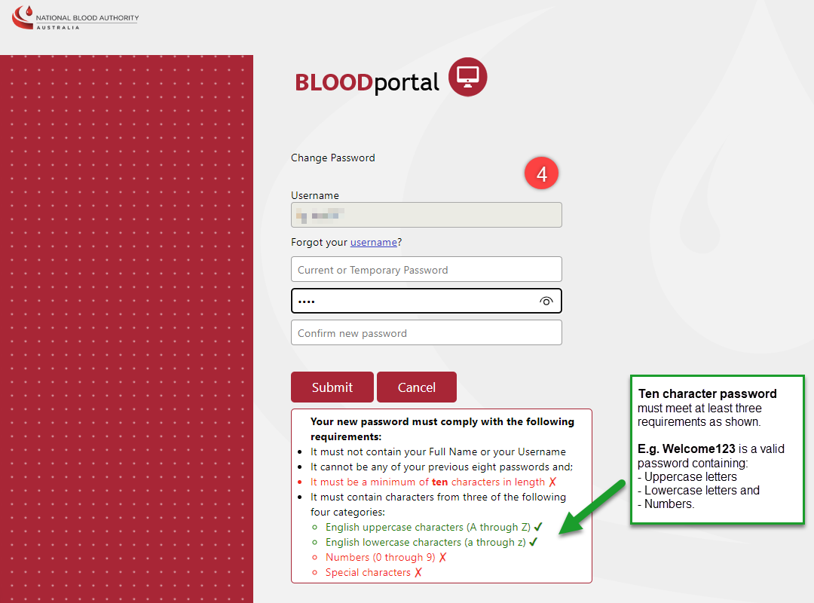

Note: When entering the new password, the system displays the password requirement line in green with a tick if the password complies or red with a cross if the password doesn't comply with the requirements.

Step 5
You will now be taken to the Blood Sector Systems home page. To access a Blood Sector System, click on the appropriate tile and follow the prompts to complete an access request.
Note: You are not required to create additional BloodPortal accounts should you need access to other facilities. If you need access to a different facility, you will need to submit an access request to the required facility within one of the Blood Sector Systems.

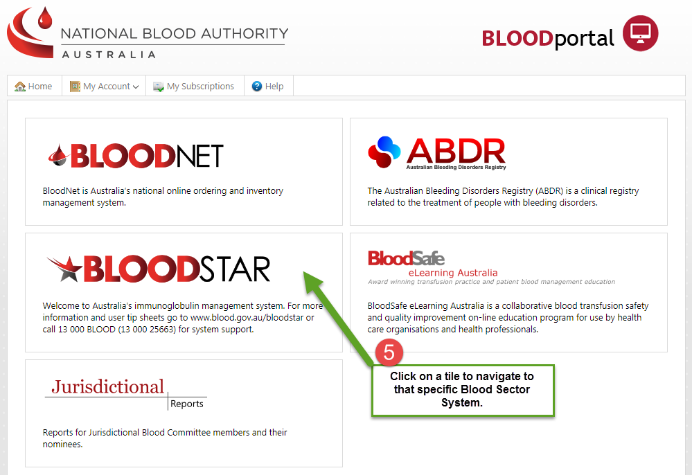
You may also wish to review the user support materials for the systems you use. Support material can be located on the NBA website: https://www.blood.gov.au/blood-systems

