**User Tip Sheet –Facility Administrator role**

**Creating Pre-approval for Medical Officers in BloodSTAR**

Facility Administrators have the ability to pre-approve access a Medical Officer for access to their BloodSTAR site. This means that when a Medical Officer submits an access request for the facility where the pre-approval was created, the Medical Officer will be granted immediate full access to the site.

1. To create a pre-approval, click on the ‘**Medical Officer Pre-approvals**’ link located on your BloodSTAR homepage.

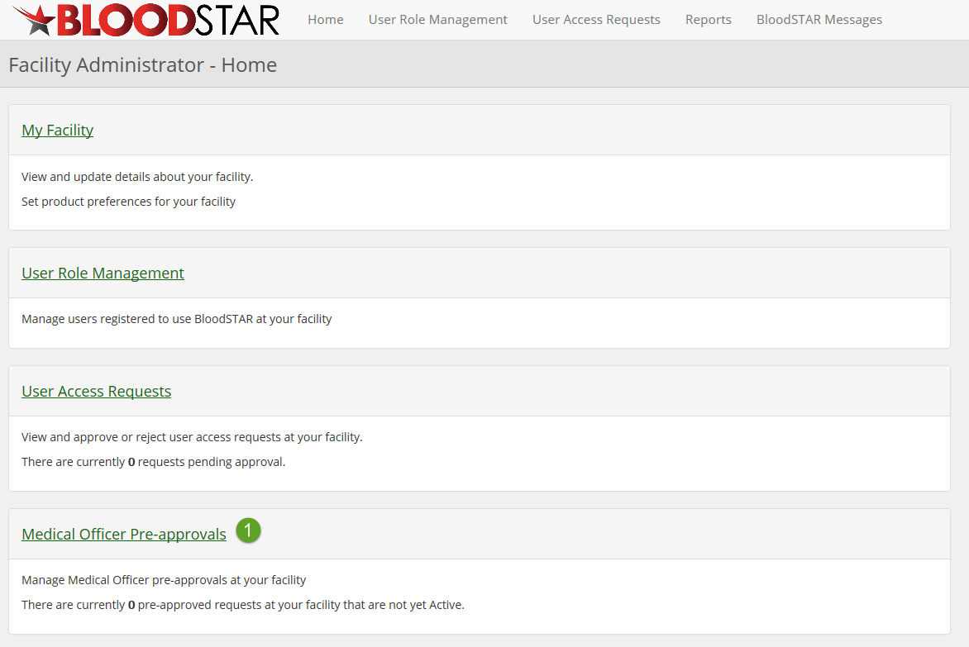

1. From here click on ‘**Create Pre-Approval**’

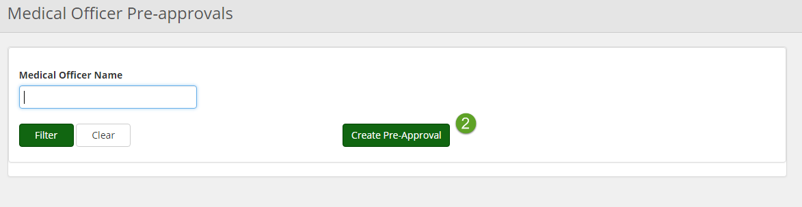

1. You will then need to enter the Medical Officers AHPRA Registration Number and click ‘**Verify AHPRA**’. The system will then populate the details of the user associated with that AHPRA number. Once you have confirmed the identity of the user, click the checkbox ‘**The Medical Practitioner holds an appropriate position at this facility**’ and click ‘**Create Pre-approval**’.

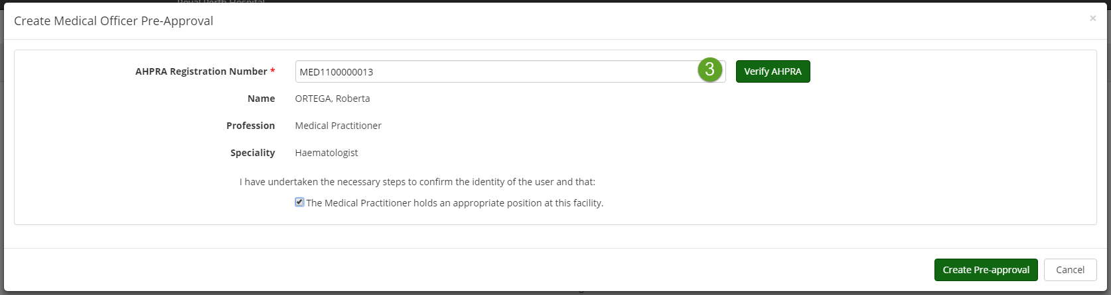

1. Once submitted, you will get a notification explaining that the pre-approval has been successfully created. If there is any discrepancy between the Medical Officer name recorded in AHPRA name and the Medical Officer name used for the access request, the Facility Administrator will be notified via email.

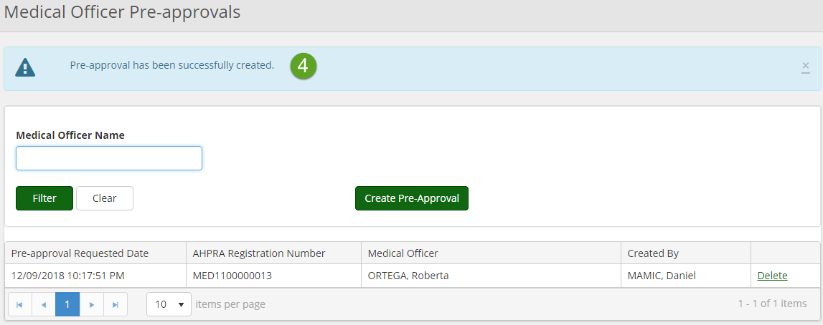

1. Facility Administrators will be notified when a pre-approved access request has been granted to the Medical Officer. Until the user requests access, Facility Administrators will have the notification that there are pre-approved requests at your facility that are not yet active.

