Recalling and/or Resubmitting an Authorisation Request
Resubmitting a Declined Authorisation Request
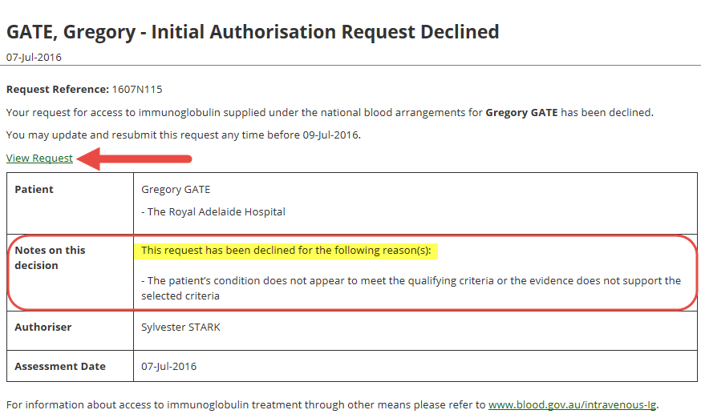
- When an Authorisation Request has been declined, you will receive both an email and a BloodSTAR in-system notification of the outcome of the assessment. To view the reasons for the declined request, either click on the link in the email to be taken directly to the message or, when logged into BloodSTAR, navigate to the BloodSTAR Messages tab and select the message to see further details. The reason that the request was declined will appear under Notes on this decision.
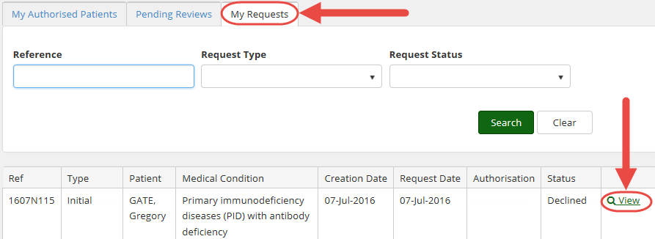
- To go in to the request, click View Request in the declined notification to be taken directly into the failed request. Another way to access the declined request is to navigate to the Medical Officer Homepage and then click My Requests. From there, locate the declined request and click View.

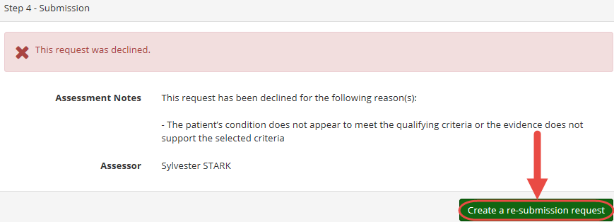
- You will automatically be taken to the bottom of the request, where the reason it was declined will be displayed. To resubmit the declined request, click Create a re-submission request.
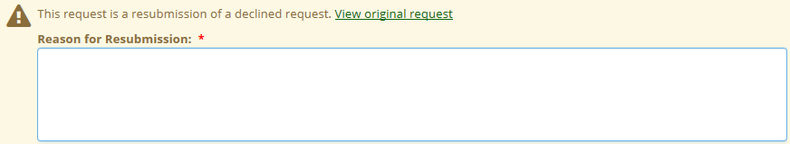
- This will take you to a new Initial Authorisation Request, with a field labelled Reason for Resubmission at the top. In this field, enter the reason that the request is being resubmitted despite having already been rejected. Entering this reason is mandatory.
Once a reason has been added, click Save and Continue.
- The details from the original Initial Authorisation Request will be pre-populated into the new request. Change all necessary details and submit the authorisation request as directed. Once all details are updated, check the box that confirms all details are accurate to the best of your knowledge and click Submit. 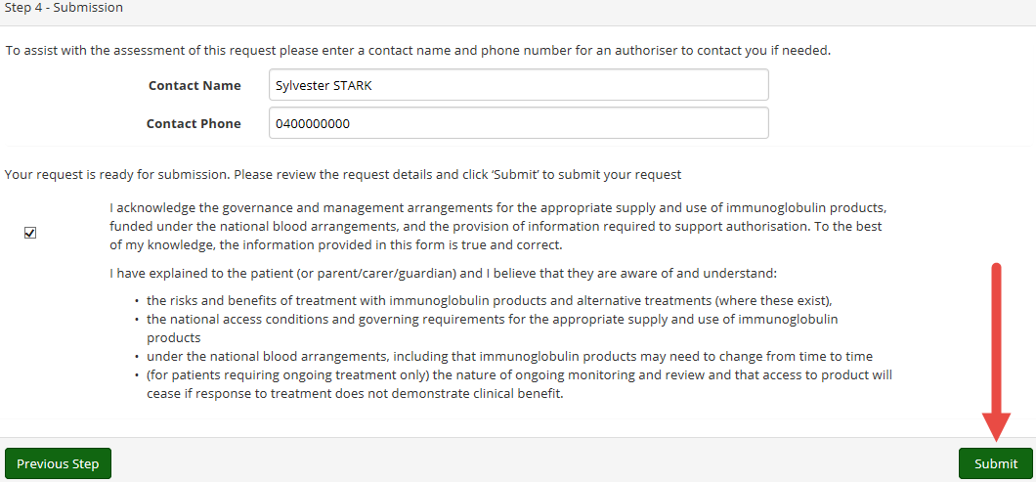

Recalling and Resubmitting an Initial Authorisation Request
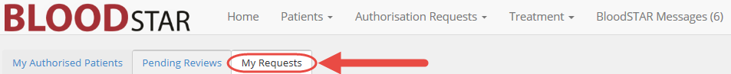
- If the details of a submitted (and not yet approved) authorisation request need to be changed, this is only possible if the request is not yet In Assessment by a Red Cross Authoriser. To recall a request that has been submitted, go to the My Requests page from the Medical Officer homepage.
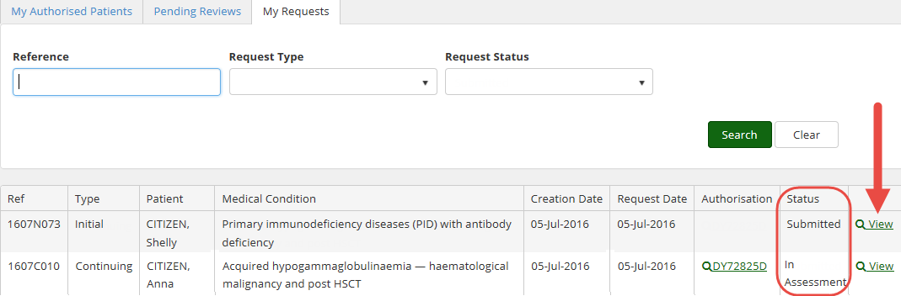
- Locate the request and check the status. If the status is Submitted, you will be able to recall it. If the status is In Assessment, you are no longer able to recall the request. If the status is at Submitted, click View.
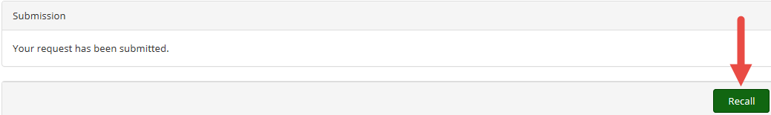
- You will be automatically taken to the bottom of the submitted request. To recall the request for editing, click Recall.
- The request will refresh with all fields available to be edited. Change any necessary details and, when satisfied with the changes made, check the box that confirms all details are accurate to the best of your knowledge and click Submit to resubmit the authorisation request for review.

