National education and training Committee
“Education about blood, blood products and patient blood management is well coordinated, of high quality, and addresses the information needs of patients and carers and the education and training needs of the Australian health care workforce”

Committee Terms of Reference

January 2015

Contents
Introduction 1
Rationale for NEAT Committee 1
Scope and Governance Structure 2
Relationship of NEAT to other NBA committees 3
Desired Outcomes and Objectives 4
Membership 4
Chair 4
Members 4
Observers 5
Expert advisors 5
Quorum of the NEAT Committee 5
Remuneration and Allowances 5
Undertaking/Conflict of Interest 5
Working Arrangements 5
Role of Chair 6
Role of Members 6
Role of NBA 6
Role of Observers 7
Role of Experts Advisors 7
Meetings 7
Out of session activities 7
Conduct 8
Review 8
Attachment 1 List of Attendees 9

Introduction
The overarching aim of the National Education and Training (NEAT) Committee is to improve patient outcomes through establishing an integrated national approach for education and training and endorsing priorities for all Australian governments. This includes:
- Leadership to stimulate coordination and direction of education and training in the blood sector
- Oversight of a national annual forum to set education and training priorities
- Engagement with relevant stakeholders and organisations to identify minimum standards and/or competencies required
- Establishment of a national framework to ensure consistency and quality in education and training programs
- Identification of gaps in training to inform course development requirements for the blood sector.
Of primary importance is the annual education and training forum to be held to facilitate engagement between providers and users and identify educational themes for the development of tools and competencies. This will involve the invitation of a wider audience of interested stakeholders who are not NEAT Committee members to a NEAT Committee meeting each year. The invitation list and the agenda will be decided by the NEAT Committee at the face-to-face meeting prior to the forum.
This document details the governance arrangements and Terms of Reference (TOR) for the NEAT committee. These governance arrangements and TOR are approved by the NBA’s General Manager and the Jurisdictional Blood Committee (JBC). Operational costs for NEAT are funded by all Australian governments. The NEAT Committee will report, via the NBA’s General Manager, to JBC.

Rationale for NEAT Committee
Current education and training capacity, quality, and effectiveness in the blood sector could be improved by:
- better national planning and coordination of education and training;
- introducing a focus on minimum standards and/or competencies; and
- introducing targeted support for delivery of education and training activities at national, state and territory, local and health service levels.
A nationally coordinated approach is needed for education and training in the blood sector for patients and carers, clinical workforce, non-clinical workforce and health service managers where transfusion or infusion of a blood product occurs.
The four key priorities articulated in the National Blood Sector Education and Training Strategy are:
- Identify and address gaps and unnecessary duplication
- Improve coordination of online learning and web based information funded by all Australian governments under the National Blood Arrangements.
- Create networking opportunities
- Engage patient groups and support their educational requirements.

Scope and Governance Structure
The NEAT Committee has been established to support the implementation of the National Blood Sector Education and Training Strategy 2013-16. Its key functions are to:
- provide advice and oversight of a strategic program of activities to support education and training relating to the implementation of the National Safety and Quality Health Service (NSQHS) standards and Health Ministers’ stewardship expectations and the implementation of nationally funded guidelines
- support improved communication and collaboration between education providers
- promote quality and reduce unnecessary duplication in education and information offered by organisations funded by all governments under the National Blood Arrangements
- influence the direction and uptake of education and training programs
- share information with other NBA committees
- support the promotion of programs
- investigate other methods of delivery
The governance structure below has been devised to support these functions.

Relationship of NEAT to other NBA committees
The NEAT committee will communicate, through the NBA secretariat and cross membership to other NBA committees to manage any common areas of interest. There are three key product related committees. These are:
- Patient Blood Management Steering Committee (PBMSC) which predominantly focusses on the appropriate use of fresh products (and avoidance of unnecessary exposure).
- Immunoglobulin Clinical Advisory Group (ICAG) which focusses on appropriate use of immunoglobulin products.
- Australian Haemophilia Centre Directors’ Organisation which focusses on appropriate use of clotting factors.
The NBA manages many of the functions that are common to all three committees without the need for additional input. These are depicted in light green below. There are some circumstances however, when specific committees are required. (eg when there is a need for specialist input or when there is a need national consistency). Committees for these purposes are depicted in dark green below.
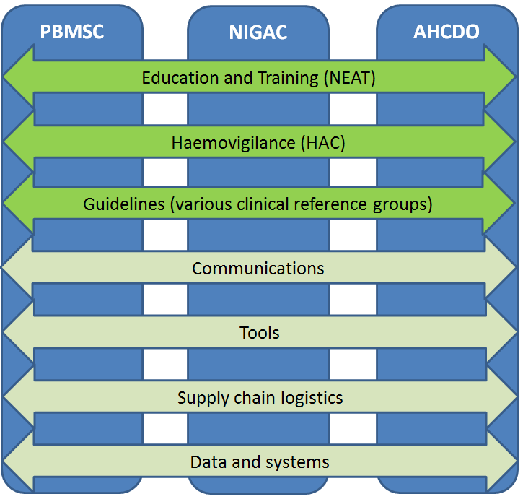

Desired Outcomes and Objectives
The NEAT Committee has been established to provide high level advice and assistance to the NBA and to JBC to facilitate implementation of the National Blood Sector Education and Training Strategy. The NEAT will also set strategic priorities for Education and Training in the sector. Where specific gaps are identified the NEAT may refer specific projects to JBC for endorsement and funding. NEAT will assist the NBA in identifying the most effective means of progressing projects. The objective of the strategy is to support delivery of safe, effective and reliable health care by well trained staff to well-informed patients through relevant high quality education, training and information.

Membership

Chair
The Chair will be appointed by the NBA General Manager. The General Manager may nominate an alternative person to be a temporary Chair where the Chair is unable to attend a meeting or is otherwise temporarily unable to perform the role of Chair.

Members
Members are appointed by the NBA General Manager. The NEAT Committee is a group comprising members with expertise and knowledge in the health sector, quality and safety, blood management and medical education. This group will enable a focussed approach to considering education and training activities. In addition to the Chair, the membership of the NEAT Committee comprises a combination of the following expertise and representation, noting that one person may represent the views of multiple organisations and that not all are required on the committee at one time as attendance requirements will depend on the current priority of the committee.
- Policy development/Government Representative
- Consumer representative(s)
- Education providers funded under the National Blood Arrangements or states/territories
- Undergraduate education provider representative(s)
- Quality and Safety representative(s)
- Postgraduate education provider representative(s)
- Education representative(s) from relevant Colleges and Societies
- Education representative(s) from private hospitals
- National Blood Authority
Members are responsible for obtaining all approvals necessary from their current employer or organisation as appropriate to accept appointment as a member and undertake the role of member.

Observers
Additional observers may be invited to attend from time to time. Observers are invited to participate in discussions but do not have voting rights on decisions.
Observers can represent any of the above organisations or can be from other organisations. Those who are invited as observers can elect to be on a distribution list of all meeting papers and outcomes but may not be invited to attend every meeting.

Experts and advisors
The NEAT Committee will be kept to minimum size to ensure that it is focused and manageable. Therefore, additional expert advice will be sought on an ad hoc basis from experts on specific issues as required.
These experts and advisors will report directly to the NEAT Committee.
A list of members, observers and experts/advisors is at Attachment 1

Quorum of the NEAT Committee
At least 50% of the current membership must be present before the NEAT Committee can conduct valid business.

Remuneration and Allowances
Remuneration and allowances for members of the NEAT Committee will be in accordance with the NBA’s ’Domestic Travel Policy – 3rd Parties’ and ‘Remuneration of Non-NBA Staff Management Instruction or as approved by the General Manager.

Undertaking/Conflict of Interest
NEAT Committee members and observers will be required to complete undertakings and comply with the terms of those undertakings, in relation to conflicts of interest, confidentiality, document control and intellectual property. Members and observers will be required to declare any actual or potential, real or perceived Conflicts of Interest.
Relevant documents will be provided to members as part of their letter of offer.

Working Arrangements
The NBA provides the necessary support to allow the NEAT Committee to perform its functions. This includes secretariat support and other appropriate resources as requested by the Chair.

Role of Chair
The Chair’s main role is to provide leadership to the NEAT Committee. The Chair will advocate consistency in key messages and ensure the NEAT Committee carries out its functions effectively and efficiently. Together with relevant NBA staff, the Chair will participate in the development of NEAT Committee agendas and ensure that NEAT Committee meetings are properly run. The Chair will also provide advice and guidance direct to the NBA General Manager or their delegate on issues as they arise outside of the NEAT Committee processes to ensure maintenance of momentum.
In undertaking the Chairperson’s roles and responsibilities, the Chair should:
- ensure the NEAT Committee provides high level advice and assistance to the NBA and the JBC
- foster coherence in advice provided to the NBA
- ensure the NEAT Committee has the necessary information to undertake its duties effectively
- undertake public relations activities in relation to NEAT Committee responsibilities if requested by the NBA General Manager
- work with the NBA to:
- ensure the proper and efficient running of NEAT Committee meetings
- ensure all necessary actions before and after meetings are completed
- coordinate and manage out of session activities of the NEAT Committee.

Role of Members
Members of the NEAT Committee have been appointed based on their specific interests, individual knowledge and skills and ability to influence stakeholders in their area of expertise or peer group.
NEAT committee members should:
- provide advice on strategies and initiatives that would influence the quality and uptake of blood related education and training in their area of practice
- participate in influencing the uptake of blood related education and training initiatives in their area of practice
- gather input on likely responses from their area of practice to suggested policy and/or initiatives and changes
- actively contribute to setting of the agenda for NEAT meetings and give input or responses as agreed in meetings and as required out of session
- ensure that they have access to timely and accurate information, and are well prepared to consider the issues addressed at NEAT committee meetings
- monitor reports of progress on implementation of NEAT activities
- express the views of the professional or consumer body they represent and in turn seek their endorsement for activities and initiatives.

Role of NBA
The NBA will provide funding, project management, secretariat services and administrative support for the NEAT Committee pending JBC approval. The NBA shall be responsible for:
- seeking relevant approvals and reporting
- establishing the governance framework and operating procedures
- managing contracts for any outsourced activities
- monitoring and managing project finances and resources to ensure they are sufficient
- booking venues and arranging travel, accommodation and meeting arrangements as required and where appropriate
- ensuring that an agenda is circulated, at least one week prior to the meeting, together with any supporting papers after approval from the Chair
- ensuring minutes of meetings are compiled and promptly provided to the Chair for approval
- circulating the minutes within two weeks of the meeting to NEAT Committee members and observers, as appropriate
- following up on agreed action items from meetings.

Role of Observers
NEAT Committee observers are invited to participate in discussions and provide their advice on the development and implementation of policy and drivers appropriate for national activities that support and encourage education and training. The NEAT Committee will consider the strategic advice from the observers when considering the most appropriate design and implementation strategies for national education and training activities.

Role of Experts and Advisors
Other influential clinical or educational stakeholders will be invited to contribute from time to time to the NEAT Committee in relation to policy changes, and design and implementation of education and training activities. Where clarification is required by the NEAT Committee, expert advisors will be asked to provide the NEAT Committee with advice to support their decisions around the priority activities.

Meetings
The timing, agenda and mode of meetings will be determined by the NBA and the Chair, after any necessary consultation with members. Meetings will ordinarily be held at the NBA’s premises in Canberra. It is intended that the NEAT Committee will meet in person at least 2 times per year. Meetings by teleconference of no more than two hours will be used when appropriate and expedient.

Out of session activities
The NEAT Committee may, in accordance with a process determined by the Chair, undertake activities to give advice or assistance to the NBA out of session. Members may be called upon for ad-hoc advice via email between meetings. They will also be required to actively participate in the development of materials and provide input via the secure web-portal ‘Govdex’ (an online management framework of collaborative initiatives across government and non-government stakeholders).
Contributions will be required on various documents including, but not limited to, statements of requirement for engaging consultants, education and training materials, meeting minutes and out-of-session papers.
Members may also be required to engage in forum style discussions. Members should not undertake out of session activities in their capacity as NEAT Committee members without the prior approval from the Chair and the NBA.

Conduct
Members of the NEAT Committee are expected to carry out their role in accordance with the highest ethical standards. A NEAT Committee member when undertaking NEAT Committee related functions should:
- act honestly, in good faith and in the best interests of NBA
- use due care and diligence
- have regard to the interests of all stakeholders of the NBA
- contribute to NBA activities in a co-operative, impartial and productive way
- be independent in judgement and actions and take all reasonable steps to be satisfied as to the soundness of advice provided by the NEAT Committee
- agree with the NBA and Chair on an appropriate response and approach to external stakeholder interest or enquiries relating to the NEAT Committee work plan
- not make improper use of information acquired as a NEAT Committee member, both during and after the term of appointment, and
- not engage in conduct likely to bring discredit upon the NBA.

Review
This document will be reviewed annually or as required by the NBA General Manager or the Jurisdictional Blood Committee

Attachment 1 List of Attendees
 | Representative | Expertise
Member
Chair |  | Medical education
Policy development/Government Representative | State and Territory Governments | Sector knowledge
Consumer representative(s) | Consumer | Patient and consumer education
Education providers funded under the National Blood Arrangements or states/territories | BloodSafe eLearning Australia  Blood Service | Current education providers in the sector
Quality and safety representative | ACSQHC representative | Blood Standard 7
Undergraduate education provider representative(s) | Medical School Deans | As required depending on priority-Education provider
Postgraduate education provider representative(s) | Postgraduate Medical Education Council | As required depending on priority-Education provider
Education representative(s) from relevant Colleges and Societies | Specialist education training and continuing professional development. | As required depending on priority-Education provider craft group expertise
Education representative(s) from private hospitals | Private Hospitals association Sector educational requirements | Education provider
National Blood Authority | Education | Sector knowledge
Observer
 |  | As required
Expert/Advisor
 |  | As required
Secretariat
National Blood Authority |  | Coordination/project management

