>APPENDIX 3: ORAL PREPARATIONS FOR TREATMENT OF IRON DEFICIENCY ANAEMIA (IDA)
IN AUSTRALIA*
NAME  (Manufacturer) | TABLET | FORMULATION | ELEMENTAL  IRON CONTENT
FERRO-LIQUID  (AFT pharmaceuticals)  PBS listed |  | Ferrous Sulphate  Oral solution | 30 mg/5 mL
FEFOL® Iron and folate supplement  (Pharm-a-care) | 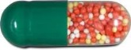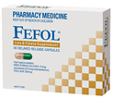 | Ferrous Sulphate 270 mg  Folic acid 300 mcg  Delayed release capsule | 87.4 mg
Ferro-f-tab  (AFT pharmaceuticals) | 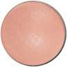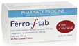 | Ferrous Fumarate 310 mg  Folic acid 350 mcg | 100 mg
Ferro-tab  (AFT pharmaceuticals) | 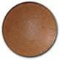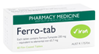 | Ferrous Fumarate 200mg | 65.7 mg
FERRO-GRADUMET  (Abbott) | 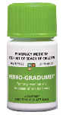 | Ferrous Sulphate 325 mg  Modified release tablet | 105 mg
FERRO-GRAD C  (Abbott) | 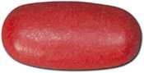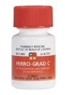 | Ferrous Sulphate 325 mg  Ascorbic acid 500 mg  Modified release tablet | 105 mg
FGF  (Abbott) | 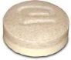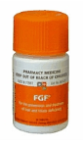 | 250 mg  Ferrous Sulphate  Modified release tablet | 80 mg
#Maltofer  (Aspen Pharmacare) | 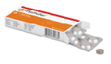 | Iron polymaltose 370 mg | 100 mg
#Maltofer Syrup  (Aspen Pharmacare) | 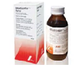 | Iron polymaltose 185 mg  Oral solution | 50 mg/5 ml

# Response to oral iron polymaltose (Maltofer) may be slower than with ferrous iron. Maltofer is licenced in Australia for treatment of iron deficiency in adults and adolescents where the use of ferrous iron supplements is not tolerated, or otherwise inappropriate.
* Modified from: BloodSafe Oral Iron Table Version 1.7 October 2011, TP-L3-410. Available at: http://www.bloodsafe.sa.gov.au
See below for dosing and considerations
Dosing and considerations:
- Usual ADULT dose for IDA is around 100–200 mg elemental iron daily in divided doses
- Ideally give 1 hr before or 2 hrs after food
  - GI upset may be reduced by taking tablet with food or at night & increasing dose gradually
- Consider giving supplement with Vitamin C (eg. orange juice) to improve absorption
- When a rapid increase in Hb is not required, intermittent dosing (1 tablet 2–3 times a week) or lower doses of iron (e.g. 30–60 mg of elemental iron, increasing to twice daily or three times a day if tolerated: try Ferro-tabs or titrate liquid) may reduce GI upset
- Multivitamin-mineral supplements should not be used to treat IDA as iron content is low and absorption may be reduced
- Iron overdose may be fatal – keep medication out of reach of children
- Based on limited available data, controlled-release iron formulations appear to have fewer GI side effects, but similar discontinuation rates and comparable efficacy; release of iron distal to the site of maximal intestinal absorption may theoretically limit response in some patients.¹

